Automate Corporate Programming

Triple Programmer Productivity

RTPA for RPG

RTPA for CLP

RTPA for COBOL

RTPA Query

RTPA On Demand Cloud Computing via FTP

User Manual

V7R1

United States Patent No. 6,775,827
Multiply programmer productivity, capability, value by 3, 5, 10, 100 Times

Copyright © 2021 by Paul Houston Harkins All Rights Reserved
Harkins & Associates, Inc.
816 Daisy Lane
West Chester, PA 19382
USA
www.realtimeprogramaudit.com

Telephone +1 610 431 1755 USA land line
+1 610 804 1527 USA cell
Languages: English
Email paulhark@aol.com

Sales and support
Locations: Philadelphia, PA USA

Sales: sales@harkinsaudit.com
paulhark@aol.com

Technical Support: support@harkinsaudit.com
paulhark@aol.com

RTPA Version: V7R1 for IBM i Version 7.1 to Version 7.4

Last Updated: yyyy/mm/dd 2022/03/16 March 16 2022

IBM i OS/400) Versions V7R1 through V7R4 (all IBM Supported Releases)
(IBM i Power5 through IBM i Power10)

The Real-Time Program Audit (RTPA) software developed by Harkins & Associates, Inc. is available “AS IS WITHOUT WARANTEE EXPRESSED OR IMPLIED”

RTPA IBM i SAVF downloads are available from Harkins & Associates, Inc. Business Partners and IBM i ISVs who distribute and support the Real-Time Program Audit (RTPA) for IBM i software

- RTPA71B1 SAVF for IBM i release V7R1 through V7R4 RTPA object library for RTPA IBM i customer use.

- RTPA71S1 SAVF for IBM i release V7R1 through V7R4 RTPA source library for RTPA IBM i development and support.

IBM i (AS/400) server system requirements:
- OS/400 V7R1 (Power7) through V7R4 (Power10)
- At least 1000 CPW processing power in an IBM i LPAR or server
- Processing in QPGMR subsystem to avoid delay of production batch job processing in subsystem QBATCH
- RTPA V7R1 distribution object code disk space of 140 Meg (download size)
- RTPA is distributed with the default JobQ RTPA, so that RTPA expansion jobs are not delayed by jobs waiting for execution in another Jobq such as Jobq QBATCH. RTPA submits several jobs for each RTPA expansion of the input source program with RTPA audit statements and the compile of the expanded RTPA source program.
- An RTPA supported CCSID Code (country language) default is CCSID 37 USA
- People giving IBM i demos should have a keyboard with the IBM i 12 command keys on top, like DELL DP/N 0F77Y5

ZZPGMPAS Real-Time Program Audit (RTPA) (V7R1) Date: 11/26/20
Time: 12:04:34
License Key Creation Serial: 2104FAW Model: 42A
21-01-25 21-11-26 22-11-26 23-11-26 30-11-26
License type T (T=Trial, 1=1 Yr, 2=2 Yrs, 3=3Yrs, P=Perpetual, A-H, X)
Company Name HARKINS & ASSOCIATES, INC.
Address 816 DAISY LANE
City WEST CHESTER
State/Province PA Zip/Postal 19382 Country USA
Contact Name PAUL HARKINS
Contact email PAULHARK@AOL.COM
Contact phone 610-431-1755 CCSID 37 (Lang.)
User Serial 2104FAW User Model 42A (leftmost position may be blank)
Prog. Language RPG Y CLP Y QUERY Y COBOL Y (Y/N)
License Key xe04msd):l9>a9"jTl</-d%r?
Security Code bssfm&z9:;>!l="1TW<2rksw\

Expiration date 21/01/25 (yy/mm/dd)
Referral Info.

F3=Exit F19=Update License Key License Key created
Enter key to validate Copyright (C) 2016 by Harkins & Associates, Inc.
The Real-Time Program Audit (RTPA) is distributed AS IS without warranty
either express or implied

RTPA license key Authorization creation requiring IBM i Serial and Model
License Key xe04msd):l9>a9"jTl</-d%r?
Security bssfm&z9:;>!l="1TW<2rksw\
- RTPA license key for the user IBM i (AS/400) server serial number, model and expiration date: (sent by email)

- 90 Day RTPA evaluation license with two GoToMeeting interactive sessions
- One and two year RTPA subscription licenses including email support
(see RTPA pricing section)
- RTPA for RPG, CLP, COBOL and RTPA Query is all included
- RTPA license is for the IBM i server (unlimited users, unlimited LPARs, unlimited cores)

Table of Contents
Table of Contents
Real-Time Program Audit (RTPA) for IBM i is “AS IS without Warrantee expressed or implied” 5
Preface 6
RTPA has digitally transformed and automated the programmer’s job 7
RTPA multiplies programmer productivity, capability, value by 3, 5. 10, 100 Times 7
RTPA replaces obsolete and invalid programmer methods 8
Real-Time Program Audit replaces ancient, unproductive, costly DevOps Technology 8
Triple Programmer Productivity and Value with Automation 10
Triple Your Programmer Productivity and Value with Automation Examples 20
Real-Time Program Audit (RTPA) products 21
RTPA and Auditing: The Origins 21
Whole Product Implementation plan at a Customer 22
RTPA Auditing of RPG, CLP, and COBOL and RTPA Query 23
RTPA Query of all Job audit output by Execution Time 26
Productivity Gains with RTPA 33
Double (at least) programmer/developer productivity, Capability, and value 34
Agile methodology, prototype development, testing and validation unique new capability 35
Quickly understand, master and maintain millions of lines of corporate application code 35
Quickly implement complex and sophisticated projects not feasible before RTPA 35
Document and secure the entire crucial corporate software that runs the business 36
Protect against staff turnover and critical loss of programmer knowledge 36
Provide a smooth transition to new capability and technology and the Cloud 36
Demystifying Legacy Programs 36
Fixing Software Glitches 36
75 % of a developers time is spent on debugging (1500 hours a year) 37
Improving Quality and Reliability 37
Creating Web GUI Reports from program data and logic 38
Advantages of Auditing with RTPA 38
Multiply Your Value, Capability, Productivity by 3, 10, 100 Times – Ride the Rocket 39
(abstract) 39
RTPA is a prototype invention, like Henry Ford’s Quadricycle and Elon Musk’s Tesla Roadster EV 42
Henry Ford’s Quadricycle Prototype 42
SS United States ocean lliner 44
Elon Musk’s Tesla Roadster EV Prototype 45
Elon Musk’s Tesla Cybertruck EV Prototype 45
The Real-Time Program Audit (RTPA) Prototype 46
Glass Half Full or Glass Half Empty 47
Converting System/36 RPGII to IBM i RPGIV (RPGLE) 47
Converting System/38 RPGIII to IBM i RPGIV (RPGLE) 48
RTPA offerings, License Pricing and support 48
RTPA - What You See is What You Get 49
What RTPA Does Do 50
What RTPA Doesn’t Do 52
How to Become a Highly Paid Corporate Programmer 54
The Future of Corporate Computing 58
Triple Programmer Productivity and Value with Automation 58
RTPA is profound and disruptive transformation of all programming 59
Why was the polaroid camera invented? 59
Setting Realistic Expectations for RTPA 60
RTPA Online Demonstrations, Videos, Webinars, Training, Papers, User Manual 61
Real-Time Program Audit Overview Multilingual Demonstration English and German 62
Automate Programs to enable Machine Learning and Artificial Intelligence and Succeed 62
Real-Time Program Audit (RTPA) replaces ancient, unproductive, costly Technology 63
Real-Time Program Audit (RTPA) How RTPA works in many languages 64
Triple Programmer Productivity and Value with Automation 66
Multiply Programmer Productivity, Capability, by 3, 5, 10, 100 Times with Automation 67
RTPA Demonstrations in many Country Languages 68
IT Customer Library Books for licensed RTPA Customers 77
RTPA Software Guaranty is “AS IS” without Warantee expressed or implied 78
Harkins & Associates, Inc. Websites 78
RTPA Web site for IBM i www.realtimeprogramaudit.com 78
RTPA for IBM i RPG Brochure 80
RTPA for IBM i COBOL and COBOL System z Brochure 85
How RTPA works for many countries and languages on the same IBM i 94
CCSID values defined on IBM i - IBM Documentation 102
Configuring secondary languages - IBM Documentation 102
Secondary language environments 102
National language version feature codes - IBM Documentation 103
RTPA supported languages (50) including support in the country native language 105
Using installed IBM i Secondary Languages 126
User GERMAN CCSID 273 DEU auditing of RPGLE batch program TESTBASP (procedures) 132
User PHARKINS CCSID 37 USA auditing of RPGLE interactive program NEWEXPSH 140
RTPA for RPG screens in 17 country languages 149
RTPA DBCS Double Byte Character Set capability 157
RTPA Object program execution in other LPARS or IBM i computers 158
RTPA expanded source program execution in other LPARS or IBM i computers 167
RTPA and Binding Directories (CRTBNDRPG) 170
ERP packages using CLP overrides OVRDBF, OVRDSPF 175
RTPA Whole Product Customer Implementation Plan 176
Chapter 1: Installing Real-Time Program Audit 177
RTPA Distribution code downloads are replacements 179
Requirements 180
Step 1: Installing RTPA from the Web to a PC 187
Step 2: Installing RTPA SAVF from the PC to the IBM i 188
Step 3: Add the JOBQ Entry RTPA to subsystem QBATCH 190
Step 4: Check the CCSID Coded character set identifiers (character set) 196
Step 5: Check the Language ID (language for displays,, messages, compile listings) 200
Step 6: Create User Profile and initial program for the user for the desired CCSID and Lang ID 202
Step 7: Enter the RTPA License Key 206
(emailed from Harkins & Associates, Inc. for the IBM i serial number and model number). 206
RTPA for RPG converts RPG3 source to RPG4 source 213
RTPA for RPG Sample program NEWEXPSH (RPGLE) 220
RTPA for RPG Audit Ranges of NEWEXPSH compile listing statements 246
RTPA for RPG Conditional Auditing of RPGLE NEWEXPSH 251
RTPA for RPG Watch Variables Auditing of RPGLE NEWEXPSH 256
RTPA for RPG Sample program TESTBASIC (RPGLE) 261
RTPA for RPG Sample program TESTFREE (RPGLE) 269
RTPA for RPG Sample program SELECTFIXE (RPGLE) 276
RTPA for RPG Sample program TESTBASP (RPGLE) Procedures 281
RTPA for RPG Overriding default compile parameters 288
RTPA for RPG Overriding default RTPA User Profile default parameters 298
RTPA for RPG Sample program TESTSQL (SQLRPGLE) 303
RTPA for COBOL COBBASIC Sample program 316
RTPA for CL ZZTEST1N Sample program 325
RTPA Query Sample program 336
RTPA Audit output by moment-in-time statement executed 349
RTPA Audit output to DB2 Disk file ZZAUDITD 359
Clearing RTPA Audit compiles in work library ZZAUDITE 362
How to create a PDM User-defined Option for RTPA 368
How to create a private RTPA User Testing Library 370
How to add RTPA Jobq to Subsystem QBATCH 373
How to change the RTPA Jobd Job Queue from RTPA to QBATCH 374
How to find the IBM i Processor Group with WRKLICINF 374
How to find the IBM i Installed IBM Licensed Products 377
RTPA interface to IBM RDI 379
RTPA interface to IBM RDI via Host Connection Emulator 379
Chapter 2: Quick Start Guide 380
Expand the Sample Program 380
Execute the Program 385
Review the Audit File (RTPA audit output file ZZAUDITP) 387
Program BATCHPGM1 audit output 393
Chapter 3: RTPA Overview – Auditing Concepts 395
Auditable Information 395
Creating an Audit – Overview 396
Audit-Enabling A Program 396
Producing an Audit File 396
Reviewing an Audit File 396
Audit Statement Ordering 396
Data Modifying Statements 396
EVAL Statements 397
Branching and Conditional Statements 397
Special Case – Uninitialized Fields 397
Chapter 4: Using RTPA 398
Selecting a source member to expand for Auditing 399
Selecting the Object Library for the expanded object 400
Selecting the Job Description to be used for source program compiles 401
Customizing the Audit 402
Selecting Ranges of Statements to Audit 402
Conditional Auditing with Variable Values 403
Example of finding a transient error with RTPA 403
Example of RTPA Conditional Auditing 410
Overriding Compile Options 412
Creating the Expanded Object Program with F10 415
View Job Status 415
RTPA Expansion Status Codes 416
Selecting multiple source members (Mass compiles) 417
Instant RTPA Program Auditing with the iRTPA command 420
Using the RTPA Maintenance Menu to manage RTPA 424
RTPA Audit output in Character and Hexadecimal (HEX) 432
Chapter 5: Advanced Auditing (Focused Auditing) 436
Using the F11 Command Key to compile the input source 437
Using the F16 Command Key to audit desired variables 438
Chapter 6: Working with Audit Files 441
Reading Audit Files (WRKSPLF and PDF files) 441
Converting spool files to PDF files on the IFS 441
Searching the ZZAUDITP Audit file with the FIND feature 442
Chapter 7: Using Auditing Options 444
Auditing Options 444
Pre-Audit Conditionals 449
Arithmetic Operations 449
Auditing Calculation Comment statements 449
Show All Variable Values 450
Audit lines of data record 450
Only Selected Variable Statements 450
Audit Zoned Decimal Variables 450
Audit File Key Fields 450
QSYSPRT Compile Printer File 450
Auditing by Change ID 451
Auditing by Change Date 451
Documentation Only with ZZC Comment Auditing 453
Chapter 8: Auditing Very Large RPG and COBOL Programs 455
RPG Compiler Limits and why RTPA uses the supported ILE compilers 455
RTPA automatic management of large source programs 456
RTPA auditing of RTPA entry program ZZPGM01R 457
RTPA auditing of RTPA program ZZPGM24R 461
How to multiply programming productivity, capability, value by 3, 5, 10, 100 TIMES without RTPA 470
Real-time auditing of RPGLE, CLP, COBOL program execution without RTPA 472
SEU Limits 477
How RTPA Inserts Audit Statements 478
Changing Audit Options to Reduce the Source Size 478
Audit Copybook Subroutines 478
Audit lines of Record Data 478
Reporting and correcting RTPA Status 9 Compile Error 478
Summary 479
Chapter 9: RTPA Reporting and Analytics 479
Summary by Programmer, Project, Ticket 479
Summary 487
Chapter 10: On-Demand Real-Time Program Audit (RTPA) enablement 488
On-Demand Real-Time Program Audit (RTPA) at user campany 488
Customer On-Demand Real-Time Program Audit (RTPA) for IBM i 488
Appendix A: Frequently Asked Questions 489
How does RTPA auditing differ from IBM i journals and audit logs? 489
How long does it take to RTPA enable a large RPG4 source program? 490
How much processing power is used when creating the RTPA audit output? 490
How much disk space is used by the RTPA audit output 491
Does RTPA for RPG audit all RPG ILE (RPG4) programs? 491
Does RTPA for RPG audit all RPG3 programs? 491
Does RTPA audit free-form RPG? 492
Does RTPA audit free-form Only RPG? 492
Why did RTPA fail to expand the program correctly? 492
Do NOT use special characters in variable or file names 494
Special-character keyboard set - IBM 494
Why can’t I compile my large RPGIV program? 495
Can I ship expanded object programs to other computers? 495
Does RTPA for RPG audit copybook statements? 495
Does RTPA for RPG audit procedure statements? 495
Will RTPA exceed maximum file limits in RPGIV? 496
Does RTPA for RPG use any indicators? 496
Does RTPA change the original source or object program? 496
How do I expand and create Module objects? 496
Where is the audit output sent during program execution? 496
How can I direct RTPA audit output to a specific Outq? 496
How can I direct RTPA to use a specific jOBD? 497
How can I expand all the members in a source file? 497
Do I need to expand all my source programs? 497
How can I selectively audit ranges of source statements? 497
What is the proper format of a Compile time Array header? 498
Appendix B: RTPA Command Keys 507
Appendix C: How RTPA Works RTPA Conditional auditing 508
Appendix D: User Profile and Job Description for RTPA 535
Typical Programmer Profile for RTPA expansion (PHH) 538
RTPA Job Description in Library QGPL 541
Appendix E: RTPA Documentation Only Examples 543
Examples of RTPA Documentation Only of Source Programs 543
Appendix F: RTPA Query Examples 552
Appendix G: RTPA audit output to DB2 file ZZAUDITD 560
RTPA ZZAUDITD logical files ZZAUDITDLX 567
Appendix H: RTPA Profile Maintenance 592
Appendix I: How RTPA for IBM i works 603
The Real-Time Program Audit US Patent 6,775,827 603
SUMMARY OF THE INVENTION 605
RTPA works similar to the IBM SQL pre-compiler 608
IBM could easily implement real-time auditing in its language compilers 608
RTPA auditing of RPGLE procedures 609
How RTPA for RPG expands Sample program TESTBASP (RPGLE) Procedures 609
Appendix J: How Fast and Efficient is RTPA auditing? 625
Computers are millions of times faster than human brains and human backs 627
Security camera real-time recording and analytics is like RTPA 627
GoToMeeting video recording is essentially infinitely fast 627
Microsoft Word Find function is essentially infinitely fast 628
IBM i Find function (F16) is essentially infinitely fast 629
RTPA real-time records and audits crucial new information 634
RTPA auditing is essentially infinitely fast 637
RTPA auditing speed illustrations IBM i environment 637
RTPA normal expansion of RPGLE NEWEXPSH 639
How to audit how RTPA expands programs? 643
Audit how RTPA expands programs 644
How RPGLE compile listing statement 1178 is audited 654
Audit the execution of all programs in an entire application job 665
Real-Time program audit all RPGLE programs now or wish you had. 669
IBM 407 - Wikipedia 670
Unit record equipment 670
In 1962 the IBM 407 Accounting Machine cost more than IBM Systems Engineers 671
Appendix K: When RTPA does not correctly expand the program 673
How to successfully real-time program audit virtually all programs 673
Simplify how you program for ultimate success 675
Appendix L: Triple Programmer Productivity and Value with Automation 678
How to Triple Programmer Productivity and Value with Automation 678
Prototype design of RPGLE program FCPPROTO 682
Prototype design of RPGLE program FCPPROTO Output 687
Prototype design of RPGLE program FCPPROTO answers with manual auditing 689
Prototype design of RPGLE program FCPPROTO answers with RTPA auditing 707
Prototype design of RPGLE program FCPPROTO RTPA audit output 710
RPGLE FCPPROTO RTPA audit source program 715
RPGLE FCPPROTO RTPA audit executable statements file ZZAUDSRC 731
Appendix M: RTPA Key Creation 734
RTPA key creation requires the IBM i Model and serial number 734
Appendix N: RTPA Creation of Source and Object SAVFs for distribution 740
Appendix O: RTPA User Manual in many languages with Google Docs 745
Appendix P: RTPA To Dos 751
Real-Time Program Audit (RTPA) products To Dos 751

Real-Time Program Audit (RTPA) for IBM i is “AS IS without Warrantee expressed or implied”
The cost of customer IBM i programmers and administrators is some 121 billion dollars annually, as is illustrated in this recent article The Humongous Investment In IBM i People in ITJungle by Editor Timothy Prickett Morgan, which is more than the 75 billion dollar annual revenue of the entire IBM Corporation.

People costs are typically, by far, the largest cost of Information Technology in IBM i customers.
Paul H. Harkins, founder and CTO of Harkins & Associates, Inc., an IBM Business Partner, has patented and authored a transformative IBM i programmer productivity software product which automates much of the current IBM i programmer and related work and analytics, the Real-Time Program Audit (RTPA), as illustrated in these YouTube videos Triple Programmer Productivity and Value with Automation and Multiply Programmer Productivity, Capability, Value by 3, 5, 10, 100 Times with Automation.

RTPA is licensed by Harkins & Associates, Inc. “AS IS” without warranty express or implied, similar to the five successful IBM Apparel Business System Installed User Programs (IUPS) for the IBM System/3 Model 6, IBM System/32, IBM System/34, IBM System/38, IBM System/370 authored and supported by Paul H. Harkins when he was an IBM Systems Engineer

Preface
In writing this manual, we assume that you are familiar with the basics of programming RPG3 or RPGIV (RPGLE) or COBOL (COBOL400 or COBOL ILE), or CLP on a System i (AS/400) computer. This manual is designed to help you get started with and use the Real-Time Program Audit™ for RPG, CLP, COBOL, and RTPA Query software utility from Harkins & Associates, Inc.

At a minimum, we hope that you will read:
Chapter 1: Installing Real-Time Program Audit to install the software
Chapter 4: Using RTPA to learn how to use RTPA
Appendix E: RTPA Examples of RTPA Audit Output

RTPA has digitally transformed and automated the programmer’s job
Real-Time Program auditing and the patented Real-Time Program Audit (RTPA) for IBM i has digitized the programmer’s job, and digitally transformed and automated all of programming.

Perhaps 80 percent or more of traditional programmer human based work, time, and cost has been automanted or eliminated by real-time program auditing, allowing programmers to focus solely on creative work.

Real-Time Program auditing and the patented Real-Time Program Audit (RTPA) for IBM i transforms computer information technology from its previous severely limited and costly methods and capability and human centric orientation into real-time control and management of all of corporate computer related activity of all users of IT in the company.

RTPA multiplies programmer productivity, capability, value by 3, 5. 10, 100 Times
Real-time program auditing and the Real-Time program Audit (RTPA) for IBM i patented software multiplies programmer productivity, capability, value by 3, 5, 10, 100 times, by fully utilizing the virtually infinitely fast and powerful and available and essentially FREE available corporate computer.

This is similar to how the automobile (automation) effortlessly multiples the speed of travel 20 times compared to walking and the jet airplane effortlessly multiplies the speed of travel 200 times compared to walking.

This is also similar to how the automation of hundreds of other human jobs has multiplied human output by hundreds of times, with far less effort and less time and less cost, like automating farm human labor with the cotton gin, the tractor, the combine and many other autonation inventions.

RTPA replaces obsolete and invalid programmer methods
Incredibly, the IBM i DevOps programmer NEVER again NEEDS or SHOULD:
- Use IBM Interactive Debug or program steppers to debug or understand programs
- Attempt to understand the program by staring at the source code
- Guess what the program could or should do by looking at the source code
- Attempt to “own” a program or an application of programs
- Use multiply screens to display and attempt to understand a large amount of source code
- Focus on might or could happen, instead of whatis happening
- Attempt to “modernize’ working programs to the newest “modern” methods
- Require structured programs or modular programs and not allow GOTO statements
- Attempt to demonstrate ypur programming excellence by using “modern” techniques that are not needed or helpful and are not actually best for the environment
- (another hundred things pushed by programming “experts” to complicate DevOps)

Incredibly, the IBM i DevOps programmer NEEDS or SHOULD:
- Automate everything – Simplify and automate every part of your job and environment
- Utilize the KISS (Keep it Simple) principle to make and keep systems simple and uncomplicated
- Fully utilize the incredible power of the computer to multiply your productivity
- Real-ti,me audit everything to provie a understanding of the actual logic flow of the computer to eliminate the need to ever use the IBM Interactive Debug or other program steppers
- Understand a program or application by lbserving how the object programs actually execute by implementing real-time auditing in YOUR programs
- “Own” and understand every program the very first day by observing its real-time execution provided by real-time auditing.
- Only display source code that you are writing or changing
- Focus ONLY on what is actually happening
- Totally eliminate guessing and speculation
- Use the style of programming that is best for YOU, including GOTO statements as desired
- Audit everything in your source programs with user cereated (bu YOU) real-time auditing statements, as illustrated in the RTPA User manual Appendix J
- (another hundred things for increased productivity developed by YOU)

Real-Time Program Audit replaces ancient, unproductive, costly DevOps Technology

https://www.youtube.com/watch?v=96EVrro_0Fc&t=404s

Computer programming, and the punched card unit record control panel wiring that preceeded stored program programming, and the totally human manual activity that preceeded punched card unit record control panel wiring has always been human centric based.

Today, computers are thousands of times, or millions of times faster than humans, and automation has largely overtaken and replaced human activity in programming as well as in so many other areas.

Machine learning and artificial intelligence (AI) by definition mean that computers are or will be not only creating programs, but also reading and maintaining programs.

Thus, the many mundane programming practices that have been created amd propagated by so called “programmer experts” to attempt to make human programmers “better” and create more readable programs that are maintainable by human programmers have little or no use in the forthcoming world of computers doing the programming and in the current world where real-time program auditing obsoletes and invalidates these ancient programming restrictive practices.

In short, it does not matter how the source program is written or constructed or modularized.

It only matters to the computer and to real-time program auditing how the program actually executes, as that is the actual flow of the program with the data processed, and that is how instant and comprehensive understanding of the program is gained by observing the actual execution of the program executing statements and data.

Current programming restrictive practices such as structured programming, modular programming, and a host of others actually result in a tortured and difficult to comprehend source program for humans to comprehend.

Real-time program auditing, implemented by the user in the user source programs or by the Real-time program audit (RTPA) software for existing programs, resolves and simplifies the issue of many source program compositions and structures by simply showing the actual source program statements as they execute with the data being processed.

Spending time learning and implementing traditional human centric programming practices such as structured programming and modular programming, and other restrictive methods, is counter productive to the success of a programmer, while implementing real-time program auditing is productive to the success of a programmer.

Triple Programmer Productivity and Value with Automation
https://youtu.be/bWVWqTaUo4Q

Virtually all computer programmers and other DevOps programming related personnel can immediately Triple their Productivity and Value with Automation by simply implementing the modern real-time programming auditing techniques presented here and illustrated in Appendix L of this RTPA User Manual.

These real-time programming techniques are immediately available to all programmers using virtualy all programming langugaes, and these simple techniques can be implemented immediately without installing any software or hardware and they are FREE.

The video “Triple Programmer Productivity and Value with Automation” illustrates exactly how virtually every computer programmer in virtually every programming language can STOP using ancient, grossly primitive, slow, and costly programming techniques, like using interactive debug to attempt to understand what is happening in executing programs inside the computer.

The forthcoming Amazon.com kindle ebook and paperbook “Triple Programmer Productivity and Value with Automation” contains all of the illustrations and examples in this video, together with much additional related material.

Programmers can immediately START saving perhaps 80 to 90 percent of the current wasted programmer time and effort, and instead focus on the unique human creatitive aspects of programming.

The video “Triple Programmer Productivity and Value with Automation” also illustrates exactly how computer programmers utilizing programing languages already implementing real-time program auditing software, such as the IBM i programming languages RPG, COBOL, and Control Language Program (CLP) can immediately STOP using ancient and grossly primitive programming techniques, like using interactive debug to attempt to understand what is happening in executing programs inside the computer.
These programmers utilizing IBM i RPG,COBOL and CLP languages can immediately START saving perhaps 80 to 90 percent of the current wasted programmer time and effort, and instead focus on the unique human creatitive aspects of programming on their current work and focus on virtually the entire existing set of corporate programs, which is often millions of lines of crucial application program code.

And, these lucky programmers utilizing IBM i programming languages RPG, COBOL and CLP can expect to immediately multiply their value by more than three times, all by utilizing the incredible and available power of the computer as a productivity tool, rather than the over matched human brain (like the chess match of the successful IBM Blue Gene computer against the world chess champion in 1997).

Today, teenagers of average IQ with a computer chess program can routinely defeat the current world chess champion Magnus Carlson, who has an IQ of 190 at chess, because the computer’s incredible and instant capability simply overpowers the brain of Magnus Carlson, and all other humans.

Today, other inventions multiply the capability and ease of human beings in very many ways, and at an astonishing and accelerating pace:
- Bicycle riding is 5 times faster than human walking
- Automobile riding is 20 times faster than walking
- Jet airplane riding is 200 times faster than walking
- Rocket riding 5,000 times faster than walking

Today, the computer multiplies the capability and ease of human beings in very many way not possible before 1950, and the computer is multiplying it’s capability, power and speed while rapidly declining in size and cost per Commercial Processing Work (CPW), an IBM metric for system performance

The early corporate computers of the 1950s (there were no PCs), like the IBM 650 and the IBM 1401 and the IBM 1440 had a CPW of LESS than 1, and only processed one program (1 core and one max thread) at a time in the entire computer.

I programmed all three of these IBM corporate computers and programmers often got only one compile (test) of their work in a day instead of the hundreds of program compiles (tests) a day available to programmers today.

Programmers in the 1950s debugged their programs by stopping the entire computer (only one program was running in the entire expensive corporate compute), and single cycled through computer memory setting break points stepping through their program statements and data by decoding the computer console displays, which were 7 (ASCII) or 8 (EBCDIC) lights per character of memory.

This manual debugging by manually stepping through the computer memory of the STOPPED corporate computer was agonizing slow and required guessing what to look at and what to look at, and what was important to manually write down for later review.

This agnoizing slow and clumsy debugging ot testing computer programs by stepping through the computer memory statement by statement with primitive stepper programs is the same technique used today, when computers are literally millions of times faster than in the 1950s.

Think of still walking across the United States instead of flying in a jet airplane.

This table is courtesy of Timothy Prickett Morgan, editor in chief of ITJungle in his article Max Thread Room ITJungle September 28, 2020 www.itjungle.com.
https://www.itjungle.com/2020/09/28/max-thread-room/

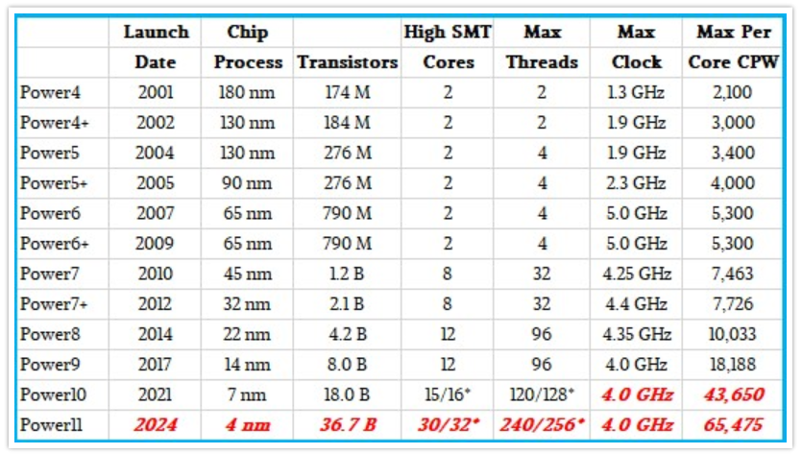

Max Thread Room ITJungle September 28, 2020 www.itjungle.com.
https://www.itjungle.com/2020/09/28/max-thread-room/

The IBM System/36 model B1 (1983) had a CPW rating of 1.

The early corporate computers of the 1950s (there were no PCs), like the IBM 650 and the IBM 1401 and the IBM 1440 had a CPW of LESS than 1, and only processed one program (1 core and one max thread) at a time in the entire computer.

Today, programmers of average IQ and limited experience in programming who utilize the FREE real-time program auditing techniques illustrated in Appendiz L of this RTPA User Manual can routinely outperform top senior corporate programmers who insist of using the primititive debug stepper techniques and who thus waste most of their time and energy guessing instead of creating superior programs and applications.

The incredible speed and power and capability of the computer, and the essentially free access to infinite computing power all day and every day has obsoleted the program debug stepper technique, and has obsoleted those programmers who still utilize the program debug stepper technique.

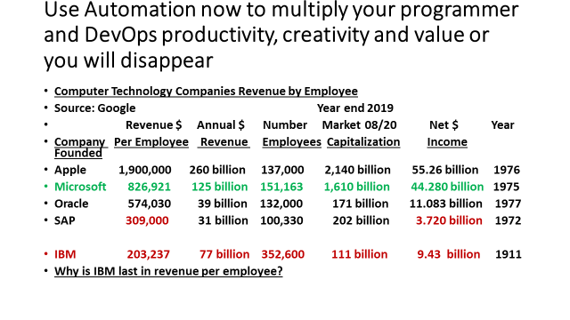
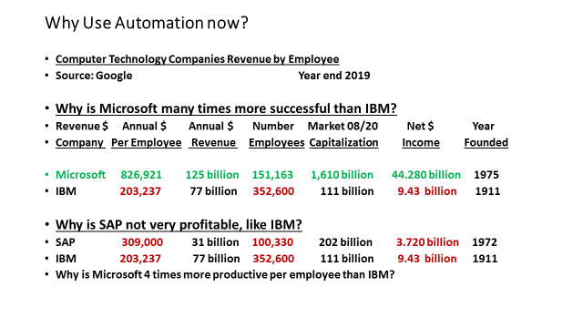
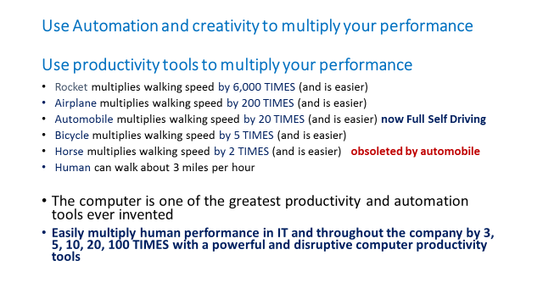
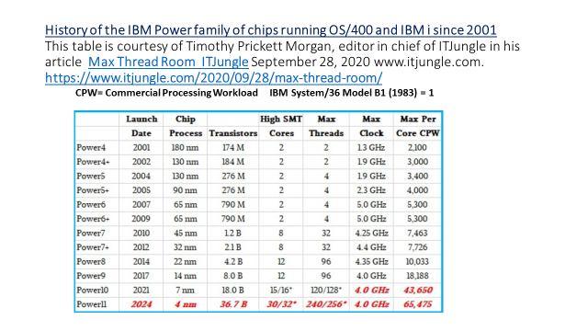
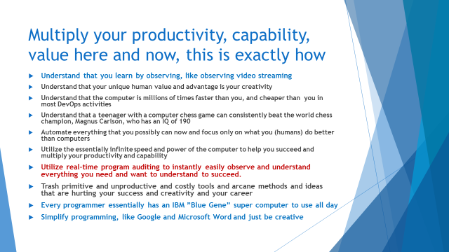
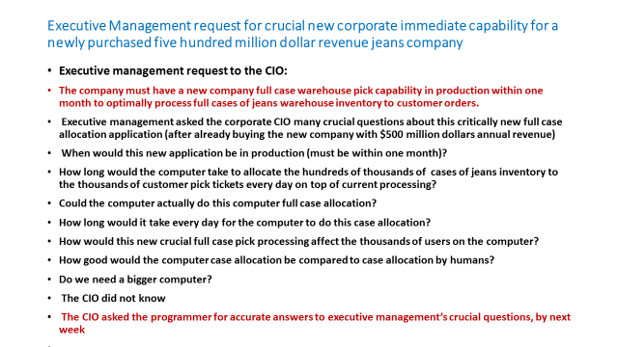
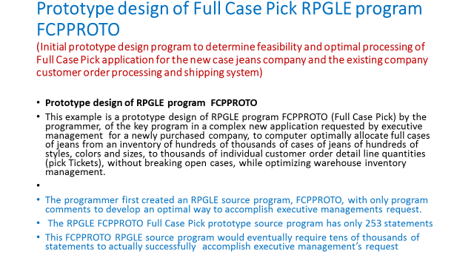
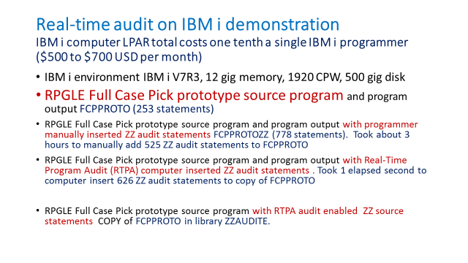

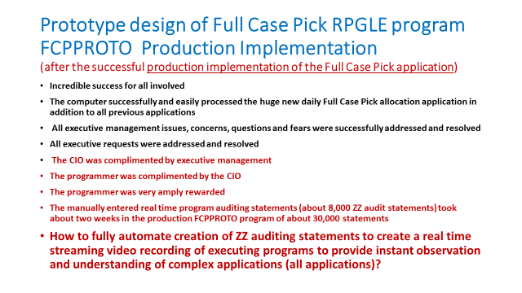
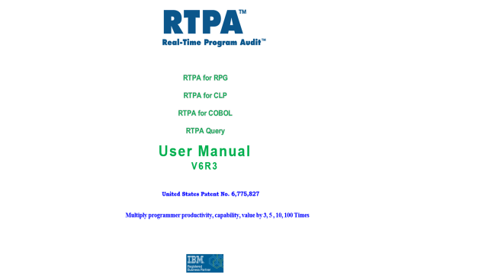
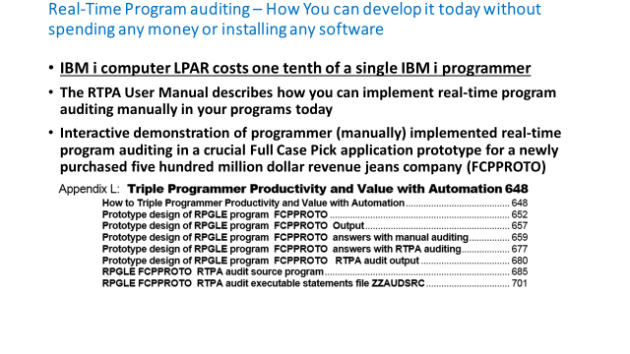
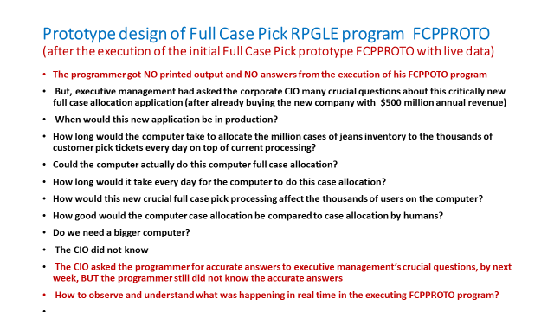

Triple Your Programmer Productivity and Value with Automation Examples
- Automate every aspect of your job, except your creativity
- Plan the entire project or program details as prototype program comments
- Review, simplify, optimize the entire project or program prototype comments
(understand exactly what you want to accomplish before coding anything by
using manual real-time program audits in existing programs to understand)
- Protoype each program as comments, as in the example FCPPROTO
- Implement manual real-time program audits as in the example FCPPROTO
if the Real-TimeProgram Audit (RTPA) software is not available
- Develop and test the program after each change by observing the real-time program audit output
- Use the FREE computer all day long to test and verify your incremental work by reviewing the manual real-time program audit output, as in FCPPROTO
- Implement more manual real-time program audit statements in each routine you add, and keep the audits in the production program as optional audit output.
(see Appendix L program ZZPGM22R example of thousands of manual
real-time program audit statements in a sophisticated production program).
- NEVER, EVER use a program stepper, like the interactive debug program to STOP the computer to attempt to guess what is executing inside the computer
- Simply observe the real-time program audit output of your program
- Learn and understand by observing programs execute in real--time ( like watching streaming video)

Real-Time Program Audit (RTPA) products
- RTPA for RPG Command RTPA (programs ZZPGMxx)
- Expand RPG source programs for Real-Time-program auditing
- RTPA for CLP Command RTPACL (programs ZZCLPxx)
- Expand CLP source programs for Real-Time-program auditing
- RTPA for COBOL Command RTPACOB (programs ZZCOBxx)
- Expand COBOL source programs for Real-Time-program auditing
- RTPA Query Command RTPAQ (programs ZZPGMxx)
- Query and analytics of RTPA expansions
- RTPA for On Demand Cloud Computing via FTP (at cloud service bureau)
- Remote On Demand RTPA expansion via FTP at a cloud service center
- Command RTPAODC (programs ZZODCxx)
- IBM i customer has only RTPA programs to request RTPA expansion (RTPA entry screens) and to FTP to service bureau and receive FTPed RTPA expansion Object program (from ZZAUDITE expanded source) from service bureau and to apply FTPed RTPA expansion to RTPA files at customer.
- (Think Google Translate and Amazon AWS)

RTPA and Auditing: The Origins
Paul H. Harkins founded Harkins & Associates, Inc. to solve some of the most frustrating aspects of working as a software developer and IT consultant. Over his 50 year career, Paul came to realize that the most unpleasant, frustrating and time-consuming activities of a programmer involved:
- Learning other people’s programs to make enhancements and corrections
- Doubling (at least) his productivity, capability, and value compared to the best programmers starting his first day at a client
- Quickly understanding and being able to support millions of lines of application programs
- Quickly and effectively develop and implement complex and sophisticated new applications
- Utilize Agile methodology, prototype development, testing and validation uniquely well
- Work far faster and more effectively than any other developer using current techniques
- Record and understand exactly each and every source statement actually executed, including the contents of variables, in the most complex application as in a security camera recording
- Tracking down bugs in production systems, and in development systems
- Validating and documenting new programs with proof of comprehensive testing
- The inability to easily and quickly solve difficult, critical, and stressful problems
- The Complex and unnecessary technical aspects of programming, particularly debugging
- Guessing and speculation of what happened or what might happen, if…
- Not being able to see exactly what was happening inside the computer all of the time
- The difficulty and loss of productivity in stopping the computer with traditional debug programs
- The lack of a recorded complete audit of what happened inside the computer programs
- The high risk and stress of supporting complex applications without any program audit trail
- The lack of an IBM i (AS/400) software permanent forensic audit of all application processing
- Understanding and visualizing exactly what was happening inside the computer

Over that time, the computer industry created a number of powerful tools and techniques to help with these activities. Programs like stepper-debuggers, 4th generation analysis tools and the structured walk-through process improved the situation. At the same time, however, applications and many programs have become larger and more complicated, and more frequently involve teams of programmers, while at the same time, the productivity expectations for programmers have risen higher and higher.

In a moment of inspiration, when faced with a perfect example of these problems, Paul invented the Real-Time Program Auditing technique. Paul had been asked, as a consultant, to solve a bug in a piece of software that brought down a major warehouse, resulting in many thousands of dollars of lost time and contract and chargeback penalties. He was given a few minutes to find and fix the bug.

After determining that the bug could be anywhere in about 20,000 lines of legacy software (consisting of both in-house and 3rd party code), he decided that his best bet to find the bug was to cause the object program code to create a record of its execution (an “audit file”) to allow him to see the program’s actual execution flow. By comparing the times and data of the entries in the audit file with the time that the system would fail, and by reviewing the source statements that were actually executed including the data that was processed, he found the object program that was executing when the bug occurred and the program problem, allowing him to find and fix the bug much faster than anyone could have expected.

Paul realized that the only sure way of understanding exactly what was happening inside the computer was to be able to see and record, like a security camera, every statement that was executed and all the data at each moment of time, without having to be present when the program was run.

Paul took this technique and expanded it into the powerful tool that programmers all around the world use today. The Real-Time Program Audit gives programmers everywhere the ability to see, in complete detail, every line of source code that executes and the values of all the variables together with other information such as the time of execution, the change ID of the source, the source statement number, and the like. Programmers who have added RTPA to their collection of software tools have saved hours, days and months of development time, eliminating the tedium and frustration that comes from guessing about how a program actually executes, and greatly increasing their productivity.

Whole Product Implementation plan at a Customer

Real-Time Program Audit (RTPA) - Whole Product implementation plan at a customer
• Initial contact
• Some interest from a key contact
• RTPA Value Proposition including competition and general pricing
• RTPA Whole Product implementation plan at customer
• Independent expert consultant evaluation, observations, issues, possible solutions
• Customer feedback
• RTPA demonstrations, GoToMeeting sessions as appropriate
• Customer feedback and decision to install RTPA to achieve defined value proposition objectives (transfer knowledge from programmers heads to the corporate software asset, double developer productivity, reduce costs, etc.)
• Install RTPA Version 5 (RTPA for RPG, COBOL, CLP and RTPA QUERY)
• Customer RTPA orientation and training
• Convert all OPM (Original Program Model AS/400 off support source code (RPG 400, COBOL 400, CLP 400) to the Integrated Language Environment (ILE announced in 1988) currently supported source programs (RPG ILE, COBOL ILE, CLP ILE (CVTRPGSRC command) to utilize the supported IBM compilers and new capabilities
• RTPA subscription pricing, support, consulting agreement
• Enhance all application source with RTPA comment)s (make programs and developers much smarter)
• Enable key application programs with RTPA auditing capability – in Test environment
• Educate developers how and why to best use RTPA to enhance their productivity and value
• Customer feedback
• Executive management feedback
• Implement RTPA prototyping with comprehensive application comments as in FCPPROTO program video (simplify the most complex applications)
• Implement RTPA premium capabilities (Version 6 (RTPA for RPG, COBOL, CLP and RTPA QUERY, Master Application Program list and Analytics, RTPA Prototyping)
• Customer feedback and reference

Harkins & Associates, Inc. can consult with the customer to implenent this Whole Product implementation immediately on RTPA implementation

RTPA Auditing of RPG, CLP, and COBOL and RTPA Query
The Real-Time Program Audit (RTPA) is designed to audit many programming languages, including the IBM i computer languages; RPG (Report Program Generator), CL (Control Language), and COBOL (Common Business Oriented Language) languages. The Integrated Language Environment (ILE) compilers for RPG, CLP and COBOL are supported, and the 100 character RPG language RPGIV is supported.

The original 80 character RPGIII OPM (Original Program Model) source type RPG format is no longer supported by RTPA as the RPGIII compiler is no longer supported by IBM. RPGIII source programs (source type RPG) may be easily converted from the 80 character format to the RPGIV 100 character format (source type RPGLE) with the free IBM command CVTRPGSRC.

RTPA for RPG supports embedded SQL source programs (types SQLRPGLE and SQLRPGMOD)

RTPA for RPG supports the following source types:
- RPGLE
- RPGMOD
- SQLRPGLE
- SQLRPGMOD

RTPA for COBOL supports embedded SQL source programs (types SQLCBL)

RTPA for COBOL supports the following source types:
- CBL (COBOL 400)
- CBLLE (COBOL ILE)
- SQLCBL (SQL COBOL)
- SQLCBLLE (SQL COBOL ILE)

The RTPA command is entered for expanding RPG source programs for auditing.
The RTPACL command is entered for expanding CL source programs for auditing.
The RTPACO command is entered for expanding COBOL source programs for auditing.
The RTPAQ command is entered for RTPA Query display and summarization of audit output.

The RTPA audit output of executing source programs and the data for variables used in the audited executing source program statements id to the printer file ZZAUDITP. There is a separate ZZAUDITP spool (printer) file for each separate audited program. The WRKSPLF command is used to select and display the ZZAUDITP audit spool files for review.
RTPA audit output may alternatively be written to a disk file ZZAUDITD, which may be the source for blockchain processing and real-time analytics as the program creating the RTPA audit output is executing.
Work with All Spooled Files

Type options, press Enter.
1=Send 2=Change 3=Hold 4=Delete 5=Display 6=Release 7=Messages
8=Attributes 9=Work with printing status

Device or Total Cur
Opt File User Queue User Data Sts Pages Page Copy
NEWEXPSH PHH ODSOUTQ RDY 44 1
NEWEXPSH PHH ODSOUTQ RDY 166 1
QPRINT2 PHH QPRINT2 TESTSQL RDY 1 1
QPRINT2 PHH QPRINT2 NEWEXPSH RDY 1 1
PRTORDER PHH ODSOUTQ NEWEXPSH RDY 1 1
5 ZZAUDITP PHH ODSOUTQ NEWEXPSH HLD 102 1

Bottom
Parameters for options 1, 2, 3 or command
===>
F3=Exit F10=View 4 F11=View 2 F12=Cancel F22=Printers F24=More keys
Figure P.1 RTPA Audit output ZZAUDITP created from the execution of call ZZTEST1N CLP
(includes the CLP, RPG, COBOL program statements actually executed in this application, including batch and interactive programs and called programs)

Display Spooled File
File . . . . . : ZZAUDITP Page/Line 1/1
Control . . . . . Columns 1 - 78
Find . . . . . .
*...+....1....+....2....+....3....+....4....+....5....+....6....+....7....+...
Program-NEWEXPSH New Expected Ship Date from Order Detail RPGIV Obj Lib
NEWEXPSH NEWEXPSH
Job: 963446 User Profile: PHH Source Type: RPGLE
Line#
1172 C *INZSR BEGSR
1173 * initialize fields and arrays
1174 C MOVEL *BLANKS MOVSW 1
1175 C Z-ADD 12 $$D
12121212121212121212121212
1176 C MOVEA *ZERO $$D2
00000000000000000000000000000
1177 C MOVEA 1111 $$D3
11110000000000000000000000000
1178 C MOVEL '88888888' $$A
1179 C ENDSR
280 * CUSTOMER MASTER KEY
More...
F3=Exit F12=Cancel F19=Left F20=Right F24=More keys
RTPA Audit output ZZAUDITP created from the execution of call ZZTEST1N CLP

RTPA Query of all Job audit output by Execution Time
The Real-Time Program Audit RTPA Query product brings together all selected ZZAUDITP audit output spool files for a Job together in a spool file ZZAUDITS by the moment in time that the program was executed. This allows viewing the source statements and data executed in a logical job for all programs expanded for auditing, including CL, RPG, and COBOL programs, for all levels of program execution that job executes. Called programs expanded for auditing are shown no matter how many levels down in the call stack of the Job. The ZZAUDITS audit summary file, and the ZZAUDITP program audit spool files may be viewed in green screen with the WRKSPLF command or the RTPAQ (RTPA Query) command screen with Option 5.

RTPA output may be converted to PDF using the IBM i Navigator software.

RTPA Query ZZAUDITS audit summary output may also contain six cross References including:
ZZPGM64R Real-Time Program Audit Query (V7R1) 6/29/19
PHARKINS User RTPA Query Summary Options Maintenance 12:41:50

Type choices, press F5 to apply as User standard RTPA Query Summary options

RTPA Query Summary Options: Option

Fields- Program Summary Y Y=Include

Files- Program Summary Y Y=Include

File I/O- Summary Y Y=Include

Displays- Summary Y Y=Include

Reports- Summary Y Y=Include

Level- Program call level Y Y=Include

F3=Exit F5=Apply standard F12=Cancel (C) 2016 Harkins & Associates, Inc.
Figure P.1 RTPA Audit output ZZAUDITP created from the execution of call ZZTEST1N CLP

- Fields- A cross reference of all fields, field attributes, file and library used in the audited program
- Files- A cross reference of all Files, file usage, record names, library used in the program
- Fileio- The program file I/O as actually used in the program (the first time a source statement is executed).
- Displays- The program WORKSTN (screen) file I/O statements and external definitions as actually used in the executing program (the first time a display source statement is executed). This illustrates the screens as created including the program variable names. Business Intelligence (BI) Metadata may be easily and correctly created using this information to create BI graphical GUI reports from key existing management displays.
- Reports- The program printer file I/O statements and printer file output variable and print positions as actually used in the executing program (the first time a printer source statement is executed). This illustrates the printer report(s) as created including the program variable names and the output print positions for both externally defined and internally defined (Output specifications) printer files. Business Intelligence (BI) Metadata may be easily and correctly created using this information to create BI graphical GUI reports from key existing management reports.
- Level- The program start time, program name, program type, and the program call stack level as actually executed in the executing logical job are displayed in the sequence the programs are initiated.

Additionally, the ZZAUDITS summary audit output and the ZZAUDITP audit output of a program execution may be searched by ANY full or partial data value or source statement executed.
- Program- Finds the first audit heading audit line for each program and the moment-of- time the program starts execution.
- File- Finds the next program file I/O statement that is executed in the program, including the File name, and the key field values and the record field values.
- Call- Finds the next program call statement to begin execution of the called program.
- Key- Finds the next program file I/O statement that is executed in the program, with Key fields and displays the key fields and data processed.
- Data- Finds the next program file I/O statement Data Area that is executed in the program.
- Printer- Finds the next program file Printer I/O statement that is executed in the program, including the printer file name, and the variable names and data printed by the program.
- Display- Finds the next program file Display Workstn I/O statement that is executed in the program, including the Workstn file and record name, and the variable names and data processed by the program.1
- SQL- Finds the next program embedded SQL statement set executed by the program.
- End- Finds the end of the program audit output.
- (character string) finds the next time the character string appears in the audit output is executed in the Green Screen WRKSPLF audit output
- (character string) finds all times the character string appears in the audit output is executed in the PDF audit output.

ZZPGM64R Real-Time Program Audit File Query V7R1 6/29/19
PHARKINS View ZZAUDITP, Combine to ZZAUDITC, Analysis to ZZAUDITS 12:52:15
CCSID 00037 Language ENU Date Format *MDY Data in Char and Hex N
1 Select ZZAUDITP file(s) combined by execution time (F8) or analytics (F10)
4 Select spool file(s) to be Deleted. then press Enter
5 Select spool file(s) to be Displayed. then press Enter
S Select WRKSPLF Spool Files from execution of program (in User Data)
Opt File User Queue User Data Pages Date Time Job #
5 ZZAUDITP PHARKINS RTPA ZZTEST1N 1 06/29/19 12:51:46 035673
5 ZZAUDITP PHARKINS RTPA NEWEXPSH 60 06/29/19 12:51:46 035673

Bottom
F3=Exit F5=Refresh F6=Summary Options F8=Create ZZAUDITC by execution time
F10=Create ZZAUDITS with summary analytics F11=ADD SPLF to ZZAUDITD DB2 File
F13=RUNQRY over ZZAUDITD DB2 Audit output (C) 2016 Harkins & Associates, Inc.
Figure P.2 RTPA Query display of ZZAUDITP Audited Programs F10 for RTPA Query Summary

Display Spooled File
File . . . . . : ZZAUDITP Page/Line 1/1
Control . . . . . Columns 1 - 78
Find . . . . . .
*...+....1....+....2....+....3....+....4....+....5....+....6....+....7....+...
Program-ZZTEST1N RTPA test 1N NEWEXPSH NEW RPGIV CODING TECHNIQUES Obj Lib
ZZ035686 ZZ035686
Job: 035673 User Profile: PHARKINS Source Type: CLP
Variable T Len. De From *...+....1....+....2....+....3....+....4....+....5.
Seqnbr
8.00 PGM
9.00 /* call RPGLE program NEWEXPSH and pass parm of 000150000001 *
10.00 CALL PGM(NEWEXPSH) +
11.00 PARM("000150000001
12.00 ")
13.00 ENDPGM

==========================================================================
W205 Timestamp
Display Spooled File
File . . . . . : ZZAUDITP Page/Line 1/1
Control . . . . . W205 Columns 205 - 280
Find . . . . . .
+....1....+....2....+....3....+....4....+....5....+....6....+....7....+....8
CLP 035673 PHARKINS ZZTEST1N 2019-06-29 12.51.46.496
CLP 035673 PHARKINS ZZTEST1N 2019-06-29 12.51.46.496
CLP 035673 PHARKINS ZZTEST1N 2019-06-29 12.51.46.496
CLP 035673 PHARKINS ZZTEST1N 2019-06-29 12.51.46.496
CLP 035673 PHARKINS ZZTEST1N 2019-06-29 12.51.46.496
CLP 035673 PHARKINS ZZTEST1N 2019-06-29 12.51.46.496
CLP 035673 PHARKINS ZZTEST1N 2019-06-29 12.51.46.496
CLP 035673 PHARKINS ZZTEST1N 2019-06-29 12.51.46.496
CLP 035673 PHARKINS ZZTEST1N 2019-06-29 12.51.46.496
CLP 035673 PHARKINS ZZTEST1N 2019-06-29 12.51.46.496
CLP 035673 PHARKINS ZZTEST1N 2019-06-29 12.51.52.957

Bottom
F3=Exit F12=Cancel F19=Left F20=Right F24=More keys

Figure P.2.1 RTPA Query display of ZZAUDITP Audited Program ZZTEST1N for RTPA Query Summary

Display Spooled File
File . . . . . : ZZAUDITP Page/Line 1/1
Control . . . . . Columns 1 - 78
Find . . . . . .
*...+....1....+....2....+....3....+....4....+....5....+....6....+....7....+...
Program-NEWEXPSH New Expected Ship Date from Order Detail RPGIV Obj Lib
NEWEXPSH NEWEXPSH
Job: 035673 User Profile: PHARKINS Source Type: RPGLE
Line
1177 C *INZSR BEGSR
1178 * initialize fields and arrays
1179 C MOVEL *BLANKS MOVSW 1

1180 C Z-ADD 12 ZZD
12121212121212121212121212
1181 C MOVEA *ZERO ZZD2
00000000000000000000000000000
1182 C MOVEA 1111 ZZD3
11110000000000000000000000000
1183 C MOVEL '88888888' ZZA
1184 C ENDSR

W205 Timestamp
Display Spooled File
File . . . . . : ZZAUDITP Page/Line 1/1
Control . . . . . W205 Columns 205 - 280
Find . . . . . . +....1....+....2....+....3....+....4....+....5....+....6....+....7....+....8
RPGLE 035673 PHARKINS NEWEXPSH 2019-06-29 12.51.46.565
RPGLE 035673 PHARKINS NEWEXPSH 2019-06-29 12.51.46.565
RPGLE 035673 PHARKINS NEWEXPSH 2019-06-29 12.51.46.565
RPGLE 035673 PHARKINS NEWEXPSH 2019-06-29 12.51.46.565
BEGSR RPGLE 035673 PHARKINS NEWEXPSH 2019-06-29 12.51.46.566
comment RPGLE 035673 PHARKINS NEWEXPSH 2019-06-29 12.51.46.566
MOVEL RPGLE 035673 PHARKINS NEWEXPSH 2019-06-29 12.51.46.566
RPGLE 035673 PHARKINS NEWEXPSH 2019-06-29 12.51.46.566
Z-ADD RPGLE 035673 PHARKINS NEWEXPSH 2019-06-29 12.51.46.567
RPGLE 035673 PHARKINS NEWEXPSH 2019-06-29 12.51.46.567
MOVEA RPGLE 035673 PHARKINS NEWEXPSH 2019-06-29 12.51.46.567
RPGLE 035673 PHARKINS NEWEXPSH 2019-06-29 12.51.46.567
MOVEA RPGLE 035673 PHARKINS NEWEXPSH 2019-06-29 12.51.46.567
RPGLE 035673 PHARKINS NEWEXPSH 2019-06-29 12.51.46.567
MOVEL RPGLE 035673 PHARKINS NEWEXPSH 2019-06-29 12.51.46.567
ENDSR RPGLE 035673 PHARKINS NEWEXPSH 2019-06-29 12.51.46.567

More...
F3=Exit F12=Cancel F19=Left F20=Right F24=More keys

Figure P.2.2 RTPA Query display of ZZAUDITP Audited Program NEWEXPSH for RTPA Query Summary

ZZPGM64R Real-Time Program Audit File Query V7R1 6/29/19
PHARKINS View ZZAUDITP, Combine to ZZAUDITC, Analysis to ZZAUDITS 13:02:45
CCSID 00037 Language ENU Date Format *MDY Data in Char and Hex N
1 Select ZZAUDITP file(s) combined by execution time (F8) or analytics (F10)
4 Select spool file(s) to be Deleted. then press Enter
5 Select spool file(s) to be Displayed. then press Enter
S Select WRKSPLF Spool Files from execution of program (in User Data)
Opt File User Queue User Data Pages Date Time Job #
1 ZZAUDITP PHARKINS RTPA ZZTEST1N 1 06/29/19 12:51:46 035673
1 ZZAUDITP PHARKINS RTPA NEWEXPSH 60 06/29/19 12:51:46 035673

Bottom
F3=Exit F5=Refresh F6=Summary Options F8=Create ZZAUDITC by execution time
F10=Create ZZAUDITS with summary analytics F11=ADD SPLF to ZZAUDITD DB2 File
F13=RUNQRY over ZZAUDITD DB2 Audit output (C) 2016 Harkins & Associates, Inc.
Figure P.2.3 RTPA Query combine audited programs for a job into time executed sequence

Select audited programs in a job to be combined into time executed sequence, Press F8

ZZPGM64R Real-Time Program Audit File Query V7R1 6/29/19
PHARKINS View ZZAUDITP, Combine to ZZAUDITC, Analysis to ZZAUDITS 13:11:11
CCSID 00037 Language ENU Date Format *MDY Data in Char and Hex N
1 Select ZZAUDITP file(s) combined by execution time (F8) or analytics (F10)
4 Select spool file(s) to be Deleted. then press Enter
5 Select spool file(s) to be Displayed. then press Enter
S Select WRKSPLF Spool Files from execution of program (in User Data)
Opt File User Queue User Data Pages Date Time Job #
ZZAUDITP PHARKINS RTPA ZZTEST1N 1 06/29/19 12:51:46 035673
ZZAUDITP PHARKINS RTPA NEWEXPSH 60 06/29/19 12:51:46 035673
5 ZZAUDITC PHARKINS RTPA ZZTEST1N 60 06/29/19 13:11:05 035673

Bottom
F3=Exit F5=Refresh F6=Summary Options F8=Create ZZAUDITC by execution time
F10=Create ZZAUDITS with summary analytics F11=ADD SPLF to ZZAUDITD DB2 File
F13=RUNQRY over ZZAUDITD DB2 Audit output (C) 2016 Harkins & Associates, Inc.
Figure P.2.4 RTPA Query file ZZAUDITC contains the combined statements executed in the job in timestamp (moment-in-time) sequence

Display Spooled File
File . . . . . : ZZAUDITC Page/Line 1/1
Control . . . . . Columns 1 - 78
Find . . . . . .
*...+....1....+....2....+....3....+....4....+....5....+....6....+....7....+...
Program-ZZTEST1N RTPA test 1N NEWEXPSH NEW RPGIV CODING TECHNIQUES Obj Lib
ZZ035686 ZZ035686
Job: 035673 User Profile: PHARKINS Source Type: CLP
Variable T Len. De From *...+....1....+....2....+....3....+....4....+....5.
Seqnbr
8.00 PGM
9.00 /* call RPGLE program NEWEXPSH and pass parm of 000150000001 *
10.00 CALL PGM(NEWEXPSH) +
11.00 PARM("000150000001
12.00 ")
Program-NEWEXPSH New Expected Ship Date from Order Detail RPGIV Obj Lib
NEWEXPSH NEWEXPSH
Job: 035673 User Profile: PHARKINS Source Type: RPGLE
Line
1177 C *INZSR BEGSR
1178 * initialize fields and arrays

W205 for Timestamp

Display Spooled File
File . . . . . : ZZAUDITC Page/Line 1/1
Control . . . . . W205 Columns 205 - 280
Find . . . . . .
+....1....+....2....+....3....+....4....+....5....+....6....+....7....+....8
CLP 035673 PHARKINS ZZTEST1N 2019-06-29 12.51.46.496
CLP 035673 PHARKINS ZZTEST1N 2019-06-29 12.51.46.496
CLP 035673 PHARKINS ZZTEST1N 2019-06-29 12.51.46.496
CLP 035673 PHARKINS ZZTEST1N 2019-06-29 12.51.46.496
CLP 035673 PHARKINS ZZTEST1N 2019-06-29 12.51.46.496
CLP 035673 PHARKINS ZZTEST1N 2019-06-29 12.51.46.496
CLP 035673 PHARKINS ZZTEST1N 2019-06-29 12.51.46.496
CLP 035673 PHARKINS ZZTEST1N 2019-06-29 12.51.46.496
CLP 035673 PHARKINS ZZTEST1N 2019-06-29 12.51.46.496
CLP 035673 PHARKINS ZZTEST1N 2019-06-29 12.51.46.496
RPGLE 035673 PHARKINS NEWEXPSH 2019-06-29 12.51.46.565
RPGLE 035673 PHARKINS NEWEXPSH 2019-06-29 12.51.46.565
RPGLE 035673 PHARKINS NEWEXPSH 2019-06-29 12.51.46.565
RPGLE 035673 PHARKINS NEWEXPSH 2019-06-29 12.51.46.565
BEGSR RPGLE 035673 PHARKINS NEWEXPSH 2019-06-29 12.51.46.566
comment RPGLE 035673 PHARKINS NEWEXPSH 2019-06-29 12.51.46.566
More...
More...
F3=Exit F12=Cancel F19=Left F20=Right F24=More keys

Figure P.2..5 RTPA Query file ZZAUDITC contains the combined statements executed in the job in timestamp (moment-in-time) sequence

Productivity Gains with RTPA
The Real-Time Program Audit (RTPA) patented software for IBM i can and should multiply programmer productivity 2, 3 5, 10 times or more over using traditional programmer techniques, specifically using interactive debug.

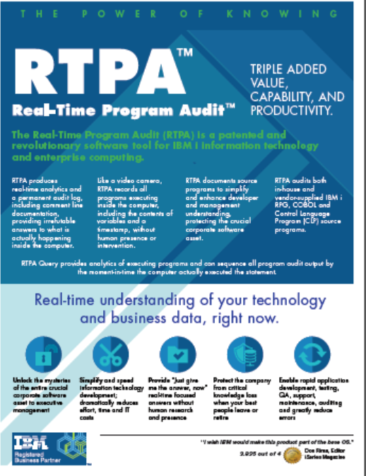

Using RTPA auditing can save almost any programmer substantial amounts of time in many different kinds of programming activities. Real-Time Program Auditing is a powerful technique, allowing programmers to more quickly learn legacy programs, find bugs in software, validate that new software functions correctly, enhance programs, and essentially eliminate guessing and speculation as to what happened or is happening. Auditing is an intuitive process, and RTPA is so easy to use that most programmers can be up and running with audit-enabled programs within minutes of installing RTPA. It is not uncommon for programmers to report that they solved a major problem the first day that they installed the software; a problem that may have been plaguing them for a while but couldn’t be found using of the conventional debugging techniques.

Double (at least) programmer/developer productivity, Capability, and value

Some developers and programmers today can and do two times, or five times or even ten times the productive work as other programmers in the same environment, and have done so throughout their entire careers, even while using similar available techniques and productivity tools.
Much of the success of these rare extraordinary developers and programmers is their innate ability to visualize and memorize what is in the application source code, how the source code is structured and organized, what they can quickly visualize as to what might happen in various scenarios, and how to quickly and effectively enhance or correct the source code.

These extraordinary developers also utilize all of the available development productivity tools to help them quickly understand the task, to develop a good solution, to test the solution, and to document the results of their work, or in a word to be productive.

The result of scores of years (60 years) of painful and incremental changes and enhancements to program development and testing has been the highly recommended and often mandated source program standards from “experts” including:
- Structured programs (top down sequential execution of the source code)
- No use of GOTO operations (branching)
- Procedures and sub-procedures
- Service Programs
- Modular programming (many small programs to do an application task
- Agile methodology and work teams
- (and many, many more)

The net result over the decades of program development, change, enhancement, of a program or application by many different developers using somewhat different programming styles and techniques, is corporate software applications of millions of lines of source code that are very difficult to understand, and safely enhance, test, and support.

RTPA dramatically changes the need for developer expertise with the application code and the structure of the program, by focusing on HOW the PROGRAM SOURCE CODE ACTUALLY EXECUTES in this specific job execution of the program, rather than on how the entire static source program(s) are coded.

That means (like it or not) that it really does not matter how the program source code is written, or is structured, or is modularized, or contains GOTO branches, or who wrote the code, or who knows the code (or not), because only the actual source statements executed in an actual job, with data and the time of execution, are important and recorded.

And RTPA means that the developer or programmer NEVER needs to try to reconstruct what may have happened by using an interactive debugger and manually stepping through perhaps thousands of lines of code and data to find and resolve a problem.

Thus, RTPA provides a real-time recording of what is happening in the program, and all that happened in the application like a security camera video, and RTPA real-time execution may be instantly analyzed as the program is executing, and is available for blockchain processing as the program executes.

RTPA is a disruptive invention in Information Technology that fundamentally changes computer management, programming, development. and operations from being people intensive and people centric to being computer intensive and computer centric.

In the same way that IBM Watson computing overpowered the brightest human contestants on the TV show Jeopardy, and Watson overpowered the world’s chess champions at chess, and that high-frequency computer trading overpowers human traders in the stock market, RTPA utilizes the power of the computer to overpower the traditional computer programmer/developer techniques and capability and make them obsolete.

Agile methodology, prototype development, testing and validation unique new capability
The Real-Time Program Audit (RTPA) productivity software dramatically enhances both the traditional waterfall development methodology of project management and the newer agile approach to development by dramatically speeding up the entire development and testing process. RTPA provides an instant and complete audit record of all development s the development takes place, including many prototyping development iterations. No interactive debugging or other analysis is needed or desirable as the complete record of the program execution and data (like a video recording of live TV) is instantly available as the program or entire application executes.

Quickly understand, master and maintain millions of lines of corporate application code
Many IBM I productions applications contain millions of lines of source code in hundreds of programs, written, enhanced and supported many developers of varying capability and skill. These key corporate applications include comprehensive vendor supplied software suite and home grown and developed applications by in-house developers and consultants. All too often the knowledge gained by the developers and the expertise of enhancing the applications is lost from the company, leaving any current developers uncertain of the code and afraid to enhance and support it, even for critical current needs.
RTPA allows competent new developers to quickly understand exactly how ALL of applications actually executes in any scenario and eliminates the need of previously knowing the application code and the value of knowing the application code, by recording exactly what is happening or happened in the code executions like a security video camera record exactly what happens, not what might possibly happen.

Quickly implement complex and sophisticated projects not feasible before RTPA
RTPA can dramatically increase the productivity and capability of any competent developer in the prototype development and testing of an incredibly complex application in a short period of time.

Document and secure the entire crucial corporate software that runs the business
RTPA can document the entire corporate software asset of RPG ILE source programs with meaningful comment statements so that all RTPA auditing is enhanced and that all developers who later review that source code will be able to much better understand the application source programs.

RTPA also audits RPG ILE, COBOL ILE, and CLP source programs which are supported buy IBMand which new developers best understand.

Protect against staff turnover and critical loss of programmer knowledge
RTPA makes it easy and simple for developers new to the company or application to quickly understand virtually all of the corporate application software that runs the business, including virtually eliminating the need for developers to spend years “owning” an application so they can maintain it, while other developers cannot.

Provide a smooth transition to new capability and technology and the Cloud
Implementing the RTPA Whole Product Implementation plan, as suggested when RTPA is installed, will result in all applications programs being in the currently supported IBM ILE language environment (RPGIV not RPGIII). Newer developers will understand the newer IBM Ile languages rather than the old and unsupported IBM OPM (Original Program Model) RPGIII and COBOL/400 programs.
This will make migrating to a remote hosted server (the Cloud) easier, particularly as the newer IBM I servers often only have the newer IBM ILE supported compilers installed.

Demystifying Legacy Programs
Many programming tasks require that a programmer first learn a legacy program before getting to the real work of enhancing, correcting or updating it. These existing programs can be very large, complex and entirely unfamiliar to the programmer, resulting in a time-consuming, often unpleasant effort, and the data being processed is often unknown. The problem of learning existing programs is particularly poignant when the enhancement is small – in these cases, most of the time and effort is expended on learning the program.

RTPA can reduce the time and effort of the learning process dramatically. Instead of printing out the program or compiling the program, and reading through the listing trying to guess where the execution flow goes, RTPA shows the actual execution flow caused by the data being processed. Programmers don’t have to guess anymore or spend time looking at sections of code that are not part of the actual program flow.

Fixing Software Glitches
A large part of a programmer’s job is finding and fixing bugs in software. All software potentially has bugs in it, many of which are easy to find and fix once they occur. However, the most frustrating and potentially expensive bugs are those that are intermittent or are hard to recreate in a test environment. Often there is too much code for a programmer to review closely in a reasonable timeframe. If the programmer isn’t even certain of where the bug occurs, stepper debuggers may not be able to help because the programmer doesn’t know where to put breakpoints. To complicate matters further, some bugs only occur under very particular input conditions that the programmer may not be able to replicate in a test environment, or in attempting to reconstruct the exact data previously processed.

Thankfully, RTPA is uniquely powerful for finding difficult software bugs, with no programmer intervention required. When a failure in a test or production environment can’t be easily replicated in the lab or if it is infrequent enough to make stepper-type debugging impractical, auditing the program can be the best way to find and fix the program. An audit-enabled program shows everything that occurs before, during and after the bug. By searching for the audit file by execution time, data values or specific operations, a programmer can find and review the problem in complete detail, and track back to the source or cause of the problem.

75 % of a developers time is spent on debugging (1500 hours a year)

https://coralogix.com/log-analytics-blog/this-is-what-your-developers-are-doing-75-of-the-time-and-this-is-the-cost-you-pay/

1) On average, a developer creates 70 bugs per 1000 lines of code (!)
2) 15 bugs per 1,000 lines of code find their way to the customers
3) Fixing a bug takes 30 times longer than writing a line of code
4) 75% of a developer’s time is spent on debugging (1500 hours a year!)
5) In the US alone, $113B is spent annually on identifying & fixing product defects

Improving Quality and Reliability
As the demand for productivity increases and applications become more complex and critical, most programmers also feel increased demand for program quality. Many programmers have had to become experts in software testing and validation as part of their jobs. The testing process can be slow and difficult in many cases, particularly when testing software modules, such as validating the values of data variables in subroutines and procedures.

RTPA offers programmers a convenient way to speed up testing and improve overall program quality. The audit allows a programmer to validate a program’s that a logic and outputs are correct without having to spend time writing output specification and “hello” statements. RTPA makes it easy to review a program’s execution without having to set breakpoints or write test code. RTPA audits are automatically produced when the enabled program is run, allowing programmer or auditor review in real-time as the program executes or later from the audit output file.

Creating Web GUI Reports from program data and logic
Many Web graphical Business Intelligence (BI) products utilize SQL to access System i DB2 databases to produce charts and reports for top management review and action. Many of these reports are now developed and produced in RPG or COBOL programs and printed in text formats using the System i Printer File (PRTF) capability. RTPA is very useful in identifying and matching the often complex computations and the DB2 databases and database fields used in producing the summarized data that is actually used on these management reports.
Thus, RTPA allows a user to simply enter a report value, such as $3,561,014.59 for Sales YTD, and search the RTPA audit report from the program (or programs) that created the report to find the source statement and the field (variable) with this value. The audit report than can be searched (backwards) to locate exactly the source statements and data of how the Sales YTD computation of 3,561,014.59 was created and the databases and database field names, and any work fields in the program were computed.

This RTPA auditing and search capability on data values allows not only the recreation of the report Sales YTD amount in the BI Web graph and Web report in SQL, but also all the drilldown totals and computations to allow the BI report to drilldown to the actual source of the Sales YTD amount, whether the drilldown is by division, product line, year or other program logic from the DB2 databases.

The current text (printer file) program file I/O may be embedded SQL, or native File I/O., in which case the native File I/O (for example Read, Write, Chain) could be converted to corresponding SQL statements in the BI report with the identified DB2 files and DB2 fields logic and computations explicitly identified in RTPA auditing.

Advantages of Auditing with RTPA
RTPA is a disruptive invention in Information Technology that fundamentally changes computer management, programming, development. and operations from being people intensive and people centric to being computer intensive and computer centric.

In the same way that IBM Watson computing overpowered the brightest human contestants on the TV show Jeopardy, and Watson overpowered the world’s chess champions at chess, and that high-frequency computer trading overpowers human traders in the stock market, RTPA utilizes the power of the computer to overpower the traditional computer programmer/developer techniques and capability and make them obsolete.

The traditional strengths

RTPA demystifies complex programs enhancing application and program design, development, maintenance, and enhancement. The full RTPA audit lists the exact program source statements that are actually executed as the computer executes them, regardless of the structure of the program, or called programs. Thus, the programmer or analyst does not have to understand the source program or guess what might happen if different conditions or data is encountered.

RTPA electronic program auditing is, by far, the fastest and most productive and effective method developing, maintaining and supporting corporate applications over any debugging tool or known other analysis technique. No prior knowledge of the application, program, files, data other details is required. Simply enable the application programs with RTPA capability, run the application, and observe exactly how the computer is actually executing or actually executed the application programs and the data using the audit disk or printed output.

Hands-Free Operation. Once you audit-enable a program with RTPA, you don’t have to set program breakpoints or stop the normal flow of the program as it executes. And, the programmer does not have to be present when the program executes.

Video camera like complete auditing to disk. RTPA for RPG, CLP, and COBOL default to completely audit every executing program statement in RTPA enabled programs to a spool file, including the source statement, contents of variables, and the exact moment the statement was executed. The RTPA Query product combines all of the called programs in a job, such as Order maintenance, or Customer invoicing, together by the moment the program was executed by the computer.

Flexible Auditing Choices. You can make your audit as in-depth or as high-level as you like. An audit can include every executable source statement in the source program and the value of every variable, or it can focus on selected program files, records, operations, variables, and subroutines. Audit output may also be started, stopped, and resumed based on the data contents of variables, or the relationships among variables in the executing program.

Low System Overhead. RTPA has a very small impact on overall system performance, allowing you to test and validate your software while it runs at near-normal speeds. In real-world tests, auditing a program adds as little as 10% to total CPU time to a job on an System i computer.

How "Multiply Your Value, Capability, Productivity by 3, 10, 100 Times"

Multiply Your Value, Capability, Productivity by 3, 10, 100 Times – Ride the Rocket

(abstract)

Multiply Your Value, Capability, Productivity by 3, 10, 100 Times

Ride the Rocket

Paul Houston Harkins

Harkins & Associates, Inc.

www.realtimeprogramaudit.com
paul.harkins@harkinsaudit.com
paulhark@aol.com

Abstract
Corporate computer programming is being accomplished virtually the exact same way today as it was at the dawn of corporate computing some 60 years ago, when programmers were cheap and corporate computers were incredibly expensive, rudimentary and very slow.

In that 60 years, corporate programmers have become very expensive and unproductive while utilizing virtually the exact same primitive programming methods and achieving essentially the same low levels of capability and productivity while corporate computers are literally millions of times faster and more powerful and are essentially free for unlimited use by the programmer.

.
This paper shows how each and every one of the millions of corporate programmers, including average programmers, can immediately become the “Bionic Man or Woman” by fully utilizing the incredible power of the computer itself, and actually immediately triple his or her value, capability and productivity (or more) in his or her existing job, or especially in a new job, by implementing these disruptive and free methods described below.

Programmers who implement these disruptive yet simple methods will quickly gain a huge competitive advantage over those programmers who continue using the current ancient, primitive, costly and wasteful programming methods developed 60 years ago.
.
The “Bionic Man” utilized revolutionary productivity tools to lever his human capability and performance, and the incredible computer itself is the key for this disruptive revolutionary success for all programmers who will fully utilize it.

Introduction

Corporate computer programming is being accomplished virtually the exact same way today as it was at the dawn of corporate computing some 60 years ago, when programmers were cheap and corporate computers were incredibly expensive, rudimentary and very slow.

In that 60 years, corporate programmers have become very expensive and unproductive while utilizing virtually the exact same primitive programming methods and achieving essentially the same low levels of capability and productivity while corporate computers are literally millions of times faster and more powerful and are essentially free for unlimited use by the programmer.

This paper shows how each and every one of the millions of corporate programmers, including average programmers, can immediately become the “Bionic Man or Woman” by fully utilizing the incredible power of the computer itself, and actually immediately triple his or her value, capability and productivity (or more) in his or her existing job, or especially in a new job, by implementing these disruptive and free methods described below.

Programmers who implement these disruptive yet simple methods will quickly gain a huge competitive advantage over those programmers who continue using the current ancient, primitive, costly and wasteful programming methods developed 60 years ago.
.
The “Bionic Man” utilized revolutionary productivity tools to lever his human capability and performance, and the incredible computer itself is the key for this disruptive revolutionary success for all programmers who will fully utilize it.

Sixty years ago at the dawn of corporate computing (and yes I was there), corporate programmers were lucky to get one shot at the corporate computer a day, getting to compile and test a single program a day (or evening after production was completed), with the source program compile taking the computer up to one hour to compile the program for possible testing.

So, every corporate programmer had to spend virtually 95 % of the day thinking about the program, keypunching the source program cards, desk checking the source program deck for logic or keypunching errors, and imagining what might happen when he or she got that single shot at the computer for one program compile and, if successful, a single test of the program with data.

Those primitive and unproductive programming methods were necessary because they were the only possible methods, as the corporate source programs (the corporate software asset) were stored in punched cards in file drawers. Source programs were written in Assembler language and the typical source program was perhaps 2,000 cards (2,000 program statements), and often the source program compile listings were not retained, so programmers shuffled through the keypunched card decks to attempt to understand what the programs probably did.

The compiled program object deck of cards was used to execute the program in testing and in production on the computer with data, and program logic errors were incredibly primitively investigated by programmers stopping the entire computer and single cycling debugging the program by stepping through the executing program and looking at the lights on the computer console (in binary coded decimal or hexadecimal) to guess where to look and attempt to understand what was happening. This is now called interactive debugging or program “stepper” debugging, and it can take a programmer many minutes or even hours to attempt.

Today, virtually all is the same in the programmer’s world, except that the source programs may be tens of thousands of lines of source code, the source programs are stored on disk (not cards), the programmer uses a display (PC) to enter and change the source program rather than keypunching cards, and the corporate computer is perhaps 100,000 TIMES faster than 60 years ago, compiling huge source programs in just several seconds (or one second).

And, the corporate computer can process hundreds of programs (jobs) and dozens of programmer’s work at the same time, and at no cost to the programmer to fully utilize this incredible bionic productivity tool all day, every day to make himself or herself incredibly valuable, capable and more productive.
.
Yet, today’s corporate programmer still uses the same incredibly primitive and unproductive way to try to understand what the source program does, and understand using the “stepper” or debug program in the very same primitive and time consuming way as 60 years ago, trying to guess what the program did and what actually happened, perhaps hours or days after the program originally executed.

Similarly, today’s corporate programmer still attempts to understand the corporation’s business and operations by reviewing the typically thousands of source programs comprising the corporations crucial software asset by staring at the program source code.

These corporation’s crucial software asset is comprised of millions of source statements which are written in programmer shorthand, usually in segments using copybooks in different programming languages and are in the varied programming styles and programming techniques, such as structured programming, of the many programmers who wrote and maintained each program.

Thus, it is literally impossible for even the most talented, gifted, experienced, and ambitious programmer to actually really understand the corporation’s crucial software asset programs by reviewing the static and monolithic source programs, as the source programs will virtually NEVER be executed with corporate data in the same sequence as in the static source program.

The programmer’s human brain is exactly the same today as it was 60 years ago, but the corporate programming world is many times more complex and sophisticated and mission critical to the corporation, and the programmer’s brain cannot effectively grasp the complexity and scope of today’s programming world.

Once again, each and every one of the millions of corporate programmers, including average programmers, can immediately become the “Bionic Man or Woman” and understand virtually the ENTIRE crucial software asset of the corporation by simply utilizing the incredible and virtually FREE and always available corporate computer by simply observing the real-time streaming video of the corporate business as it actually executes, like on-demand streaming TV videos.

How to chuck how the unproductive and primitive way IT corporate programming is now accomplished for a disruptive, free, and available way to personally multiple your value, capability, productivity, job security and satisfaction is illustrated below.

RTPA is a prototype invention, like Henry Ford’s Quadricycle and Elon Musk’s Tesla Roadster EV

Henry Ford’s Quadricycle Prototype

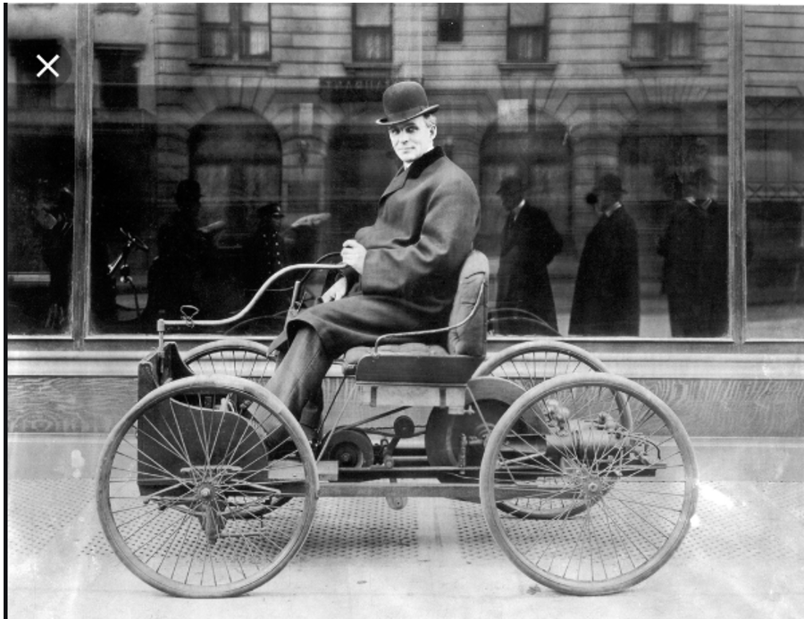

1896 Ford Quadricycle Wikipedia

Henry Ford’s 1896 prototype invention of the Quadricle revolutionized and transformed and automated transportation as it had been known for milliena, and literally propelled the capabilities of transportation by multiple times over the horse and buggy.

Ford’s Quadricycle was created in a small shed behind Fords house in Henry Ford;’s spare time, had only a 4 horsepower engine, 4 bicycle wheels, a bicycle chain for propulsion, no brakes, no steering wheel, and a maximum speed of 20 miles per hour.

Yet, the first test drive of the Quadricycle clearly demonstrated to those who could and would see and understand and believe that the motorized automobile was the future and the horse and buggy was doomed as the primary method of personal transportation, in spite of those who said “But, grass is free”.

It took Henry Ford decades to enhance and refine and commercialize his 1896 Quardicycle prototype invention of the automobile into the wildly successful Model T Ford that sold millions of automobilesin the 1920s, and eventually made Henry Ford the wealthiest person in the entire world.

SS United States ocean lliner

SS United States from a cruise ship on the Delaware River in 2006 - Wikipedia

The SS United States was built in 1950 and 1951 and was the fastest ocean liner to ever cross the atlantic ocean.

Transatlantic ocean liners were obsoleted in 1958 by the Boeing 707 jet plane, which traveled 20 TIMES faster than the SS United States.

Elon Musk’s Tesla Roadster EV Prototype
2007 Wikipedia

Elon Musk’s 2007 prototype invention of the electrically powered (EV) Roadster at Tesla in 2007 was the first product of the startup Tesla, Inc.

Elon Musk’s Tesla Cybertruck EV Prototype

Tesla Cybertruck prototype
2019

Prototype presentations do not always work as intended.

It took Tesla more than a dozen years to enhance and refine and commercialize their EVs and the loss of billions of dollars before Tesla finally made a profit and proved to the world that electric vehicles (EVs) were transformatively and disruptively the way of the future, in spite of the ferocious resistenance of entrenched oil interests.

It took over century, and Tesla and GPS and computers, for the automobile to be refined and enhanced for the machine to be remotely “Summoned” as the hourse could be for thousands of years.

The vision and action of Elon Musk to fully utilize the virtually infinite and virtually free clean energy of the Sun to power fundamentally more efficient and effective electrical vehicles and devices rather than the internal combustion engine (ICE) automobiles of Henry Ford might make Elon Musk the wealthiest person in the world as well as the person who most saved the world environment.

The Real-Time Program Audit (RTPA) Prototype
Paul Harkins 2004 prototype invention of the Real-Time Program Audit (RTPA) software disrupted and transformed the fundamental way Information Technology and computer programming are accomplished from essentially human centric (programmers) towards virtually all real-time computer automated processing and Artificial Intelligence (AI) , in a manner similar to the way Henry Ford transformed personal transportation from the horse (animal powered) to virtually all automated (the automobile with the Internal Combuston Engine).

Just as robots have replaced human automotive assembly line workers in manufacturing automobiles in every new and successful automotive company, like Tesla, for purely productibity and financial reasons, so is the computer itself and Real-Time Program Auditing methodology replacing the traditional corporate computer programmer in all but the most creative activities, and with similar spectactular results.

The great news is that computer programmers are now able to multiply their crucial and unique creative capabilitites without being burdened in tasks they are not well suited to perform.

Glass Half Full or Glass Half Empty
Jim Cramer Glass Half Full, Glass Half Empty CNBC
https://www.cnbc.com/video/2019/11/12/jim-cramer-i-doubt-the-stock-market-can-absorb-much-higher-tariffs.html

If you are dying of thirst, then either a glass of water half full or half empty will save you.

If you or your company are uncompetitive and failing, then less than perfect real help will help you.

Converting System/36 RPGII to IBM i RPGIV (RPGLE)
IBM System/36 RPGII source programs and System/36 object compiled programs, and IBM System/36 OCL (job control) can still (after more than thirty after the System/36 was replaced by the System/38 and then the IBM i ), using the IBM i System /36 Emulation product using the command STRS36 (Start System/36)

This IBM i System/36 Emulation, including RPGII and OCL (job language predecessor to the IBM i CL language), apparently tens of thousands of IBM System/36 computers to be easily ported to the IBM/38, IBM AS/400, and the IBM i computer environment, and operated in exactly IBM System/36 mode.

Apparently thousands of IBM i customers who are still using the IBM i System/36 Emulation mode (command STRS36) are slowly converting the System/36 RPGII source programs, System/36 dis[lays (S and D specs) and OCL (job control), and other conversions including internal to external file definitions to native IBM i formats.

RTPA for IBM i auditing now requires the native IBM i format as available in 1988 (thirty years ago) with the announcement of the ILE Integrated Language Environment, RPGIV and the 100 character source program format, rather than the RPGII and RPGIII 80 character source program of the original IBM System/38 OPM Original Program Model RPGIII which his now off IBM support.

IBM i customers using the IBM System/36 Emulation software (STRS36) can automatically convert their System/36 RPGII source, OCL, display definitions (S and D specs) and other file definitions directly to Native RPGIV and IBM ILE format by using one of several available vendor conversion products.

Google RPGII to RPGIV conversion

Google Converting OCL and RPG II

RTPA requires the native IBM i source program format of 100 character format for the RPG (RPGLE), CL, and COBOL languages, not including the IBM System/36 RPGII source program format, and not including the RPGIII System/38 Original Program Model (OPM) 80 character source program format.

Converting System/38 RPGIII to IBM i RPGIV (RPGLE)
RTPA for IBM i auditing now requires the native IBM i format as available in 1988 (thirty years ago) with the announcement of the ILE Integrated Language Environment, RPGIV and the 100 character source program format, rather than the RPGII and RPGIII 80 character source program of the original IBM System/38 OPM Original Program Model RPGIII which his now off IBM support.

IBM i customers using the IBM RPGIII OPM 80 character format (type RPG) can easily convert the RPGIII 80 character format source programs to RPGIV (RPGLE) source with the FREE Command CVTRPGSRC.

IBM i customers using the IBM RPGIII OPM 80 character format (type RPG) can also easily convert the RPGIII 80 character format source programs to RPGIV (RPGLE) source with several available conversion products, including optional conversion of RPGIII source programs( fixed format) to RPGIV Free-format source programs, including”.

Google Practical RPG: Converting to Free-Form RPG, Part 1
Google RPG Conversion Wizard - HelpSystems
Google RPG Toolbox
Google Conversion to RPG Free Format | Application ... - ARCAD Software
Google Rational Cafe:RPG Cafe:RPG Cafe:Free Format conversion - IBM

RTPA offerings, License Pricing and support

References
The Convert RPG Source (CVTRPGSRC) command converts RPG III or RPG/400 source code to ILE RPG source code.
RPG III is a dialect of the RPG programming language that was first announced with the IBM System/38 in 1978. An upgraded version, RPG IV, was introduced in 1994. In 2001 RPG was again updated to remove a number of column restrictions, although it is still not competely "free form."
RPG IV (a.k.a. RPGLE or ILE RPG^{[3]}) was released in 1994 as part of the v3r2 release of OS/400.^{[4]} With the release of RPG IV, the RPG name was officially no longer an initialism. RPG IV offered a greater variety of expressions within its Extended Factor-2 Calculation Specification and, later in life, its free-format Calculation Specifications and Procedure syntax. RPG IV is the only version of RPG supported by IBM in its long line of successors to the AS/400 system (iSeries, System i, etc.). (Wikipedia)
ILE RPG is an implementation of the RPG IV programming language in the Integrated Language Environment®.
Harkins & Associates. Inc.
816 Daisy Lane
West Chester, Pa 19382
USA
Email sales@harkinsaudit.com

www.realtimeprogramaudit.com

RTPA - What You See is What You Get
This Real-Time Program Audit (RTPA) User’s Manual is intended to provide an “Off the Shelf” RTPA customer installation, implementation, orientations and RTPA training capability through very comprehensive RTPA sample programs for RPG, CL, COBOL and RTPA Query testing and training.

Chapter one of this RTPA User’s Manual illustrates how to download the RTPA object distribution save File (SAVF) and install RTPA on your IBM I, normally within one half hour.

After the RTPA for IBM I code is installed on your IBM I, it is very important to exercise all of the appropriate sample programs in Chapter one, BEFORE using RTPA on your own source programs

If you do not see a capability that you need or desire in this RTPA User’s Manual, or if an IBM i capability that you use does not work when tried with RTPA, then do not expect RTPA current capability to successfully audit this program (at least without some workaround).

What RTPA Does Do
The Real-Time Program Audit (RTPA) software provides the tools, capability and the immediate opportunity for IBM I customers and their employees to transform themselves from the ancient and now very unproductive and costly development and support people centric world they are in, and take a quantum leap into the modern world of computer centric development and support.

The Real-Time Program Audit (RTPA) productivity tool is designed to provide a real-time security camera like recording for the vast majority of the hundreds of BILLIONS of lines of RPG, CL, and COBOL source code used by IBM i customers over decades of development and maintenance in IBM i customers.

RTPA may NOT necessarily yet implement some of “enhancements” to RPG implemented by IBM in its desire to morph RPG into the C programming language, and away from the proven benefits of simple traditional RPG English like programming.

- RTPA should audit RPGLE source programs using the CTL-OPT heading in a one line statement of the form: (see RTPA program TESTCTLOPT)

0002.00 CTL-OPT; (see RTPA program TESTCTLOPT)

- RTPA should audit RPGLE source programs using procedures, however RTPA does NOT audit the procedure statements at this time, as RTPA does audit subroutine statements. see RTPA program GSR426. (see Appendix J)
RTPA auditing of calculation specifications in procedures is a planned enhancement

- RTPA does not audit Free Form Only RPGLE source programs at this time

- RTPA for RPG audits variable names up to 14 characters long, including any subscript (RPG output specification limit)

- RTPA for RPG audits comment statements AFTER the first executable (calculation) statement in the source program

RTPA provides the capability to multiply the productivity and capability of IBM i developers and programmers and related jobs including QA and testing to be accomplished much more effectively and quickly and correctly by a multiple of two, or five or even ten times that of people using the ancient techniques, including the interactive debugger, used today.

Cars that drive themselves, fighter planes without human pilots, smartphones that record hours of HD video, Google, IBM Watson, Virtual Reality, and a host of other computer centric inventions are transforming many industries, replacing people and ancient technology with real-time computer centric technology and capability.

The IBM i programmer has an essentially infinitly fast and powerful IBM i computer always available, and FREE to the programmer, for hundreds of program compiles a day.

Yet, almost all IBM i programmers have traditionally very sparingly utilized the FREE IBM i computer virtually infinite capabiliry to do the difficult work it alone does best, which is provide instant understanding of everything being processed in real-time.

Instead, IBM i programmers traditionally waste most of the day using primitive and ancient tools like IBM’s Interactive Debug program, staring at source programs or compile listings, using techniques like structured programming and modular programming and worst of all trying to use their human brains to attempt to guess what is actually happening, when the computer itself provides those answeres in real-time for FREE and all day long.

IBM i programmers all actually have a FREE rocket or jet in the infinitly powerful computer, available all of the time to transform and multiply their efforts, but they waste their time and effort, and billions of dollars annually at IBM i customers, walking and guessing as if they have no fantastic productivity tool.

RTPA utilizes real-time recording and auditing of exactly what is now executing in real-time in computer programs and recording everything that actually executed in computer programs, thereby obsoleting and making unnecessary, and even undesirable, a huge part of what developers, programmers, QA, testing and auditing people do today.

Thus, a knowledgeable person utilizing RTPA can quickly understand and master millions of lines of complex application code without previously knowing anything about that code or how it is structured, and support that code effectively.

This new RTPA capability transforms the fundamental desired characteristics, skills, capabilities and requirements and work of a developer or programmer and related jobs in as dramatic a way as changing from caring for and riding a horse to caring for and driving (or soon to be riding in a self-driven) automobile.

What RTPA Doesn’t Do
The Real-Time Program Audit (RTPA) for IBM i defaults to real-time audit (like streaming video) the execution of every RPGLE, COBOL, or CLP language statement as it executes including the contents of every variable and a time stamp of the executing program statement.

However, the IBM RPGLE, COBOL, and CLP compilers were designed and implemented decades ago, long before the incredible advantages of real-time program auditing were understood.

The IBM RPGLE, COBOL, and CLP compilers have severe limitations and constraints that limit the full implementation of real-time program auditing in the Real-Time Program Audit (RTPA) for IBM i software, both IBM i compiler size limit limitations, and source program constraints, such as the SELECT statement must be followed only by a WHEN statement (or a comment), not RTPA inserted auditing statements.

Thus, for example, the RPGLE group SELECT, WHEN, ENDSL in free format may not be audited by RTPA correctly and should be avoided or not RTPA audited. (although the RPGLE group SELECT, WHEN, ENDSL in fixed format is correctly aufited by RTPA).

So in a more general observation, RTPA, like the IBM compilers, has evolved over time to provide much additionsal capability, as has the RPGcompiler RPGLE evolved from RPG2, RPG3, and RPF4 fixed format only, and many enhancements that continue to be implemented by IBM.

However, RTPA has successfully expanded thousands of RPG3 and RPGLE source programs with ZZ audit statements and successfully provided RTPA real-time audits.

If RTPA does not successfully expand your RPGLE source program with ZZ audit statements and compile the expanded RPGLE program in library ZZAUDITE, then the programmer should consider why RTPA is not correctly auditing the source program, and consider changing the RPGLE source program to simplify it so that RTPA does audit the program and provide meaningful RTPA real-time audits.

For instance, a free format group of SELECT, WHEN, ENDSL, could be changed to If statements (anf yes GOTO statements) so that RTPA can successfully audit the program. (until RTPA is enhanced to provide that capability).
Programmers who use RTPA auditing starting when an RPGLE source program is created will benefit from RTPA auditing throughout the entire lifecycle of the program.

As RTPA inserts potentially thousands of ZZ audit statements in a COPY of the input RPGLE or COBOL source program to achieve real-time program auditing during execution of the audit enabled compiled program, RTPA may sometimes not correctly insert the correct ZZ audit statements for complex or unexpected programming styles and techniques RTPA has not encountered before .

Think full autonomous driving for a similar example.

Currently the incredible advantages of automomus driving (Full Self Driving) are just now becoming available, however there are restrictions and controls placed on drivers, such as in one implemention, turning left at an intersection is not allowed and instead three right turns must be performed.

Think also of a programmer writing or modifying an RPGLE or COBOL source program and making a coding error which would cause the resulting compiled program to compile with terminal (level 30) errors.

The programmer would have to correct or remove the error source statements, and that is the same with RTPA.

So, if RTPA currently does not currently perfectly exand an IBM RPGLE or COBOL program with audit statements in your unique programming style, realize that RTPA is evolving and being enhanced with ever more IBM i customer source program knowledge from many programmers, like the Tesla autonomous driving videos.

The very best approach, as always, is to SIMPLIFY program coding, and find a way that works and use that way to succeed, as all successful programmers are doing today.

Appendix K: When RTPA does not expand correctly illustrates how RTPA can be uses successfully on virtually customer RPGLE, C OBOL, and CLP programs to multiply programmer productivity, capability, and value by 3, 5, 10, 100 times.

RTPA, or an implementation of real-time program auditing by IBM or another vendor, will eventually, like Tesla full automomous driving, work essentially perfectly and transform the entire computing world.

The Real-Time Program Audit (RTPA) for IBM i patented software provides essentially real-time “streaming video” of IBM i program execution, and RTPA does this over IBM i language compilers that are significantly limited and were not designed for the quantum jump of real-time program auditing and for the disruptive and transformational computing possible with real-time auditing of executing programs.

How to Become a Highly Paid Corporate Programmer

https://www.amazon.com/dp/158347045X/ref=rdr_ext_tmb

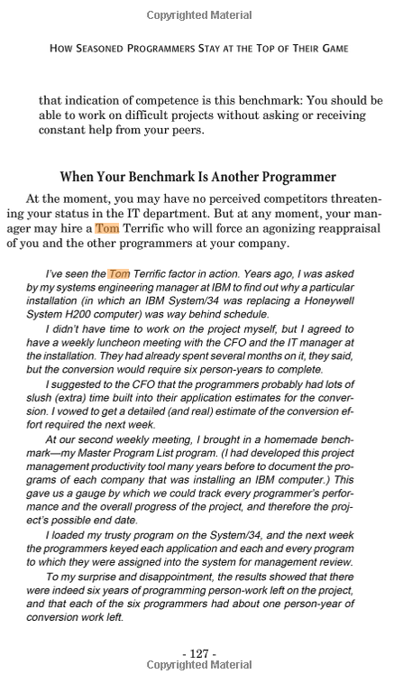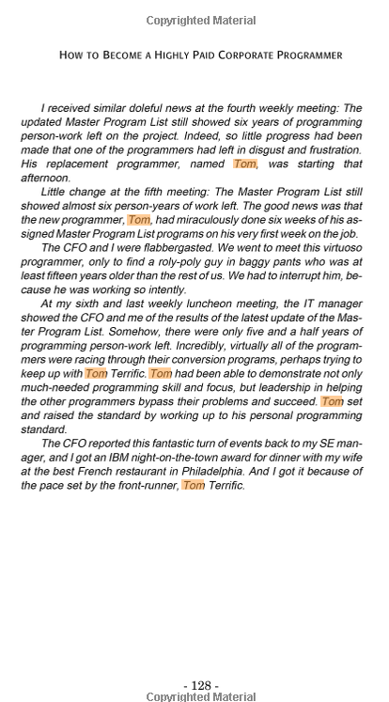

The Future of Corporate Computing

https://www.amazon.com/Future-Corporate-Computing-Houston-Harkins/dp/1507529104/ref=sr_1_1?ie=UTF8&qid=1528824615&sr=8-1&keywords=Paul+Houston+Harkins

Triple Programmer Productivity and Value with Automation
https://youtu.be/bWVWqTaUo4Q

RTPA is profound and disruptive transformation of all programming
The Real-Time Program Audit (RTPA) patented software for IBM i presents a profound and disruptive transformation and fundamental change how corporate programming is accomplished, by automating many costly and primitive aspects of the corporate programmers human centric job and enabling AI (artificial intelligence) implementation.

The shock of transformational change in programming is rejected most by those who stand to be replaced by this transformational change as is illustrated by the article SO MAYBE I WAS WRONG, where the titans and experts in place rejected the obvious incredible inventions.

SO MAYBE I WAS WRONG
https://yougottobekidding.wordpress.com/2017/06/13/so-maybe-i-was-wrong/

There are actually hundreds of similar examples, including one that directly influenced the invention of the Real-Time Program Audit patented software, the Polorid camera.
Edwin Land invented the Polaroid, or instant camera, after his young daughter asked why she couldn't see photographs immediately after they were taken.

Why was the polaroid camera invented?
http://moisescocinaybano.es/site/4fidd.php?55299c=why-was-the-polaroid-camera-invented

The history of the Polaroid camera starts with Edwin H. Land, founder of Polaroid.
In 1943, his three year old daughter asked him why she can’t see the photo he had just taken of her. Edwin Land invented the Polaroid, or instant camera, after his young daughter asked why she couldn't see photographs immediately after they were taken.

Setting Realistic Expectations for RTPA
The IBM i Customer community of more than 100,000 customers with more than 200,000 customer programmers and dozens of IBM i software vendors has created over a BILLION RPG, CLP, and COBOL source programs with HUNDREDS of BILLIONS of lines or RPG, CLP, and COBOL source ststements in the 41 years since the IBM System/38 was announced in 1978.

Additionally, billions more RPG and COBOL source statemenst were previously developed on the previous IBM Rystem/3, IBM System/34 and System/36 computers and ported to the IBM System/38 (AS/400) computers.

The Real-time program Audit (RTPA) software is designed to provide a unique and powerful dynamic auditing and recording capability, unlike any other known capability, to virtually ALL of the hundreds of billions of lines of RPG, CLP and COBOL IBM i source code, written by literally hundreds of thousands of programmers, each with his or her own programming syyle and technique. WITHOUT creating a single RTPA expansion error in huge and complex source programs of 10,000, 20,000 or more source statements.

This is something like writing an RPG, COBOL, or CLP source program of 10,000 or 20,000 ststements without ever compiling it to check for errors, and expecting ZERO errors of any kind in logic or grammar spelling or syntax by the programmer.

RTPA and the IBM i RPG, COBOL and CLP compilers are actually translators, that translate input source statements into a totally different machine readable language.

Likewise, the IBM SQL precompiler is used in SQLRPGLE source programs to insert SQL executable statemeents into the source program as the SQLRPGLE source program is compiled.

The IBM i RPG, COBOL, and CLP compilers translate input source programs with ZERO spelling, grammar, and syntax (PERFECT) source programs into machine language object programs executable by the IBM i computer.

RTPA translates IBM i RPG, CLP and COBOL source programs into a “smarter” program which can audit and record its execution in real-time, like a video security camera, by inserting executable program auditing source statements.

The millions of people in New York City speak at least 800 different languages, and expecting any human or computer translator to perfectly translate the 800 languages into 800 other languages perfectly is perhaps and is actually not neccessray to have the translation be valuable.

A example is the airline staff multi-language training to teach the airline English speaking personnel perhaps 100 words of Spanish, which is sufficient to communicate with Spanish speaking passengers.

Thus, the very real benefits of the translators including the OPM compilers, the IBM SQL pre compiler, spoken and written language human and computer translators now include the Rral-Time Program Audit (RTPA) translator that enables real-time program execution auditing and provides a quantum leap in understamnding of programs.

All of these translatoers are significantly improving by adding new vocabulary words, enhancing grammer capability and learning from real world experience to provide even better and more useful translation, including the Real-Time Program Audit (RTPA).

Simply put, expecting translation perfection as deemed by the person without some correction is a fools errand and risks total loss of the vast potential benefits of the translation.

RTPA Online Demonstrations, Videos, Webinars, Training, Papers, User Manual
Online and interactive RTPA demonstrations and training are available worldwide at the IBM i user location via GoToMeeting interactive sessions and recorded YouTube videos. The user requirements for interactive GoToMeeting (or WebEx) sessions are a Windows PC or a Mac and a high-speed Internet connection. The preferred and default audio for these GoToMeeting sessions is the PC speakers and microphone as this method eliminates phone costs.

The GoToMeeting interactive sessions are available to up to 251 attendees (separate emails) of the GoToMeeting session and may be OPTIONALLY recorded and made available to customers with secured password or public access, as desired by the RTPA customer.

These recorded GoToMeeting sessions provide valuable RTPA orientation, education, and training for new customer personnel and reinforcement learning sessions for current personnel, as the sessions relate directly to the customer RTPA implementation. The recorded GoToMeeting sessions could be an important in-house IT reference library for the customer, together with the complimentary IT books provided to RTPA licensed customers, as requested.

All Real-Time Program Audit (RTPA) for IBM i licensed customers receive at least one RTPA GoToMeeting orientations one hour session with their license. The GoToMeeting Meeting interactive orientation session should provide an excellent start for developers to immediately become proficient with RTPA.

Additional RTPA interactive GoToMeeting sessions are available and provide the customer and developers with additional RTPA capability and techniques and may be also recorded for the customer IT library.

Our intention is to provide the RTPA customer and every developer/programmer or interested person with the ability to become proficient with RTPA in one day, and to immediately at least double his or her productivity and capability in actual customer programming projects.

RTPA YouTube Videos

Real-Time Program Audit Overview Multilingual Demonstration English and German

Real-Time Program Audit Overview Multilingual Demonstration English and German - YouTube

With German subtitles (subtitles in many languages)

17.48 minutes

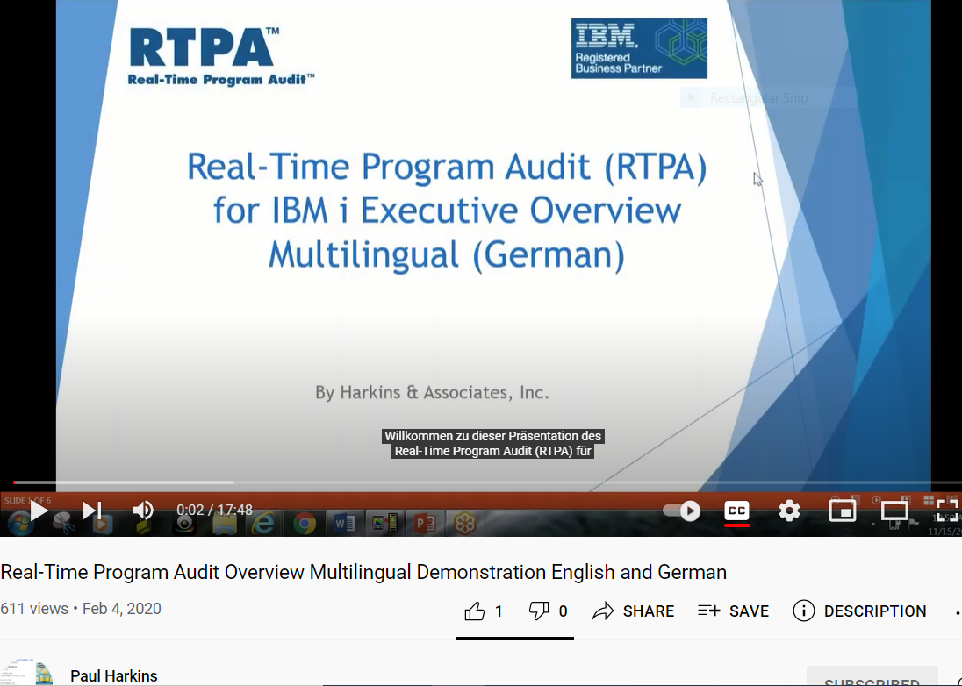

Automate Programs to enable Machine Learning and Artificial Intelligence and Succeed

Automate Programs to enable Machine Learning and Artificial Intelligence and Succeed - YouTube

34.42 minutes

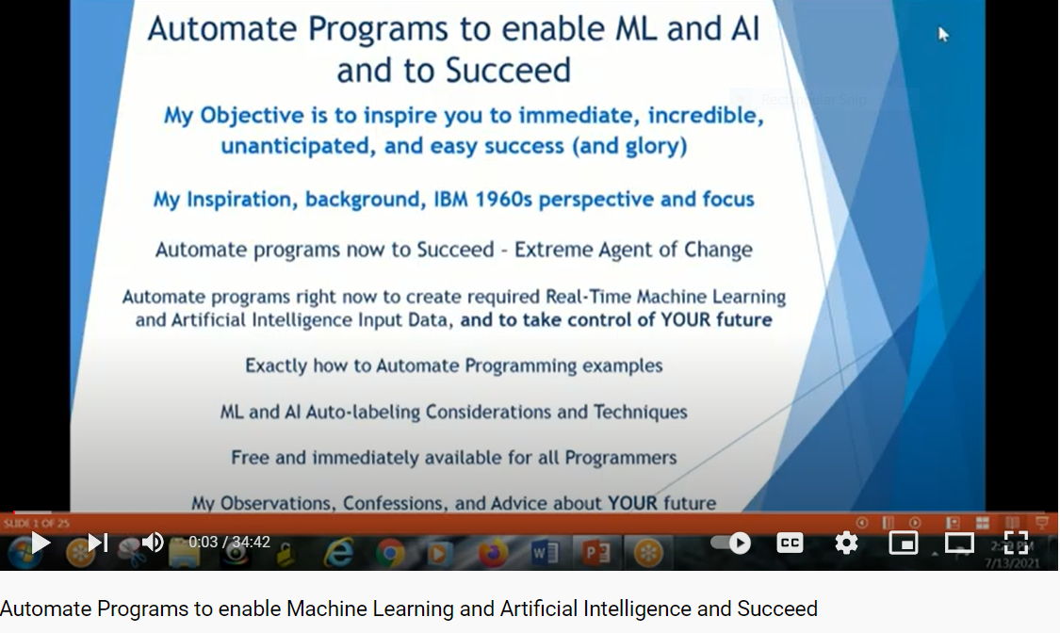

Real-Time Program Audit (RTPA) replaces ancient, unproductive, costly Technology

Real-Time Program Audit (RTPA) replaces ancient, unproductive, costly DevOps Technology - YouTube

26.33 minutes

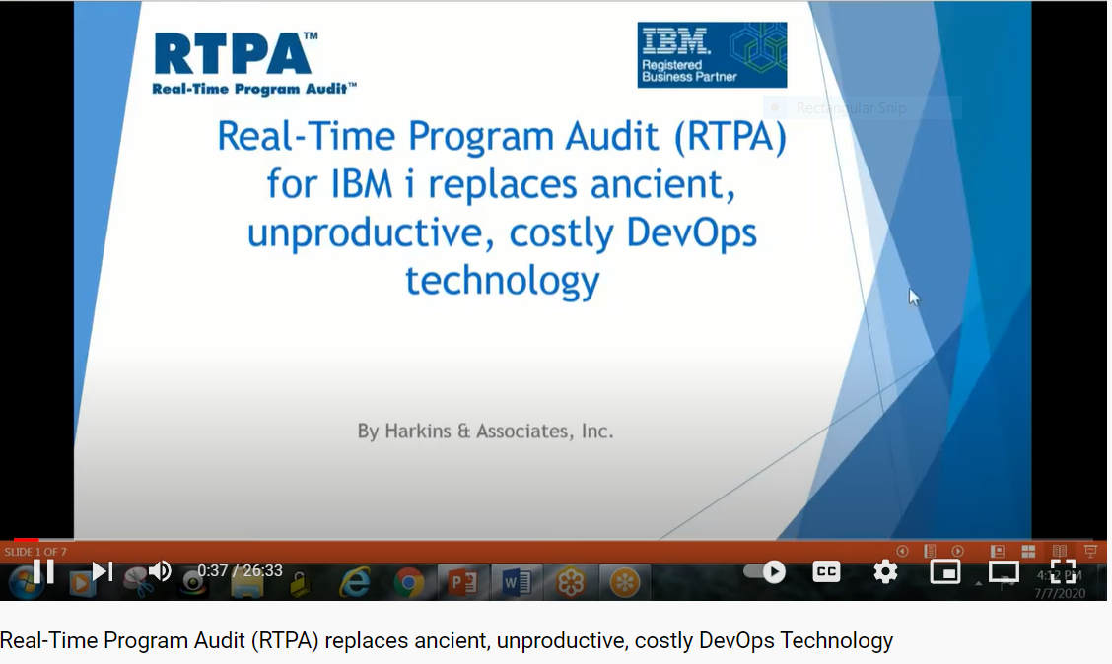

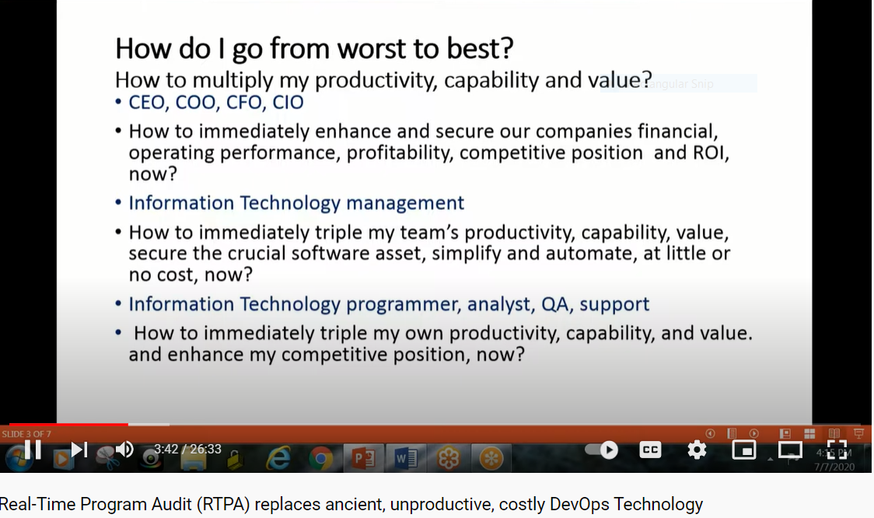

Real-Time Program Audit (RTPA) How RTPA works in many languages

Real-Time Program Audit (RTPA) How RTPA works in many languages - YouTube

42.08 minutes

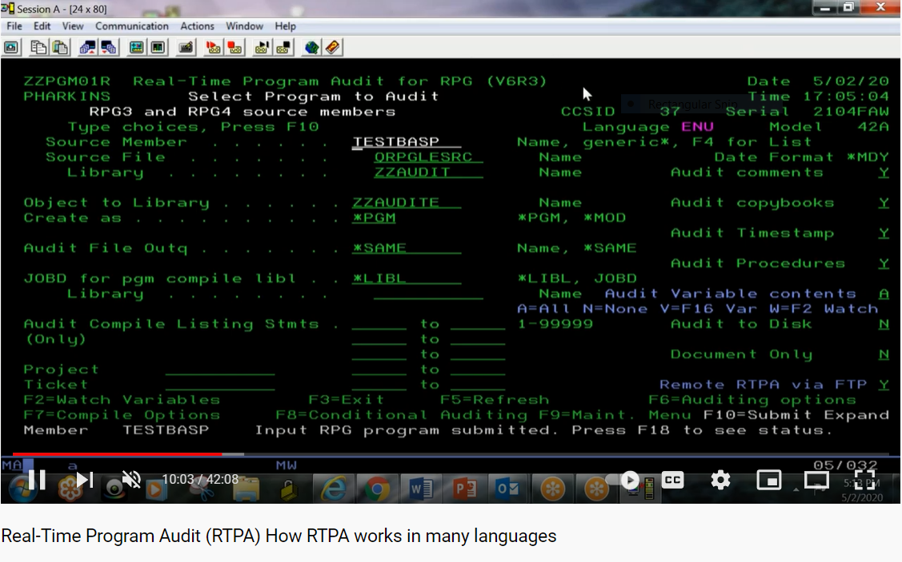
RTPA initial display in English (CCSID 37)

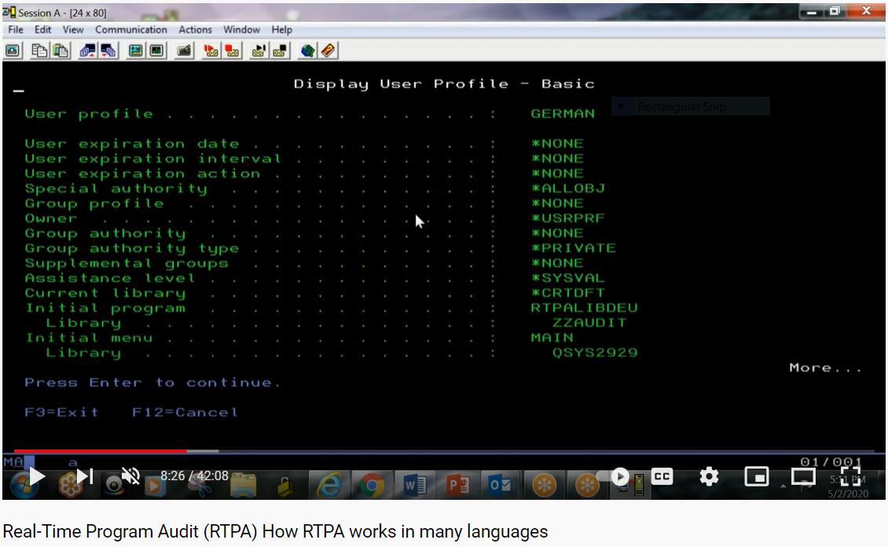

IBM i German language library is QYSY2929
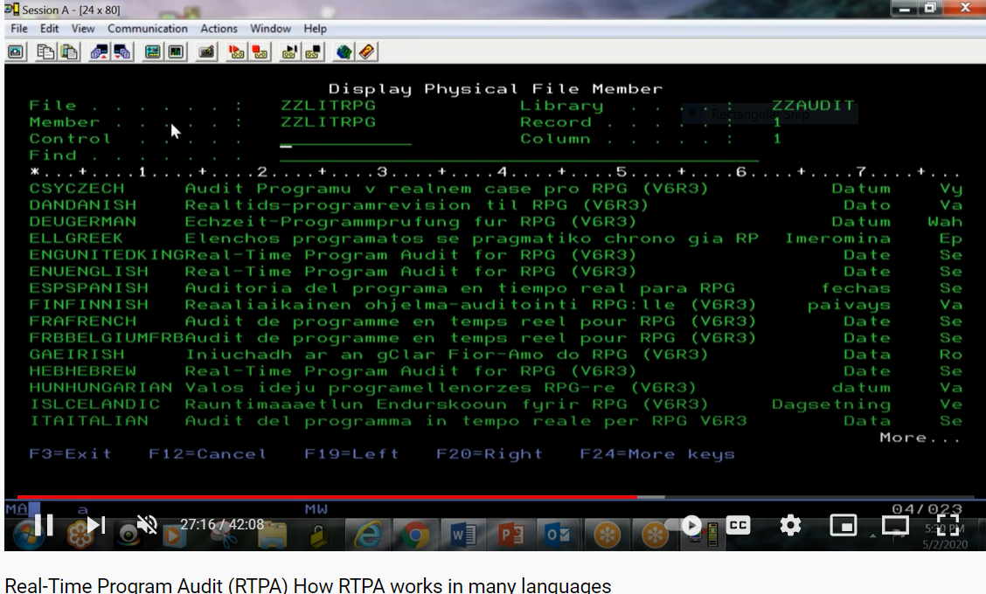

German Language (DEU) literals used in RTPA displays in RTPA Languages File

Triple Programmer Productivity and Value with Automation

Triple Programmer Productivity and Value with Automation - YouTube

29.00 minutes

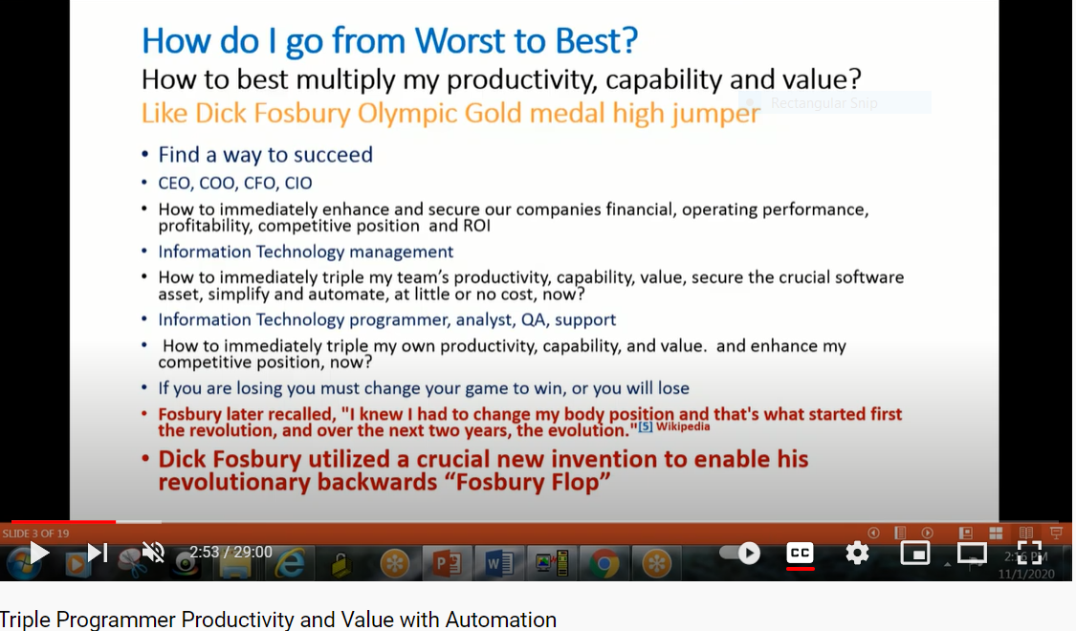

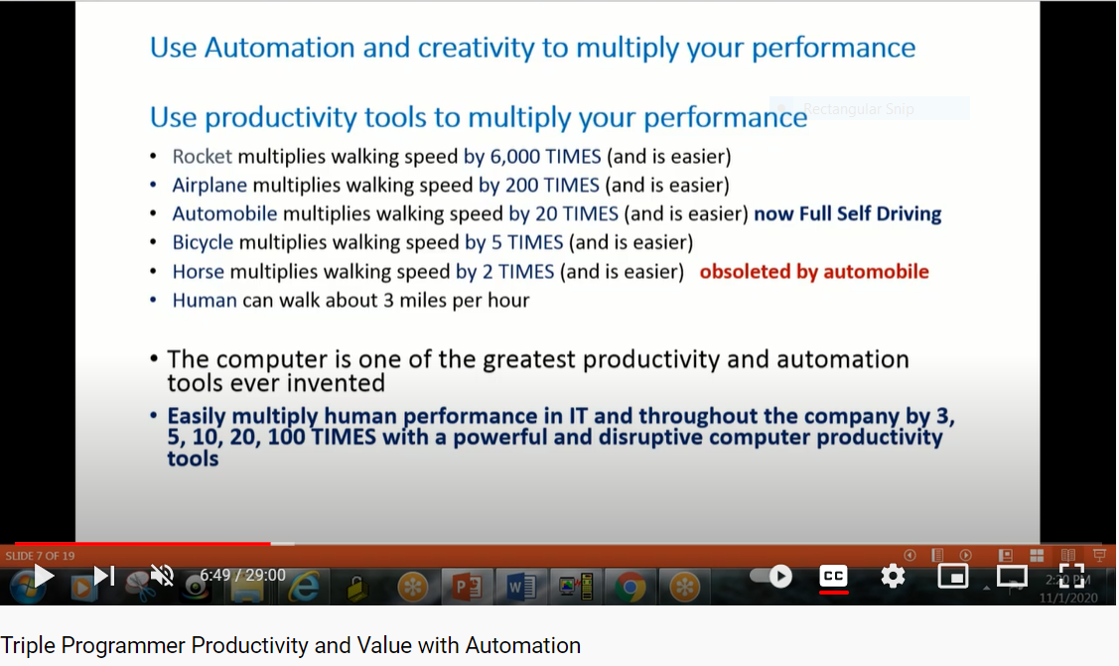

Multiply Programmer Productivity, Capability, by 3, 5, 10, 100 Times with Automation

Multiply Programmer Productivity, Capability, Value by 3, 5, 10, 100 Times with Automation – YouTube

53.04 minutes
F
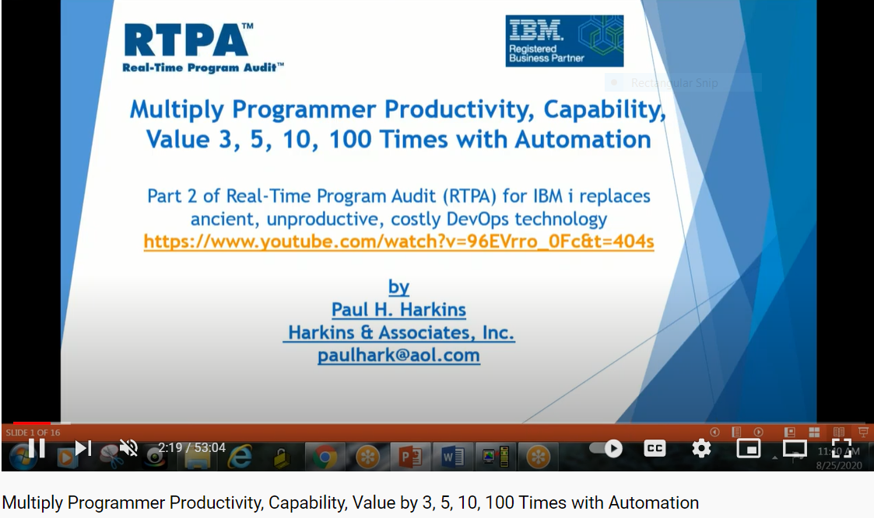

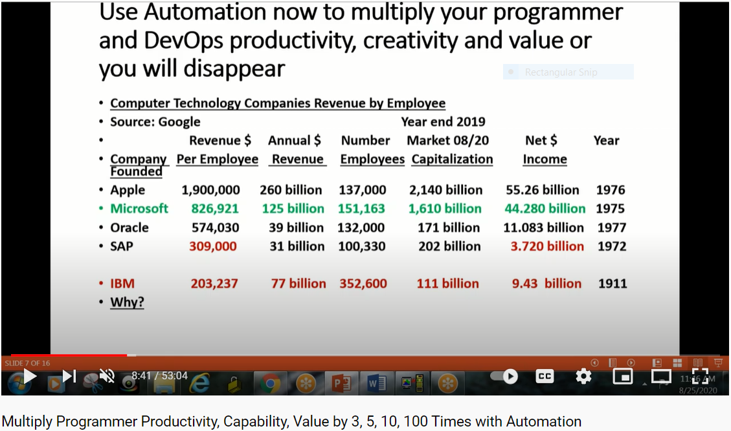

RTPA Demonstrations in many Country Languages
Online and interactive RTPA demonstrations and training are available worldwide in more than 20 languages by GoToMeeting sessions from the RTPA development and support IBM i.

Current country languages for RTPA demonstrations and training include:

Work with User Enrollment
System: LS053
Type options below, then press Enter.
1=Add 2=Change 3=Copy 4=Remove 5=Display

Opt User Description

CANADAFR Canada French User Profile qsy2981 CCSID 297
DANISH Danish language User Profile qsy2926 CCSID 277
DUTCHNET DUTCH NETHERLANDS Profile qsy2923 CCSID 256
FINNISH FINNISH language User Profile qsy2925 CCSID 278
FRENCH FRENCH language User Profile qsy29284 CCSID 297
GERMAN German language User Profile qsy2929 CCSID 273
ITALIAN Italian language User Profile qsy2932 CCSID 280
NOREGIAN Noregian language User Profile qsy2933 CCSID 277
PORTUGESE PORTUGESE Language LANGID PTG CCSID 284
SPANISH Spanish language User Profile qsy2931 CCSID 284
SWEDISH Swedish language User Profile qsys2937 CCSID 278
USA USA language User Profile qsy2924 CCSID 37
User Sign on for RTPA demonstrations in different countries

Sign On
System . . . . . : LS053
Subsystem . . . . : QINTER
Display . . . . . : QPADEV0001

User . . . . . . . . . . . . . . GERMAN
Password . . . . . . . . . . . .
Program/procedure . . . . . . . .
Menu . . . . . . . . . . . . . .
Current library . . . . . . . . .

User Sign GERMAN for German language demonstration of RTPA
CCSID 273 Language ID DEU

MAIN IBM i-Hauptmen}
System: LS053
Auswahlm¦glichkeiten:

1. Benutzeraufgaben
2. B}roaufgaben
3. Allgemeine Systemaufgaben
4. Dateien, Bibliotheken und Ordner
5. Programmierung
6. Datenfernverarbeitung
7. System definieren oder {ndern
8. Problembehandlung
9. Men} anzeigen
10. Unterst}tzende Informationen - Auswahlm¦glichkeiten
11. IBM i Access-Aufgaben

90. Abmelden

Auswahl oder Befehl
===> rtpa

F3=Verlassen F4=Bedienerf}hrung F9=Auffinden F12=Abbrechen
F13=Unterst}tzende Informationen F23=Anfangsmen} festlegen
(C) COPYRIGHT IBM CORP. 1980, 2015.
(
User display is in German and compiles are in German Language DEU

ZZPGM01R Echzeit-Programmprufung fur RPG (V7R1) Datum 26/11/20
GERMAN Wahlen Sie das zu prufende Programm Zeit 15:36:19
RPG3- unt RPG4- Quellmitglieder CCSID 273 Serienumm 2104FAW
Geben Sie eine Auswahl ein und drucken Sie F10 Sprache DEU Modell 42A
Quellenteildatei . . . . . NEWEXPSH Name, generisch*, *ALL,F4 Liste
Quellendatei . . . . . . . QRPGLESRC Name Datumsformat *DMY
Bibliothek . . . . . . . ZZAUDIT Name Prufungskommentare Y

Objekt zur Bibliothek . . . . ZZAUDITE Name Audithefte Y
Prufzeitstempel Y
Audit-Datei Outq. . . . . . . *SAME Name, *SAME
Prufungsverfahren Y
JOBD fur pgm kompilieren libl *LIBL *LIBL, JOBD
Bibliothek . . . . . . . Name Pruf den Inhalt von var A
A=All N=Kein V=F16 Var. W=F2 Schen
to 1-99999 Auf Datentrager pr N
(Nur) to
to Nur Dokument N
Projekt to
Fahrkarte to Remote-RTPA uber FTP N
F2=Variablen beobachten F3=Ausfart F6=Prufungsoptionen F7=Optionen kompiliere
F8=Bedingte Prufung F9=Grose Menu F10=einreichen er F12=Stornieren
F18=RTPA-Geschichte heute F24=Weitere Schlussel (C) Harkins & Associates, Inc.
RTPA wird "wei besehen" ohne ausdruckliche oder stillschweigende Garantie vert
Enter the RPGLE soure member name NEWEXPSH

ZZPGM01R Echzeit-Programmprufung fur RPG (V7R1) Datum 12/08/20
GERMAN Wahlen Sie das zu prufende Programm Zeit 15:50:22
RPG3- unt RPG4- Quellmitglieder CCSID 273 Serienumm 2104FAW
Geben Sie eine Auswahl ein und drucken Sie F10 Sprache DEU Modell 42A
Quellenteildatei . . . . . NEWEXPSH Name, generisch*, *ALL,F4 Liste
Quellendatei . . . . . . . QRPGLESRC Name Datumsformat *DMY
Bibliothek . . . . . . . ZZAUDIT Name Prufungskommentare Y

Objekt zur Bibliothek . . . . ZZAUDITE Name Audithefte Y

Prufzeitstempel Y
Audit-Datei Outq. . . . . . . *SAME Name, *SAME
Prufungsverfahren Y
JOBD fur pgm kompilieren libl *LIBL *LIBL, JOBD
Bibliothek . . . . . . . Name Pruf den Inhalt von var A
A=All N=Kein V=F16 Var. W=F2 Schen
Auditr Kompilieren von Stmts to 1-99999 Auf Datentrager pr N
(Nur) to
to Nur Dokument N
Projekt to
Fahrkarte to Remote-RTPA uber FTP N
F2=Variablen beobachten F3=Ausfart F6=Prufungsoptionen F7=Optionen kompiliere
F8=Bedingte Prufung F9=Grose Menu F10=einreichen er F12=Stornieren
Mitglied NEWEXPSH eingereicht. Drunken Sie F18, um den Status anzuzeigen

User RTPA display is in German and compiles are in German Language DEU

ZZPGM01R Echzeit-Programmprufung fur RPG (V7R1) Datum 12/08/20
GERMAN RTPA-Geschichte heute Zeit 15:51:52
German language User Profile qsy2929 CCSID 273 CCSID: 273
Gaben Sie die option ein und druken Sprache DEU
4= Loschen 5= Anzeigen Datumsformat *DMY

O Programm Status Programmname Job Datum Zeit
5 NEWEXPSH 8 EXPN OK New Expected Ship Date from Or 101265 12/08/20 15:50:22

F3=Ausfart F5=Aktualisierung F12=Stornieren F20=RTPA-Benutzer Geschic
F22=RTPA Analytics-Berich (C) HARKINS & ASSOCIATES, INC.
User RTPA display is in German and compiles are in German Language DEU

ZZPGM01R Echzeit-Programmprufung fur RPG (V7R1) Datum 12/08/20
GERMAN Wahlen Sie das zu prufende Programm Zeit 15:53:27
Projekt Fahrkarte *DMY CCSID 273 Sprache DEU
Programm NEWEXPSH New Expected Ship Date from Order Deta Pruf den Inhalt vo A
Status 8 Erweitern Sie Pgm kompili Prufungskommentare Y Auf Datentrager pr N
Audithefte Y Nur Dokument N
Gaben Sie die option ein und druken Prufzeitstempel Y Remote RTPA-uber F N
5= Kompilierliste anzeigen Prufungsverfahren Y Variable verw 220
OPT-Jobnummer-Datensatze wurden ubermittel Abgeschlosse Abgelaufen Comp-Daten
Eingang 101265 1,186 12/08/20 15:50:22 12/08/20 15:50:23 1 1,333
Eingefug 101266 5,509 12/08/20 15:50:31 12/08/20 15:50:36 5
Erweiter 101268 6,695 12/08/20 15:50:38 12/08/20 15:50:44 6 6,670
Exp Obj lib ZZAUDITE Programm Objektgrose 4,587,520
Quelldati QRPGLESRC Erwei Datei QRPGLESRC Aufnahmeformat 7 Hefte Y
Quelle Libl ZZAUDIT Erw Que Bib ZZAUDITE Druckerdateien 2 *INZSR Y
RPG-Ausfuhr 4 RPGLE PrufungJOBQ RTPA Erweiterung %parms
Von Zu PrufungOUTQ Unterprogramm 9 /free Y
Von Zu Prufung Bib *LIBL Uberlauf OE Einzug
Von Zu JOBS-Biblio Prototyp/Verfa N CTA Y SDS Y
Von Zu Maximale Seiten 15000 SDS Name QXXDS SDS Qual
Von Zu Variablen b DBCS 291 Start/Stop conditional N
F8=Bedingte Prufung F13=Dateien/Auf F14=Felder F15=Operationen F16=Variablen
F2=Variablen beobachten F17=Etiketten F19=Genannt Pgm F21=Bedingte Betreisb
F3=Ausfart F22=Indikatoren F23=Vor Prufung (C) 2016 Harkins & Associates, Inc.
User RTPA display is in German and compiles are in German Language DEU

Input RPGLE source program contained 1,186 source statements
RTPA inserted 5,509 audit statements to a copy of input source in library ZZAUDITE
All 220 program variables were audited
All program comments were audited
All program copybooks were audited
All program subroutines were audited
All program procedures were audited
All executable program statements were audited
All executing program statements are timestamped
RTPA audit output ZZAUDITP is to WRKSPLF rather than to disk ZZAUDITD

RTPA complete auditing of the RPGLE program NEWEXPSH execution is in real-time as the expanded NEWEXPSH program executes and is permanently available, without ANY programmer work or involvement, and takes only several elapsed seconds.
Spool-Datei anzeigen
Datei . . . . . : NEWEXPSH Seite/Zeile 1/1
Steuerung . . . . Spalten 1 - 78
Suchen . . . . .
*...+....1....+....2....+....3....+....4....+....5....+....6....+....7....+...
5770WDS V7R3M0 160422 RN IBM ILE RPG QTEMP/NEWEXPSH
Befehl . . . . . . . . . . . . . : CRTBNDRPG
Ausgegeben von . . . . . . . . : GERMAN
Programm . . . . . . . . . . . . : NEWEXPSH
Bibliothek . . . . . . . . . . : QTEMP
Text 'Beschreibung' . . . . . . : *SRCMBRTXT
Quellenteildatei . . . . . . . . : NEWEXPSH
Quellendatei . . . . . . . . . . : ZZCOPINP
Bibliothek . . . . . . . . . . : QTEMP
CCSID . . . . . . . . . . . . : 273
Text 'Beschreibung' . . . . . . : copied input RPG source to QTEMP
Letzte ¢nderung . . . . . . . . : 08/12/20 15:50:22
Generierungsbewertungsstufe . . : 10
Standardaktivierungsgruppe . . . : *YES
Umwandlungsprogrammauswahlm¦gl. : *XREF *GEN *NOSECLVL *SHOWC
*EXPDDS *EXT *NOSHOWSKP *NOSRC
Weitere ...
F3=Verlassen F12=Abbrechen F19=Links F20=Rechts F24=Weitere Tasten

User RTPA display is in German and compiles are in German Language DEU

RPGLE program NEWEXPSH is executed normally using the RTPA expanded program with audit statements in library ZZAUDITE

MAIN IBM i-Hauptmen}
System: LS053
Auswahlm¦glichkeiten:

1. Benutzeraufgaben
2. B}roaufgaben
3. Allgemeine Systemaufgaben
4. Dateien, Bibliotheken und Ordner
5. Programmierung
6. Datenfernverarbeitung
7. System definieren oder {ndern
8. Problembehandlung
9. Men} anzeigen
10. Unterst}tzende Informationen - Auswahlm¦glichkeiten
11. IBM i Access-Aufgaben

90. Abmelden

Auswahl oder Befehl
===> call zztest1n

F3=Verlassen F4=Bedienerf}hrung F9=Auffinden F12=Abbrechen
F13=Unterst}tzende Informationen F23=Anfangsmen} festlegen

NEWEXPSH Order Inquiry of expected Ship Date 8/12/20 16:20:18

Order Number 1500

Line Number 1

F3=Exit Enter=Display expected ship date

RTPA is auditing the execution of RPGLE NEWEXPSH in real-time as the program executes, with RTA audit output to file ZZAUDITP

WRKSPLF to display RTPA auditing of NEWEXPSH expanded program

Mit allen Spool-Dateien arbeiten

Auswahl eingeben und Eingabetaste dr}cken.
1=Senden 2=¢ndern 3=Anhalten 4=L¦schen 5=Anzeigen 6=Freigeben
7=Nachrichten 8=Attribute 9=Mit Druckstatus arbeiten

Einheit Seiten Akt.
Opt Datei Benutzer Warteschl. Ben.-Daten Stat gesamt Seite Kop.
NEWEXPSH GERMAN RTPA RDY 40 1
NEWEXPSH GERMAN RTPA RDY 154 1
QPRINT2 GERMAN QPRINT2 TEST3 RDY 1 1
QPRINT2 GERMAN QPRINT2 NEWEXPSH RDY 1 1
PRTORDER GERMAN RTPA NEWEXPSH RDY 1 1
5 ZZAUDITP GERMAN RTPA NEWEXPSH HLD 48 1

Ende
Parameter f}r Auswahl 1, 2, 3 oder Befehl
===>
F3=Verl. F10=Sicht 4 F11=Sicht2 F12=Abbrechen F22=Drucker
F24=Weit. Tasten

RTPA audit output of NEWEXPSH program execution, with the NEWEXPSH input source program and RTPA expanded source program compiles

Spool-Datei anzeigen
Datei . . . . . : ZZAUDITP Seite/Zeile 1/1
Steuerung . . . . Spalten 1 - 78
Suchen . . . . .
*...+....1....+....2....+....3....+....4....+....5....+....6....+....7....+...
Program-NEWEXPSH New Expected Ship Date from Order Detail RPGIV Obj Lib
NEWEXPSH NEWEXPSH
Job: 101252 User Profile: GERMAN Source Type: RPGLE
Line
1177 C *INZSR BEGSR
1178 * initialize fields and arrays
1179 C MOVEL *BLANKS MOVSW 1

1180 C Z-ADD 12 ZZD
12121212121212121212121212
1181 C MOVEA *ZERO ZZD2
00000000000000000000000000000
1182 C MOVEA 1111 ZZD3
11110000000000000000000000000
1183 C MOVEL '88888888' ZZA
1184 C ENDSR
Weitere ...
F3=Verlassen F12=Abbrechen F19=Links F20=Rechts F24=Weitere Tasten

==== Timestamp window 205 ====(F not W )================================
Spool-Datei anzeigen
Datei . . . . . : ZZAUDITP Seite/Zeile 1/1
Steuerung . . . . F205 Spalten 205 - 280
Suchen . . . . .
+....1....+....2....+....3....+....4....+....5....+....6....+....7....+....8
RPGLE 101252 GERMAN NEWEXPSH 2020-08-12 16.20.18.795
RPGLE 101252 GERMAN NEWEXPSH 2020-08-12 16.20.18.795
RPGLE 101252 GERMAN NEWEXPSH 2020-08-12 16.20.18.795
RPGLE 101252 GERMAN NEWEXPSH 2020-08-12 16.20.18.795
BEGSR RPGLE 101252 GERMAN NEWEXPSH 2020-08-12 16.20.18.797
comment RPGLE 101252 GERMAN NEWEXPSH 2020-08-12 16.20.18.797
MOVEL RPGLE 101252 GERMAN NEWEXPSH 2020-08-12 16.20.18.797
RPGLE 101252 GERMAN NEWEXPSH 2020-08-12 16.20.18.797
Z-ADD RPGLE 101252 GERMAN NEWEXPSH 2020-08-12 16.20.18.797
RPGLE 101252 GERMAN NEWEXPSH 2020-08-12 16.20.18.797
MOVEA RPGLE 101252 GERMAN NEWEXPSH 2020-08-12 16.20.18.797
RPGLE 101252 GERMAN NEWEXPSH 2020-08-12 16.20.18.797
MOVEA RPGLE 101252 GERMAN NEWEXPSH 2020-08-12 16.20.18.797
RPGLE 101252 GERMAN NEWEXPSH 2020-08-12 16.20.18.797
MOVEL RPGLE 101252 GERMAN NEWEXPSH 2020-08-12 16.20.18.797
ENDSR RPGLE 101252 GERMAN NEWEXPSH 2020-08-12 16.20.18.797
Weitere ..
F3=Verlassen F12=Abbrechen F19=Links F20=Rechts F24=Weitere Tasten

===========================================================================

280 * CUSTOMER MASTER KEY
284 *
285 * RECEIVE PARAMETERS PASSED FROM CALLING PROGRAM
286 C *ENTRY PLIST
287 C PARM PARMIN 44
000150000001
288 *
289 * INPUT DATA AREA TSTDTA
291 C IN TSTDTA
TSTDTA 1 'ABCDEFGHIJKLMNOPQRSTUVWZYZ012345 BB
292 *
293 C TIME TIMES 6 0
162018
294 * MOVE INPUT PARM INTO FOUR PARM FIELDS IN DS
295 C MOVEL PARMIN PARMRE
000150000001
296 C Movel Rptid Progid
NEWEXPSH
297 C Movel Rptdesc Progde
Open Order Detail Report by O
298 C Movel Rpthead Headde
Customer Name Cust
299 * start free form
301 // now in free form RPG
302 torder = 1500;
1500
303 iorder = 78.543;
78.543
304 // value of iorder has now been computed
305 xorder = torder + 13.45 +
1618.19 1500
Weitere ...
F3=Verlassen F12=Abbrechen F19=Links F20=Rechts F24=Weitere Tasten
RTPA audit output of NEWEXPSH program execution

IT Customer Library Books for licensed RTPA Customers
RTPA licensed customers have the option to request and receive a complementary Customer IT library starter package shipped from Amazon.com directly to the customer of several IT related books by authors relating directly to the IBM i (AS/400),

The books are selected by Harkins & Associates, Inc. and are intended to provide relevant background and current information relating directly to the IBM I (AS/400), and would be a start for the Customer IT library.

The books will be shipped to the RTPA licensed customer only when requested by the customer.

Complementary IT Customer library books may include:

- How To Become a Highly Paid Corporate Programmer
- The Future of Corporate Computing
- Triple Programmer Productivity and Value with Automation
- Thank You IBM: Special Edition

Real-Time Program (RTPA) white papers, user testimonials, case studies and the RTPA User Manual may be downloaded directly from www.realtimeprogramaudit.com

RTPA Software Guaranty is “AS IS” without Warantee expressed or implied

Real-Time Program Audit (RTPA) software is distributed on an “as is” basis, without warranty express or implied.

The Real-Time Program Audit (RTPA) licensed software is intended to be used in a development and test environment, not in a production environment.

Harkins & Associates, Inc. Websites
Harkins & Associates, Inc. develops, maintains, and supports the RTPA family of programmer productivity software products. Web site www.realtimeprogramaudit.com contains information about these products, downloadable program code, manuals, and other information about these products.

RTPA Web site for IBM i www.realtimeprogramaudit.com

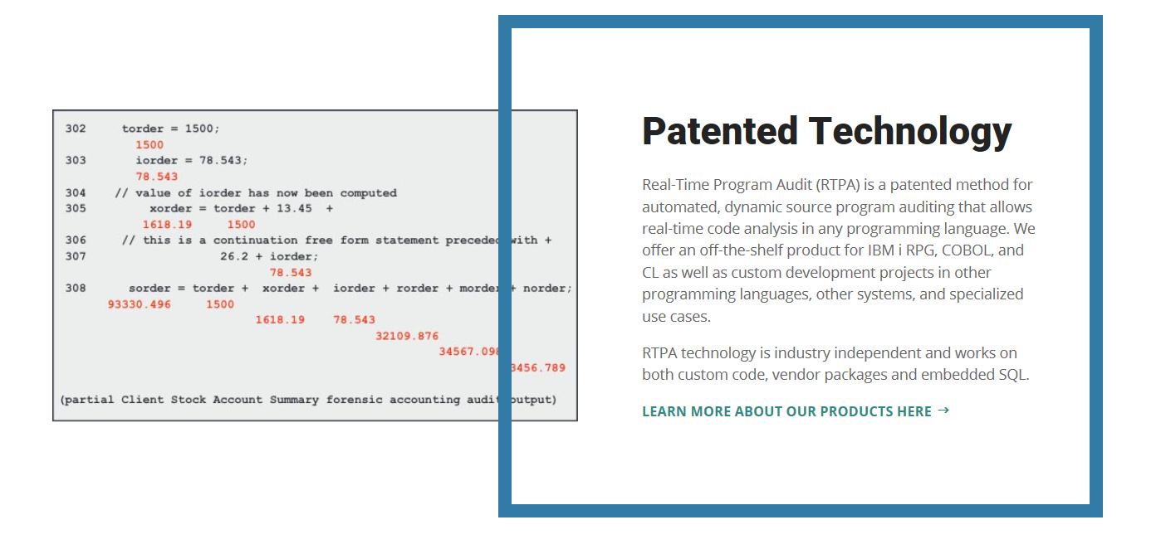
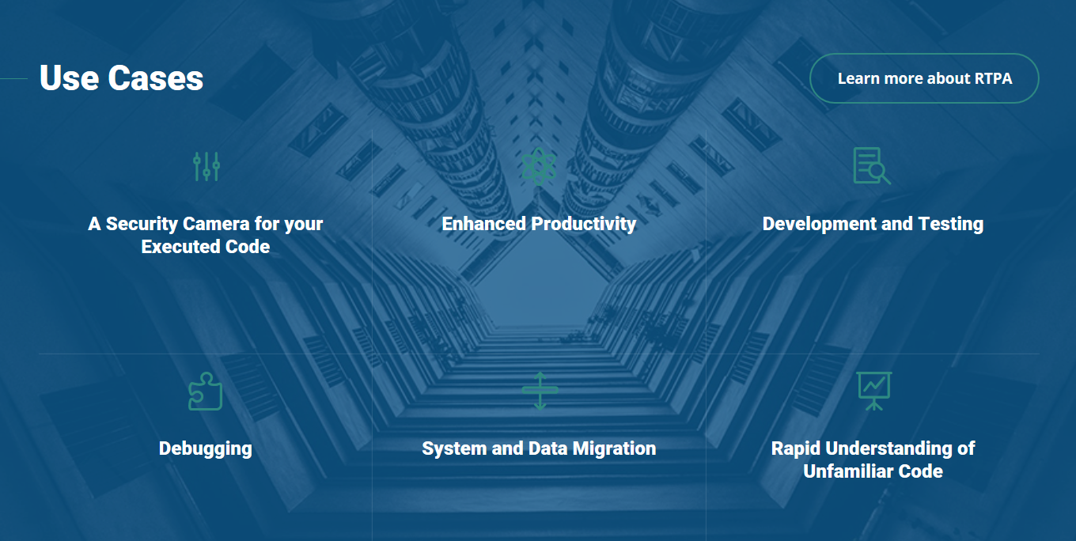

RTPA for IBM i RPG Brochure
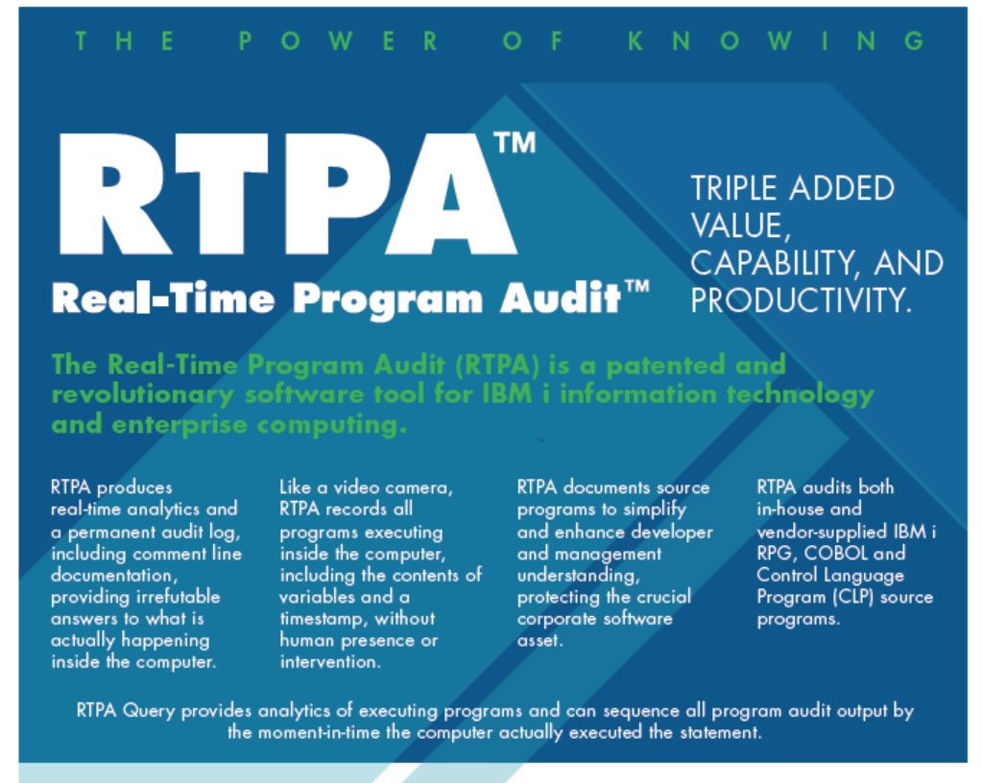

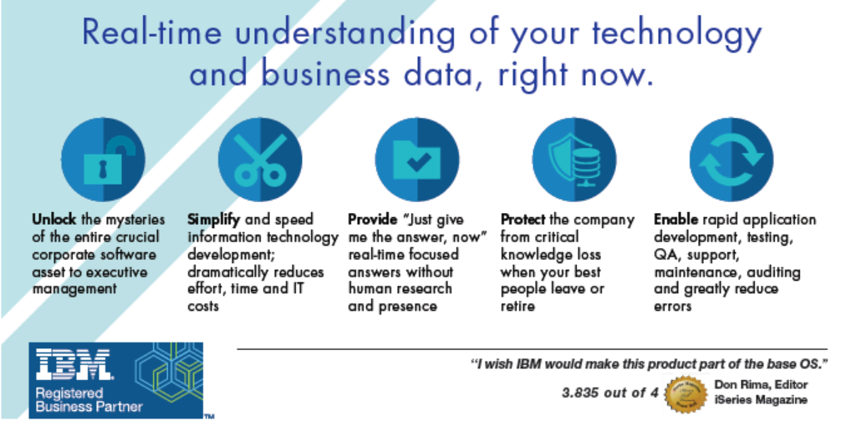

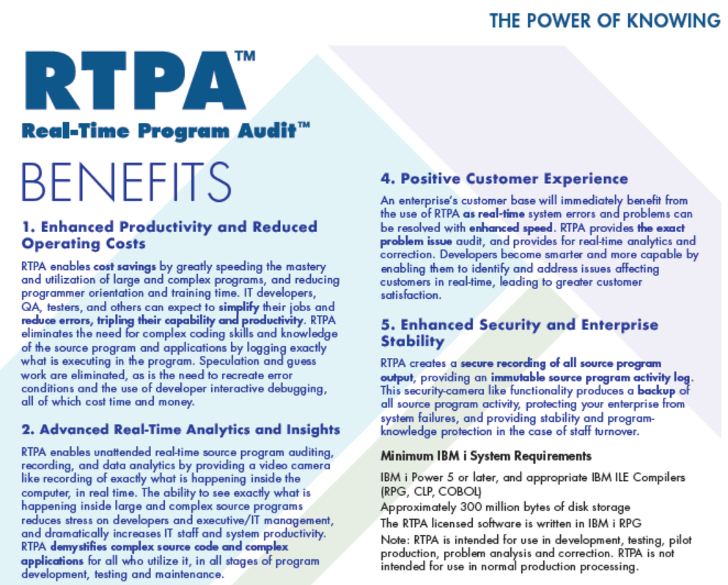
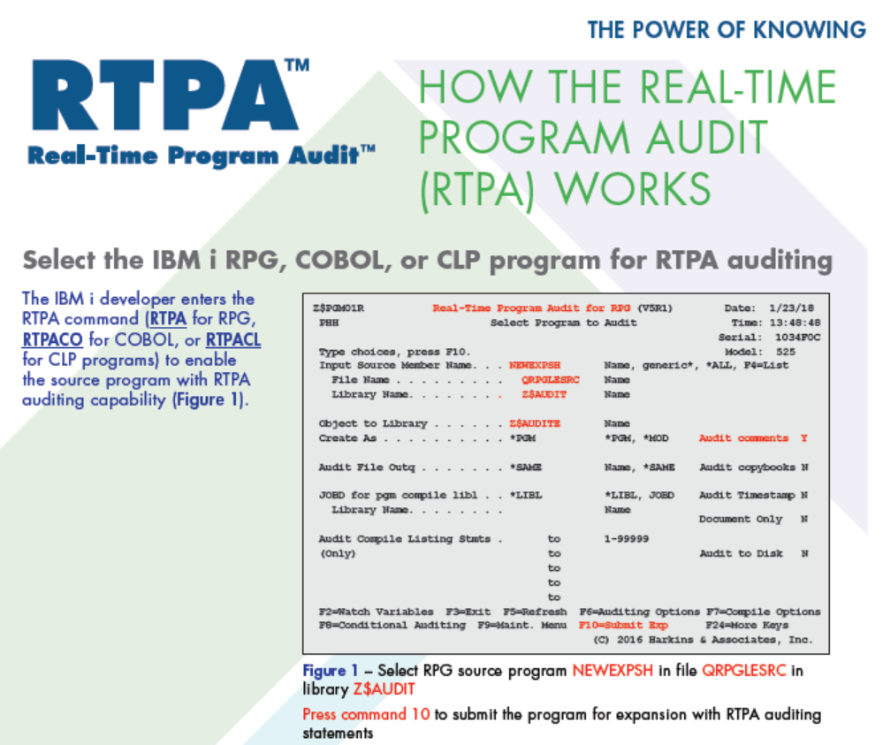
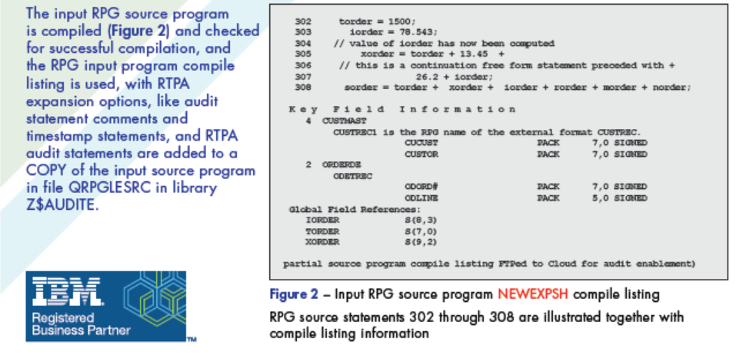
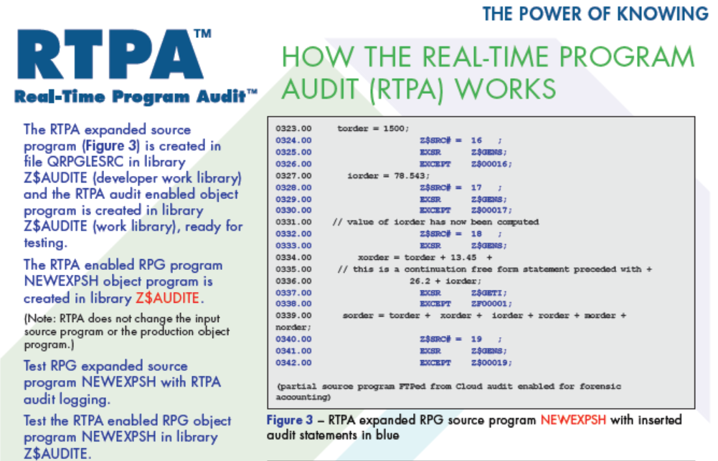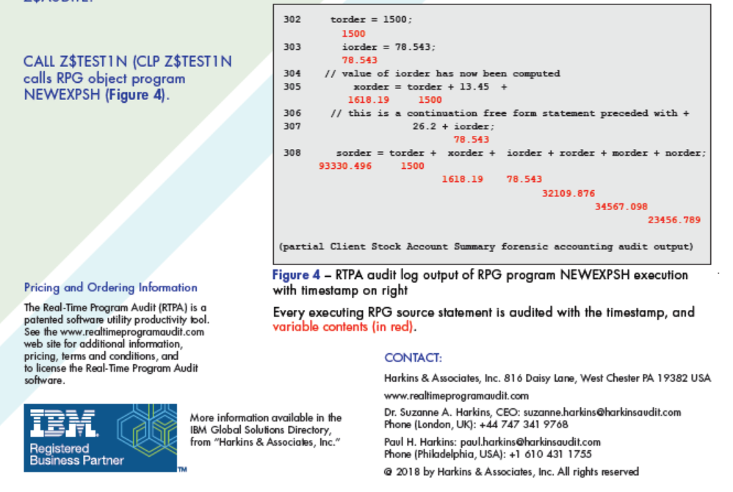

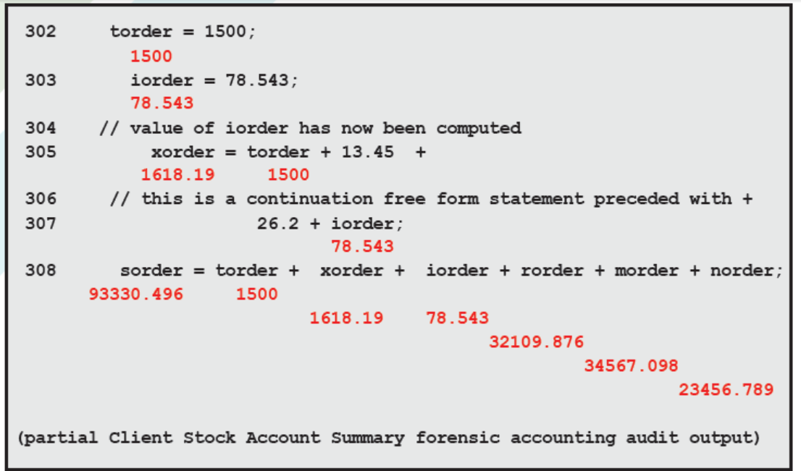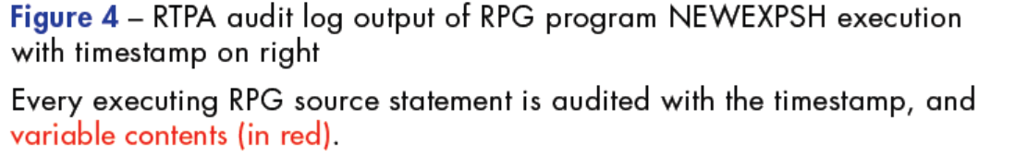

RTPA for IBM i COBOL and COBOL System z Brochure

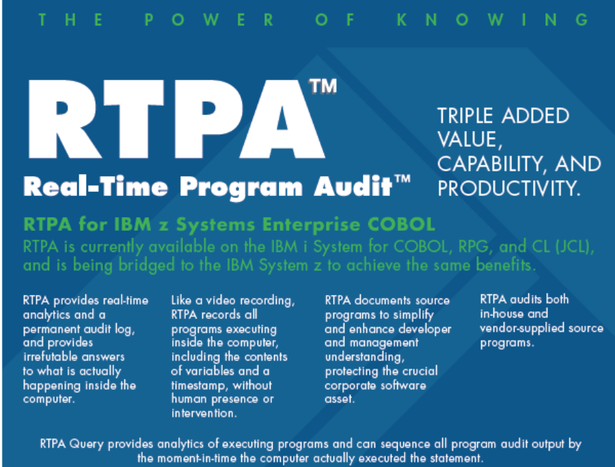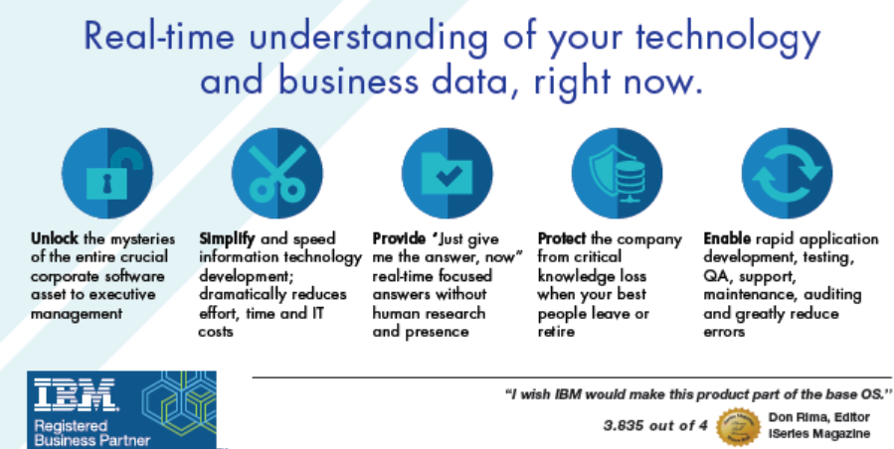
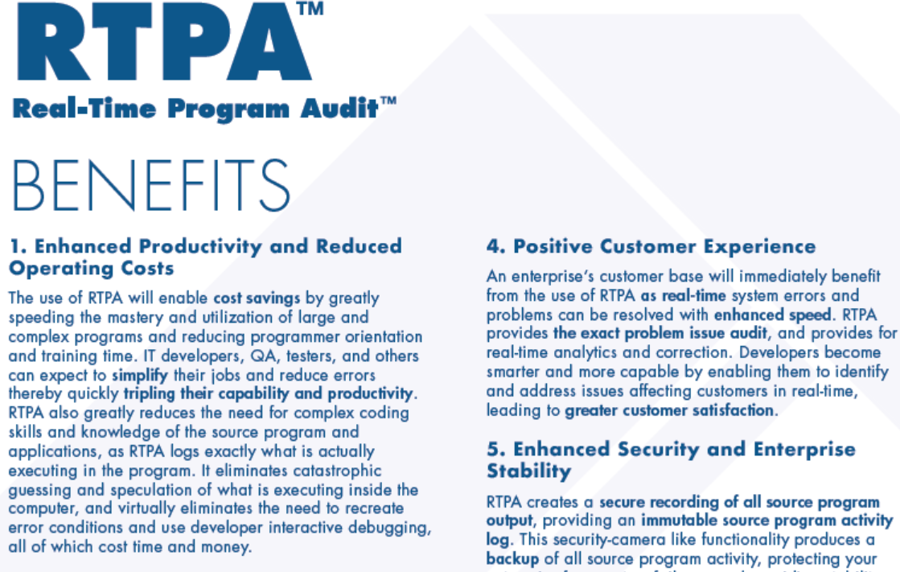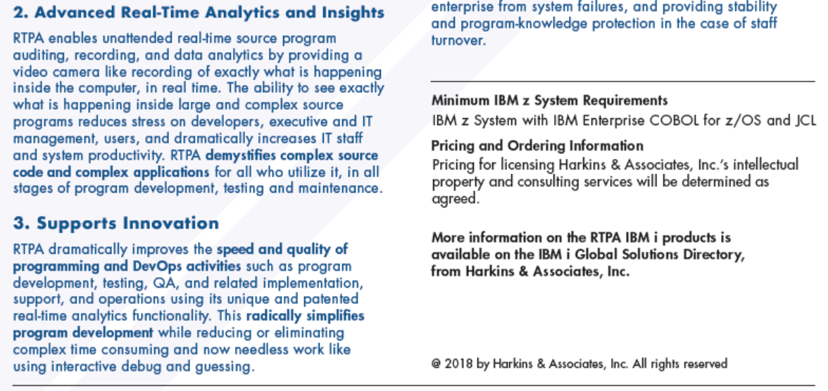

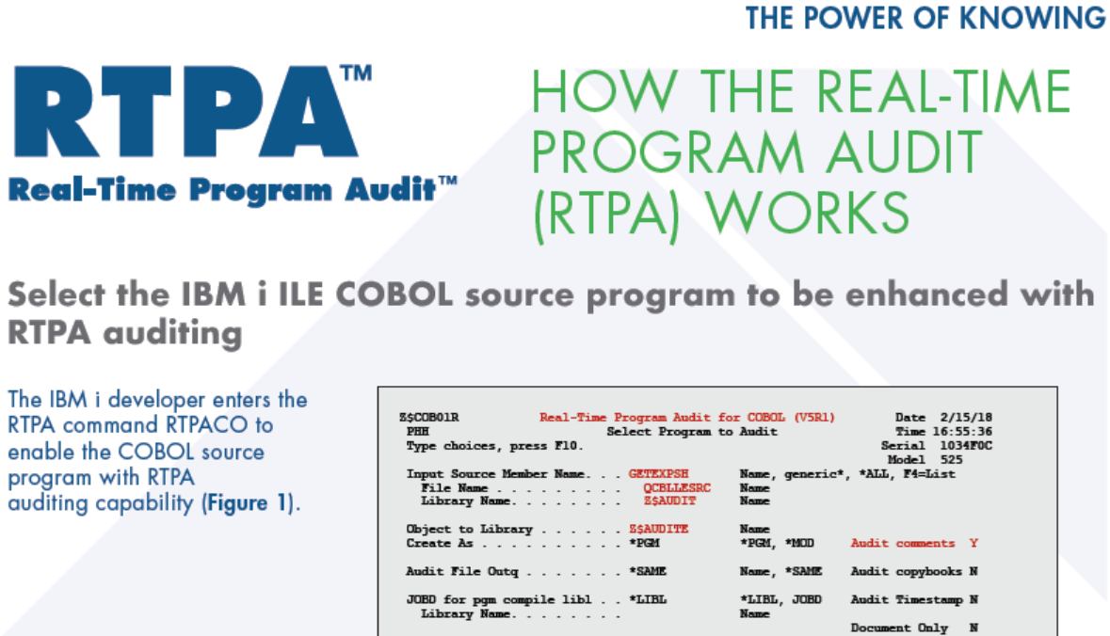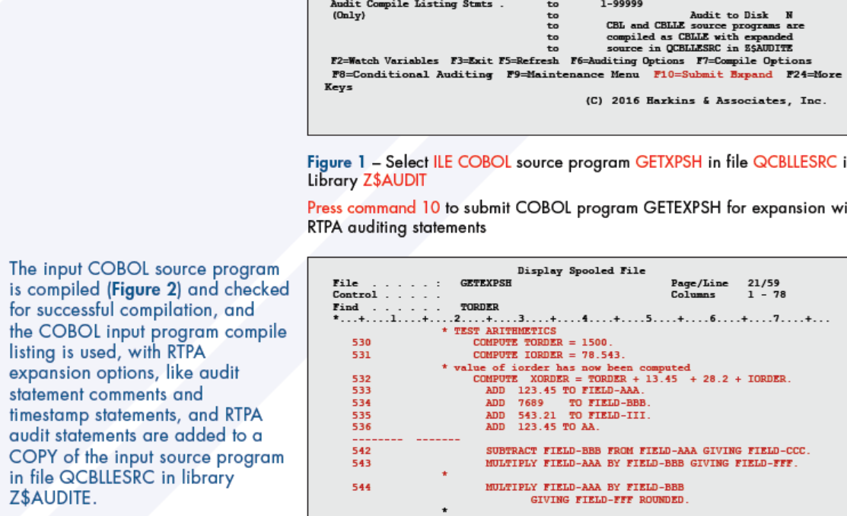
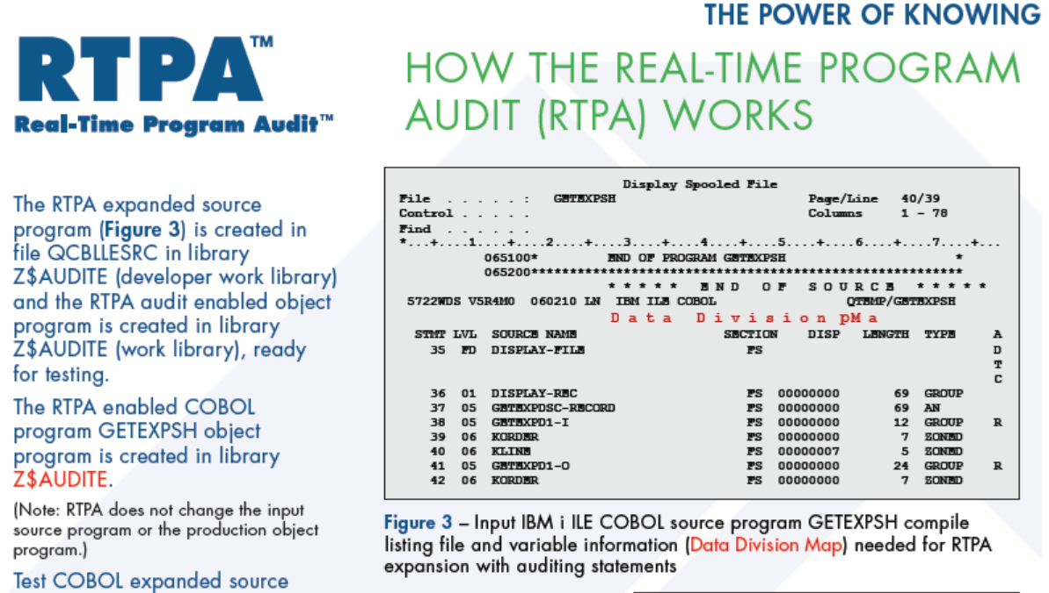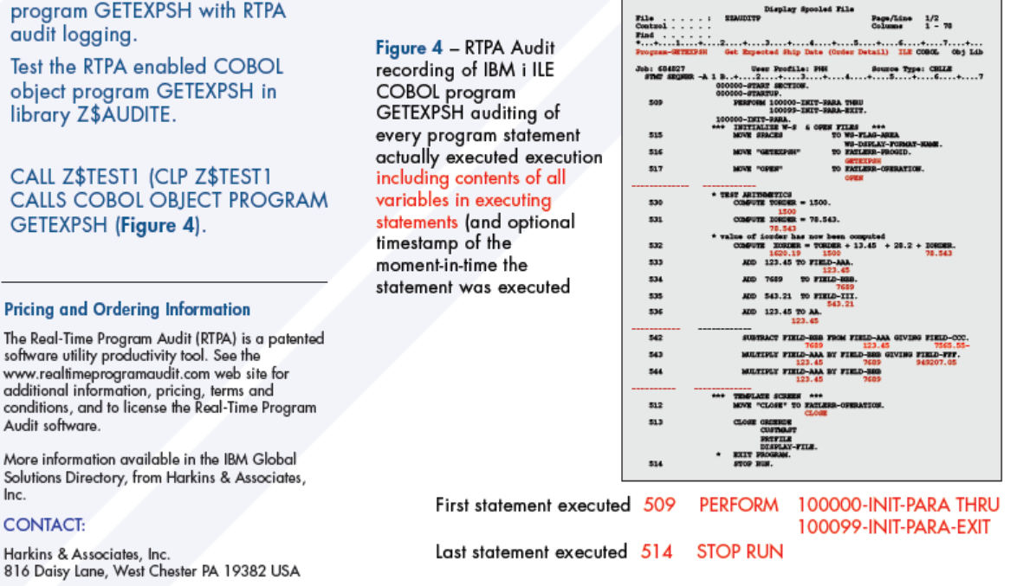

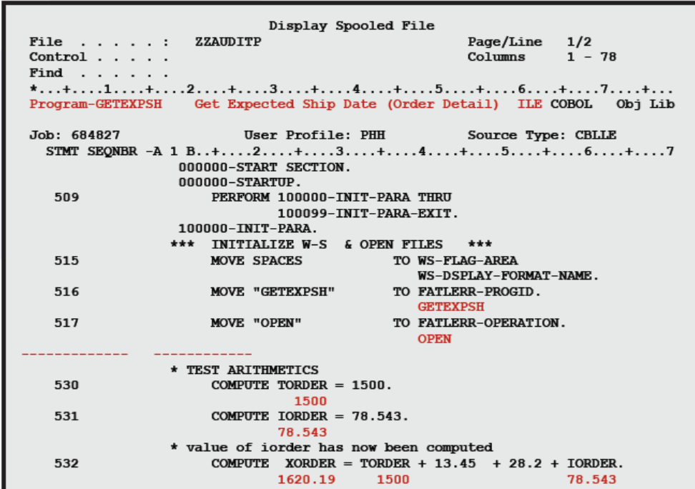

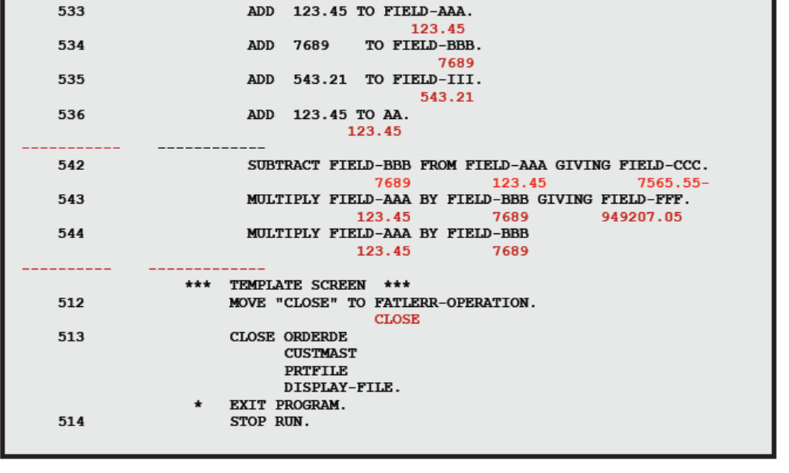

How RTPA works for many countries and languages on the same IBM i
RTPA uses the IBM i User Profile (the sign-on user name) to allow many countries and languages to be processed simultaneously by the same IBM i , including different special characters and keyboards the countries use in the languages.

Note- Some German language speaking countries like Switzerland, Austria, and the Netherlands use different special characters than the special characters used in Germany, and this is accommodated with changes to the User profiles.
RTPA User Profile for Germany is User Profile GERMAN

Change User Profile (CHGUSRPRF)

Type choices, press Enter.

User profile . . . . . . . . . . > GERMAN Name
User password . . . . . . . . . *SAME Character value, *SAME, *NONE
Set password to expired . . . . *NO *SAME, *NO, *YES
Status . . . . . . . . . . . . . *ENABLED *SAME, *ENABLED, *DISABLED
User class . . . . . . . . . . . *PGMR *SAME, *USER, *SYSOPR...
Assistance level . . . . . . . . *SYSVAL *SAME, *SYSVAL, *BASIC...
Current library . . . . . . . . *CRTDFT Name, *SAME, *CRTDFT
Initial program to call . . . . RTPALIBDEU Name, *SAME, *NONE
Library . . . . . . . . . . . ZZAUDIT Name, *LIBL, *CURLIB
Initial menu . . . . . . . . . . MAIN Name, *SAME, *SIGNOFF
Library . . . . . . . . . . . *LIBL Name, *LIBL, *CURLIB
Limit capabilities . . . . . . . *NO *SAME, *NO, *PARTIAL, *YES
Text 'description' . . . . . . . 'German language User Profile qsy2929 CCSID
273'

Additional Parameters

Special authority . . . . . . . *JOBCTL *SAME, *USRCLS, *NONE...
+ for more values
Special environment . . . . . . *SYSVAL *SAME, *SYSVAL, *NONE, *S36
Display sign-on information . . *SYSVAL *SAME, *NO, *YES, *SYSVAL
Password expiration interval . . *SYSVAL 1-366, *SAME, *SYSVAL, *NOMAX
Block password change . . . . . *SYSVAL 1-99, *SAME, *SYSVAL, *NONE
Local password management . . . *YES *SAME, *YES, *NO
Limit device sessions . . . . . *SYSVAL *SAME, *SYSVAL, *YES, *NO...
Keyboard buffering . . . . . . . *SYSVAL *SAME, *SYSVAL, *NO...
Maximum allowed storage large . *NOMAX
Maximum allowed storage . . . . *SAME Kilobytes, *SAME, *NOMAX
Highest schedule priority . . . 3 0-9, *SAME
Type choices, press Enter.

Job description . . . . . . . . QDFTJOBD Name, *SAME
Library . . . . . . . . . . . QGPL Name, *LIBL, *CURLIB
Group profile . . . . . . . . . *NONE Name, *SAME, *NONE
Owner . . . . . . . . . . . . . *USRPRF *SAME, *USRPRF, *GRPPRF
Group authority . . . . . . . . *NONE *SAME, *NONE, *ALL...
Group authority type . . . . . . *PRIVATE *PRIVATE, *PGP, *SAME
Supplemental groups . . . . . . *NONE Name, *SAME, *NONE
+ for more values
Accounting code . . . . . . . . *BLANK
Document password . . . . . . . *SAME Name, *SAME, *NONE
Message queue . . . . . . . . . GERMAN Name, *SAME, *USRPRF
Library . . . . . . . . . . . QUSRSYS Name, *LIBL, *CURLIB
Delivery . . . . . . . . . . . . *NOTIFY *SAME, *NOTIFY, *BREAK...
Severity code filter . . . . . . 0 0-99, *SAME
Print device . . . . . . . . . . *WRKSTN Name, *SAME, *WRKSTN, *SYSVAL
Type choices, press Enter.

Output queue . . . . . . . . . . RTPA Name, *SAME, *WRKSTN, *DEV
Library . . . . . . . . . . . QGPL Name, *LIBL, *CURLIB
Attention program . . . . . . . *SYSVAL Name, *SAME, *SYSVAL...
Library . . . . . . . . . . . Name, *LIBL, *CURLIB
Sort sequence . . . . . . . . . *SYSVAL Name, *SAME, *SYSVAL, *HEX...
Library . . . . . . . . . . . Name, *LIBL, *CURLIB
Language ID . . . . . . . . . . DEU *SAME, *SYSVAL...
Country or region ID . . . . . . DE *SAME, *SYSVAL...
Coded character set ID . . . . . 273 *SAME, *SYSVAL, *HEX...
Character identifier control . . *SYSVAL *SAME, *SYSVAL, *DEVD...
Locale job attributes . . . . . *SYSVAL *SAME, *SYSVAL, *NONE...
+ for more values
Locale . . . . . . . . . . . . . *SAME

User options . . . . . . . . . . *NONE *SAME, *NONE, *CLKWD...
+ for more values
More...
Type choices, press Enter.

User ID number . . . . . . . . . 107 1-4294967294, *SAME
Group ID number . . . . . . . . *NONE 1-4294967294, *SAME, *GEN...
Home directory . . . . . . . . . *SAME

EIM association:
EIM identifier . . . . . . . . *NOCHG
Association type . . . . . . . *TARGET, *SOURCE, *TGTSRC...
Association action . . . . . . *REPLACE, *ADD, *REMOVE
Create EIM identifier . . . . *NOCRTEIMID, *CRTEIMID
User expiration date . . . . . . *NONE Date, *NONE, *USREXPITV...
User expiration interval . . . . 1-366

The RTPA uses the User Profile initial program to set the User Profile library list and language parameters
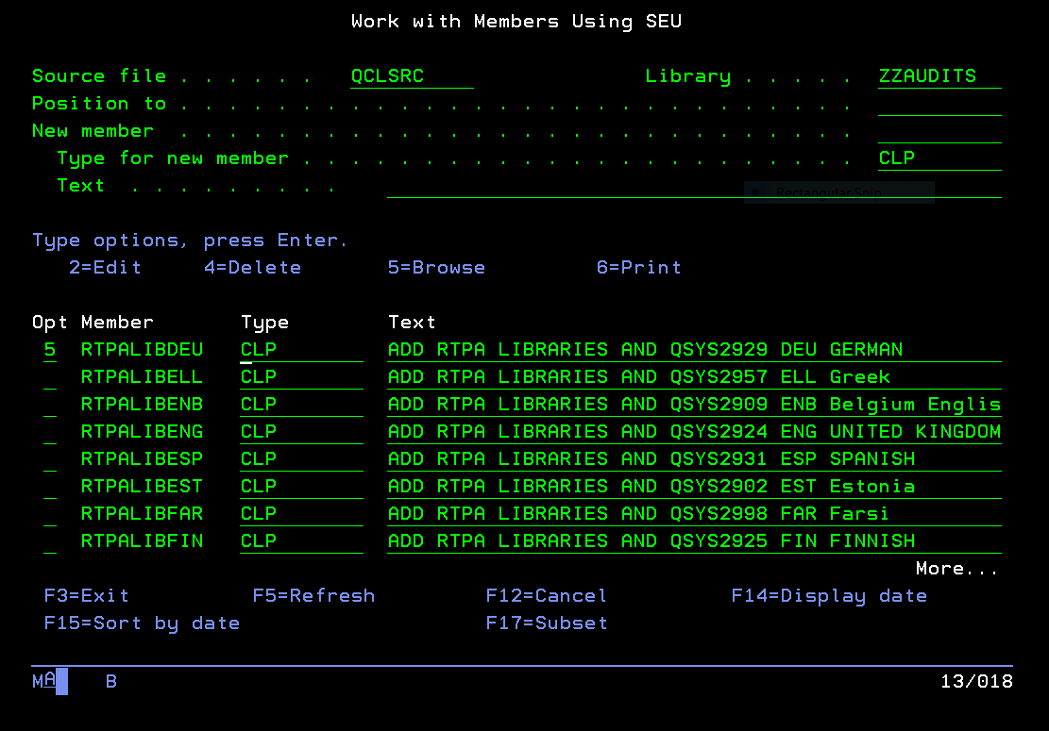
The RTPA German user profile GERMAN initial program CLP RTPALIBDEU is illustrated below:

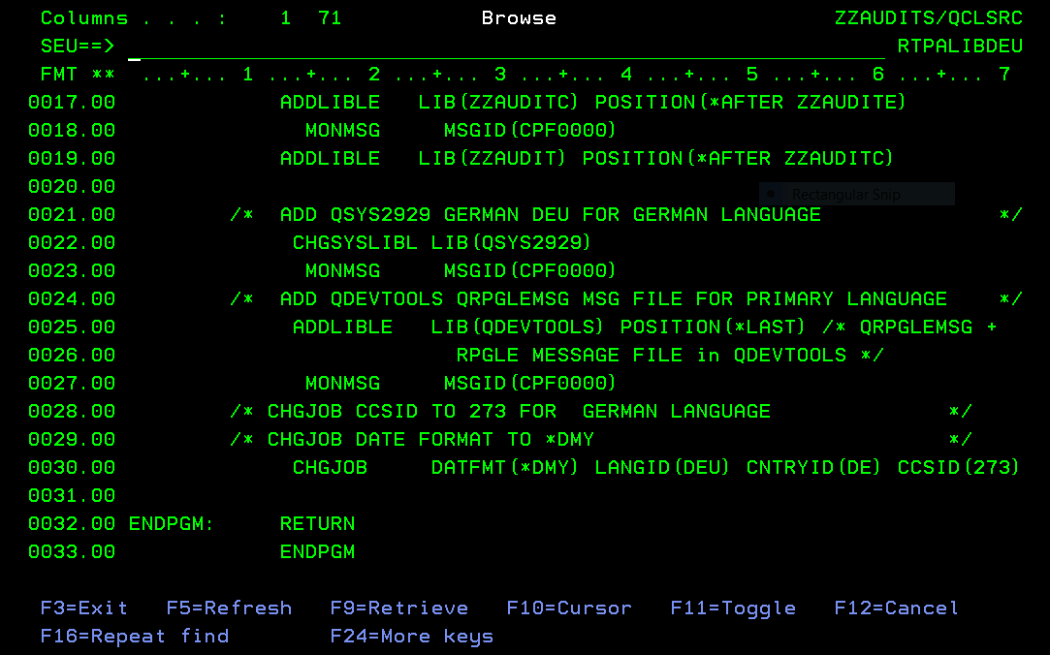

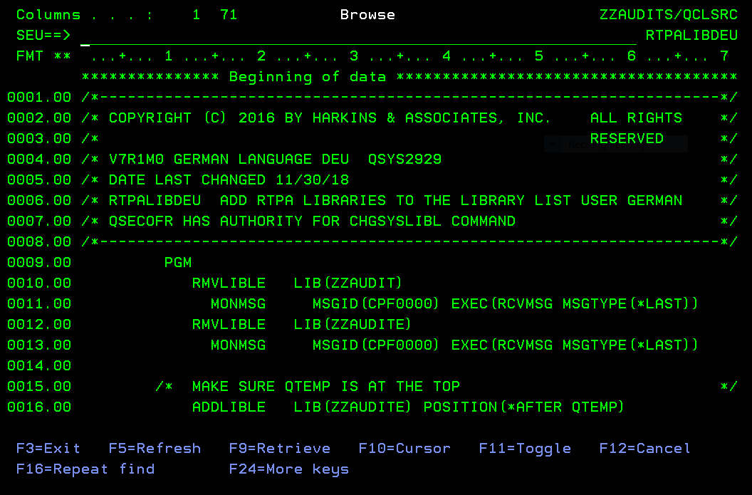

GERMAN User Profile initial program (CLP RTPALIBLDEU)
RTPA language related User Profiles
User profile for all is *ALLOBJ
User program class for all is *PGMR

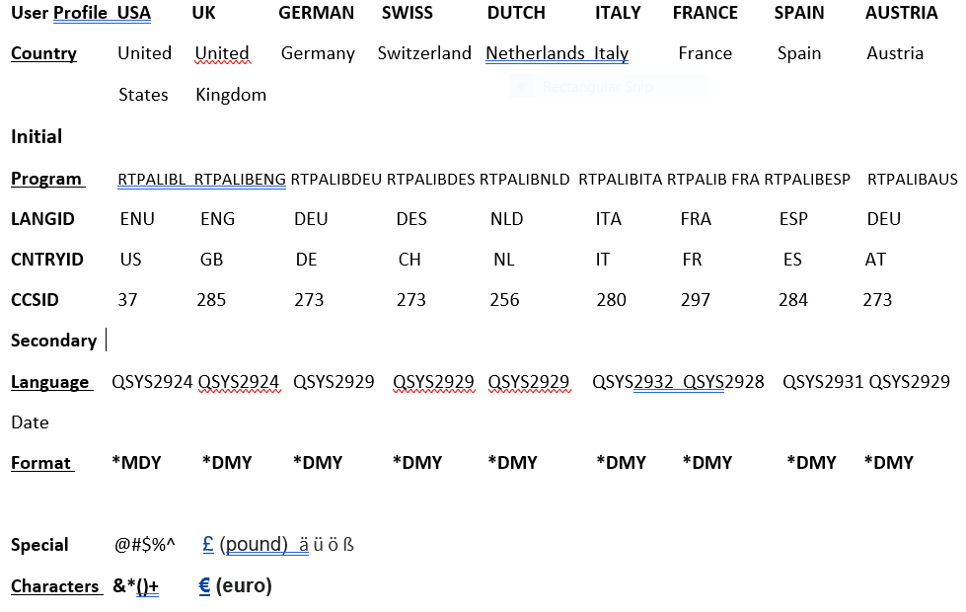

British and American keyboards - Wikipedia
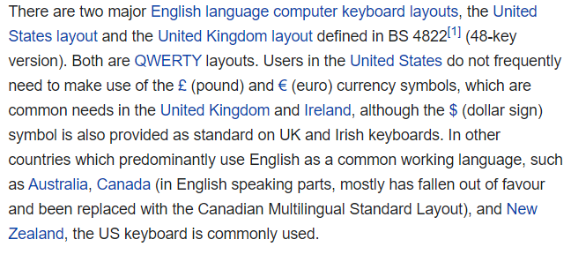
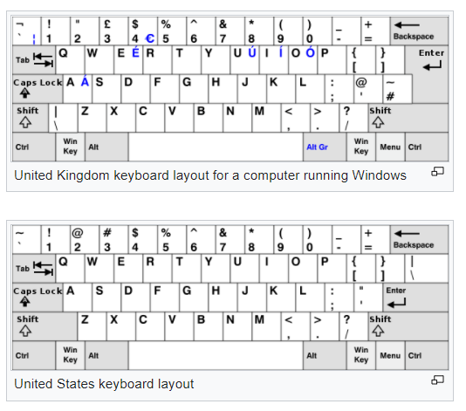
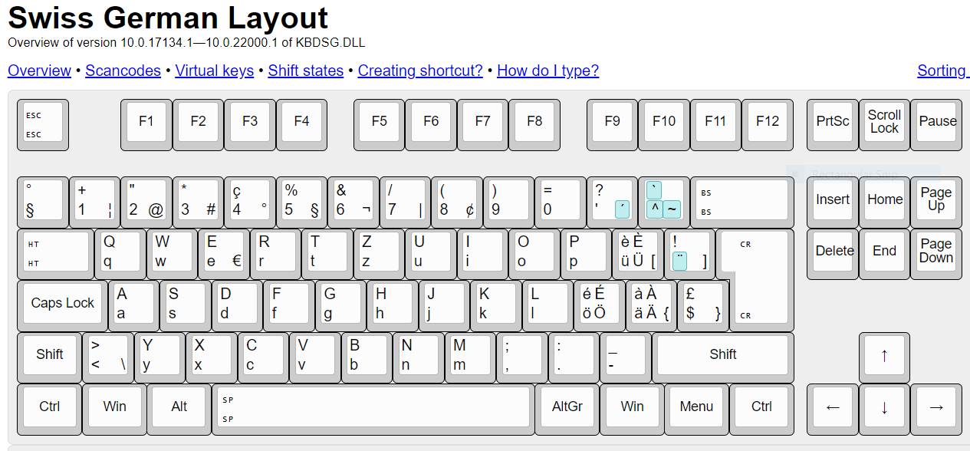

CCSID values defined on IBM i - IBM Documentation
This table lists the coded character set identifiers (CCSIDs) that are defined on the IBM® i operating system.
CCSID | Encoding | Description
00037 | 1100 | US, Canada, Netherlands, Portugal, Brazil, New Zealand, Australia
00256 | 1100 | Netherlands
00273 | 1100 | Austria, Germany
00277 | 1100 | Denmark, Norway
00278 | 1100 | Finland, Sweden
00280 | 1100 | Italy
00284 | 1100 | Spanish, Latin America
00285 | 1100 | United Kingdom

Top of Form

Configuring secondary languages - IBM Documentation
A secondary language consists of textual data for all licensed programs supported for a national language version.
When you install a secondary language, the textual data for licensed programs installed on your system is copied into the secondary language library. See the chapter called "Installing a Secondary Language" in the Software Installation PDF for instructions on installing secondary languages.
The program code is not included in the secondary language version.

Secondary language environments
Some multilingual environments have more than one national language version installed. To have a single system support multiple languages, you must have the associated hardware installed. You must also have sufficient disk storage space available to contain all of the system and application textual data for the secondary languages. The amount of disk storage space that is required varies by language and application, but it is typically somewhere in the range of 50 to 300 MB.
The languages currently supported on IBM i as either primary or secondary languages can be found in National Language Version (NLV) feature codes. Listed are the national language versions, their feature codes, and the program libraries from which they are available.
Each of the national language versions available from the program library (primary or secondary) include cultural- and language-dependent system values for that particular language. Date format, date and time separators, code page and character set, and keyboard types are examples. The system values are initially set to the cultural values of the primary language. By setting up a subsystem, however, you can ensure that the cultural values for the secondary languages are set properly for users of the secondary languages.
Applications can use language values that are available in message CPX8416, in file QCPFMSG, accessed using the library list. Message CPX8416 gives the correct values for the primary or secondary language, depending on the library list.
Except for logical partitioning (LPAR), when you use a multilingual environment, the primary language version and any secondary languages must be at the same release level. You must also order and install the correct devices (workstation controllers, display stations, and printers) to support your languages.
- Enabling the secondary language
You must ensure that secondary languages can be used after they have been installed on the system.
- Multilingual support
Multilingual support on the IBM i operating system is the support that includes more than one language on one system.

National language version feature codes - IBM Documentation
This table lists the available national language version feature codes on the IBM® i operating system. When you order an IBM i licensed program, you identify the national language version you want by specifying a language feature code.
National language version | Primary language feature code | Secondary language feature code
Albanian | 2995 | 5595
Arabic | 2954 | 5554
Belgian Dutch | 2963 | 5563
Belgian English | 2909 | 5509
Belgian French | 2966 | 5566
Brazilian Portuguese | 2980 | 5580
Bulgarian | 2974 | 5574
Canadian French | 2981 | 5581
Croatian | 2912 | 5512
Czech | 2975 | 5575
Danish | 2926 | 5526
Dutch Netherlands | 2923 | 5523
English | 2924 | 5524
English Uppercase Support for Double-Byte Character Set (DBCS) | 2938 | 5538
English Uppercase and Lowercase Support for Double-Byte Character Set (DBCS) | 2984 | 5584
Estonian | 2902 | 5502
Farsi | 2998 | 5598
Finnish | 2925 | 5525

Bottom of Form

RTPA supported languages (50) including support in the country native language
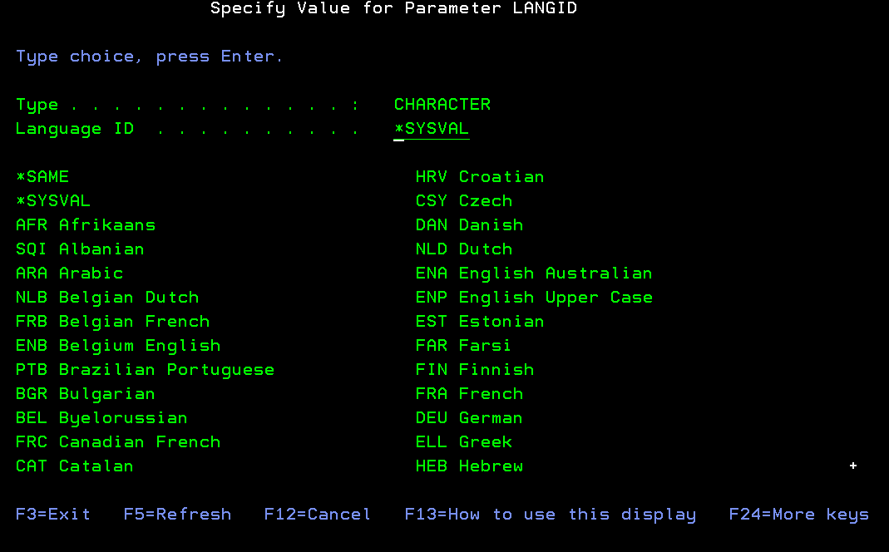
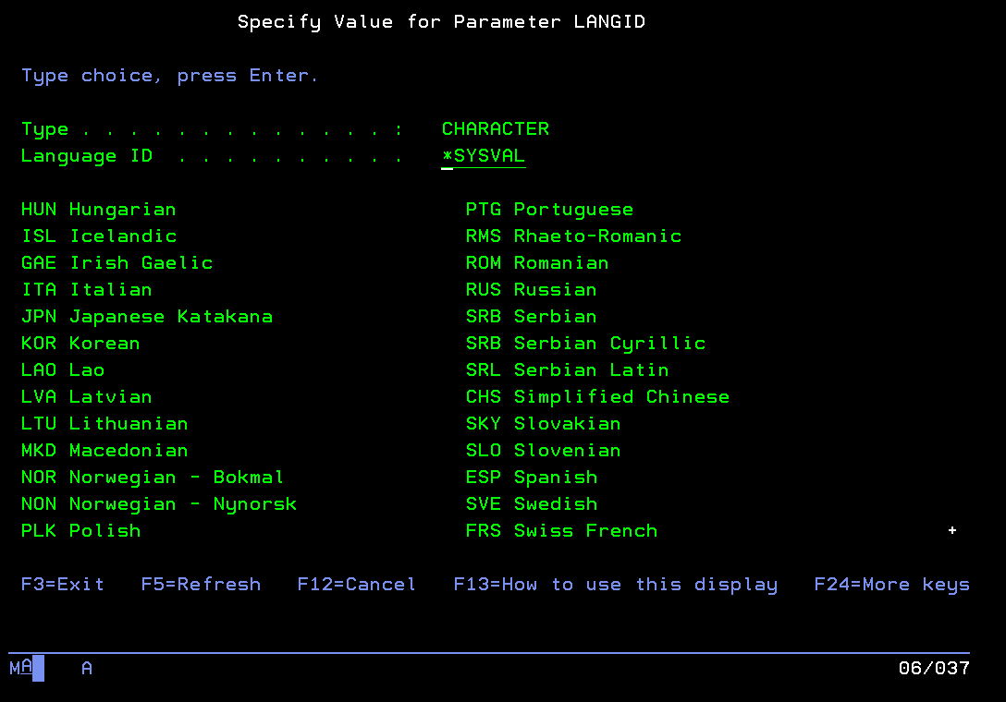
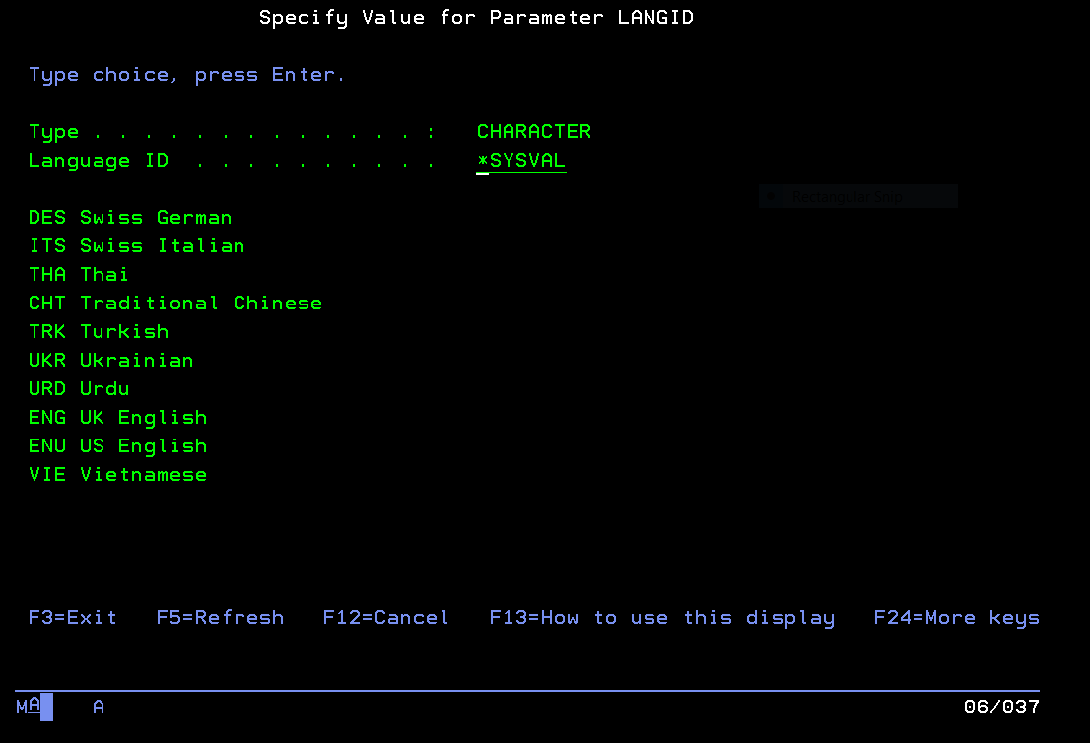

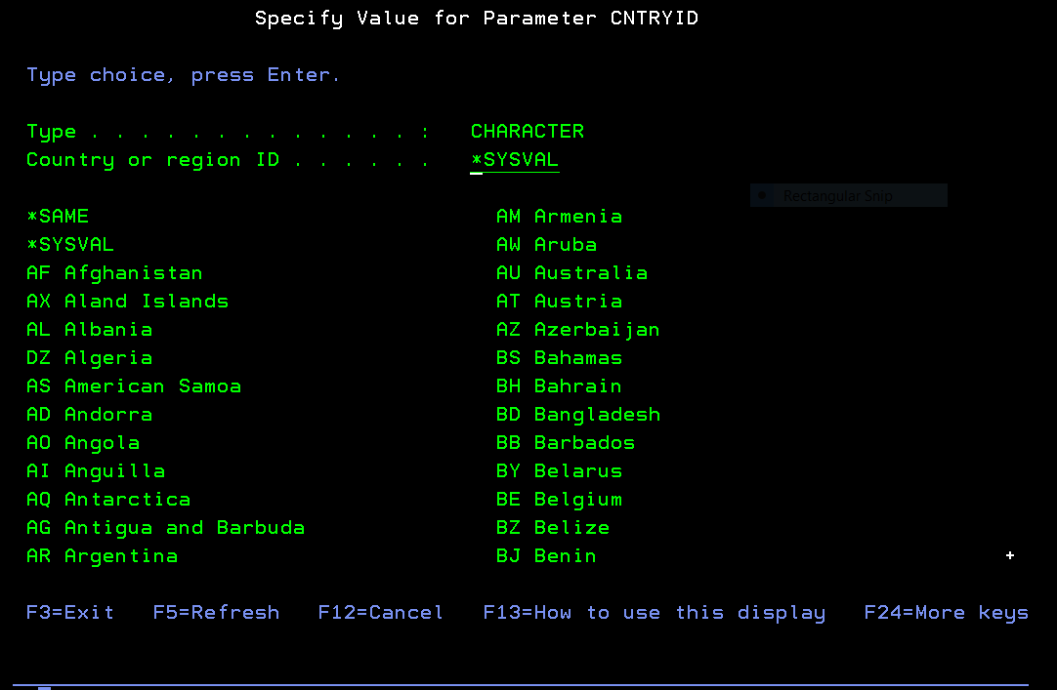
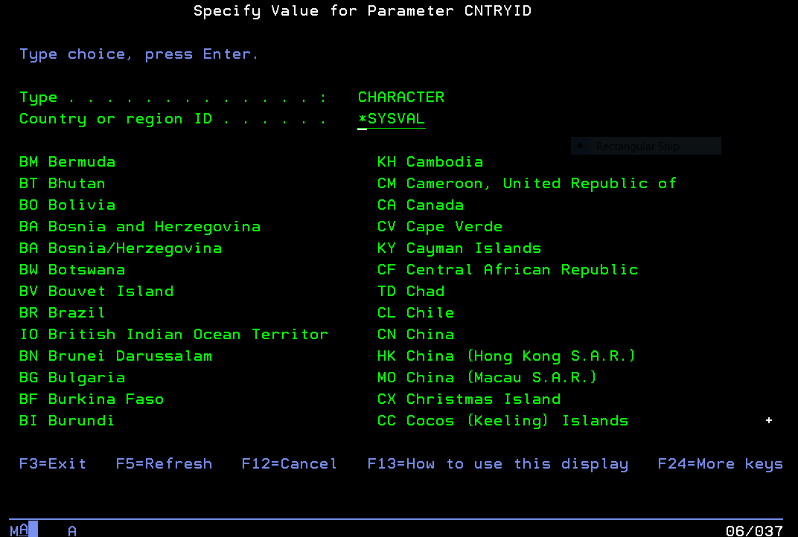
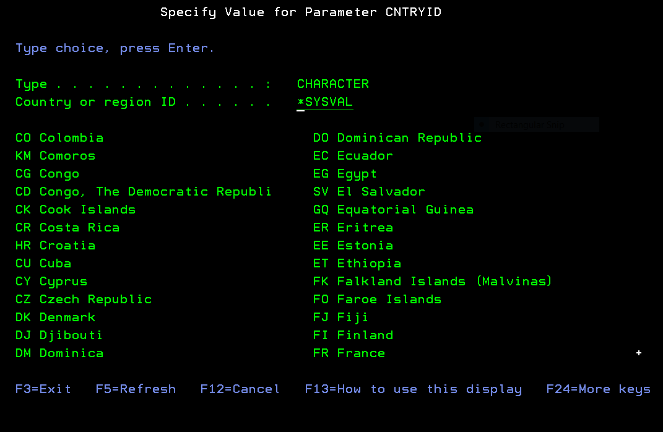
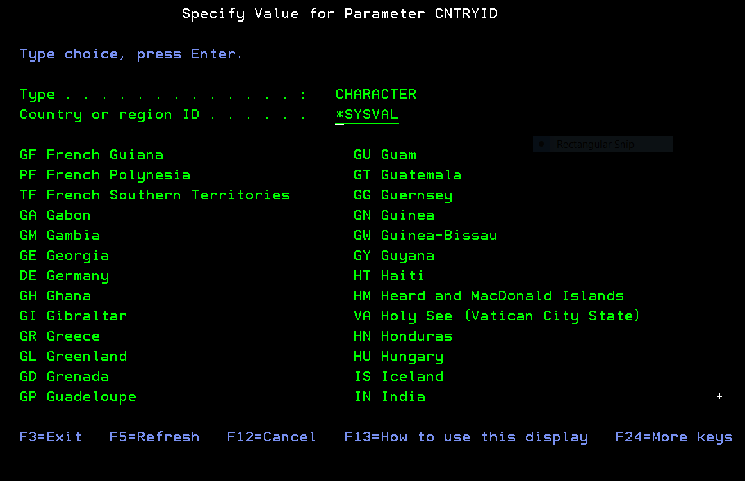
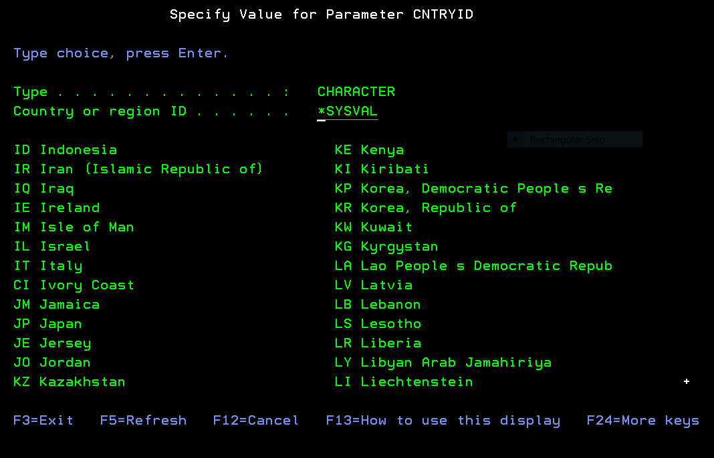
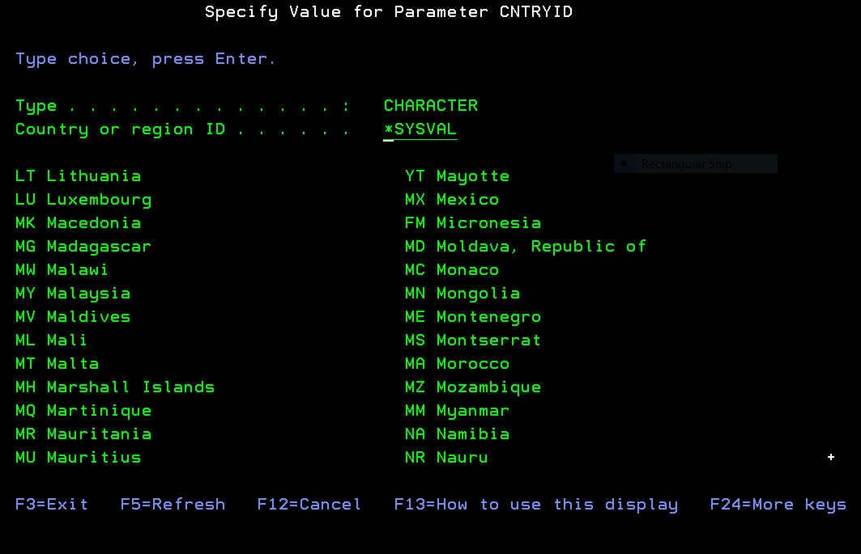
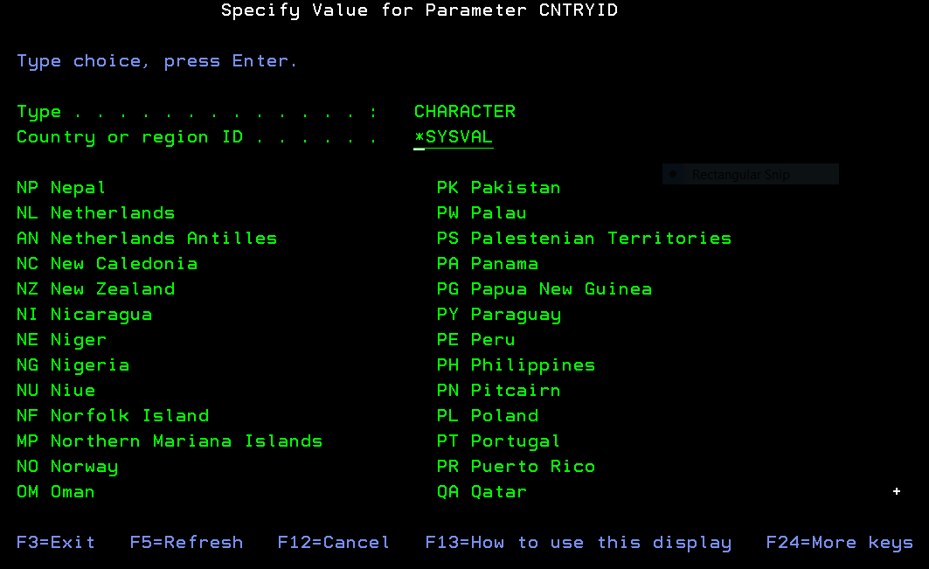
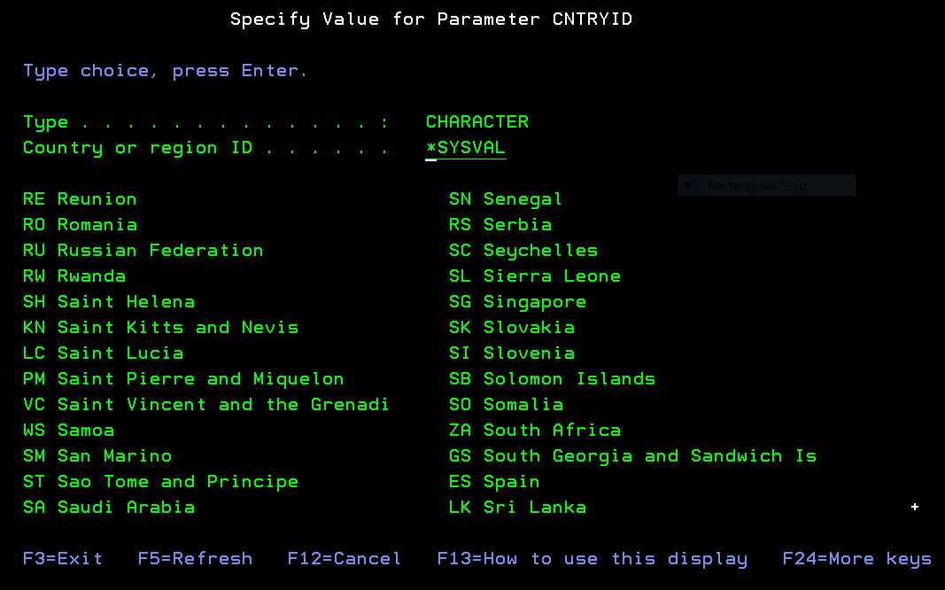
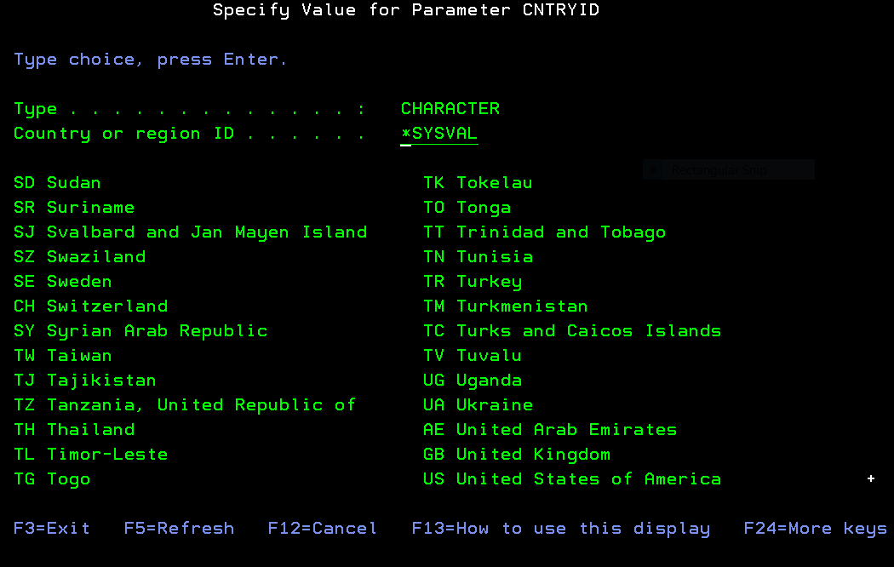
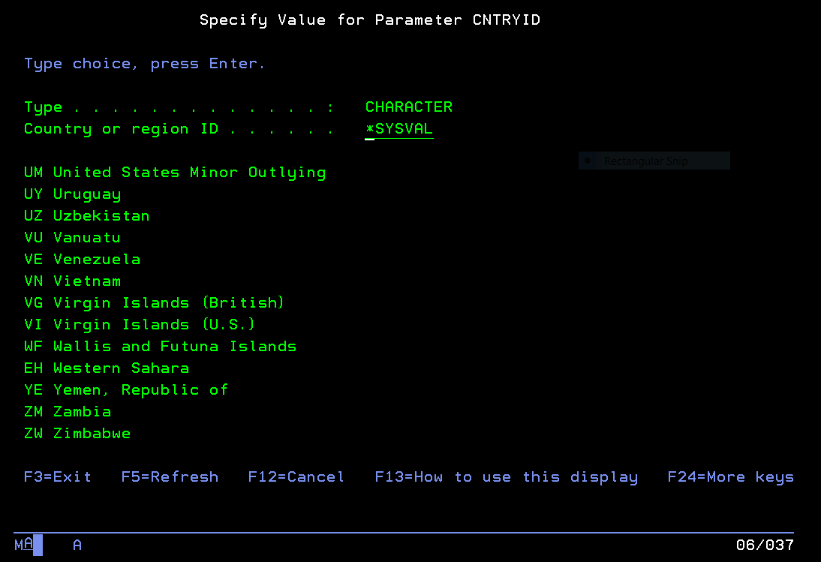

USA User Profile PHARKINS

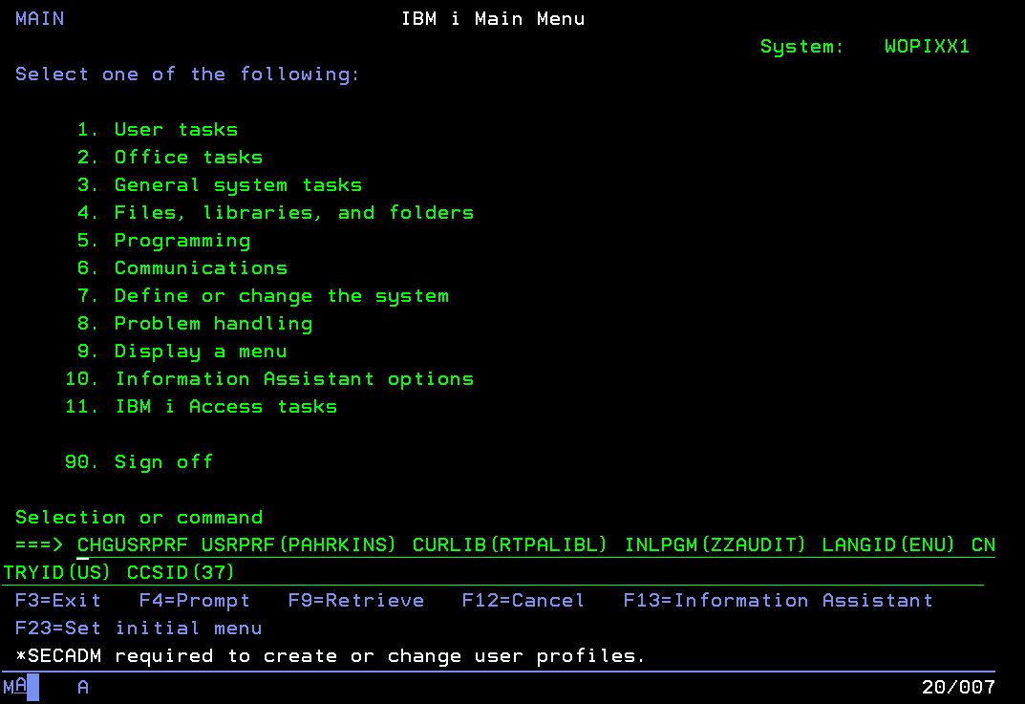

These are the IBM i secondary languages libraries downloaded from the IBM i optical drive.
For example: QSYS2929 library is the German language IBM i secondary language library used to display IBM messages in German.

Display Object Description - Basic
Library 1 of 1
Library . . . . . . . : QSYS Library ASP device . : *SYSBAS
Library ASP group . . : *SYSBAS

Type options, press Enter.
5=Display full attributes 8=Display service attributes

Opt Object Type Attribute Size Text
QSYS2925 *LIB PROD 2064384 Finnish LANGID FIN
QSYS2926 *LIB PROD 2064384 Danish LANGID DAN C
QSYS2928 *LIB PROD 2129920 French LANGID FRA cc
QSYS2929 *LIB PROD 2162688 German LANGID DEU C
QSYS2930 *LIB PROD 2129920
QSYS2931 *LIB PROD 2162688 Spanish LANGID ESP C
QSYS2932 *LIB PROD 2129920 Italian LANGID ITA
QSYS2933 *LIB PROD 2162688 Noregian LANGID NOR
QSYS2937 *LIB PROD 2129920 Swedish LANGID SVE
QSYS2938 *LIB PROD 2129920
QSYS2939 *LIB PROD 2129920
QSYS2940 *LIB PROD 2162688
More...
F3=Exit F12=Cancel F17=Top F18=Bottom

QSYS2929 *LIB PROD 2162688 German LANGID DEU C

IBM i secondary languages downloaded from the IBM i optical disk to provide native language IBM messages for IBM programs

Note – No IBM i secondary language libraries are needed to use RTPA (the primary IBM i language is used unless an IBM i secondary language is downloadd and put in the system library list (CHGSYSLIBL command)

Note – Customer users may use the same user profile as before when using RTPA, using the system values (*SYSVAL) parameters in their User profile

The RTPA libraries ZZAUDITE (before ZZAUDIT) and library ZZAUDIT would need to be added to the library list before the RTPA command would display the RTPA for RPG entry screen.

Alternately, the User profile could use an initial program RTPALIBS to add these RTPA libraries

Columns . . . : 1 71 Edit ZZAUDITS/QCLSRC
SEU==> RTPALIBS
FMT ** ...+... 1 ...+... 2 ...+... 3 ...+... 4 ...+... 5 ...+... 6 ...+... 7
*************** Beginning of data *************************************
0001.00 /*-------------------------------------------------------------------*/
0002.00 /* COPYRIGHT (C) 2016 BY HARKINS & ASSOCIATES, INC. ALL RIGHTS */
0003.00 /* RESERVED */
0004.00 /* V6R2M0 ENGLISH LANGUAGE ENG */
0005.00 /* DATE LAST CHANGED 02/27/19 */
0006.00 /* RTPALIBS ADD RTPA LIBRARIES TO THE LIBRARY LIST */
0007.00 /*-------------------------------------------------------------------*/
0008.00 PGM
0009.00 RMVLIBLE LIB(ZZAUDIT)
0010.00 MONMSG MSGID(CPF0000) EXEC(RCVMSG MSGTYPE(*LAST))
0011.00 RMVLIBLE LIB(ZZAUDITE)
0012.00 MONMSG MSGID(CPF0000) EXEC(RCVMSG MSGTYPE(*LAST))
0013.00 RMVLIBLE LIB(ZZAUDITC)
0014.00 MONMSG MSGID(CPF0000) EXEC(RCVMSG MSGTYPE(*LAST))
0015.00
0016.00 /* MAKE SURE QTEMP IS AT THE TOP */
0017.00 ADDLIBLE LIB(ZZAUDITE) POSITION(*AFTER QTEMP)
0018.00 ADDLIBLE LIB(ZZAUDITC) POSITION(*AFTER ZZAUDITE)
0019.00 ADDLIBLE LIB(ZZAUDIT) POSITION(*AFTER ZZAUDITC)
0020.00 ADDLIBLE LIB(QSQL)
0021.00 ADDLIBLE LIB(QDEVTOOLS)
0022.00
0023.00 ENDPGM: RETURN
0024.00 ENDPGM
0025.00 /*-------------------------------------------------------------------*/
****************** End of data ****************************************

RTPA initial program to user profile to add RTPA libraries ZZAUDITE and ZZAUDIT to the user library list

NOTE –
Library ZZAUDITE is the Expanded RTPA source and expanded object work library
Library ZZAUDIT is the RTPA distribution system library
Library ZZAUDITC is not replaced on new RTPA updates and is used for:
- RTPA User converted RPG3 to RPG4 source programs in file QRPGLESRC
- User created RTPA custom multilingual literal files to customize the RTPA display screens from English to the desired language (examples German if the Language ID is DEU or Italian if the Language code is ITA)
- User custom work

RTPA User Profile TESTSYSVAL illustrates using the system values when using RTPA, instead of coding them in each User profile.

NOTE- The User Profiles uses for RTPA can have Special authority of *JOBCTL or *NONE or *ALLOBJ

Special authority . . . . . . . *JOBCTL

Change User Profile (CHGUSRPRF)

Type choices, press Enter.

User profile . . . . . . . . . . > TESTSYSVAL Name
User password . . . . . . . . . *SAME Character value, *SAME, *NONE
Set password to expire . . . . *NO *SAME, *NO, *YES
Status . . . . . . . . . . . . . *ENABLED *SAME, *ENABLED, *DISABLED
User class . . . . . . . . . . . *USER *SAME, *USER, *SYSOPR...
Assistance level . . . . . . . . *SYSVAL *SAME, *SYSVAL, *BASIC...
Current library . . . . . . . . *CRTDFT Name, *SAME, *CRTDFT
Initial program to call . . . . RTPALIBS Name, *SAME, *NONE
Library . . . . . . . . . . . ZZAUDIT Name, *LIBL, *CURLIB
Initial menu . . . . . . . . . . MAIN Name, *SAME, *SIGNOFF
Library . . . . . . . . . . . *LIBL Name, *LIBL, *CURLIB
Limit capabilities . . . . . . . *NO *SAME, *NO, *PARTIAL, *YES
Text 'description' . . . . . . . 'TEST using all system values *SYSVAL'
Change User Profile (CHGUSRPRF)

Type choices, press Enter.

Additional Parameters

Special authority . . . . . . . *JOBCTL *SAME, *USRCLS, *NONE...
+ for more values
Special environment . . . . . . *SYSVAL *SAME, *SYSVAL, *NONE, *S36
Display sign-on information . . *SYSVAL *SAME, *NO, *YES, *SYSVAL
Password expiration interval . . *SYSVAL 1-366, *SAME, *SYSVAL, *NOMAX
Block password change . . . . . *SYSVAL 1-99, *SAME, *SYSVAL, *NONE
Local password management . . . *YES *SAME, *YES, *NO
Limit device sessions . . . . . *SYSVAL *SAME, *SYSVAL, *YES, *NO...
Keyboard buffering . . . . . . . *SYSVAL *SAME, *SYSVAL, *NO...
Maximum allowed storage large . *NOMAX
Maximum allowed storage . . . . *SAME Kilobytes, *SAME, *NOMAX
Highest schedule priority . . . 3 0-9, *SAME

Change User Profile (CHGUSRPRF)

Type choices, press Enter.

Job description . . . . . . . . QDFTJOBD Name, *SAME
Library . . . . . . . . . . . QGPL Name, *LIBL, *CURLIB
Group profile . . . . . . . . . *NONE Name, *SAME, *NONE
Owner . . . . . . . . . . . . . *USRPRF *SAME, *USRPRF, *GRPPRF
Group authority . . . . . . . . *NONE *SAME, *NONE, *ALL...
Group authority type . . . . . . *PRIVATE *PRIVATE, *PGP, *SAME
Supplemental groups . . . . . . *NONE Name, *SAME, *NONE
+ for more values
Accounting code . . . . . . . . *BLANK
Document password . . . . . . . *SAME Name, *SAME, *NONE
Message queue . . . . . . . . . TESTSYSVAL Name, *SAME, *USRPRF
Library . . . . . . . . . . . QUSRSYS Name, *LIBL, *CURLIB
Delivery . . . . . . . . . . . . *NOTIFY *SAME, *NOTIFY, *BREAK...
Severity code filter . . . . . . 0 0-99, *SAME
Print device . . . . . . . . . . *WRKSTN Name, *SAME, *WRKSTN, *SYSVAL

Change User Profile (CHGUSRPRF)

Type choices, press Enter.

Output queue . . . . . . . . . . *WRKSTN Name, *SAME, *WRKSTN, *DEV
Library . . . . . . . . . . . Name, *LIBL, *CURLIB
Attention program . . . . . . . *SYSVAL Name, *SAME, *SYSVAL...
Library . . . . . . . . . . . Name, *LIBL, *CURLIB
Sort sequence . . . . . . . . . *SYSVAL Name, *SAME, *SYSVAL, *HEX...
Library . . . . . . . . . . . Name, *LIBL, *CURLIB
Language ID . . . . . . . . . . *SYSVAL *SAME, *SYSVAL...
Country or region ID . . . . . . *SYSVAL *SAME, *SYSVAL...
Coded character set ID . . . . . *SYSVAL *SAME, *SYSVAL, *HEX...
Character identifier control . . *SYSVAL *SAME, *SYSVAL, *DEVD...
Locale job attributes . . . . . *SYSVAL *SAME, *SYSVAL, *NONE...
+ for more values
Locale . . . . . . . . . . . . . *SAME

User options . . . . . . . . . . *NONE *SAME, *NONE, *CLKWD...
+ for more values
More...
F3=Exit F4=Prompt F5=Refresh F12=Cancel F13=How to use this display
F24=More keys

Change User Profile (CHGUSRPRF)

Type choices, press Enter.

User ID number . . . . . . . . . 180 1-4294967294, *SAME
Group ID number . . . . . . . . *NONE 1-4294967294, *SAME, *GEN...
Home directory . . . . . . . . . *SAME

EIM association:
EIM identifier . . . . . . . . *NOCHG
Association type . . . . . . . *TARGET, *SOURCE, *TGTSRC...
Association action . . . . . . *REPLACE, *ADD, *REMOVE
Create EIM identifier . . . . *NOCRTEIMID, *CRTEIMID
User expiration date . . . . . . *NONE Date, *NONE, *USREXPITV...
User expiration interval . . . . 1-366

Bottom
F3=Exit F4=Prompt F5=Refresh F12=Cancel F13=How to use this display

RTPA User Profile TESTSYSVAL used the *SYSVAL default values in QSYSVAL for the CCSID, LANGID, and CNTRY ID.

Sign On
System . . . . . : LS053
Subsystem . . . . : QINTER
Display . . . . . : QPADEV0001

User . . . . . . . . . . . . . . TESTSYSVAL
Password . . . . . . . . . . . .
Program/procedure . . . . . . . .
Menu . . . . . . . . . . . . . .
Current library . . . . . . . . .

(C) COPYRIGHT IBM CORP. 1980, 2015.
RTPA User Profile TESTSYSVAL used the *SYSVAL default values in QSYSVAL for the CCSID, LANGID, and CNTRY ID.

MAIN IBM i Main Menu
System: LS053
Select one of the following:

1. User tasks
2. Office tasks

4. Files, libraries, and folders

6. Communications

8. Problem handling
9. Display a menu
10. Information Assistant options
11. IBM i Access tasks

90. Sign off

Selection or command
===> RTPA

F3=Exit F4=Prompt F9=Retrieve F12=Cancel F13=Information Assistant
F23=Set initial menu
(C) COPYRIGHT IBM CORP. 1980, 2015.

Enter RTPA
The TESTBASP CCSID and Language ID are retrived from the IBM i System Values, because the User Profile CCSID and Language ID in the user profile are *SYSVAL

ZZPGM01R Real-Time Program Audit for RPG (V7R1) Date 8/13/20
PHARKINS Select Program to Audit Time 11:59:13
RPG3 and RPG4 source members CCSID 37 Serial 2104FAW
Type choices, Press F10 Language ENU Model 42A
Source Member . . . . . . TESTBASP Name, generic*, *ALL, F4 for List
Source File . . . . . . . QRPGLESRC Name Date Format *MDY
Library . . . . . . . . ZZAUDIT Name Audit comments Y

Object to Library . . . . . . ZZAUDITE Name Audit copybooks Y

Audit Timestamp Y
Audit File Outq . . . . . . . *SAME Name, *SAME
Audit Procedures Y
JOBD for pgm compile libl . . *LIBL *LIBL, JOBD
Library . . . . . . . . Name Audit Variable contents A
A=All N=None V=F16 Var W=F2 Watch
Audit Compile Listing Stmts . to 1-99999 Audit to Disk N
(Only) to
to Document Only N
Project to
Ticket to Remote RTPA via FTP N
F2=Watch Variables F3=Exit F6=Auditing options F7=Compile Options
F8=Conditional Auditing F9=Maint. Menu F10=Submit Expand F12=Cancel
F18=RTPA history today F24=More Keys (C) Harkins & Associates, Inc.

The system values are CCSID 65565 and LANGID ENU

PHARKINS User Profile for USA CCSID 037

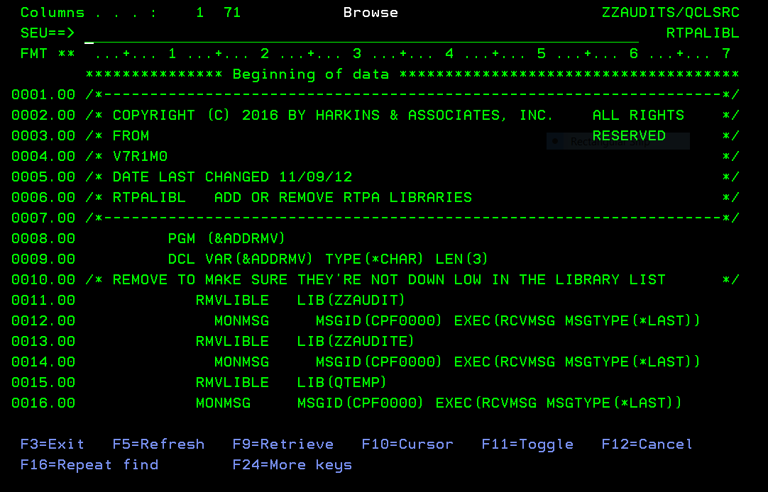

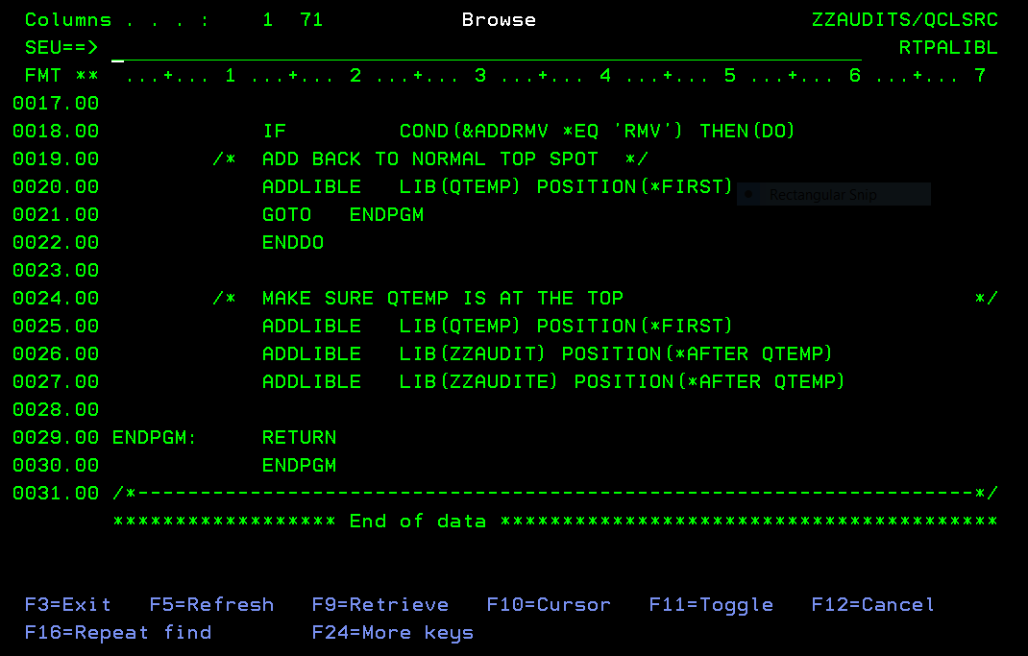

Using installed IBM i Secondary Languages

The following User Profiles may be used when multiple IBM i secondary languages are installed, in addition to the IBM i programming language, so that multiple IBM I language environments (eg GERMAN and ITALIAN) may be simultaneously processed by different users without changing the IBM i system values.
Change User Profile (CHGUSRPRF)

Type choices, press Enter.

User profile . . . . . . . . . . > GERMAN Name
User password . . . . . . . . . *SAME Character value, *SAME, *NONE
Set password to expired . . . . *NO *SAME, *NO, *YES
Status . . . . . . . . . . . . . *ENABLED *SAME, *ENABLED, *DISABLED
User class . . . . . . . . . . . *PGMR *SAME, *USER, *SYSOPR...
Assistance level . . . . . . . . *SYSVAL *SAME, *SYSVAL, *BASIC...
Current library . . . . . . . . *CRTDFT Name, *SAME, *CRTDFT
Initial program to call . . . . RTPALIBDEU Name, *SAME, *NONE
Library . . . . . . . . . . . ZZAUDIT Name, *LIBL, *CURLIB
Initial menu . . . . . . . . . . MAIN Name, *SAME, *SIGNOFF
Library . . . . . . . . . . . *LIBL Name, *LIBL, *CURLIB
Limit capabilities . . . . . . . *NO *SAME, *NO, *PARTIAL, *YES
Text 'description' . . . . . . . 'German language User Profile qsy2929 CCSID
273'

Additional Parameters

Special authority . . . . . . . *JOBCTL *SAME, *USRCLS, *NONE...
+ for more values
Special environment . . . . . . *SYSVAL *SAME, *SYSVAL, *NONE, *S36
Display sign-on information . . *SYSVAL *SAME, *NO, *YES, *SYSVAL
Password expiration interval . . *SYSVAL 1-366, *SAME, *SYSVAL, *NOMAX
Block password change . . . . . *SYSVAL 1-99, *SAME, *SYSVAL, *NONE
Local password management . . . *YES *SAME, *YES, *NO
Limit device sessions . . . . . *SYSVAL *SAME, *SYSVAL, *YES, *NO...
Keyboard buffering . . . . . . . *SYSVAL *SAME, *SYSVAL, *NO...
Maximum allowed storage large . *NOMAX
Maximum allowed storage . . . . *SAME Kilobytes, *SAME, *NOMAX
Highest schedule priority . . . 3 0-9, *SAME
Type choices, press Enter.

Job description . . . . . . . . QDFTJOBD Name, *SAME
Library . . . . . . . . . . . QGPL Name, *LIBL, *CURLIB
Group profile . . . . . . . . . *NONE Name, *SAME, *NONE
Owner . . . . . . . . . . . . . *USRPRF *SAME, *USRPRF, *GRPPRF
Group authority . . . . . . . . *NONE *SAME, *NONE, *ALL...
Group authority type . . . . . . *PRIVATE *PRIVATE, *PGP, *SAME
Supplemental groups . . . . . . *NONE Name, *SAME, *NONE
+ for more values
Accounting code . . . . . . . . *BLANK
Document password . . . . . . . *SAME Name, *SAME, *NONE
Message queue . . . . . . . . . GERMAN Name, *SAME, *USRPRF
Library . . . . . . . . . . . QUSRSYS Name, *LIBL, *CURLIB
Delivery . . . . . . . . . . . . *NOTIFY *SAME, *NOTIFY, *BREAK...
Severity code filter . . . . . . 0 0-99, *SAME
Print device . . . . . . . . . . *WRKSTN Name, *SAME, *WRKSTN, *SYSVAL
Type choices, press Enter.

Output queue . . . . . . . . . . RTPA Name, *SAME, *WRKSTN, *DEV
Library . . . . . . . . . . . QGPL Name, *LIBL, *CURLIB
Attention program . . . . . . . *SYSVAL Name, *SAME, *SYSVAL...
Library . . . . . . . . . . . Name, *LIBL, *CURLIB
Sort sequence . . . . . . . . . *SYSVAL Name, *SAME, *SYSVAL, *HEX...
Library . . . . . . . . . . . Name, *LIBL, *CURLIB
Language ID . . . . . . . . . . DEU *SAME, *SYSVAL...
Country or region ID . . . . . . DE *SAME, *SYSVAL...
Coded character set ID . . . . . 273 *SAME, *SYSVAL, *HEX...
Character identifier control . . *SYSVAL *SAME, *SYSVAL, *DEVD...
Locale job attributes . . . . . *SYSVAL *SAME, *SYSVAL, *NONE...
+ for more values
Locale . . . . . . . . . . . . . *SAME

User options . . . . . . . . . . *NONE *SAME, *NONE, *CLKWD...
+ for more values
More...
Type choices, press Enter.

User ID number . . . . . . . . . 107 1-4294967294, *SAME
Group ID number . . . . . . . . *NONE 1-4294967294, *SAME, *GEN...
Home directory . . . . . . . . . *SAME

EIM association:
EIM identifier . . . . . . . . *NOCHG
Association type . . . . . . . *TARGET, *SOURCE, *TGTSRC...
Association action . . . . . . *REPLACE, *ADD, *REMOVE
Create EIM identifier . . . . *NOCRTEIMID, *CRTEIMID
User expiration date . . . . . . *NONE Date, *NONE, *USREXPITV...
User expiration interval . . . . 1-366

GERMAN User Profile
Columns . . . : 1 71 Edit ZZAUDITS/QCLSRC
SEU==> RTPALIBDEU
FMT ** ...+... 1 ...+... 2 ...+... 3 ...+... 4 ...+... 5 ...+... 6 ...+... 7
*************** Beginning of data *************************************
0001.00 /*-------------------------------------------------------------------*/
0002.00 /* COPYRIGHT (C) 2016 BY HARKINS & ASSOCIATES, INC. ALL RIGHTS */
0003.00 /* RESERVED */
0004.00 /* V6R2M0 GERMAN LANGUAGE DEU QSYS2929 */
0005.00 /* DATE LAST CHANGED 11/30/18 */
0006.00 /* RTPALIBDEU ADD RTPA LIBRARIES TO THE LIBRARY LIST USER GERMAN */
0007.00 /*-------------------------------------------------------------------*/
0008.00 PGM
0009.00 RMVLIBLE LIB(ZZAUDIT)
0010.00 MONMSG MSGID(CPF0000) EXEC(RCVMSG MSGTYPE(*LAST))
0011.00 RMVLIBLE LIB(ZZAUDITE)
0012.00 MONMSG MSGID(CPF0000) EXEC(RCVMSG MSGTYPE(*LAST))
0013.00
0014.00 /* MAKE SURE QTEMP IS AT THE TOP */
0015.00 ADDLIBLE LIB(ZZAUDITE) POSITION(*AFTER QTEMP)
0017.00
0018.00 /* ADD QSYS2929 GERMAN DEU FOR GERMAN LANGUAGE */
0019.00 CHGSYSLIBL LIB(QSYS2929)
0020.00 MONMSG MSGID(CPF0000)
0021.00 /* ADD QDEVTOOLS QRPGLEMSG MSG FILE FOR PRIMARY LANGUAGE */
0022.00 ADDLIBLE LIB(QDEVTOOLS) POSITION(*LAST) /* QRPGLEMSG +
0023.00 RPGLE MESSAGE FILE in QDEVTOOLS */
0024.00 MONMSG MSGID(CPF0000)
0025.00 /* CHGJOB CCSID TO 273 FOR GERMAN LANGUAGE */
0026.00 /* CHGJOB DATE FORMAT TO *DMY */
0027.00 CHGJOB DATFMT(*DMY) LANGID(DEU) CNTRYID(DE) CCSID(273)
0028.00
0029.00 ENDPGM: RETURN
0030.00 ENDPGM
0031.00 /*-------------------------------------------------------------------*/
****************** End of data **************************************** 0016.00 ADDLIBLE LIB(ZZAUDIT) POSITION(*AFTER ZZAUDITE)

GERMAN User Profile initial program
GERMAN is date format *DMY

User GERMAN CCSID 273 DEU auditing of RPGLE batch program TESTBASP (procedures)

MAIN IBM i-Hauptmen}
System: LS053
Auswahlm¦glichkeiten:

1. Benutzeraufgaben
2. B}roaufgaben
3. Allgemeine Systemaufgaben
4. Dateien, Bibliotheken und Ordner
5. Programmierung
6. Datenfernverarbeitung
7. System definieren oder {ndern
8. Problembehandlung
9. Men} anzeigen
10. Unterst}tzende Informationen - Auswahlm¦glichkeiten
11. IBM i Access-Aufgaben

90. Abmelden

Auswahl oder Befehl
===> rtpa

F3=Verlassen F4=Bedienerf}hrung F9=Auffinden F12=Abbrechen
F13=Unterst}tzende Informationen F23=Anfangsmen} festlegen
(C) COPYRIGHT IBM CORP. 1980, 2015.

GERMAN User Signon
MAIN IBM i-Hauptmen}
System: LS053
Auswahlm¦glichkeiten:

1. Benutzeraufgaben
2. B}roaufgaben
3. Allgemeine Systemaufgaben
4. Dateien, Bibliotheken und Ordner
5. Programmierung
6. Datenfernverarbeitung
7. System definieren oder {ndern
8. Problembehandlung
9. Men} anzeigen
10. Unterst}tzende Informationen - Auswahlm¦glichkeiten
11. IBM i Access-Aufgaben

90. Abmelden

Auswahl oder Befehl
===> rtpa

F3=Verlassen F4=Bedienerf}hrung F9=Auffinden F12=Abbrechen
F13=Unterst}tzende Informationen F23=Anfangsmen} festlegen
(C) COPYRIGHT IBM CORP. 1980, 2015.

GERMAN User RTPA expansion of RPGLE source TESTBASP
ZZPGM01R Echzeit-Programmprufung fur RPG (V7R1) Datum 26/11/20
GERMAN Wahlen Sie das zu prufende Programm Zeit 15:31:43
RPG3- unt RPG4- Quellmitglieder CCSID 273 Serienumm 2104FAW
Geben Sie eine Auswahl ein und drucken Sie F10 Sprache DEU Modell 42A
Quellenteildatei . . . . . TESTBASP Name, generisch*, *ALL,F4 Liste
Quellendatei . . . . . . . QRPGLESRC Name Datumsformat *DMY
Bibliothek . . . . . . . ZZAUDIT Name Prufungskommentare Y

Objekt zur Bibliothek . . . . ZZAUDITE Name Audithefte Y
Prufzeitstempel Y
Audit-Datei Outq. . . . . . . *SAME Name, *SAME
Prufungsverfahren Y
JOBD fur pgm kompilieren libl *LIBL *LIBL, JOBD
Bibliothek . . . . . . . Name Pruf den Inhalt von var A
A=All N=Kein V=F16 Var. W=F2 Schen
to 1-99999 Auf Datentrager pr N
(Nur) to
to Nur Dokument N
Projekt to
Fahrkarte to Remote-RTPA uber FTP N
F2=Variablen beobachten F3=Ausfart F6=Prufungsoptionen F7=Optionen kompiliere
F8=Bedingte Prufung F9=Grose Menu F10=einreichen er F12=Stornieren
F18=RTPA-Geschichte heute F24=Weitere Schlussel (C) Harkins & Associates, Inc.
RTPA wird "wei besehen" ohne ausdruckliche oder stillschweigende Garantie vert

GERMAN User RTPA successful expansion of RPGLE source TESTBASIC

ZZPGM01R Echzeit-Programmprufung fur RPG (V7R1) Datum 13/08/20
GERMAN RTPA-Geschichte heute Zeit 12:06:17
German language User Profile qsy2929 CCSID 273 CCSID: 273
Gaben Sie die option ein und druken Sprache DEU
4= Loschen 5= Anzeigen Datumsformat *DMY

O Programm Status Programmname Job Datum Zeit
5 TESTBASP 8 EXPN OK TESTBAS basic with CALLP INIT 101324 13/08/20 12:06:09

F3=Ausfart F5=Aktualisierung F12=Stornieren F20=RTPA-Benutzer Geschic
F22=RTPA Analytics-Berich (C) HARKINS & ASSOCIATES, INC.

GERMAN User RTPA successful expansion of RPGLE source TESTBASP RTPA expansion details, date format *DMY

ZZPGM01R Echzeit-Programmprufung fur RPG (V7R1) Datum 13/08/20
GERMAN Wahlen Sie das zu prufende Programm Zeit 12:07:57
Projekt Fahrkarte *DMY CCSID 273 Sprache DEU
Programm TESTBASP TESTBAS basic with CALLP INIT Pruf den Inhalt vo A
Status 8 Erweitern Sie Pgm kompili Prufungskommentare Y Auf Datentrager pr N
Audithefte Y Nur Dokument N
Gaben Sie die option ein und druken Prufzeitstempel Y Remote RTPA-uber F N
5= Kompilierliste anzeigen Prufungsverfahren Y Variable verw 15
OPT-Jobnummer-Datensatze wurden ubermittel Abgeschlosse Abgelaufen Comp-Daten
Eingang 101324 70 13/08/20 12:06:09 13/08/20 12:06:10 1 70
Eingefug 101325 481 13/08/20 12:06:12 13/08/20 12:06:13 1
5 Erweiter 101327 551 13/08/20 12:06:14 13/08/20 12:06:15 1 575
Exp Obj lib ZZAUDITE Programm Objektgrose 397,312
Quelldati QRPGLESRC Erwei Datei QRPGLESRC Aufnahmeformat Hefte
Quelle Libl ZZAUDIT Erw Que Bib ZZAUDITE Druckerdateien *INZSR
RPG-Ausfuhr 4 RPGLE PrufungJOBQ RTPA Erweiterung 4 %parms
on Zu PrufungOUTQ Unterprogramm 1 /free Y
on Zu Prufung Bib *LIBL Uberlauf OG Einzug
on Zu JOBS-Biblio Prototyp/Verfa Y CTA N SDS
on Zu Maximale Seiten 15000 SDS Name SDS Qual
on Zu Variablen b DBCS 11 Start/Stop conditional N
8=Bedingte Prufung F13=Dateien/Auf F14=Felder F15=Operationen F16=Variablen
F2=Variablen beobachten F17=Etiketten F19=Genannt Pgm F21=Bedingte Betreisb
F3=Ausfart F22=Indikatoren F23=Vor Prufung (C) 2016 Harkins & Associates, Inc.

GERMAN User RTPA successful expansion of RPGLE source TESTBASP RTPA expansion details, date format *DMY

RTPA expansion took 3 elapsed seconds with no programmer intervention

Spool-Datei anzeigen
Spool-Datei anzeigen
Datei . . . . . : TESTBASP Seite/Zeile 1/1
Steuerung . . . . E Spalten 1 - 78
Suchen . . . . .
*...+....1....+....2....+....3....+....4....+....5....+....6....+....7....+...
5770WDS V7R3M0 160422 RN IBM ILE RPG ZZAUDITE/TESTBASP
Befehl . . . . . . . . . . . . . : CRTBNDRPG
Ausgegeben von . . . . . . . . : GERMAN
Programm . . . . . . . . . . . . : TESTBASP
Bibliothek . . . . . . . . . . : ZZAUDITE
Text 'Beschreibung' . . . . . . : TESTBAS basic with CALLP INIT
Quellenteildatei . . . . . . . . : TESTBASP
Quellendatei . . . . . . . . . . : QRPGLESRC
Bibliothek . . . . . . . . . . : ZZAUDITE
CCSID . . . . . . . . . . . . : 37
Text 'Beschreibung' . . . . . . :
Letzte ¢nderung . . . . . . . . : 08/13/20 12:06:13
Generierungsbewertungsstufe . . : 10
Standardaktivierungsgruppe . . . : *NO
Umwandlungsprogrammauswahlm¦gl. : *NOXREF *GEN *NOSECLVL *NOSHO
*NOEXPDDS *EXT *NOSHOWSKP *NOSRC
Weitere ...
F3=Verlassen F12=Abbrechen F19=Links F20=Rechts F24=Weitere Tasten

RTPA expansion compile listing of TESTBASP in German
E to display bottom of compile (E for ENDE not B for BOTTOM)

Spool-Datei anzeigen
Datei . . . . . : TESTBASP Seite/Zeile 18/3
Steuerung . . . . E Spalten 1 - 78
Suchen . . . . .
*...+....1....+....2....+....3....+....4....+....5....+....6....+....7....+...
E n d z u s a m m e n f a s s u n g
Nachrichten}bersicht:
Information (00) . . . . . . . : 12
Warnung (10) . . . . . . . . . : 0
Fehler (20) . . . . . . . . . . : 0
Schwerwiegender Fehler (30+) . : 0
--------------------------------- -------
Summe . . . . . . . . . . . . . : 12
Quellens{tze insgesamt:
S{tze . . . . . . . . . . . . . : 575
Bestimmungen . . . . . . . . . : 545
Datens{tze . . . . . . . . . . : 0
Bemerkungen . . . . . . . . . . : 10
* * * * * E N D E D E R E N D Z U S A M M E N F A S S U N G * * * * *
Programm TESTBASP in Bibliothek ZZAUDITE gestellt. H¦chste Bewertungsstufe ist
* * * * * E N D E D E R U M S E T Z U N G * * * * *
Ende
F3=Verlassen F12=Abbrechen F19=Links F20=Rechts F24=Weitere Tasten

GERMAN User RTPA successful expansion of RPGLE source TESTBASP RTPA input program compile listing (in German)

Execute RPGLE program TESTBASP with RTPA audits

CALL TESTBASP

WRKSPLF to display RTPA real-time udits of batch program TESTBASP
Mit allen Spool-Dateien arbeiten

Auswahl eingeben und Eingabetaste dr}cken.
1=Senden 2=¢ndern 3=Anhalten 4=L¦schen 5=Anzeigen 6=Freigeben
7=Nachrichten 8=Attribute 9=Mit Druckstatus arbeiten

Einheit Seiten Akt.
Opt Datei Benutzer Warteschl. Ben.-Daten Stat gesamt Seite Kop.
TESTBASP GERMAN RTPA RDY 8 1
TESTBASP GERMAN RTPA RDY 18 1
5 ZZAUDITP GERMAN RTPA TESTBASP HLD 2 1

Ende
Parameter f}r Auswahl 1, 2, 3 oder Befehl
===>
F3=Verl. F10=Sicht 4 F11=Sicht2 F12=Abbrechen F22=Drucker
F24=Weit. Tasten

GERMAN User RTPA successful real-time auditing of RPGLE source TESTBASP in RTPA audit file ZZAUDITP

Spool-Datei anzeigen
Datei . . . . . : ZZAUDITP Seite/Zeile 1/1
Steuerung . . . . Spalten 1 - 78
Suchen . . . . .
*...+....1....+....2....+....3....+....4....+....5....+....6....+....7....+...
Program-TESTBASP TESTBAS basic with CALLP INIT Obj Lib
TESTBASP TESTBASP
Job: 101323 User Profile: GERMAN Source Type: RPGLE
Line
12 C MOVEL 'AAAAAAAA' CHECKP 8
AAAAAAAA
13 C MOVEL 'BBBB' HOLDP 4
BBBB
14 c movel 'pppppppp' hold8
pppppppp
15 c movel 'aaaaaaaaa' hold9
aaaaaaaaa
16 c movel '111' intdta
111
17 C MOVEL 'DDDD' HOLDD 4
DDDD

=========== Window 205 to see timestamp of each executing statatement
Spool-Datei anzeigen
Datei . . . . . : ZZAUDITP Seite/Zeile 1/1
Steuerung . . . . F205 Spalten 205 - 280
Suchen . . . . .
+....1....+....2....+....3....+....4....+....5....+....6....+....7....+....8
RPGLE 101323 GERMAN TESTBASP 2020-08-13 12.22.18.137
RPGLE 101323 GERMAN TESTBASP 2020-08-13 12.22.18.137
RPGLE 101323 GERMAN TESTBASP 2020-08-13 12.22.18.137
RPGLE 101323 GERMAN TESTBASP 2020-08-13 12.22.18.137
MOVEL RPGLE 101323 GERMAN TESTBASP 2020-08-13 12.22.18.138
RPGLE 101323 GERMAN TESTBASP 2020-08-13 12.22.18.138
MOVEL RPGLE 101323 GERMAN TESTBASP 2020-08-13 12.22.18.138
RPGLE 101323 GERMAN TESTBASP 2020-08-13 12.22.18.138
MOVEL RPGLE 101323 GERMAN TESTBASP 2020-08-13 12.22.18.138
RPGLE 101323 GERMAN TESTBASP 2020-08-13 12.22.18.138
MOVEL RPGLE 101323 GERMAN TESTBASP 2020-08-13 12.22.18.138
RPGLE 101323 GERMAN TESTBASP 2020-08-13 12.22.18.138
MOVEL RPGLE 101323 GERMAN TESTBASP 2020-08-13 12.22.18.145
RPGLE 101323 GERMAN TESTBASP 2020-08-13 12.22.18.145
MOVEL RPGLE 101323 GERMAN TESTBASP 2020-08-13 12.22.18.145
RPGLE 101323 GERMAN TESTBASP 2020-08-13 12.22.18.145

18 C MOVEL 'AAAAAAAA' CHECK8 8
AAAAAAAA
19 C Z-ADD 5 FIRST 2 0
5
20 C EVAL HOLD7 = '6666666'
6666666
21 C MOVEL 'BBBB' HOLDB 4
BBBB
22 C CHECK8 IFEQ 'AAAAAAAA'
AAAAAAAA
23 C holdb andeq 'BBBB'
BBBB
24 C movel 'CCCC' holdr 4
CCCC
25 C endif
26 C MOVEL 'DDDD' HOLDD 4
DDDD
27 C MOVEL 'EEEE' HOLDE 4
EEEE
29 if check8 = 'AAAAAAAA' and holdb = 'BBBB';
AAAAAAAA BBBB
30 holdr = 'CCCC';
CCCC
31 endif;
32 holdd = 'DDDD';
DDDD
34 * call a procedure in fixed format
35 c callp longproc Call-
52 plongproc b
53 * comment in a prototyped call longproc
54 C EVAL HOLD7 = '6666666'
6666666
55 C CHECKP IFEQ 'AAAAAAAA'
AAAAAAAA
56 C holdP andeq 'BBBB'
BBBB
57 C movel 'CCCC' holdr
CCCC
58 C endif
59 C MOVEL 'DDDD' HOLDD
DDDD
60 plongproc e
36 C Z-ADD 10 SECOND 2 0
10
38 eval hold7 = 'fffffff';
fffffff
39 // call a procedure in free format
40 callp freeproc(); Call-
61 pfreeproc b
63 // free form comment in a procedure
64 eval hold9 = 'hhhhhhhhh';
hhhhhhhhh
65 if checkp = 'AAAAAAAA' and holdp = 'BBBB';
AAAAAAAA BBBB
66 holdr = 'CCCC';
CCCC
67 endif;
68 holdd = 'DDDD';
DDDD
70 pfreeproc e
41 holdd = 'XXXX';
XXXX
42 holde = 'FFFF';
FFFF
44 c movel 'ccccccc' hold7 7
ccccccc
45 C exsr shipto
49 C shipto begsr
50 C z-add 20 value 5 0
20
51 C endsr
46 * end program
47 C move '1' *inlr
1
48 C RETURN

GERMAN User RTPA real-time auditing of RPGLE program TESTBASP procedures

User PHARKINS CCSID 37 USA auditing of RPGLE interactive program NEWEXPSH

Programmer Menu
System: LS053
Select one of the following:
1. Start Data File Utility
2. Work with Queries
3. Create an object from a source file object name, type, pgm for CMD
4. Call a program program name
5. Run a command command
6. Submit a job (job name), , ,(command)
7. Go to a menu menu name
8. Edit a source file member (srcmbr), (type)
9. Design display format using SDA (srcmbr), ,(mode)
90. Sign off (*nolist, *list)

Selection . . . . . 5 Parm . . . .
Type . . . . . . . Parm 2 . . .
Command . . . . . . rtpa

Source file . . . . Source library . . . . . . . *LIBL
Object library . . Job description . . . . . . *USRPRF

F3=Exit F4=Prompt F6=Display messages F10=Command entry
F12=Cancel F14=Work with submitted jobs F18=Work with output

PHARKINS (USA User Profile) RTPA entry screen date format *MDY

ZZPGM01R Real-Time Program Audit for RPG (V7R1) Date 8/13/20
PHARKINS Select Program to Audit Time 15:35:31
RPG3 and RPG4 source members CCSID 37 Serial 2104FAW
Type choices, Press F10 Language ENU Model 42A
Source Member . . . . . . NEWEXPSH Name, generic*, *ALL, F4 for List
Source File . . . . . . . QRPGLESRC Name Date Format *MDY
Library . . . . . . . . ZZAUDIT Name Audit comments Y

Object to Library . . . . . . ZZAUDITE Name Audit copybooks Y

Audit Timestamp Y
Audit File Outq . . . . . . . *SAME Name, *SAME
Audit Procedures Y
JOBD for pgm compile libl . . *LIBL *LIBL, JOBD
Library . . . . . . . . Name Audit Variable contents A
A=All N=None V=F16 Var W=F2 Watch
Audit Compile Listing Stmts . to 1-99999 Audit to Disk N
(Only) to
to Document Only N
Project to
Ticket to Remote RTPA via FTP N
F2=Watch Variables F3=Exit F6=Auditing options F7=Compile Options
F8=Conditional Auditing F9=Maint. Menu F10=Submit Expand F12=Cancel
F18=RTPA history today F24=More Keys (C) Harkins & Associates, Inc.

RTPA expand RPGLE interactive source program NEWEXPSH with audits
ZZPGM01R Real-Time Program Audit for RPG (V7R1) Date 8/13/20
PHARKINS RTPA history today Time 15:37:39
Paul Harkins RTPA user profile CCSID: 37
Type option, press Enter Language ENU
4=Delete 5=Display Date Format *MDY

O Program Status Program Name Job Date Time
5 NEWEXPSH 8 EXPN OK New Expected Ship Date from Or 101355 8/13/20 15:37:20

F3=Exit F5=Refresh F12=Cancel F20=RTPA User history
F22=RTPA Analytics Report (C) HARKINS & ASSOCIATES, INC.

RTPA expand RPGLE interactive source program NEWEXPSH with audits

ZZPGM01R Real-Time Program Audit for RPG (V7R1) Date 8/13/20
PHARKINS Select Program to Audit Time 15:38:18
Project Ticket *MDY CCSID 37 Language ENU
Program NEWEXPSH New Expected Ship Date from Order Deta Audit Variable con A
Status 8 Expand Pgm compiled OK Audit comments Y Audit to Disk N
Audit copybooks Y Document Only N
Type option, press Enter Audit Timestamp Y Remote RTPA FTP N
5=Display compile listing Audit Procedures Y Variable used 220
OPT Job Records Submitted Completed Elapsed Comp recds
Input 101355 1,186 8/13/20 15:37:20 8/13/20 15:37:21 1 1,333
Inserted 101356 5,509 8/13/20 15:37:25 8/13/20 15:37:31 6
Expanded 101358 6,695 8/13/20 15:37:32 8/13/20 15:37:38 6 6,670
Exp Obj lib ZZAUDITE Program Object size 4,587,520
Source File QRPGLESRC Expand File QRPGLESRC Record formats 7 copybooks Y
Source Libl ZZAUDIT Exp Src lib ZZAUDITE Printer files 2 *INZSR Y
RPG Version 4 RPGLE Audit JOBQ RTPA Extension %parms
From To Audit outq Subroutines 9 /free Y
From To Audit Libr. *LIBL Overflow OE Indent
From To JOBD Libr. Protoype/Proc. N CTA Y SDS Y
From To Maximum Pages 15000 SDS Name QXXDS SDS Qual
From To Watch varia DBCS J 291 Start/Stop conditional N
F8=Conditional Auditing F13=Files/Recd F14=Fields F15=Operations F16=Variables
F2=Watch Variables F17=Labels F19=Called Pgm F21=Cond Oper

RTPA expand RPGLE interactive source program NEWEXPSH with audits

Input RPGLE source has 1,186 statements
RTPA inserted 5,509 suditing ststements to audit all executable statements
RTPA audits the contents of all 220 variables processed in the program
RTPA sudits all program comments, copybooks, subroutines, procedures
RTPA takes only seconds to expand the input source program, wiout programmer intervention

Execite the program normally

Call ZZTESTIN (CLP ZZTEST1N calls RPLGE program NEWEXPSH

NEWEXPSH Order Inquiry of expected Ship Date 8/13/20 15:39:19

Customer 1000 ABC STORES STORE #522 Store 522

Order Number 1500

Line Number 1

Expected Ship Date 9/27/20

F3=Exit Enter=Change expected ship date
3

RTPA is real-time auditing the execution of RPGLE NEWEXPSH from the expanded NEWEXPSH object program in ZZAUDITE to RTPA audit file ZZAUDITP

Press shift and escape and key 3 to interrupt NEWEXPSH execution and display job

Display Job
System: LS053
Job: QPADEV0001 User: PHARKINS Number: 101340

Select one of the following:

1. Display job status attributes
2. Display job definition attributes
3. Display job run attributes, if active
4. Display spooled files

10. Display job log, if active, on job queue, or pending
11. Display call stack, if active
12. Display locks, if active
13. Display library list, if active
14. Display open files, if active
15. Display file overrides, if active
16. Display commitment control status, if active
More...
Selection
4

F3=Exit F12=Cancel

4 to display spooled files for the job including RTPA file ZZAUDITP

Work with All Spooled Files

Type options, press Enter.
1=Send 2=Change 3=Hold 4=Delete 5=Display 6=Release 7=Messages
8=Attributes 9=Work with printing status

Device or Total Cur
Opt File User Queue User Data Sts Pages Page Copy
NEWEXPSH PHARKINS RTPA RDY 44 1
NEWEXPSH PHARKINS RTPA RDY 170 1
QPRINT2 PHARKINS QPRINT2 NEWEXPSH OPN 0 1
PRTORDER PHARKINS RTPA NEWEXPSH OPN 0 1
5 ZZAUDITP PHARKINS RTPA NEWEXPSH HLD 7 1

Bottom
Parameters for options 1, 2, 3 or command
===>
F3=Exit F10=View 4 F11=View 2 F12=Cancel F22=Printers F24=More keys

RTPA audit file ZZAUDITP contains 7 pages of RTPA audits in real-time for this NEWEXPSH program

Display Spooled File
File . . . . . : ZZAUDITP Page/Line 1/1
Control . . . . . Columns 1 - 78
Find . . . . . .
*...+....1....+....2....+....3....+....4....+....5....+....6....+....7....+...
Program-NEWEXPSH New Expected Ship Date from Order Detail RPGIV Obj Lib
NEWEXPSH NEWEXPSH
Job: 101354 User Profile: PHARKINS Source Type: RPGLE
Line
1177 C *INZSR BEGSR
1178 * initialize fields and arrays
1179 C MOVEL *BLANKS MOVSW 1

1180 C Z-ADD 12 ZZD
12121212121212121212121212
1181 C MOVEA *ZERO ZZD2
00000000000000000000000000000
1182 C MOVEA 1111 ZZD3
11110000000000000000000000000
1183 C MOVEL '88888888' ZZA
1184 C ENDSR
280 * CUSTOMER MASTER KEY
284 *
285 * RECEIVE PARAMETERS PASSED FROM CALLING PROGRAM
286 C *ENTRY PLIST
287 C PARM PARMIN 44
000150000001
288 *
289 * INPUT DATA AREA TSTDTA
291 C IN TSTDTA
TSTDTA 1 'ABCDEFGHIJKLMNOPQRSTUVWZYZ012345 BB
292 *
293 C TIME TIMES 6 0
153918
294 * MOVE INPUT PARM INTO FOUR PARM FIELDS IN DS
295 C MOVEL PARMIN PARMRE
000150000001
296 C Movel Rptid Progid
NEWEXPSH
297 C Movel Rptdesc Progde
Open Order Detail Report by O
298 C Movel Rpthead Headde
Customer Name Cust
299 * start free form
301 // now in free form RPG
302 torder = 1500;
1500
303 iorder = 78.543;
78.543
304 // value of iorder has now been computed
305 xorder = torder + 13.45 +
1618.19 1500 306 // this is a continuation free form statement preceeded with +
307 26.2 + iorder;
78.543
308 sorder = torder + xorder + iorder + rorder + morder + norder;
93330.496 1500
1618.19 78.543
32109.876
34567.098
23456.789
309 // end of free form
311 * resume fixed format calc statements
312 c eval rorder = iorder +98
176.543
78.543
313 * add 30 days to startLdate to get endLdate
314 c startLdate adddur 30:*days endLdate 1998-12-18 1999-01-17
315 * add 1 month to endLdate
316 c adddur 1:*months endLdate
1999-02-17
317 * extract day number from date
318 c extrct endLdate:*D dayno 2 0
1999-02-17
17
319 * extract month number from date
320 c extrct endLdate:*M MonthLno 2 0
1999-02-17
2
321 * extract year number from date
322 c extrct endLdate:*Y YearLno 4 0
1999-02-17
1999 323 * add 1 year to startLdate
324 c employLdat adddur 1:*years annivLdat
12/29/1992 12/29/1993
325 * add 3 hours, 22 minutes and 50 seconds to midnight
326 c T'00.00.00' adddur 3:*hours endLtime
03:00:00
327 c adddur 22:*minutes endLtime
03:22:00
328 c adddur 50:*seconds endLtime
03:22:50
329 * add 100 milliseconds to a time stamp (26 character date and time)
330 c adddur 100:*ms totalLtime
0001-01-01-00.00.00.000100
331 C Z-ADD 14.25 TESD 12 3
14.250
332 C Z-ADD *zero LocatTotal 323 * add 1 year to startLdate
324 c employLdat adddur 1:*years annivLdat
12/29/1992 12/29/1993
325 * add 3 hours, 22 minutes and 50 seconds to midnight
326 c T'00.00.00' adddur 3:*hours endLtime
03:00:00
327 c adddur 22:*minutes endLtime
03:22:00
328 c adddur 50:*seconds endLtime
03:22:50
329 * add 100 milliseconds to a time stamp (26 character date and time)
330 c adddur 100:*ms totalLtime
0001-01-01-00.00.00.000100
331 C Z-ADD 14.25 TESD 12 3
14.250
332 C Z-ADD *zero LocatTotal 00000000000000000000000000000
333 *
334 * MOVE INPUT ORDER AND LINE TO KORDER AND LINE (KEYED)
335 C Z-ADD PORDER KORDER
1500
1500
336 C Z-ADD PLINE KLINE
1
1
337 *----------------------------------------------------------------
338 * DISPLAY HEADING SCREEN
339 *----------------------------------------------------------------
340 C DISP01 TAG
341 * CLEAR EXPECTED SHIP DATE AND ERROR CODE
342 C Z-ADD *ZERO PEXPSH
0
343 C MOVEL *BLANKS PERROR

344 C Z-ADD *ZEROS KCUSNO
0
345 C Z-ADD *ZEROS KSTORE
0
346 C MOVEL *BLANKS KCUSNA

347 C Z-ADD *ZERO EXPMDY
0
348 C TIME TIMEN 6 0
153918
349 C EXFMT NEWEXPD1

*IN03-0 *IN42-0 KORDER-0001500 KLINE-00001 UDATE-081320 TIMEN-153918
349 C EXFMT NEWEXPD1 *IN03-0 *IN42-0 KORDER-0001500 KLINE-00001 UDATE-081320 TIMEN-153918
350 * TEST F3
351 C *IN03 CABEQ *ON DONE
0
352 *
353 * VALIDATE ORDER AND LINE
354 * GET ORDER DETAIL RECORD FOR ORDER AND LINE
355 C Z-ADD KORDER OORDER
1500
1500
356 C Z-ADD KLINE OLINE
1
1
357 C SETOFF 42
358 * NO INDICATOR USED ON CHAIN chain by file name, not record name 359 * AUDIT RPGIV CHAIN STATEMENT (NO ERROR INDICATOR)
360 C ordkey chain orderde
000150000001
ODORD-0000000 ODLINE-00000 ODCUST-0000000 ODSTOR-0000000 ODITEM- ODP
ODTYPE-
361 C if not%found
364 C END
365 *---------------------------------------------------------------------
366 *
367 * DID GET ORDER DETAIL RECORD
368 * CONVERT ODEXPD FORMAT YYYYMMDD TO PEXPSH FORMAT MMDDYY
369 C odexpd ifne *zero
20200327
370 C z-add odexpd expmd 4 0
20200327
327
== Window 205 of 280 character ZZAUDITP record for timestamp ============
Display Spooled File
File . . . . . : ZZAUDITP Page/Line 2/57
Control . . . . . W205 Columns 205 - 280
Find . . . . . .
+....1....+....2....+....3....+....4....+....5....+....6....+....7....+....8
comment RPGLE 101354 PHARKINS NEWEXPSH 2020-08-13 15.39.19.776
CHAIN RPGLE 101354 PHARKINS NEWEXPSH 2020-08-13 15.39.19.776
RPGLE 101354 PHARKINS NEWEXPSH 2020-08-13 15.39.19.776
RPGLE 101354 PHARKINS NEWEXPSH 2020-08-13 15.39.19.776
RPGLE 101354 PHARKINS NEWEXPSH 2020-08-13 15.39.19.776
RPGLE 101354 PHARKINS NEWEXPSH 2020-08-13 15.39.19.777
END RPGLE 101354 PHARKINS NEWEXPSH 2020-08-13 15.39.19.777
comment RPGLE 101354 PHARKINS NEWEXPSH 2020-08-13 15.39.19.777
comment RPGLE 101354 PHARKINS NEWEXPSH 2020-08-13 15.39.19.777
comment RPGLE 101354 PHARKINS NEWEXPSH 2020-08-13 15.39.19.777
comment RPGLE 101354 PHARKINS NEWEXPSH 2020-08-13 15.39.19.778
RPGLE 101354 PHARKINS NEWEXPSH 2020-08-13 15.39.19.778
RPGLE 101354 PHARKINS NEWEXPSH 2020-08-13 15.39.19.778
Z-ADD RPGLE 101354 PHARKINS NEWEXPSH 2020-08-13 15.39.19.778
RPGLE 101354 PHARKINS NEWEXPSH 2020-08-13 15.39.19.778
RPGLE 101354 PHARKINS NEWEXPSH 2020-08-13 15.39.19.778
More...

Real-Time Program Audit (RTPA) supported languages including support in the native language

RTPA for RPG screens in 17 country languages
RTPA for RPG supports RTPA screens in 17 country languages in addition to the RTPA support for virtually all 50 IBM i secondary languages. (except double byte character set DBCS)

There is a supplemtal RTPA module that supports DBCS Double Byte Characters using library ZZDBCS.

Language support is based on the three character Language ID defined in the System Values and User Profile

RTPA for RPG screens in county languages include:

- Danish
- Dutch Netherlands
- English – USA
- English – UK
- Finnish
- French
- French Canadian
- German
- Hungarian
- Italian
- Noreign
- Polish
- Portuguese
- Brazilian Portuguese
- Spanish
- Swedish
- Turkish

Change User Profile (CHGUSRPRF)

Type choices, press Enter.

Output queue . . . . . . . . . . RTPA Name, *SAME, *WRKSTN, *DEV
Library . . . . . . . . . . . QGPL Name, *LIBL, *CURLIB
Attention program . . . . . . . *SYSVAL Name, *SAME, *SYSVAL...
Library . . . . . . . . . . . Name, *LIBL, *CURLIB
Sort sequence . . . . . . . . . *SYSVAL Name, *SAME, *SYSVAL, *HEX...
Library . . . . . . . . . . . Name, *LIBL, *CURLIB
Language ID . . . . . . . . . . DEU *SAME, *SYSVAL...
Country or region ID . . . . . . DE *SAME, *SYSVAL...
Coded character set ID . . . . . 273 *SAME, *SYSVAL, *HEX...
Character identifier control . . *SYSVAL *SAME, *SYSVAL, *DEVD...
Locale job attributes . . . . . *SYSVAL *SAME, *SYSVAL, *NONE...
+ for more values
Locale . . . . . . . . . . . . . *SAME

User options . . . . . . . . . . *NONE *SAME, *NONE, *CLKWD...
+ for more values
More...
F3=Exit F4=Prompt F5=Refresh F12=Cancel F13=How to use this display
RTPA initial program to user profile to add RTPA libraries ZZAUDITE and ZZAUDIT to the user library list

Language ID . . . . . . . . . . DEU (GERMAN)

The RTPA file ZZLITRPG contains the language literals for 24 or more countries, and the language literals from file ZZLITRPG for that country are displayed in most IBM I for RPG screens if that language is in the ZZLITRPG file.

Language ENU (English) is displayed if the language is not in the ZZLITRPG file

CALL ZZPGM13R to enter or change RTPA language literals by country, or select option 3 of the RTPA Maintence Menu

RTPA Maintenance Menu

Type option, press Enter

1. User Profile Maintenance
2. User standard audit options Maintenance
3. RTPA language Literals Maintenance by country
ZZPGM13R Real-Time Program Audit Language Literals V7R1) 6/29/19
RTPA Language Literals Maintenance Time: 15:01:58
Create new Language ID New Langid Copy from
Select option, press Enter.
1=Maintenance 5=Display
Opt Lang Language Title Date
BAV BAVARIAN Echzeit-Programmprufung fur RPG (V7R1) Datum
CSY CZECH Audit Programu v realnem case pro RPG (V7R1) Datum
DAN DANISH Realtids-programrevision til RPG (V7R1) Dato
1 DEU GERMAN Echzeit-Programmprufung fur RPG (V7R1) Datum
ELL GREEK Elenchos programatos se pragmatiko chrono gia Imeromina
ENG UNITEDKING Real-Time Program Audit for RPG (V7R1) Date
ENU ENGLISH Real-Time Program Audit for RPG (V7R1) Date
ESP LPANISH Auditoria del programa en tiempo real para RPG fechas
FIN FINNISH Reaaliaikainen ohjelma-auditointi RPG:lle (V6R paivays
FRA FRENCH Audit de programme en temps reel pour RPG (V6R Date
FRB BELGIUMFRB Audit de programme en temps reel pour RPG (V6R Date
GAE IRISH Iniuchadh ar an gClar Fior-Amo do RPG (V7R1) Data
HEB HEBREW Real-Time Program Audit for RPG (V7R1) Date
HUN HUNGARIAN Valos ideju programellenorzes RPG-re (V7R1) datum
ISL CELANDIC Rauntimaaaetlun Endurskooun fyrir RPG (V7R1) Dagsetning
ITA ITALIAN Audit del programma in tempo reale per RPG V6R Data
NLB INGEIUMNLB Realtime Programma-Audit voor RPG (V7R1) Datum
NLD DUTCHNETH Realtime Programma-Audit voor RPG (V7R1) Datum
NOR NOREGIAN Sanntids Programrevisjon til RPG (V7R1) Dato
PLK POLISH Audyt programow w czasie rzeczywwistym dia RPG Data
PTB BRAZILPORT Auditoria do programa em tempo real para RPG Encontro
PTG PORTUGUESE Auditoria do programa em tempo real para RPG Encontro
RUS RUSSIAN Audit programm v real'nom vrenami dlya RPG (V6 Data
SVE SWEDISH Realtidsproramrevision for RPG (V7R1) Datum
TRK TURKISH RPG icin Gereck Zamanli Program Denetimi (V7R1 tarih

3=Exit F12=Cancel Page Down=More languages
(C) 2019 Harkins & Associates, Inc.

RTPA File ZZLITRPG contains the language literals by country for display in IBM i RTPA screens

RTPA DEU GERMAN Echzeit-Programmprufung fur RPG (V7R1) Datum
Wahlen Sie das zu prufende Programm Sprache Datum Zeit
RPG3- unt RPG4- Quellmitglieder Serienumm Modell Zeit
Geben Sie eine Auswahl ein und drucken Sie F10 Datumsformat Name, *SAME
Objekt zur Bibliothek . . . . Name, generisch*, F4 fur Liste Name, Name
AS erstellen Prufungskommentare *PGM, *MOD Job# (Nur)
Audit-Datei Outq. . . . . . . Audithefte *LIBL, JOBD Projekt
JOBD fur pgm kompilieren libl Prufzeitstempel Fahrkarte Von Zu
Auditr Kompilieren von Stmts Nur Dokument Auf Datentrager pr Quelldati
Beruflicher Werdegang Programm Status Quelle Libl
Gaben Sie die option ein und druken 4= Loschen 5= Anzeigen
Detaillierte Auftragsliste Programmname MoglichKeit
Job Audit-OPTionen Eingang Eingefug Erweiter
Jobkompilierungsoptionen Ausgewahlte Variablen beobachten Display BAV
Wahlen Sie die zu prufenden Dateien aus RPGIV-Betriebscode-Wartung
Wartung von-Job-Audit-Optionen fur dies Erweit Standard-Unterprogramm, das umga
Bedingte Prufung Start/Stopp Erstellen Sie eine RTPA-Testbibl
RTPA-Wartungsmenu Loschen Sie Spooldateien fur Ben
5= Kompilierliste anzeigen Abgeschlosse Abgelaufen
OPT-Jobnummer-Datensatze wurden ubermittel Benutzerprofpflege
Benutzer Standard-Uberwachungsoptionen Wartung Losen Sie erweiterte RTPA-Objekt
Pflege der RTPA-Sprachliterale nach Land ZZAUDITE fur all CALL ZZCLRFIL
F3=Exit F12=Cancel F5=Update Enter=More Literals for Langiage

RTPA File ZZLITRPG contains the language literals for LANGID DEU GERMAN

Display BAV means to display the Language literals for BAV Bavaria when the language code is DEU (to allow the Bavaria dialect for the User)

MAIN IBM i-Hauptmen}
System: LS053
Auswahlm¦glichkeiten:

1. Benutzeraufgaben
2. B}roaufgaben
3. Allgemeine Systemaufgaben
4. Dateien, Bibliotheken und Ordner
5. Programmierung
6. Datenfernverarbeitung
7. System definieren oder {ndern
8. Problembehandlung
9. Men} anzeigen
10. Unterst}tzende Informationen - Auswahlm¦glichkeiten
11. IBM i Access-Aufgaben

90. Abmelden

Auswahl oder Befehl
===> rtpa

F3=Verlassen F4=Bedienerf}hrung F9=Auffinden F12=Abbrechen
F13=Unterst}tzende Informationen F23=Anfangsmen} festlegen
(C) COPYRIGHT IBM CORP. 1980, 2015.
RTPA for a GERMAN User (language ID DEU)

ZZPGM01R Echzeit-Programmprufung fur RPG (V7R1) Datum 13/08/20
GERMAN Wahlen Sie das zu prufende Programm Zeit 16:24:43
RPG3- unt RPG4- Quellmitglieder CCSID 273 Serienumm 2104FAW
Geben Sie eine Auswahl ein und drucken Sie F10 Sprache DEU Modell 42A
Quellenteildatei . . . . . TESTBASP Name, generisch*, *ALL,F4 Liste
Quellendatei . . . . . . . QRPGLESRC Name Datumsformat *DMY
Bibliothek . . . . . . . ZZAUDIT Name Prufungskommentare Y

Objekt zur Bibliothek . . . . ZZAUDITE Name Audithefte Y

Prufzeitstempel Y
Audit-Datei Outq. . . . . . . *SAME Name, *SAME
Prufungsverfahren Y
JOBD fur pgm kompilieren libl *LIBL *LIBL, JOBD
Bibliothek . . . . . . . Name Pruf den Inhalt von var A
A=All N=Kein V=F16 Var. W=F2 Schen
Auditr Kompilieren von Stmts to 1-99999 Auf Datentrager pr N
(Nur) to
to Nur Dokument N
Projekt to
Fahrkarte to Remote-RTPA uber FTP N
F2=Variablen beobachten F3=Ausfart F6=Prufungsoptionen F7=Optionen kompiliere
F8=Bedingte Prufung F9=Grose Menu F10=einreichen er F12=Stornieren
Mitglied TESTBASP eingereicht. Drunken Sie F18, um den Status anzuzeigen
RTPA for a GERMAN User (language ID DEU)

ZZPGM01R Echzeit-Programmprufung fur RPG (V7R1) Datum 13/08/20
GERMAN RTPA-Geschichte heute Zeit 16:26:02
German language User Profile qsy2929 CCSID 273 CCSID: 273
Gaben Sie die option ein und druken Sprache DEU
4= Loschen 5= Anzeigen Datumsformat *DMY

O Programm Status Programmname Job Datum Zeit
5 TESTBASP 8 EXPN OK TESTBAS basic with CALLP INIT 101364 13/08/20 16:24:43

F3=Ausfart F5=Aktualisierung F12=Stornieren F20=RTPA-Benutzer Geschic
F22=RTPA Analytics-Berich (C) HARKINS & ASSOCIATES, INC.
RTPA for a GERMAN User (language ID DEU)

ZZPGM01R Echzeit-Programmprufung fur RPG (V7R1) Datum 13/08/20
GERMAN Wahlen Sie das zu prufende Programm Zeit 16:27:20
Projekt Fahrkarte *DMY CCSID 273 Sprache DEU
Programm TESTBASP TESTBAS basic with CALLP INIT Pruf den Inhalt vo A
Status 8 Erweitern Sie Pgm kompili Prufungskommentare Y Auf Datentrager pr N
Audithefte Y Nur Dokument N
Gaben Sie die option ein und druken Prufzeitstempel Y Remote RTPA-uber F N
5= Kompilierliste anzeigen Prufungsverfahren Y Variable verw 15
OPT-Jobnummer-Datensatze wurden ubermittel Abgeschlosse Abgelaufen Comp-Daten
Eingang 101364 70 13/08/20 16:24:43 13/08/20 16:24:43 70
Eingefug 101365 481 13/08/20 16:24:46 13/08/20 16:24:47 1
Erweiter 101367 551 13/08/20 16:24:48 13/08/20 16:24:49 1 575
Exp Obj lib ZZAUDITE Programm Objektgrose 397,312
Quelldati QRPGLESRC Erwei Datei QRPGLESRC Aufnahmeformat Hefte
Quelle Libl ZZAUDIT Erw Que Bib ZZAUDITE Druckerdateien *INZSR
RPG-Ausfuhr 4 RPGLE PrufungJOBQ RTPA Erweiterung 4 %parms
Von Zu PrufungOUTQ Unterprogramm 1 /free Y
Von Zu Prufung Bib *LIBL Uberlauf OG Einzug
Von Zu JOBS-Biblio Prototyp/Verfa Y CTA N SDS
Von Zu Maximale Seiten 15000 SDS Name SDS Qual
Von Zu Variablen b DBCS 11 Start/Stop conditional N
F8=Bedingte Prufung F13=Dateien/Auf F14=Felder F15=Operationen F16=Variablen
F2=Variablen beobachten F17=Etiketten F19=Genannt Pgm F21=Bedingte Betreisb
F3=Ausfart F22=Indikatoren F23=Vor Prufung (C) 2016 Harkins & Associates, Inc.
RTPA for a GERMAN User (language ID DEU) CCSID 273
RTPA screens are in German

SWEDISH User (language ID SVE)

MAIN IBM i Huvudmeny
System: LS053
Alternativ:

1. Anv{ndarrutiner
2. Kontorsfunktioner
3. Systemfunktioner
4. Filer, bibliotek och mappar
5. Programmering
6. Kommunikation
7. Beskriv/{ndra systemet
8. Felhantering
9. Visa meny
10. Informationsassistans
11. IBM i Access

90. Logga av

Val eller kommando
===> rtpa

F3=Avsluta F4=Prompt/lista F9=F¦reg}ende kommando F12=Avbryt
F13=Assistans F23=Ny ¦ppningsmeny
(C) COPYRIGHT IBM CORP. 1980, 2015.
RTPA for a SWEDISH User (language ID SVE)

ZZPGM01R Realtidsproramrevision for RPG (V7R1) Datum 13/08/20
SWEDISH Valj Program for granskning Tid 16:29:46
RPG3 och RPG4 kallmedlemmar CCSID 278 Serie 2104FAW
Skriv val, tryck pa F10 Sprak SVE Modell 42A
Source Member . . . . . . TESTBASIC Namn, generisk*, *ALL, F4 Lista
Source File . . . . . . . QRPGLESRC Namn Datumformat *DMY
Library . . . . . . . . ZZAUDIT Namn Revisions kommenta Y

Objelt til biblioteket. . . . ZZAUDITE Namn Granska copybooks Y

Granska Timestamp Y
Revisionsfil Outq . . . . . . *SAME Namn, *SAME
Revisionsrutiner N
Jobb for pgm kompilera libnl. *LIBL *LIBL, JOBD
Library . . . . . . . . Namn Granskning av variabelt A
A=Allt N=Ingen V=Var. W=kolla pa
Granska Kompilera lista Stmts to 1-99999 Granskning till di N
(Endast) to
to Endast dokument N
Projekt to
Biljett to Remote RTPA via FTP N
F2=Titta pa variabler F3=Utgang F6=Revisionsalterna F7=Samla alternativ
F8=Villkorig revision F9=Maint. Meny F10=Skika expande F12=Annullera
F18=RTPA-historia i dag F24=Fler nycklar (C) Harkins & Associates, Inc.
RTPA for a SWEDISH User (language ID SVE CCSID 278)
RTPA screens are in Swedish

RTPA DBCS Double Byte Character Set capability
A supplemental RTPA module incudes support for DBCS Double Byte Character Set characters for Japanese, Korean, and Chinese RTPA displays.

RTPA library ZZDBCS in this RTPA supplemental RTPA module contains the RTPA entry program ZZPGM01R and RTPA for RPG entry program display file ZZPGM01D, the RTPA language maintenance program ZZPGM13R and ZZPGM13D, and the RTPA for RPG language file ZZLITRPG enabled for Double Byte Character Set characters.

ZZPGM13R Real-Time Program Audit Language Literals V7R1) 7/30/20
RTPA RPG Language Literals Maintenance Time: 11:14:06
Create new Language ID New Langid Copy from
Select Option, press Enter. Display and Maintain Double Byte Characters Y
1=Maintenance 5=Display DB=DBCS J-Japan K-Korea S-China (Simp) T=China (Trad)
Op Lang DB Country Title Date
5 JPN Y áÃçX Real-Time Program Audit for RPG (V7R1)

F3=Exit F12=Cancel Page Down=More languages
(C) 2019 Harkins & Associates, Inc.
RTPA Japanese DBCS characters maintenance

RTPA JPN áÂáÃçX Real-Time Program Audit for RPG (V7R1) áÂå)
ñTåËàþà®äPä]äBäÝäwàãç)+= ãé.5
ç)+=ëbàããÁá7àýàm

Display

F3=Exit F12=Cancel F5=Update Enter=More Literals for Language

RTPA Japanese DBCS characters display

RTPA Object program execution in other LPARS or IBM i computers
RTPA for RPG creates object programs that create the real-time RTPA audit logs ZZAUDITP (audit log to WRKSPLF) or ZZAUDITD (audit log the DB2 file) when the object program is executed.

In a typical DevOps envirobment, the RTPA object program is normally created by the programmer many times during program development or testing in the same DevOps LPAR as the programmer used the RTPA command to create the RTPA audit enabled object program in library ZZAUDITE

ZZAUDITE is the work library used by RTPA to contain RTPA enabled (expanded) source and object programs during DevOps development. RTPA work libray ZZAUDITE, an expanded RTPA library is cleared by CALL ZZCLRFIL. Programmers may create their own RTPA development libraries if desired.

RTPA audit enabled object programs may be ported to other IBM i LPARs (partitions) or to other IBM i computers as any other IBM i object programs.

RTPA does NOT store the RPG source statements used in the RTPA audit output in Debug views in the RTPA audit enabled object program.
RTPA routinely audits thousands of source program statements and typically hundreds of variables used in the source program, which often adds tens of thousands of RTPA audit statements to the expanded RPG source program in QRPGLESRC in LIBRARY ZZAUDITE to provide the real-time program ‘streaming video’ of executing programs.

Instead of storing the source program statements in the Object program as Debug views, RTPA stores RTPA audited source statements in file ZZAUDSRC by program and job and compile listing statement number for retrieval during the execution of the RTPA enabled object program.

Display Physical File Member
File . . . . . . : ZZAUDSRC Library . . . . : ZZAUDIT
Member . . . . . : ZZAUDSRC Record . . . . . : 1
Control . . . . . Column . . . . . : 1
Find . . . . . . .
*...+....1....+....2....+....3....+....4....+....5....+....6....+....7....+...
TESTBASP 1013721000001MOVEL 12 C MOVEL 'AAAAAAAA'
TESTBASP 1013721000002MOVEL 13 C MOVEL 'BBBB'
TESTBASP 1013721000003MOVEL 14 c movel 'pppppppp'
TESTBASP 1013721000004MOVEL 15 c movel 'aaaaaaaaa
TESTBASP 1013721000005MOVEL 16 c movel '111'
TESTBASP 1013721000006MOVEL 17 C MOVEL 'DDDD'
TESTBASP 1013721000007MOVEL 18 C MOVEL 'AAAAAAAA'
TESTBASP 1013721000008Z-ADD 19 C Z-ADD 5
TESTBASP 1013722000001EVAL 20 C EVAL HOLD7 = '6
TESTBASP 1013721000009MOVEL 21 C MOVEL 'BBBB'
TESTBASP 1013722000002IFEQ 22 C CHECK8 IFEQ 'AAAAAAAA'
TESTBASP 1013722000003ANDEQ 23 C holdb andeq 'BBBB'
TESTBASP 1013721000010MOVEL 24 C movel 'CCCC'
TESTBASP 1013721000011ENDIF 25 C endif
TESTBASP 1013721000012MOVEL 26 C MOVEL 'DDDD' TESTBASP 1013721000013MOVEL 27 C MOVEL 'EEEE'
TESTBASP 1013721000014 29 if check8 = 'AAAAAAAA' and holdb =
TESTBASP 1013721000015 30 holdr = 'CCCC';
TESTBASP 1013721000016 31 endif;
TESTBASP 1013721000017 32 holdd = 'DDDD';
TESTBASP 1013721000018comment 34 * call a procedure in fixed format
TESTBASP 1013721000019CALLP 35 c callp longproc
TESTBASP 1013721000020Z-ADD 36 C Z-ADD 10
TESTBASP 1013721000021 38 eval hold7 = 'fffffff';
TESTBASP 1013721000022comment 39 // call a procedure in free format
TESTBASP 1013721000023 40 callp freeproc();
TESTBASP 1013721000024 41 holdd = 'XXXX';
TESTBASP 1013721000025 42 holde = 'FFFF';
TESTBASP 1013721000026MOVEL 44 c movel 'ccccccc'
TESTBASP 1013721000027MOVEL 45 C exsr shipto TESTBASP 1013721000028comment 46 * end program
TESTBASP 1013721000029MOVE 47 C move '1'
TESTBASP 1013721000030RETURN 48 C RETURN
TESTBASP 1013721000031BEGSR 49 C shipto begsr
TESTBASP 1013721000032Z-ADD 50 C z-add 20
TESTBASP 1013721000033ENDSR 51 C endsr
TESTBASP 1013721000034B 52 plongproc b
TESTBASP 1013721000035comment 53 * comment in a prototyped call longproc
TESTBASP 1013722000004EVAL 54 C EVAL HOLD7 = '6
TESTBASP 1013722000005IFEQ 55 C CHECKP IFEQ 'AAAAAAAA'
TESTBASP 1013722000006ANDEQ 56 C holdP andeq 'BBBB'
TESTBASP 1013721000036MOVEL 57 C movel 'CCCC'
TESTBASP 1013721000037ENDIF 58 C endif
TESTBASP 1013721000038MOVEL 59 C MOVEL 'DDDD'
TESTBASP 1013721000039E 60 plongproc e TESTBASP 1013721000040B 61 pfreeproc b
TESTBASP 1013721000041comment 63 // free form comment in a procedure
TESTBASP 1013721000042 64 eval hold9 = 'hhhhhhhhh';
TESTBASP 1013721000043 65 if checkp = 'AAAAAAAA' and holdp =
TESTBASP 1013721000044 66 holdr = 'CCCC';
TESTBASP 1013721000045 67 endif;
TESTBASP 1013721000046 68 holdd = 'DDDD';
TESTBASP 1013721000047E 70 pfreeproc e
****** END OF DATA ******

RTPA file ZZAUDSRC in library ZZAUDITcontains the statement source for RTPA auditing, rather than as Debug views in the compiled object program

RTPA audited enabled object programs may be transmitted to other LPARS or IBM iI computers and executed normally (the remote IBM i LPAR or computer should have the RTPA library ZZAUDIT).

The RTPA stored statements for the RTPA audit enabled object program from file ZZAUDSRC for the program and job may also be transmitted with the RTPA object program (perhaps a a SAVF) and restored to the remote ZZAUDSRC file, which allows the RTPA audit output log ZZAUDITP or ZZAUDITD on the remote system to show the audit source statememt contents.

ZZPGM01R Real-Time Program Audit for RPG (V7R1) Date 12/22/19
PHARKINS Select Program to Audit Time 14:15:08
RPG3 and RPG4 source members CCSID 37 Serial 2104FAW
Type choices, Press F10 Language ENU Model 42A
Source Member . . . . . . TESTBASIC Name, generic*, F4 for List
Source File . . . . . . . QRPGLESRC Name Date Format *MDY
Library . . . . . . . . ZZAUDIT Name

Object to Library . . . . . . ZZAUDITE Name Audit comments Y
Create as . . . . . . . . . . *PGM *PGM, *MOD
Audit copybooks Y
Audit File Outq . . . . . . . *SAME Name, *SAME
Audit Timestamp Y
JOBD for pgm compile libl . . *LIBL *LIBL, JOBD
Library . . . . . . . . Name Audit Procedures N

Audit Compile Listing Stmts . to 1-99999 Audit Variable contents A
(Only) to A=All N=None V=F16 Var W=F2 Watch
to Audit to Disk N
Project to
Ticket to Document Only N
F2=Watch Variables F3=Exit F5=Refresh F6=Auditing options
F7=Compile Options F8=Conditional Auditing F9=Maint. Menu F10=Submit Expand
Member TESTBASIC Input RPG program submitted. Press F18 to see status.
RPGLE batch program TESTBASIC RTPA expansion

ZZPGM01R Real-Time Program Audit for RPG (V7R1) Date 12/22/19
PHARKINS Select Program to Audit Time 14:17:17
Project Ticket *MDY CCSID 37 Language ENU
Program TESTBASIC Test basic flow F10 Express Y
Status 8 EXPAND RPG COMPILED OK Document Only N Audit to Disk N
Audit comments Y Audit Timestamp Y
Type option, press Enter Audit copybooks Y On demand FTP N
5=Display compile listing Audit Variable con A Variable used 23
OPT Job Records Submitted Completed Elapsed Comp recds
Input 059530 109 12/22/19 14:15:07 12/22/19 14:15:09 2 130
Inserted 059531 837 12/22/19 14:15:13 12/22/19 14:15:14 1
Expanded 059533 946 12/22/19 14:15:16 12/22/19 14:15:18 2 946
Exp Obj lib ZZAUDITE Program Object size 602,112
Source File QRPGLESRC Expand File QRPGLESRC Record formats 1 copybooks
Source Libl ZZAUDIT Exp Src lib ZZAUDITE Printer files *INZSR
RPG Version 4 RPGLE Audit JOBQ RTPA Extension %parms
rom To Audit outq Subroutines /free
rom To Audit Libr. *LIBL Overflow OG Indent
rom To JOBD Libr. Protoype SDS Y
rom To Maximum Pages 15000 SDS Name QXXDS SDS Qual
rom To Watch varia Start/Stop conditional Audit N
8=Conditional Auditing F13=Files/Recd F14=Fields F15=Operations F16=Variables
F2=Watch Variables F17=Labels F19=Called Pgm F21=Cond Oper
F3=Exit F22=Indicators F23=Pre Audit (C) 2016 Harkins & Associates, Inc.
RPGLE batch program TESTBASIC RTPA expansion successful

CALL TESTBASIC

Work with All Spooled Files

Type options, press Enter.
1=Send 2=Change 3=Hold 4=Delete 5=Display 6=Release 7=Messages
8=Attributes 9=Work with printing status

Device or Total Cur
Opt File User Queue User Data Sts Pages Page Copy
TESTBASIC PHARKINS RTPA RDY 12 1
TESTBASIC PHARKINS RTPA RDY 29 1
5 ZZAUDITP PHARKINS RTPA TESTBASIC HLD 2 1

Bottom
Parameters for options 1, 2, 3 or command
===>
F3=Exit F10=View 4 F11=View 2 F12=Cancel F22=Printers F24=More keys
RTPA Audit output of TESTBASIC execution to ZZAUDITP (WRKSPLF)

Display Spooled File
File . . . . . : ZZAUDITP Page/Line 1/1
Control . . . . . Columns 1 - 78
Find . . . . . .
*...+....1....+....2....+....3....+....4....+....5....+....6....+....7....+...
Program-TESTBASIC Test basic flow Obj Lib
TESTBASIC TESTBASIC
Job: 059521 User Profile: PHARKINS Source Type: RPGLE
Line
48 * initialize key list to customer 2050
49 C Z-ADD 2050 CUCUST
2050
50 C Z-ADD 1 CUSTOR
1
51 C movel 'BBBB' holdb 4
BBBB
52 C custor IFEQ 1
1
53 C holdb andeq 'BBBB'
BBBB
54 C movel 'CCCC' holdb
++++++++++++++++++++++++++++++++++++++++++++++++++++++++++++
(WINDOW 78)
Display Spooled File
File . . . . . : ZZAUDITP Page/Line 1/1
Control . . . . . W78 Columns 78 - 155
Find . . . . . .
..8....+....9....+....0....+....1....+....2....+....3....+....4....+....5
b: ZZAUDITE Initiated: 12/22/19 14.22.36.682 PAGE 1 RPGLE

Source File/Library: QRPGLESRC ZZAUDIT TESTBASIC JOB 059530
DoX SrcId ChgDat Seq
080405 2700
030419 2800

030419 2900

0113 180113 3000

01 0113 180113 3300
Mo
++++++++++++++++++++++++++++++++++++++++++++++++++++++++++++
(WINDOW 205)

Display Spooled File
File . . . . . : ZZAUDITP Page/Line 1/1
Control . . . . . W205 Columns 205 - 280
Find . . . . . .
+....1....+....2....+....3....+....4....+....5....+....6....+....7....+....8
RPGLE 059521 PHARKINS TESTBASIC 2019-12-22 14.22.36.682
RPGLE 059521 PHARKINS TESTBASIC 2019-12-22 14.22.36.682
RPGLE 059521 PHARKINS TESTBASIC 2019-12-22 14.22.36.682
RPGLE 059521 PHARKINS TESTBASIC 2019-12-22 14.22.36.682
comment RPGLE 059521 PHARKINS TESTBASIC 2019-12-22 14.22.36.682
Z-ADD RPGLE 059521 PHARKINS TESTBASIC 2019-12-22 14.22.36.682
RPGLE 059521 PHARKINS TESTBASIC 2019-12-22 14.22.36.682
Z-ADD RPGLE 059521 PHARKINS TESTBASIC 2019-12-22 14.22.36.682
RPGLE 059521 PHARKINS TESTBASIC 2019-12-22 14.22.36.682
MOVEL RPGLE 059521 PHARKINS TESTBASIC 2019-12-22 14.22.36.682
RPGLE 059521 PHARKINS TESTBASIC 2019-12-22 14.22.36.682
RPGLE 059521 PHARKINS TESTBASIC 2019-12-22 14.22.36.685
RPGLE 059521 PHARKINS TESTBASIC 2019-12-22 14.22.36.685
RPGLE 059521 PHARKINS TESTBASIC 2019-12-22 14.22.36.685
RPGLE 059521 PHARKINS TESTBASIC 2019-12-22 14.22.36.685
MOVEL RPGLE 059521 PHARKINS TESTBASIC 2019-12-22 14.22.36.689

RTPA Audit output of TESTBASIC execution to ZZAUDITP with display of audited RPG executed source statement from file ZZAUDSRC

If the ZZAUDSRC records for the RTPA expanded source program are NOT in file ZZAUDSRC, no RPGLE source statements are available in the RTPA audit output (NO SRC)

CLRPFM ZZAUDSRC

CALL TESTBASIC (No TESTBASIC source statements)

Display Spooled File
File . . . . . : ZZAUDITP Page/Line 1/1
Control . . . . . Columns 1 - 78
Find . . . . . .
*...+....1....+....2....+....3....+....4....+....5....+....6....+....7....+...
Program-TESTBASIC Test basic flow Obj Lib
TESTBASIC TESTBASIC
Job: 059521 User Profile: PHARKINS Source Type: RPGLE
Line
00001 NO SRC
00002 NO SRC
2050
00003 NO SRC
1
00004 NO SRC
BBBB

1

BBBB
00005 NO SRC
(WINDOW 78)
Display Spooled File
File . . . . . : ZZAUDITP Page/Line 1/1
Control . . . . . W78 Columns 78 - 155
Find . . . . . .
..8....+....9....+....0....+....1....+....2....+....3....+....4....+....5
b: ZZAUDITE Initiated: 12/22/19 14.22.36.682 PAGE 1 RPGLE

Source File/Library: QRPGLESRC ZZAUDIT TESTBASIC JOB 059530
DoX SrcId ChgDat Seq
080405 2700
030419 2800

030419 2900

0113 180113 3000

01 0113 180113 3300
Mo
++++++++++++++++++++++++++++++++++++++++++++++++++++++++++++
(WINDOW 205)

Display Spooled File
File . . . . . : ZZAUDITP Page/Line 1/1
Control . . . . . W205 Columns 205 - 280
Find . . . . . .
+....1....+....2....+....3....+....4....+....5....+....6....+....7....+....8
Display Spooled File
File . . . . . : ZZAUDITP Page/Line 1/1
Control . . . . . W205 Columns 205 - 280
Find . . . . . .
+....1....+....2....+....3....+....4....+....5....+....6....+....7....+....8
RPGLE 059521 PHARKINS TESTBASIC 2019-12-22 14.45.19.767
RPGLE 059521 PHARKINS TESTBASIC 2019-12-22 14.45.19.767
RPGLE 059521 PHARKINS TESTBASIC 2019-12-22 14.45.19.767
RPGLE 059521 PHARKINS TESTBASIC 2019-12-22 14.45.19.767
RPGLE 059521 PHARKINS TESTBASIC 2019-12-22 14.45.19.767
RPGLE 059521 PHARKINS TESTBASIC 2019-12-22 14.45.19.767
RPGLE 059521 PHARKINS TESTBASIC 2019-12-22 14.45.19.767
RPGLE 059521 PHARKINS TESTBASIC 2019-12-22 14.45.19.767
RPGLE 059521 PHARKINS TESTBASIC 2019-12-22 14.45.19.767
RPGLE 059521 PHARKINS TESTBASIC 2019-12-22 14.45.19.767
RPGLE 059521 PHARKINS TESTBASIC 2019-12-22 14.45.19.767
RPGLE 059521 PHARKINS TESTBASIC 2019-12-22 14.45.19.767
RPGLE 059521 PHARKINS TESTBASIC 2019-12-22 14.45.19.767
RPGLE 059521 PHARKINS TESTBASIC 2019-12-22 14.45.19.767
RPGLE 059521 PHARKINS TESTBASIC 2019-12-22 14.45.19.767
RPGLE 059521 PHARKINS TESTBASIC 2019-12-22 14.45.19.767
More...
F3=Exit F12=Cancel F19=Left F20=Right F24=More keys
RTPA Audit output of TESTBASIC execution to ZZAUDITP WITHOUT display of audited RPG executed source statement from file ZZAUDSRC

Job: 059521 User Profile: PHARKINS Source Type: RPGLE
Line
00001 NO SRC
00002 NO SRC
2050

The line number is the sequence number of the TESTBASIC audited statement

Transmission of the RTPA expanded source program to another LPARCompiling
If the ZZAUDSRC records for the RTPA expanded source program are NOT in file ZZAUDSRC, no RPGLE source statements are available in the RTPA audit output (NO SRC)

RTPA expanded source program execution in other LPARS or IBM i computers
RTPA creates the expanded RPGLE source program with audit statements in source file QRPGLESRC in library ZZAUDITE before compiling it into the RTPA expanded object program in ZZAUDITE.

Work with Members Using SEU

Source file . . . . . . QRPGLESRC Library . . . . . ZZAUDITE
Position to . . . . . . . . . . . . . . . . . . . . . . . . . . . .
New member . . . . . . . . . . . . . . . . . . . . . . . . . . . .
Type for new member . . . . . . . . . . . . . . . . . . . . . . . RPGLE
Text . . . . . . . . .

Type options, press Enter.
2=Edit 4=Delete 5=Browse 6=Print

Opt Member Type Text
5 TESTBASIC RPGLE Test basic flow

Bottom
F3=Exit F5=Refresh F12=Cancel F14=Display date
F15=Sort by date F17=Subset
(C) COPYRIGHT IBM CORP. 1981, 2013

RTPA Audit expansion of RPGLE TESTBASIC source program in file QRPGLESRC in library ZZAUDITE

Columns . . . : 1 71 Browse ZZAUDITE/QRPGLESRC
SEU==> TESTBASIC
FMT H .....HKeywords+++++++++++++++++++++++++++++++++++++++++++++++++++++++++
*************** Beginning of data *************************************
0001.00 H option( *nodebugio)
0002.00 FCUSTMAST IF E K DISK
0003.00 F RENAME(CUSTREC:CUSTREC1)
0004.00 * PROGRAM DATA STRUCTURE
0005.00 ZZ FZZAUDITP O F 280 PRINTER USROPN
0006.00 ZZ FZZAUDSRC IF E K DISK
0007.00 D QXXDS SDS
0008.00 ZZ D ZZPROG 1 10
0009.00 ZZ D ZZPRLI 81 90
0010.00 ZZ D ZZJBNA 244 253
0011.00 ZZ D ZZUSRP 254 263
0012.00 ZZ D ZZJOB 264 269
0013.00 ZZ D ZZPROP 334 343
0014.00 ZZ D ZZPROM 344 353
0015.00 * PROGRAM DEFINED SDS FIELDS
0016.00 D INPRNA 1 10
0017.00 D INPRLB 81 90
0018.00 D INJBNA 244 253
0019.00 D INUSRP 254 263
0020.00 D INJOBX 264 269
0021.00 *
0022.00 D* TEST DATA AREA
0023.00 ZZ D ZZH S 100 DIM(300)
0024.00 ZZ D DS
0025.00 ZZ D ZZBIN4 1 4B 0
0026.00 ZZ D ZZSTOPA 5 5
0027.00 ZZ D ZZMAXP 7 11 0
0028.00 ZZ D ZZNME 12 25
0029.00 ZZ D ZZCONS C CONST('0115000 N '
0030.00 ZZ D ZZCON1 C CONST('TESTBASIC JOB 059530'
0031.00 ZZ D ZZCON2 C CONST(' ')
0032.00 ZZ D ZZCON3 C CONST(' ')
0033.00 ZZ D ZZCONF C CONST('QRPGLESRC ZZAUDIT '

RTPA Audit expansion of RPGLE TESTBASIC source program in file QRPGLESRC in library ZZAUDITE

The ZZ statements are inserted by RTPA into a copy of the input source RPGLE source program

'TESTBASIC JOB 059530'

The JOB number of the RTPA compile listing that created the RTPA expanded object program is stored in the RTPA expanded RPGLE TESTBASIC source program, so the RTPA TESTBASIC program may be transmitted to another target LPAR or IBM I computer and recompiled there and still properly access the transmitted the ZZAUDSRC file source statements on the target computer.

Both the transmitted RPGLE expanded source program and the transmitted ZZAUDSRC records for the compiled program have the same JOB number, which is the JOB number of the RTPA command that compiled the input source pogram for RTPA expansion (NOT the target LPAR or IBM i computer compile)

RTPA and Binding Directories (CRTBNDRPG)

RTPA for RPG supports RPGLE Binding directories in the RTPA compile of the RTPA expanded RPGLE compile listing from file QRPGLESRC in Library ZZAUDITE.

RPGLE source programs may contain binding directory information in the Header (H) specification. DftActGrp(*No) BndDir('CGIBNDDIR') ACTGRP(*NEW)

0001.00 H Debug DatEdit(*DMY/) Option(*srcstmt : *nodebugio
0002.00 H DftActGrp(*No) BndDir('CGIBNDDIR') ACTGRP(*NEW)

> CRTBNDDIR BNDDIR(EQUATION) TEXT('Binding Directory EQUATION')

Display Binding Directory

Binding Directory: EQUATION Library: QGPL

-------Creation--------
Object Type Library Activation Date Time

(No binding directory entries for this binding directory.)

Bottom
F3=Exit F10=Refresh to top F12=Cancel F17=Top F18=Bottom
(C) COPYRIGHT IBM CORP. 1980, 2015.
Display Binding Directory EQUATION

Submit expanded RTPA compile source from QRPGLESRC in library for compile (CRTBNDRPG) with binding directory EQUATION

Command Entry LS053
Request level: 3
Previous commands and messages:
> /* Programmer menu started */
> rtpa
> CRTBNDRPG PGM(ZZAUDITE/NEWEXPSH) SRCFILE(ZZAUDITE/QRPGLESRC) DFTACTGRP(*N
O) BNDDIR(EQUATION) OPTION(*NOXREF *NOEXPDDS *NOSHOWCPY)
Program NEWEXPSH placed in library ZZAUDITE. 00 highest severity. Created
on 04/19/19 at 11:40:22.

Bottom
Type command, press Enter.
===>

F3=Exit F4=Prompt F9=Retrieve F10=Include detailed messages
F11=Display full F12=Cancel F13=Information Assistant F24=More keys
Submit RPGLE compile CRTBNDRPG with binding directory EQUATION
CRTBNDRPG PGM(ZZAUDITE/NEWEXPSH) SRCFILE(ZZAUDITE/QRPGLESRC) DFTACTGRP(*NO) BNDDIR(EQUATION) OPTION(*NOXREF *NOEXPDDS *NOSHOWCPY)

Display Spooled File
File . . . . . : NEWEXPSH Page/Line 1/1
Control . . . . . Columns 1 - 78
Find . . . . . .
*...+....1....+....2....+....3....+....4....+....5....+....6....+....7....+...
5770WDS V7R3M0 160422 RN IBM ILE RPG ZZAUDITE/NEWEXPSH
Command . . . . . . . . . . . . : CRTBNDRPG
Issued by . . . . . . . . . . : QSECOFR
Program . . . . . . . . . . . . : NEWEXPSH
Library . . . . . . . . . . . : ZZAUDITE
Text 'description' . . . . . . . : *SRCMBRTXT
Source Member . . . . . . . . . : NEWEXPSH
Source File . . . . . . . . . . : QRPGLESRC
Library . . . . . . . . . . . : ZZAUDITE
CCSID . . . . . . . . . . . . : 37
Text 'description' . . . . . . . : New Expected Ship Date from Order Detai
Last Change . . . . . . . . . . : 04/18/19 11:04:27
Generation severity level . . . : 10
Default activation group . . . . : *NO
Compiler options . . . . . . . . : *XREF *GEN *NOSECLVL *SHOWC
*EXPDDS *EXT *NOSHOWSKP *NOSRC
*DEBUGIO *UNREF *NOEVENTF
Debugging views . . . . . . . . : *STMT
Debug encryption key . . . . . . : *NONE
Output . . . . . . . . . . . . . : *PRINT
Optimization level . . . . . . . : *NONE
Source listing indentation . . . : *NONE
Type conversion options . . . . : *NONE
Sort sequence . . . . . . . . . : *HEX
Language identifier . . . . . . : *JOBRUN
Replace program . . . . . . . . : *YES
User profile . . . . . . . . . . : *USER
Authority . . . . . . . . . . . : *LIBCRTAUT
Truncate numeric . . . . . . . . : *YES
Fix numeric . . . . . . . . . . : *NONE
Target release . . . . . . . . . : *CURRENT
Allow null values . . . . . . . : *NO
Storage model . . . . . . . . . : *SNGLVL
Binding directory . . . EQUATION
Library . . . . . . . *LIBL
Activation group . . . . . . . . : *STGMDL
Define condition names . . . . . : *NONE
Enable performance collection . : *PEP
Profiling data . . . . . . . . . : *NOCOL
Licensed Internal Code options . :
Generate program interface . . . : *NO
Include directory . . . . . . . :
Preprocessor options . . . . . . : *NONE
5770WDS V7R3M0 160422 RN IBM ILE RPG ZZAUDITE/NEWEXPSH
Line <---------------------- Source Specifications ------------------------
More...
F3=Exit F12=Cancel F19=Left F20=Right F24=More keys
RPGLE NEWEXPSH compile with expanded RTPA statements with Binding Directory EQUATION

*--------------------------------------------------------------------*
* Compiler Options in Effect: *
*--------------------------------------------------------------------*
* Text 'description' . . . . . . . : *
* New Expected Ship Date from Order Detail RPGIV *
* Generation severity level . . . : 10 *
* Default activation group . . . . : *NO *
* Compiler options . . . . . . . . : *XREF *GEN *
* *NOSECLVL *SHOWCPY *
* *EXPDDS *EXT *
* *NOSHOWSKP *SRCSTMT *
* *NODEBUGIO *UNREF *
* *NOEVENTF *
* Optimization level . . . . . . . : *NONE *
* Source listing indentation . . . : *NONE *
* Type conversion options . . . . : *NONE *
* Sort sequence . . . . . . . . . : *HEX *
* Language identifier . . . . . . : *JOBRUN *
* User profile . . . . . . . . . . : *USER *
* Authority . . . . . . . . . . . : *LIBCRTAUT *
* Truncate numeric . . . . . . . . : *YES *
* Fix numeric . . . . . . . . . . : *NONE *
* Allow null values . . . . . . . : *NO *
* Storage model . . . . . . . . . : *SNGLVL *
* Binding directory from Command . : EQUATION
* Library . . . . . . . . . . . : *LIBL
* Binding directory from Source . : *NONE *
* Activation group . . . . . . . . : *STGMDL *
* Enable performance collection . : *PEP *
* Profiling data . . . . . . . . . : *NOCOL *
* Generate program interface . . . : *NO *
*--------------------------------------------------------------------*
RPGLE NEWEXPSH compile of expanded RTPA statements with Binding Directory EQUATION

Display Spooled File
File . . . . . : NEWEXPSH Page/Line 201/3
Control . . . . . B Columns 1 - 78
Find . . . . . .
*...+....1....+....2....+....3....+....4....+....5....+....6....+....7....+...
F i n a l S u m m a r y
Message Totals:
Information (00) . . . . . . . : 44
Warning (10) . . . . . . . : 0
Error (20) . . . . . . . : 0
Severe Error (30+) . . . . . . : 0
--------------------------------- -------
Total . . . . . . . . . . . . . : 44
Source Totals:
Records . . . . . . . . . . . . : 7747
Specifications . . . . . . . . : 6929
Data records . . . . . . . . . : 439
Comments . . . . . . . . . . . : 370
* * * * * E N D O F F I N A L S U M M A R Y * * * * *
Program NEWEXPSH placed in library ZZAUDITE. 00 highest severity. Created on 0
* * * * * E N D O F C O M P I L A T I O N * * * * *
Bottom
F3=Exit F12=Cancel F19=Left F20=Right F24=More keys

RPGLE NEWEXPSH compile of expanded RTPA statements with Binding Directory EQUATION

ERP packages using CLP overrides OVRDBF, OVRDSPF
Several popular ERP packages utilize CLP override commands OVRDBF and OVRDSPF to override the CLP program parameters to dynamically create Data Base files (DBF) or Display files (DSPF) during source program compiles.

RTPA expects the RPG and COBOL source members entered in the RTPA RPG and COBOL entry programs to successfully compile with the specified library list, as all display and data base files referenced in the RPG or COBOL input source program should be in the compile library list.

RTPA may be’tweaked’ to allow ERP package source CLP programs using the OVRDBF and OVRDSPF commands to be successfully expanded by RTPA.

RTPA may be ‘tweaked’ to allow ERP packages using similar CLP override and compile techniques to be successfully expanded by RTPA.

RTPA Whole Product Customer Implementation Plan
Real-Time Program Audit (RTPA) - Whole Product implementation plan at a customer
- Initial contact
- Some interest from a key contact
- RTPA Value Proposition including competition and general pricing
- RTPA Executive (C level) GoToMeeting presentation one-half hour benefits only NO FEATURES
- RTPA Whole Product implementation plan at customer
- Independent expert consultant evaluation, observations, issues, possible solutions
- Customer feedback
- RTPA demonstrations, GoToMeeting sessions as appropriate
- Customer feedback and decision to install RTPA to achieve defined value proposition objectives (transfer knowledge from programmers heads to the corporate software asset, double developer productivity, reduce costs, etc.)
- Install RTPA Version 6 (RTPA for RPG, COBOL, CLP and RTPA QUERY)
- Customer RTPA orientation and training
- Convert all OPM (Original Program Model AS/400 off support source code (RPG 400, COBOL 400, CLP 400) to the Integrated Language Environment (ILE announced in 1988) currently supported source programs (RPG ILE, COBOL ILE, CLP ILE (CVTRPGSRC command) to RPGLE

Chapter
1
2

Chapter 1: Installing Real-Time Program Audit
This chapter outlines the steps for installing RTPA for the first time or as a complete reinstall for an upgrade release.
RTPA V7R1 RTPA71B1 SAVF Multilingual IBM i V7R1 through V7R4 with CTL-OPT and some other V7R1 and later IBM enhancements, uses prefix ZZ (No special characters)

Note – The RTPA RTPA71B1 distribution code was uploaded to the www.realtimeprogramaudit.com web site was an IBM i SAVF as a binary file, ZIP condensed.

Display Object Description - Basic
Library 1 of 1
Library . . . . . . . : QGPL Library ASP device . : *SYSBAS
Library ASP group . . : *SYSBAS

Type options, press Enter.
5=Display full attributes 8=Display service attributes

Opt Object Type Attribute Size Text
RTPA71B1 *FILE SAVF 140795904

Display Object Description - Full
Library 1 of 1
Object . . . . . . . : RTPA71B1 Attribute . . . . . : SAVF
Library . . . . . : QGPL Owner . . . . . . . : QPGMR
Library ASP device . : *SYSBAS Library ASP group . : *SYSBAS
Type . . . . . . . . : *FILE Primary group . . . : *NONE

User-defined information:
Attribute . . . . . . . . . . . . . :
Text . . . . . . . . . . . . . . . . :

Creation information:
Creation date/time . . . . . . . . . : 01/19/21 12:15:15
Created by user . . . . . . . . . . : QSECOFR
System created on . . . . . . . . . : LS053
Object domain . . . . . . . . . . . : *SYSTEM

Bottom
F3=Exit F12=Cancel F17=Top F18=Bottom

RTPA71B1 *FILE SAVF 140094795

RTPA for IBM i Version 7 Release 1 V7R1 RTPA71B1 SAVF all languages, all countries, no special characters distribution save file (SAVF) for IBM I V7R1 through V7R4

RTPA Distribution code downloads are replacements
Real-Time Program Audit for RPG, COBOL, CLP and RTPA Query V6R1 distribution downloads from Web Site www.realtimeprogramaudit.com are complete replacements for any prior RTPA distribution downloads at the IBM i customer.

Before downloading and installing a new RTPA distribution code, the IBM i customer should delete or rename RTPA libraries ZZAUDIT and ZZAUDITE from any prior RTPA download.

Also check QGPL and delete any other RTPA objects (RTPA*) from the previous RTPA install, and the previous RTPA71B1 downloaded SAVF file and the unpacked RTPA71B1 file.

Display Object Description - Basic
Library 1 of 1
Library . . . . . . . : QGPL Library ASP device . : *SYSBAS
Library ASP group . . : *SYSBAS

Type options, press Enter.
5=Display full attributes 8=Display service attributes

Opt Object Type Attribute Size Text
RTPA *PGM QGPL CLP RTPA for RPG Real Time Prog
RTPACL *PGM QGPL CLP RTPACL for RPG Real Time Pr
RTPACO *PGM QGPL CLP RTPA for COBOL Real Time Pr
RTPAQ *PGM QGPL CLP RTPA Query Real Time Progra
RTPA *JOBQ QGPL RTPA Job QUEUE
RTPA *OUTQ QGPL
RTPA *JOBD QGPL RTPA JOB DESCRIPTION
RTPA *CMD QGPL REALTIME AUDITS RTPA Comman
RTPACL *CMD QGPL REALTIME AUDITS RTPA Comman
RTPACO *CMD QGPL REALTIME AUDITS RTPACO Comm
RTPALIBL *CMD QGPL REALTIME ADD/REMOVE RTPA li
RTPAQ *CMD QGPL REALTIME AUDITS RTPAQ Comma

Bottom
F3=Exit F12=Cancel F17=Top F18=Bottom

DSPOBJD OBJ(QGPL/RTPA*) OBJTYPE(*ALL)
Display Object Description - Basic
Library 1 of 1
Library . . . . . . . : QGPL Library ASP device . : *SYSBAS
Library ASP group . . : *SYSBAS

Type options, press Enter.
5=Display full attributes 8=Display service attributes

Opt Object Type Attribute Size Text
ZZAUDIT *FILE SAVF 117465088
ZZAUDITC *FILE SAVF 106496
ZZAUDITP *FILE PRTF 8192 Prtf for RTPA Audits
ZZRPG3WK *FILE PF 24576 RPGIII SOURCE WORK FI
ZZRPG4WK *FILE PF 24576 RPGIV SOURCE WORK FIL

Bottom
F3=Exit F12=Cancel F17=Top F18=Bottom
(C) COPYRIGHT IBM CORP. 1980, 2015.

DSPOBJD OBJ(QGPL/ZZ*) OBJTYPE(*ALL)

Requirements
IBM i (AS/400) Power 5 or later
OS/400 V7R1 or later
QSECOFR password (or QPGMR with all objects authority)
About 140 megabytes of disk (for RTPA executable object and sample programs)
Secure the RTPA email with the RTPA license authorization for the IBM i serial number and model number from Harkins & Associates, Inc. sales@harkinsaudit.com
Secure the IP address of the IBM i (AS/400)
Sign on as QSECOFR. (or QPGMR with all objects authority)

Download and Installation Instructions actual example from RTPA V6R2 download and install on IBM i (AS/400) in library QPL

FIRST, On the IBM i (AS/400), create a save file (SAVF) in library QGPL to hold the FTPed RTPA distribution download file RTPA71B1 from www.realtimeprogramaudit.com
The RTPA71B1 SAVF in library QGPL MUST have been created BEFORE the RTPA distribution download is performed from www.realtimeprogramaudit.com

Create Save File (CRTSAVF)

Type choices, press Enter.

Save file . . . . . . . . . . . RTPA71B1 Name
Library . . . . . . . . . . . QGPL Name, *CURLIB
Text 'description' . . . . . . . RTPA for IBM i distribution download SAVF

Bottom
F3=Exit F4=Prompt F5=Refresh F10=Additional parameters F12=Cancel
F13=How to use this display F24=More keys

Display Object Description - Basic
Library 1 of 1
Library . . . . . . . : QGPL Library ASP device . : *SYSBAS
Library ASP group . . : *SYSBAS

Type options, press Enter.
5=Display full attributes 8=Display service attributes

Opt Object Type Attribute Size Text
5 RTPA71B1 *FILE SAVF 24576 RTPA for IBM i distri

Bottom
F3=Exit F12=Cancel F17=Top F18=Bottom
(C) COPYRIGHT IBM CORP. 1980, 2015.

Empty RTPA71B1 SAVF in library QGPL ready for RTPA download from www.realtimeprogramaudit.com
Display Object Description - Full
Library 1 of 1
Object . . . . . . . : RTPA71B1 Attribute . . . . . : SAVF
Library . . . . . : QGPL Owner . . . . . . . : QSECOFR
Library ASP device . : *SYSBAS Library ASP group . : *SYSBAS
Type . . . . . . . . : *FILE Primary group . . . : *NONE

User-defined information:
Attribute . . . . . . . . . . . . . :
Text . . . . . . . . . . . . . . . . : RTPA for IBM i distribution download
SAVF
Creation information:
Creation date/time . . . . . . . . . : 01/19/21 12:15:15
Created by user . . . . . . . . . . : QSECOFR
System created on . . . . . . . . . : LS053
Object domain . . . . . . . . . . . : *SYSTEM

More...
Press Enter to continue.

F3=Exit F12=Cancel
(C) COPYRIGHT IBM CORP. 1980, 2015.
Display Object Description - Full
Library 1 of 1
Object . . . . . . . : RTPA71B1 Attribute . . . . . : SAVF
Library . . . . . : QGPL Owner . . . . . . . : QSECOFR
Library ASP device . : *SYSBAS Library ASP group . : *SYSBAS
Type . . . . . . . . : *FILE Primary group . . . : *NONE

Change/Usage information:
Change date/time . . . . . . . . . . : 01/19/21 12:15:15
Usage data collected . . . . . . . . : YES
Last used date . . . . . . . . . . . :
Days used count . . . . . . . . . . : 0
Reset date . . . . . . . . . . . . :
Allow change by program . . . . . . : YES
Auditing/Integrity information:
Object auditing value . . . . . . . : *NONE
Digitally signed . . . . . . . . . . : NO

More...
Press Enter to continue.

F3=Exit F12=Cancel
Display Object Description - Full
Library 1 of 1
Object . . . . . . . : RTPA71B1 Attribute . . . . . : SAVF
Library . . . . . : QGPL Owner . . . . . . . : QSECOFR
Library ASP device . : *SYSBAS Library ASP group . : *SYSBAS
Type . . . . . . . . : *FILE Primary group . . . : *NONE

Storage information:
Size . . . . . . . . . . . . . . . . : 24576
Offline size . . . . . . . . . . . . : 0
Associated space size . . . . . . . : 4096
Optimum space alignment . . . . . . : YES
Freed . . . . . . . . . . . . . . . : NO
Compressed . . . . . . . . . . . . . : INELIGIBLE
Object ASP number . . . . . . . . . : 1
Object overflowed . . . . . . . . : NO
Object ASP device . . . . . . . . . : *SYSBAS
Object ASP group . . . . . . . . . . : *SYSBAS

More...
Press Enter to continue.

F3=Exit F12=Cancel

RTPA71B1 SAVF in QGPL is empty, ready to be filled with the FTPed RTPA71B1 distribution download file from the PC folder QTEMP after the download from www.real-timeprogramaudit.com to the PC folder QTEMP

1. Download the RTPA71B1 savf from the Harkins & Associates, Inc. website www.realtimeprogramaudit.com.
.

From your PC, go to http://www.realtimeprogramaudit.com/download/rtpa.shtml
Create a folder on your C:\ to download RTPA71B1.zip (RTPA Version 7 object )
Download the file RTPA71B1.ZIP to your PC into the folder created above
2. Use WINZIP or Sendto/Extract All on the PC to expand the file into the same directory

3. On the IBM i (AS/400), create a save file (SAVF).
71
CRTSAVF FILE(QGPL/RTPA71B1)
4. FTP the RTPA71B1 Savf file to the IBM i (AS/400).
5. c:\>ftp xxx.xxx.x.xxx (the user IBM i IP address)
6. Connected to xxx.xxx.x.xxx.
7. User (xxx.xxx.x.xxx:(none)): (enter user QSECOFR name here)
8. 331 Enter QSECOFR password.
9. Password: (enter password here)
10. ftp> bin
11. 200 Representation type is binary IMAGE.
12. ftp> lcd c:\temp
13. Local directory now c:\temp
14. ftp> put RTPA71b1.savf
15. 200 PORT subcommand request successful.
16. 150 Sending file to member FILE in file RTPA71B1 in library QGPL.
17. 226 File transfer completed successfully.
18. ftp: (about 140 meg) bytes sent in (about 500) Seconds (about 300K)bytes/sec.
19. ftp>

20. Display SAVF on IBM i to confirm that the following that all libraries exist:

Display Saved Objects

Library saved . . . . . . . : QGPL

Type Options, press Enter.
5=Display

Opt Object Type Attribute Owner Size (K) Data
ZZAUDIT *FILE SAVF QPGMR 127256 YES
IRM *PGM RPGLE QPGMR 248 YES
IRM *FILE SAVF QSECOFR 16 YES
IRMD *FILE DSPF QPGMR 16 YES

Bottom
F3=Exit F11=Alternate view F12=Cancel F16=Display header

DSPSAVF (QGPL/RTPA71B1) (RTPA Version 6)
Display Saved Objects
Library saved . . . . . . . : QGPL
Type Options, press Enter.
5=Display
- Restore the object RTPA71B1. From the RTPA71B1.savf
RSTOBJ OBJ(*ALL) SAVLIB(QGPL) DEV(*SAVF) SAVF(RTPA71B1)

21. Run RTPA Install Procedure – CALL IRM

IRMD01 Real-Time Program Audit for RPG, CL, COBOL, Query (V7R1)
Install Program

Select one of the following choices, press Enter.

1. Install Product (Overwrite)

3. Uninstall Product

Option: 1

F3=Exit

(C) 2016 Harkins & Associates, Inc.

IRMD02 Real-Time Program Audit for RPG, CL, and COBOL (V7R1)
INSTALL RTPA

Press Enter to continue.

Back up library ZZAUDIT . . . . . . . . . . .
Restore new version of product . . . . . . .
Put command RTPA and printer file in QGPL . .

F3=Exit

(C) 2016 Harkins & Associates, Inc.

Press Enter to install RTPA

RTPA V7R1 takes about 3 minutes to download from www.realtimeprogramaudit.com to local the PC (or from a thumb drive with RTPA71B1.sav)

RTPA V7R1 takes about 5 minutes to transfer from local PC to local IBM i (AS/400)
Then run RTPA Install procedure CALL IRM to create the RTPA libraries ZZAUDIT, ZZAUDITE

Step 1: Installing RTPA from the Web to a PC

- Download the files from the Harkins & Associates, Inc. website as directed during free trial registration or purchase.

  - Go to the website as directed and the steps to download RTPA to your PC.
  - Download the file RTPA71B1.ZIP to your PC into directory such as C:\temp
The Folder temp in local drive C of your PC maybe created in the download process.
This download of the RTPA licensed code to your PC should take less than four minutes (see the How to Install RTPA video).
  - WINZIP (Unzip) the downloaded RTPA71B1.ZIP savf on the PC to expand the file into a directory such as C:\temp, to extract the .SAVF file
  - The WINZIP (ZIP and UNZIP files) is available on the Internet.

(Example from RTPA71B1 SAVF)
- Computer OS© 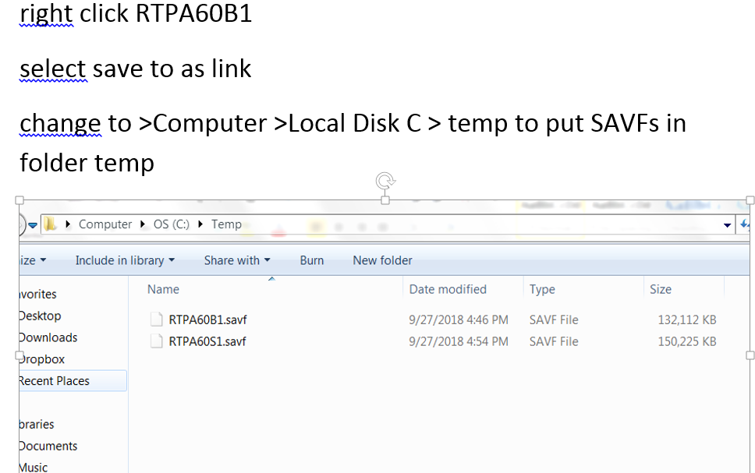

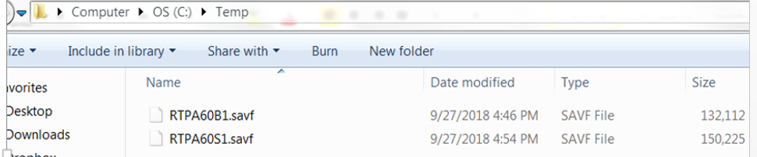

ftp>

- On the IBM i (AS/400), create a save file.
CRTSAVF FILE(QGPL/RTPA71B1)

Step 2: Installing RTPA SAVF from the PC to the IBM i
Enter the FTP commands from a DOS-shell on your Windows PC

- Press the Microsoft Start button (lower right of the Desktop)
- Key CMD
- Press enter to display the DOS shell for entering DOS commands
- 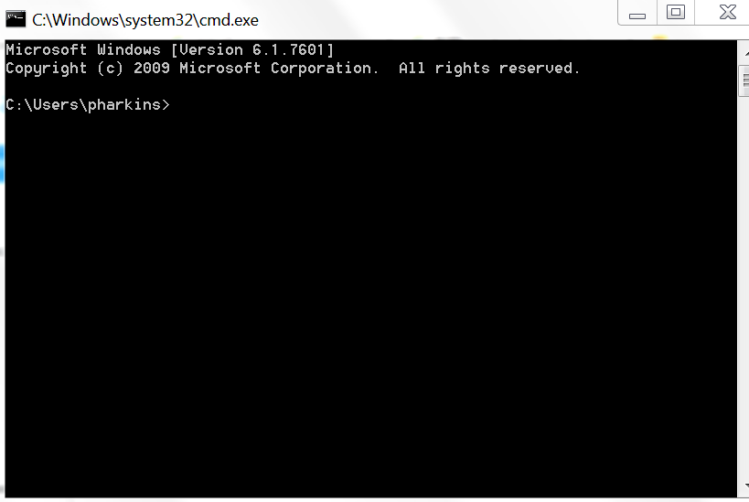

- FTP from the Windows PC to the save file on the IBM i

  - From a DOS command prompt, type: (Start, Run, Cmd for DOS window)
ftp XXX.XXX.XXX.XXX
where XXX.XXX.XXX.XXX is the IP address of the AS/400.

  - Provide the username QSECOFR and the proper password.
  - Transfer the file by typing:

lcd c:\temp
bin
cd qgpl
put rtpa71b1.savf
quit

The FTP of the PC file to the AS/400 should take about ten seconds.

Display Object Description - Basic
Library 1 of 1
Library . . . . . . . : QGPL Library ASP device . : *SYSBAS
Library ASP group . . : *SYSBAS

Type options, press Enter.
5=Display full attributes 8=Display service attributes

Opt Object Type Attribute Size Text
RTPA71B1 *FILE SAVF 138960896

Bottom
F3=Exit F12=Cancel F17=Top F18=Bottom
(C) COPYRIGHT IBM CORP. 1980, 2015.

- Restore the object RTPA71B1. From the AS/400, type
RSTOBJ OBJ(*ALL) SAVLIB(QGPL) DEV(*SAVF) SAVF(RTPA71B1)
- Run the installation program. From the AS/400, type
CALL QGPL/IRM

Step 3: Add the JOBQ Entry RTPA to subsystem QBATCH
- RTPA is distributed with the default JobQ RTPA, so that RTPA expansion jobs are not delayed by jobs waiting for execution in another Jobq such as Jobq QBATCH. RTPA submits several jobs for each RTPA expansion of the input source program with RTPA audit statements and the compile of the expanded RTPA source program.

- If the user initial testing with RTPA results in an RTPA job status of 1 (Input Compile Submitted) instead of completing with the normal RTPA job status of 8 EXPN OK, there may be an authority or other problem with the RTPA Jobq in library QGPL, or the RTPA jobq may not have been added to an active Subsystem such as subsystem QBATCH (below).

- RTPA uses the IBM i library QTEMP (the temporary library available only for the duration of an IBM i Job number) for many programs during the expansion of an input source program with RTPA audit statements. IBM library QTEMP, and also library QGPL, MUST be BEFORE the RTPA library ZZAUDIT in all JOB Descriptions (JOBDs) used in the RTPA entry screen.

JOBQ RTPA in Library QGPL should already have been reated in thst RTPA IRM install step

Edit Library List
System: LS053
Type new/changed information, press Enter.

Sequence Sequence Sequence
Number Library Number Library Number Library
0 150 300
10 QDEVTOOLS 160 310
20 QSQL 170 320
30 QGPL 180 330
40 QTEMP 190 340
50 ZZAUDITE 200 350
60 ZZAUDITC 210 360
70 ZZAUDIT 220 370
80 230 380
90 240 390
100 250 400
110 260 410
120 270 420
130 280 430
140 290 440
More...
F3=Exit F5=Refresh F12=Cancel

Library QTEMP (and QGPL) must always be BEFORE library ZZAUDITE and ZZAUDITC and library ZZAUDIT in the library list when RTPA programs execute, including in USER JOBDs used in the RTPA entry screen.

Create Job Queue (CRTJOBQ)

Type choices, press Enter.

Job queue . . . . . . . . . . . rtpa Name
Library . . . . . . . . . . . qgpl Name, *CURLIB
Text 'description' . . . . . . . RTPA Jobq

Bottom
F3=Exit F4=Prompt F5=Refresh F10=Additional parameters F12=Cancel
F13=How to use this display F24=More keys

If jobq RTPA is not in library QGPL, create JOBQ RTPA in library QGPL before doing the ADDJOBQE below

- QSYS/ADDJOBQE SBSD(QBATCH) JOBQ

- The RTPA Jobq may be added as an active Jobq to subsystem QBATCh with the following command , with proper authority.

Display Job Queue Entries
System: S1034F0C
Subsystem description: QBATCH Status: ACTIVE

Seq Job Max ---------Max by Priority----------
Nbr Queue Library Active 1 2 3 4 5 6 7 8 9
10 QBATCH QGPL 3 * * * * * * * * *
20 QS36EVOKE QGPL *NOMAX * * * * * * * * *
50 QTXTSRCH QGPL *NOMAX * * * * * * * * *
55 RTPA QGPL 1 * * * * * * * * *

Bottom
Press Enter to continue.

F3=Exit F12=Cancel

- QSYS/ADDJOBQE SBSD(QBATCH) JOBQ(RTPA) SEQNBR(99) the sequence# is determined by what is available and you must be authorized to command ADDJOBQE.
RTPA submits RTPA expansion compiles (by pressing F10 on the RTPA entry screen) to JOBQ RTPA and uses subsystem QPGMR to compile the RTPA compiles, so that RTPA submitted jobs do not wait behind other batch jobs in subsystem QBATCH
Subsystem QPGMR should be active for RTPA submitted compiles to ve processed Work with Active Jobs S1034F0C
05/30/18 15:51:56
CPU %: .8 Elapsed time: 00:01:05 Active jobs: 380

Type options, press Enter.
2=Change 3=Hold 4=End 5=Work with 6=Release 7=Display message
8=Work with spooled files 13=Disconnect ...
Current
Opt Subsystem/Job User Type CPU % Function Status
BC400SERVR QSYS SBS .0 DEQW
BC400SVRJD BACKUP BCH .0 PGM-BC400_SRVR TIMW
QBATCH QSYS SBS .0 DEQW
QCMN QSYS SBS .0 DEQW
QCTL QSYS SBS .0 DEQW
QSYSSCD QPGMR BCH .0 PGM-QEZSCNEP EVTW
QINTER QSYS SBS .0 DEQW
QPADEV000K PHH INT .0 CMD-WRKACTJOB RUN
---------------------------------------------------------------------------------
QPGMR QSYS SBS .0 DEQW

The WRKACTJOB command (Work With Active Jobs) displays the IBM i subsystems used by RTPA

The user is signed on as an entry in the QINTER (interactive jobs )Subsystem
RTPA submitted jobs (command key 10 in the RTPA entry screen), starting with the compile of the input source program are processed in the QPGMR Subsystem (NOT the QBATCH Subsystem where production batch jobs are normally processed)

Display User Profile - Basic

User profile . . . . . . . . . . . . . . . : PHH

Previous sign-on . . . . . . . . . . . . . : 05/30/18 15:50:38
Sign-on attempts not valid . . . . . . . . : 0
Status . . . . . . . . . . . . . . . . . . : *ENABLED
Date password last changed . . . . . . . . : 04/17/08
Password expiration interval . . . . . . . : *SYSVAL
Set password to expired . . . . . . . . . : *NO
Local password management . . . . . . . . : *YES
User class . . . . . . . . . . . . . . . . : *PGMR
Special authority . . . . . . . . . . . . : *JOBCTL

*SAVSYS
Group profile . . . . . . . . . . . . . . : ODSQPGMR
Owner . . . . . . . . . . . . . . . . . . : *GRPPRF
Group authority . . . . . . . . . . . . . : *NONE
Group authority type . . . . . . . . . . . : *PRIVATE
Supplemental groups . . . . . . . . . . . : *NONE
User profile . . . . . . . . . . . . . . . : PHH

Assistance level . . . . . . . . . . . . . : *INTERMED
Current library . . . . . . . . . . . . . : ODSQGPL
Initial program . . . . . . . . . . . . . : *NONE
Library . . . . . . . . . . . . . . . . :
Initial menu . . . . . . . . . . . . . . . : MAIN
Library . . . . . . . . . . . . . . . . : *LIBL
Limit capabilities . . . . . . . . . . . . : *NO
Text . . . . . . . . . . . . . . . . . . . : ODS User

Display sign-on information . . . . . . . : *SYSVAL
Limit device sessions . . . . . . . . . . : *SYSVAL
Keyboard buffering . . . . . . . . . . . . : *SYSVAL
User profile . . . . . . . . . . . . . . . : PHH

Storage information:
Maximum storage allowed . . . . . . . . : *NOMAX
Storage used . . . . . . . . . . . . . . : 3928
Storage used on independent ASP . . . . : *NO
Highest scheduling priority . . . . . . . : 3
Job description . . . . . . . . . . . . . : RTPA
Library . . . . . . . . . . . . . . . . : ODSQGPL
Accounting code . . . . . . . . . . . . . :
Message queue . . . . . . . . . . . . . . : PHH
Library . . . . . . . . . . . . . . . . : QUSRSYS
Message queue delivery . . . . . . . . . . : *NOTIFY
Message queue severity . . . . . . . . . . : 00
Output queue . . . . . . . . . . . . . . . : ODSOUTQ
Library . . . . . . . . . . . . . . . . : ODSQGPL
Printer device . . . . . . . . . . . . . . : ODSOUTQ
User profile . . . . . . . . . . . . . . . : PHH

Special environment . . . . . . . . . . . : *SYSVAL
Attention program . . . . . . . . . . . . : CLPATNPGM
Library . . . . . . . . . . . . . . . . : *LIBL
Sort sequence . . . . . . . . . . . . . . : *SYSVAL
Library . . . . . . . . . . . . . . . . :

The DSPUSRPRF (Display User Profile displays the USER profile details, including the User Job description (RTPA in library ODSQGPL)

Job description . . . . . . . . . . . . . : RTPA
Library . . . . . . . . . . . . . . . . : ODSQGPL

Display Job Description
System: S1034F0C
Job description: RTPA Library: ODSQGPL

User profile . . . . . . . . . . . . . . . . . . : *RQD
CL syntax check . . . . . . . . . . . . . . . . : *NOCHK
Hold on job queue . . . . . . . . . . . . . . . : *NO
End severity . . . . . . . . . . . . . . . . . . : 30
Job date . . . . . . . . . . . . . . . . . . . . : *SYSVAL
Job switches . . . . . . . . . . . . . . . . . . : 00000000
Inquiry message reply . . . . . . . . . . . . . : *RQD
Job priority (on job queue) . . . . . . . . . . : 4
Job queue . . . . . . . . . . . . . . . . . . . : QPGMR
Library . . . . . . . . . . . . . . . . . . . : QGPL
Output priority (on output queue) . . . . . . . : 5
Printer device . . . . . . . . . . . . . . . . . : *USRPRF
Output queue . . . . . . . . . . . . . . . . . . : *USRPRF
Library . . . . . . . . . . . . . . . . . . . :

The DSPJOBD command displays the Job description for RTPA submitted jobs (RTPA compiles), including the JOB Queue used by RTPA which is subsystem QPGMR in library QGPL (NOT subsystem QBATCH)

This is to provide programmers with a separate job Queue for RTPA submitted jobs, and NOT have to wait for productions jobs to end, and much quicker RTPA turnaround and testing.

Job queue . . . . . . . . . . . . . . . . . . . : QPGMR
Library . . . . . . . . . . . . . . . . . . . : QGPL

Step 4: Check the CCSID Coded character set identifiers (character set)
CCSID is an abbreviation used by IBM to mean "Coded Character Set Identifier". It is a 16-bit number that represents a specific encoding of a specific code page. For example, Unicode is a code page that has several encoding forms, like UTF-8, UTF-16 and UTF-32.
https://www.ibm.com/support/knowledgecenter/en/ssw_ibm_i_71/nls/rbagsccsidcdepgscharsets.htm
Some CCSIDs do not allow special characters.
CCSID 273 used in Germany does not allow the special characters @ or $

Programmer Menu
System: S1034F0C
Select one of the following:
1. Start Data File Utility
2. Work with Queries
3. Create an object from a source file object name, type, pgm for CMD
4. Call a program program name
5. Run a command command
6. Submit a job (job name), , ,(command)
7. Go to a menu menu name
8. Edit a source file member (srcmbr), (type)
9. Design display format using SDA (srcmbr), ,(mode)
90. Sign off (*nolist, *list)

Selection . . . . . 5 Parm . . . .
Type . . . . . . . Parm 2 . . .
Command . . . . . . DSPSYSVAL SYSVAL(QCCSID)

Source file . . . . Source library . . . . . . . *LIBL
Object library . . Job description . . . . . . *USRPRF

F3=Exit F4=Prompt F6=Display messages F10=Command entry
F12=Cancel F14=Work with submitted jobs F18=Work with output

Display the IBM i CCSID Country Language code with DSPSYSVAL SYSVAL(QCCSID)

Display System Value

System value . . . . . : QCCSID
Description . . . . . : Coded character set identifier

Coded character set
identifier . . . . . : 37 1-65535

Press Enter to continue.

F3=Exit F12=Cancel

RTPA is developed and distributed with CCSID 37 (USA English)

https://www-01.ibm.com/software/globalization/ccsid/ccsid_registered.html

The Real-Time Program Audit software is distributed with the IBM i CCSID 37 (USA)

CCSID is the normal character translation code used in the United States and Europe, and allows constants and variables to include special characters including the @ (at sign) and $

Coded character set identifiers CCSID
https://www-01.ibm.com/software/globalization/ccsid/ccsid_registered.html

https://www.ibm.com/support/knowledgecenter/ssw_ibm_i_72/nls/rbagsmstpdf.pdf

Language identifiers and associated default CCSIDs - IBM
https://www.ibm.com/support/knowledgecenter/...ibm.../rbagslngidsdefaultccsids.htm
- Cached
If the QTQ_DEFAULT_CCSID system level environment variable is defined, then it consists of pairs of valid language ID and single-byte or mixed-byte EBCDIC ...

https://www.ibm.com/support/knowledgecenter/en/ssw_ibm_i_72/nls/rbagslngidsdefaultccsids.htm

========================================================

=====================================================
Coded character set identifier job attribute:
When an interactive job is started on the IBM i operating system, the job CCSID value is taken from the
user profile. When a batch job is started, the current job CCSID is used unless a CCSID is specifically
entered on the SBMJOB command.
=========================================================================

https://www.ibm.com/support/knowledgecenter/en/ssw_ibm_i_71/nls/rbagsccsidcdepgscharsets.htm

Some other CCSID numbers, such as CCSID 273, used in Germany and Austria , do not allow the @ (at sign) in constants or variables, and thus the RTPA sample tutorial source programs will not compile during RTPA expansion of the source program due to a compiler token error.

5770WDS V7R3M0 160422 RN IBM ILE RPG QTEMP/NEWEXPSH PW8BHA 04.07.18 15:12:41 Seite 1

Befehl . . . . . . . . . . . . . : CRTBNDRPG
Ausgegeben von . . . . . . . . : RSCH
Programm . . . . . . . . . . . . : NEWEXPSH
Bibliothek . . . . . . . . . . : QTEMP
Text 'Beschreibung' . . . . . . : *SRCMBRTXT

Quellenteildatei . . . . . . . . : NEWEXPSH
Quellendatei . . . . . . . . . . : ZZCOPINP
Bibliothek . . . . . . . . . . : QTEMP
CCSID . . . . . . . . . . . . : 273
Text 'Beschreibung' . . . . . . : copied input RPG source to QTEMP
Letzte Änderung . . . . . . . . : 04.07.18 15:12:41

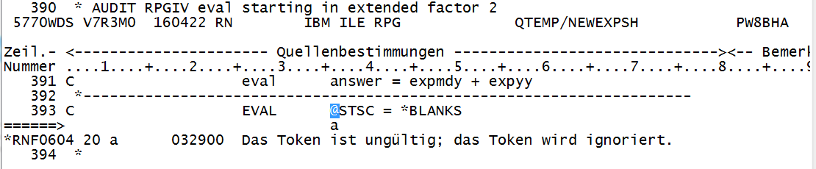

*RNF0604 20 a 032900 Das Token ist ungültig; das Token wird ignoriert.

Step 5: Check the Language ID (language for displays,, messages, compile listings)
Display the IBM I Country Language code with DSPSYSVAL SYSVAL(QLANGID)
Programmer Menu
Sys
Select one of the following:
1. Start Data File Utility
2. Work with Queries
3. Create an object from a source file object name, ty
4. Call a program program name
5. Run a command command
6. Submit a job (job name), , ,
7. Go to a menu menu name
8. Edit a source file member (srcmbr), (type
9. Design display format using SDA (srcmbr), ,(mod
90. Sign off (*nolist, *list

Selection . . . . . 5 Parm . . . .
Type . . . . . . . Parm 2 . . .
Command . . . . . . DSPSYSVAL SYSVAL(QLANGID)

Display System Value

System value . . . . . : QLANGID
Description . . . . . : Language identifier

Language identifier . : ENU Language abbreviation

Press Enter to continue.
USA English

Display Object Description - Basic
Library 1 of 1
Library . . . . . . . : QSYS Library ASP device . : *SYSBAS
Library ASP group . . : *SYSBAS

Type options, press Enter.
5=Display full attributes 8=Display service attributes

Opt Object Type Attribute Size Text
QSYS2909 *LIB PROD 2129920 Belgium English LANGI
QSYS2922 *LIB PROD 2064384 Portugese LANGID PTG
QSYS2923 *LIB PROD 2064384 Dutch Netherlands LA
QSYS2925 *LIB PROD 2064384 Finnish LANGID FIN
QSYS2926 *LIB PROD 2064384 Danish LANGID DAN
QSYS2928 *LIB PROD 2129920 French LANGID FRA
QSYS2929 *LIB PROD 2162688 German LANGID DEU
QSYS2931 *LIB PROD 2162688 Spanish LANGID ESP
QSYS2932 *LIB PROD 2129920 Italian LANGID ITA
QSYS2933 *LIB PROD 483328 Noregian LANGID NOR
QSYS2937 *LIB PROD 2129920 Swedish LANGID SVE
QSYS2958 *LIB PROD 278528 Islandic LANGID ISL QSYS2963 *LIB PROD 2129920 Belgium Dutch LANGID NLB QSYS2981 *LIB PROD 2129920 Canadian French LANGI FRC
Downloaded secondary languages

Step 6: Create User Profile and initial program for the user for the desired CCSID and Lang ID
NOTE – The secondary language library for the desired language ID must be downloaded to the user environment

GERMAN user profile example

Display User Profile - Basic

User profile . . . . . . . . . . . . . . . : GERMAN

Previous sign-on . . . . . . . . . . . . . : 10/08/18 19:43:36
Password verifications not valid . . . . . : 0
Status . . . . . . . . . . . . . . . . . . : *ENABLED
Date password last changed . . . . . . . . : 10/08/18 16:30:50
Password is *NONE . . . . . . . . . . . . : *NO
Password expiration interval . . . . . . . : *SYSVAL
Password set expired by command . . . . . : *NO
Block password change . . . . . . . . . . : *SYSVAL
Local password management . . . . . . . . : *YES
User class . . . . . . . . . . . . . . . . : *PGMR
Creation date/time . . . . . . . . . . . . : 10/08/18 16:30:50
Created by user . . . . . . . . . . . . . : QSECOFR
Change date/time . . . . . . . . . . . . . : 10/08/18 19:38:41
Last used date . . . . . . . . . . . . . . : 10/08/18
Restore date/time . . . . . . . . . . . . : User profile . . . . . . . . . . . . . . . : GERMAN

User expiration date . . . . . . . . . . . : *NONE
User expiration interval . . . . . . . . . : *NONE
User expiration action . . . . . . . . . . : *NONE
Special authority . . . . . . . . . . . . : *JOBCTL
Group profile . . . . . . . . . . . . . . : *NONE
Owner . . . . . . . . . . . . . . . . . . : *USRPRF
Group authority . . . . . . . . . . . . . : *NONE
Group authority type . . . . . . . . . . . : *PRIVATE
Supplemental groups . . . . . . . . . . . : *NONE
Assistance level . . . . . . . . . . . . . : *SYSVAL
Current library . . . . . . . . . . . . . : *CRTDFT
Initial program . . . . . . . . . . . . . : RTPALIBDEU
Library . . . . . . . . . . . . . . . . : ZZAUDIT
Initial menu . . . . . . . . . . . . . . . : MAIN
Library . . . . . . . . . . . . . . . . : *LIBL Display User Profile - Basic

User profile . . . . . . . . . . . . . . . : GERMAN

Limit capabilities . . . . . . . . . . . . : *NO
Text . . . . . . . . . . . . . . . . . . . : German language User Profile 1qs
y2929 CCSID 273
Display sign-on information . . . . . . . : *SYSVAL
Limit device sessions . . . . . . . . . . : *SYSVAL
Keyboard buffering . . . . . . . . . . . . : *SYSVAL
Storage information:
Maximum storage allowed . . . . . . . . : *NOMAX
Storage used . . . . . . . . . . . . . . : 240
Storage used on independent ASP . . . . : *NO
Highest scheduling priority . . . . . . . : 3
Job description . . . . . . . . . . . . . : QDFTJOBD
Library . . . . . . . . . . . . . . . . : QGPL Display User Profile - Basic

User profile . . . . . . . . . . . . . . . : GERMAN

Message queue . . . . . . . . . . . . . . : GERMAN
Library . . . . . . . . . . . . . . . . : QUSRSYS
Message queue delivery . . . . . . . . . . : *NOTIFY
Message queue severity . . . . . . . . . . : 00
Output queue . . . . . . . . . . . . . . . : RTPA
Library . . . . . . . . . . . . . . . . : QGPL
Printer device . . . . . . . . . . . . . . : *WRKSTN
Special environment . . . . . . . . . . . : *SYSVAL
Attention program . . . . . . . . . . . . : *SYSVAL
Library . . . . . . . . . . . . . . . . :
Sort sequence . . . . . . . . . . . . . . : *SYSVAL
Library . . . . . . . . . . . . . . . . :
Language identifier . . . . . . . . . . . : DEU
Country or region identifier . . . . . . . : *SYSVAL
Coded character set identifier . . . . . . : 273
Accounting code . . . . . . . . . . . . . : Display User Profile - Basic

User profile . . . . . . . . . . . . . . . : GERMAN

Character identifier control . . . . . . . : *SYSVAL
Locale job attributes . . . . . . . . . . : *SYSVAL

Columns . . . : 1 71 Edit ZZAUDITS/QCLSRC
SEU==> RTPALIBDEU
FMT ** ...+... 1 ...+... 2 ...+... 3 ...+... 4 ...+... 5 ...+... 6 ...+... 7
*************** Beginning of data *************************************
0001.00 /*-------------------------------------------------------------------*/
0002.00 /* COPYRIGHT (C) 2016 BY HARKINS & ASSOCIATES, INC. ALL RIGHTS */
0003.00 /* RESERVED */
0004.00 /* V6R2M0 GERMAN LANGUAGE DEU QSYS2929 */
0005.00 /* DATE LAST CHANGED 10/08/18 */
0006.00 /* RTPALIBDEU ADD RTPA LIBRARIES TO THE LIBRARY LIST USER GERMAN */
0007.00 /*-------------------------------------------------------------------*/
0008.00 PGM
0009.00 RMVLIBLE LIB(ZZAUDIT)
0010.00 MONMSG MSGID(CPF0000) EXEC(RCVMSG MSGTYPE(*LAST))
0011.00 RMVLIBLE LIB(ZZAUDITE)
0012.00 MONMSG MSGID(CPF0000) EXEC(RCVMSG MSGTYPE(*LAST))
0013.00
0014.00 /* MAKE SURE QTEMP IS AT THE TOP */
0015.00 ADDLIBLE LIB(ZZAUDITE) POSITION(*AFTER QTEMP)
0016.00 ADDLIBLE LIB(ZZAUDIT) POSITION(*AFTER ZZAUDITE)
0009.00 RMVLIBLE LIB(ZZAUDIT)
0010.00 MONMSG MSGID(CPF0000) EXEC(RCVMSG MSGTYPE(*LAST))
0011.00 RMVLIBLE LIB(ZZAUDITE)
0012.00 MONMSG MSGID(CPF0000) EXEC(RCVMSG MSGTYPE(*LAST))
0013.00
0014.00 /* MAKE SURE QTEMP IS AT THE TOP */
0015.00 ADDLIBLE LIB(ZZAUDITE) POSITION(*AFTER QTEMP)
0016.00 ADDLIBLE LIB(ZZAUDIT) POSITION(*AFTER ZZAUDITE)
0017.00
0018.00 /* ADD QSYS2929 GERMAN DEU FOR GERMAN LANGUAGE */
0019.00 CHGSYSLIBL LIB(QSYS2929)
0020.00 MONMSG MSGID(CPF0000)
0021.00
0022.00 ENDPGM: RETURN
0023.00 ENDPGM
Initial program for GERMAN User Profile

Sign On
System . . . . . : LS053
Subsystem . . . . : QINTER
Display . . . . . : QPADEV0001

User . . . . . . . . . . . . . . GERMAN
Password . . . . . . . . . . . .
Program/procedure . . . . . . . .
Menu . . . . . . . . . . . . . .
Current library . . . . . . . . .

Sign on for GERMAN user CCSID 273 LANGID DEU

MAIN IBM i-Hauptmen}
System: LS053
Auswahlm¦glichkeiten:

1. Benutzeraufgaben
2. B}roaufgaben
3. Allgemeine Systemaufgaben
4. Dateien, Bibliotheken und Ordner
5. Programmierung
6. Datenfernverarbeitung
7. System definieren oder {ndern
8. Problembehandlung
9. Men} anzeigen
10. Unterst}tzende Informationen - Auswahlm¦glichkeiten
11. IBM i Access-Aufgaben

90. Abmelden

Auswahl oder Befehl
===>

F3=Verlassen F4=Bedienerf}hrung F9=Auffinden F12=Abbrechen
F13=Unterst}tzende Informationen F23=Anfangsmen} festlegen
(C) COPYRIGHT IBM CORP. 1980, 2015.
Initial display for GERMAN USER PROFILE

Step 7: Enter the RTPA License Key

(emailed from Harkins & Associates, Inc. for the IBM i serial number and model number).
RTPA processing requires that an RTPA license key has been sent to the user and the license key had been entered on the user IBM i or when the RTPA command RTPA is entered the following message will be displayed.

.
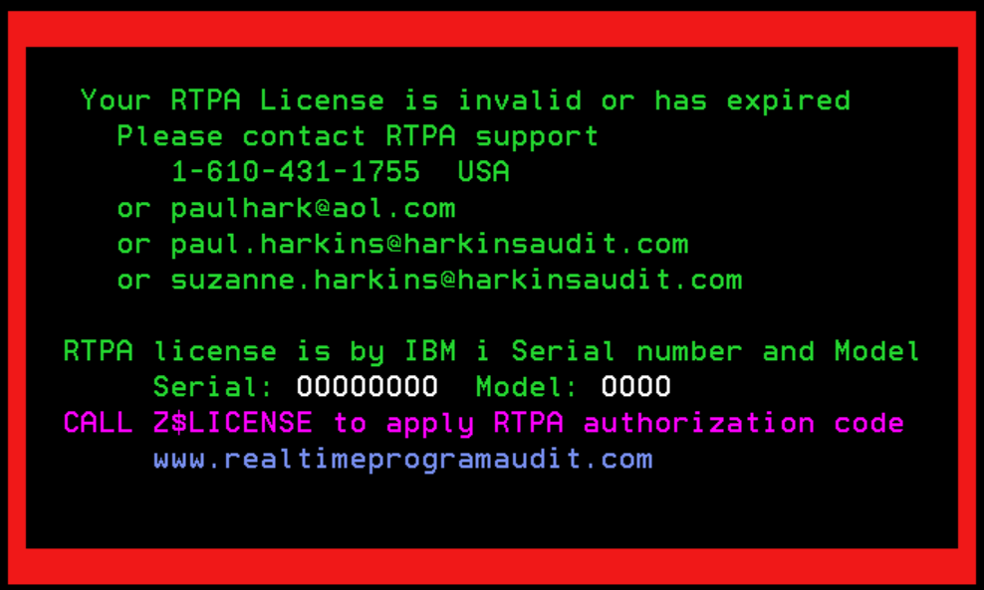

The RTPA license key requires the following information, which RTPA support will enter and sent the license key to the user via email

CALL ZZLICENSE to apply the emailed RTPA authorization code

Real Time Program Audit Authorization for IBM i Licensed software

ZZPGMPAS Real-Time Program Audit (RTPA) (V7R1) Date: 11/26/20
Time: 12:04:34
License Key Creation Serial: 2104FAW Model: 42A
21-01-25 21-11-26 22-11-26 23-11-26 30-11-26
License type T (T=Trial, 1=1 Yr, 2=2 Yrs, 3=3Yrs, P=Perpetual, A-H, X)
Company Name HARKINS & ASSOCIATES, INC.
Address 816 DAISY LANE
City WEST CHESTER
State/Province PA Zip/Postal 19382 Country USA
Contact Name PAUL HARKINS
Contact email PAULHARK@AOL.COM
Contact phone 610-431-1755 CCSID 37 (Lang.)
User Serial 2104FAW User Model 42A (leftmost position may be blank)
Prog. Language RPG Y CLP Y QUERY Y COBOL Y (Y/N)
License Key xe04msd):l9>a9"jTl</-d%r?
Security Code bssfm&z9:;>!l="1TW<2rksw\

Expiration date 21/01/25 (yy/mm/dd)
Referral Info.

F3=Exit F19=Update License Key License Key created
Enter key to validate Copyright (C) 2016 by Harkins & Associates, Inc.
The Real-Time Program Audit (RTPA) is distributed AS IS without warranty
either express or implied

Real-Time Program Audit (RTPA) (V7R1) Date: 6/29/19
Time: 15:51:16
License Key Creation Serial: 2104FAW
Model: 42A
19-08-28 20-06-29 21-06-29 39-06-29
License type T (T=Trial, 1=One Year, 2=Two years, P=Perpetual, A-H, X)
Company Name
Address
City
State/Province Zip/Postal Country
Contact Name
Contact email
Contact phone CCSID (Lang.)
User Serial User Model (leftmost position may be blank)

Prog. Language RPG Y CLP Y QUERY Y COBOL Y (Y/N)
License Key
Security Code

Expiration date (yy/mm/dd)
Referral Info.

F3=Exit
Enter key to validate Copyright (C) 2016 by Harkins & Associates, Inc.

User Serial User Model (leftmost position may be blank)

RTPA for IBM i is licensed to the IBM i( AS/400) serial and Model

An RTPA license key will be sent to the user via email

Prog. Language RPG Y CLP Y QUERY Y COBOL Y (Y/N)
License Key xe0hmks):u9>@f"uTd</-f%r?
Security Code bjlfm&$s:;>!u="1Tv<2kkr#\

Expiration date 18/08/08 (yy/mm/dd)

The user keys the RTPA license key, or copies each of the two lines (License Key and Security code) separately from the emailed RTPA authorization form, and pastes each of the two lines separately into the RTPA license Key entry screen with the Edit button then paste drop down option.
To key the RTPA license and security key:
(With RTPA library ZZAUDIT in the library list)

- From the command line, type:

- CALL ZZLICENSE

Real-Time Program Audit (RTPA) (V7R1) Date: 6/09/19
Time: 14:05:49
RTPA License Key Entry Serial: 1034F0C
Model: 525

License Key
Security Code
1 2
1234567890123456789012345

F3=Exit

Copyright (C) 2016 by Harkins & Associates, Inc.

Real-Time Program Audit (RTPA) (V7R1) Date: 6/09/19
Time: 14:05:49
RTPA License Key Entry Serial: 1034F0C
Model: 525

License Key QWERTYUIOPASDFGHHJKL;'ZXC
Security Code VBNM,./1234567890QWERTYUI
1 2
1234567890123456789012345

F3=Exit

Copyright (C) 2016 by Harkins & Associates, Inc.

Enter the entire 50 character RTPA license key and security code and press enter (or copy and Edit and paste each line separately on the RTPA license Key entry screen

Press enter to enter the RTPA license and security key into the RTPA DATA AREA.

Press F10 Command key 10 to update the RTPA license key on the user IBM i

Figure 1.3 RTPA License Key Authorization Screen

The RTPA license key is now updated on the user IBM i, and all of the RTPA processing including RPG, CLP, COBOL and RTPA Query should be enabled

OR, The RTPA license key and security key may be entered into the RTPA data area in library ZZAUDIT with the CHGDTAARA command as follows

You can enable the RTPA license key by simply changing the RTPA data area with a CHGDTAARA with your license key

CHGDTAARA allows both upper and lower case to the RTPA data area in library ZZAUDIT.

Change Data Area (CHGDTAARA)

Type choices, press Enter.

Data area specification:
Data area . . . . . . . . . . > RTPA Name, *LDA, *GDA, *PDA
Library . . . . . . . . . . *LIBL Name, *LIBL, *CURLIB
Substring specifications:
Substring starting position . > 1 1-2000, *ALL
Substring length . . . . . . . > 25 1-2000
New value . . . . . . . . . . . > '1234567890123456789012345'

Bottom
F3=Exit F4=Prompt F5=Refresh F12=Cancel F13=How to use this display
F24=More keys

Change positions 1-25 of RTPA DATAAREA in library ZZAUDIT

Change Data Area (CHGDTAARA)

Type choices, press Enter.

Data area specification:
Data area . . . . . . . . . . > RTPA Name, *LDA, *GDA, *PDA
Library . . . . . . . . . . *LIBL Name, *LIBL, *CURLIB
Substring specifications:
Substring starting position . > 26 1-2000, *ALL
Substring length . . . . . . . > 25 1-2000
New value . . . . . . . . . . . > '6789012345678901234567890'

Bottom
F3=Exit F4=Prompt F5=Refresh F12=Cancel F13=How to use this display
F24=More keys

Change positions 26-50 of RTPA DATAAREA in library ZZAUDIT

(junk data entered)

Edit Library List
System: S1034F0C
Type new/changed information, press Enter.

Sequence Sequence Sequence
Number Library Number Library Number Library
0 150 300
10 QTEMP 160 310
20 QGPL 170 320
30 ZZAUDITE 180 330
40 ZZAUDIT 190 340
50 200 350
60 210 360
70 220 370
80 230 380
90 240 390
100 250 400
110 260 410
120 270 420
130 280 430
140 290 440
More...
F3=Exit F5=Refresh F12=Cancel

Add the two RTPA libraries to the library list AFTER libraries QTEMP and QGPL

ZZAUDITE is the RTPA work library for RTPA Expanded source and object programs
ZZAUDIT is the RTPA object library of RTPA licensed programs

These two libraries must be in the library list before user libraries, with library ZZAUDITE first

RTPA work library ZZAUDITE will contain the expanded RTPA object programs and the expanded RTPA source programs with RTPA inserted ZZ audit statements, which enable real-time program auditing.

RTPA for RPG converts RPG3 source to RPG4 source

NOTE – RTPA for RPG also dynamically converts RPG3 source members to RPG4 source members with the CVTRPGSRC utility, and creates the RPG4 source member in file QRPGLESRC in library ZZAUDITC

Work with Members Using SEU

Source file . . . . . . QRPGLESRC Library . . . . . ZZAUDITC
Position to . . . . . . . . . . . . . . . . . . . . . . . . . . . .
New member . . . . . . . . . . . . . . . . . . . . . . . . . . . .
Type for new member . . . . . . . . . . . . . . . . . . . . . . . RPGLE
Text . . . . . . . . .

Type options, press Enter.
2=Edit 4=Delete 5=Browse 6=Print

Opt Member Type Text

(No members in the file)

F3=Exit F5=Refresh F12=Cancel F14=Display date
F15=Sort by date F17=Subset
(C) COPYRIGHT IBM CORP. 1981, 2013

RTPA uses the IBM command CVTRPGSRC to convert RPG3 source members to RPG4 fixed Format source members in file QRPGLESRC in library ZZZAUDITC.

ZZPGM01R Real-Time Program Audit for RPG (V7R1) Date 8/13/20
PHARKINS Select Program to Audit Time 16:54:23
RPG3 and RPG4 source members CCSID 37 Serial 2104FAW
Type choices, Press F10 Language ENU Model 42A
Source Member . . . . . . GETEXPSH Name, generic*, *ALL, F4 for List
Source File . . . . . . . QRPGSRC Name Date Format *MDY
Library . . . . . . . . ZZAUDIT Name Audit comments Y

Object to Library . . . . . . ZZAUDITE Name Audit copybooks Y

Audit Timestamp Y
Audit File Outq . . . . . . . *SAME Name, *SAME
Audit Procedures Y
JOBD for pgm compile libl . . *LIBL *LIBL, JOBD
Library . . . . . . . . Name Audit Variable contents A
A=All N=None V=F16 Var W=F2 Watch
Audit Compile Listing Stmts . to 1-99999 Audit to Disk N
(Only) to
to Document Only N
Project to
Ticket to Remote RTPA via FTP N
F2=Watch Variables F3=Exit F6=Auditing options F7=Compile Options
F8=Conditional Auditing F9=Maint. Menu F10=Submit Expand F12=Cancel
Member GETEXPSH Input RPG program submitted. Press F18 to see status.

Convert RPG3 source member in file QRPGSRC in library ZZAUDIT with IBM COMMAND CVTRPGSRC to RPG4 fixed format source member in file QRPGLESRC in library ZZAUDITC (ZZAUDITC library contains converted RPG4 source members).

Then Insert RPTA audits in converted RPG4 source in ZZAUDITC and compile RPG4 expanded source program in ZZAUDITE.
ZZPGM01R Real-Time Program Audit for RPG (V7R1) Date 8/13/20
PHARKINS RTPA history today Time 16:55:28
Paul Harkins RTPA user profile CCSID: 37
Type option, press Enter Language ENU
4=Delete 5=Display Date Format *MDY

O Program Status Program Name Job Date Time
5 GETEXPSH 8 EXPN OK GET EXPECTED SHIP DATE FROM OR 101378 8/13/20 16:54:23

F3=Exit F5=Refresh F12=Cancel F20=RTPA User history
F22=RTPA Analytics Report (C) HARKINS & ASSOCIATES, INC.

ZZPGM01R Real-Time Program Audit for RPG (V7R1) Date 8/13/20
PHARKINS Select Program to Audit Time 16:56:16
Project Ticket *MDY CCSID 37 Language ENU
Program GETEXPSH GET EXPECTED SHIP DATE FROM ORDER DETA Audit Variable con A
Status 8 Expand Pgm compiled OK Audit comments Y Audit to Disk N
Converted RPG3 source to ZZAUDITC Audit copybooks Y Document Only N
Type option, press Enter Audit Timestamp Y Remote RTPA FTP N
5=Display compile listing Audit Procedures Y Variable used 169
OPT Job Records Submitted Completed Elapsed Comp recds
Input 101378 664 8/13/20 16:54:23 8/13/20 16:54:24 1 810
Inserted 101379 3,188 8/13/20 16:54:28 8/13/20 16:54:31 3
Expanded 101381 3,852 8/13/20 16:54:32 8/13/20 16:54:36 4 3,840
RPG3 File QRPGSRC Exp Obj lib ZZAUDITE Program Object size 2,576,384
Source File QRPGLESRC Expand File QRPGLESRC Record formats 7 copybooks
Source Libl ZZAUDITC Exp Src lib ZZAUDITE Printer files 2 *INZSR Y
RPG Version 4 RPGLE Audit JOBQ RTPA Extension %parms
From To Audit outq Subroutines 7 /free
From To Audit Libr. *LIBL Overflow OE Indent
From To JOBD Libr. Protoype/Proc. N CTA N SDS Y
From To Maximum Pages 15000 SDS Name QXXDS SDS Qual
From To Watch varia DBCS J 218 Start/Stop conditional N
F8=Conditional Auditing F13=Files/Recd F14=Fields F15=Operations F16=Variables
F2=Watch Variables F17=Labels F19=Called Pgm F21=Cond Oper
F3=Exit F22=Indicators F23=Pre Audit (C) 2016 Harkins & Associates, Inc.

RPG3 source GETEXPSH converted to RPG4 source in QRPGLESRC in Library ZZAUDITC, the RTPA audits inserted in expanded RPG4 source in QRPGLESRC in Library ZZAUDITE

Work with Members Using SEU

Source file . . . . . . QRPGLESRC Library . . . . . ZZAUDITC
Position to . . . . . . . . . . . . . . . . . . . . . . . . . . . .
New member . . . . . . . . . . . . . . . . . . . . . . . . . . . .
Type for new member . . . . . . . . . . . . . . . . . . . . . . . RPGLE
Text . . . . . . . . .

Type options, press Enter.
2=Edit 4=Delete 5=Browse 6=Print

Opt Member Type Text
GETEXPSH RPGLE GET EXPECTED SHIP DATE FROM ORDER DETAIL RPGIII

Bottom
F3=Exit F5=Refresh F12=Cancel F14=Display date
F15=Sort by date F17=Subset
(C) COPYRIGHT IBM CORP. 1981, 2013

CVTRPGSRC converted RPG4 source program in file QRPGLESRC in library ZZAUDITC

Then, immediately expand the converted RPG4 source member in file QRPGLESRC in library ZZAUDITC and put the expanded RPG4 source member in library ZZAUDITE, and compile the expanded RPG4 expanded source member and output the expanded RTPA audit enabled object program in library ZZAUDITE.

RTPA for RPG then expands the converted RPG4 source member in file QRPGLESRC and creates the expanded source with RTPA audit statements in file QRPGLESRC in library ZZAUDITE and the expanded object program in ZZAUDITE.

RTPA expanded source member in library ZZAUDITE with RTPA ZZ audit statements
Work with Members Using SEU

Source file . . . . . . QRPGLESRC Library . . . . . ZZAUDITE
Position to . . . . . . . . . . . . . . . . . . . . . . . . . . . .
New member . . . . . . . . . . . . . . . . . . . . . . . . . . . .
Type for new member . . . . . . . . . . . . . . . . . . . . . . . RPGLE
Text . . . . . . . . .

Type options, press Enter.
2=Edit 4=Delete 5=Browse 6=Print

Opt Member Type Text
GETEXPSH RPGLE GET EXPECTED SHIP DATE FROM ORDER DETAIL RPGIII

Bottom
F3=Exit F5=Refresh F12=Cancel F14=Display date
F15=Sort by date F17=Subset
(C) COPYRIGHT IBM CORP. 1981, 2013

Converted (CVTRPGSRC) RPG4 GETEXPSH source in file QRPGLESRC in library ZZAUDITE with RTPA ZZ audit statements
Columns . . . : 1 71 Edit ZZAUDITE/QRPGLESRC
SEU==> GETEXPSH
FMT * ..... *. 1 ...+... 2 ...+... 3 ...+... 4 ...+... 5 ...+... 6 ...+... 7
*************** Beginning of data *************************************
0001.00 H*
0002.00 *----------------------------------------------------------------
0003.00 * DATE LAST CHANGED 01/18/20 PROJECT
0004.00 * (THIS IS AN RPGIII SOURCE PROGRAM FOR THE IBM ISERIES 400)
0005.00 *----------------------------------------------------------------
0006.00 *
0007.00 * PROGRAM: GETEXPSH - GET EXPECTED SHIP DATE FOR ORDER , LINE
0008.00 * AUTHOR: PAUL H HARKINS
0009.00 * DATE: 08/15/19
0010.00 * PROJECT: 12345
0011.00 *
0012.00 * OBJECTIVE: THIS PROGRAM RETRIVES THE EXPECTED SHIP DATE FROM
0013.00 * THE ORDER DETAIL RECORD FOR THE ORDER AND LINE
0014.00 * PASSED TO IT FROM A CALLING PROGRAM. THIS PROGRAM
0015.00 * CONVERTS THE EXPECTED SHIP DATE TO MM/DD/YY FORMAT
0016.00 * AND RETURNS IT TO THE CALLING PROGRAM. 0017.00 *
0018.00 *
0019.00 * DISPLAYS: NONE
0020.00 *
0021.00 * PRINTERS: QPRINT2 FOR PROGRAM LOGIC AUDITS
0022.00 *
0023.00 * DATA BASES: ORDERDE - ORDER DETAIL FILE RECORD ODETREC
0024.00 *
0025.00 *----------------------------------------------------------------
0026.00 * FUNCTIONAL STEPS: PSEUDOCODE OF THE MAJOR PROCESSING FUNCTIONS
0027.00 *----------------------------------------------------------------
0028.00 *
0029.00 * 1. A CALLING PROGRAM PASSES PARAMETERS TO THIS PROGRAM
0030.00 * AS ONE 44 CHARACTER FIELD IN THE FOLLOWING FORMAT:
0031.00 * - PORDER - ORDER (7,0)
0032.00 * - PLINE - ORDER LINE (5,0)
0033.00 * - PEXPSH - EXPECTED SHIP DATE (6,0) MMDDYY 0034.00 * - PCUSNA - CUSTOMER NAME (25A)
0035.00 * - PERROR - ERROR CODE (1A) E IF ANY ERROR
0036.00 * 2. RECEIVE THE INPUT PARAMETER OF ORDER AND LINE
0037.00 * AND CLEAR THE EXPECTED SHIP DATE AND ERROR CODE
0038.00 * 3. GET THE ORDER DETAIL RECORD FOR THE ORDER AND LINE
0039.00 * 4. IF THE ORDER DETAIL RECORD IS FOUND, AND IS NOT ZERO
0040.00 * CONVERT THE EXPECTED SHIP DATE (FIELD ODEXPD) FROM
0041.00 * YYYYMMDD INTO FIELD PEXPSH IN FORMAT MMDDYY
0042.00 * ALSO GET THE CUSTOMER STORE NAME
0043.00 * 5. IF THE ORDER DETAIL RECORD IS NOT FOUND, MOVE THE
0044.00 * LETTER INTO THE ERROR CODE (FIELD PERROR)
0045.00 * 6. RETURN TO THE CALLING PROGRAM
0046.00 *
0047.00 *
0048.00 *----------------------------------------------------------------
0049.00 * MODIFICATIONS:
0050.00 *---------------------------------------------------------------- FMT * ..... *. 1 ...+... 2 ...+... 3 ...+... 4 ...+... 5 ...+... 6 ...+...
0051.00 *
0052.00 *--------------------------------------------------------------
0053.00 * FILE DESCRIPTIONS:
0054.00 *--------------------------------------------------------------
0055.00 FGETEXPDS CF E WORKSTN
0056.00 FORDERDE UF E K DISK
0057.00 *
0058.00 * 3 Keys ODCUST ODORD ODLINE
0059.00 FORDERDL2 IF E K DISK
0060.00 F RENAME(ODETREC:ODETREL2)
0061.00 FCUSTMAST IF E K DISK
0062.00 F RENAME(CUSTREC:CUSTREC1)
0063.00 * OUTPUT WORK FILE FOR ORDER DETAIL FILE
0064.00 FORDERWK O E K DISK
0065.00 * Printer for Order Detail report - Externally defined *PRT
0066.00 FPRTORDR O E PRINTER
0067.00 * PRINT AUDIT 0068.00 FQPRINT2 O F 132 PRINTER OFLIND(*INOG)
0069.00 *
0070.00 *
0071.00 ZZ FZZAUDITP O F 280 PRINTER USROPN
0072.00 ZZ FZZAUDSRC IF E K DISK
0073.00 D ZZD S 2 0 DIM(13)
0074.00 *
0075.00 *------------------------------------------------------------
0076.00 * COPYBOOKS
0077.00 *------------------------------------------------------------
0078.00 *
0079.00 *------------------------------------------------------------
0080.00 * INPUTS AND WORK AREAS
0081.00 *------------------------------------------------------------
0082.00 * PROGRAM DATA STRUCTURE
0083.00 D QXXDS SDS
0084.00 ZZ D ZZPROG 1 10

Converted RPG4 GETEXPSH source in file QRPGLESRC in library ZZAUDITE with RTPA ZZ audit statements to enable RTPA auditing

RTPA auditing inserted ZZ audit statements
0071.00 ZZ FZZAUDITP O F 280 PRINTER USROPN
0072.00 ZZ FZZAUDSRC IF E K DISK
0073.00 D ZZD S 2 0 DIM(13)
0074.00 *
0075.00 *------------------------------------------------------------
0076.00 * COPYBOOKS
0077.00 *------------------------------------------------------------
0078.00 *
0079.00 *------------------------------------------------------------
0080.00 * INPUTS AND WORK AREAS
0081.00 *------------------------------------------------------------
0082.00 * PROGRAM DATA STRUCTURE
0083.00 D QXXDS SDS
0084.00 ZZ D ZZPROG 1 10

RTPA for RPG Sample program NEWEXPSH (RPGLE)
NEWEXPSH is an RPGLE interactive program

Enter the RTPA for RPG command RTPA to audit enable RPG source programs

RTPA (to display the entry screen for RTPA for RPG)

NOTE – If the RTPA for RPG program entry screen is NOT displayed, then there is an error in the RTPA license or security code.

MAIN IBM i Main Menu
System: LS053
Select one of the following:

1. User tasks
2. Office tasks
3. General system tasks
4. Files, libraries, and folders
5. Programming
6. Communications
7. Define or change the system
8. Problem handling
9. Display a menu
10. Information Assistant options
11. IBM i Access tasks

90. Sign off

Selection or command
===> rtpa

F3=Exit F4=Prompt F9=Retrieve F12=Cancel F13=Information Assistant
F23=Set initial menu
(C) COPYRIGHT IBM CORP. 1980, 2015.

Key RTPA to display the RTPA for RPG entry screen

PHARKINS (USA User Profile) RTPA entry screen date format *MDY

ZZPGM01R Real-Time Program Audit for RPG (V7R1) Date 8/13/20
PHARKINS Select Program to Audit Time 15:35:31
RPG3 and RPG4 source members CCSID 37 Serial 2104FAW
Type choices, Press F10 Language ENU Model 42A
Source Member . . . . . . NEWEXPSH Name, generic*, *ALL, F4 for List
Source File . . . . . . . QRPGLESRC Name Date Format *MDY
Library . . . . . . . . ZZAUDIT Name Audit comments Y

Object to Library . . . . . . ZZAUDITE Name Audit copybooks Y

Audit Timestamp Y
Audit File Outq . . . . . . . *SAME Name, *SAME
Audit Procedures Y
JOBD for pgm compile libl . . *LIBL *LIBL, JOBD
Library . . . . . . . . Name Audit Variable contents A
A=All N=None V=F16 Var W=F2 Watch
Audit Compile Listing Stmts . to 1-99999 Audit to Disk N
(Only) to
to Document Only N
Project to
Ticket to Remote RTPA via FTP N
F2=Watch Variables F3=Exit F6=Auditing options F7=Compile Options
F8=Conditional Auditing F9=Maint. Menu F10=Submit Expand F12=Cancel
F18=RTPA history today F24=More Keys (C) Harkins & Associates, Inc.

(the RTPA for RPG program entry screen is displayed)

Expand RPGLE source program

Enter the RPGLE Source program name (NEWEXPSH) source file (QRPGLESRC) and source library ZZAUDIT to be RTPA audit enabled (expanded with RTPA ZZ audit statements in a COPY of the program)

RTPA sample RPGLE source program NEWEXPSH in file QRPGLESRC in library ZZAUDIT is selected.

Audit comments Y Executing Source program comment statements will be in the RTPA audit output

Audit copybooks Y Executing Source program copybooks statements will be in the RTPA audit output

Audit procedures Y Executing Source program procedure statements will be audited in the RTPA audit output

Audit Timestamp Y Executing Source program statements will be timestamped in the RTPA audit output

Press command Key 10 (F10) to submit RPGLE program NEWEXPSH to be audit enabled.

Note – additional RTPA for RPG auditing options are available by keying the appropriate Command key
F2=Watch Variables F3=Exit F5=Refresh F6=Auditing Options F7=Compile Options
F8=Conditional Auditing F9=Maint. Menu F10=Submit Expand F24=More Keys
Member NEWEXPSH submitted. Press F18 to see status.

Command Key 2 to enter Watch Variables to audit statements containing the watch variables
Command Key 6 to enter auditing options (like Document Only)
Command Key 8 to enter conditional auditing statements
Command Key 11 for advanced auditing

Audit Compile Listing Stmts . to 1-99999
(Only) to
to
to
to

The Audit Compile Listing Statements option allows up to five ranges of the input source program compile listing statements to be selected for auditing, while all other compile listing statements are not audited

(the selection of ranges of compile listing source statements greatly reduces the number of RTPA ZZ Audit statements inserted into a COPY of the source program in library ZZAUDITE, as the default for RTPA is to audit all executable source statements as they execute

Member NEWEXPSH submitted. Press F18 to see status.

Press command key 18 (F18) to display the results of the RTPA expansion of RPGLE source program NEWEXPSH with RTPA audt statements

RTPA expand RPGLE interactive source program NEWEXPSH with audits
ZZPGM01R Real-Time Program Audit for RPG (V7R1) Date 8/13/20
PHARKINS RTPA history today Time 15:37:39
Paul Harkins RTPA user profile CCSID: 37
Type option, press Enter Language ENU
4=Delete 5=Display Date Format *MDY

O Program Status Program Name Job Date Time
5 NEWEXPSH 8 EXPN OK New Expected Ship Date from Or 101355 8/13/20 15:37:20

F3=Exit F5=Refresh F12=Cancel F20=RTPA User history
F22=RTPA Analytics Report (C) HARKINS & ASSOCIATES, INC.

RTPA expanded jobs today for this User summary

RTPA job status 8 means that the RPGLE source program NEWEXPSH was successfully compiled and a COPY of the source program with RTPA ZZ auditing statements was put in file QRPGLESRC in library ZZAUDITE, and the expanded source program was successfully compiled from file QRPGLESRC in library ZZAUDITE and the object program placed in library ZZAUDITE.

The expanded NEWEXPSH object program in library ZZAUDITE may now be executed to produce the RTPA audit log.

NOTE:
RTPA job status 3 (ERROR) means that the RPGLE source program NEWEXPSH was NOT successfully compiled (a source program or library list error)

RTPA job status 9 (ERROR) means that the RPGLE source program NEWEXPSH was successfully compiled, but the expanded COPY of the source program in file QRPGLESRC in library ZZAUDITE compile had an error (an RTPA ZZ inserted source statement error)

Key 5 to display the job details of the RTPA expansion of RPGLE source program NEWEXPSH

ZZPGM01R Real-Time Program Audit for RPG (V7R1) Date 8/13/20
PHARKINS Select Program to Audit Time 15:38:18
Project Ticket *MDY CCSID 37 Language ENU
Program NEWEXPSH New Expected Ship Date from Order Deta Audit Variable con A
Status 8 Expand Pgm compiled OK Audit comments Y Audit to Disk N
Audit copybooks Y Document Only N
Type option, press Enter Audit Timestamp Y Remote RTPA FTP N
5=Display compile listing Audit Procedures Y Variable used 220
OPT Job Records Submitted Completed Elapsed Comp recds
Input 101355 1,186 8/13/20 15:37:20 8/13/20 15:37:21 1 1,333
Inserted 101356 5,509 8/13/20 15:37:25 8/13/20 15:37:31 6
Expanded 101358 6,695 8/13/20 15:37:32 8/13/20 15:37:38 6 6,670
Exp Obj lib ZZAUDITE Program Object size 4,587,520
Source File QRPGLESRC Expand File QRPGLESRC Record formats 7 copybooks Y
Source Libl ZZAUDIT Exp Src lib ZZAUDITE Printer files 2 *INZSR Y
RPG Version 4 RPGLE Audit JOBQ RTPA Extension %parms
From To Audit outq Subroutines 9 /free Y
From To Audit Libr. *LIBL Overflow OE Indent
From To JOBD Libr. Protoype/Proc. N CTA Y SDS Y
From To Maximum Pages 15000 SDS Name QXXDS SDS Qual
From To Watch varia DBCS J 291 Start/Stop conditional N
F8=Conditional Auditing F13=Files/Recd F14=Fields F15=Operations F16=Variables
F2=Watch Variables F17=Labels F19=Called Pgm F21=Cond Oper

RTPA expand RPGLE interactive source program NEWEXPSH with audits

Input RPGLE source has 1,186 statements
RTPA inserted 5,509 suditing ststements to audit all executable statements
RTPA audits the contents of all 220 variables processed in the program
RTPA sudits all program comments, copybooks, subroutines, procedures
RTPA takes only seconds to expand the input source program, wiout programmer intervention

RTPA inserts 5,509 ZZ RTPA audit statements into the expanded COPY of NEWEXPSH source program in library ZZAUDITE
F3=Exit F8=Start/Stop F13=Files/Recds F14=Fields F15=Operations F16=Variables
F17=Labels F19=Called Pgm F21=Cond Oper F22=Indicators F23=Pre-audit
(C) 2016 Harkins & Associates, Inc.
Command Key 19 may be pressed to display programs called by the NEWEXPSH program
F19=Called Pgm

QRPGLESRC in library ZZAUDITE (The RTPA Expansion work library)

ZZPGM01R Real-Time Program Audit for RPG (V7R1) Date 8/13/20
Select Called program Time 15:38:47
Program NEWEXPSH
Type choices, press F5 to apply
Y=Include
C
Opt Seq. Called program B Comment
Y 567 BATCHPGM1 batch program with call to another batch pr CALL BATCH PR
Y 574 TESTCOB1 COBOL ILE Test Program 1 Basic CALL BATCH PR
Y 948 TEST3 TEST SOURCE PROGRAM 3 RPGIV batch program W CALL BATCH PR

F3=Exit F12=Cancel ENTER=Accept choices and continue
(C) 2016 Harkins & Associates, Inc.

RPGLE source program NEWEXPSH calls three programs.

These three programs are called by RPGLE program NEWEXPSH and are in the ZZAUDITP audit output for program NEWEXPSH, AND these called programs may also be expanded by RTPA so their program execution is in an RTPA ZZAUDITP or ZZAUDITD audit log

A separate RTPA audit output file ZZAUDITP is produced for EACH program expanded by RTPA that is actually executed in the execution of the job stream (both interactive and batch programs)

Execute the program normally

Call ZZTESTIN (CLP ZZTEST1N calls RPLGE program NEWEXPSH passing parms

NEWEXPSH Order Inquiry of expected Ship Date 8/13/20 15:39:19

Customer 1000 ABC STORES STORE #522 Store 522

Order Number 1500

Line Number 1

Expected Ship Date 9/27/20

F3=Exit Enter=Change expected ship date
3

RTPA is real-time auditing the execution of RPGLE NEWEXPSH from the expanded NEWEXPSH object program in ZZAUDITE to RTPA audit file ZZAUDITP

Press shift and escape and key 3 to interrupt NEWEXPSH execution and display job

Display Job
System: LS053
Job: QPADEV0001 User: PHARKINS Number: 101340

Select one of the following:

1. Display job status attributes
2. Display job definition attributes
3. Display job run attributes, if active
4. Display spooled files

10. Display job log, if active, on job queue, or pending
11. Display call stack, if active
12. Display locks, if active
13. Display library list, if active
14. Display open files, if active
15. Display file overrides, if active
16. Display commitment control status, if active
More...
Selection
4

F3=Exit F12=Cancel

4 to display spooled files for the job including RTPA file ZZAUDITP

Work with All Spooled Files

Type options, press Enter.
1=Send 2=Change 3=Hold 4=Delete 5=Display 6=Release 7=Messages
8=Attributes 9=Work with printing status

Device or Total Cur
Opt File User Queue User Data Sts Pages Page Copy
NEWEXPSH PHARKINS RTPA RDY 44 1
NEWEXPSH PHARKINS RTPA RDY 170 1
QPRINT2 PHARKINS QPRINT2 NEWEXPSH OPN 0 1
PRTORDER PHARKINS RTPA NEWEXPSH OPN 0 1
5 ZZAUDITP PHARKINS RTPA NEWEXPSH HLD 7 1

Bottom
Parameters for options 1, 2, 3 or command
===>
F3=Exit F10=View 4 F11=View 2 F12=Cancel F22=Printers F24=More keys

RTPA audit file ZZAUDITP contains 7 pages of RTPA audits in real-time for this NEWEXPSH program
Display Spooled File
File . . . . . : ZZAUDITP Page/Line 1/1
Control . . . . . Columns 1 - 78
Find . . . . . .
*...+....1....+....2....+....3....+....4....+....5....+....6....+....7....+...
Program-NEWEXPSH New Expected Ship Date from Order Detail RPGIV Obj Lib
NEWEXPSH NEWEXPSH
Job: 101354 User Profile: PHARKINS Source Type: RPGLE
Line
1177 C *INZSR BEGSR
1178 * initialize fields and arrays
1179 C MOVEL *BLANKS MOVSW 1

1180 C Z-ADD 12 ZZD
12121212121212121212121212
1181 C MOVEA *ZERO ZZD2
00000000000000000000000000000
1182 C MOVEA 1111 ZZD3
11110000000000000000000000000
1183 C MOVEL '88888888' ZZA
1184 C ENDSR
280 * CUSTOMER MASTER KEY
284 *
285 * RECEIVE PARAMETERS PASSED FROM CALLING PROGRAM
286 C *ENTRY PLIST
287 C PARM PARMIN 44
000150000001
288 *
289 * INPUT DATA AREA TSTDTA
291 C IN TSTDTA
TSTDTA 1 'ABCDEFGHIJKLMNOPQRSTUVWZYZ012345 BB
292 *
293 C TIME TIMES 6 0
153918
294 * MOVE INPUT PARM INTO FOUR PARM FIELDS IN DS
295 C MOVEL PARMIN PARMRE
000150000001
296 C Movel Rptid Progid
NEWEXPSH
297 C Movel Rptdesc Progde
Open Order Detail Report by O
298 C Movel Rpthead Headde
Customer Name Cust
299 * start free form
301 // now in free form RPG
302 torder = 1500;
1500
303 iorder = 78.543;
78.543
304 // value of iorder has now been computed
305 xorder = torder + 13.45 +
1618.19 1500 306 // this is a continuation free form statement preceeded with +
307 26.2 + iorder;
78.543
308 sorder = torder + xorder + iorder + rorder + morder + norder;
93330.496 1500
1618.19 78.543
32109.876
34567.098
23456.789
309 // end of free form
311 * resume fixed format calc statements
312 c eval rorder = iorder +98
176.543
78.543
313 * add 30 days to startLdate to get endLdate
314 c startLdate adddur 30:*days endLdate 1998-12-18 1999-01-17
315 * add 1 month to endLdate
316 c adddur 1:*months endLdate
1999-02-17
317 * extract day number from date
318 c extrct endLdate:*D dayno 2 0
1999-02-17
17
319 * extract month number from date
320 c extrct endLdate:*M MonthLno 2 0
1999-02-17
2
321 * extract year number from date
322 c extrct endLdate:*Y YearLno 4 0
1999-02-17
1999 323 * add 1 year to startLdate
324 c employLdat adddur 1:*years annivLdat
12/29/1992 12/29/1993
325 * add 3 hours, 22 minutes and 50 seconds to midnight
326 c T'00.00.00' adddur 3:*hours endLtime
03:00:00
327 c adddur 22:*minutes endLtime
03:22:00
328 c adddur 50:*seconds endLtime
03:22:50
329 * add 100 milliseconds to a time stamp (26 character date and time)
330 c adddur 100:*ms totalLtime
0001-01-01-00.00.00.000100
331 C Z-ADD 14.25 TESD 12 3
14.250
332 C Z-ADD *zero LocatTotal 323 * add 1 year to startLdate
324 c employLdat adddur 1:*years annivLdat
12/29/1992 12/29/1993
325 * add 3 hours, 22 minutes and 50 seconds to midnight
326 c T'00.00.00' adddur 3:*hours endLtime
03:00:00
327 c adddur 22:*minutes endLtime
03:22:00
328 c adddur 50:*seconds endLtime
03:22:50
329 * add 100 milliseconds to a time stamp (26 character date and time)
330 c adddur 100:*ms totalLtime
0001-01-01-00.00.00.000100
331 C Z-ADD 14.25 TESD 12 3
14.250
332 C Z-ADD *zero LocatTotal 00000000000000000000000000000
333 *
334 * MOVE INPUT ORDER AND LINE TO KORDER AND LINE (KEYED)
335 C Z-ADD PORDER KORDER
1500
1500
336 C Z-ADD PLINE KLINE
1
1
337 *----------------------------------------------------------------
338 * DISPLAY HEADING SCREEN
339 *----------------------------------------------------------------
340 C DISP01 TAG
341 * CLEAR EXPECTED SHIP DATE AND ERROR CODE
342 C Z-ADD *ZERO PEXPSH
0
343 C MOVEL *BLANKS PERROR

344 C Z-ADD *ZEROS KCUSNO
0
345 C Z-ADD *ZEROS KSTORE
0
346 C MOVEL *BLANKS KCUSNA

347 C Z-ADD *ZERO EXPMDY
0
348 C TIME TIMEN 6 0
153918
349 C EXFMT NEWEXPD1

*IN03-0 *IN42-0 KORDER-0001500 KLINE-00001 UDATE-081320 TIMEN-153918
349 C EXFMT NEWEXPD1 *IN03-0 *IN42-0 KORDER-0001500 KLINE-00001 UDATE-081320 TIMEN-153918
350 * TEST F3
351 C *IN03 CABEQ *ON DONE
0
352 *
353 * VALIDATE ORDER AND LINE
354 * GET ORDER DETAIL RECORD FOR ORDER AND LINE
355 C Z-ADD KORDER OORDER
1500
1500
356 C Z-ADD KLINE OLINE
1
1
357 C SETOFF 42
358 * NO INDICATOR USED ON CHAIN chain by file name, not record name 359 * AUDIT RPGIV CHAIN STATEMENT (NO ERROR INDICATOR)
360 C ordkey chain orderde
000150000001
ODORD-0000000 ODLINE-00000 ODCUST-0000000 ODSTOR-0000000 ODITEM- ODP
ODTYPE-
361 C if not%found
364 C END
365 *---------------------------------------------------------------------
366 *
367 * DID GET ORDER DETAIL RECORD
368 * CONVERT ODEXPD FORMAT YYYYMMDD TO PEXPSH FORMAT MMDDYY
369 C odexpd ifne *zero
20200327
370 C z-add odexpd expmd 4 0
20200327
327
== Window 205 of 280 character ZZAUDITP record for timestamp ============
Display Spooled File
File . . . . . : ZZAUDITP Page/Line 2/57
Control . . . . . W205 Columns 205 - 280
Find . . . . . .
+....1....+....2....+....3....+....4....+....5....+....6....+....7....+....8
comment RPGLE 101354 PHARKINS NEWEXPSH 2020-08-13 15.39.19.776
CHAIN RPGLE 101354 PHARKINS NEWEXPSH 2020-08-13 15.39.19.776
RPGLE 101354 PHARKINS NEWEXPSH 2020-08-13 15.39.19.776
RPGLE 101354 PHARKINS NEWEXPSH 2020-08-13 15.39.19.776
RPGLE 101354 PHARKINS NEWEXPSH 2020-08-13 15.39.19.776
RPGLE 101354 PHARKINS NEWEXPSH 2020-08-13 15.39.19.777
END RPGLE 101354 PHARKINS NEWEXPSH 2020-08-13 15.39.19.777
comment RPGLE 101354 PHARKINS NEWEXPSH 2020-08-13 15.39.19.777
comment RPGLE 101354 PHARKINS NEWEXPSH 2020-08-13 15.39.19.777
comment RPGLE 101354 PHARKINS NEWEXPSH 2020-08-13 15.39.19.777
comment RPGLE 101354 PHARKINS NEWEXPSH 2020-08-13 15.39.19.778
RPGLE 101354 PHARKINS NEWEXPSH 2020-08-13 15.39.19.778
RPGLE 101354 PHARKINS NEWEXPSH 2020-08-13 15.39.19.778
Z-ADD RPGLE 101354 PHARKINS NEWEXPSH 2020-08-13 15.39.19.778
RPGLE 101354 PHARKINS NEWEXPSH 2020-08-13 15.39.19.778
RPGLE 101354 PHARKINS NEWEXPSH 2020-08-13 15.39.19.778
More...

RTPA audit output file ZZAUDITP of RPGLE program NEWEXPSH execution in real-time as the program executes.

Work with Members Using SEU

Source file . . . . . . QRPGLESRC Library . . . . . ZZAUDITE
Position to . . . . . . . . . . . . . . . . . . . . . . . . . . . .
New member . . . . . . . . . . . . . . . . . . . . . . . . . . . .
Type for new member . . . . . . . . . . . . . . . . . . . . . . . RTPA
Text . . . . . . . . .

Type options, press Enter.
2=Edit 4=Delete 5=Browse 6=Print

Opt Member Type Text
2 NEWEXPSH RPGLE New Expected Ship Date from Order Detail RPGIV

Bottom
F3=Exit F5=Refresh F12=Cancel F14=Display date
F15=Sort by date F17=Subset
(C) COPYRIGHT IBM CORP. 1981, 2013

RTPA expanded source in library ZZAUDITE with ZZ RTPA audit statements

Any RTPA expansion errors when insrerting RTPA ZZaudit statements, resulting in an RTPA status 9 (error in expanded RTPA source compile), may be corrected and the expanded source compiled from ZZAUDITE with the program object to ZZAUDITE.

Typically RTPA expansion errors in inserting ZZ audit statements are corrected by commenting the error ZZ audit records in the expanded RPGLE source in library ZZAUDITE.

Columns . . . : 1 71 Edit ZZAUDITE/QRPGLESRC
SEU==> NEWEXPSH
FMT H .....HKeywords+++++++++++++++++++++++++++++++++++++++++++++++++++++++++
*************** Beginning of data *************************************
0001.00 H*title Text Advanced RPGIV operations and Built-In-Functions (BIF
0002.00 H DATEDIT(*MDY)
0003.00 H*
0004.00 H altseq(*NONE)
0005.00 H option(*srcstmt)
0006.00
0007.00 *----------------------------------------------------------------
0008.00 * DATE LAST CHANGED 01/02/12 replace Z with Z UKm Swedish
0009.00 * (THIS IS AN RPGIV SOURCE PROGRAM FOR THE IBM System i COMPUTER)
0010.00 * (THIS RPGIV SOURCE PROGRAM USES SOME NEW RPGIV CODING TECHNIQUE
0011.00 *----------------------------------------------------------------
0012.00 *
0013.00 * PROGRAM: NEWEXPSH - NEW EXPECTED SHIP DATE FOR ORDER, LINE
0014.00 * AUTHOR: PAUL H HARKINS
0015.00 * DATE: 08/15/05
0016.00 * PROJECT: RTPA
0017.00 *
0018.00 * OBJECTIVE: THIS PROGRAM RETRIVES THE EXPECTED SHIP DATE FROM
0019.00 * THE ORDER DETAIL RECORD FOR THE ORDER AND LINE
0020.00 * PASSED TO IT FROM A CALLING PROGRAM. THIS PROGRAM
0021.00 * CONVERTS THE EXPECTED SHIP DATE TO MM/DD/YY FORMAT
0022.00 * AND RETURNS IT TO THE CALLING PROGRAM.
0023.00 *
0024.00 *
0025.00 * DISPLAYS: NONE
0026.00 *
0027.00 * PRINTERS: QPRINT2 and PRTORDER
0028.00 *
0029.00 * DATA BASES: ORDERDE - ORDER DETAIL FILE RECORD ODETREC
0030.00 *
0031.00 *----------------------------------------------------------------
0032.00 * FUNCTIONAL STEPS: PSEUDOCODE OF THE MAJOR PROCESSING FUNCTIONS
0033.00 *---------------------------------------------------------------- 0034.00 *
0035.00 * 1. A CALLING PROGRAM PASSES PARAMETERS TO THIS PROGRAM
0036.00 * AS ONE 44 CHARACTER FIELD IN THE FOLLOWING FORMAT:
0037.00 * - PORDER - ORDER (7,0)
0038.00 * - PLINE - ORDER LINE (5,0)
0039.00 * - PEXPSH - EXPECTED SHIP DATE (6,0) MMDDYY
0040.00 * - PCUSNA - CUSTOMER NAME (25A)
0041.00 * - PERROR - ERROR CODE (1A) E IF ANY ERROR
0042.00 * 2. RECEIVE THE INPUT PARAMETER OF ORDER AND LINE
0043.00 * AND CLEAR THE EXPECTED SHIP DATE AND ERROR CODE
0044.00 * 3. GET THE ORDER DETAIL RECORD FOR THE ORDER AND LINE
0045.00 * 4. IF THE ORDER DETAIL RECORD IS FOUND, AND IS NOT ZERO
0046.00 * CONVERT THE EXPECTED SHIP DATE (FIELD ODEXPD) FROM
0047.00 * YYYYMMDD INTO FIELD PEXPSH IN FORMAT MMDDYY
0048.00 * ALSO GET THE CUSTOMER STORE NAME
0049.00 * 5. IF THE ORDER DETAIL RECORD IS NOT FOUND, MOVE THE
0050.00 * LETTER INTO THE ERROR CODE (FIELD PERROR) 0051.00 * 6. RETURN TO THE CALLING PROGRAM
0052.00 *
0053.00 *
0054.00 *----------------------------------------------------------------
0055.00 * MODIFICATIONS:
0056.00 *----------------------------------------------------------------
0057.00 *
0058.00 *----------------------------------------------------------------
0059.00 * FILE DESCRIPTIONS:
0060.00 *----------------------------------------------------------------
0061.00 *
0062.00 * Screens for NEWEXPSH *DSP
0063.00 FNEWEXPDS CF E WORKSTN
0064.00 *
0065.00 * Order Detail File for RPGIV *PHY
0066.00 * 2 Keys ODORD ODLINE
0067.00 FORDERDE UF E K DISK 0068.00 *
0069.00 * 3 Keys ODCUST ODORD ODLINE
0070.00 FORDERDL2 IF E K DISK
0071.00 F RENAME(ODETREC:ODETREL2)
0072.00 *
0073.00 * Customer Master File *PHY
0074.00 * 2 Keys CUCUST CUSTOR
0075.00 FCUSTMAST IF E K DISK
0076.00 F RENAME(CUSTREC:CUSTREC1)
0077.00 * OUTPUT WORK FILE FOR ORDER DETAIL FILE
0078.00 *
0079.00 * Order Detail Output Work File *PHY
0080.00 FORDERWK O E K DISK
0081.00 * error report
0082.00 *
0083.00 * Printer for Order Detail report - Externally defined *PRT
0084.00 FPRTORDER O E PRINTER 0085.00 * PRINT AUDIT
0086.00 *
0087.00 * Default spool print file for two copy output *PRT
0088.00 FQPRINT2 O F 132 PRINTER OFLIND(*INOG)
0089.00 *
0090.00 ZZ FZZAUDITP O F 280 PRINTER USROPN
0091.00 ZZ FZZAUDSRC IF E K DISK
0092.00 d WsLEdate s 10 inz
0093.00 d startLdate s d DATFMT(*ISO) inz(D'1998-12-1
0094.00 d endLdate s d DATFMT(*ISO)
0095.00 d monthLend s d DATFMT(*USA) inz(D'1994-10-3
0096.00 d employLdat s d DATFMT(*USA) inz(D'1992-12-2
0097.00 d annivLdat s d DATFMT(*USA)
0098.00 d endLtime s t TIMFMT(*HMS)
0099.00 d totalLtime s z
0100.00 d ds
0101.00 d parmre2 1 44
0280.00 *----------------------------------------------------------------
0281.00 * CALCULATIONS:
0282.00 *----------------------------------------------------------------
0283.00 *
0284.00 * ORDER DETAIL RECORD KEY
0285.00 ZZ D XYB S 100 DIM(00184)
0286.00 ZZ C ZZAUDKEY KLIST
0287.00 ZZ C KFLD ZDPROG
0288.00 ZZ C KFLD ZDJOB1
0289.00 ZZ C KFLD ZDVISEQ
0290.00 ZZ C CALLP ZZINIT
0291.00 ZZ C SETON 0
0292.00 C ORDKEY KLIST
0293.00 C KFLD OORDER 7 0
0294.00 C KFLD OLINE 5 0
0295.00 * CUSTOMER MASTER KEY
0296.00 ZZ C Z-ADD 1 ZZSRCX 0297.00 ZZ C CALLP ZZGENS
0298.00 C CUSKEY KLIST
0299.00 C KFLD CUCUST
0300.00 C KFLD CUSTOR
0301.00 *
0302.00 ZZ C Z-ADD 2 ZZSRCX
0303.00 ZZ C CALLP ZZGENS
0304.00 * RECEIVE PARAMETERS PASSED FROM CALLING PROGRAM
0305.00 ZZ C Z-ADD 3 ZZSRCX
0306.00 ZZ C CALLP ZZGENS
0307.00 C *ENTRY PLIST
0308.00 C PARM PARMIN 44
0309.00 ZZ C CALLP ZZGETI
0310.00 ZZ C EXCEPT ZX00001
0311.00 ZZ C MOVE *BLANKS ZZTIMB 12
0312.00 *
0313.00 ZZ C Z-ADD 4 ZZSRCX
0314.00 ZZ C CALLP ZZGENS
0315.00 * INPUT DATA AREA TSTDTA
0316.00 ZZ C Z-ADD 5 ZZSRCX
0317.00 ZZ C CALLP ZZGENS
0318.00 C *DTAARA DEFINE TSTDTA
0319.00 C IN TSTDTA
0320.00 ZZ C Z-ADD 6 ZZSRCX
0321.00 ZZ C CALLP ZZGENS
0322.00 ZZ C MOVE *BLANKS ZZH
0323.00 ZZ C MOVEA TSTDTA ZZH(1)
0324.00 ZZ C Z-ADD 00256 ZZEND
0325.00 ZZ C MOVEL 'TSTDTA 'ZZNME
0326.00 ZZ C CALLP ZZZMLP
0327.00 *
0328.00 ZZ C Z-ADD 7 ZZSRCX
0329.00 ZZ C CALLP ZZGENS
0330.00 C TIME TIMES 6 0 0331.00 ZZ C Z-ADD 8 ZZSRCX
0332.00 ZZ C CALLP ZZGENS
0333.00 ZZ C EXCEPT ZZ00008
0334.00 * MOVE INPUT PARM INTO FOUR PARM FIELDS IN DS
0335.00 ZZ C Z-ADD 9 ZZSRCX
0336.00 ZZ C CALLP ZZGENS
0337.00 C MOVEL PARMIN PARMRE
0338.00 ZZ C Z-ADD 10 ZZSRCX
0339.00 ZZ C CALLP ZZGENS
0340.00 ZZ C EXCEPT ZZ00010
0341.00 C Movel Rptid Progid
0342.00 ZZ C Z-ADD 11 ZZSRCX
0343.00 ZZ C CALLP ZZGENS
0344.00 ZZ C EXCEPT ZZ00011
0345.00 C Movel Rptdesc Progde
0346.00 ZZ C Z-ADD 12 ZZSRCX
0347.00 ZZ C CALLP ZZGENS
0348.00 ZZ C EXCEPT ZZ00012
0349.00 C Movel Rpthead Headde
0350.00 ZZ C Z-ADD 13 ZZSRCX
0351.00 ZZ C CALLP ZZGENS
0352.00 ZZ C EXCEPT ZZ00013
0353.00 * start free form
0354.00 ZZ C Z-ADD 14 ZZSRCX
0355.00 ZZ C CALLP ZZGENS
0356.00 /FREE
0357.00 301 // now in free form RPG
0358.00 ZZ ZZSRCX = 15 ;
0359.00 ZZ CALLP ZZGENS();
0360.00 302 torder = 1500;
0361.00 ZZ ZZSRCX = 16 ;
0362.00 ZZ CALLP ZZGENS();
0363.00 ZZ EXCEPT ZZ00016;
0364.00 303 iorder = 78.543;

RTPA expanded source in library ZZAUDITE with ZZ RTPA audit statements

Display Physical File Member
File . . . . . . : ZZAUDSRC Library . . . . : ZZAUDIT
Member . . . . . : ZZAUDSRC Record . . . . . : 1
Control . . . . . Column . . . . . : 1
Find . . . . . . .
*...+....1....+....2....+....3....+....4....+....5....+....6....+....7....+...
NEWEXPSH 0357361000001comment 280 * CUSTOMER MASTER KEY
NEWEXPSH 0357361000002comment 284 *
NEWEXPSH 0357361000003comment 285 * RECEIVE PARAMETERS PASSED FROM CALLIN
NEWEXPSH 0357362000001PLIST 286 C *ENTRY PLIST
NEWEXPSH 0357362000002PARM 287 C PARM
NEWEXPSH 0357361000004comment 288 *
NEWEXPSH 0357361000005comment 289 * INPUT DATA AREA TSTDTA
NEWEXPSH 0357361000006IN 291 C IN TSTDTA
NEWEXPSH 0357361000007comment 292 *
NEWEXPSH 0357361000008TIME 293 C TIME
NEWEXPSH 0357361000009comment 294 * MOVE INPUT PARM INTO FOUR PARM FIELDS
NEWEXPSH 0357361000010MOVEL 295 C MOVEL PARMIN
NEWEXPSH 0357361000011MOVEL 296 C Movel Rptid
NEWEXPSH 0357361000012MOVEL 297 C Movel Rptdesc
NEWEXPSH 0357361000013MOVEL 298 C Movel Rpthead
NEWEXPSH 1014231000014comment 299 * start free form
NEWEXPSH 1014231000015comment 301 // now in free form RPG
NEWEXPSH 1014231000016 302 torder = 1500;
NEWEXPSH 1014231000017 303 iorder = 78.543;
NEWEXPSH 1014231000018comment 304 // value of iorder has now been compu
NEWEXPSH 1014231000019 308 sorder = torder + xorder + iorder
NEWEXPSH 1014231000020comment 309 // end of free form
NEWEXPSH 1014231000021comment 311 * resume fixed format calc statements
NEWEXPSH 1014232000003EVAL 312 c eval rorder = i
NEWEXPSH 1014231000022comment 313 * add 30 days to startLdate to get endL
NEWEXPSH 1014231000023ADDDUR 314 c startLdate adddur 30:*days
NEWEXPSH 1014231000024comment 315 * add 1 month to endLdate
NEWEXPSH 1014231000025ADDDUR 316 c adddur 1:*months
NEWEXPSH 1014231000026comment 317 * extract day number from date
NEWEXPSH 1014231000027EXTRCT 318 c extrct endLdate:*
More...
F3=Exit F12=Cancel F19=Left F20=Right F24=More keys

RTPA source statements for RTPA auditing (calculation specs) are stored in RTPA file ZZAUDSRC rather than as Debug views in the expanded object program

The NEWEXPSH audited source statements are stored in physical file ZZAUDSRC and are retrieved during RTPA auditing at execution time instead of being stored in the compiled object program.

Test the RTPA NEWEXPSH object audit enanbled object program in ZZAUDITE
Edit Library List
System: S1034F0C
Type new/changed information, press Enter.

Sequence Sequence Sequence
Number Library Number Library Number Library
0 150 300
10 QTEMP 160 310
20 ZZAUDITE 170 320
30 ZZAUDIT 180 330
40 QGPL 190 340
50 200 350
60 210 360
70 220 370
80 230 380
90 240 390
100 250 400
110 260 410
120 270 420
130 280 430
140 290 440
More...
F3=Exit F5=Refresh F12=Cancel

RTPA libraries ZZAUDITE and ZZAUDIT must be in the library list BEFORE any user libraries

CALL ZZTEST1N (RPGLE program NEWEXPSH is an interactive program called by CLP ZZTEST1N)

MAIN IBM i Main Menu
System: LS053
Select one of the following:

1. User tasks
2. Office tasks
3. General system tasks
4. Files, libraries, and folders
5. Programming
6. Communications
7. Define or change the system
8. Problem handling
9. Display a menu
10. Information Assistant options
11. IBM i Access tasks

90. Sign off

Selection or command
===> call zztest1n

F3=Exit F4=Prompt F9=Retrieve F12=Cancel F13=Information Assistant
F23=Set initial menu

NEWEXPSH Order Inquiry of expected Ship Date 9/30/19 17:06:18

Order Number 1500

Line Number 1

F3=Exit Enter=Display expected ship date

The interactive RPGLE program NEWEXPSH is called by the CLP program ZZTEST1N (passing the order nember 1500 and order line number 1), and the NEWEXPSH program displays this Order Inquiry screen

RTPA is real-Time Auditing this RPGLE interactive program and is creating a real-time RTPA audit log ZZAUDITP.

Display the IBM i program job to see the programs being executed

Press the Shift and escape keys and key 3 and press enter

NEWEXPSH Order Inquiry of expected Ship Date 8/13/20 15:15:17

Order Number 1500

Line Number 1

F3=Exit Enter=Display expected ship date

Display Job
System: LS053
Job: QPADEV0001 User: PHARKINS Number: 035735

Select one of the following:

1. Display job status attributes
2. Display job definition attributes
3. Display job run attributes, if active
4. Display spooled files

10. Display job log, if active, on job queue, or pending
11. Display call stack, if active
12. Display locks, if active
13. Display library list, if active
14. Display open files, if active
15. Display file overrides, if active
16. Display commitment control status, if active
More...
Selection
11

Display Call Stack
System: LS053
Job: QPADEV0001 User: PHARKINS Number: 035735
Thread: 0000011B

Type Program Statement Procedure
QCMD QSYS /0519
QUICMENU QSYS /00C1
1 QUIMNDRV QSYS /061E
2 QUIMGFLW QSYS /04D7
3 QUICMD QSYS /056F
ZZTEST1N ZZAUDIT 1000 /000B
NEWEXPSH ZZAUDITE _QRNP_PEP_NEWEXPSH
NEWEXPSH ZZAUDITE 49100 NEWEXPSH
QRNXIO QSYS 63 _QRNX_WS_EXFMT
QWSGET QSYS /0667
QT3REQIO QSYS /0256

Bottom
F3=Exit F5=Refresh F11=Display activation group F12=Cancel
F16=Job menu F17=Top F18=Bottom F22=Display entire field

NEWEXPSH program stack

Display Job
System: LS053
Job: QPADEV0001 User: PHARKINS Number: 035735

Select one of the following:

1. Display job status attributes
2. Display job definition attributes
3. Display job run attributes, if active
4. Display spooled files

10. Display job log, if active, on job queue, or pending
11. Display call stack, if active
12. Display locks, if active
13. Display library list, if active
14. Display open files, if active
15. Display file overrides, if active
16. Display commitment control status, if active
More...
Selection
4

F3=Exit F12=Cancel

Display Job spooled files including real-time RTPA audit output fil e ZZAUDITP
Display Job Spooled Files

Job: QPADEV0001 User: PHARKINS Number: 035735

Type options, press Enter.
5=Display

Device or Total Current
Opt File Queue User Data Status Pages Page Copies
QPRINT2 QPRINT2 NEWEXPSH OPN 0 1
PRTORDER RTPA NEWEXPSH OPN 0 1
5 ZZAUDITP RTPA NEWEXPSH HLD 1 1

Bottom
F3=Exit F10=View 3 F11=View 2 F12=Cancel F24=More keys

RTPA is auditing the executing statements of RPGLE NEWEXPSH in real-time on RTPA audit log ZZAUDITP

Display Spooled File
File . . . . . : ZZAUDITP Page/Line 1/1
Control . . . . . Columns 1 - 78
Find . . . . . .
*...+....1....+....2....+....3....+....4....+....5....+....6....+....7....+...
Program-NEWEXPSH New Expected Ship Date from Order Detail RPGIV Obj Lib
NEWEXPSH NEWEXPSH
Job: 035735 User Profile: PHARKINS Source Type: RPGLE
Line
1177 C *INZSR BEGSR
1178 * initialize fields and arrays
1179 C MOVEL *BLANKS MOVSW 1

1180 C Z-ADD 12 ZZD
12121212121212121212121212
1181 C MOVEA *ZERO ZZD2
00000000000000000000000000000
1182 C MOVEA 1111 ZZD3
11110000000000000000000000000
1183 C MOVEL '88888888' ZZA
1184 C ENDSR
280 * CUSTOMER MASTER KEY
284 *
285 * RECEIVE PARAMETERS PASSED FROM CALLING PROGRAM
286 C *ENTRY PLIST
287 C PARM PARMIN 44
000150000001
288 *
289 * INPUT DATA AREA TSTDTA
291 C IN TSTDTA
TSTDTA 1 'ABCDEFGHIJKLMNOPQRSTUVWZYZ012345 BB
101 'CCCCCCCCCCCCCCCCCCCCCCCCCCCCC DD
201 'EEEEEEEEEEEEEEEEEEEEEEEEEEEEE FF
292 *
293 C TIME TIMES 6 0
190225
294 * MOVE INPUT PARM INTO FOUR PARM FIELDS IN DS
295 C MOVEL PARMIN PARMRE
000150000001
000150000001
296 C Movel Rptid Progid
NEWEXPSH
297 C Movel Rptdesc Progde
Open Order Detail Report by O
298 C Movel Rpthead Headde
Customer Name Cust
299 * start free form
301 // now in free form RPG
302 torder = 1500;
1500
303 iorder = 78.543;
78.543
304 // value of iorder has now been computed
305 xorder = torder + 13.45 +
1618.19 1500
306 // this is a continuation free form statement preceeded with +
307 26.2 + iorder;
78.543
308 sorder = torder + xorder + iorder + rorder + morder + norder;
93330.496 1500
1618.19 78.543
32109.876
34567.098
23456.789
309 // end of free form
311 * resume fixed format calc statements
312 c eval rorder = iorder +98
176.543
78.543

Window 205 for time stamp
Display Spooled File
File . . . . . : ZZAUDITP Page/Line 1/1
Control . . . . . W205 Columns 205 - 280
Find . . . . . .
+....1....+....2....+....3....+....4....+....5....+....6....+....7....+....8
RPGLE 035735 PHARKINS NEWEXPSH 2019-06-29 19.02.25.286
RPGLE 035735 PHARKINS NEWEXPSH 2019-06-29 19.02.25.286
RPGLE 035735 PHARKINS NEWEXPSH 2019-06-29 19.02.25.286
RPGLE 035735 PHARKINS NEWEXPSH 2019-06-29 19.02.25.286
BEGSR RPGLE 035735 PHARKINS NEWEXPSH 2019-06-29 19.02.25.293
comment RPGLE 035735 PHARKINS NEWEXPSH 2019-06-29 19.02.25.293
MOVEL RPGLE 035735 PHARKINS NEWEXPSH 2019-06-29 19.02.25.293
RPGLE 035735 PHARKINS NEWEXPSH 2019-06-29 19.02.25.293
Z-ADD RPGLE 035735 PHARKINS NEWEXPSH 2019-06-29 19.02.25.382
RPGLE 035735 PHARKINS NEWEXPSH 2019-06-29 19.02.25.382
MOVEA RPGLE 035735 PHARKINS NEWEXPSH 2019-06-29 19.02.25.382
RPGLE 035735 PHARKINS NEWEXPSH 2019-06-29 19.02.25.382
MOVEA RPGLE 035735 PHARKINS NEWEXPSH 2019-06-29 19.02.25.382
RPGLE 035735 PHARKINS NEWEXPSH 2019-06-29 19.02.25.382
MOVEL RPGLE 035735 PHARKINS NEWEXPSH 2019-06-29 19.02.25.382
ENDSR RPGLE 035735 PHARKINS NEWEXPSH 2019-06-29 19.02.25.382
comment RPGLE 035735 PHARKINS NEWEXPSH 2019-06-29 19.02.25.382
comment RPGLE 035735 PHARKINS NEWEXPSH 2019-06-29 19.02.25.382
comment RPGLE 035735 PHARKINS NEWEXPSH 2019-06-29 19.02.25.382
RPGLE 035735 PHARKINS NEWEXPSH 2019-06-29 19.02.25.382
RPGLE 035735 PHARKINS NEWEXPSH 2019-06-29 19.02.25.382
RPGLE 035735 PHARKINS NEWEXPSH 2019-06-29 19.02.25.382
comment RPGLE 035735 PHARKINS NEWEXPSH 2019-06-29 19.02.25.384
comment RPGLE 035735 PHARKINS NEWEXPSH 2019-06-29 19.02.25.384
IN RPGLE 035735 PHARKINS NEWEXPSH 2019-06-29 19.02.25.384
RPGLE 035735 PHARKINS NEWEXPSH 2019-06-29 19.02.25.384
RPGLE 035735 PHARKINS NEWEXPSH 2019-06-29 19.02.25.384
RPGLE 035735 PHARKINS NEWEXPSH 2019-06-29 19.02.25.384
comment RPGLE 035735 PHARKINS NEWEXPSH 2019-06-29 19.02.25.384
TIME RPGLE 035735 PHARKINS NEWEXPSH 2019-06-29 19.02.25.384
RPGLE 035735 PHARKINS NEWEXPSH 2019-06-29 19.02.25.384
comment RPGLE 035735 PHARKINS NEWEXPSH 2019-06-29 19.02.25.387
MOVEL RPGLE 035735 PHARKINS NEWEXPSH 2019-06-29 19.02.25.388
RPGLE 035735 PHARKINS NEWEXPSH 2019-06-29 19.02.25.388
RPGLE 035735 PHARKINS NEWEXPSH 2019-06-29 19.02.25.388
MOVEL RPGLE 035735 PHARKINS NEWEXPSH 2019-06-29 19.02.25.388
RPGLE 035735 PHARKINS NEWEXPSH 2019-06-29 19.02.25.388
MOVEL RPGLE 035735 PHARKINS NEWEXPSH 2019-06-29 19.02.25.388
RPGLE 035735 PHARKINS NEWEXPSH 2019-06-29 19.02.25.388
MOVEL RPGLE 035735 PHARKINS NEWEXPSH 2019-06-29 19.02.25.388
RPGLE 035735 PHARKINS NEWEXPSH 2019-06-29 19.02.25.388
comment RPGLE 035735 PHARKINS NEWEXPSH 2019-06-29 19.02.25.388
comment RPGLE 035735 PHARKINS NEWEXPSH 2019-06-29 19.02.25.388
RPGLE 035735 PHARKINS NEWEXPSH 2019-06-29 19.02.25.388
RPGLE 035735 PHARKINS NEWEXPSH 2019-06-29 19.02.25.388
RPGLE 035735 PHARKINS NEWEXPSH 2019-06-29 19.02.25.388
RPGLE 035735 PHARKINS NEWEXPSH 2019-06-29 19.02.25.388
comment RPGLE 035735 PHARKINS NEWEXPSH 2019-06-29 19.02.25.388

RTPA audit output in file ZZAUDITP of every executing statement in RPGLE program NEWEXPSH. including contents of variables and moment-in-time the statement was executed

First executed statement is *INZSR (initial subroutine) compile statement 1171

Window 78
Display Spooled File
File . . . . . : ZZAUDITP Page/Line 1/1
Control . . . . . W78 Columns 78 - 155
Find . . . . . .
..8....+....9....+....0....+....1....+....2....+....3....+....4....+....5....+
b: ZZAUDITE Initiated: 6/29/19 19.02.25.286 PAGE 1 RPGLE

Source File/Library: QRPGLESRC ZZAUDIT NEWEXPSH JOB 035736
DoX SrcId ChgDat Seq
ph456 011227 111300
060318 111400
ph456 011227 111500

ph456 190102 111600

ph456 190102 111700
00000000000
ph457 190102 111800
000000000000000000000000
ph456 190102 111900
ph456 011227 112000
More...
F3=Exit F12=Cancel F19=Left F20=Right F24=More keys

Window 78 of 280 length RTPA audit output record

RTPA for RPG Audit Ranges of NEWEXPSH compile listing statements
RTPA for RPG provides for auditing up to five ranges of compile listing source statements.

Auditing ranges of compile listing source statements allows only auditing source program statements of interest, rather than auditing all of the statements in the source program, thus reducing the number of RTPA ZZ audit statements inserted into a COPY of the source program in library ZZAUDITE.

First RTPA expand RPGLE program (NEWEXPSH) to get the compile listing of the input RPGLE NEWEXPSH.
Display Spooled File
File . . . . . : NEWEXPSH Page/Line 8/56
Control . . . . . Columns 1 - 78
Find . . . . . . 299
*...+....1....+....2....+....3....+....4....+....5....+....6....+....7....+..
298 C Movel Rpthead Headde
299 * start free form
300 /free
301 // now in free form RPG
302 torder = 1500;
5722WDS V5R4M0 060210 RN IBM ILE RPG QTEMP/NEWEXPSH
Line <---------------------- Source Specifications ------------------------
Number ....1....+....2....+....3....+....4....+....5....+....6....+....7....+
303 iorder = 78.543;
304 // value of iorder has now been computed
305 xorder = torder + 13.45 +
306 // this is a continuation free form statement preceeded with +
307 26.2 + iorder;
308 sorder = torder + xorder + iorder + rorder + morder + norder;
309 // end of free form
310 /end-free
More..
F3=Exit F12=Cancel F19=Left F20=Right F24=More keys
String found in position 4.

Then select up to five ranges of compile listing calculation (executable) statements of interest to be audited by RTPA

Select NEWEXPSH compile listing statements 299 through 309 for RTPA auditing
ZZPGM01R Real-Time Program Audit for RPG (V7R1) Date 8/14/20
PHARKINS Select Program to Audit Time 10:48:14
RPG3 and RPG4 source members CCSID 37 Serial 2104FAW
Type choices, Press F10 Language ENU Model 42A
Source Member . . . . . . NEWEXPSH Name, generic*, *ALL, F4 for List
Source File . . . . . . . QRPGLESRC Name Date Format *MDY
Library . . . . . . . . ZZAUDIT Name Audit comments Y

Object to Library . . . . . . ZZAUDITE Name Audit copybooks Y

Audit Timestamp Y
Audit File Outq . . . . . . . *SAME Name, *SAME
Audit Procedures Y
JOBD for pgm compile libl . . *LIBL *LIBL, JOBD
Library . . . . . . . . Name Audit Variable contents A
A=All N=None V=F16 Var W=F2 Watch
Audit Compile Listing Stmts . 299 to 309 1-99999 Audit to Disk N
(Only) to
to Document Only N
Project to
Ticket to Remote RTPA via FTP N
F2=Watch Variables F3=Exit F6=Auditing options F7=Compile Options
F8=Conditional Auditing F9=Maint. Menu F10=Submit Expand F12=Cancel
F18=RTPA history today F24=More Keys (C) Harkins & Associates, Inc.

Then enter the range of compile listing statements of interest to be audited by RTPA

Audit Compile Listing Stmts . 299 to 309 1-99999

Press Command key 10 to expand RPGLE program NEWEXPSH with RTPA auditing statement for statements 299 through 309.

ZZPGM01R Real-Time Program Audit for RPG (V7R1) Date 8/14/20
PHARKINS Select Program to Audit Time 10:49:51
Project Ticket *MDY CCSID 37 Language ENU
Program NEWEXPSH New Expected Ship Date from Order Deta Audit Variable con A
Status 8 Expand Pgm compiled OK Audit comments Y Audit to Disk N
Audit copybooks Y Document Only N
Type option, press Enter Audit Timestamp Y Remote RTPA FTP N
5=Display compile listing Audit Procedures Y Variable used 220
OPT Job Records Submitted Completed Elapsed Comp recds
Input 101431 1,186 8/14/20 10:49:33 8/14/20 10:49:34 1 1,333
Inserted 101432 322 8/14/20 10:49:39 8/14/20 10:49:41 2
Expanded 101434 1,508 8/14/20 10:49:43 8/14/20 10:49:44 1 1,498
Exp Obj lib ZZAUDITE Program Object size 577,536
Source File QRPGLESRC Expand File QRPGLESRC Record formats 7 copybooks Y
Source Libl ZZAUDIT Exp Src lib ZZAUDITE Printer files 2 *INZSR Y
RPG Version 4 RPGLE Audit JOBQ RTPA Extension %parms
From 299 To 309 Audit outq Subroutines 9 /free Y
From To Audit Libr. *LIBL Overflow OE Indent
From To JOBD Libr. Protoype/Proc. N CTA Y SDS Y
From To Maximum Pages 15000 SDS Name QXXDS SDS Qual
From To Watch varia DBCS J 291 Start/Stop conditional N
F8=Conditional Auditing F13=Files/Recd F14=Fields F15=Operations F16=Variables
F2=Watch Variables F17=Labels F19=Called Pgm F21=Cond Oper
F3=Exit F22=Indicators F23=Pre Audit (C) 2016 Harkins & Associates, Inc.

Only 322 RTPA ZZ auditing statements (instead of 5,509 auditing statements) were inserted into the expanded COPY of the RPGLE program NEWEXPSH to audit statements 299 through 310

Excecute program NEWEXPSH normally

CALL ZZTEST1N
Work with All Spooled Files

Type options, press Enter.
1=Send 2=Change 3=Hold 4=Delete 5=Display 6=Release 7=Messages
8=Attributes 9=Work with printing status

Device or Total Cur
Opt File User Queue User Data Sts Pages Page Copy
NEWEXPSH PHARKINS RTPA RDY 44 1
NEWEXPSH PHARKINS RTPA RDY 37 1
QPRINT2 PHARKINS QPRINT2 NEWEXPSH RDY 1 1
PRTORDER PHARKINS RTPA NEWEXPSH RDY 1 1
5 ZZAUDITP PHARKINS RTPA NEWEXPSH HLD 1 1

Bottom
Parameters for options 1, 2, 3 or command
===>
F3=Exit F10=View 4 F11=View 2 F12=Cancel F22=Printers F24=More keys

Only one RTPA ZZAUDITP output page was needed to audit the NEWEXPSH program executing statements 299 through 310

Display Spooled File
File . . . . . : ZZAUDITP Page/Line 1/1
Control . . . . . Columns 1 - 78
Find . . . . . .
*...+....1....+....2....+....3....+....4....+....5....+....6....+....7....+...
Program-NEWEXPSH New Expected Ship Date from Order Detail RPGIV Obj Lib
NEWEXPSH NEWEXPSH
Job: 101422 User Profile: PHARKINS Source Type: RPGLE
Line
301 // now in free form RPG
302 torder = 1500;
1500
303 iorder = 78.543;
78.543
304 // value of iorder has now been computed
305 xorder = torder + 13.45 +
1618.19 1500
306 // this is a continuation free form statement preceeded with +
307 26.2 + iorder;
78.543
308 sorder = torder + xorder + iorder + rorder + morder + norder; 93330.496 1500
1618.19 78.543
32109.876
34567.098
23456.789
309 // end of free form

========================================================================== Display Spooled File
File . . . . . : ZZAUDITP Page/Line 1/17
Control . . . . . W205 Columns 205 - 280
Find . . . . . .
+....1....+....2....+....3....+....4....+....5....+....6....+....7....+....8
RPGLE 101422 PHARKINS NEWEXPSH 2020-08-14 10.54.16.016
RPGLE 101422 PHARKINS NEWEXPSH 2020-08-14 10.54.16.016
RPGLE 101422 PHARKINS NEWEXPSH 2020-08-14 10.54.16.016
RPGLE 101422 PHARKINS NEWEXPSH 2020-08-14 10.54.16.016
RPGLE 101422 PHARKINS NEWEXPSH 2020-08-14 10.54.16.016
comment RPGLE 101422 PHARKINS NEWEXPSH 2020-08-14 10.54.16.016

Only one RTPA ZZAUDITP output page was needed to audit the NEWEXPSH program executing statements 299 through 310

The contents of all variables executed are also output, along with the timestamp
All RTPA audited statements in program NEWEXPSH executed in the SAME millisecond 2020-08-14 10.54.16.016

RTPA for RPG Conditional Auditing of RPGLE NEWEXPSH
RTPA for RPG provides for dynamically auditing executing RPG statements variables based on the contents of the executing variables with RTPA Conditional Auditing (Command key 8)

Audit executing statements in RPGLE NEWEXPSH only when the contents of variable cucust is 2050. (2050 is apparently an error condition)

ZZPGM01R Real-Time Program Audit for RPG (V7R1) Date 8/14/20
PHARKINS Conditional auditing start/stop Time 11:01:01

Enter conditions, Press F5 to apply Valid Conditions
IFxx, ANDxx, ORxx, ELSE, ENDIF
Auditing is OFF until condition ON is true (xx=EQ, GE, LT, NE, NG, NL)
Multiple IFxx statements mau be entered ON OFF
Line Factor 1 Condition Factor 2 ON=Audit on OFF=Audit off
1
2
3
4
5
6
7
8
9
10
11
12
13
14
F3=Exit F5=Apply F7=Program variables F12=Cancel ENTER=Validate Input

Press Command key 8 (F8) to enter the conditional auditing statements, which will be inserted into the RTPA expanded source program in file QRPGLESRC in library ZZAUDITE for this job.

ZZPGM01R Real-Time Program Audit for RPG (V7R1) Date 8/14/20
PHARKINS Conditional auditing start/stop Time 12:36:28

Enter conditions, Press F5 to apply Valid Conditions
IFxx, ANDxx, ORxx, ELSE, ENDIF
Auditing is OFF until condition ON is true (xx=EQ, GE, LT, NE, NG, NL)
Multiple IFxx statements mau be entered ON OFF
Line Factor 1 Condition Factor 2 ON=Audit on OFF=Audit off
1 OFF
2 CUCUST IFEQ 2050
3 ON
4 ELSE
5 OFF
6 ENDIF
7
8
9
10
11
12
13
14
F3=Exit F5=Apply F7=Program variables F12=Cancel ENTER=Validate Input

Enter the conditional auditing statements for this RTPA expansion of RPGLE NEWEXPSH and press F5 to apply

Press F8 in the RTPA Job Detail screen shows the conditional auditing statements that have been inserted into the RPGLE NEWEXPSHC expanded source in file QRPGLESRC in library ZZAUDITE for this job.

The first RTPA conditional auditing statement should always be OFF to turn off RTPA auditing until the conditional statement is executed

- OFF (Turn RTPA auding OFF)

NEWEXPSH program variable CUCUST will only be audited by RTPA if the contents of executing statement variable are 2050 during NEWEXPSH program execution

Then press F10 to submit this RPGLE NEWEXPSH expansion

ZZPGM01R Real-Time Program Audit for RPG (V7R1) Date 8/14/20
PHARKINS Select Program to Audit Time 12:38:55
Project Ticket *MDY CCSID 37 Language ENU
Program NEWEXPSH New Expected Ship Date from Order Deta Audit Variable con A
Status 8 Expand Pgm compiled OK Audit comments Y Audit to Disk N
Audit copybooks Y Document Only N
Type option, press Enter Audit Timestamp Y Remote RTPA FTP N
5=Display compile listing Audit Procedures Y Variable used 220
OPT Job Records Submitted Completed Elapsed Comp recds
Input 101485 1,186 8/14/20 12:38:16 8/14/20 12:38:17 1 1,333
Inserted 101486 5,515 8/14/20 12:38:21 8/14/20 12:38:26 5
Expanded 101488 6,701 8/14/20 12:38:28 8/14/20 12:38:34 6 6,676
Exp Obj lib ZZAUDITE Program Object size 4,620,288
Source File QRPGLESRC Expand File QRPGLESRC Record formats 7 copybooks Y
Source Libl ZZAUDIT Exp Src lib ZZAUDITE Printer files 2 *INZSR Y
RPG Version 4 RPGLE Audit JOBQ RTPA Extension %parms
From To Audit outq Subroutines 9 /free Y
From To Audit Libr. *LIBL Overflow OE Indent
From To JOBD Libr. Protoype/Proc. N CTA Y SDS Y
From To Maximum Pages 15000 SDS Name QXXDS SDS Qual
From To Watch varia DBCS J 291 Start/Stop conditional Y
F8=Conditional Auditing F13=Files/Recd F14=Fields F15=Operations F16=Variables
F2=Watch Variables F17=Labels F19=Called Pgm F21=Cond Oper
F3=Exit F22=Indicators F23=Pre Audit (C) 2016 Harkins & Associates, Inc.

The expansion of NEWEXPSH with conditional auditing still inserts the 5,509 audit statements as hwen auditing all executable source statements and the contents of all 200 variables.

However RTPA now inserts 6 additional auditing statements for a total of 5,515 ZZauditing statements, as all of the NEWEXPSH executable statements may be audited depending on the contents of variable CUCUST.

Only when variable CUCUST is 2050 will RTPA auditing be turned on.

Display Spooled File
File . . . . . : NEWEXPSH Page/Line 120/38
Control . . . . . Columns 1 - 78
Find . . . . . . 2050
*...+....1....+....2....+....3....+....4....+....5....+....6....+....7....+...
6743 PZZGETI b
6744 C MOVEL '1' *IN01
6745 C CUCUST IFEQ 2050
6746 C MOVEL '0' *IN01
6747 C ELSE
6748 C MOVEL '1' *IN01
6749 C ENDIF
6750 C TIME ZZDATETIME
6751 C MOVE ZZDATETIME ZZDATETIMEDS
6752 C MOVE ZZTIME ZZTIMN
6753 C MOVE ZZTIMN ZZTIMERE
6754 C MOVE ZZDATE ZZDATERE
6755 C ZZNOPR TAG
6756 PZZGETI e
6757 PZZZMLP b
6758 C Z-ADD *ZEROS FRMZ
More...
F3=Exit F12=Cancel F19=Left F20=Right F24=More keys

RTPA expanded RPGLE program NEWEXPSH in ZZAUDITE with conditional auditing statements.

Columns . . . : 1 71 Edit ZZAUDITE/QRPGLESRC
SEU==> NEWEXPSH
FMT CX .....CL0N01Factor1+++++++Opcode&ExtExtended-factor2++++++++++++++++++++
0332.00 ZZ C CALLP ZZGENS
0333.00 ZZ C N01 EXCEPT ZZ00008
0334.00 * MOVE INPUT PARM INTO FOUR PARM FIELDS IN DS
0335.00 ZZ C Z-ADD 9 ZZSRCX
0336.00 ZZ C CALLP ZZGENS
0337.00 C MOVEL PARMIN PARMRE
0338.00 ZZ C Z-ADD 10 ZZSRCX
0339.00 ZZ C CALLP ZZGENS
0340.00 ZZ C N01 EXCEPT ZZ00010
0341.00 C Movel Rptid Progid
0342.00 ZZ C Z-ADD 11 ZZSRCX
0343.00 ZZ C CALLP ZZGENS
0344.00 ZZ C N01 EXCEPT ZZ00011
0345.00 C Movel Rptdesc Progde
0346.00 ZZ C Z-ADD 12 ZZSRCX
0347.00 ZZ C CALLP ZZGENS
0348.00 ZZ C N01 EXCEPT ZZ00012

F3=Exit F4=Prompt F5=Refresh F9=Retrieve F10=Cursor F11=Toggle
F16=Repeat find F17=Repeat change F24=More keys

RTPA uses the first unused indicator in the program (indicator 01) to condition the conditional auditing on and off.
Display Spooled File
File . . . . . : ZZAUDITP Page/Line 1/1
Control . . . . . Columns 1 - 78
Find . . . . . .
*...+....1....+....2....+....3....+....4....+....5....+....6....+....7....+...
Program-NEWEXPSH New Expected Ship Date from Order Detail RPGIV Obj Lib
NEWEXPSH NEWEXPSH
Job: 101476 User Profile: PHARKINS Source Type: RPGLE
Line
558 C ADD 1050 CUCUST
2050
559 C Z-ADD 1 CUSTOR
1
560 C ENDIF
561 * call with parms
562 *
563 * Batch program with call to another batch program
564 C UPDREC IFEQ 3
2
570 C ENDIF
571 *
572 C UPDREC IFEQ 4
2
575 C ENDIF
576 *----------------------------------------------------------------
577 C CUSKEY CHAIN CUSTREC1 30
N30 00020500000001
CUCUST-0002050 CUSTOR-0000001 CUNAME-ABC STORES STORE #522
578 C z-add *all'1' aa 3 0
111
579 C z-add *all'2' bb 3 0
222
580 C z-add *all'3' cc 3 0
333
581 C z-add *all'4' dd 3 0
444
582 C z-add *all'5' ee 3 0 572 C UPDREC IFEQ 4
2
575 C ENDIF
576 *----------------------------------------------------------------
577 C CUSKEY CHAIN CUSTREC1 30
N30 00020500000001
CUCUST-0002050 CUSTOR-0000001 CUNAME-ABC STORES STORE #522
578 C z-add *all'1' aa 3 0
111
579 C z-add *all'2' bb 3 0
222
580 C z-add *all'3' cc 3 0
333
581 C z-add *all'4' dd 3 0
444
582 C z-add *all'5' ee 3 0 0
593 * GOT CUSTOMER MASTER
594 C Z-ADD CUCUST KCUSNO
2050
2050
595 C Z-ADD CUSTOR KSTORE
1
1
596 C MOVEL CUNAME KCUSNA
XYZ STORE - ARDMORE
XYZ STORE - ARDMORE
597 C MOVEL CUNAME PCUSNA
XYZ STORE - ARDMORE
XYZ STORE - ARDMORE
601 C ENDIF 603 * DISPLAY DETAIL SCREEN
604 C DISP02 TAG
605 C TIME TIMEN 6 0
125750
606 C EXFMT NEWEXPD2

*IN03-0 *IN43-0 EXPMDY-092720 KCUSNO-0002050 KCUSNA-XYZ STORE - ARDMORE
606 C EXFMT NEWEXPD2

*IN03-0 *IN43-0 EXPMDY-092720 KCUSNO-0002050 KCUSNA-XYZ STORE - ARDMORE
607 * TEST F3
608 C *IN03 CABEQ *ON DONE
0
609 *
610 * VALIDATE CHANGED DATE, AND UPDATE ORDER DETAIL
611 *
============================================================================
More...
F3=Exit F12=Cancel F19=Left F20=Right F24=More keys

RTPA turns on auditing at the first executing ststement where variable CUCUST is 2050 (statement 558) and turns off auditing at the first executing statement where variable CUCUST is not 2050.

558 C ADD 1050 CUCUST
2050

RTPA for RPG Watch Variables Auditing of RPGLE NEWEXPSH
RTPA for RPG provides for dynamically auditing executing RPG statements variables that rae entered as watch variables (similar to COBOL watch variables) with RTPA
watch variable Auditing (Command key 2)

RTPA watch variable auditing only inserts RTPA auditing for program statements containing the watch variables, so watch variable auditing results in smaller expanded programs.

Audit executing statements in RPGLE NEWEXPSH only when the statement contains the variable CUCUST.

ZZPGM01R Real-Time Program Audit for RPG (V7R1) Date 8/14/20
PHARKINS Select Program to Audit Time 13:19:02
RPG3 and RPG4 source members CCSID 37 Serial 2104FAW
Type choices, Press F10 Language ENU Model 42A
Source Member . . . . . . NEWEXPSH Name, generic*, *ALL, F4 for List
Source File . . . . . . . QRPGLESRC Name Date Format *MDY
Library . . . . . . . . ZZAUDIT Name Audit comments Y

Object to Library . . . . . . ZZAUDITE Name Audit copybooks Y

Audit Timestamp Y
Audit File Outq . . . . . . . *SAME Name, *SAME
Audit Procedures Y
JOBD for pgm compile libl . . *LIBL *LIBL, JOBD
Library . . . . . . . . Name Audit Variable contents A
A=All N=None V=F16 Var W=F2 Watch
Audit Compile Listing Stmts . to 1-99999 Audit to Disk N
(Only) to
to Document Only N
Project to
Ticket to Remote RTPA via FTP N
F2=Watch Variables F3=Exit F6=Auditing options F7=Compile Options
F8=Conditional Auditing F9=Maint. Menu F10=Submit Expand F12=Cancel
F18=RTPA history today F24=More Keys (C) Harkins & Associates, Inc.

Press Command key 2 (F2) to enter the watch variables to be audited during program execution.

ZZPGM01R Real-Time Program Audit for RPG (V7R1) Date 8/14/20
PHARKINS Watch selected variables Time 13:19:02

Auditing is Off unless statement contains a watched variable
Enter Variables to be Audited
Line Variable
1 CUCUST
2
3
4
5
6
7
8
9
10
11
12
13
14
15
16
F3=Exit F5=Apply Watched Variables F12=Cancel

Enter the watch variables for this RTPA expansion of RPGLE NEWEXPSH and press F5 to apply

ZZPGM01R Real-Time Program Audit for RPG (V7R1) Date 8/14/20
PHARKINS Select Program to Audit Time 13:23:15
Project Ticket *MDY CCSID 37 Language ENU
Program NEWEXPSH New Expected Ship Date from Order Deta Audit Variable con A
Status 8 Expand Pgm compiled OK Audit comments Y Audit to Disk N
Audit copybooks Y Document Only N
Type option, press Enter Audit Timestamp Y Remote RTPA FTP N
5=Display compile listing Audit Procedures Y Variable used 220
OPT Job Records Submitted Completed Elapsed Comp recds
Input 101492 1,186 8/14/20 13:23:03 8/14/20 13:23:05 2 1,333
Inserted 101493 416 8/14/20 13:23:09 8/14/20 13:23:11 2
Expanded 101495 1,602 8/14/20 13:23:12 8/14/20 13:23:14 2 1,592
Exp Obj lib ZZAUDITE Program Object size 626,688
Source File QRPGLESRC Expand File QRPGLESRC Record formats 7 copybooks Y
Source Libl ZZAUDIT Exp Src lib ZZAUDITE Printer files 2 *INZSR Y
RPG Version 4 RPGLE Audit JOBQ RTPA Extension %parms
From To Audit outq Subroutines 9 /free Y
From To Audit Libr. *LIBL Overflow OE Indent
From To JOBD Libr. Protoype/Proc. N CTA Y SDS Y
From To Maximum Pages 15000 SDS Name QXXDS SDS Qual
From To Watch varia Y DBCS J 291 Start/Stop conditional N
F8=Conditional Auditing F13=Files/Recd F14=Fields F15=Operations F16=Variables
F2=Watch Variables F17=Labels F19=Called Pgm F21=Cond Oper
F3=Exit F22=Indicators F23=Pre Audit (C) 2016 Harkins & Associates, Inc.

Only 416 RTPA audit statements are inserted into the expanded NEWEXPSH program as only executing statements with containing variable CUCUST will be audited (not all 220 variables)

ZZPGM01R Watch Variables Job 101492 8/14/20 13:19:02
NEWEXPSH
Only RPG statements with Watch Variables will be audited
Variable
1 CUCUST

ENTER=Previous F12=Cancel (C) 2016 Harkins & Associates, Inc.

F2 to display the watch variables for NEWEXPSH

Display Spooled File
File . . . . . : ZZAUDITP Page/Line 1/1
Control . . . . . B Columns 1 - 78
Find . . . . . .
*...+....1....+....2....+....3....+....4....+....5....+....6....+....7....+...
Program-NEWEXPSH New Expected Ship Date from Order Detail RPGIV Obj Lib
NEWEXPSH NEWEXPSH
Job: 101476 User Profile: PHARKINS Source Type: RPGLE
Line
553 C Z-ADD ODCUST CUCUST
1000
1000
594 C Z-ADD CUCUST KCUSNO
1000
1000
553 C Z-ADD ODCUST CUCUST
1000
1000
594 C Z-ADD CUCUST KCUSNO
1000
1000
553 C Z-ADD ODCUST CUCUST
1000
1000
558 C ADD 1050 CUCUST
2050
594 C Z-ADD CUCUST KCUSNO
2050
2050
735 C CUCUST SETLL CUSTREC1
0002050
736 C CUCUST READE CUSTREC1 84
N84 0002050
CUCUST-0002050 CUSTOR-0000000 CUNAME-XYZ CORPORATE OFFICE
739 C CUCUST READE CUSTREC1 84
N84 0002050
CUCUST-0002050 CUSTOR-0000001 CUNAME-XYZ STORE - ARDMORE
739 C CUCUST READE CUSTREC1 84
84 0002050
887 C CUCUST SETLL CUSTREC1
0002050
950 C eval cucust = 1000
1000
951 C CUCUST SETLL CUSTREC1
0001000
952 C CUCUST READE CUSTREC1
0001000
CUCUST-0001000 CUSTOR-0000000 CUNAME-ABC STORES INC.
955 C CUCUST READE CUSTREC1
0001000
CUCUST-0001000 CUSTOR-0000001 CUNAME-ABC STORES INC
955 C CUCUST READE CUSTREC1
0001000 CUCUST-0001000 CUSTOR-0000002 CUNAME-ABC STORES STORE #2
955 C CUCUST READE CUSTREC1
0001000

RPGLE NEWEXPSH watch variables statements auditing ZZAUDITP

RTPA for RPG Sample program TESTBASIC (RPGLE)
TESTBASIC is an RPGLE batch program

Enter the RTPA for RPG command RTPA to audit enable RPG source programs

RTPA (to display the entry screen for RTPA for RPG)

NOTE – If the RTPA for RPG program entry screen is NOT displayed, then there is an error in the RTPA license or security code.

MAIN IBM i Main Menu
System: LS053
Select one of the following:

1. User tasks
2. Office tasks
3. General system tasks
4. Files, libraries, and folders
5. Programming
6. Communications
7. Define or change the system
8. Problem handling
9. Display a menu
10. Information Assistant options
11. IBM i Access tasks

90. Sign off

Selection or command
===> rtpa

F3=Exit F4=Prompt F9=Retrieve F12=Cancel F13=Information Assistant
F23=Set initial menu
(C) COPYRIGHT IBM CORP. 1980, 2015.

Key RTPA to display the RTPA for RPG entry screen

PHARKINS (USA User Profile) RTPA entry screen date format *MDY

ZZPGM01R Real-Time Program Audit for RPG (V7R1) Date 10/16/20
PHARKINS Select Program to Audit Time 13:41:34
RPG3 and RPG4 source members CCSID 37 Serial 2104FAW
Type choices, Press F10 Language ENU Model 42A
Source Member . . . . . . TESTBASIC Name, generic*, *ALL, F4 for List
Source File . . . . . . . QRPGLESRC Name Date Format *MDY
Library . . . . . . . . ZZAUDIT Name Audit comments Y

Object to Library . . . . . . ZZAUDITE Name Audit copybooks Y

Audit Timestamp Y
Audit File Outq . . . . . . . *SAME Name, *SAME
Audit Procedures Y
JOBD for pgm compile libl . . *LIBL *LIBL, JOBD
Library . . . . . . . . Name Audit Variable contents A
A=All N=None V=F16 Var W=F2 Watch
Audit Compile Listing Stmts . to 1-99999 Audit to Disk N
(Only) to
to Document Only N
Project to
Ticket to Remote RTPA via FTP N
F2=Watch Variables F3=Exit F6=Auditing options F7=Compile Options
F8=Conditional Auditing F9=Maint. Menu F10=Submit Expand F12=Cancel
F18=RTPA history today F24=More Keys (C) Harkins & Associates, Inc.

(the RTPA for RPG program entry screen is displayed)

Expand RPGLE source program TESTBASIC

Enter the RPGLE Source program name TESTBASIC source file (QRPGLESRC) and source library ZZAUDIT to be RTPA audit enabled (expanded with RTPA ZZ audit statements in a COPY of the program)

RTPA sample RPGLE source program TESTBASIC in file QRPGLESRC in library ZZAUDIT is selected.
Press command Key 10 (F10) to submit TESTBASIC for RTPA expansion with auditing statements

F10=Submit Expand

Member TESTBASIC Input RPG program submitted. Press F18 to see status.
ZZPGM01R Real-Time Program Audit for RPG (V7R1) Date 10/16/20
PHARKINS RTPA history today Time 13:42:58
Paul Harkins CCSID: 37
Type option, press Enter Language ENU
4=Delete 5=Display Date Format *MDY
O Program Status Program Name Job Date Time
5 TESTBASIC 8 EXPN OK Test basic flow 113988 10/16/20 13:40:30

F3=Exit F5=Refresh F12=Cancel F20=RTPA User history
F22=RTPA Analytics Report (C) HARKINS & ASSOCIATES, INC.

The TESTBASIC RPGLE source program is successfully expanded with RTPA audit ststements in library ZZAUDITE

Key 5 to display the RTPA detail expansion screen

ZZPGM01R Real-Time Program Audit for RPG (V7R1) Date 10/16/20
PHARKINS Select Program to Audit Time 13:43:33
Project Ticket *MDY CCSID 37 Language ENU
Program TESTBASIC Test basic flow Audit Variable con A
Status 8 Expand Pgm compiled OK Audit comments Y Audit to Disk N
Audit copybooks Y Document Only N
Type option, press Enter Audit Timestamp Y Remote RTPA FTP N
5=Display compile listing Audit Procedures Y Variable used 24
OPT Job Records Submitted Completed Elapsed Comp recds
Input 113988 109 10/16/20 13:40:30 10/16/20 13:40:31 1 130
Inserted 113989 855 10/16/20 13:40:34 10/16/20 13:40:35 1
Expanded 113991 964 10/16/20 13:40:36 10/16/20 13:40:38 2 964
Exp Obj lib ZZAUDITE Program Object size 741,376
Source File QRPGLESRC Expand File QRPGLESRC Record formats 1 copybooks
Source Libl ZZAUDIT Exp Src lib ZZAUDITE Printer files *INZSR
RPG Version 4 RPGLE Audit JOBQ RTPA Extension %parms
From To Audit outq Subroutines /free
From To Audit Libr. *LIBL Overflow OG Indent
From To JOBD Libr. Protoype/Proc. N CTA N SDS Y
From To Maximum Pages 15000 SDS Name QXXDS SDS Qual
From To Watch varia DBCS 48 Start/Stop conditional N
F8=Conditional Auditing F13=Files/Recd F14=Fields F15=Operations F16=Variables
F2=Watch Variables F17=Labels F19=Called Pgm F21=Cond Oper
F3=Exit F22=Indicators F23=Pre Audit (C) 2016 Harkins & Associates, Inc.

The TESTBASIC RPGLE source program is successfully expanded with all 24 variables audited and all executable RTPA atatements audited (the RTPA defaults)

Execute the TESTBASIC batch program with RTPA audits from library ZZAUDITE

CALL TESTBASIC

Work with All Spooled Files

Type options, press Enter.
1=Send 2=Change 3=Hold 4=Delete 5=Display 6=Release 7=Messages
8=Attributes 9=Work with printing status

Device or Total Cur
Opt File User Queue User Data Sts Pages Page Copy
TESTBASIC PHARKINS RTPA RDY 12 1
TESTBASIC PHARKINS RTPA RDY 30 1
5 ZZAUDITP PHARKINS RTPA TESTBASIC HLD 2 1

Bottom
Parameters for options 1, 2, 3 or command
===>
F3=Exit F10=View 4 F11=View 2 F12=Cancel F22=Printers F24=More keys

The TESTBASIC RPGLE source program is successfully expanded with RTPA audit statements in library ZZAUDITE

WRKSPLF to display the RTPA audit file of TESTBASIC execution ZZAUDITP

Display Spooled File
File . . . . . : ZZAUDITP Page/Line 1/1
Control . . . . . Columns 1 - 78
Find . . . . . .
*...+....1....+....2....+....3....+....4....+....5....+....6....+....7....+...
Program-TESTBASIC Test basic flow Obj Lib
TESTBASIC TESTBASIC
Job: 113969 User Profile: PHARKINS Source Type: RPGLE
Line
48 * initialize key list to customer 2050
49 C Z-ADD 2050 CUCUST
2050
50 C Z-ADD 1 CUSTOR
1
51 C movel 'BBBB' holdb 4
BBBB
52 C custor IFEQ 1
1
53 C holdb andeq 'BBBB'
BBBB
54 C movel 'CCCC' holdb
CCCC
55 C endif
57 * chain by file name
58 c CUSKEY CHAIN CUSTMAST 30
N30 00020500000001
CUCUST-0002050 CUSTOR-0000001 CUNAME- CUAD1-
CUTELE-
59 C *IN30 IFEQ *OFF
0
60 C MOVEL CUNAME KCUSNA 25
XYZ STORE - ARDMORE
XYZ STORE - ARDMORE
61 C MOVEL CUAD1 KAD1 25
122 MONTGOMERY AVE
122 MONTGOMERY AVE
62 C MOVEL CUAD2 KAD2 25
CCCC
THIRD FLOOR
THIRD FLOOR
63 C MOVEL CUCITY KCITY 25
ARDMORE
ARDMORE
64 C MOVEL CUSTA KSTA 2
PA
PA
65 C MOVEL CUZIP KZIP 9
18555
18555
66 C MOVEL CUTELE KTELE 11
610-555-1212
610-555-121
67 C ENDIF
68 C MOVEL 'AAAAAA' HOLD6 6 AAAAAA
69 * chain by record name
70 C CUSKEY CHAIN CUSTREC1 30
N30 00020500000001
CUCUST-0002050 CUSTOR-0000001 CUNAME-XYZ STORE - ARDMORE CUAD1-122 MONTG
CUTELE-610-555-1212
71 * check for a good chain - indicator 30 will be off
72 C *IN30 IFEQ *OFF
0
73 C cucust andeq 1050
2050
82 C ENDIF
83 * initialize key list to customer 1000
84 C Z-ADD 1000 CUCUST
1000
85 C Z-ADD 1 CUSTOR 1
86 * chain by file name
87 C CUSKEY CHAIN CUSTMAST 30
N30 00010000000001
CUCUST-0001000 CUSTOR-0000001 CUNAME-XYZ STORE - ARDMORE CUAD1-122 MONTG
CUTELE-610-555-1212
88 C *IN30 IFEQ *OFF
0
89 C MOVEL CUNAME KCUSNA 25
ABC STORES INC
ABC STORES INC
90 C MOVEL CUAD1 KAD1 25
423 MONTGOMERY AVENUE
423 MONTGOMERY AVENUE
91 C MOVEL CUAD2 KAD2 25

92 C MOVEL CUCITY KCITY 25
ARDMORE
ARDMORE
93 C MOVEL CUSTA KSTA 2
PA
PA
94 C MOVEL CUZIP KZIP 9
19333
19333
95 C MOVEL CUTELE KTELE 11
888-825-1212
888-825-121
96 C ENDIF
97 C MOVEL 'BBBBBB' HOLD6 6
BBBBBB 98 * chain by record name
99 C CUSKEY CHAIN CUSTREC1 30
N30 00010000000001
CUCUST-0001000 CUSTOR-0000001 CUNAME-ABC STORES INC CUAD1-423 MONTG
CUTELE-888-825-1212
100 * check for a good chain - indicator 30 will be off
101 C *IN30 IFEQ *OFF
0
102 * move the customer record fields to work fields
103 C MOVEL CUNAME KCUSNA 25
ABC STORES INC
ABC STORES INC
104 C MOVEL CUAD1 KAD1 25
423 MONTGOMERY AVENUE
423 MONTGOMERY AVENUE
105 C MOVEL CUAD2 KAD2 25

106 C MOVEL CUCITY KCITY 25
ARDMORE
ARDMORE
107 C MOVEL CUSTA KSTA 2
PA
PA
108 C MOVEL CUZIP KZIP 9
19333
19333
109 C MOVEL CUTELE KTELE 11
888-825-1212
888-825-121
110 C ENDIF
111 C MOVEL 'CCCCCC' HOLD6 6
CCCCCC
112 * Call program TEST3
113 c call 'TEST3 ' Call-
114 C MOVEL '1' X 1
1
115 * Call program ZZpgm01C
116 C CALL 'ZZPGM01C'
117 C PARM INUSRP
PAUL HARKI
118 C z-add *zeros SSD
00000000000000000000000000
119 c if SSd(13) = *zero
0
122 *
123 c if SSwk1 < *zeros
0 125 C ENDIF
126 C ENDIF
127 * Exit program
128 C MOVEL '1' *INLR
1
129 * return to calling program
130 C RETURN

Window 205 for time stamp
Display Spooled File
File . . . . . : ZZAUDITP Page/Line 2/57
Control . . . . . W205 Columns 205 - 280
Find . . . . . .
+....1....+....2....+....3....+....4....+....5....+....6....+....7....+....8
ENDIF RPGLE 113969 PHARKINS TESTBASIC 2020-10-16 13.45.01.346
ENDIF RPGLE 113969 PHARKINS TESTBASIC 2020-10-16 13.45.01.346
comment RPGLE 113969 PHARKINS TESTBASIC 2020-10-16 13.45.01.346
MOVEL RPGLE 113969 PHARKINS TESTBASIC 2020-10-16 13.45.01.346
RPGLE 113969 PHARKINS TESTBASIC 2020-10-16 13.45.01.346
comment RPGLE 113969 PHARKINS TESTBASIC 2020-10-16 13.45.01.346
RETURN RPGLE 113969 PHARKINS TESTBASIC 2020-10-16 13.45.01.346

All TESTBASIC executing statements are audited together with the contents of all variables and the timestamp of each executing statement

RTPA for RPG Sample program TESTFREE (RPGLE)
TESTFREE is an RPGLE free form and fixed format batch program

Enter the RTPA for RPG command RTPA to audit enable RPG source programs

RTPA (to display the entry screen for RTPA for RPG)

NOTE – If the RTPA for RPG program entry screen is NOT displayed, then there is an error in the RTPA license or security code.

MAIN IBM i Main Menu
System: LS053
Select one of the following:

1. User tasks
2. Office tasks
3. General system tasks
4. Files, libraries, and folders
5. Programming
6. Communications
7. Define or change the system
8. Problem handling
9. Display a menu
10. Information Assistant options
11. IBM i Access tasks

90. Sign off

Selection or command
===> rtpa

F3=Exit F4=Prompt F9=Retrieve F12=Cancel F13=Information Assistant
F23=Set initial menu
(C) COPYRIGHT IBM CORP. 1980, 2015.

Key RTPA to display the RTPA for RPG entry screen

PHARKINS (USA User Profile) RTPA entry screen date format *MDY

ZZPGM01R Real-Time Program Audit for RPG (V7R1) Date 10/16/20
PHARKINS Select Program to Audit Time 14:27:58
RPG3 and RPG4 source members CCSID 37 Serial 2104FAW
Type choices, Press F10 Language ENU Model 42A
Source Member . . . . . . TESTFREE Name, generic*, *ALL, F4 for List
Source File . . . . . . . QRPGLESRC Name Date Format *MDY
Library . . . . . . . . ZZAUDIT Name Audit comments Y

Object to Library . . . . . . ZZAUDITE Name Audit copybooks Y

Audit Timestamp Y
Audit File Outq . . . . . . . *SAME Name, *SAME
Audit Procedures Y
JOBD for pgm compile libl . . *LIBL *LIBL, JOBD
Library . . . . . . . . Name Audit Variable contents A
A=All N=None V=F16 Var W=F2 Watch
Audit Compile Listing Stmts . to 1-99999 Audit to Disk N
(Only) to
to Document Only N
Project to
Ticket to Remote RTPA via FTP N
F2=Watch Variables F3=Exit F6=Auditing options F7=Compile Options
F8=Conditional Auditing F9=Maint. Menu F10=Submit Expand F12=Cancel
Member TESTFREE Input RPG program submitted. Press F18 to see status.

(the RTPA for RPG program entry screen is displayed)

Expand RPGLE source program TESTFREE

Enter the RPGLE Source program name TESTFREE source file (QRPGLESRC) and source library ZZAUDIT to be RTPA audit enabled (expanded with RTPA ZZ audit statements in a COPY of the program)

RTPA sample RPGLE source program TESTFREE in file QRPGLESRC in library ZZAUDIT is selected.
Press command Key 10 (F10) to submit TESTREE for RTPA expansion with auditing statements

F10=Submit Expand

Member TESTFREE Input RPG program submitted. Press F18 to see status.
ZZPGM01R Real-Time Program Audit for RPG (V7R1) Date 10/16/20
PHARKINS RTPA history today Time 14:29:09
Paul Harkins CCSID: 37
Type option, press Enter Language ENU
4=Delete 5=Display Date Format *MDY
O Program Status Program Name Job Date Time
5 TESTFREE 8 EXPN OK Test Free format RPG specs mix 113996 10/16/20 14:27:58

F3=Exit F5=Refresh F12=Cancel F20=RTPA User history
F22=RTPA Analytics Report (C) HARKINS & ASSOCIATES, INC.

The TESTFREE RPGLE source program is successfully expanded with RTPA audit ststements in library ZZAUDITE

Key 5 to display the RTPA detail expansion screen

ZZPGM01R Real-Time Program Audit for RPG (V7R1) Date 10/16/20
PHARKINS Select Program to Audit Time 14:30:16
Project Ticket *MDY CCSID 37 Language ENU
Program TESTFREE Test Free format RPG specs mixed with Audit Variable con A
Status 8 Expand Pgm compiled OK Audit comments Y Audit to Disk N
Audit copybooks Y Document Only N
Type option, press Enter Audit Timestamp Y Remote RTPA FTP N
5=Display compile listing Audit Procedures Y Variable used 37
OPT Job Records Submitted Completed Elapsed Comp recds
Input 113996 141 10/16/20 14:27:58 10/16/20 14:27:59 1 183
Inserted 113997 1,093 10/16/20 14:28:02 10/16/20 14:28:04 2
Expanded 113999 1,234 10/16/20 14:28:05 10/16/20 14:28:07 2 1,172
Exp Obj lib ZZAUDITE Program Object size 823,296
Source File QRPGLESRC Expand File QRPGLESRC Record formats 2 copybooks
Source Libl ZZAUDIT Exp Src lib ZZAUDITE Printer files 1 *INZSR
RPG Version 4 RPGLE Audit JOBQ RTPA Extension %parms
From To Audit outq Subroutines 1 /free Y
From To Audit Libr. *LIBL Overflow OG Indent
From To JOBD Libr. Protoype/Proc. N CTA N SDS
From To Maximum Pages 15000 SDS Name SDS Qual
From To Watch varia DBCS 50 Start/Stop conditional N
F8=Conditional Auditing F13=Files/Recd F14=Fields F15=Operations F16=Variables
F2=Watch Variables F17=Labels F19=Called Pgm F21=Cond Oper
F3=Exit F22=Indicators F23=Pre Audit (C) 2016 Harkins & Associates, Inc..

The TESTFREE RPGLE source program is successfully expanded with all 37 variables audited and all executable RTPA atatements audited (the RTPA defaults)

Execute the TESTFREE batch program with RTPA audits from library ZZAUDITE

CALL TESTFREE

Work with All Spooled Files

Type options, press Enter.
1=Send 2=Change 3=Hold 4=Delete 5=Display 6=Release 7=Messages
8=Attributes 9=Work with printing status

Device or Total Cur
Opt File User Queue User Data Sts Pages Page Copy
TESTFREE PHARKINS RTPA RDY 12 1
TESTFREE PHARKINS RTPA RDY 37 1
QPRINT PHARKINS RTPA TESTCOB7 RDY 1 1
QPRINT PHARKINS RTPA TESTCOB5 RDY 1 1
QPRINT2 PHARKINS QPRINT2 CUSTSQL RDY 1 1
QPRINT PHARKINS RTPA TESTFREE RDY 1 1
5 ZZAUDITP PHARKINS RTPA TESTFREE HLD 3 1

Bottom
Parameters for options 1, 2, 3 or command
===>
F3=Exit F10=View 4 F11=View 2 F12=Cancel F22=Printers F24=More keys

The TESTFREE RPGLE source program is successfully expanded with RTPA audit statements in library ZZAUDITE

WRKSPLF to display the RTPA audit file of TESTFREE execution ZZAUDITP

Display Spooled File
File . . . . . : ZZAUDITP Page/Line 1/1
Control . . . . . Columns 1 - 78
Find . . . . . .
*...+....1....+....2....+....3....+....4....+....5....+....6....+....7....+...
Program-TESTFREE Test Free format RPG specs mixed with Fixed format Obj Lib
TESTFREE TESTFREE
Job: 113969 User Profile: PHARKINS Source Type: RPGLE
Line
50 * get current time
51 c time times 6 0
143126
52 c eval cucust = 4321
4321
53 c except audstr
54 * start free form
56 sorderLmax = 1234.56;
1234.56
57 // comment 1
58 porder = 1500 + 100 + 200 + 300 + 400 + 500 + 600 +700 + 800 +900 + 8
6080
59 // comment 2
137 c moveit begsr
138 c eval movesw2 = '11'
11
139 c endsr
61 iorder = 78.543;
78.543
62 // complex free form statement compute xorder
63 xorder = porder + 13.45 +
6198.19 6080
64 // this is a continuation free form statement preceeded with +
65 26.2 + iorder;
78.543
66 if porder <= 1500;
6080
70 endif; 71 // comment 4
72 zorderLfinal = porder - iorder + xorder + sorderLmax;
13434.2070 6080
78.543
6198.19 1234.56
73 scust=1000;
1000
74 // compound if group
75 if porder >= 1500 or +
6080
76 iorder = xorder or +
78.543
6198.19
77 xorder >= 1.1234;
6198.19
78 xorder = porder + (porder * 2) + 87.43 + 19509.47 6080 6080
79 1103.5 + iorder;
78.543
80 // comment 3
81 endif;
82 setll scust custmast;
1000
0001000
83 reade scust custmast;
0001000

CUCUST-0001000 CUSTOR-0000000 CUNAME-ABC STORES INC. CUAD1-15 CORPOR
CUTELE-1-610-555-1212 CUSTAT- CUWEB1-AAAAAAAAAAAAAAAAAAAAAAAAA CUWEB2-BBBBBB

CUCUST-0001000 CUSTOR-0000000 CUNAME-ABC STORES INC. CUAD1-15 CORPOR
CUTELE-1-610-555-1212 CUSTAT- CUWEB1-AAAAAAAAAAAAAAAAAAAAAAAAA CUWEB2-BBBBBB
84
85 dow not %eof( custmast );
86 fstore = custor;
0 0
87 // output report line
89 reade scust custmast;
0001000
CUCUST-0001000 CUSTOR-0000001 CUNAME-ABC STORES INC CUAD1-423 MONTG
CUTELE-888-825-1212 CUSTAT- CUWEB1-1111111111111111111111111 CUWEB2-222222
84
85 dow not %eof( custmast );
86 fstore = custor;
1 1
87 // output report line
89 reade scust custmast;

WINDOW 205 for time stamp
Display Spooled File
File . . . . . : ZZAUDITP Page/Line 1/65
Control . . . . . W205 Columns 205 - 280
Find . . . . . .
+....1....+....2....+....3....+....4....+....5....+....6....+....7....+....8
RPGLE 113969 PHARKINS TESTFREE 2020-10-16 14.31.26.997
RPGLE 113969 PHARKINS TESTFREE 2020-10-16 14.31.27.000
RPGLE 113969 PHARKINS TESTFREE 2020-10-16 14.31.27.000
RPGLE 113969 PHARKINS TESTFREE 2020-10-16 14.31.27.000
RPGLE 113969 PHARKINS TESTFREE 2020-10-16 14.31.27.000
comment RPGLE 113969 PHARKINS TESTFREE 2020-10-16 14.31.27.000
RPGLE 113969 PHARKINS TESTFREE 2020-10-16 14.31.27.000
RPGLE 113969 PHARKINS TESTFREE 2020-10-16 14.31.27.000
RPGLE 113969 PHARKINS TESTFREE 2020-10-16 14.31.27.000
RPGLE 113969 PHARKINS TESTFREE 2020-10-16 14.31.27.000
RPGLE 113969 PHARKINS TESTFREE 2020-10-16 14.31.27.000
RPGLE 113969 PHARKINS TESTFREE 2020-10-16 14.31.27.000
RPGLE 113969 PHARKINS TESTFREE 2020-10-16 14.31.27.005
RPGLE 113969 PHARKINS TESTFREE 2020-10-16 14.31.27.005
comment RPGLE 113969 PHARKINS TESTFREE 2020-10-16 14.31.27.005
RPGLE 113969 PHARKINS TESTFREE 2020-10-16 14.31.27.005
More...
F3=Exit F12=Cancel F19=Left F20=Right F24=More keys

RTPA for RPG Sample program SELECTFIXE (RPGLE)
SELECTFIXE is an RPGLE fixed format batch program with SELECT WHEN

Enter the RTPA for RPG command RTPA to audit enable RPG source programs

RTPA (to display the entry screen for RTPA for RPG)

NOTE – If the RTPA for RPG program entry screen is NOT displayed, then there is an error in the RTPA license or security code.

MAIN IBM i Main Menu
System: LS053
Select one of the following:

1. User tasks
2. Office tasks
3. General system tasks
4. Files, libraries, and folders
5. Programming
6. Communications
7. Define or change the system
8. Problem handling
9. Display a menu
10. Information Assistant options
11. IBM i Access tasks

90. Sign off

Selection or command
===> rtpa

F3=Exit F4=Prompt F9=Retrieve F12=Cancel F13=Information Assistant
F23=Set initial menu
(C) COPYRIGHT IBM CORP. 1980, 2015.

Key RTPA to display the RTPA for RPG entry screen

PHARKINS (USA User Profile) RTPA entry screen date format *MDY

ZZPGM01R Real-Time Program Audit for RPG (V7R1) Date 10/16/20
PHARKINS Select Program to Audit Time 14:42:24
RPG3 and RPG4 source members CCSID 37 Serial 2104FAW
Type choices, Press F10 Language ENU Model 42A
Source Member . . . . . . SELECTFIXE Name, generic*, *ALL, F4 for List
Source File . . . . . . . QRPGLESRC Name Date Format *MDY
Library . . . . . . . . ZZAUDIT Name Audit comments Y

Object to Library . . . . . . ZZAUDITE Name Audit copybooks Y

Audit Timestamp Y
Audit File Outq . . . . . . . *SAME Name, *SAME
Audit Procedures Y
JOBD for pgm compile libl . . *LIBL *LIBL, JOBD
Library . . . . . . . . Name Audit Variable contents A
A=All N=None V=F16 Var W=F2 Watch
Audit Compile Listing Stmts . to 1-99999 Audit to Disk N
(Only) to
to Document Only N
Project to
Ticket to Remote RTPA via FTP N
F2=Watch Variables F3=Exit F6=Auditing options F7=Compile Options
F8=Conditional Auditing F9=Maint. Menu F10=Submit Expand F12=Cancel
Member SELECTFIXE Input RPG program submitted. Press F18 to see status.

(the RTPA for RPG program entry screen is displayed)

Expand RPGLE source program SELECTFIXE

Enter the RPGLE Source program name SELECTFIXE source file (QRPGLESRC) and source library ZZAUDIT to be RTPA audit enabled (expanded with RTPA ZZ audit statements in a COPY of the program)

RTPA sample RPGLE source program SELECTFIXE in file QRPGLESRC in library ZZAUDIT is selected.

SELECTFIXE uses the CAS statements SELECT WHEN ENDSL
Press command Key 10 (F10) to submit TESTBASIC for RTPA expansion with auditing statements

F10=Submit Expand

Member SELECTFIXE Input RPG program submitted. Press F18 to see status.
ZZPGM01R Real-Time Program Audit for RPG (V7R1) Date 10/16/20
PHARKINS RTPA history today Time 14:43:32
Paul Harkins CCSID: 37
Type option, press Enter Language ENU
4=Delete 5=Display Date Format *MDY
O Program Status Program Name Job Date Time
5 SELECTFIXE 8 EXPN OK SELECT WHEN AND/OR WHEN FIXED 114002 10/16/20 14:42:24

F3=Exit F5=Refresh F12=Cancel F20=RTPA User history
F22=RTPA Analytics Report (C) HARKINS & ASSOCIATES, INC.

The SELECTFIXE RPGLE source program is successfully expanded with RTPA audit ststements in library ZZAUDITE

Key 5 to display the RTPA detail expansion screen

ZZPGM01R Real-Time Program Audit for RPG (V7R1) Date 10/16/20
PHARKINS Select Program to Audit Time 14:44:08
Project Ticket *MDY CCSID 37 Language ENU
Program SELECTFIXE SELECT WHEN AND/OR WHEN FIXED FORM Audit Variable con A
Status 8 Expand Pgm compiled OK Audit comments Y Audit to Disk N
Audit copybooks Y Document Only N
Type option, press Enter Audit Timestamp Y Remote RTPA FTP N
5=Display compile listing Audit Procedures Y Variable used 3
OPT Job Records Submitted Completed Elapsed Comp recds
Input 114002 21 10/16/20 14:42:24 10/16/20 14:42:24 21
Inserted 114003 311 10/16/20 14:42:27 10/16/20 14:42:28 1
Expanded 114005 332 10/16/20 14:42:29 10/16/20 14:42:30 1 332
Exp Obj lib ZZAUDITE Program Object size 274,432
Source File QRPGLESRC Expand File QRPGLESRC Record formats copybooks
Source Libl ZZAUDIT Exp Src lib ZZAUDITE Printer files *INZSR
RPG Version 4 RPGLE Audit JOBQ RTPA Extension %parms
From To Audit outq Subroutines /free
From To Audit Libr. *LIBL Overflow OG Indent
From To JOBD Libr. Protoype/Proc. N CTA N SDS
From To Maximum Pages 15000 SDS Name SDS Qual
From To Watch varia DBCS 6 Start/Stop conditional N
F8=Conditional Auditing F13=Files/Recd F14=Fields F15=Operations F16=Variables
F2=Watch Variables F17=Labels F19=Called Pgm F21=Cond Oper
F3=Exit F22=Indicators F23=Pre Audit (C) 2016 Harkins & Associates, Inc.

The SELECTFIZE RPGLE source program is successfully expanded with all 3 variables audited and all executable RTPA atatements audited (the RTPA defaults)

Execute the SELECTFIXE batch program with RTPA audits from library ZZAUDITE

CALL SELECTFIXE
Work with All Spooled Files

Type options, press Enter.
1=Send 2=Change 3=Hold 4=Delete 5=Display 6=Release 7=Messages
8=Attributes 9=Work with printing status

Device or Total Cur
Opt File User Queue User Data Sts Pages Page Copy
SELECTFIXE PHARKINS RTPA RDY 7 1
SELECTFIXE PHARKINS RTPA RDY 13 1
5 ZZAUDITP PHARKINS RTPA SELECTFIXE HLD 1 1

Bottom
Parameters for options 1, 2, 3 or command
===>
F3=Exit F10=View 4 F11=View 2 F12=Cancel F22=Printers F24=More keys

The SELECTFIXE RPGLE source program is successfully expanded with RTPA audit statements in library ZZAUDITE

WRKSPLF to display the RTPA audit file of SELECTFIXE execution ZZAUDITP

Display Spooled File
File . . . . . : ZZAUDITP Page/Line 1/1
Control . . . . . Columns 1 - 78
Find . . . . . .
*...+....1....+....2....+....3....+....4....+....5....+....6....+....7....+...
Program-SELECTFIXE SELECT WHEN AND/OR WHEN FIXED FORM Obj Lib
SELECTFIXE SELECTFIXE
Job: 113969 User Profile: PHARKINS Source Type: RPGLE
Line
8 c z-add 1900 torder
1900
9 * AUDIT SELECT WHEN ENDSL
10 c select
11 c when torder=1900
1900
12 c z-add 5 iorder
5
17 c endsl
18 * END SELECT
19 * eval *INLR on
20 c eval *inlr=*on
1
21 c return

RTPA for RPG Sample program TESTBASP (RPGLE) Procedures
TESTBASP is an RPGLE batch program with procedures.

See Appendix I to see how RTPA audits RPGLE program TESTBASP

Enter the RTPA for RPG command RTPA to audit enable RPG source programs

RTPA (to display the entry screen for RTPA for RPG)

NOTE – If the RTPA for RPG program entry screen is NOT displayed, then there is an error in the RTPA license or security code.

MAIN IBM i Main Menu
System: LS053
Select one of the following:

1. User tasks
2. Office tasks
3. General system tasks
4. Files, libraries, and folders
5. Programming
6. Communications
7. Define or change the system
8. Problem handling
9. Display a menu
10. Information Assistant options
11. IBM i Access tasks

90. Sign off

Selection or command
===> rtpa

F3=Exit F4=Prompt F9=Retrieve F12=Cancel F13=Information Assistant
F23=Set initial menu
(C) COPYRIGHT IBM CORP. 1980, 2015.

Key RTPA to display the RTPA for RPG entry screen

PHARKINS (USA User Profile) RTPA entry screen date format *MDY

ZZPGM01R Real-Time Program Audit for RPG (V7R1) Date 8/17/20
PHARKINS Select Program to Audit Time 12:36:42
RPG3 and RPG4 source members CCSID 37 Serial 2104FAW
Type choices, Press F10 Language ENU Model 42A
Source Member . . . . . . TESTBASP Name, generic*, *ALL, F4 for List
Source File . . . . . . . QRPGLESRC Name Date Format *MDY
Library . . . . . . . . ZZAUDIT Name Audit comments Y

Object to Library . . . . . . ZZAUDITE Name Audit copybooks Y

Audit Timestamp Y
Audit File Outq . . . . . . . *SAME Name, *SAME
Audit Procedures Y
JOBD for pgm compile libl . . *LIBL *LIBL, JOBD
Library . . . . . . . . Name Audit Variable contents A
A=All N=None V=F16 Var W=F2 Watch
Audit Compile Listing Stmts . to 1-99999 Audit to Disk N
(Only) to
to Document Only N
Project PROCEDURES to
Ticket T1234567 to Remote RTPA via FTP N
F2=Watch Variables F3=Exit F6=Auditing options F7=Compile Options
F8=Conditional Auditing F9=Maint. Menu F10=Submit Expand F12=Cancel
F18=RTPA history today F24=More Keys (C) Harkins & Associates, Inc.

(the RTPA for RPG program entry screen is displayed)

Expand RPGLE source program TESTBASP TESPBASP has two procedures

Enter the RPGLE Source program name TESTBASP source file (QRPGLESRC) and source library ZZAUDIT to be RTPA audit enabled (expanded with RTPA ZZ audit statements in a COPY of the program)

RTPA sample RPGLE source program TESTBASP in file QRPGLESRC in library ZZAUDIT is selected.
Press command Key 10 (F10) to submit TESTBASP for RTPA expansion with auditing statements

RTPA tracks projects and tickets
Project PROCEDURES
Ticket T1234567

F10=Submit Expand

Member TESTBASP Input RPG program submitted. Press F18 to see status.
ZZPGM01R Real-Time Program Audit for RPG (V7R1) Date 8/17/20
PHARKINS RTPA history today Time 12:41:21
Paul Harkins RTPA user profile CCSID: 37
Type option, press Enter Language ENU
4=Delete 5=Display Date Format *MDY

O Program Status Program Name Job Date Time
5 TESTBASP 8 EXPN OK TESTBAS basic with CALLP INIT 101758 8/17/20 12:41:10

F3=Exit F5=Refresh F12=Cancel F20=RTPA User history
F22=RTPA Analytics Report (C) HARKINS & ASSOCIATES, INC.

The TESTBASP RPGLE source program is successfully expanded with RTPA audit ststements in library ZZAUDITE

Key 5 to display the RTPA detail expansion screen

ZZPGM01R Real-Time Program Audit for RPG (V7R1) Date 8/17/20
PHARKINS Select Program to Audit Time 12:42:04
Project PROCEDURES Ticket T1234567 *MDY CCSID 37 Language ENU
Program TESTBASP TESTBAS basic with CALLP INIT Audit Variable con A
Status 8 Expand Pgm compiled OK Audit comments Y Audit to Disk N
Audit copybooks Y Document Only N
Type option, press Enter Audit Timestamp Y Remote RTPA FTP N
5=Display compile listing Audit Procedures Y Variable used 15
OPT Job Records Submitted Completed Elapsed Comp recds
Input 101758 70 8/17/20 12:41:10 8/17/20 12:41:11 1 70
Inserted 101759 481 8/17/20 12:41:13 8/17/20 12:41:14 1
Expanded 101761 551 8/17/20 12:41:15 8/17/20 12:41:16 1 575
Exp Obj lib ZZAUDITE Program Object size 397,312
Source File QRPGLESRC Expand File QRPGLESRC Record formats copybooks
Source Libl ZZAUDIT Exp Src lib ZZAUDITE Printer files *INZSR
RPG Version 4 RPGLE Audit JOBQ RTPA Extension 4 %parms
From To Audit outq Subroutines 1 /free Y
From To Audit Libr. *LIBL Overflow OG Indent
From To JOBD Libr. Protoype/Proc. Y CTA N SDS
From To Maximum Pages 15000 SDS Name SDS Qual
From To Watch varia DBCS J 11 Start/Stop conditional N
F8=Conditional Auditing F13=Files/Recd F14=Fields F15=Operations F16=Variables
F2=Watch Variables F17=Labels F19=Called Pgm F21=Cond Oper
F3=Exit F22=Indicators F23=Pre Audit (C) 2016 Harkins & Associates, Inc.

The TESTBASP RPGLE source program is successfully expanded with all 15 variables audited and all executable RTPA atatements audited (the RTPA defaults)

Execute the TESTBASP batch program with RTPA audits from library ZZAUDITE

CALL TESTBASP

Work with All Spooled Files

Type options, press Enter.
1=Send 2=Change 3=Hold 4=Delete 5=Display 6=Release 7=Messages
8=Attributes 9=Work with printing status

Device or Total Cur
Opt File User Queue User Data Sts Pages Page Copy
TESTBASP PHARKINS RTPA RDY 9 1
TESTBASP PHARKINS RTPA RDY 19 1
5 ZZAUDITP PHARKINS RTPA TESTBASP HLD 2 1

Bottom
Parameters for options 1, 2, 3 or command
===>
F3=Exit F10=View 4 F11=View 2 F12=Cancel F22=Printers F24=More keys

The TESTBASP RPGLE source program is successfully expanded with RTPA audit statements in library ZZAUDITE

WRKSPLF to display the RTPA audit file of TESTBASP execution ZZAUDITP

Display Spooled File
File . . . . . : ZZAUDITP Page/Line 1/1
Control . . . . . Columns 1 - 78
Find . . . . . .
*...+....1....+....2....+....3....+....4....+....5....+....6....+....7....+...
Program-TESTBASP TESTBAS basic with CALLP INIT Obj Lib
TESTBASP TESTBASP
Job: 101737 User Profile: PHARKINS Source Type: RPGLE
Line
12 C MOVEL 'AAAAAAAA' CHECKP 8
AAAAAAAA
13 C MOVEL 'BBBB' HOLDP 4
BBBB
14 c movel 'pppppppp' hold8
pppppppp
15 c movel 'aaaaaaaaa' hold9
aaaaaaaaa
16 c movel '111' intdta
111
17 C MOVEL 'DDDD' HOLDD 4 18 C MOVEL 'AAAAAAAA' CHECK8 8
AAAAAAAA
19 C Z-ADD 5 FIRST 2 0
5
20 C EVAL HOLD7 = '6666666'
6666666
21 C MOVEL 'BBBB' HOLDB 4
BBBB
22 C CHECK8 IFEQ 'AAAAAAAA'
AAAAAAAA
23 C holdb andeq 'BBBB'
BBBB
24 C movel 'CCCC' holdr 4
CCCC
25 C endif
26 C MOVEL 'DDDD' HOLDD 4 DDDD
27 C MOVEL 'EEEE' HOLDE 4
EEEE
29 if check8 = 'AAAAAAAA' and holdb = 'BBBB';
AAAAAAAA BBBB
30 holdr = 'CCCC';
CCCC
31 endif;
32 holdd = 'DDDD';
DDDD
34 * call a procedure in fixed format
35 c callp longproc Call-
52 plongproc b
53 * comment in a prototyped call longproc
54 C EVAL HOLD7 = '6666666'
6666666
55 C CHECKP IFEQ 'AAAAAAAA'
AAAAAAAA
56 C holdP andeq 'BBBB'
BBBB
57 C movel 'CCCC' holdr
CCCC
58 C endif
59 C MOVEL 'DDDD' HOLDD
DDDD
60 plongproc e
36 C Z-ADD 10 SECOND 2 0
10
38 eval hold7 = 'fffffff';
fffffff
39 // call a procedure in free format
40 callp freeproc(); Call- 61 pfreeproc b
63 // free form comment in a procedure
64 eval hold9 = 'hhhhhhhhh';
hhhhhhhhh
65 if checkp = 'AAAAAAAA' and holdp = 'BBBB';
AAAAAAAA BBBB
66 holdr = 'CCCC';
CCCC
67 endif;
68 holdd = 'DDDD';
DDDD
70 pfreeproc e
41 holdd = 'XXXX';
XXXX
42 holde = 'FFFF';
FFFF 44 c movel 'ccccccc' hold7 7
ccccccc
45 C exsr shipto
49 C shipto begsr
50 C z-add 20 value 5 0
20
51 C endsr
46 * end program
47 C move '1' *inlr
1
48 C RETURN
===== window 205 for statement timestamp ==============================
Display Spooled File
File . . . . . : ZZAUDITP Page/Line 1/81
Control . . . . . W205 Columns 205 - 280
Find . . . . . .
+....1....+....2....+....3....+....4....+....5....+....6....+....7....+....8
MOVEL RPGLE 101737 PHARKINS TESTBASP 2020-08-17 12.43.46.759
RPGLE 101737 PHARKINS TESTBASP 2020-08-17 12.43.46.759
MOVEL RPGLE 101737 PHARKINS TESTBASP 2020-08-17 12.43.46.759
BEGSR RPGLE 101737 PHARKINS TESTBASP 2020-08-17 12.43.46.759
Z-ADD RPGLE 101737 PHARKINS TESTBASP 2020-08-17 12.43.46.759
RPGLE 101737 PHARKINS TESTBASP 2020-08-17 12.43.46.759
ENDSR RPGLE 101737 PHARKINS TESTBASP 2020-08-17 12.43.46.759
comment RPGLE 101737 PHARKINS TESTBASP 2020-08-17 12.43.46.759
MOVE RPGLE 101737 PHARKINS TESTBASP 2020-08-17 12.43.46.759
RPGLE 101737 PHARKINS TESTBASP 2020-08-17 12.43.46.759
RETURN RPGLE 101737 PHARKINS TESTBASP 2020-08-17 12.43.46.763

All TESTBASP executing statements are audited together with the contents of all variables and the timestamp of each executing statement

The the execution of the two procedures is audited
52 plongproc b
61 pfreeproc b

RTPA for RPG Overriding default compile parameters
RTPA for RPG provides for overriding RPGLE compile default parameters and for entering selection parameters such as watch variables.

The RTPA RPG default compile parameters may be entered using command key 7 (F7) in the RTPA for RPG entry screen.

The RPGLE compile overrides are displayed from the RTPA user profile record, file ZZFI01, which is created automatically when the user first signs on to RTPA.

Keyed overrides are applied FOR THIS EXPANSION (for this job only) by RTPA by pressing command key 5 ( F5=Apply) before pressing command key 10 (F10) to submit the RPGLE program for expansion.

ZZPGM01R Real-Time Program Audit for RPG (V7R1) Date 8/14/20
PHARKINS Select Program to Audit Time 15:23:06
RPG3 and RPG4 source members CCSID 37 Serial 2104FAW
Type choices, Press F10 Language ENU Model 42A
Source Member . . . . . . TESTBASIC Name, generic*, *ALL, F4 for List
Source File . . . . . . . QRPGLESRC Name Date Format *MDY
Library . . . . . . . . ZZAUDIT Name Audit comments Y

Object to Library . . . . . . ZZAUDITE Name Audit copybooks Y

Audit Timestamp Y
Audit File Outq . . . . . . . *SAME Name, *SAME
Audit Procedures Y
JOBD for pgm compile libl . . *LIBL *LIBL, JOBD
Library . . . . . . . . Name Audit Variable contents A
A=All N=None V=F16 Var W=F2 Watch
Audit Compile Listing Stmts . to 1-99999 Audit to Disk N
(Only) to
to Document Only N
Project to
Ticket to Remote RTPA via FTP N
F2=Watch Variables F3=Exit F6=Auditing options F7=Compile Options
F8=Conditional Auditing F9=Maint. Menu F10=Submit Expand F12=Cancel
F18=RTPA history today F24=More Keys (C) Harkins & Associates, Inc.

Press F7 to override the default RPGLE compile Generation Level severity code of 10 to 11.
ZZPGM01R Real-Time Program Audit for RPG (V7R1) Date 8/14/20
TESTBASIC Job Compile Options Time 15:23:06
RPGLE Overrides Valid Overrides RTPA Default
Generation Severity Level 10 1-21 Language 10
Type Conversion Option (all valid options) *NONE

Default Activation Group *NO, *YES (RPGLE) *YES
Delay PREPARE *YES, *NO *NO
Commitment Control *ALL, *CSL, *NONE *CHG
Close SQL Cursor *ENDMOD, *ENDACTGRP *ENDACTGRP
Allow Null values (all valid options) *NO
Fix Numeric (all valid options) *NONE
*ZONED, *INPUTPACKED
Debugging Views (all valid options) *LIST
Optimization Level *BASIC, *FULL, *NONE *NONE
Truncate Numeric *NO, *YES *YES
RPGLE
Jobq for Audits RTPA (Valid Jobq)
Target Release (all valid options) *CURRENT
User Profile (all valid options)
Authority (all valid options) *LIBCRTAUT
Language ID (all valid options) *JOBRUN
F3=Exit F5=Apply F12=Cancel
ENTER=Validate (C) 2016 Harkins & Associates, Inc.
F5=Apply

Change the RPGLE default generation severity of 10 to 11 FOR this job only AND PRESS F5 to apply.

ZZPGM01R Real-Time Program Audit for RPG (V7R1) Date 6/30/19
TESTBASIC Job Compile Options and Overrides - RPGLE Time 11:05:34
RPGLE Override Valid Overrides RTPA Default
Generation Severity Level 11 1-21 10
Type Conversion Options (all valid options) *NONE

Default Activation Group *NO, *YES (RPGLE) *YES
Delay PREPARE *YES, *NO *NO
Commitment Control *ALL, *CSL, *NONE *CHG
Close SQL Cursor *ENDMOD, *ENDACTGRP *ENDACTGRP
Allow Null Values (all valid options) *NO
Fix Numeric (all valid options) *NONE
*ZONED, *INPUTPACKED
Debugging Views (all valid options) *LIST
Optimization Level *BASIC, *FULL, *NONE *NONE
Truncate Numeric *NO, *YES *YES
RPGLE
Jobq for Audits RTPA (Valid Jobq)
Target Release (all valid options) *CURRENT
User Profile (all valid options)
Authority (all valid options) *LIBCRTAUT
Language ID (all valid options) *JOBRUN
F3=Exit F5=Apply F6=RPGIII Compile Options and Overrides F12=Cancel
Enter=Validate (C) 2016 Harkins & Associates, Inc.

F5=Apply
severity of 10 to 11 AND PRESS F5 to apply.

Note- The RTPA User Profile, File ZZFI01 in library ZZAUDITcontains the standard compiler override options and other defaults and is created when the User first signs on to RTPA.

This File ZZFI01 may be changed to reflect standard override information for each user .

Display Spooled File
File . . . . . : TESTBASIC Page/Line 1/1
Control . . . . . Columns 1 - 78
Find . . . . . .
*...+....1....+....2....+....3....+....4....+....5....+....6....+....7....+...
5770WDS V7R3M0 160422 RN IBM ILE RPG QTEMP/TESTBASIC
Command . . . . . . . . . . . . : CRTBNDRPG
Issued by . . . . . . . . . . : PHARKINS
Program . . . . . . . . . . . . : TESTBASIC
Library . . . . . . . . . . . : QTEMP
Text 'description' . . . . . . . : *SRCMBRTXT
Source Member . . . . . . . . . : TESTBASIC
Source File . . . . . . . . . . : ZZCOPINP
Library . . . . . . . . . . . : QTEMP
CCSID . . . . . . . . . . . . : 37
Text 'description' . . . . . . . : copied input RPG source to QTEMP
Last Change . . . . . . . . . . : 08/14/20 15:26:33
Generation severity level . . . : 11
Default activation group . . . . : *YES
Compiler options . . . . . . . . : *XREF *GEN *NOSECLVL *SHOWC
*EXPDDS *EXT *NOSHOWSKP *NOSRC
More...
F3=Exit F12=Cancel F19=Left F20=Right F24=More keys

The RPGLE input source Compile is now generation severity 11, and the RPGLE expanded source program in library ZZAUDITE is now generation severity 11.

F5=Apply is also used in other RTPA selection screens, such as entering watch variables to confirm the selection.

The RTPA user profile parameters for RPG used in the F7 compile overrides may be changed for the User by changing the ZZFI01 RTPA user profile with the DFU utility program

Change a Data File

Type choices, press Enter.

Program . . . . . . . . . . DFUZZFI01 Name, F4 for list
Library . . . . . . . . . ZZAUDIT Name, *LIBL, *CURLIB

Data file . . . . . . . . . ZZFI01 Name, *SAME, F4 for list

Library . . . . . . . . . ZZAUDIT Name, *LIBL, *CURLIB
Member . . . . . . . . . . *FIRST Name, *FIRST, F4 for list

Change the RPGLE compile defaults for an RTPA for RPG User

RTPA creates an RTPA User (signon) profile in file ZZFI01 in library ZZAUDIT to allow RTPA defaults that are created the first time an IBM i User signs on to RTPA, to be changed.

ZZPGM01R Real-Time Program Audit for RPG (V7R1) Date 8/14/20
PHARKINS Select Program to Audit Time 15:31:11
RPG3 and RPG4 source members CCSID 37 Serial 2104FAW
Type choices, Press F10 Language ENU Model 42A
Source Member . . . . . . TESTBASIC Name, generic*, *ALL, F4 for List
Source File . . . . . . . QRPGLESRC Name Date Format *MDY
Library . . . . . . . . ZZAUDIT Name Audit comments Y

Object to Library . . . . . . ZZAUDITE Name Audit copybooks Y

Audit Timestamp Y
Audit File Outq . . . . . . . *SAME Name, *SAME
Audit Procedures Y
JOBD for pgm compile libl . . *LIBL *LIBL, JOBD
Library . . . . . . . . Name Audit Variable contents A
A=All N=None V=F16 Var W=F2 Watch
Audit Compile Listing Stmts . to 1-99999 Audit to Disk N
(Only) to
to Document Only N
Project to
Ticket to Remote RTPA via FTP N
F2=Watch Variables F3=Exit F6=Auditing options F7=Compile Options
F8=Conditional Auditing F9=Maint. Menu F10=Submit Expand F12=Cancel
F18=RTPA history today F24=More Keys (C) Harkins & Associates, Inc.

F9=Maint. Menu

Command Key 9 (F9) Option 1 on the RTPA entry screen allows several of the RTPA user profile options to be changed.
ZZPGM01R Real-Time Program Audit for RPG (V7R1) Date 8/14/20
PHARKINS Select Program to Audit Time 15:31:11
RPG3 and RPG4 source members CCSID 37 Serial 2104FAW
Type choices, Press F10 Language ENU Model 42A
Source Member
Source File . RTPA Maintenance Menu Y
Library . . Y
Type option, press Enter
Object to Library Y
1. User Profile Maintenance
2. User standard audit options Maintenance Y
Audit File Outq . 3. RTPA Language Literals Maintenance by country
4. RPGIV Operation code Maint. Y
JOBD for pgm comp 5. Standard subroutine to be bypass
Library . . 6. Create user RTPA testing library A
7. WRKSPLF
Audit Compile Lis 8. Delete spooled files for user N
(Only) 9. WRKSBMJOB *JOB
A. RTPA Analytics Report N
Project Option 1
Ticket Clear RTPA expanded objects in N
F2=Watch Variable F3=Exit ZZAUDITE for all CALL ZZCLRFIL
F8=Conditional Au
F18=RTPA history

RTPA Maintenmance menu Option 1 allows several ZZFI01 RTPA User profile options to be nepermanently changed

ZZPGM11R Real-Time Program Audit for RPGLE (V7R1) Date: 8/19/20
PHARKINS User Profile Maintenance Time: 15:21:10
Type options, press F5 to apply. Paul Harkins RTPA user profile
RPGLE Only Override Valid Overrides RTPA Default
Generation Severity Level 10 1-21 10
Type Conversion Options (all valid options) *NONE

Default Activation Group *NO, *YES (RPGLE) *YES
Delay PREPARE *YES, *NO *NO
Commitment Control *ALL, *CSL, *NONE *CHG
Close SQL Cursor *ENDMOD, *ENDACTGRP *ENDACTGRP
Allow Null Values (all valid options) *NO
Audit Comment statements Y Y or N Y
Audit Copy books Y Y or N N
Insert Audit timestamp Y Y or N N
Audit RPGLE Procedures Y Y or N N
Audit to disk N Y or N ZZAUDITD N ZZAUDITP
Default Jobq for Audits RTPA Default Outq for Audits
Audit RTPA expansion blank or Y to audit RTPA expsnsion
User Profile (all valid options)
Authority (all valid options) *LIBCRTAUT
Language ID (all valid options) *JOBRUN
F3=Exit F5=Apply F6=RPG Compile Options and Overrides F12=Cancel
Enter=Validate (C) 2000 Harkins & Associates, Inc.

F6 to change RTPA user compile options and overrides

ZZPGM11R Real-Time Program Audit for COBOL (V7R1) Date: 8/14/20
User Profile Maintenance - RPGLE Time: 15:37:28
Type options, press F5 to apply.

Override Valid Overrides RTPA Default
Generation Severity Level 10 1-21 9
Type Conversion Options (All valid options) *DATETIME

Allow Null Values *YES, *NO *NO
Ignore decimal data error *YES, *NO *NO
Delay PREPARE *YES, *NO *NO
Commitment Control *ALL, *CS, *NONE, *CHG *CHG
Close SQL Cursor *ENDJOB, *ENDSQL *ENDPGM
Stop All Variable audits after
Compile source statements 15000 No variable audits after 15000 stmts
Compile referenced variable 800 No variable audits after 800 variables

F3=Exit F5=Apply F12=Cancel Enter=Validate (Non-standard)
(C) 2000-2002 Harkins Audit Software, Inc.

F5 to apply

Stop All Variable audits after
Compile source statements 15000 No variable audits after 15000 stmts
Compile referenced variable 800 No variable audits after 800 variables

The Stop All variable audits after 15,000 source statements OR 800 variables is used by RTPA to stop auditing of ALL variables for huge RPGLE programs, due to RPGLE compiler limititations.

All RTPA file ZZFI01 User profile default options may be changed with DFU

DFUZZFI01 Mode . . . . : CHANGE
Format . . . . : ZZF01REC File . . . . : ZZFI01

Z1USRP: PHARKINS
Z1UTXT: PAUL HARKINS PROFILE
Z1APRO: Z1RPGL: 3 Z1FIL1:
Z1F3SF: Z1F3SL: Z1T3SF:
Z1T3SL: Z1CR3L: Z1FIL2:
Z1F4SF: QRPGLESRC Z1F4SL: ZZAUDIT Z1T4SF: QRPGLESRC
Z1T4SL: ZZAUDITE Z1CR4L: Z1CRTO: Y
Z1JOBQ: RTPA Z1OUTQ: Z1JOBD:
Z1JOBDLI: Z1DEL2: Z1COM2:
Z1CLO2: Z1GEN3: 10 Z1TY41:
Z1TY42: Z1TY43: Z1TY44:
Z1DEF3: Z1ALL4: Z1FIX1:
Z1FIX2: Z1LAID: Z1DEBV:
Z1OPTL: Z1DEL4: Z1COM4:
Z1CLO4: Z1TARG: Z1UPRF:
Z1AUTH: Z1TRUN: Z1DCRT: 20190623
Z1TCRT: 173556 Z1DCHG: 0 Z1TCHG: 0

F3=Exit F5=Refresh F6=Select format
F9=Insert F10=Entry F11=Change

(press Enter for the second screen)
DFUZZFI01 Mode . . . . : CHANGE
Format . . . . : ZZF01REC File . . . . : ZZFI01

Z1USER: Z1PROG: Z1SMBR: TESTBASIC
Z1SFIL: QRPGLESRC Z1SLIB: ZZAUDIT Z1SPRO:
Z1SOUT: *SAME Z1SJBD: *LIBL Z1SJBDLI:
Z1SOBJ: ZZAUDITE Z1SMAX: 15000 Z1SCHI:
Z1SCHD: 0 Z1SCHC: 00 Z1SFRS: 0
Z1STOS: 0 Z1SFR2: 0 Z1STO2: 0
Z1SFR3: 0 Z1STO3: 0 Z1SMOD: *PGM
Z1AUDDISK: N Z1AUDSTAMP: Y Z1COMMENTS: Y
Z1COPYBOOK: Y Z1ONDEMAND: Z1CHGOBJL: N
Z1CCSID: 0 Z1LANG:

Change the RPGLE compile defaults for an RTPA User
Generation level from 10 to 11
Z1GEN3: 10

The RPGLE compile defaults for an RTPA Expanded object to library may also be changed (with CAUTION to prevent RTPA object programs from overriding objects in libraries other than the RTPA expansion work libray ZZAUDITE)
Z1SOBJ: ZZAUDITE

DFUZZFI01 Mode . . . . : CHANGE
Format . . . . : ZZF01REC File . . . . : ZZFI01

Z1USRP: KPASSEYZZ
Z1UTXT: Kevin Passey PROFILE
Z1APRO: Z1RPGL: 3 Z1FIL1:
Z1F3SF: Z1F3SL: Z1T3SF:
Z1T3SL: Z1CR3L: Z1FIL2:
Z1F4SF: QRPGLESRC Z1F4SL: ZZAUDIT Z1T4SF: QRPGLESRC
Z1T4SL: ZZAUDITE Z1CR4L: Z1CRTO: Y
Z1JOBQ: RTPA Z1OUTQ: Z1JOBD:
Z1JOBDLI: Z1DEL2: Z1COM2:
Z1CLO2: Z1GEN3: 11 Z1TY41:
Z1TY42: Z1TY43: Z1TY44:
Z1DEF3: Z1ALL4: Z1FIX1:
Z1FIX2: Z1LAID: Z1DEBV:
Z1OPTL: Z1DEL4: Z1COM4:
Z1CLO4: Z1TARG: Z1UPRF:
Z1AUTH: Z1TRUN: Z1DCRT: 20190617
Z1TCRT: 175056 Z1DCHG: 0 Z1TCHG: 0

F3=Exit F5=Refresh F6=Select format
F9=Insert F10=Entry F11=Change

Change the RPGLE compile defaults for an RTPA User
Generation level from 10 to 11

Z1GEN3: 11

ZZPGM01R Real-Time Program Audit for RPG (V7R1) Date 6/30/19
TESTBASIC Job Compile Options and Overrides - RPGLE Time 13:11:43
RPGLE Override Valid Overrides RTPA Default
Generation Severity Level 11 1-21 10
Type Conversion Options (all valid options) *NONE

Default Activation Group *NO, *YES (RPGLE) *YES
Delay PREPARE *YES, *NO *NO
Commitment Control *ALL, *CSL, *NONE *CHG
Close SQL Cursor *ENDMOD, *ENDACTGRP *ENDACTGRP
Allow Null Values (all valid options) *NO
Fix Numeric (all valid options) *NONE
*ZONED, *INPUTPACKED
Debugging Views (all valid options) *LIST
Optimization Level *BASIC, *FULL, *NONE *NONE
Truncate Numeric *NO, *YES *YES
RPGLE
Jobq for Audits RTPA (Valid Jobq)
Target Release (all valid options) *CURRENT
User Profile (all valid options)
Authority (all valid options) *LIBCRTAUT
Language ID (all valid options) *JOBRUN
F3=Exit F5=Apply F6=RPGIII Compile Options and Overrides F12=Cancel
Enter=Validate (C) 2016 Harkins & Associates, Inc.

Default RTPA user profile generation level is now 11, so no F7 compile override is necessary for any job unless the desired generation level is not 11

RTPA for RPG Overriding default RTPA User Profile default parameters
RTPA for RPG provides for overriding RPTA User Profile default parameters , which are automatically created the first time an RTPA entry screen is used for an IBM i User Profile in file ZZFI012 in library ZZAUDIT.

RTPA file ZZFI01 default parameters , such as compile generation severity level 10, may be changed for an RTPA User profile with DFU program ZZFI01 in library ZZAUDIT.

Data File Utility (DFU)

Select one of the following:

1. Run a DFU program
2. Create a DFU program
3. Change a DFU program
4. Delete a DFU program
5. Update data using temporary program

Selection or command
===> 1

F3=Exit F4=Prompt F9=Retrieve F12=Cancel

Option 1 to run a DFU program
Run a DFU Program

Select one of the following:

1. Change a data file
2. Display a data file

Selection or command
===> 1

F3=Exit F4=Prompt F9=Retrieve F12=Cancel

Option 1 to change a DFU program

Change a Data File

Type choices, press Enter.

Program . . . . . . . . . . CHGZZFI01 Name, F4 for list
Library . . . . . . . . . ZZAUDIT Name, *LIBL, *CURLIB

Data file . . . . . . . . . ZZFI01 Name, *SAME, F4 for list

Library . . . . . . . . . ZZAUDIT Name, *LIBL, *CURLIB
Member . . . . . . . . . . ZZFI01 Name, *FIRST, F4 for list

F3=Exit F4=Prompt F12=Cancel

Press enter to change the RTPA User profile defaults in ZZFI01 for user PHARKINS
CHGZZFI01 Mode . . . . : CHANGE
Format . . . . : ZZF01REC File . . . . : ZZFI01

Z1USRP: PHARKINS

F3=Exit F5=Refresh F6=Select format
F9=Insert F10=Entry F11=Change

Press enter to change the RTPA User profile defults in ZZFI01 for user PHARKINS.

CHGZZFI01 Mode . . . . : CHANGE
Format . . . . : ZZF01REC File . . . . : ZZFI01

Z1USRP: PHARKINS
Z1UTXT: PAUL HARKINS PROFILE
Z1F4SF: QRPGLESRC
Z1F4SL: ZZAUDIT
Z1JOBQ: RTPA
Z1OUTQ:
Z1GEN3: 10

F3=Exit F5=Refresh F6=Select format
F9=Insert F10=Entry F11=Change

Change the default RPGLE generation severity level for RTPA User PHARKINS from 10 to 15 (for all RTPA activity)
CHGZZFI01 Mode . . . . : CHANGE
Format . . . . : ZZF01REC File . . . . : ZZFI01

Z1USRP: PHARKINS
Z1UTXT: PAUL HARKINS PROFILE
Z1F4SF: QRPGLESRC
Z1F4SL: ZZAUDIT
Z1JOBQ: RTPA
Z1OUTQ:
Z1GEN3: 15

F3=Exit F5=Refresh F6=Select format
F9=Insert F10=Entry F11=Change

Press enter to change field ZZGEN3 ibn file ZZF01 from 10 to 15

Display Spooled File
File . . . . . : TESTBASIC Page/Line 1/1
Control . . . . . Columns 1 - 78
Find . . . . . .
*...+....1....+....2....+....3....+....4....+....5....+....6....+....7....+...
5770WDS V7R3M0 160422 RN IBM ILE RPG QTEMP/TESTBASIC
Command . . . . . . . . . . . . : CRTBNDRPG
Issued by . . . . . . . . . . : PHARKINS
Program . . . . . . . . . . . . : TESTBASIC
Library . . . . . . . . . . . : QTEMP
Text 'description' . . . . . . . : *SRCMBRTXT
Source Member . . . . . . . . . : TESTBASIC
Source File . . . . . . . . . . : ZZCOPINP
Library . . . . . . . . . . . : QTEMP
CCSID . . . . . . . . . . . . : 37
Text 'description' . . . . . . . : copied input RPG source to QTEMP
Last Change . . . . . . . . . . : 02/23/19 12:25:38
Generation severity level . . . : 15
Default activation group . . . . : *YES
Compiler options . . . . . . . . : *XREF *GEN *NOSECLVL *SHOWC
*EXPDDS *EXT *NOSHOWSKP *NOSRC
More...
F3=Exit F12=Cancel F19=Left F20=Right F24=More keys

Display Spooled File
File . . . . . : TESTBASIC Page/Line 1/1
Control . . . . . Columns 1 - 78
Find . . . . . .
*...+....1....+....2....+....3....+....4....+....5....+....6....+....7....+...
5770WDS V7R3M0 160422 RN IBM ILE RPG ZZAUDITE/TESTBASIC
Command . . . . . . . . . . . . : CRTBNDRPG
Issued by . . . . . . . . . . : PHARKINS
Program . . . . . . . . . . . . : TESTBASIC
Library . . . . . . . . . . . : ZZAUDITE
Text 'description' . . . . . . . : Test basic flow
Source Member . . . . . . . . . : TESTBASIC
Source File . . . . . . . . . . : QRPGLESRC
Library . . . . . . . . . . . : ZZAUDITE
CCSID . . . . . . . . . . . . : 37
Text 'description' . . . . . . . :
Last Change . . . . . . . . . . : 02/23/19 12:25:48
Generation severity level . . . : 15
Default activation group . . . . : *YES
Compiler options . . . . . . . . : *NOXREF *GEN *NOSECLVL *NOSHO
*NOEXPDDS *EXT *NOSHOWSKP *NOSRC
More...
F3=Exit F12=Cancel F19=Left F20=Right F24=More keys

All future RTPA activity for user PHARKINS will default to generation severity level of 15, unless overridden by F7 of the RTPA entry screen for that RTPA expansion job.

RTPA for RPG Sample program TESTSQL (SQLRPGLE)
Also CUSTSQL SQLRPGLE Sample program, which calls COBOL program TESTCOB5

Add QSQL to the library list for embedded SQL RPGLE source programs
Edit Library List
System: LS053
Type new/changed information, press Enter.

Sequence Sequence Sequence
Number Library Number Library Number Library
0 150 300
10 QTEMP 160 310
20 ZZAUDITE 170 320
30 ZZAUDIT 180 330
40 QDEVTOOLS 190 340
50 QSQL 200 350
60 QGPL 210 360
70 220 370
80 230 380
90 240 390
100 250 400
110 260 410
120 270 420
130 280 430
140 290 440
More...
F3=Exit F5=Refresh F12=Cancel

ZZPGM01R Real-Time Program Audit for RPG (V7R1) Date 8/14/20
PHARKINS Select Program to Audit Time 15:48:46
RPG3 and RPG4 source members CCSID 37 Serial 2104FAW
Type choices, Press F10 Language ENU Model 42A
Source Member . . . . . . TESTSQL Name, generic*, *ALL, F4 for List
Source File . . . . . . . QRPGLESRC Name Date Format *MDY
Library . . . . . . . . ZZAUDIT Name Audit comments Y

Object to Library . . . . . . ZZAUDITE Name Audit copybooks Y

Audit Timestamp Y
Audit File Outq . . . . . . . *SAME Name, *SAME
Audit Procedures Y
JOBD for pgm compile libl . . *LIBL *LIBL, JOBD
Library . . . . . . . . Name Audit Variable contents A
A=All N=None V=F16 Var W=F2 Watch
Audit Compile Listing Stmts . to 1-99999 Audit to Disk N
(Only) to
to Document Only N
Project to
Ticket to Remote RTPA via FTP N
F2=Watch Variables F3=Exit F6=Auditing options F7=Compile Options
F8=Conditional Auditing F9=Maint. Menu F10=Submit Expand F12=Cancel
F18=RTPA history today F24=More Keys (C) Harkins & Associates, Inc.

Enter TESTSQL and press F10 to submit job for RTPA expansion with audit statements

ZZPGM01R Real-Time Program Audit for RPG (V7R1) Date 8/14/20
PHARKINS Select Program to Audit Time 15:53:59
RPG3 and RPG4 source members CCSID 37 Serial 2104FAW
Type choices, Press F10 Language ENU Model 42A
Source Member . . . . . . TESTSQL Name, generic*, *ALL, F4 for List
Source File . . . . . . . QRPGLESRC Name Date Format *MDY
Library . . . . . . . . ZZAUDIT Name Audit comments Y

Object to Library . . . . . . ZZAUDITE Name Audit copybooks Y

Audit Timestamp Y
Audit File Outq . . . . . . . *SAME Name, *SAME
Audit Procedures Y
JOBD for pgm compile libl . . *LIBL *LIBL, JOBD
Library . . . . . . . . Name Audit Variable contents A
A=All N=None V=F16 Var W=F2 Watch
Audit Compile Listing Stmts . to 1-99999 Audit to Disk N
(Only) to
to Document Only N
Project to
Ticket to Remote RTPA via FTP N
F2=Watch Variables F3=Exit F6=Auditing options F7=Compile Options
F8=Conditional Auditing F9=Maint. Menu F10=Submit Expand F12=Cancel
Member TESTSQL Input RPG program submitted. Press F18 to see status.

TESTSQL is an embedded SQL RPG source program in file QRPGLESRC

ZZPGM01R Real-Time Program Audit for RPG (V7R1) Date 8/14/20
PHARKINS RTPA history today Time 15:54:51
Paul Harkins RTPA user profile CCSID: 37
Type option, press Enter Language ENU
4=Delete 5=Display Date Format *MDY

O Program Status Program Name Job Date Time
5 TESTSQL 8 EXPN OK SQLRPGLE Select Custmast 101531 8/14/20 15:53:59

F3=Exit F5=Refresh F12=Cancel F20=RTPA User history
F22=RTPA Analytics Report (C) HARKINS & ASSOCIATES, INC.

Job status 8 is successful RTPA expansion of SQLRPGLE TESTSQL
Test SQLRPGLE TESTSQL with RTPA audits (in ZZAUDITE)
RTPA expansion of TESTSQL SQLRPGLE source program

ZZPGM01R Real-Time Program Audit for RPG (V7R1) Date 8/14/20
PHARKINS Select Program to Audit Time 15:55:24
Project Ticket *MDY CCSID 37 Language ENU
Program TESTSQL SQLRPGLE Select Custmast Audit Variable con A
Status 8 Expand Pgm compiled OK Audit comments Y Audit to Disk N
Audit copybooks Y Document Only N
Type option, press Enter Audit Timestamp Y Remote RTPA FTP N
5=Display compile listing Audit Procedures Y Variable used 37
OPT Job Records Submitted Completed Elapsed Comp recds
Input 101531 89 8/14/20 15:53:59 8/14/20 15:54:00 1 198
Inserted 101532 527 8/14/20 15:54:03 8/14/20 15:54:04 1
Expanded 101534 616 8/14/20 15:54:05 8/14/20 15:54:07 2 745
Exp Obj lib ZZAUDITE Program Object size 532,480
Source File QRPGLESRC Expand File QRPGLESRC Record formats copybooks Y
Source Libl ZZAUDIT Exp Src lib ZZAUDITE Printer files *INZSR
RPG Version 4 SQLRPGLE Audit JOBQ RTPA Extension %parms
From To Audit outq Subroutines /free
From To Audit Libr. *LIBL Overflow OG Indent
From To JOBD Libr. Protoype/Proc. Y CTA N SDS
From To Maximum Pages 15000 SDS Name SDS Qual
From To Watch varia DBCS J 114 Start/Stop conditional N
F8=Conditional Auditing F13=Files/Recd F14=Fields F15=Operations F16=Variables
F2=Watch Variables F17=Labels F19=Called Pgm F21=Cond Oper
F3=Exit F22=Indicators F23=Pre Audit (C) 2016 Harkins & Associates, Inc.

TESTSQL RTPA expansion detail

Execute TESTSQL

CALL TESTSQL

Work with All Spooled Files

Type options, press Enter.
1=Send 2=Change 3=Hold 4=Delete 5=Display 6=Release 7=Messages
8=Attributes 9=Work with printing status

Device or Total Cur
Opt File User Queue User Data Sts Pages Page Copy
TESTSQL PHARKINS RTPA RDY 13 1
TESTSQL PHARKINS RTPA RDY 29 1
5 ZZAUDITP PHARKINS RTPA TESTSQL HLD 2 1

Bottom
Parameters for options 1, 2, 3 or command
===>
F3=Exit F10=View 4 F11=View 2 F12=Cancel F22=Printers F24=More keys

Execution of SQLRPGLE program TESTSQL with RTPA audit output in ZZAUDITP

Display Spooled File
File . . . . . : ZZAUDITP Page/Line 1/1
Control . . . . . Columns 1 - 78
Find . . . . . .
*...+....1....+....2....+....3....+....4....+....5....+....6....+....7....+...
Program-TESTSQL SQLRPGLE Select Custmast Obj Lib
TESTSQL TESTSQL
Job: 101476 User Profile: PHARKINS Source Type: SQLRPGLE
Line
114 *copy QRPGLESRC,COPYBKD
115 * ---------------------------------------------------------------
116 C MOVEL 'BB' FIELDB 2
BB
117 C MOVEL 'CCCCCCC' FIELDC 7
CCCCCCC
118 * get the current time in field TIMES
119 C TIME TIMES 6 0
155857
120 * the current time is in field TIMES
121 C Z-ADD 1500 PORDER
1500
122 C Z-ADD 2050 CUCUST 7 0
2050
123 C Z-ADD 1 CUSTOR 7 0
1
124 C MOVEL *BLANKS CUNAME 25

125 C 100 DIV 5.25 NET 3 0
19
126 C MVR FRACT 4 4
.2500
127 * retrieve the customer master records with SQL
128 *EXEC SQL
129 * select CUNAME
130 * into :CUNAME
131 * from custmast
132 * where CUCUST = :CUCUST and
133 * CUSTOR = :CUSTOR
134 *END-EXEC
145 C *IN30 IFEQ *OFF
0
146 C MOVE *ON *IN30
1
147 C END
148 C SQLCOD IFGE 0
0
149 C SQLCOD ANDNE 100
0
150 C MOVE *OFF *IN30
0
151 C END
152 * GOT CUSTOMER MASTER CUNAME FIELD
153 C *IN30 IFEQ *OFF 0
154 * got customer master record, move to hold fields
155 C MOVEL CUNAME HLDNAM 25
XYZ STORE - ARDMORE
XYZ STORE - ARDMORE
156 C MOVEL CUTELE HLDTEL 14

157 C END
158 C PORDER IFEQ 1500
1500
159 C Z-ADD PORDER WRKORD 7 0
1500
1500
160 C END
161 * retrieve the customer telephone number with SQL 162 C Z-ADD 2050 CUCUST 7 0
2050
163 C Z-ADD 1 CUSTOR 7 0
1
164 C MOVEL *BLANKS CUTELE 14

165 *EXEC SQL
166 * select CUTELE
167 * into :CUTELE
168 * from CUSTMAST
169 * where CUCUST = :CUCUST and
170 * CUSTOR = :CUSTOR
171 *END-EXEC
182 C *IN31 IFEQ *OFF
0
183 C MOVE *ON *IN31 1
184 C END
185 C SQLCOD IFGE 0
0
186 C SQLCOD ANDNE 100
0
187 C MOVE *OFF *IN31
0
188 C END
189 * print audit of successful SQL record retrieval
190 * GOT CUSTOMER MASTER TELEPHONE NUMBER
191 C *IN31 IFEQ *OFF
0
192 * got customer master record, move to hold fields
193 C MOVEL CUNAME HLDNAM 25
XYZ STORE - ARDMORE XYZ STORE - ARDMORE
194 C MOVEL CUTELE HLDTEL 14
610-555-1212
610-555-1212
195 C END
196 * exit program
197 C SETON LR
198 C RETURN

CUNAME retrieved by SQL
127 * retrieve the customer master records with SQL
128 *EXEC SQL
129 * select CUNAME
130 * into :CUNAME
131 * from custmast
132 * where CUCUST = :CUCUST and
133 * CUSTOR = :CUSTOR
134 *END-EXEC
145 C *IN30 IFEQ *OFF
0
146 C MOVE *ON *IN30
1
147 C END
148 C SQLCOD IFGE 0
0
149 C SQLCOD ANDNE 100
0
150 C MOVE *OFF *IN30
0
151 C END
152 * GOT CUSTOMER MASTER CUNAME FIELD
153 C *IN30 IFEQ *OFF 0
154 * got customer master record, move to hold fields
155 C MOVEL CUNAME HLDNAM 25
XYZ STORE - ARDMORE

CUTELE retrieved by SQL

165 *EXEC SQL
166 * select CUTELE
167 * into :CUTELE
168 * from CUSTMAST
169 * where CUCUST = :CUCUST and
170 * CUSTOR = :CUSTOR
171 *END-EXEC
182 C *IN31 IFEQ *OFF
0
183 C MOVE *ON *IN31 1
184 C END
185 C SQLCOD IFGE 0
0
186 C SQLCOD ANDNE 100
0
187 C MOVE *OFF *IN31
0
188 C END
189 * print audit of successful SQL record retrieval
190 * GOT CUSTOMER MASTER TELEPHONE NUMBER
191 C *IN31 IFEQ *OFF
0
192 * got customer master record, move to hold fields
193 C MOVEL CUNAME HLDNAM 25
XYZ STORE - ARDMORE XYZ STORE - ARDMORE
194 C MOVEL CUTELE HLDTEL 14
610-555-1212
610-555-1212

RTPA audit output of SQLRPGLE program TESTSQL

Display Spooled File
File . . . . . : TESTSQL Page/Line 1/1
Control . . . . . Columns 1 - 78
Find . . . . . .
*...+....1....+....2....+....3....+....4....+....5....+....6....+....7....+...
5770WDS V7R3M0 160422 RN IBM ILE RPG QTEMP/TESTSQL
Command . . . . . . . . . . . . : CRTBNDRPG
Issued by . . . . . . . . . . : PHARKINS
Program . . . . . . . . . . . . : TESTSQL
Library . . . . . . . . . . . : QTEMP
Text 'description' . . . . . . . : *SRCMBRTXT
Source Member . . . . . . . . . : TESTSQL
Source File . . . . . . . . . . : QSQLTEMP1
Library . . . . . . . . . . . : QTEMP
CCSID . . . . . . . . . . . . : 37
Text 'description' . . . . . . . : copied input RPG source to QTEMP
Last Change . . . . . . . . . . : 09/30/19 17:10:07
Generation severity level . . . : 10
Default activation group . . . . : *YES
Compiler options . . . . . . . . : *XREF *GEN *NOSECLVL *SHOWC
*EXPDDS *EXT *NOSHOWSKP *NOSRC *DEBUGIO *UNREF *NOEVENTF
Debugging views . . . . . . . . : *STMT
Debug encryption key . . . . . . : *NONE
Output . . . . . . . . . . . . . : *PRINT
Optimization level . . . . . . . : *NONE
Source listing indentation . . . : *NONE
Type conversion options . . . . : *NONE
Sort sequence . . . . . . . . . : *JOB
Language identifier . . . . . . : *JOB
Replace program . . . . . . . . : *YES
User profile . . . . . . . . . . : *USER
Authority . . . . . . . . . . . : *LIBCRTAUT
Truncate numeric . . . . . . . . : *YES
Fix numeric . . . . . . . . . . : *NONE
Target release . . . . . . . . . : V7R3M0
Allow null values . . . . . . . : *NO Define condition names . . . . . : *NONE
Enable performance collection . : *PEP
Profiling data . . . . . . . . . : *NOCOL
Licensed Internal Code options . :
Generate program interface . . . : *NO
Include directory . . . . . . . :
Preprocessor options . . . . . . : *NONE
5770WDS V7R3M0 160422 RN IBM ILE RPG QTEMP/TESTSQL
Line <---------------------- Source Specifications -------------------------
Number ....1....+....2....+....3....+....4....+....5....+....6....+....7....+.
S o u r c e L i s t i n g
1 * * * * NEEDS SQL LIBRARY QSQL * * * * * * * * * * * CPF9E71
2 FQPRINT2 O F 132 PRINTER OFLIND(*INOF)
3 D CUSTPL E DS EXTNAME(CUSTMAST)
*---------------------------------------------------------------------
* Data structure . . . . . . : CUSTPL * External format . . . . . : CUSTREC : ZZAUDIT/CUSTMAST
*---------------------------------------------------------------------
4=D CUCUST 7P 0
5=D CUSTOR 7P 0
6=D CUNAME 25A
7=D CUAD1 25A
8=D CUAD2 25A
9=D CUCITY 25A
10=D CUSTA 2A
11=D CUZIP 9A
12=D CUTELE 14A
13=D CUSTAT 2A
14=D CUWEB1 25A
15=D CUWEB2 25A
16=D CUWEB3 25A
17=D CUWEB4 25A
More... 18=D CUWEB5 50A
19=D CUWEB6 50A
20=D CUWEB7 50A
21=D CUWEB8 75A
22=D CUWEB9 100A
23=D CUWEBA 256A
24 D DS
25 D PARMRE 1 44
26 D PORDER 1 7 0
27 /SET CCSID(*CHAR:*JOBRUNMIX)
28 // SQL COMMUNICATION AREA
29 DCL-DS SQLCA;
30 SQLCAID CHAR(8) INZ(X'0000000000000000');
31 SQLAID CHAR(8) OVERLAY(SQLCAID);
32 SQLCABC INT(10);
33 SQLABC BINDEC(9) OVERLAY(SQLCABC); ...+....1....+....2....+....3....+....4....+....5....+....6....+....7....+..
34 SQLCODE INT(10);
35 SQLCOD BINDEC(9) OVERLAY(SQLCODE);
36 SQLERRML INT(5);
37 SQLERL BINDEC(4) OVERLAY(SQLERRML);
38 SQLERRMC CHAR(70);
39 SQLERM CHAR(70) OVERLAY(SQLERRMC);
40 SQLERRP CHAR(8);
41 SQLERP CHAR(8) OVERLAY(SQLERRP);
42 SQLERR CHAR(24);
43 SQLER1 BINDEC(9) OVERLAY(SQLERR:*NEXT);
44 SQLER2 BINDEC(9) OVERLAY(SQLERR:*NEXT);
45 SQLER3 BINDEC(9) OVERLAY(SQLERR:*NEXT);
5770WDS V7R3M0 160422 RN IBM ILE RPG QTEMP/TESTSQL
ine <---------------------- Source Specifications ------------------------
umber ....1....+....2....+....3....+....4....+....5....+....6....+....7....+
46 SQLER4 BINDEC(9) OVERLAY(SQLERR:*NEXT); 47 SQLER5 BINDEC(9) OVERLAY(SQLERR:*NEXT);
48 SQLER6 BINDEC(9) OVERLAY(SQLERR:*NEXT);
49 SQLERRD INT(10) DIM(6) OVERLAY(SQLERR);
50 SQLWRN CHAR(11);
51 SQLWN0 CHAR(1) OVERLAY(SQLWRN:*NEXT);
52 SQLWN1 CHAR(1) OVERLAY(SQLWRN:*NEXT);
53 SQLWN2 CHAR(1) OVERLAY(SQLWRN:*NEXT);
54 SQLWN3 CHAR(1) OVERLAY(SQLWRN:*NEXT);
55 SQLWN4 CHAR(1) OVERLAY(SQLWRN:*NEXT);
56 SQLWN5 CHAR(1) OVERLAY(SQLWRN:*NEXT);
57 SQLWN6 CHAR(1) OVERLAY(SQLWRN:*NEXT);
58 SQLWN7 CHAR(1) OVERLAY(SQLWRN:*NEXT);
59 SQLWN8 CHAR(1) OVERLAY(SQLWRN:*NEXT);
60 SQLWN9 CHAR(1) OVERLAY(SQLWRN:*NEXT);
61 SQLWNA CHAR(1) OVERLAY(SQLWRN:*NEXT);
62 SQLWARN CHAR(1) DIM(11) OVERLAY(SQLWRN); 63 SQLSTATE CHAR(5);
64 SQLSTT CHAR(5) OVERLAY(SQLSTATE);
65 END-DS SQLCA;
66 DCL-PR SQLROUTE_CALL EXTPGM(SQLROUTE);
67 CA LIKEDS(SQLCA);
68 *N BINDEC(4) OPTIONS(*NOPASS);
69 *N CHAR(1) OPTIONS(*NOPASS);
70 END-PR SQLROUTE_CALL;
71 DCL-PR SQLOPEN_CALL EXTPGM(SQLOPEN);
72 CA LIKEDS(SQLCA);
73 *N BINDEC(4);
74 END-PR SQLOPEN_CALL;
75 DCL-PR SQLCLSE_CALL EXTPGM(SQLCLSE);
76 CA LIKEDS(SQLCA);
77 *N BINDEC(4);
78 END-PR SQLCLSE_CALL; 79 DCL-PR SQLCMIT_CALL EXTPGM(SQLCMIT);
80 CA LIKEDS(SQLCA);
81 *N BINDEC(4);
82 END-PR SQLCMIT_CALL;
83 /RESTORE CCSID(*CHAR)
84 DCL-C SQLROUTE CONST('QSYS/QSQROUTE');
85 DCL-C SQLOPEN CONST('QSYS/QSQLOPEN');
86 DCL-C SQLCLSE CONST('QSYS/QSQLCLSE');
87 DCL-C SQLCMIT CONST('QSYS/QSQLCMIT');
88 DCL-C SQFRD CONST(2);
89 DCL-C SQFCRT CONST(8);
90 DCL-C SQFOVR CONST(16);
91 DCL-C SQFAPP CONST(32);
92 D DS
93 D SQL_00000 1 2B 0 INZ(128)
94 D SQL_00001 3 4B 0 INZ(1) 95 D SQL_00002 5 8U 0 INZ(0)
96 D SQL_00003 9 9A INZ('0') CCSID(*JOBRUNMIX)
97 D SQL_00004 10 128A CCSID(*JOBRUNMIX)
98 D SQL_00005 129 132P 0
99 D SQL_00006 133 136P 0
100 D SQL_00007 137 161A CCSID(*JOBRUNMIX)
101 D DS
5770WDS V7R3M0 160422 RN IBM ILE RPG QTEMP/TESTSQL
ine <---------------------- Source Specifications ------------------------
umber ....1....+....2....+....3....+....4....+....5....+....6....+....7....+
102 D SQL_00008 1 2B 0 INZ(128)
103 D SQL_00009 3 4B 0 INZ(2)
104 D SQL_00010 5 8U 0 INZ(0)
105 D SQL_00011 9 9A INZ('0') CCSID(*JOBRUNMIX)
106 D SQL_00012 10 128A CCSID(*JOBRUNMIX)
107 D SQL_00013 129 132P 0 108 D SQL_00014 133 136P 0
109 D SQL_00015 137 150A CCSID(*JOBRUNMIX)
110 C CUSKEY KLIST
111 C KFLD CUCUST
112 C KFLD CUSTOR
113 c*copy QRPGLESRC,COPYBKD
114 * ---------------------------------------------------------------
115 C MOVEL 'BB' FIELDB 2
116 C MOVEL 'CCCCCCC' FIELDC 7
117 * get the current time in field TIMES
118 C TIME TIMES 6 0
119 * the current time is in field TIMES
120 C Z-ADD 1500 PORDER
121 C Z-ADD 2050 CUCUST 7 0
122 C Z-ADD 1 CUSTOR 7 0
123 C MOVEL *BLANKS CUNAME 25 124 C 100 DIV 5.25 NET 3 0
125 C MVR FRACT 4 4
126 * retrieve the customer master records with SQL
127 C*EXEC SQL
128 C* select CUNAME
129 C* into :CUNAME
130 C* from custmast
131 C* where CUCUST = :CUCUST and
132 C* CUSTOR = :CUSTOR
133 C*END-EXEC
134 SQL_00005 = CUCUST;
135 SQL_00006 = CUSTOR;
136 SQLER6 = -4;
137 SQLROUTE_CALL(
138 SQLCA
139 : SQL_00000 140 );
141 IF SQL_00003 = '1';
142 EVAL CUNAME = SQL_00007;
143 ENDIF;
144 C *IN30 IFEQ *OFF
145 C MOVE *ON *IN30
146 C END
147 C SQLCOD IFGE 0
148 C SQLCOD ANDNE 100
149 C MOVE *OFF *IN30
150 C END
151 * GOT CUSTOMER MASTER CUNAME FIELD
152 C *IN30 IFEQ *OFF
153 * got customer master record, move to hold fields
154 C MOVEL CUNAME HLDNAM 25
155 C MOVEL CUTELE HLDTEL 14 5770WDS V7R3M0 160422 RN IBM ILE RPG QTEMP/TESTSQL
Line <---------------------- Source Specifications -----------------------
Number ....1....+....2....+....3....+....4....+....5....+....6....+....7....
156 C END
157 C PORDER IFEQ 1500
158 C Z-ADD PORDER WRKORD 7 0
159 C END
160 * retrieve the customer telephone number with SQL
161 C Z-ADD 2050 CUCUST 7 0
162 C Z-ADD 1 CUSTOR 7 0
163 C MOVEL *BLANKS CUTELE 14
164 C*EXEC SQL
165 C* select CUTELE
166 C* into :CUTELE
167 C* from CUSTMAST
168 C* where CUCUST = :CUCUST and 169 C* CUSTOR = :CUSTOR
170 C*END-EXEC
171 SQL_00013 = CUCUST;
172 SQL_00014 = CUSTOR;
173 SQLER6 = -4;
174 SQLROUTE_CALL(
175 SQLCA
176 : SQL_00008
177 );
178 IF SQL_00011 = '1';
179 EVAL CUTELE = SQL_00015;
180 ENDIF;
181 C *IN31 IFEQ *OFF
182 C MOVE *ON *IN31
183 C END
184 C SQLCOD IFGE 0 185 C SQLCOD ANDNE 100
186 C MOVE *OFF *IN31
187 C END
188 * print audit of successful SQL record retrieval
189 * GOT CUSTOMER MASTER TELEPHONE NUMBER
190 C *IN31 IFEQ *OFF
191 * got customer master record, move to hold fields
192 C MOVEL CUNAME HLDNAM 25
193 C MOVEL CUTELE HLDTEL 14
194 C END
195 * exit program
196 C SETON ----LR
197 C RETURN
* * * * * E N D O F S O U R C E * * * * *
5770WDS V7R3M0 160422 RN IBM ILE RPG QTEMP/TESTSQL
A d d i t i o n a l D i a g n o s t i c M e s s a g e s
More...

SQLRPGLE TESTSQL input compile listing

RTPA for COBOL COBBASIC Sample program
Also COBOL source program GETEXPSH is a larger program that calls several programs

Also IBM i COBOL/400 (type CBL) and COBOL ILE (type CBLLE) source programs require the appropriate COBOL compilers to be installed on the IBM i

COBOL source program GETEXPSH is a larger program that calls several programs
NOTE- Companies not using IBM i COBOL should skip to the RTPA for CL ZZTEST1N sample program step

Enter the RTPA for COBOL command RTPACO to audit enable COBOL source programs

NOTE – The appropriate IBM i ILE COBOL compiler must be installed to compile COBOL programs (COBOL/400 for type CBL source programs, COBOL ILE for type CBLLE source programs
NOTE – IBM i COBOL/400 (type CBL) source programs may usually be changed to the COBOL ILE type CBLLE as the apppropriate IBM i COBOL compiler must be installed to compile COBOL source programs.

The IBM COBOL compilers (COBOL/400 and COBOL ILE) are very similar, so the supported IBM i COBOL ILE compiler is preferred.

NOTE – If the RTPA for COBOL program entry screen is NOT displayed, then there is an error in the RTPA license or security code.

RTPACO (to display the entry screen for RTPA for COBOL)

NOTE – If the RTPA for COBOL program entry screen is NOT displayed, then there is an error in the RTPA license or security code.

MAIN IBM i Main Menu
System: LS053
Select one of the following:

1. User tasks
2. Office tasks
3. General system tasks
4. Files, libraries, and folders
5. Programming
6. Communications
7. Define or change the system
8. Problem handling
9. Display a menu
10. Information Assistant options
11. IBM i Access tasks

90. Sign off

Selection or command
===> rtpaco

F3=Exit F4=Prompt F9=Retrieve F12=Cancel F13=Information Assistant
F23=Set initial menu

ZZCOB01R Real-Time Program Audit for COBOL (V7R1) Date 2/08/20
PHARKINS Select Program to Audit Time 16:43:03
CBL and CBLLE source members CCSID 37 Serial 2104FAW
Type choices, Press F10 Language ENU Model 42A
Source Member . . . . . . COBBASIC Name, generic*, F4 for List
Source File . . . . . . . QCBLLESRC Name Date Format *MDY
Library . . . . . . . . ZZAUDIT Name

Object to Library . . . . . . ZZAUDITE Name Audit comments Y
Create as . . . . . . . . . . *PGM *PGM, *MOD
Audit copybooks Y
Audit File Outq . . . . . . . *SAME Name, *SAME
Audit Timestamp Y
JOBD for pgm compile libl . . *LIBL *LIBL, JOBD
Library . . . . . . . . Name Audit to Disk N

to 1-99999 Audit Variable contents A
(Only) to A=All N=None V=F16 Var W=F2 Watch
to
Project to CBL source compiled as CBLLE
Ticket to Document Only N
F2=Watch Variables F3=Exit F5=Refresh F6=Auditing options
F7=Compile Options F8=Conditional Auditing F9=Maint. Menu F10=Submit Expand
Member COBBASIC Input CBL program submitted. Press F18 to see status.

(the RTPA for COBOL program entry screen is displayed)

Enter the COBOL Source program name (COBBASIC) source file (QCBLLESRC) and source library ZZAUDIT to be RTPA audit enabled

RTPA sample batch COBOL source program COBBASIC in file QCBLLESRC in library ZZAUDIT is selected.

Press command Key 10 (F10) o submit COBOL program COBBASIC for to be audit enabled.

Press command key 18 (F18) to display the results of the RTPA expansion of COBOL source program COBBASIC with RTPA audt statements

ZZCOB01R Real-Time Program Audit for COBOL (V7R1) Date 2/08/20
PHARKINS Time 16:44:53
PAUL HARKINSPAUL HARKINS PROFILE CCSID: 37
Type option, press Enter Language ENU
4=Delete 5=Display Date Format *MDY

O Program Status Program Name Job Date Time
5 COBBASIC 8 EXPN OK COBOL ILE COBOL BASIC program 062653 2/08/20 16:43:03

F3=Exit F5=Refresh F12=Cancel
(C) 2016 Harkins & Associates, Inc.

Key 5 to display the job details of the RTPA expansion of COBOL source program COBBASIC

ZZCOB01R Real-Time Program Audit for COBOL (V7R1) Date 2/08/20
PHARKINS Select Program to Audit Time 16:45:35
Project Ticket *MDY CCSID 37 Language ENU
Program COBBASIC COBOL ILE COBOL BASIC program F10 Express Y
Status 8 EXPAND CBL COMPILED OK Document Only N Audit to Disk N
Audit comments Y Audit Timestamp Y
Type option, press Enter Audit copybooks Y On demand FTP N
5=Display compile listing Audit Variable con A Variable used 12
Completed Elapsed Comp recds
Input 062653 114 2/08/20 16:43:03 2/08/20 16:43:04 1 114
Inserted 062654 381 2/08/20 16:43:05 2/08/20 16:43:07 2
Expanded 062655 495 2/08/20 16:43:07 2/08/20 16:43:08 1 495
Program Object size 151,552
Source File QCBLLESRC Exp Obj lib ZZAUDITE
Source Libl ZZAUDIT Expand File QCBLLESRC Watch varia
RPG Version L CBLLE Exp Src lib ZZAUDITE Declaratives
From To Audit JOBQ RTPA Start/Stop conditional Audit
From To Audit outq
From To Audit Libr. *LIBL
From To JOBD Libr.
From To
F8=Conditional Auditing F13=Files/Recd F15=Operations F16=Variables
F2=Watch Variables F17=Labels F19=Called Pgm F21=Cond Oper
F3=Exit F22=Indicators (C) 2016 Harkins & Associates, Inc.

COBOL source program COBBASIC has 114 source statements

RTPA inserted 3781 ZZ audit statements in a COPY of the input source program COBBASIC in file QCBLLESRC in library ZZAUDITE (The RTPA Expansion work library)

RTPA compiled the expanded COBOL source prgram in library ZZAUDITE and created the expanded COBBASIC object program in library ZZAUDITE.

F2=Watch Variables F3=Exit F8=Conditional Auditing Start/Stop F12=Previous
F13=Program Files F16=Variables F19=Called Programs F15=Commands
(C) 2016 Harkins & Associates, Inc.

Command Key 19 may be pressed to display programs called by this COBBASIC program
F19=Called Pgm
ZZCOB01R Real-Time Program Audit for COBOL (V7R1) Date 11/03/19
Select Called program Time 10:09:57
Program COBBASIC
Type choices, press F5 to apply
Y=Include
C
Opt Seq. Called program B Comment
NONE

F3=Exit F12=Cancel ENTER=Accept choices and continue
(C) 2016 Harkins & Associates, Inc.

No programs were called by this COBOL COBBASIC program

Selection or command
===> call cobbasic

CALL COBBASIC to produce the RTPA audit on ZZAUDITP

Work with All Spooled Files

Type options, press Enter.
1=Send 2=Change 3=Hold 4=Delete 5=Display 6=Release 7=Messages
8=Attributes 9=Work with printing status

Device or Total Cur
Opt File User Queue User Data Sts Pages Page Copy
COBBASIC PHARKINS RTPA RDY 9 1
COBBASIC PHARKINS RTPA RDY 14 1
QPRINT PHARKINS RTPA COBBASIC RDY 1 1
5 ZZAUDITP PHARKINS RTPA COBBASIC HLD 3 1

CALL COBBASIC to produce the RTPA audit on ZZAUDITP

Display Spooled File
File . . . . . : ZZAUDITP Page/Line 1/2
Control . . . . . Columns 1 - 78
Find . . . . . .
*...+....1....+....2....+....3....+....4....+....5....+....6....+....7....+...
Program-COBBASIC COBOL ILE COBOL BASIC program Obj Lib

Job: 035822 User Profile: PHARKINS Source Type: CBLLE
STMT SEQNBR -A 1 B..+....2....+....3....+....4....+....5....+....6....+....7
7800 100-MAIN-MODULE.
8000* OPEN FILES
55 8100 OPEN INPUT ORDER-FILE
8200 OUTPUT ORDER-REPORT.
8400* ORDER DETAIL RECORD PROCESSING
56 8500 READ ORDER-FILE
8800 END-READ
58 8900 PERFORM 200-PROCESS-RECORD
9000 UNTIL ANY-MORE-RECORDS = 'NO '.
YES
9700 200-PROCESS-RECORD.
9800* ORDER DETAIL RECORD routine
10000* MOVE DISK FIELDS TO REPORT FIELDS
61 10100 MOVE SPACES TO PRINT-RECORD.
62 10200 MOVE ORDER-NUMBER TO ORDER-NUMBER-P.
1500 1500
63 10300 MOVE ORDER-LINE TO ORDER-LINE-P.
1 1
64 10400 MOVE CUSTOMER-NUMBER TO CUSTOMER-NUMBER-P.
1000 1000
65 10500 MOVE STORE-NUMBER TO STORE-NUMBER-P.
522 522
66 10600 MOVE ITEM-CODE TO ITEM-CODE-P.
Y1815 Y1815
10700* WRITE PRINT LINE
67 10800 WRITE PRINT-RECORD.
0001500 00001 0001000 0000522 Y1815
11000* READ ANOTHER ORDER DETAIL RECORD
68 11100 READ ORDER-FILE
11400 END-READ.
9700 200-PROCESS-RECORD.
9800* ORDER DETAIL RECORD routine
10000* MOVE DISK FIELDS TO REPORT FIELDS
61 10100 MOVE SPACES TO PRINT-RECORD.
62 10200 MOVE ORDER-NUMBER TO ORDER-NUMBER-P.
1500 1500
63 10300 MOVE ORDER-LINE TO ORDER-LINE-P.
2 2
64 10400 MOVE CUSTOMER-NUMBER TO CUSTOMER-NUMBER-P.
1000 1000
65 10500 MOVE STORE-NUMBER TO STORE-NUMBER-P.
522 522
66 10600 MOVE ITEM-CODE TO ITEM-CODE-P.
Y2430 Y2430
Window 205 for timestamp
Display Spooled File
File . . . . . : ZZAUDITP Page/Line 1/2
Control . . . . . W205 Columns 205 - 280
Find . . . . . .
+....1....+....2....+....3....+....4....+....5....+....6....+....7....+....8
CBLLE 035822 PHARKINS COBBASIC 2019-06-30 16.06.59.998
CBLLE 035822 PHARKINS COBBASIC 2019-06-30 16.06.59.998
CBLLE 035822 PHARKINS COBBASIC 2019-06-30 16.06.59.998
CBLLE 035822 PHARKINS COBBASIC 2019-06-30 16.06.59.998
CBLLE 035822 PHARKINS COBBASIC 2019-06-30 16.06.59.998
CBLLE 035822 PHARKINS COBBASIC 2019-06-30 16.07.00.005
CBLLE 035822 PHARKINS COBBASIC 2019-06-30 16.07.00.016
CBLLE 035822 PHARKINS COBBASIC 2019-06-30 16.07.00.016
CBLLE 035822 PHARKINS COBBASIC 2019-06-30 16.07.00.016
CBLLE 035822 PHARKINS COBBASIC 2019-06-30 16.07.00.016
CBLLE 035822 PHARKINS COBBASIC 2019-06-30 16.07.00.016
CBLLE 035822 PHARKINS COBBASIC 2019-06-30 16.07.00.016
CBLLE 035822 PHARKINS COBBASIC 2019-06-30 16.07.00.016
CBLLE 035822 PHARKINS COBBASIC 2019-06-30 16.07.00.016
CBLLE 035822 PHARKINS COBBASIC 2019-06-30 16.07.00.016
CBLLE 035822 PHARKINS COBBASIC 2019-06-30 16.07.00.016

COBOL source program GETEXPSH is a larger interactive program that calls several programs

ZZCOB01R Real-Time Program Audit for COBOL (V7R1) Date 6/30/19
PHARKINS Select Program to Audit Time 16:30:53
Type choices, press F10. CCSID 37 Serial 2104FAW
CBL and CBLLE source members Language ENU ModeI 42A
Input Source Member Name. . . GETEXPSH Name, generic*, *ALL, F4=List
File Name . . . . . . . . . QCBLLESRC Name Date format *MDY
Library Name. . . . . . . . ZZAUDIT Name

Object to Library . . . . . . ZZAUDITE Name
Create As . . . . . . . . . . *PGM *PGM, *MOD Audit comments Y

Audit File Outq . . . . . . . *SAME Name, *SAME Audit copybooks N

JOBD for pgm compile libl . . *LIBL *LIBL, JOBD Audit Timestamp Y
Library Name. . . . . . . . Name
Document Only N
Audit Compile Listing Stmts . to 1-99999
(Only) to Audit to Disk N
to CBL and CBLLE source programs are
Project COBOL INTE to compiled as CBLLE with expanded
Ticket T7654321 to source in QCBLLESRC in ZZAUDITE
F2=Watch Variables F3=Exit F5=Refresh F6=Auditing Options F7=Compile Options
F8=Conditional Auditing F9=Maintenance Menu F10=Submit Expand F24=More Keys
(C) 2016 Harkins & Associates, Inc.

ZZCOB01R Real-Time Program Audit for COBOL (V6R#) Date: 6/30/19
PHARKINS Job History Time: 16:31:52
PAUL HARKINS PROFILE CCSID: 37
Type option, press Enter. Language: ENU
4=Delete 5=Display Date format: *MDY

O Program Job Status Program Name Job# Date Time
5 GETEXPSH 8 EXPN OK Get Expected Ship Date (Order 035835 6/30/19 16:31:26

ZZCOB01R Real-Time Program Audit for COBOL (V7R1) Date: 6/30/19
PHARKINS Detailed Job Record Time: 16:33:47
Project COBOL INTE Ticket T7654321 CCSID 37 Language: ENU
Program GETEXPSH Get Expected Ship Date (Order Detail) ILE COBOL *MDY
Status 8 EXPAND CBL COMPILED OK Document only N F10 Express Y
Audit comments Y Audit to Disk N
Type options, press Enter. Audit copybooks N Audit Timestamp Y
5=Display Compile listing P=PDF Compile listing On Demand FTP
Opt Job Job # Records Submitted Completed Elapsed
Input 035835 1,396 6/30/19 16:31:26 6/30/19 16:31:29 3
Insert 035836 4,108 6/30/19 16:31:35 6/30/19 16:31:41 6
Expand 035837 5,504 6/30/19 16:31:41 6/30/19 16:31:48 7

Source File QCBLLESRC Object Lib ZZAUDITE Declaratives Y
Library ZZAUDIT Audit JOBQ RTPA
CBL Ver L CBLLE Audit OUTQ
From To Audit JOBD *LIBL
From To JOBD Libr
From To Watch Var.
From To Start/Stop
From To
F2=Watch Variables F3=Exit F8=Conditional Auditing Start/Stop F12=Previous
F13=Program Files F16=Variables F19=Called Programs F15=Commands
(C) 2016 Harkins & Associates, Inc.

RTPA Expansion detail of CBLLE GETEXPSH

Command key 19 to display called programs by GETEXPSH
ZZCOB01R Real-Time Program Audit for COBOL (V7R1) Date: 6/30/19
Select Called Programs to Audit Time: 16:30:53
Program GETEXPSH
Type choices, press Enter.
Y=Include in audit
Copy
Stmt# Seq# Called Pgm Called program description Book
468 225 FATLERR Fatlerr propgram to dump fatal rror COBOL Y
481 251 FATLERR Fatlerr propgram to dump fatal rror COBOL Y
494 277 FATLERR Fatlerr propgram to dump fatal rror COBOL Y
507 303 FATLERR Fatlerr propgram to dump fatal rror COBOL Y
900 1201 ODSSY050 Y
915 1250 ODSSY050 Y
930 1295 ODSSY050 Y
935 1306 QCAEXEC Y
963 1383 FATLERR Fatlerr propgram to dump fatal rror COBOL Y
.
Called programs byCOBOL program GETEXPSH
Compile listing statement 468 calls FATLERR program

These programs are called by COBOL program GETEXPSH and are in the ZZAUDITP audit output for program GETEXPSH, AND these called programs may also be expanded by RTPA so their program execution is in an RTPA ZZAUDITP log

A separate RTPA audit output file ZZAUDITP is produced for EACH program expanded by RTPA that is actually executed in the execution of the job stream (both interactive and batch programs)

RTPA for CL ZZTEST1N Sample program

Enter the RTPA for CL command RTPACL to audit enable CL (CLP) source programs

Columns . . . : 1 71 Edit ZZAUDIT/QCLSRC
SEU==> ZZTEST1N
FMT ** ...+... 1 ...+... 2 ...+... 3 ...+... 4 ...+... 5 ...+... 6 ...+... 7
*************** Beginning of data *************************************
0001.00 /*-------------------------------------------------------------------*/
0002.00 /* COPYRIGHT (C) 2000 BY HARKINS & ASSOCIATES, INC. ALL RIGHTS */
0003.00 /* RESERVED */
0004.00 /* V6R1M0 */
0005.00 /* DATE LAST CHANGED 09/09/12 */
0006.00 /* AUDIT PROGRAM NEWEXPSH WITH TEST DATA 1N NEW RPGIV CODING TECHNIQ.*/
0007.00 /*-------------------------------------------------------------------*/
0008.00 PGM
0009.00 /* call RPGLE program NEWEXPSH and pass parm of 000150000001 */
0010.00 CALL PGM(NEWEXPSH) +
0011.00 PARM('000150000001 -
0012.00 ')
0013.00 ENDPGM
0014.00 /*-------------------------------------------------------------------*/
****************** End of data ****************************************.
CLP Source program ZZTEST1N in library ZZAUDIT calls RPGLE interactive program NEWEXPSH and passes twp parameters to NEWEXPSH

RTPACL (to display the entry screen for RTPA for CL)

NOTE – If the RTPA for CL program entry screen is NOT displayed, then there is an error in the RTPA license or security code.
ZZCLP01R Real-Time Program Audit for CLP (V7R1) Date 11/03/19
PHARKINS Select Program to Audit Time 9:50:53
CLP and CLLE source members CCSID 37 Serial 2104FAW
Type choices, Press F10 Language ENU Model 42A
Source Member . . . . . . ZZTEST1N Name, generic*, F4 for List
Source File . . . . . . . QCLSRC Name Date Format *MDY
Library . . . . . . . . ZZAUDIT

Object to Library . . . . . . ZZAUDITE Name
Create as . . . . . . . . . . *PGM *PGM, *MOD Audit comments Y

Audit File Outq . . . . . . . *SAME Name, *SAME Audit Timestamp Y
Maximum Pages 10000 1-99999
Audit to Disk N
JOBD for pgm compile libl . . *LIBL *LIBL, JOBD
Library . . . . . . . . Name

Project CLP EXPAND CLP source compiled as CLLE
Ticket T987654321
F3=Exit F5=Refresh F6=Auditing options F7=Compile Options
F9=Maint. Menu F10=Submit Expand F12=Cancel F24=More Keys
Member ZZTEST1N Input CLP program submitted. Press F18 to see status.

Enter the CL Source program name (ZZTEST1N) source file (QCLSRC) and source library ZZAUDIT to be RTPA audit enabled

RTPA sample CL source program ZZTEST1N in file QCLSRC in library ZZAUDIT is selected.

Audit Timestamp Y

Key Y to timestamp each executing RTPA audited statement is executed when the RTPA enhanced program is run

Press command Key 10 (F10) o submit CL program ZZTEST1N for to be audit enabled.

(Note – CL program ZZTEST1N CALLS RPGLE program NEWEXPSH and passes two parameters (order # 1500 and order line # 001) to NEWEXPSH

Press command key 18 (F18) to display the results of the RTPA expansion of CL source program ZZTEST1N with RTPA audt statements

ZZCLP01R Real-Time Program Audit for CLP (V7R1) Date 11/03/19
PHARKINS Detailed Job Record Time 9:52:20
PAUL HARKINS PROFILE CCSID: 37
Type option, press Enter Language ENU
4=Delete 5=Display Date Format *MDY

O Program Status Program Name Job Date Time
5 ZZTEST1N 8 EXPN OK RTPA test 1N NEWEXPSH NEW RPGI 054919 11/03/19 9:50:53

F3=Exit F5=Refresh F12=Cancel
(C) 2016 Harkins & Associates, Inc.

F3=Exit F5=Refresh F12=Cancel
(C) 2016 Harkins & Associates, Inc.

Key 5 to display the job details of the RTPA expansion of CL source program ZZTEST1N

ZZCLP01R Real-Time Program Audit for CLP (V7R1) Date 11/03/19
PHARKINS Select Program to Audit Time 9:53:05
Project CLP EXPAND Ticket T987654321 *MDY CCSID 37 Language ENU
Program ZZTEST1N RTPA test 1N NEWEXPSH NEW RPGIV CODING TECHN F10 Express Y
Status 8 EXPAND CLP COMPILED OK Audit comments Y
Audit to Disk N
Type option, press Enter Audit Timestamp Y
5=Display compile listing On demand FTP N
OPT Job Records Submitted Completed Elapsed Comp recds
Input 054919 13 11/03/19 9:50:53 11/03/19 9:50:53
054922 175 11/03/19 9:50:54 11/03/19 9:50:56 2
Expanded 054923 188 11/03/19 9:50:56 11/03/19 9:50:57 1
Program Object size 204,800
Source File QCLSRC Exp Obj lib ZZAUDITE
Source Libl ZZAUDIT Expand File QCLSRC
RPG Version C CLP Exp Src lib ZZAUDITE
Audit JOBQ RTPA
Audit outq
Audit Libr. *LIBL
JOBD Libr.
Maximum Pages 10000
RPGLE Auditing program of CLP execution ZZ054919
F3=Exit F12=Cancel
(C) 2016 Harkins & Associates, INC.

CL source program ZZTEST1N has 13 source statements

RTPA inserted 175 ZZ audit statements in a COPY of the input source program ZZTEST1N in file QCLSRC in library ZZAUDITE (The RTPA Expansion work library)

Note – RTPA inserts CALL statements into the COPY of the input CL source program ZZTEST1N in file QCLSRC in library ZZAUDITE to call an RTPA created RPGLE source program, which creates the RTPA ZZAUDITP audit output of the executing CL program ZZTEST1N.

The RTPA created RPGLE program is named ZZNNNNNN (ZZ and Job number)

ZZ054919 is the RPGLE source program that actually produces the RTPA audit log when ZZTEST1N CLP is executed (as IBM i CLP has no easy printer capability)

RTPA compiled the expanded CL source prgram in library ZZAUDITE and created the expanded ZZTEST1N object program in library ZZAUDITE.

RTPA compiled the RPGLE ZZ035838 RPGLE audit program in library ZZAUDITE and created the expanded RPGLE ZZ035838 object program in library ZZAUDITE.

RPGLE program ZZ035838 does the actual RTPA auditing of CL ZZTEST1N to audit file ZZPRINTP

Test the RTPA ZZTEST1N object audit enanbled object program in ZZAUDITE
Work with All Spooled Files

Type options, press Enter.
1=Send 2=Change 3=Hold 4=Delete 5=Display 6=Release 7=Messages
8=Attributes 9=Work with printing status

Device or Total Cur
Opt File User Queue User Data Sts Pages Page Copy
NEWEXPSH PHARKINS RTPA RDY 44 1
NEWEXPSH PHARKINS RTPA RDY 176 1
ZZTEST1N PHARKINS RTPA RDY 3 1
ZZ054919 PHARKINS RTPA RDY 16 1
ZZTEST1N PHARKINS RTPA RDY 3 1

Bottom
Parameters for options 1, 2, 3 or command
===>
F3=Exit F10=View 4 F11=View 2 F12=Cancel F22=Printers F24=More keys

CALL ZZTEST1N (ZZTEST1N CL calls RPGLE interactive program NEWEXPSH) program)

Programming Development Manager (PDM)

Select one of the following:

1. Work with libraries
2. Work with objects
3. Work with members

9. Work with user-defined options

Selection or command
===> call zztest1n

F3=Exit F4=Prompt F9=Retrieve F10=Command entry
F12=Cancel F18=Change defaults
(C) COPYRIGHT IBM CORP. 1981, 2007.

The interactive RPGLE program NEWEXPSH (previouly enebled with RTPA aiditing statements) display a screen. CL ZZTEST1N has called NEWEXPSH, passig the order number (1500) and the order line number (1)

NEWEXPSH Order Inquiry of expected Ship Date 11/03/19 9:47:41

Order Number 1500

Line Number 1

F3=Exit Enter=Display expected ship date

F3=Exit Enter=Display expected ship date

Enter key

NEWEXPSH Order Inquiry of expected Ship Date 11/03/19 9:48:20

Customer 1000 ABC STORES STORE #522 Store 522

Order Number 1500

Line Number 1

Expected Ship Date 12/30/19

F3=Exit Enter=Change expected ship date

RTPA created a real-time audit of every executed statement in CL program ZZTEST1N, including the contents of variables processed on spool file ZZPRINTP without programmer intervention or debugging.

RTPA also created a real-time audit of every executed statement in RPGLE program NEWEXPSH, including the contents of variables processed on spool file ZZPRINTP without programmer intervention or debugging.

Note – RPGLE program NEWEXPSH had been previously RTPA audit enabled.

NOTE- The elapsed time between executing program statements could be easily computed (in RTPA Query) and used for real-time analytics of many important issues for both computer and human productivity analysis

Work with All Spooled Files

Type options, press Enter.
1=Send 2=Change 3=Hold 4=Delete 5=Display 6=Release 7=Messages
8=Attributes 9=Work with printing status

Device or Total Cur
Opt File User Queue User Data Sts Pages Page Copy
NEWEXPSH PHARKINS RTPA RDY 44 1
NEWEXPSH PHARKINS RTPA RDY 176 1
ZZTEST1N PHARKINS RTPA RDY 3 1
ZZ054919 PHARKINS RTPA RDY 16 1
ZZTEST1N PHARKINS RTPA RDY 3 1
QPRINT2 PHARKINS QPRINT2 NEWEXPSH RDY 1 1
PRTORDER PHARKINS RTPA NEWEXPSH RDY 1 1
5 ZZAUDITP PHARKINS RTPA ZZTEST1N HLD 1 1
5 ZZAUDITP PHARKINS RTPA NEWEXPSH HLD 52 1
Bottom
Parameters for options 1, 2, 3 or command

NOTE- The elapsed time between executing programs could be easily computed (in RTPA Query) and used for real-time analytics of many important issues.

Display Spooled File
File . . . . . : ZZAUDITP Page/Line 1/1
Control . . . . . Columns 1 - 78
Find . . . . . .
*...+....1....+....2....+....3....+....4....+....5....+....6....+....7....+...
Program-ZZTEST1N RTPA test 1N NEWEXPSH NEW RPGIV CODING TECHNIQUES Obj Lib
ZZ054919 ZZ054919
Job: 054879 User Profile: PHARKINS Source Type: CLP
Variable T Len. De From *...+....1....+....2....+....3....+....4....+....5.
Seqnbr
8.00 PGM
9.00 /* call RPGLE program NEWEXPSH and pass parm of 000150000001 *
10.00 CALL PGM(NEWEXPSH) +
11.00 PARM("000150000001
12.00 ")
13.00 ENDPGM

++++++++++++++++++++++++++++++++++++++++++++++++++++++++++++++++++++++++++

(NEWEXPSH RPGLE program called by ZZTEST1N CLP program)

Display Spooled File
File . . . . . : ZZAUDITP Page/Line 1/1
Control . . . . . Columns 1 - 78
Find . . . . . .
*...+....1....+....2....+....3....+....4....+....5....+....6....+....7....+...
Program-NEWEXPSH New Expected Ship Date from Order Detail RPGIV Obj Lib
NEWEXPSH NEWEXPSH
Job: 054879 User Profile: PHARKINS Source Type: RPGLE
Line
1177 C *INZSR BEGSR
1178 * initialize fields and arrays
1179 C MOVEL *BLANKS MOVSW 1

1180 C Z-ADD 12 ZZD
280 * CUSTOMER MASTER KEY
284 *
285 * RECEIVE PARAMETERS PASSED FROM CALLING PROGRAM
286 C *ENTRY PLIST
287 C PARM PARMIN 44
000150000001
288 *
289 * INPUT DATA AREA TSTDTA
291 C IN TSTDTA
TSTDTA 1 'ABCDEFGHIJKLMNOPQRSTUVWZYZ012345 BB
101 'CCCCCCCCCCCCCCCCCCCCCCCCCCCCC DD
201 'EEEEEEEEEEEEEEEEEEEEEEEEEEEEE FF
292 *
293 C TIME TIMES 6 0
95739
294 * MOVE INPUT PARM INTO FOUR PARM FIELDS IN DS 12121212121212121212121212
1181 C MOVEA *ZERO ZZD2
00000000000000000000000000000
1182 C MOVEA 1111 ZZD3
11110000000000000000000000000
1183 C MOVEL '88888888' ZZA
1184 C ENDSR
295 C MOVEL PARMIN PARMRE
000150000001
000150000001
296 C Movel Rptid Progid
NEWEXPSH
297 C Movel Rptdesc Progde
Open Order Detail Report by O
298 C Movel Rpthead Headde
Customer Name Cust
299 * start free form
301 // now in free form RPG
302 torder = 1500;
1500
303 iorder = 78.543;
78.543
304 // value of iorder has now been computed

++++++++++++++++++++++++++++++++++++++++++++++++++++++

(window 205 to see statement execution time stamp)
Display Spooled File
File . . . . . : ZZAUDITP Page/Line 1/33
Control . . . . . W205 Columns 205 - 280
Find . . . . . .
+....1....+....2....+....3....+....4....+....5....+....6....+....7....+....8
MOVEL RPGLE 054879 PHARKINS NEWEXPSH 2019-11-03 09.57.39.147
RPGLE 054879 PHARKINS NEWEXPSH 2019-11-03 09.57.39.147
RPGLE 054879 PHARKINS NEWEXPSH 2019-11-03 09.57.39.147
MOVEL RPGLE 054879 PHARKINS NEWEXPSH 2019-11-03 09.57.39.147
RPGLE 054879 PHARKINS NEWEXPSH 2019-11-03 09.57.39.147
MOVEL RPGLE 054879 PHARKINS NEWEXPSH 2019-11-03 09.57.39.147
RPGLE 054879 PHARKINS NEWEXPSH 2019-11-03 09.57.39.147
MOVEL RPGLE 054879 PHARKINS NEWEXPSH 2019-11-03 09.57.39.147
RPGLE 054879 PHARKINS NEWEXPSH 2019-11-03 09.57.39.147
comment RPGLE 054879 PHARKINS NEWEXPSH 2019-11-03 09.57.39.147
comment RPGLE 054879 PHARKINS NEWEXPSH 2019-11-03 09.57.39.147
RPGLE 054879 PHARKINS NEWEXPSH 2019-11-03 09.57.39.147
RPGLE 054879 PHARKINS NEWEXPSH 2019-11-03 09.57.39.147
RPGLE 054879 PHARKINS NEWEXPSH 2019-11-03 09.57.39.147
RPGLE 054879 PHARKINS NEWEXPSH 2019-11-03 09.57.39.147
comment RPGLE 054879 PHARKINS NEWEXPSH 2019-11-03 09.57.39.147
More...

(entire page of NEWEXPSH executing statements in the SAME millisecond)

RTPA Query Sample program

RTPA Query provides analysis and summary reporting of the RTPA audit output files ZZAUDITP (WRKSPLF) or ZZAUDITD (DB2 disk files) of previously executed IBM i jobs that include RTPA enhanced RPG, COBOL or CL programs.

RTPA Query provides search (Find) capability for all RTPA audit output, including executed program source statements, variables, variable data, and optionally the moment-in-time the source program was executed (if the RTPA Timestamp option is Y.
Six standard RTPA report options are provided, which may be selected before the RTPA Query analysis reports are produced for the selected RTPA audit output logs.

If the RTPA audit to disk (ZZAUDITD) is selected (Audit to Disk is Y), then the ZZAUDITD DB2 disk RTPA audit output may be queried with SQL or another analytical tool.

Enter the RTPA Query command RTPAQ to display the select options for RTPA Query

RTPAQ (to display the entry screen for RTPA Query)

NOTE – If the RTPAQuery entry screen is NOT displayed, then there is an error in the RTPA license or security code.

Programming Development Manager (PDM)

Select one of the following:

1. Work with libraries
2. Work with objects
3. Work with members

9. Work with user-defined options

Selection or command
===> rtpaq

F3=Exit F4=Prompt F9=Retrieve F10=Command entry
F12=Cancel F18=Change defaults
(C) COPYRIGHT IBM CORP. 1981, 2007.

ZZPGM64R Real-Time Program Audit File Query V7R1 6/30/19
PHARKINS View ZZAUDITP, Combine to ZZAUDITC, Analysis to ZZAUDITS 17:25:45
CCSID 00037 Language ENU Date Format *MDY Data in Char and Hex N
1 Select ZZAUDITP file(s) combined by execution time (F8) or analytics (F10)
4 Select spool file(s) to be Deleted. then press Enter
5 Select spool file(s) to be Displayed. then press Enter
S Select WRKSPLF Spool Files from execution of program (in User Data)
Opt File User Queue User Data Pages Date Time Job #
ZZAUDITP PHARKINS RTPA ZZTEST1N 1 06/30/19 17:25:28 035834
ZZAUDITP PHARKINS RTPA NEWEXPSH 53 06/30/19 17:25:28 035834

Bottom
F3=Exit F5=Refresh F6=Summary Options F8=Create ZZAUDITC by execution time
F10=Create ZZAUDITS with summary analytics F11=ADD SPLF to ZZAUDITD DB2 File
F13=RUNQRY over ZZAUDITD DB2 Audit output (C) 2016 Harkins & Associates, Inc.

Command Key 6 to display six audit report summary options

ZZPGM64R Real-Time Program Audit Query (V7R1) 6/30/19
PHARKINS User RTPA Query Summary Options Maintenance 17:25:45

Type choices, press F5 to apply as User standard RTPA Query Summary options

RTPA Query Summary Options: Option

Fields- Program Summary Y Y=Include

Files- Program Summary Y Y=Include

Fileio- Summary Y Y=Include

Displays- Summary Y Y=Include

Reports- Summary Y Y=Include

Level- Program call level Y Y=Include

F3=Exit F5=Apply standard F12=Cancel (C) 2016 Harkins & Associates, Inc.

Command Key 6 to display six audit report summary options

The RTPA Query audit output will list the ZZAUDITP audit output of executed program statements, and summarize the ZZAUDITP RTPA audit output for EACH program selected.

ZZPGM64R Real-Time Program Audit File Query V7R1 6/30/19
PHARKINS View ZZAUDITP, Combine to ZZAUDITC, Analysis to ZZAUDITS 17:29:35
CCSID 00037 Language ENU Date Format *MDY Data in Char and Hex N
1 Select ZZAUDITP file(s) combined by execution time (F8) or analytics (F10)
4 Select spool file(s) to be Deleted. then press Enter
5 Select spool file(s) to be Displayed. then press Enter
S Select WRKSPLF Spool Files from execution of program (in User Data)
Opt File User Queue User Data Pages Date Time Job #
1 ZZAUDITP PHARKINS RTPA ZZTEST1N 1 06/30/19 17:25:28 035834
1 ZZAUDITP PHARKINS RTPA NEWEXPSH 53 06/30/19 17:25:28 035834

Bottom
F3=Exit F5=Refresh F6=Summary Options F8=Create ZZAUDITC by execution time
F10=Create ZZAUDITS with summary analytics F11=ADD SPLF to ZZAUDITD DB2 File
F13=RUNQRY over ZZAUDITD DB2 Audit output (C) 2016 Harkins & Associates, Inc.

Select the RTPA audit logs ZZAUDITP for CLP ZZTEST1N and RPGLE NEWEXPSH for summary reporting
ZZPGM64R Real-Time Program Audit File Query V7R1 6/30/19
PHARKINS View ZZAUDITP, Combine to ZZAUDITC, Analysis to ZZAUDITS 17:31:07
CCSID 00037 Language ENU Date Format *MDY Data in Char and Hex N
1 Select ZZAUDITP file(s) combined by execution time (F8) or analytics (F10)
4 Select spool file(s) to be Deleted. then press Enter
5 Select spool file(s) to be Displayed. then press Enter
S Select WRKSPLF Spool Files from execution of program (in User Data)
Opt File User Queue User Data Pages Date Time Job #
ZZAUDITP PHARKINS RTPA ZZTEST1N 1 06/30/19 17:25:28 035834
ZZAUDITP PHARKINS RTPA NEWEXPSH 53 06/30/19 17:25:28 035834
5 ZZAUDITC PHARKINS RTPA ZZTEST1N 52 06/30/19 17:30:59 035834

Bottom
F3=Exit F5=Refresh F6=Summary Options F8=Create ZZAUDITC by execution time
F10=Create ZZAUDITS with summary analytics F11=ADD SPLF to ZZAUDITD DB2 File
F13=RUNQRY over ZZAUDITD DB2 Audit output (C) 2016 Harkins & Associates, Inc.

File ZZAUDITC is the combined ZZAUDITP files for CLP ZZTEST1N and RPGLE NEWEXPSH in Timestamp (moment-in-Time) sequence as executed by the IBM i.

ZZPGM64R Real-Time Program Audit File Query V7R1 6/30/19
PHARKINS View ZZAUDITP, Combine to ZZAUDITC, Analysis to ZZAUDITS 17:31:07
CCSID 00037 Language ENU Date Format *MDY Data in Char and Hex N
1 Select ZZAUDITP file(s) combined by execution time (F8) or analytics (F10)
4 Select spool file(s) to be Deleted. then press Enter
5 Select spool file(s) to be Displayed. then press Enter
S Select WRKSPLF Spool Files from execution of program (in User Data)
Opt File User Queue User Data Pages Date Time Job #
ZZAUDITP PHARKINS RTPA ZZTEST1N 1 06/30/19 17:25:28 035834
ZZAUDITP PHARKINS RTPA NEWEXPSH 53 06/30/19 17:25:28 035834
5 ZZAUDITC PHARKINS RTPA ZZTEST1N 52 06/30/19 17:30:59 035834

Bottom
F3=Exit F5=Refresh F6=Summary Options F8=Create ZZAUDITC by execution time
F10=Create ZZAUDITS with summary analytics F11=ADD SPLF to ZZAUDITD DB2 File
F13=RUNQRY over ZZAUDITD DB2 Audit output (C) 2016 Harkins & Associates, Inc.

File ZZAUDITC is the combined ZZAUDITP files for CLP ZZTEST1N and RPGLE NEWEXPSH in Timestamp (moment-in-time) sequence as executed by the IBM i.

Display Spooled File
File . . . . . : ZZAUDITC Page/Line 1/1
Control . . . . . Columns 1 - 78
Find . . . . . .
*...+....1....+....2....+....3....+....4....+....5....+....6....+....7....+...
Program-ZZTEST1N RTPA test 1N NEWEXPSH NEW RPGIV CODING TECHNIQUES Obj Lib
ZZ035868 ZZ035868
Job: 035834 User Profile: PHARKINS Source Type: CLP
Variable T Len. De From *...+....1....+....2....+....3....+....4....+....5.
Seqnbr
8.00 PGM
9.00 /* call RPGLE program NEWEXPSH and pass parm of 000150000001 *
10.00 CALL PGM(NEWEXPSH) +
11.00 PARM("000150000001
12.00 ")
Program-NEWEXPSH New Expected Ship Date from Order Detail RPGIV Obj Lib
NEWEXPSH NEWEXPSH
Job: 035834 User Profile: PHARKINS Source Type: RPGLE
Line
1177 C *INZSR BEGSR
1178 * initialize fields and arrays
1179 C MOVEL *BLANKS MOVSW 1

1180 C Z-ADD 12 ZZD
12121212121212121212121212
1181 C MOVEA *ZERO ZZD2
00000000000000000000000000000
1182 C MOVEA 1111 ZZD3
11110000000000000000000000000
1183 C MOVEL '88888888' ZZA
1184 C ENDSR
280 * CUSTOMER MASTER KEY
284 *
285 * RECEIVE PARAMETERS PASSED FROM CALLING PROGRAM
286 C *ENTRY PLIST
287 C PARM PARMIN 44
000150000001
======================================================================

Window 205 for timestamp

Display Spooled File
File . . . . . : ZZAUDITC Page/Line 1/1
Control . . . . . W205 Columns 205 - 280
Find . . . . . .
+....1....+....2....+....3....+....4....+....5....+....6....+....7....+....8
CLP 035834 PHARKINS ZZTEST1N 2019-06-30 17.25.28.215
CLP 035834 PHARKINS ZZTEST1N 2019-06-30 17.25.28.215
CLP 035834 PHARKINS ZZTEST1N 2019-06-30 17.25.28.215
CLP 035834 PHARKINS ZZTEST1N 2019-06-30 17.25.28.215
CLP 035834 PHARKINS ZZTEST1N 2019-06-30 17.25.28.215
CLP 035834 PHARKINS ZZTEST1N 2019-06-30 17.25.28.215
CLP 035834 PHARKINS ZZTEST1N 2019-06-30 17.25.28.215
CLP 035834 PHARKINS ZZTEST1N 2019-06-30 17.25.28.215
CLP 035834 PHARKINS ZZTEST1N 2019-06-30 17.25.28.215
CLP 035834 PHARKINS ZZTEST1N 2019-06-30 17.25.28.215
RPGLE 035834 PHARKINS NEWEXPSH 2019-06-30 17.25.28.286
RPGLE 035834 PHARKINS NEWEXPSH 2019-06-30 17.25.28.286
RPGLE 035834 PHARKINS NEWEXPSH 2019-06-30 17.25.28.286
RPGLE 035834 PHARKINS NEWEXPSH 2019-06-30 17.25.28.286
BEGSR RPGLE 035834 PHARKINS NEWEXPSH 2019-06-30 17.25.28.288
comment RPGLE 035834 PHARKINS NEWEXPSH 2019-06-30 17.25.28.288
More...
F3=Exit F12=Cancel F19=Left F20=Right F24=More keys

Select the RTPA audit logs ZZAUDITP for CLP ZZTEST1N and RPGLE NEWEXPSH for summary reporting

ZZPGM64R Real-Time Program Audit File Query V7R1 6/30/19
PHARKINS View ZZAUDITP, Combine to ZZAUDITC, Analysis to ZZAUDITS 19:08:43
CCSID 00037 Language ENU Date Format *MDY Data in Char and Hex N
1 Select ZZAUDITP file(s) combined by execution time (F8) or analytics (F10)
4 Select spool file(s) to be Deleted. then press Enter
5 Select spool file(s) to be Displayed. then press Enter
S Select WRKSPLF Spool Files from execution of program (in User Data)
Opt File User Queue User Data Pages Date Time Job #
1 ZZAUDITP PHARKINS RTPA ZZTEST1N 1 06/30/19 17:25:28 035834
1 ZZAUDITP PHARKINS RTPA NEWEXPSH 53 06/30/19 17:25:28 035834
ZZAUDITC PHARKINS RTPA ZZTEST1N 52 06/30/19 17:30:59 035834

Bottom
F3=Exit F5=Refresh F6=Summary Options F8=Create ZZAUDITC by execution time
F10=Create ZZAUDITS with summary analytics F11=ADD SPLF to ZZAUDITD DB2 File
F13=RUNQRY over ZZAUDITD DB2 Audit output (C) 2016 Harkins & Associates, Inc.

F10=Create ZZAUDITS with summary analytics
Press command key 10 to create the ZZAUDITS summary audit log with summary reports

Key 5 to display the RTPA audit logs of the combined ZZTEST1N CL which calls RPG NEWEXPSH (displayed in program name sequence, as no RTPA moment-in-time timestamp was selected)

NOTE – The RTPA audit logs for CL ZZTEST1N and RPG NEWEXPSH are displayed sequentially by executing program NAME (in RTPA audit log record) positions 247 – 256), NOT in moment-of-time of execution), together with the six RTPA analysis reports at the end of each program audit log.

NOTE – The RTPA audit logs for CL ZZTEST1N and RPG NEWEXPSH are displayed sequentially by executing program moment-in-time as the computer executes the statement, if the Timestamp Y option is selected warn the programs are expanded, AND Command key 8 is selected when the ZZAUDITC summary report is created

ZZPGM64R Real-Time Program Audit File Query V7R1 6/30/19
PHARKINS View ZZAUDITP, Combine to ZZAUDITC, Analysis to ZZAUDITS 19:10:47
CCSID 00037 Language ENU Date Format *MDY Data in Char and Hex N
1 Select ZZAUDITP file(s) combined by execution time (F8) or analytics (F10)
4 Select spool file(s) to be Deleted. then press Enter
5 Select spool file(s) to be Displayed. then press Enter
S Select WRKSPLF Spool Files from execution of program (in User Data)
Opt File User Queue User Data Pages Date Time Job #
ZZAUDITP PHARKINS RTPA ZZTEST1N 1 06/30/19 17:25:28 035834
ZZAUDITP PHARKINS RTPA NEWEXPSH 53 06/30/19 17:25:28 035834
ZZAUDITC PHARKINS RTPA ZZTEST1N 52 06/30/19 17:30:59 035834
5 ZZAUDITS PHARKINS RTPA ZZTEST1N 57 06/30/19 19:10:41 035834

Bottom
F3=Exit F5=Refresh F6=Summary Options F8=Create ZZAUDITC by execution time
F10=Create ZZAUDITS with summary analytics F11=ADD SPLF to ZZAUDITD DB2 File
F13=RUNQRY over ZZAUDITD DB2 Audit output (C) 2016 Harkins & Associates, Inc.

The ZZAUDITS RTPA audit summary file is created, listing the selected ZZAUDITP audit logs, and with summary reports

Display Spooled File
File . . . . . : ZZAUDITS Page/Line 1/1
Control . . . . . Columns 1 - 78
Find . . . . . .
*...+....1....+....2....+....3....+....4....+....5....+....6....+....7....+...
Program-ZZTEST1N RTPA test 1N NEWEXPSH NEW RPGIV CODING TECHNIQUES Obj Lib
ZZ035868 ZZ035868
Job: 035834 User Profile: PHARKINS Source Type: CLP
Variable T Len. De From *...+....1....+....2....+....3....+....4....+....5.
Seqnbr
8.00 PGM
9.00 /* call RPGLE program NEWEXPSH and pass parm of 000150000001 *
10.00 CALL PGM(NEWEXPSH) +
11.00 PARM("000150000001
12.00 ")
13.00 ENDPGM
Program ZZTEST1N Displays produced in the program with variable names and Di
Displays-ZZTEST1N
Line Source Statement
Program ZZTEST1N Reports produced in the program with variable names and Rep
Reports-ZZTEST1N Line Source Statement
ZZTEST1N End-________________________________________________________________
Program-NEWEXPSH New Expected Ship Date from Order Detail RPGIV Obj Lib
NEWEXPSH NEWEXPSH
Job: 035834 User Profile: PHARKINS Source Type: RPGLE
Line
1177 C *INZSR BEGSR
1178 * initialize fields and arrays
1179 C MOVEL *BLANKS MOVSW 1

1180 C Z-ADD 12 ZZD
12121212121212121212121212
1181 C MOVEA *ZERO ZZD2
00000000000000000000000000000
1182 C MOVEA 1111 ZZD3
11110000000000000000000000000

Window 205 for timestamp

Display Spooled File
File . . . . . : ZZAUDITS Page/Line 1/1
Control . . . . . W205 Columns 205 - 280
Find . . . . . .
+....1....+....2....+....3....+....4....+....5....+....6....+....7....+....8
CLP 035834 PHARKINS ZZTEST1N 2019-06-30 17.25.28.215
CLP 035834 PHARKINS ZZTEST1N 2019-06-30 17.25.28.215
CLP 035834 PHARKINS ZZTEST1N 2019-06-30 17.25.28.215
CLP 035834 PHARKINS ZZTEST1N 2019-06-30 17.25.28.215
CLP 035834 PHARKINS ZZTEST1N 2019-06-30 17.25.28.215
CLP 035834 PHARKINS ZZTEST1N 2019-06-30 17.25.28.215
CLP 035834 PHARKINS ZZTEST1N 2019-06-30 17.25.28.215
CLP 035834 PHARKINS ZZTEST1N 2019-06-30 17.25.28.215
CLP 035834 PHARKINS ZZTEST1N 2019-06-30 17.25.28.215
CLP 035834 PHARKINS ZZTEST1N 2019-06-30 17.25.28.215
CLP 035834 PHARKINS ZZTEST1N 2019-06-30 17.25.35.687
2019-06-30
2019-06-30
2019-06-30
2019-06-30
2019-06-30 2019-06-30
____________________________________________________________________________
RPGLE 035834 PHARKINS NEWEXPSH 2019-06-30 17.25.28.286
RPGLE 035834 PHARKINS NEWEXPSH 2019-06-30 17.25.28.286
RPGLE 035834 PHARKINS NEWEXPSH 2019-06-30 17.25.28.286
RPGLE 035834 PHARKINS NEWEXPSH 2019-06-30 17.25.28.286
BEGSR RPGLE 035834 PHARKINS NEWEXPSH 2019-06-30 17.25.28.288
comment RPGLE 035834 PHARKINS NEWEXPSH 2019-06-30 17.25.28.288
MOVEL RPGLE 035834 PHARKINS NEWEXPSH 2019-06-30 17.25.28.288
RPGLE 035834 PHARKINS NEWEXPSH 2019-06-30 17.25.28.288
Z-ADD RPGLE 035834 PHARKINS NEWEXPSH 2019-06-30 17.25.28.295
RPGLE 035834 PHARKINS NEWEXPSH 2019-06-30 17.25.28.295
MOVEA RPGLE 035834 PHARKINS NEWEXPSH 2019-06-30 17.25.28.295
RPGLE 035834 PHARKINS NEWEXPSH 2019-06-30 17.25.28.295
MOVEA RPGLE 035834 PHARKINS NEWEXPSH 2019-06-30 17.25.28.295
RPGLE 035834 PHARKINS NEWEXPSH 2019-06-30 17.25.28.295
More...

Display Spooled File
File . . . . . : ZZAUDITS Page/Line 52/79
Control . . . . . Columns 1 - 78
Find . . . . . .
*...+....1....+....2....+....3....+....4....+....5....+....6....+....7....+...
1124 C RETURN
Program-NEWEXPSH Field Cross Reference
Fields-NEWEXPSH
Field T Len. Dec Elem U R File Library Description
$$A A 10 100 Y
$$D P 2 0 13 Y
$$D2 P 3 0 13 Y
$$D3 P 4 0 13 Y
$$D4 P 4 0 20 Y
*IN N 1 99 Y
*INLR N 1 Y
*INOG N 1
*IN03 N 1 I Y NEWEXPDS ZZAUDIT EXIT
*IN25 N 1 Y
*IN26 N 1 Y
*IN27 N 1 Y
Program NEWEXPSH Files Cross Reference
Files-NEWEXPSH
File U A Device Record Library Type File Name
CUSTMAST I DISK CUSTREC1 ZZAUDIT *PHY CUSTOMER MASTER FILE
NEWEXPDS C WORKSTN NEWEXPD1 ZZAUDIT *DSP Screens for NEWEXPSH RPG
NEWEXPDS C WORKSTN NEWEXPD2 *DSP Screens for NEWEXPSH RPG
ORDERDE U DISK ODETREC ZZAUDIT *PHY ORDER DETAIL FILE for RPGIII
ORDERDL2 I DISK ODETREL2 ZZAUDIT *LGL ORDER DETAIL FILE by Cust, O
ORDERWK O DISK ODETWRK ZZAUDIT *PHY Order Detail Output Work Fil
PRTORDER O PRINTER FINTOTAL ZZAUDIT *PRT PRTF for Order Printing Exte
PRTORDER O PRINTER HEADER *PRT PRTF for Order Printing Exte
PRTORDER O PRINTER ORDDETAIL *PRT PRTF for Order Printing Exte
PRTORDER O PRINTER ORDHEADER *PRT PRTF for Order Printing Exte
PRTORDER O PRINTER ORDTOTAL *PRT PRTF for Order Printing Exte
QPRINT2 O PRINTER *PRT Default spool print file for
------------------------------------------------------------------------------
Program NEWEXPSH Fileio Cross Reference of program file I/O
Fileio-NEWEXPSH
Line # Source Statement
349 C EXFMT NEWEXPD1

360 C ordkey chain orderde
000150000001
571 C CUSKEY CHAIN CUSTREC1 30
N30 00010000000522
600 C EXFMT NEWEXPD2

657 C N42 UPDATE ODETREC

677 C N42 WRITE ODETWRK

729 C CUCUST SETLL CUSTREC1
0002050
Program NEWEXPSH Displays produced in the program with variable names and Di
Displays-NEWEXPSH
Line # Source Statement
349 C EXFMT NEWEXPD1
*IN03-0 *IN42-0 KORDER-0001500 KLINE-00001 UDATE-061418 TIMEN-113518
1233=O *IN42 1N CHAR 1
1234=O KORDER 8S ZONE 7,0
1235=O KLINE 13S ZONE 5,0
1236=O UDATE 19S ZONE 6,0
1237=O TIMEN 25S ZONE 6,0
600 C EXFMT NEWEXPD2
*IN03-0 *IN43-0 EXPMDY-062118 KCUSNO-0001000 KCUSNA-ABC STORES STORE #522
1239=O *IN43 1N CHAR 1
1240=O KCUSNO 8S ZONE 7,0
1241=O KCUSNA 33A CHAR 25
1242=O KSTORE 40S ZONE 7,0
Program NEWEXPSH Reports produced in the program with variable names and Rep
Reports-NEWEXPSH
Line # Source Statement
969 C WRITE Header
PROGID-NEWEXPSH UDATE-061418 TIMES-113518 PROGDE-Open Order Detail Report by
HEADDE-Customer Name Cust # Order Line Store Item # Pri
1280=O PROGID 10A CHAR 10
1281=O UDATE 16S ZONE 6,0
1282=O TIMES 22S ZONE 6,0
1283=O PROGDE 72A CHAR 50
1284=O PAGE 76S ZONE 4,0
1285=O HEADDE 207A CHAR 131
998 C Write Ordheader
CUSNAM-ABC STORES STORE #5 ODCUST-0001000 ODORD#-0001500
1287=O CUSNAM 20A CHAR 20
1288=O ODCUST 27S ZONE 7,0
NEWEXPSH End-________________________________________________________________
Call Level Cross reference of Logical Job
Level-
Start Time Type Level Program Program Description
11.35.18.82 CLP 1 ZZTEST1N RTPA test 1N NEWEXPSH NEW RPGIV CODIN
11.35.18.86 RPGLE 1 NEWEXPSH New Expected Ship Date from Order Det
13.36.27.569 RPGLE 2 NEWEXPSH ield Cross Reference
Bottom

RTPA Query ZZAUDITS Summary file of selected ZZAUDITP audit output files with summary reports

Display Spooled File
File . . . . . : ZZAUDITS Page/Line 1/1
Control . . . . . W78 Columns 78 - 155
Find . . . . . .
..8....+....9....+....0....+....1....+....2....+....3....+....4....+....5....+
b: ZZAUDITE Initiated: 6/14/18 11.35.18.823 PAGE 1 CLP

Source File/Library: QCLSRC ZZAUDIT
....+....6....+....7....+....8....+....9....+....0
Do# SrcId ChgDat Seq# Time
991126 000800
*/ 070720 000900
Call- 000909 001000
- 000402 001100
000402 001200
991126 001300
isplay output positions

port Output positions

More...
F3=Exit F12=Cancel F19=Left F20=Right F24=More keys

Window 78 positions to the right of the 280 character RTPA audit log record

Display Spooled File
File . . . . . : ZZAUDITS Page/Line 1/1
Control . . . . . W210 Columns 210 - 280
Find . . . . . .
1....+....2....+....3....+....4....+....5....+....6....+....7....+....8
012211 PHH ZZTEST1N 2018-06-14 11.35.18.823
012211 PHH ZZTEST1N 2018-06-14 11.35.18.823
012211 PHH ZZTEST1N 2018-06-14 11.35.18.823
012211 PHH ZZTEST1N 2018-06-14 11.35.18.823
012211 PHH ZZTEST1N 2018-06-14 11.35.18.823
012211 PHH ZZTEST1N 2018-06-14 11.35.18.823
012211 PHH ZZTEST1N 2018-06-14 11.35.18.823
012211 PHH ZZTEST1N 2018-06-14 11.35.18.823
012211 PHH ZZTEST1N 2018-06-14 11.35.18.823
012211 PHH ZZTEST1N 2018-06-14 11.35.18.823
012211 PHH ZZTEST1N 2018-06-14 13.36.33.246
2018-06-14
2018-06-14
2018-06-14
2018-06-14
2018-06-14
More...
F3=Exit F12=Cancel F19=Left F20=Right F24=More keys

Window 210 positions to the right of the 280 character RTPA audit log record

012211 PHH ZZTEST1N 2018-06-14 11.35.18.823

The Job #, User, Program and timestamp is displayed for each executing program statement.

Programs, statements, variables, data, moment-in time executed in an RTPA Query job streams may be displayed with the Find capability.

Combining RTPA Audit output programs by the moment-in-time the computer actually executed the program statement.

RTPA Audit output by moment-in-time statement executed
Real-Time Program Audit output can audit the statements executed by moment-in-time from multiple programs (like CLP program ZZTEST1N calling RPGLE program NEWEXPSH, and any other RTPA audited programs called by these two programs in a job), exactly as the computer executes each statement.

The programs( CLP, RPGLE, COBOL) must be audit enabled with the audit timestamp Y option when the program is RTPA audit enabled

Enter RTPAQ to display the selection screen for RTPA Query

RTPAQ

Programming Development Manager (PDM)

Select one of the following:

1. Work with libraries
2. Work with objects
3. Work with members

9. Work with user-defined options

Selection or command
===> rtpaq

F3=Exit F4=Prompt F9=Retrieve F10=Command entry
F12=Cancel F18=Change defaults
(C) COPYRIGHT IBM CORP. 1981, 2007.

ZZPGM64R Real-Time Program Audit File Query V7R1 6/17/18
PHH View ZZAUDITP, Combine to ZZAUDITC, Analysis to ZZAUDITS 12:50:43
Data in Char and Hex N
1 Select ZZAUDITP file(s) combined by execution time (F8) or analytics (F10)
4 Select spool file(s) to be Deleted. then press Enter
5 Select spool file(s) to be Displayed. then press Enter
S Select WRKSPLF Spool Files from execution of program (in User Data)
Opt File User Queue User Data Pages Date Time Job #
5 ZZAUDITP PHH ODSOUTQ ZZTEST1N 1 06/15/18 11:35:18 012211
5 ZZAUDITP PHH ODSOUTQ NEWEXPSH 52 06/15/18 11:35:18 012211
ZZAUDITS PHH ODSOUTQ ZZTEST1N 57 06/15/18 16:29:10 015781

Bottom
F3=Exit F5=Refresh F6=Summary Options F8=Create ZZAUDITC by execution time
F10=Create ZZAUDITS with summary analytics F11=ADD SPLF to ZZAUDITD DB2 File
F13=RUNQRY over ZZAUDITD DB2 Audit output (C) 2016 Harkins & Associates, Inc.

Key 5 in the Option field of the two previously RTPA expanded programs audit ouput to confirm the time stamp in the audit output

Display Spooled File
File . . . . . : ZZAUDITP Page/Line 1/1
Control . . . . . Columns 1 - 78
Find . . . . . .
*...+....1....+....2....+....3....+....4....+....5....+....6....+....7....+...
Program-ZZTEST1N RTPA test 1N NEWEXPSH NEW RPGIV CODING TECHNIQUES Obj Lib
ZZ012499 ZZ012499
Job: 012211 User Profile: PHH Source Type: CLP
Variable T Len. De From *...+....1....+....2....+....3....+....4....+....5.
Seqnbr
8.00 PGM
9.00 /* call RPGLE program NEWEXPSH and pass parm of 000150000001 *
10.00 CALL PGM(NEWEXPSH) +
11.00 PARM("000150000001
12.00 ")
13.00 ENDPGM

Bottom
F3=Exit F12=Cancel F19=Left F20=Right F24=More keys

Display Spooled File
File . . . . . : ZZAUDITP Page/Line 1/1
Control . . . . . W210 Columns 210 - 280
Find . . . . . .
1....+....2....+....3....+....4....+....5....+....6....+....7....+....8
012211 PHH ZZTEST1N 2018-06-14 11.35.18.823
012211 PHH ZZTEST1N 2018-06-14 11.35.18.823
012211 PHH ZZTEST1N 2018-06-14 11.35.18.823
012211 PHH ZZTEST1N 2018-06-14 11.35.18.823
012211 PHH ZZTEST1N 2018-06-14 11.35.18.823
012211 PHH ZZTEST1N 2018-06-14 11.35.18.823
012211 PHH ZZTEST1N 2018-06-14 11.35.18.823
012211 PHH ZZTEST1N 2018-06-14 11.35.18.823
012211 PHH ZZTEST1N 2018-06-14 11.35.18.823
012211 PHH ZZTEST1N 2018-06-14 11.35.18.823
012211 PHH ZZTEST1N 2018-06-14 13.36.33.246

Bottom
F3=Exit F12=Cancel F19=Left F20=Right F24=More keys

Window 210

The time stamp of each executed program statement is in positions 258 – 280 of each RTPA output record for job 012211, user PHH, program ZZTEST1N in RTPA file ZZAUDITP.

2018-06-14 11.35.18.823 is the timestamp of the first statement executed in CLP ZZTEST1N for job 012211

Display Spooled File
File . . . . . : ZZAUDITP Page/Line 1/1
Control . . . . . Columns 1 - 78
Find . . . . . .
*...+....1....+....2....+....3....+....4....+....5....+....6....+....7....+...
Program-NEWEXPSH New Expected Ship Date from Order Detail RPGIV Obj Lib
NEWEXPSH NEWEXPSH
Job: 012211 User Profile: PHH Source Type: RPGLE
Line#
1171 C *INZSR BEGSR
1172 * initialize fields and arrays
1173 C MOVEL *BLANKS MOVSW 1

1174 C Z-ADD 12 $$D
12121212121212121212121212
1175 C MOVEA *ZERO $$D2
00000000000000000000000000000
1176 C MOVEA 1111 $$D3
11110000000000000000000000000
1177 C MOVEL '88888888' $$A
1178 C ENDSR
More...
F3=Exit F12=Cancel F19=Left F20=Right F24=More keys

Display Spooled File
File . . . . . : ZZAUDITP Page/Line 1/1
Control . . . . . W210 Columns 210 - 280
Find . . . . . .
1....+....2....+....3....+....4....+....5....+....6....+....7....+....8
012211 PHH NEWEXPSH 2018-06-14 11.35.18.863
012211 PHH NEWEXPSH 2018-06-14 11.35.18.863
012211 PHH NEWEXPSH 2018-06-14 11.35.18.863
012211 PHH NEWEXPSH 2018-06-14 11.35.18.863
012211 PHH NEWEXPSH 2018-06-14 11.35.18.863
012211 PHH NEWEXPSH 2018-06-14 11.35.18.863
012211 PHH NEWEXPSH 2018-06-14 11.35.18.863
012211 PHH NEWEXPSH 2018-06-14 11.35.18.863
012211 PHH NEWEXPSH 2018-06-14 11.35.18.863
012211 PHH NEWEXPSH 2018-06-14 11.35.18.863
012211 PHH NEWEXPSH 2018-06-14 11.35.18.863
012211 PHH NEWEXPSH 2018-06-14 11.35.18.863
012211 PHH NEWEXPSH 2018-06-14 11.35.18.863
012211 PHH NEWEXPSH 2018-06-14 11.35.18.863
012211 PHH NEWEXPSH 2018-06-14 11.35.18.863
012211 PHH NEWEXPSH 2018-06-14 11.35.18.863
More..
F3=Exit F12=Cancel F19=Left F20=Right F24=More keys

Window 210

The time stamp of each executed program statement is in positions 258 – 280 of each RTPA output record for job 012211, user PHH, program NEWEXPSH in RTPA file ZZAUDITP

2018-06-14 11.35.18.863 is the timestamp of the first statement executed in RPGLE NEWEXPSH for job 012211

ZZPGM64R Real-Time Program Audit File Query V7R1 6/17/18
PHH View ZZAUDITP, Combine to ZZAUDITC, Analysis to ZZAUDITS 13:27:53
Data in Char and Hex N
1 Select ZZAUDITP file(s) combined by execution time (F8) or analytics (F10)
4 Select spool file(s) to be Deleted. then press Enter
5 Select spool file(s) to be Displayed. then press Enter
S Select WRKSPLF Spool Files from execution of program (in User Data)
Opt File User Queue User Data Pages Date Time Job #
1 ZZAUDITP PHH ODSOUTQ ZZTEST1N 1 06/15/18 11:35:18 012211
1 ZZAUDITP PHH ODSOUTQ NEWEXPSH 52 06/15/18 11:35:18 012211
ZZAUDITS PHH ODSOUTQ ZZTEST1N 57 06/15/18 16:29:10 015781

Bottom
F3=Exit F5=Refresh F6=Summary Options F8=Create ZZAUDITC by execution time
F10=Create ZZAUDITS with summary analytics F11=ADD SPLF to ZZAUDITD DB2 File
F13=RUNQRY over ZZAUDITD DB2 Audit output (C) 2016 Harkins & Associates, Inc.

Key 1 in the option field of the two ZZAUDITP audit output program (ZZTEST1N and NEWEXPSH) to be combined by the moment-in-time each statement was executed by the computer.

NOTE – The RTPA program summary information is NOT included in the ZZAUDITC combined RTPA audit output of executed program source statements by moment-in-time

Press command key 8 to create an RTPA audit file ZZAUDITC of the selected RTPA audit output files by the timestamp

ZZPGM64R Real-Time Program Audit File Query V7R1 6/17/18
PHH View ZZAUDITP, Combine to ZZAUDITC, Analysis to ZZAUDITS 13:32:38
Data in Char and Hex N
1 Select ZZAUDITP file(s) combined by execution time (F8) or analytics (F10)
4 Select spool file(s) to be Deleted. then press Enter
5 Select spool file(s) to be Displayed. then press Enter
S Select WRKSPLF Spool Files from execution of program (in User Data)
Opt File User Queue User Data Pages Date Time Job #
ZZAUDITP PHH ODSOUTQ ZZTEST1N 1 06/17/18 11:35:18 012211
ZZAUDITP PHH ODSOUTQ NEWEXPSH 52 06/17/18 11:35:18 012211
ZZAUDITS PHH ODSOUTQ ZZTEST1N 57 06/17/18 16:29:10 015781
5 ZZAUDITC PHH ODSOUTQ ZZTEST1N 52 06/17/18 13:32:36 020643

Bottom
F3=Exit F5=Refresh F6=Summary Options F8=Create ZZAUDITC by execution time
F10=Create ZZAUDITS with summary analytics F11=ADD SPLF to ZZAUDITD DB2 File
F13=RUNQRY over ZZAUDITD DB2 Audit output (C) 2016 Harkins & Associates, Inc.

Key 5 in the option field of the RTPA ZZAUDITC combined audit file by moment-in-time of statement execution to display the program statements (and data) as they were executed by the computer.

Display Spooled File
File . . . . . : ZZAUDITC Page/Line 1/1
Control . . . . . Columns 1 - 78
Find . . . . . .
*...+....1....+....2....+....3....+....4....+....5....+....6....+....7....+...
Program-ZZTEST1N RTPA test 1N NEWEXPSH NEW RPGIV CODING TECHNIQUES Obj Lib
ZZ012499 ZZ012499
Job: 012211 User Profile: PHH Source Type: CLP
Variable T Len. De From *...+....1....+....2....+....3....+....4....+....5.
Seqnbr
8.00 PGM
9.00 /* call RPGLE program NEWEXPSH and pass parm of 000150000001 *
10.00 CALL PGM(NEWEXPSH) +
11.00 PARM("000150000001
12.00 ")
Program-NEWEXPSH New Expected Ship Date from Order Detail RPGIV Obj Lib
NEWEXPSH NEWEXPSH
Job: 012211 User Profile: PHH Source Type: RPGLE
Line#
1171 C *INZSR BEGSR
1172 * initialize fields and arrays
1173 C MOVEL *BLANKS MOVSW 1

1174 C Z-ADD 12 $$D
12121212121212121212121212
1175 C MOVEA *ZERO $$D2
00000000000000000000000000000
1176 C MOVEA 1111 $$D3
11110000000000000000000000000
1177 C MOVEL '88888888' $$A
1178 C ENDSR
280 * CUSTOMER MASTER KEY
284 *
285 * RECEIVE PARAMETERS PASSED FROM CALLING PROGRAM
286 C *ENTRY PLIST
287 C PARM PARMIN 44
288 *
289 * INPUT DATA AREA TSTDTA
291 C IN TSTDTA
TSTDTA 1 'ABCDEFGHIJKLMNOPQRSTUVWZYZ012345 BB
101 'CCCCCCCCCCCCCCCCCCCCCCCCCCCCC DD
201 'EEEEEEEEEEEEEEEEEEEEEEEEEEEEE FF
292 *
293 C TIME TIMES 6 0
113518
294 * MOVE INPUT PARM INTO FOUR PARM FIELDS IN DS
295 C MOVEL PARMIN PARMRE
000150000001
000150000001
296 C Movel Rptid Progid
NEWEXPSH
297 C Movel Rptdesc Progde
1118 * Write report Final Total
1119 C movel FINTOTDE Totdes
Final Total
1120 C EXCEPT FinTotali
1121 *---------------------------------------------------------------------
1122 * exit program
1123 C eval *inlr = *on
1
1124 C RETURN
13.00 ENDPGM
Bottom

Statement 1124 is the RETURN statement in RPGLE NEWEXPSH

Statement 13.00 is the ENDPGM ststement in CLP ZZTEST1N

- 10.00 CALL PGM(NEWEXPSH) +
11.00 PARM("000150000001
12.00 ")
Program-NEWEXPSH New Expected Ship Date from Order Detail RPGIV Obj Lib
NEWEXPSH NEWEXPSH
Job: 012211 User Profile: PHH Source Type: RPGLE
Line#
1171 C *INZSR BEGSR

Statement 10.00 is the CALL NEWEXPSH in CLP ZZTEST1N

Statement 1171 is the *INZSR (Initialize subroutine in RPGLE NEWEXPSH

Display Spooled File
File . . . . . : ZZAUDITC Page/Line 1/1
Control . . . . . W210 Columns 210 - 280
Find . . . . . .
1....+....2....+....3....+....4....+....5....+....6....+....7....+....8
012211 PHH ZZTEST1N 2018-06-14 11.35.18.823
012211 PHH ZZTEST1N 2018-06-14 11.35.18.823
012211 PHH ZZTEST1N 2018-06-14 11.35.18.823
012211 PHH ZZTEST1N 2018-06-14 11.35.18.823
012211 PHH ZZTEST1N 2018-06-14 11.35.18.823
012211 PHH ZZTEST1N 2018-06-14 11.35.18.823
012211 PHH ZZTEST1N 2018-06-14 11.35.18.823
012211 PHH ZZTEST1N 2018-06-14 11.35.18.823
012211 PHH ZZTEST1N 2018-06-14 11.35.18.823
012211 PHH ZZTEST1N 2018-06-14 11.35.18.823
012211 PHH NEWEXPSH 2018-06-14 11.35.18.863
012211 PHH NEWEXPSH 2018-06-14 11.35.18.863
012211 PHH NEWEXPSH 2018-06-14 11.35.18.863
012211 PHH NEWEXPSH 2018-06-14 11.35.18.863
012211 PHH NEWEXPSH 2018-06-14 11.35.18.863
012211 PHH NEWEXPSH 2018-06-14 11.35.18.863
More...
F3=Exit F12=Cancel F19=Left F20=Right F24=More keys

Window 210 of ZZAUDITC audit output

CLP ZZTEST1N called RPGLE NEWEXPSH at
012211 PHH ZZTEST1N 2018-06-14 11.35.18.823

RPGLE NEWEXPSH started executing at
012211 PHH NEWEXPSH 2018-06-14 11.35.18.863
. Elapsed calendar secords for CALL 0.04 seconds .040

Display Spooled File
File . . . . . : ZZAUDITC Page/Line 52/57
Control . . . . . W210 Columns 210 - 280
Find . . . . . .
1....+....2....+....3....+....4....+....5....+....6....+....7....+....8
012211 PHH NEWEXPSH 2018-06-14 13.36.33.163
012211 PHH NEWEXPSH 2018-06-14 13.36.33.163
012211 PHH NEWEXPSH 2018-06-14 13.36.33.163
012211 PHH NEWEXPSH 2018-06-14 13.36.33.163
012211 PHH NEWEXPSH 2018-06-14 13.36.33.163
012211 PHH NEWEXPSH 2018-06-14 13.36.33.164
012211 PHH NEWEXPSH 2018-06-14 13.36.33.164
012211 PHH NEWEXPSH 2018-06-14 13.36.33.164
012211 PHH NEWEXPSH 2018-06-14 13.36.33.164
012211 PHH NEWEXPSH 2018-06-14 13.36.33.164
012211 PHH NEWEXPSH 2018-06-14 13.36.33.164
012211 PHH NEWEXPSH 2018-06-14 13.36.33.164
012211 PHH NEWEXPSH 2018-06-14 13.36.33.164
012211 PHH NEWEXPSH 2018-06-14 13.36.33.164
012211 PHH NEWEXPSH 2018-06-14 13.36.33.164
012211 PHH ZZTEST1N 2018-06-14 13.36.33.246
Bottom
F3=Exit F12=Cancel F19=Left F20=Right F24=More keys

Window 210 bottom of ZZAUDITC audit output

RPGLE NEWEXPSH ended (RETURN) executing at
012211 PHH NEWEXPSH 2018-06-14 13.36.33.164

CLP ZZTEST1N ended executing (ENDPGM) at
012211 PHH ZZTEST1N 2018-06-14 13.36.33.246
Elapsed calendar secords for RETURN 0.082 seconds .082

See Appendix F: RTPA Query Examples including and RTPA Query analytics over the RTPA ZZAUDITD DB2 audit file with the IBM Query capability.

RTPA Audit output to DB2 Disk file ZZAUDITD
Real-Time Program Audit output can audit to DB2 Disk file ZZAUDITD by selecting the Audit to Disk option Y. The statements executed by moment-in-time from multiple programs (like CLP program ZZTEST1N calling RPGLE program NEWEXPSH, and any other RTPA audited programs called by these two programs in a job), exactly as the computer executes each statement.

The programs( CLP, RPGLE, COBOL) should be audit enabled with the audit timestamp Y option when the program is RTPA audit enabled, and the audit to disk option must be Y to create RTPA audit output to ZZAUDITD rather than the WRKSPLF output ZZAUDITP.

The ZZAUDITD and ZZAUDITP RTPA audit output is the same 280 character audit record.

Audit to Disk Y

Display Physical File Member
File . . . . . . : ZZAUDITD Library . . . . : ZZAUDIT
Member . . . . . : ZZAUDITD Record . . . . . : 1
Control . . . . . W1 Column . . . . . : 1
Find . . . . . . .
*...+....1....+....2....+....3....+....4....+....5....+....6....+....7....+...
Program-NEWEXPSH New Expected Ship Date from Order Detail RPGIV Obj Lib
NEWEXPSH NEWEXPSH
Job: 210740 User Profile: PHH Source Type: RPGLE
Line#
1171 C *INZSR BEGSR
1172 * initialize fields and arrays
1173 C MOVEL *BLANKS MOVSW 1

1174 C Z-ADD 12 $$D
12121212121212121212121212
1175 C MOVEA *ZERO $$D2
00000000000000000000000000000
1176 C MOVEA 1111 $$D3
11110000000000000000000000000
1177 C MOVEL '88888888' $$A

(window 220)
Display Physical File Member
File . . . . . . : ZZAUDITD Library . . . . : ZZAUDIT
Member . . . . . : ZZAUDITD Record . . . . . : 1
Control . . . . . W220 Column . . . . . : 220
Find . . . . . . .
2....+....3....+....4....+....5....+....6....+....7....+....8
210740 PHH NEWEXPSH 2018- 08-20 14.42.34.617
210740 PHH NEWEXPSH 2018-08-20 14.42.34.617
210740 PHH NEWEXPSH 2018-08-20 14.42.34.617
210740 PHH NEWEXPSH 2018-08-20 14.42.34.617
210740 PHH NEWEXPSH 2018-08-20 14.42.34.618
210740 PHH NEWEXPSH 2018-08-20 14.42.34.618
210740 PHH NEWEXPSH 2018-08-20 14.42.34.618
210740 PHH NEWEXPSH 2018-08-20 14.42.34.618
210740 PHH NEWEXPSH 2018-08-20 14.42.34.618
210740 PHH NEWEXPSH 2018-08-20 14.42.34.618
210740 PHH NEWEXPSH 2018-08-20 14.42.34.618
210740 PHH NEWEXPSH 2018-08-20 14.42.34.618
210740 PHH NEWEXPSH 2018-08-20 14.42.34.618
210740 PHH NEWEXPSH 2018-08-20 14.42.34.618
210740 PHH NEWEXPSH 2018-08-20 14.42.34.620

(bottom)
Display Physical File Member
File . . . . . . : ZZAUDITD Library . . . . : ZZAUDIT
Member . . . . . : ZZAUDITD Record . . . . . : 5212
Control . . . . . W1 Column . . . . . : 1
Find . . . . . . .
*...+....1....+....2....+....3....+....4....+....5....+....6....+....7....+...
1123 C eval *inlr = *on
1
1124 C RETURN
Program-ZZTEST1N RTPA test 1N NEWEXPSH NEW RPGIV CODING TECHNIQUES Obj Lib
ZZ210768 ZZ210768
Job: 210740 User Profile: PHH Source Type: CLP
Variable T Len. De From *...+....1....+....2....+....3....+....4....+....5.
Seqnbr
8.00 PGM
9.00 /* call RPGLE program NEWEXPSH and pass parm of 000150000001 *
10.00 CALL PGM(NEWEXPSH) +
11.00 PARM("000150000001
12.00 ")
13.00 ENDPGM

****** END OF DATA ******
(window 220)
Display Physical File Member
File . . . . . . : ZZAUDITD Library . . . . : ZZAUDIT
Member . . . . . : ZZAUDITD Record . . . . . : 5212
Control . . . . . W220 Column . . . . . : 220
Find . . . . . . .
2....+....3....+....4....+....5....+....6....+....7....+....8
210740 PHH NEWEXPSH 2018-08-20 14.42.41.025
210740 PHH NEWEXPSH 2018-08-20 14.42.41.025
210740 PHH NEWEXPSH 2018-08-20 14.42.41.025
210740 PHH ZZTEST1N 2018-08-20 14.42.34.529
210740 PHH ZZTEST1N 2018-08-20 14.42.34.529
210740 PHH ZZTEST1N 2018-08-20 14.42.34.529
210740 PHH ZZTEST1N 2018-08-20 14.42.34.529
210740 PHH ZZTEST1N 2018-08-20 14.42.34.529
210740 PHH ZZTEST1N 2018-08-20 14.42.34.529
210740 PHH ZZTEST1N 2018-08-20 14.42.34.529
210740 PHH ZZTEST1N 2018-08-20 14.42.34.529
210740 PHH ZZTEST1N 2018-08-20 14.42.34.529
210740 PHH ZZTEST1N 2018-08-20 14.42.34.529
210740 PHH ZZTEST1N 2018-08-20 14.42.41.056
****** END OF DATA ******

The RTPA audited CLP program ZZTEST1N called the RTPA audited RPGLE program NEWEXPSH and BOTH the RTPA audit outputs are to the RTPA DB2 ZZAUDITD file in moment-of-time executed sequence.

The computer actually writes a BLOCK of audit records to disk ZZAUDITD and a BLOCK of records at end-of-job, so a logical file by RTPA time stamp (ZZAUDITD positions 258 through 280 would allow analysis by the moment in time each program statement in each executing program was executed, for ALL jobs (and users) writing to the same RTPA ZZAUDITD DB2 audit file.

NOTE – RTPA creates an RPGLE program using the job number (ZZ210740) to actually create the RTPA audit output when CLP program ZZTEST1N is executed.

Clearing RTPA Audit compiles in work library ZZAUDITE
The Real-Time Program Audit licensed software utilizes a work library ZZAUDITE to store all RTPA expanded source programs and all expanded object programs created in RTPA use (commands RTPA, RTPACO, RTPACL)

RTPA is NOT intended to create or change any source or object programs, except in the RTPA work library ZZAUDITE (RTPA Expanded library)

The RTPA work library ZZAUDITE is distributed with only the EMPTY QRPGLESRC, QCBLLESRC, and QCLSRC source files.

All developers share this ZZAUDITE work library as RTPA is distributed, although a separate RTPA testing environment for each developer could be set up by the customer.

After the above RTPA sample programs have been exercised at the customer, The RTPA work library ZZAUDITE contains the expanded source and expanded object programs:

CALL ZZCLRFIL also clears the WRKSPLF of all spool files for the user.

Display Library

Library . . . . . . : ZZAUDITE Number of objects . : 12
Type . . . . . . . . : PROD Library ASP number . : 1
Create authority . . : *SYSVAL Library ASP device . : *SYSBAS
Library ASP group . : *SYSBAS

Type options, press Enter.
5=Display full attributes 8=Display service attributes

Opt Object Type Attribute Size Text
NEWEXPSH *PGM RPGLE 5427200 New Expected Ship Dat
ZZTEST1N *PGM CLP 40960 RTPA test 1N NEWEXPSH
ZZ012499 *PGM RPGLE 196608 RTPA test 1N NEWEXPSH
QCBLLESRC *FILE PF 16384 RTPA ILE COBOL Expand
QCBLSRC *FILE PF 16384 RTPA COBOL Expanded s
QCLLESRC *FILE PF 16384 RTPA CLLE Expanded so
QCLSRC *FILE PF 36864 RTPA CLP Expanded sou
QEXPLESRC *FILE PF 16384 RTPA RPG4 Expanded so
QEXPSRC *FILE PF 16384 RTPA RPG3 Expanded so
QRPGLESRC *FILE PF 999424 RTPA RPG4 Expanded so
More...
F3=Exit F12=Cancel F17=Top F18=Bottom
(C) COPYRIGHT IBM CORP. 1980, 2005.

RTPA library ZZAUDITE (Expanded or Work RTPA library) contains the copied source programs with RTPA ZZ inserted statements and the compiled RTPA expanded and audit enabled object programs.

The expanded source programs in RTPA work library ZZAUDITE contain the ZZ RTPA inserted statements that enable the RTPA auditing.

Work with Members Using SEU

Source file . . . . . . QRPGLESRC Library . . . . . ZZAUDITE
Position to . . . . . . . . . . . . . . . . . . . . . . . . . . . .
New member . . . . . . . . . . . . . . . . . . . . . . . . . . . .
Type for new member . . . . . . . . . . . . . . . . . . . . . . . RPGLE
Text . . . . . . . . .

Type options, press Enter.
2=Edit 4=Delete 5=Browse 6=Print

Opt Member Type Text
5 NEWEXPSH RPGLE New Expected Ship Date from Order Detail RPGIV
ZZ012499 RPGLE RTPA test 1N NEWEXPSH NEW RPGIV CODING TECHNIQUES

Bottom
F3=Exit F5=Refresh F12=Cancel F14=Display date
F15=Sort by date F17=Subset
(C) COPYRIGHT IBM CORP. 1981, 2005.

Columns . . . : 1 71 Browse ZZAUDITE/QRPGLESRC
SEU==> NEWEXPSH
FMT * ..... *. 1 ...+... 2 ...+... 3 ...+... 4 ...+... 5 ...+... 6 ...+... 7
0059.00 * FILE DESCRIPTIONS:
0060.00 *----------------------------------------------------------------
0061.00 ZZC *
0062.00 ZZC * Screens for NEWEXPSH *DSP
0063.00 FNEWEXPDS CF E WORKSTN
0064.00 ZZC *
0065.00 ZZC * Order Detail File for RPGIV *PHY
0066.00 ZZC * 2 Keys ODORD# ODLINE
0067.00 FORDERDE UF E K DISK
0068.00 ZZC *
0069.00 ZZC * 3 Keys ODCUST ODORD# ODLINE
0070.00 FORDERDL2 IF E K DISK
0071.00 F RENAME(ODETREC:ODETREL2)
0072.00 ZZC *
0073.00 ZZC * Customer Master File *PHY
0074.00 ZZC * 2 Keys CUCUST CUSTOR
0075.00 FCUSTMAST IF E K DISK
3157.00 * FIRST TIME ROUTINE
3158.00 ph456C *INZSR BEGSR
3159.00 ZZ C EXSR ZZINIT
3160.00 ZZ C Z-ADD 661 ZZSRC#
3161.00 ZZ C EXSR ZZGENS
3162.00 * initialize fields and arrays
3163.00 ZZ C Z-ADD 662 ZZSRC#
3164.00 ZZ C EXSR ZZGENS
3165.00 ph456C MOVEL *BLANKS MOVSW 1
3166.00 ZZ C Z-ADD 663 ZZSRC#
3167.00 ZZ C EXSR ZZGENS
3168.00 ZZ C EXCEPT ZZ00663
3169.00 ph456C Z-ADD 12 $$D
3170.00 ZZ C Z-ADD 664 ZZSRC#
3171.00 ZZ C EXSR ZZGENS
3172.00 ZZ C EXCEPT ZZ00664
3173.00 ph456C MOVEA *ZERO $$D2

RTPA inserts ZZC Comment statements for enhanced documentation.

RTPA inserts ZZ executable statements to perform the real-time program auditing to the RTPA audit log file (ZZAUDITP or ZZAUDITD)

RTPA File ZZAUDITP is the RTPA audit log file that contains the executed program st6atements and data in a 280 character audit record.

Display Spooled File
File . . . . . : ZZAUDITP Page/Line 1/1
Control . . . . . Columns 1 - 78
Find . . . . . .
*...+....1....+....2....+....3....+....4....+....5....+....6....+....7....+...
Program-NEWEXPSH New Expected Ship Date from Order Detail RPGIV Obj Lib
NEWEXPSH NEWEXPSH
Job: 012211 User Profile: PHH Source Type: RPGLE
Line#
1171 C *INZSR BEGSR
1172 * initialize fields and arrays
1173 C MOVEL *BLANKS MOVSW 1

1174 C Z-ADD 12 $$D
12121212121212121212121212
1175 C MOVEA *ZERO $$D2
00000000000000000000000000000
1176 C MOVEA 1111 $$D3
11110000000000000000000000000
1177 C MOVEL '88888888' $$A
1178 C ENDSR

RTPA File ZZAUDSRC contains the audited source program statements for the RTPA audit enabled programs, that are retrieved for use in the ZZAUDITP WRKSPLF, or ZZAUDITD DB2 audit output

Display Physical File Member
File . . . . . . : ZZAUDSRC Library . . . . : ZZAUDIT
Member . . . . . : ZZAUDSRC Record . . . . . : 1
Control . . . . . Column . . . . . : 1
Find . . . . . . .
*...+....1....+....2....+....3....+....4....+....5....+....6....+....7....+...
NEWEXPSH 0124091000001 280 * CUSTOMER MASTER KEY
NEWEXPSH 0124091000002 284 *
NEWEXPSH 0124091000003 285 * RECEIVE PARAMETERS PASSED FROM CALLING PROGRAM
NEWEXPSH 0124092000001 286 C *ENTRY PLIST
NEWEXPSH 0124092000002 287 C PARM PARMIN
NEWEXPSH 0124091000004 288 *
NEWEXPSH 0124091000005 289 * INPUT DATA AREA TSTDTA
NEWEXPSH 0124091000006 291 C IN TSTDTA
NEWEXPSH 0124091000007 292 *
NEWEXPSH 0124091000008 293 C TIME TIMES
NEWEXPSH 0124091000009 294 * MOVE INPUT PARM INTO FOUR PARM FIELDS IN DS
NEWEXPSH 0124091000010 295 C MOVEL PARMIN PARMRE
NEWEXPSH 0124091000011 296 C Movel Rptid Progid
NEWEXPSH 0124091000012 297 C Movel Rptdesc Progde
NEWEXPSH 0124091000013 298 C Movel Rpthead Headde

RTPA ZZ inserted source statements into the COPY of the source program accomplish the audit output to the ZZAUDIP RTPA audit file when the source statement is actually executed
0260.00 * CUSTOMER MASTER KEY
0261.00 ZZ C Z-ADD 1 ZZSRC#
0262.00 ZZ C EXSR ZZGENS

The RTPA audit work library ZZAUDITE library and RTPA file ZZAUDSRC, and related RTPA testing information should be periodically cleared so that RTPA testing may be resumed WITHOUT previous RTPA testing work.

This RTPA testing clearing or resetting may be accomplished daily, weekly, or as desired with the ZZCLRFIL program, which clears all previous RTPA testing for all users.

Programming Development Manager (PDM)

Select one of the following:

1. Work with libraries
2. Work with objects
3. Work with members

9. Work with user-defined options

Selection or command
===> call ZZCLRFIL

F3=Exit F4=Prompt F9=Retrieve F10=Command entry
F12=Cancel F18=Change defaults
(C) COPYRIGHT IBM CORP. 1981, 2007.

CALL ZZCLRFIL

Display Library

Library . . . . . . : ZZAUDITE Number of objects . : 8
Type . . . . . . . . : PROD Library ASP number . : 1
Create authority . . : *SYSVAL Library ASP device . : *SYSBAS
Library ASP group . : *SYSBAS

Type options, press Enter.
5=Display full attributes 8=Display service attributes

Opt Object Type Attribute Size Text
QCBLLESRC *FILE PF 16384 RTPA ILE COBOL Expand
QCBLSRC *FILE PF 16384 RTPA COBOL Expanded s
QCLLESRC *FILE PF 16384 RTPA CLLE Expanded so
QCLSRC *FILE PF 16384 RTPA CLP Expanded sou
QEXPLESRC *FILE PF 16384 RTPA RPG4 Expanded so
QEXPSRC *FILE PF 16384 RTPA RPG3 Expanded so
QRPGLESRC *FILE PF 16384 RTPA RPG4 Expanded so
QRPGSRC *FILE PF 16384 RTPA RPG3 Expanded so

Bottom
F3=Exit F12=Cancel F17=Top F18=Bottom
(C) COPYRIGHT IBM CORP. 1980, 2005.

The RTPA ZZAUDITE work library, RTPA file ZZAUDSRC, and related RTPA files are cleared

All programmer RTPA source program expansions and expanded RTPA object programs are cleared.

The RTPA ZZCLRFIL testing cleanup CLP ZZCLRFIL should normally done at least weekly.

How to create a PDM User-defined Option for RTPA
A final RTPA installation step may be optionally accomplished to define a PDM User-defined option to allow PDM to pass a selected PDM source program name back into the RTPA Main screen when PDM is selected in the RTPA main screen.

Programming Development Manager (PDM)

Select one of the following:

1. Work with libraries
2. Work with objects
3. Work with members

9. Work with user-defined options

Information about new tools - press F1 for details

Selection or command
===> 9

F3=Exit F4=Prompt F9=Retrieve F10=Command entry
F12=Cancel F18=Change defaults
(C) COPYRIGHT IBM CORP. 1981, 2005.
Figure 1.4 Select PDM option 9 to create a User-defined PDM Option

Work with User-Defined Options APPCON

File . . . . . . . : QAUOOPT Member . . . . . . : QAUOOPT
Library . . . . : QGPL Position to . . . :

Type options, press Enter.
2=Change 3=Copy 4=Delete 5=Display

Opt Option Command
S rtpc &n
AB STRCODECMD CMD('CODEBRWS "</ADM>&ZP/&ZL/&ZT/&ZN"')
AD STRCODECMD CMD('CODEDSU "</ADM>&ZP/&ZL/&ZT/&ZN"')
AE STRCODECMD CMD('CODEEDIT "</ADM>&ZP/&ZL/&ZT/&ZN"')
C CALL &O/&N
CB STRCODECMD CMD('CODEBRWS "<>&L/&F(&N)"')
CC CHGCURLIB CURLIB(&L)
CD STRDFU OPTION(2)
CE STRCODECMD CMD('CODEEDIT "<>&L/&F(&N)"')
More...
Command
===>
F3=Exit F4=Prompt F5=Refresh F6=Create
F9=Retrieve F10=Command entry F24=More keys

Figure 1.5 Press F6 to create the RTPA PDM User-defined option
Note – The RTPA User-defined option S is already in the list of PDM user-defined options

Create User-Defined Option

Type option and command, press Enter.

Option . . . . . . . . . S Option to create

Command . . . . . . . . . rtpc &n

F3=Exit F4=Prompt F12=Cancel

Figure 1.6 Enter the PDM RTPA User-defined option to allow selection of a member name in PDM

This PDM RTPA User-defined option allows PDM to pass a member name selected with an S (blank then S and the Enter Key) back to the RTPA main screen in the source member name field, when PDM is selected with command key 4 and the cursor is on the source member name field in the RTPA main screen.

How to create a private RTPA User Testing Library
Each programmer using RTPA may create a private testing library by selecting Option 6 of the RTPA Maintenance menu (F9 on the RTPA main screen). This library may be placed first in the library list with the E command.

ZZPGM01R Real-Time Program Audit for RPG (V7R1) Date 7/01/19
PHARKINS Select Program to Audit Time 13:02:25
RPG3 and RPG4 source members CCSID 37 Serial 2104FAW
Type choices, Press F10 Language ENU Model 42A
Source Member
Source File . RTPA Maintenance Menu Y
Library . .
Type option, press Enter
Object to Library
Create as . . . . 1. User Profile Maintenance Y
2. User standard audit options Maintenance
Audit File Outq . 3. RTPA Language Literals Maintenance by country Y
4. RPGIV Operation code Maint.
JOBD for pgm comp 5. Standard subroutine to be bypass Y
Library . . 6. Create user RTPA testing library
7. WRKSPLF N
Audit Compile Lis 8. Delete spooled files for user
(Only) 9. WRKSBMJOB *JOB N

Project Option# 6
Ticket Clear RTPA expanded objects in
F2=Watch Variable F3=Exit ZZAUDITE for all CALL ZZCLRFIL s
F8=Conditional Au

Figure 1.7 Creation of a private User testing library named PHHRTPA

ZZPGM05R Real-Time Program Audit for RPG (V7R1) Date: 7/01/19
PHARKINS Create RTPA NEW User Library for Audit Testing Time: 13:04:05

PAUL HARKINS PROFILE

Enter NEW Library Name PHHRTPA

This RTPA library Name for RTPA User Audit Testing will be before the RTPA
Libraries ZZAUDITE and ZZAUDIT in the *LIBL

The suggested name for this library is the User initials suffixed with RTPA
(for example PHHRTPA)

F3=Exit Press Enter to validate and create NEW User Library
Copyright (C) 2000 by Harkins & Associates, Inc.
Figure 1.8 Creation of a private User testing library named PHHRTPA

ZZPGM05R Real-Time Program Audit for RPG (V7R1) Date: 7/01/19
PHARKINS Create RTPA NEW User Library for Audit Testing Time: 13:05:34

PAUL HARKINS PROFILE

Enter NEW Library Name PHHRTPA

This RTPA library Name for RTPA User Audit Testing will be before the RTPA
Libraries ZZAUDITE and ZZAUDIT in the *LIBL

The suggested name for this library is the User initials suffixed with RTPA
(for example PHHRTPA)

User Test Library successfully created
PHHRTPA
Test with ADDLIBLE User Test library then RTPA command on command line
F3=Exit Press Enter to validate and create NEW User Library
Copyright (C) 2000 by Harkins & Associates, Inc.
Figure 1.8.1 Creation of a private User testing library named PHHRTPA

Display Library

Library . . . . . . : PHHRTPA Number of objects . : 11
Type . . . . . . . . : PROD Library ASP number . : 1
Create authority . . : *SYSVAL Library ASP device . : *SYSBAS
Library ASP group . : *SYSBAS

Type options, press Enter.
5=Display full attributes 8=Display service attributes

Opt Object Type Attribute Size Text
RTPALIBL *PGM CLP 49152 Add/Remove RTPA for R
QCBLLESRC *FILE PF 16384 RTPA ILE COBOL User T
QCBLSRC *FILE PF 16384 RTPA COBOL User Testi
QCLLESRC *FILE PF 16384 RTPA CLLE User Testin
QCLSRC *FILE PF 36864 RTPA CLP User testing
QCMDSRC *FILE PF 16384 RTPA CMD User Testing
QCPYLESRC *FILE PF 16384 RTPA COPY book source
QCPYSRC *FILE PF 16384 RTPA COPY book source
QDDSSRC *FILE PF 16384 RTPA DDS User Testing
QRPGLESRC *FILE PF 16384 RTPA RPG4 User Testin
QRPGSRC *FILE PF 16384 RTPA RPG3 User Testin
Figure 1.8.32 PHHRTPA testing library

How to add RTPA Jobq to Subsystem QBATCH
RTPA is distributed with the default JobQ RTPA, so that RTPA expansion jobs are not delayed by jobs waiting for execution in another Jobq such as Jobq QBATCH. RTPA submits several jobs for each RTPA expansion of the input source program with RTPA audit statements and the compile of the expanded RTPA source program.

If the user initial testing with RTPA results in an RTPA job status of 1 (Input Compile Submitted) instead of completing with the normal RTPA job status of 8 EXPN OK, there may be an authority or other problem with the RTPA Jobq in library QGPL, or the RTPA jobq may not have been added to an active Subsystem such as subsystem QBATCH..

The RTPA Jobq may be added as an active Jobq to subsystem QBATCh with the following command , with proper authority.

QSYS/ADDJOBQE SBSD(QBATCH) JOBQ(RTPA) SEQNBR(99) the sequence# is determined by what is available and you must be authorized to command ADDJOBQE.

Display Job Queue Entries
System: S10BE1B2
Subsystem description: QBATCH Status: ACTIVE

Seq Job Max ---------Max by Priority----------
Nbr Queue Library Active 1 2 3 4 5 6 7 8 9
10 QBATCH QGPL 1 * * * * * * * * *
11 QIDRPA QGPL 1 * * * * * * * * *
20 QS36EVOKE QGPL *NOMAX * * * * * * * * *
30 APP30 QGPL 1 * * * * * * * * *
35 APP21 QGPL 1 * * * * * * * * *
40 APPDEV30 QGPL 1 * * * * * * * * *
45 APPDEV21 QGPL 1 * * * * * * * * *
50 QTXTSRCH QGPL *NOMAX * * * * * * * * *
55 RTPA QGPL 1 * * * * * * * * *
Bottom
Press Enter to continue.

F3=Exit F12=Cancel
Figure 1.8 Display Subsystem QBATCH Jobq entries

How to change the RTPA Jobd Job Queue from RTPA to QBATCH
RTPA is distributed with the default Job Description RTPA. The Job Queue in this job RTPA job description is RTPA, so that RTPA expansion jobs are not delayed by jobs waiting for execution in another Jobq such as QBATCH.

If the user initial testing with RTPA results in an RTPA job status of 1 (Input Compile Submitted) instead of completing with the normal RTPA job status of 8 EXPN OK, there may be an authority or other problem with the RTPA Jobq in library QGPL.

The RTPA Jobd for a job may be changed by changing the RTPA Job Description Job Queue entry from RTPA to QBATCH, or another active job queue.

Display Job Description
System:
Job description: RTPA Library: QGPL

User profile . . . . . . . . . . . . . . . . . . : *RQD
CL syntax check . . . . . . . . . . . . . . . . : *NOCHK
Hold on job queue . . . . . . . . . . . . . . . : *NO
End severity . . . . . . . . . . . . . . . . . . : 30
Job date . . . . . . . . . . . . . . . . . . . . : *SYSVAL
Job switches . . . . . . . . . . . . . . . . . . : 00000000
Inquiry message reply . . . . . . . . . . . . . : *RQD
Job priority (on job queue) . . . . . . . . . . : 5
Job queue . . . . . . . . . . . . . . . . . . . : RTPA
Library . . . . . . . . . . . . . . . . . . . : QGPL
Output priority (on output queue) . . . . . . . : 5
Printer device . . . . . . . . . . . . . . . . . : *USRPRF
Output queue . . . . . . . . . . . . . . . . . . : *USRPRF
Library . . . . . . . . . . . . . . . . . . . :

Press Enter to continue.

Figure 1.9 Changing the default RTPA Job description job queue from RTPA to another Jobq

How to find the IBM i Processor Group with WRKLICINF
Use the WRKLICINF command to display the System i Processor Group, serial number, and installed IBM software with feature codes.

Programming Development Manager (PDM)

Select one of the following:

1. Work with libraries
2. Work with objects
3. Work with members

9. Work with user-defined options

Selection or command
===> wrklicinf

F3=Exit F4=Prompt F9=Retrieve F10=Command entry
F12=Cancel F18=Change defaults

Work with License Information LS053
07/01/19 13:12:29
System serial number . . . . . . . . . : 2104FAW
Processor group . . . . . . . . . . . : P20

Type options, press Enter.
1=Add license key 2=Change 5=Display detail 6=Print detail
8=Work with license users ...

License
Opt Product Term Feature Description
5770SS1 V7R3M0 5050 IBM i
5770SS1 V7 5051 IBM i
5770SS1 V7R3M0 5103 Media and Storage Extensions
5770SS1 V7R3M0 5112 PSF for IBM i 1-55 IPM Printer Support
5770SS1 V7R3M0 5113 PSF for IBM i 1-100 IPM Printer Support
5770SS1 V7R3M0 5114 PSF for IBM i Any Speed Printer Support
5770SS1 V7R3M0 5116 HA Switchable Resources
5770SS1 V7R3M0 5117 HA Journal Performance
5722IP1 V5R3M0 5050 IBM Infoprint Server for iSeries
5722IP1 V5R3M0 5101 IBM Infoprint Server for iSeries PS to AFP
5761CM1 V6R1M0 5050 Communications Utilities
5770BR1 V7R3M0 5050 Backup Recovery and Media Services for IBM
5770BR1 V7R3M0 5101 BRMS-Network Feature
5770BR1 V7R3M0 5102 BRMS-Advanced Functions Feature
5770PT1 V7R3M0 5050 IBM Performance Tools for i - Base
5770PT1 V7R3M0 5101 Performance Tools - Manager Feature
5770PT1 V7R3M0 5102 Performance Tools - Agent Feature
5770PT1 V7R3M0 5103 Performance Tools - Job Watcher
5770PT1 V7R3M0 5104 Performance Tools - Reserved
5770PT1 V7R3M0 5105 Performance Tools - Reserved
5770QU1 V7R3M0 5050 IBM Query for i
5770ST1 V7R3M0 5050 IBM DB2 Query Manager and SQL Development
5770WDS V7R3M0 5050 IBM Rational Development Studio for i
5770WDS V7R3M0 5103 Application Development ToolSet
5770WDS V7R3M0 5101 ILE COMPILERS: RPG, COBOL, C/C++
5770WDS V7R3M0 5102 HERITAGE COMPILERS: OPM, S/36, S/38 RPG CO
5770XW1 V7 5050 IBM i Access Family
5770XW1 V7R3M0 5101 IBM i Access Enablement Support
Figure 1.10 Find the System i Processor Group and Serial number with WRKLICINF

Display System Value

System value . . . . . : QMODEL
Description . . . . . : System model number

Model number . . . . . : 42A

Use the DSPSYSVAL command with system value QMODEL to display the System i model number.

How to find the IBM i Installed IBM Licensed Products
NOTE – The IBM RPGLE ILE compiler must be installed to make source program changes to the RTPA distribution source programs,
RTPA is written in the RPGLE language.

NOTE – The IBM COBOL ILE compiler must be installed to compile COBOL source programs

INSTALLED SOFTWARE INFORMATION

HARDWARE:
SERIAL NUMBER . . : 2104FAW
PROCESSOR GROUP . : P20

PRODUCT RELEASE OPTION FEATURE DESCRIPTION
5770SS1 V7R3M0 *BASE 5050 IBM i
5770SS1 V7R3M0 18 5103 Media and Storage Extensions
5770SS1 V7R3M0 38 5114 PSF for IBM i Any Speed Printer Support
5722IP1 V5R3M0 *BASE 5050 IBM Infoprint Server for iSeries
5761CM1 V6R1M0 *BASE 5050 Communications Utilities
5770BR1 V7R3M0 *BASE 5050 Backup Recovery and Media Services for IBM
5770BR1 V7R3M0 1 5101 BRMS-Network Feature
5770PT1 V7R3M0 *BASE 5050 IBM Performance Tools for i - Base
5770PT1 V7R3M0 1 5101 Performance Tools - Manager Feature
5770QU1 V7R3M0 *BASE 5050 IBM Query for i er
5770ST1 V7R3M0 *BASE 5050 IBM DB2 Query Manager and SQL Development
5770WDS V7R3M0 21 5103 Application Development ToolSet for itorm
5770WDS V7R3M0 31 5101 Compiler - ILE RPG IVnt ToolSet for itorm
5770WDS V7R3M0 34 5102 Compiler - RPG/400 IVnt ToolSet for itorm
5770XW1 V7R3M0 1 5101 IBM i Access Enablement Support
5770PT1 V7R3M0 2 5102 Performance Tools - Agent Feature
5770PT1 V7R3M0 3 5103 Performance Tools - Job Watcher
Bottom
F3=EXIT F11=DISPLAY LICENSE INFORMATION F12=CANCEL
HARDWARE:
SERIAL NUMBER . . : 2104FAW
PROCESSOR GROUP . : P20

PRODUCT RELEASE PROCESSOR FEATURE KEY EXPIRATION DATE
5770WDS V7R3M0 P20 5101 51C7465A53018EF301 *NONE
5770WDS V7R3M0 P20 5102 67088417193BD93901 *NONE
5770XW1 V7R3M0 P20 5101 1BCF6E1B1C8C3D4701 *NONE
5770PT1 V7R3M0 5102
5770PT1 V7R3M0 5103

Bottom
F3=EXIT F11=DISPLAY DESCRIPTION F12=CANCEL

CALL QSFWINV to display all IBM licensed Installed software

F11 to display License information

RTPA interface to IBM RDI
The simplest interface from RDI to RTPA is to start another User Session (Upper shift command key 1) and sign-on with a User profile that contains the RTPA libraries ZZAUDITE and ZZAUDIT, then key RTPA.

This allows virtually instant access to both RDI and to RTPA.

RTPA User profile USA provides RTPA in Langid ENU (USA) and CCSID 37.
RTPA User profile GERMAN provides RTPA in Langid DEU (German) and CCSID 273.

IBM RDI from another IBM i may assess source libraries on an IBM i

RTPA interface to IBM RDI via Host Connection Emulator
In RDI, right click RSE connection and click on Host Connection Emulator to open a 5250 session.

Chapter
2

Chapter 2: Quick Start Guide
This chapter gives you a simple demonstration of RTPA with a sample program to help you get started with RTPA for the first time.
In this chapter, we will:
- Expand an RPGIV source program (NEWEXPSH)
- Compile and execute the expanded program
- Review the audit file to learn how the program works

Expand the Sample Program
- Launch RTPA by typing at the command line:
RTPA
- Select NEWEXPSH for expansion. This is an RPGLE source member in source file QRPGLESRC in library ZZAUDIT.

- Select an appropriate library in which to put the audit-enabled object program (such as ZZAUDITE). The expanded RTPA enabled object program can be placed in any library, but should not overlay the production object.

- Select an output queue for the RTPA audit output file ZZAUDITP.

- Select the Job Description and the Job Description Library that contains the libraries needed for the source program files used. The default JOBD and JOBD library for the User Profile is displayed from the signed on User Profile.

- The RTPA sample programs use the JOBD RTPA and JOBD Library QGPL.

Tip: Create a library exclusively for your audit-enabled program objects so you can always remember where they are. By adding and removing that library from your library list, you can change from executing the expanded object to executing the normal object. Or, you can use the RTPA provided ZZAUDITE library (RTPA Expanded library).

ZZPGM01R Real-Time Program Audit for RPG (V7R1) Date 7/01/19
PHARKINS Select Program to Audit Time 16:33:09
RPG3 and RPG4 source members CCSID 37 Serial 2104FAW
Type choices, Press F10 Language ENU Model 42A
Source Member . . . . . . NEWEXPSH Name, generic*, F4 for List
Source File . . . . . . . QRPGLESRC Name Date Format *MDY
Library . . . . . . . . ZZAUDIT Name

Object to Library . . . . . . ZZAUDITE Name
Create as . . . . . . . . . . *PGM *PGM, *MOD Audit comments Y

Audit File Outq . . . . . . . *SAME Name, *SAME Audit copybooks Y

JOBD for pgm compile libl . . *LIBL *LIBL, JOBD Audit Timestamp Y
Library . . . . . . . . Name
Document Only N
Audit Compile Listing Stmts . to 1-99999
(Only) to Audit to Disk N
to
Project EXPAND RPG to
Ticket T123456789 to
F2=Watch Variables F3=Exit F5=Refresh F6=Auditing Options F7=Compile Options
F8=Conditional Auditing F9=Maint. Menu F10=Submit Expand F24=More Keys
(C) 2016 Harkins & Associates, Inc.
Figure 2.1 Select Program to Audit Screen with NEWEXPSH Selected

NOTE – The RTPA distribution software only allows RTPA to create object programs in the RTPA work (expansion) library ZZAUDITE. This is accomplished by protecting the Object to library on the entry display, and protects user production programs in other libraries from being inadvertently replaced.

RTPA profile maintenance can be used, by authorized users, to enable the RTPA Object to library to be changed to user a User TEST library.

- Next, expand and compile the program by pressing F10. This is the normal expansion which audits virtually every executable source statement and all the data being processed.

The message: Member NEWEXPSH submitted. Press F18 to see status. is displayed at the bottom of the screen, and the input source program goes through eight status steps to audit enable the expanded object program.

- To verify that the expansion was successful, press F18 to get the screen shown in Figure 2.2.

ZZPGM01R Real-Time Program Audit for RPG (V7R1) Date 7/01/19
PHARKINS Detailed Job Record Time 16:36:03
PAUL HARKINS PROFILE CCSID: 37
Type option, press Enter Language ENU
4=Delete 5=Display Date Format *MDY

O Program Status Program Name Job# Date Time
5 NEWEXPSH 8 EXPN OK New Expected Ship Date from Or 035958 7/01/19 16:35:15

F3=Exit F5=Refresh Subfile F12=Cancel
(C) 2016 Harkins & Associates, Inc.
Figure 2.2 Programmer Audit Compiles by submitted Job# Screen (for Today)

In Figure 2.2, the status of 8 EXPN OK indicates that the source code was expanded and that the compile of the expanded program completed successfully. If the program has not reached status code 8, you may press Enter to refresh the screen. This screen shows all RTPA expanded programs (Jobs) for Today.

Status 8 Expand OK means that the RTPA audit enabled object program (from the audit enabled source copy of the program in ZZAUDITE) has been successfully created, and the program may be run to produce an RTPA audit.

- Exit RTPA by pressing F3 twice.

Note – Entering a 5 to the left of the program name displays the RTPA detailed Job History screen, which is informational only.

ZZPGM01R Real-Time Program Audit for RPG (V7R1) Date 7/01/19
PHARKINS Select Program to Audit Time 16:37:17
Project EXPAND RPG Ticket T123456789 CCSID 37 Language ENU
Program NEWEXPSH New Expected Ship Date from Order Detail RPGIV *MDY
Status 8 EXPAND RPG COMPILED OK Document Only N F10 Express Y
Audit comments Y Audit to Disk N
Type option, press Enter Audit copybooks Y Audit Timestamp Y
5=Display compile listing On Demand FTP
OPT Job # Records Submitted Completed Elapsed
Input 035958 1,186 7/01/19 16:35:15 7/01/19 16:35:20 5
Inserted 035959 6,617 7/01/19 16:35:31 7/01/19 16:35:42 11
Expanded 035961 7,803 7/01/19 16:35:45 7/01/19 16:36:01 16
Expn. Object Lib ZZAUDITE
Source File QRPGLESRC Expn. File QRPGLESRC Record formats 7 Copybooks Y
Source Libl ZZAUDIT Expn. Libr ZZAUDITE Printer Files 2 *INZSR Y
RPG Ver 4 RPGLE Audit JOBQ RTPA Extension %parms
From To Audit OUTQ Subroutines 9 /free Y
From To Audit JOBD *LIBL Overflow OE Indent
From To JOBD Libr Prototype SDS Y
From To Max Audit Pages 15000 SDS Name QXXDS SDS Qual
From To Watch Var. Start/Stop conditions F8 N
F3=Exit F8=Start/Stop F13=Files/Recds F14=Fields F15=Operations F16=Variables
F2=Watch F17=Labels F19=Called Pgm F21=Cond Oper F22=Indicators F23=Pre-audit
(C) 2016 Harkins & Associates, Inc.
Figure 2.3 RTPA Expanded Job Detailed Information screen

- Pressing Command Key 19 displays all called programs from this expanded program.
- Expanding these called programs will provide RTPA program audits of these called programs when the NEWEXPSH expanded object program is executed.
- Expanding all the application source programs in a source file and library with the RTPA generic program name *ALL will audit enable all programs executed in a job, at all levels.

ZZPGM01R Real-Time Program Audit for RPG (V7R1) Date 7/01/19
Select Called Programs to Audit Time 16:33:09
Program NEWEXPSH
Type choices, press Enter.
Y=Include in audit
C
Opt Seq# Called Pgm Called program description B Comment
Y 567 BATCHPGM1 batch program with call to another batch pr CALL BATCH PR
Y 574 TESTCOB1 COBOL ILE Test Program 1 Basic CALL BATCH PR
Y 948 TEST3 TEST SOURCE PROGRAM 3 RPGIV batch program W CALL BATCH PR

F3=Exit F12=Cancel Enter=Accept options and continue
(C) 2016 Harkins & Associates, Inc.
Figure 2.4 RTPA called programs from program NEWEXPSH

Entering a 5 to the left of the Input will display the input source program compile listing.

Entering a 5 to the left of the Expand will display the expanded RTPA audit enabled compile listing, illustrating exactly how RTPA enables RPG programs for program auditing.

RTPA compiles the input RPG source program to ensure a valid RPG compile, and to obtain a compile listing, which includes all copybook and SQL expansions and a field cross reference listing.

Display Spooled File
File . . . . . : NEWEXPSH Page/Line 1/1
Control . . . . . Columns 1 - 78
Find . . . . . .
*...+....1....+....2....+....3....+....4....+....5....+....6....+....7....+...
5770WDS V7R3M0 160422 RN IBM ILE RPG QTEMP/NEWEXPSH
Command . . . . . . . . . . . . : CRTBNDRPG
Issued by . . . . . . . . . . : PHARKINS
Program . . . . . . . . . . . . : NEWEXPSH
Library . . . . . . . . . . . : QTEMP
Text 'description' . . . . . . . : *SRCMBRTXT
Source Member . . . . . . . . . : NEWEXPSH
Source File . . . . . . . . . . : ZZCOPINP
Library . . . . . . . . . . . : QTEMP
CCSID . . . . . . . . . . . . : 37
Text 'description' . . . . . . . : copied input RPG source to QTEMP
Last Change . . . . . . . . . . : 07/01/19 16:35:16
Generation severity level . . . : 11
Default activation group . . . . : *YES
Compiler options . . . . . . . . : *XREF *GEN *NOSECLVL *SHOWC
*EXPDDS *EXT *NOSHOWSKP *NOSRC
More...
F3=Exit F12=Cancel F19=Left F20=Right F24=More keys
Figure 2.5 Input compile for NEWEXPSH input source program

The Expanded RTPA compile listing shows the inserted RTPA ZZ audit statements from the copied input source member, which is always in a source member in library ZZAUDITE.

Execute the Program
- Execute the audit-enabled program NEWEXPSH using the expanded object program (in library ZZAUDITE) by typing on the command line:
CALL ZZTEST1N
(This is a CLP that calls program NEWEXPSH passing order number and line number parameters)
NEWEXPSH Order Inquiry of expected Ship Date 7/01/19 16:42:34

Order Number 1500

Line Number 1

F3=Exit Enter=Display expected ship date

Figure 2.7 The audit enabled program NEWEXPSH executes, recording audits in real-time to RTPA audit log ZZAUDITP

Press the enter key to allow change to the Expected Ship Date
NEWEXPSH Order Inquiry of expected Ship Date 7/01/19 16:43:05

Customer 1000 ABC STORES STORE #522 Store 522

Order Number 1500

Line Number 1

Expected Ship Date 8/30/19

F3=Exit Enter=Change expected ship date

Figure 2.8 The audit enabled program NEWEXPSH executes, recording audits in real-time to RTPA audit log ZZAUDITP

Review the Audit File (RTPA audit output file ZZAUDITP)
The NEWEXPSH program object created an audit file in printer file ZZAUDITP, which you will identify by the user data NEWEXPSH in the user outq, or whatever the outq was specified in the RTPA main screen.

- Use the IBM WRKSPLF command to display the audit file. At the command line, type:
WRKSPLF

Work with All Spooled Files

Type options, press Enter.
1=Send 2=Change 3=Hold 4=Delete 5=Display 6=Release 7=Messages
8=Attributes 9=Work with printing status

Device or Total Cur
Opt File User Queue User Data Sts Pages Page Copy
NEWEXPSH PHARKINS RTPA RDY 44 1
NEWEXPSH PHARKINS RTPA RDY 202 1
QPRINT2 PHARKINS QPRINT2 NEWEXPSH RDY 1 1
PRTORDER PHARKINS RTPA NEWEXPSH RDY 1 1
5 ZZAUDITP PHARKINS RTPA NEWEXPSH HLD 46 1

Bottom
Parameters for options 1, 2, 3 or command
===>
F3=Exit F10=View 4 F11=View 2 F12=Cancel F22=Printers F24=More keys

Figure 2.9 Display ZZAUDITP audit output of program NEWEXPSH

The spool file shows the compile listing for the NEWEXPSH input source program (46 pages), and for the NEWEXPSH RTPA audit enabled compile listing (202 pages) from the RTPA expand of the input source program.

The NEWEXPSH program produces two out print files (QPRINT2 and QPRINT).

- RTPA for RPG produces a ZZAUDITP audit report of 78 pages showing every executing source statement, the data processed, and the exact time the statement was executed.

RTPA for RPG also audits all called programs from the expanded source program, if the called programs have been also expanded by RTPA. Program BATCHPGM1 is audited (because it was also previously expanded by RTPA), and is called from program NEWEXPSH on page 22 of the audit output.

- Review the NEWEXPSH 39 page entry of the spool file listing and select option 5 to display the RTPA audit output
- The ZZAUDITP audit print file is 280 characters.

Display Spooled File
File . . . . . : ZZAUDITP Page/Line 1/1
Control . . . . . Columns 1 - 78
Find . . . . . .
*...+....1....+....2....+....3....+....4....+....5....+....6....+....7....+...
Program-NEWEXPSH New Expected Ship Date from Order Detail RPGIV Obj Lib
NEWEXPSH NEWEXPSH
Job: 035952 User Profile: PHARKINS Source Type: RPGLE
Line
1177 C *INZSR BEGSR
1178 * initialize fields and arrays
1179 C MOVEL *BLANKS MOVSW 1

1180 C Z-ADD 12 ZZD
12121212121212121212121212
1181 C MOVEA *ZERO ZZD2
00000000000000000000000000000
1182 C MOVEA 1111 ZZD3
11110000000000000000000000000
1183 C MOVEL '88888888' ZZA
1184 C ENDSR
280 * CUSTOMER MASTER KEY
284 *
285 * RECEIVE PARAMETERS PASSED FROM CALLING PROGRAM
286 C *ENTRY PLIST
287 C PARM PARMIN 44
000150000001
288 *
289 * INPUT DATA AREA TSTDTA
291 C IN TSTDTA
TSTDTA 1 'ABCDEFGHIJKLMNOPQRSTUVWZYZ012345 BB
101 'CCCCCCCCCCCCCCCCCCCCCCCCCCCCC DD
201 'EEEEEEEEEEEEEEEEEEEEEEEEEEEEE FF
292 *
293 C TIME TIMES 6 0
164233
294 * MOVE INPUT PARM INTO FOUR PARM FIELDS IN DS
295 C MOVEL PARMIN PARMRE
000150000001
000150000001
296 C Movel Rptid Progid
NEWEXPSH
297 C Movel Rptdesc Progde
Open Order Detail Report by O
298 C Movel Rpthead Headde
Customer Name Cust
299 * start free form
301 // now in free form RPG
302 torder = 1500;
1500
303 iorder = 78.543;
78.543
304 // value of iorder has now been computed
305 xorder = torder + 13.45 +
1618.19 1500
306 // this is a continuation free form statement preceeded with +
307 26.2 + iorder;
78.543
308 sorder = torder + xorder + iorder + rorder + morder + norder;
93330.496 1500
1618.19 78.543
32109.876
34567.098
23456.789
309 // end of free form
311 * resume fixed format calc statements
312 c eval rorder = iorder +98
176.543
78.543
313 * add 30 days to startLdate to get endLdate
314 c startLdate adddur 30:*days endLdate
1998-12-18 1999-01-17
315 * add 1 month to endLdate
316 c adddur 1:*months endLdate
1999-02-17
317 * extract day number from date
318 c extrct endLdate:*D dayno 2 0
1999-02-17
17
319 * extract month number from date
320 c extrct endLdate:*M MonthLno 2 0
1999-02-17
2
321 * extract year number from date
322 c extrct endLdate:*Y YearLno 4 0

Window205 for timestamp

File . . . . . : ZZAUDITP Page/Line 1/1
Control . . . . . W205 Columns 205 - 280
Find . . . . . .
+....1....+....2....+....3....+....4....+....5....+....6....+....7....+....8
RPGLE 035952 PHARKINS NEWEXPSH 2019-07-01 16.42.33.896
RPGLE 035952 PHARKINS NEWEXPSH 2019-07-01 16.42.33.896
RPGLE 035952 PHARKINS NEWEXPSH 2019-07-01 16.42.33.896
RPGLE 035952 PHARKINS NEWEXPSH 2019-07-01 16.42.33.896
BEGSR RPGLE 035952 PHARKINS NEWEXPSH 2019-07-01 16.42.33.944
comment RPGLE 035952 PHARKINS NEWEXPSH 2019-07-01 16.42.33.944
MOVEL RPGLE 035952 PHARKINS NEWEXPSH 2019-07-01 16.42.33.944
RPGLE 035952 PHARKINS NEWEXPSH 2019-07-01 16.42.33.944
Z-ADD RPGLE 035952 PHARKINS NEWEXPSH 2019-07-01 16.42.33.963
RPGLE 035952 PHARKINS NEWEXPSH 2019-07-01 16.42.33.963
MOVEA RPGLE 035952 PHARKINS NEWEXPSH 2019-07-01 16.42.33.963
RPGLE 035952 PHARKINS NEWEXPSH 2019-07-01 16.42.33.963
MOVEA RPGLE 035952 PHARKINS NEWEXPSH 2019-07-01 16.42.33.963
RPGLE 035952 PHARKINS NEWEXPSH 2019-07-01 16.42.33.963
MOVEL RPGLE 035952 PHARKINS NEWEXPSH 2019-07-01 16.42.33.963
ENDSR RPGLE 035952 PHARKINS NEWEXPSH 2019-07-01 16.42.33.963
comment RPGLE 035952 PHARKINS NEWEXPSH 2019-07-01 16.42.33.964
comment RPGLE 035952 PHARKINS NEWEXPSH 2019-07-01 16.42.33.964
comment RPGLE 035952 PHARKINS NEWEXPSH 2019-07-01 16.42.33.964
RPGLE 035952 PHARKINS NEWEXPSH 2019-07-01 16.42.33.964
RPGLE 035952 PHARKINS NEWEXPSH 2019-07-01 16.42.33.964
RPGLE 035952 PHARKINS NEWEXPSH 2019-07-01 16.42.33.964
comment RPGLE 035952 PHARKINS NEWEXPSH 2019-07-01 16.42.33.965
comment RPGLE 035952 PHARKINS NEWEXPSH 2019-07-01 16.42.33.965
IN RPGLE 035952 PHARKINS NEWEXPSH 2019-07-01 16.42.33.965
RPGLE 035952 PHARKINS NEWEXPSH 2019-07-01 16.42.33.965
RPGLE 035952 PHARKINS NEWEXPSH 2019-07-01 16.42.33.965
RPGLE 035952 PHARKINS NEWEXPSH 2019-07-01 16.42.33.965
comment RPGLE 035952 PHARKINS NEWEXPSH 2019-07-01 16.42.33.965
TIME RPGLE 035952 PHARKINS NEWEXPSH 2019-07-01 16.42.33.965
RPGLE 035952 PHARKINS NEWEXPSH 2019-07-01 16.42.33.965
comment RPGLE 035952 PHARKINS NEWEXPSH 2019-07-01 16.42.33.976

Figure 2.10 Display ZZAUDITP audit output of program NEWEXPSH

The RTPA audit output for RPGLE shows the exact time the statement was executed to the millisecond.

The EXFMT (execute Format) instruction is a WRITE to the screen, then a READ from the screen (with keyed data or command keys). RTPA audits both the WRITE and the READ, with the exact times of each, and shows the contents of the screen variables and variables.

Thus RTPA for RPG auditing shows and records the time the user took to enter the data and to press the enter key, or a command key, and RTPA records exactly what was keyed.
The user changed the order line number (KLINE) from 1 to 2, and took a little over 3 seconds to press the enter key.

Note that RTPA auditing shows the contents of all variables processed, the status of all command keys used, and the contents of KLISTS and Parameters.

RTPA auditing from the input source statement (and the input program compile listing) provides powerful capabilities to customize the audit output to achieve desired auditing analysis results, as is illustrated but the double audit of the EXFMT (Execute Format) operation code. Thus the programmer or auditor can see the display file record variable contents, command keys and exact time the screen was displayed (Write), and then the display file record variable contents, command keys and exact time when the screen was read (READ).
ZZPGM01R Real-Time Program Audit for RPG (V7R1) Date 10/16/20
PHARKINS Select Program to Audit Time 15:56:33
RPG3 and RPG4 source members CCSID 37 Serial 2104FAW
Type choices, Press F10 Language ENU Model 42A
Source Member . . . . . . BATCHPGM1 Name, generic*, *ALL, F4 for List
Source File . . . . . . . QRPGLESRC Name Date Format *MDY
Library . . . . . . . . ZZAUDIT Name Audit comments Y

Object to Library . . . . . . ZZAUDITE Name Audit copybooks Y

Audit Timestamp Y
Audit File Outq . . . . . . . *SAME Name, *SAME
Audit Procedures Y
JOBD for pgm compile libl . . *LIBL *LIBL, JOBD
Library . . . . . . . . Name Audit Variable contents A
A=All N=None V=F16 Var W=F2 Watch
Audit Compile Listing Stmts . to 1-99999 Audit to Disk N
(Only) to
to Document Only N
Project to
Ticket to Remote RTPA via FTP N
F2=Watch Variables F3=Exit F6=Auditing options F7=Compile Options
F8=Conditional Auditing F9=Maint. Menu F10=Submit Expand F12=Cancel
Member BATCHPGM1 Input RPG program submitted. Press F18 to see status.
Figure 2.13 RTPA expansion of batch program BATCHPGM1 (called by NEWEXPSH)

ZZPGM01R Real-Time Program Audit for RPG (V7R1) Date 10/16/20
PHARKINS RTPA history today Time 15:59:59
Paul Harkins CCSID: 37
Type option, press Enter Language ENU
4=Delete 5=Display Date Format *MDY
O Program Status Program Name Job Date Time
5 BATCHPGM1 8 EXPN OK batch program with call to ano 114010 10/16/20 15:56:33

F3=Exit F5=Refresh F12=Cancel F20=RTPA User history
F22=RTPA Analytics Report (C) HARKINS & ASSOCIATES, INC.
Figure 2.13 RTPA expansion of batch program BATCHPGM1 (called by NEWEXPSH)

ZZPGM01R Real-Time Program Audit for RPG (V7R1) Date 10/16/20
PHARKINS Select Program to Audit Time 16:01:21
Project Ticket *MDY CCSID 37 Language ENU
Program BATCHPGM1 batch program with call to another bat Audit Variable con A
Status 8 Expand Pgm compiled OK Audit comments Y Audit to Disk N
Audit copybooks Y Document Only N
Type option, press Enter Audit Timestamp Y Remote RTPA FTP N
5=Display compile listing Audit Procedures Y Variable used 12
OPT Job Records Submitted Completed Elapsed Comp recds
Input 114010 35 10/16/20 15:56:33 10/16/20 15:56:33 35
Inserted 114011 408 10/16/20 15:56:36 10/16/20 15:56:37 1
Expanded 114013 443 10/16/20 15:56:39 10/16/20 15:56:40 1 443
Exp Obj lib ZZAUDITE Program Object size 372,736
Source File QRPGLESRC Expand File QRPGLESRC Record formats copybooks
Source Libl ZZAUDIT Exp Src lib ZZAUDITE Printer files *INZSR
RPG Version 4 RPGLE Audit JOBQ RTPA Extension %parms
rom To Audit outq Subroutines /free
rom To Audit Libr. *LIBL Overflow OG Indent
rom To JOBD Libr. Protoype/Proc. N CTA N SDS
rom To Maximum Pages 15000 SDS Name SDS Qual
rom To Watch varia DBCS 6 Start/Stop conditional N
8=Conditional Auditing F13=Files/Recd F14=Fields F15=Operations F16=Variables
F2=Watch Variables F17=Labels F19=Called Pgm F21=Cond Oper
F3=Exit F22=Indicators F23=Pre Audit (C) 2016 Harkins & Associates, Inc.
Figure 2.13 RTPA expansion of batch program BATCHPGM1 (called by NEWEXPSH)

RPGLE BATCHPGM1 batch program is called by RPG:E program NEWEXPSH (with parms)

Program BATCHPGM1 audit output

Display Spooled File
File . . . . . : ZZAUDITP Page/Line 1/1
Control . . . . . Columns 1 - 78
Find . . . . . .
*...+....1....+....2....+....3....+....4....+....5....+....6....+....7....+...
Program-BATCHPGM1 batch program with call to another batch program Obj Lib
BATCHPGM1 BATCHPGM1
Job: 035952 User Profile: PHARKINS Source Type: RPGLE
Line
4 C *ENTRY PLIST
5 C PARM PARMA 79
AAAAAAAAAAAAAAAAAAAAAAAAAAAAA
6 C PARM PARMB 79
BBBBBBBBBBBBBBBBBBBBBBBBBBBBB
7 *
8 C MOVEL 'AAAAAAAA' CHECK8 8
AAAAAAAA
9 C Z-ADD 5 FIRST 2 0
5
10 C Z-ADD 14.2 SECND 3 2
4.20
Figure 2.14 Program BATCHPGM1 Audit output

Chapter
3

Chapter 3: RTPA Overview – Auditing Concepts
This chapter covers the concepts, commands and basic conventions to start auditing software with RTPA.
RTPA is intuitive and easy to use. This chapter explains general concepts that you should understand to maximize the value you get from using RTPA.

For step-by-step instructions on using the RTPA features, turn to:

Chapter 4: Using RTPA

Auditable Information
RTPA can capture just about everything that your program does when it executes. RTPA also allows you to refine your audit to include only the information that you want.

Auditable information includes:
- Source statements
- Comments
- Variable contents
- Compile listing statement sequence number
- Change ID of the source statement (positions one through five of the source statement)
- Statement change date
- Time of execution

Creating an Audit – Overview
RTPA is a software utility that programmers use to create audits of their programs. It may be useful to think of RTPA as a pre-compiler because the bulk of its work is done prior to compiling the object. RTPA’s process is remarkably simple:

- RTPA analyses the source code and creates a new, temporary source code file (called the audit-enabled source code) containing both the source code and audit statements.

- RTPA compiles the audit-enabled source code with the regular compiler. The resulting object is an audit-enabled executable object program.

- When the audit-enabled executable object program is initiated (interactive or batch), the executable itself produces an audit output file, which we normally refer to as an audit file or audit.

Audit-Enabling A Program
Using the RTPA interface, a programmer selects source files for auditing, chooses what types of auditable information to include in the audit file and the conditions under which the information should be audited. (The default is to include all information under any condition.)

Once the software and options are selected, RTPA temporarily creates an audit-enabled source file in QTEMP.

RTPA then compiles the audit-enabled source program using the OS/400 compiler, putting the audit-enabled executable object into the library that you selected on the main screen.

Producing an Audit File
When the audit-enabled executable object is executed, it automatically produces audit output, which is sent to the printer file ZZAUDITP.

Reviewing an Audit File
The audit file is sent to the printer file ZZAUDITP. You can print out that file or use WRKSPLF to display the spooled file.

Audit Statement Ordering
By default, RTPA audits some statements prior to execution, such as conditional statements like IF statements, and audits other statements after execution, like arithmetic statements.

Data Modifying Statements
By default, RTPA audits data modifying statements (i.e., ADD, MULTIPLY, MOVE, CHAIN) after they are executed. The audit produced this way reflects the data results of the statement.

EVAL Statements
The EVAL, DOW and WHEN statements are audited after the EVAL and all continuation statements (i.e., AND/OR) for the EVAL are executed.

Branching and Conditional Statements
Branching and Conditional RPG operations (i.e., EXSR, GOTO, IF, RETURN) are audited before the source statement is executed.

Special Case – Uninitialized Fields
Numeric fields defined as define storage (DS) fields (data type Z or zoned decimal in RPGIII and data type S in RPGIV) that are located in an IF statement are not audited prior to execution. This is done to avoid possible decimal data errors. Zoned decimal (data types Z and S) fields are audited in all other source program statements.

The DO UNTIL DOUXX (RPGIII) and DOU (RPGIV) operation statement code does not show the content of the variables.

Note – Compiler override statements in the RPGLE program may also be used to ignore decimal data errors. Also RTPA compile override options may be used to bypass decimal data errors.

Chapter
4

Chapter 4: Using RTPA
This chapter explains RTPA, a utility program that allows you to perform all of the functions required to create audit-enabled programs.
You can use RTPA to audit-enable specific programs after you have finished editing them with PDM and are sure that they compile correctly.

- To get the RTPA main screen, at the command line, type:
RTPA
The following screen will be displayed, as shown in Figure 4.1:

ZZPGM01R Real-Time Program Audit for RPG (V7R1) Date 7/01/19
PHARKINS Select Program to Audit Time 17:02:16
RPG3 and RPG4 source members CCSID 37 Serial 2104FAW
Type choices, Press F10 Language ENU Model 42A
Source Member . . . . . . NEWEXPSH Name, generic*, F4 for List
Source File . . . . . . . QRPGLESRC Name Date Format *MDY
Library . . . . . . . . ZZAUDIT Name

Object to Library . . . . . . ZZAUDITE Name
Create as . . . . . . . . . . *PGM *PGM, *MOD Audit comments Y

Audit File Outq . . . . . . . *SAME Name, *SAME Audit copybooks Y

JOBD for pgm compile libl . . *LIBL *LIBL, JOBD Audit Timestamp Y
Library . . . . . . . . Name
Document Only N
Audit Compile Listing Stmts . to 1-99999
(Only) to Audit to Disk N
to
Project EXPAND RPG to
Ticket T543217677 to
F2=Watch Variables F3=Exit F5=Refresh F6=Auditing Options F7=Compile Options
F8=Conditional Auditing F9=Maint. Menu F10=Submit Expand F24=More Keys
Member NEWEXPSH submitted. Press F18 to see status.
Figure 4.1 RTPA for RPG Main Selection Screen

Selecting a source member to expand for Auditing
Note – RTPA for RPG redisplays the source member name, source file, and source library from the last RTPA expansion by the user.

The first step in creating an audit is to select a source file to audit-enable (expand). The source file’s type and location are dependent on the following values:

Parameter Description
Member Name The name of the member to audit
File Name The source file that contains the member.
Library Name The library that contains the source file.

There are two ways to select a source file:

- Type the Member Name, File Name and Library Name, or

- Select the program in PDM by blanking the program name in the RTPA main screen, then pressing F4 to display the source members in PDM. Choose the desired source member name to return to the RTPA main screen program by entering S (S blank or blank S) next to the member name in the Opt column and then pressing Enter, then press command 3 to exit PDM, as shown in Figure 4.2. The selected PDM member name will be returned to the RTPA main screen in the source member name field.

- PDM may be used to edit or browse a source member in the RTPA main screen by pressing F4 with the cursor on the member name field.

- NOTE - Audit Timestamp N Audit Timestamp defaults to N (NO) to save inserting RTPA ZZ audit statements for the timestamp of each audited source statement.

- Only select Audit Timestamp Y (Yes) if the timestamp is needed to combine the programs in a job by the moment-in-time the computer executes the statement, or to analyze the elapsed time between exceuted statements, or for additional analysis in RTPA Query.

Work with Members Using PDM LS053

File . . . . . . QRPGLESRC
Library . . . . ZZAUDIT Position to . . . . .

Type options, press Enter.
2=Edit 3=Copy 4=Delete 5=Display 6=Print 7=Rename
8=Display description 9=Save 13=Change text 14=Compile 15=Create module...

Opt Member Type Text
BATCHPGM1 RPGLE batch program with call to another batch program
BATCHPGM2 RPGLE Batch RPGLE program calling SQLRPG RPG3 program
CGIXLS RPGLE CGI Free Format
COPYBKC RPGLE TEST COPYBOOK calc specs
COPYBKD RPGLE TEST COPYBOOK calc specs
COPYBKE RPGLE TEST COPYBOOK calc specs in a copy book
COPYBK1 RPGLE TEST COPYBOOK
COPYBK2 RPGLE TEST COPYBOOK in COPYBK1
More...
Parameters or command
===>
F3=Exit F4=Prompt F5=Refresh F6=Create
F9=Retrieve F10=Command entry F23=More options F24=More keys

Figure 4.2 Work with Members Using PDM Screen
TIP: Make sure that your program compiles correctly prior to selecting it for expansion. RTPA uses the AS/400’s native compiler and may not be able to expand or compile programs with errors in them.

Selecting the Object Library for the expanded object
The expanded audit-enabled object program will be created in a library that you specify in the Object To Library field. This is the object program that will produce audit output on printer file ZZAUDITP.
NOTE – The RTPA distribution software only allows RTPA to create object programs in the RTPA work (expansion) library ZZAUDITE. This is accomplished by protecting the Object to library on the entry display, and protects user production programs in other libraries from being inadvertently replaced.

RTPA profile maintenance can be used, by authorized users, to enable the RTPA Object to library to be changed to user a User TEST library.

Selecting the Job Description to be used for source program compiles
- RTPA uses the IBM i library QTEMP (the temporary library available only for the duration of an IBM i Job number) for many programs during the expansion of an input source program with RTPA audit statements. IBM library QTEMP, and also library QGPL, MUST be BEFORE the RTPA library ZZAUDIT in all JOB Descriptions (JOBDs) used in the RTPA entry screen,

Edit Library List
System: LS053
Type new/changed information, press Enter.

Sequence Sequence Sequence
Number Library Number Library Number Library
0 150 300
10 QDEVTOOLS 160 310
20 QSQL 170 320
30 QGPL 180 330
40 QTEMP 190 340
50 ZZAUDITE 200 350
60 ZZAUDITC 210 360
70 ZZAUDIT 220 370
80 230 380
90 240 390
100 250 400
110 260 410
120 270 420
130 280 430
140 290 440
More...
F3=Exit F5=Refresh F12=Cancel

Library QTEMP (and QGPL) must always be BEFORE library ZZAUDITE and ZZAUDITC and library ZZAUDIT in the library list when RTPA programs execute, including in USER JOBDs used in the RTPA entry screen.

The user may enter a Job Description name and library to be used to provide the correct library list for compiles of the RPG input source program and fro the compile of the expanded RPG source programs with inserted ZZ audit statements.

JOBD for pgm compile libl . . RTPA *LIBL, JOBD
Library Name. . . . . . . . QGPL Name

JOBD for pgm compile libl . . *LIBL *LIBL, JOBD
Library Name. . . . . . . . Name

JOBD *LIBL is to used the signed on job description library list with any added or deleted libraries from an EDTLIBL command. This is the *CURRENT library list

Customizing the Audit
RTPA offers many options for determining what information is included in the audit file. While auditing everything is appropriate for many tasks, there are situations where it becomes useful to limit what is audited. You can select to include/exclude certain operations, turn the audit on or off based on specific conditions in the program, view the values of specific variables, only audit statements with a specific Change ID or Change Date, etc.

One key reason for reducing the number of audited statements is the source file size limitation of the RPGIII compiler. The RPGIII compiler has a limitation on the number of lines that a source file can contain. Because RTPA works by temporarily adding statements to the source member before compiling, it is possible that a very large source file will grow past the file size limit of the RPGIII compiler when you audit-enable it. In that case, you must refine your audit to limit the number of statements that RTPA adds to your program. (See Chapter 8: Auditing Very Large RPG Programs for more information on handing audits of very large files.)

Selecting Ranges of Statements to Audit
You can choose to audit up to five ranges of statements based on the program compile listing sequence numbers.

- On the main screen, tab to Audit Compile Listing Statements. Enter the input RTPA compile listing statement line whole number on which to start the audit and the statement line number on which to end the audit.

You can obtain the sequence numbers by first using RTPA to compile the original source program and reviewing the spool file compile listing. RTPA always uses the compile listing whole number line numbers, as this includes generated source statements.

Conditional Auditing with Variable Values
RTPA for RPG provides a very powerful capability to selectively turn auditing on and off based on the contents of variables. RTPA allows you to start, stop, and resume auditing at any point in the execution of the program based on the contents of any variable or combination of variables in the statements being executed.

RTPA conditional auditing with Command Key 8 (F8 at the RTPA main screen) is available before submitting the input source compile for both Full auditing (F10) and advanced auditing (F11).
ZZPGM01R Real-Time Program Audit for RPG (V7R1) Date 7/01/19
PHARKINS Conditional auditing start/stop Time 17:07:19

Enter conditions, press F5 to apply Valid Conditions:
IFxx, ANDxx, ORxx, ELSE, ENDIF
Auditing is OFF until condition ON is true (xx=EQ, GE, LT, NE, NG, NL)
Multiple IFxx statements may be entered ON OFF
Line Factor 1 Condition Factor 2 ON=Audit on OFF=Audit off
1 OFF
2 CUCUST IFEQ 2050
3 ON
4 ELSE
5 OFF
6 ENDIF
7
8
9
10
11
12
13
14
F3=Exit F5=Apply F7=Program Variables F12=Cancel Enter=Validate Input

RTPA will only produce ZZAUDITP (or ZZAUDITD) audit outpur when variavle CUCUST is equal to 2050 during programexecution

Example of finding a transient error with RTPA
The RTPA for RPG example interactive program NEWEXPSH contains a transient, or intermittent bug that happens only one time in the program. This is when the displayed order number 1500, changes from customer number 1000 (ABC Stores) store 522, to customer number 2050 (XYZ Stores) store 1.

Programming Development Manager (PDM)

Select one of the following:

1. Work with libraries
2. Work with objects
3. Work with members

9. Work with user-defined options

Selection or command
===> call ZZTEST1N

F3=Exit F4=Prompt F9=Retrieve F10=Command entry
F12=Cancel F18=Change defaults
(C) COPYRIGHT IBM CORP. 1981, 2007.
CALL ZZTEST1N CLP which calls RTPA audited RPGLE NEWEXPSH

NEWEXPSH Order Inquiry of expected Ship Date 6/18/18 16:38:13

Order Number 1500

Line Number 1

F3=Exit Enter=Display expected ship date

Press the Enter key to display the customer and order and order line number

NEWEXPSH Order Inquiry of expected Ship Date 6/18/18 16:40:41

Customer 1000 ABC STORES STORE #522 Store 522

Order Number 1500

Line Number 1

Expected Ship Date 6/21/18

Figure 4.3 Program NEWEXPSH displaying the correct customer number 1000 ABC STORES

- The expected ship date for order 1500 line 1 may be changed

Press the enter key several times until the customer number is 2050 XYX stores - This is a transient error in program NEWEXPSH

Customer 2050 XYZ STORE - ARDMORE Store 1

The customer number for order 1500 changed from 1000 to 2050 (ERROR)

NEWEXPSH Order Inquiry of expected Ship Date 6/18/18 16:45:34

Customer 2050 XYZ STORE - ARDMORE Store 1

Order Number 1500

Line Number 1

Expected Ship Date 6/21/18

F3=Exit Enter=Change expected ship date

Figure 4.4 Program NEWEXPSH displaying incorrect customer number 2050

The programmer using RTPA for RPG auditing has several effective and simplified methods easily this transient problem, which in a batch program could occur in the millionth order being processed.

A very simple method is to use the time of the noted error (16:45:34)to review the RTPA audit output and search for the first time the customer number 2050 appeared. (Without ever looking at the source program member)

Because RTPA is real-time auditing the NEWEXPSH audited source statements to RTPA audit log ZZAUDITP, the audit log may be displayed WHILE THE PROGRAM IS EXECUTING to locate the transient error

Display Job
System: S1034F0C
Job: QPADEV000K User: PHH Number: 023871

Select one of the following:

1. Display job status attributes
2. Display job definition attributes
3. Display job run attributes, if active
4. Display spooled files

10. Display job log, if active, on job queue, or pending
11. Display call stack, if active
12. Display locks, if active
13. Display library list, if active
14. Display open files, if active
15. Display file overrides, if active
16. Display commitment control status, if active
More...
Selection
4

Interrupt the executing program and display the job log (Upper shift and escape keys) and display Display spooled files with option 4 , .file ZZAUDITP to view the RTPA executing statements.

Display Job Spooled Files

Job: QPADEV000K User: PHH Number: 023871

Type options, press Enter.
5=Display

Device or Total Current
Opt File Queue User Data Status Pages Page Copies
QPRINT2 QPRINT2 NEWEXPSH OPN 0 1
PRTORDER ODSOUTQ NEWEXPSH OPN 0 1
5 ZZAUDITP ODSOUTQ NEWEXPSH HLD 20 1
QPRINT2 QPRINT2 TESTSQL RDY 1 1

Bottom
F3=Exit F10=View 3 F11=View 2 F12=Cancel F24=More keys

Display Spooled File
File . . . . . : ZZAUDITP Page/Line 1/1
Control . . . . . Columns 1 - 78
Find . . . . . . 2050
*...+....1....+....2....+....3....+....4....+....5....+....6....+....7....+...
Program-NEWEXPSH New Expected Ship Date from Order Detail RPGIV Obj Lib
NEWEXPSH NEWEXPSH
Job: 023871 User Profile: PHH Source Type: RPGLE
Line#
1171 C *INZSR BEGSR
1172 * initialize fields and arrays
1173 C MOVEL *BLANKS MOVSW 1

1174 C Z-ADD 12 $$D
12121212121212121212121212
1175 C MOVEA *ZERO $$D2
00000000000000000000000000000
1176 C MOVEA 1111 $$D3
11110000000000000000000000000
1177 C MOVEL '88888888' $$A
1178 C ENDSR
More...
F3=Exit F12=Cancel F19=Left F20=Right F24=More keys

RTPA audits the CONTENTS of all variables processed in the auditing source statements, so enter 2050 (the error customer number) and press F16 to FIND 2050 in the audit output

Display Spooled File
File . . . . . : ZZAUDITP Page/Line 20/21
Control . . . . . Columns 1 - 78
Find . . . . . . 2050
*...+....1....+....2....+....3....+....4....+....5....+....6....+....7....+...
558 C ADD 1050 CUCUST
2050
559 C Z-ADD 1 CUSTOR
1
560 C MOVEL *ALL'A' @MSGDA
AAAAAAAAAAAAAAAAAAAAAAAAAAAAA
561 C MOVEL *ALL'B' @MSGDB
BBBBBBBBBBBBBBBBBBBBBBBBBBBBB
562 * call with parms
563 *
564 * Batch program with call to another batch program
565 C call 'BATCHPGM1' Call-
566 C PARM @MSGDA 79
AAAAAAAAAAAAAAAAAAAAAAAAAAAAA
567 C PARM @MSGDB 79
BBBBBBBBBBBBBBBBBBBBBBBBBBBBB
More...
F3=Exit F12=Cancel F19=Left F20=Right F24=More keys
String found in position 52.

Find . . . . . . 2050
*...+....1....+....2....+....3....+....4....+....5....+....6....+....7....+...
558 C ADD 1050 CUCUST
2050

Find String 2050 is the result whencompile listing statement of RPGLE program NEWEXPSH added 1050 to the contents of variable CUCUST (1000 + 1050 = 2050).

Display Spooled File
File . . . . . : ZZAUDITP Page/Line 20/21
Control . . . . . W210 Columns 210 - 280
Find . . . . . . 2050
1....+....2....+....3....+....4....+....5....+....6....+....7....+....8
023871 PHH NEWEXPSH 2018-06-18 16.45.34.535
023871 PHH NEWEXPSH 2018-06-18 16.45.34.535
023871 PHH NEWEXPSH 2018-06-18 16.45.34.535
023871 PHH NEWEXPSH 2018-06-18 16.45.34.535
023871 PHH NEWEXPSH 2018-06-18 16.45.34.535
023871 PHH NEWEXPSH 2018-06-18 16.45.34.535
023871 PHH NEWEXPSH 2018-06-18 16.45.34.535
023871 PHH NEWEXPSH 2018-06-18 16.45.34.535
023871 PHH NEWEXPSH 2018-06-18 16.45.34.535
023871 PHH NEWEXPSH 2018-06-18 16.45.34.535
023871 PHH NEWEXPSH 2018-06-18 16.45.34.535
023871 PHH NEWEXPSH 2018-06-18 16.45.34.819
023871 PHH NEWEXPSH 2018-06-18 16.45.34.819
023871 PHH NEWEXPSH 2018-06-18 16.45.34.819
023871 PHH NEWEXPSH 2018-06-18 16.45.34.819
023871 PHH NEWEXPSH 2018-06-18 16.45.34.819
More..
F3=Exit F12=Cancel F19=Left F20=Right F24=More keys

Window 210 to view the statement timestamp
2018-06-18 16.45.34.535 (the same time as the display file was displayed )

NEWEXPSH Order Inquiry of expected Ship Date 6/18/18 16:45:34

RTPA Conditional Auditing
A more powerful RTPA auditing method allows the programmer to start auditing when the customer number is first 2050, and stop auditing when the customer number is no longer 2050. This provides a focused audit of only the error condition and what caused it.

The focused RTPA auditing could also have been turned only when Order # was 1000.

Expanding the NEWEXPSH program with RTPA allows the programmer to display all the variables actually used in the source program, using the F16 command key.

The programmer can then identify the customer number as variable CUCUST.

ZZPGM01R Real-Time Program Audit for RPG (V6R1) Date: 6/13/18
Select Variables to Audit Time: 13:53:21
Program NEWEXPSH
Type options, press Enter. Position to . . .
Y=Include in audit

S Variable T Len. Dec Elem U R Description DB2 File DB2 Libr.
Y CUAD2 A 25 I ADDRESS 2 CUSTMAST ZZAUDIT
Y CUCITY A 25 I CITY CUSTMAST ZZAUDIT
Y CUCUST P 7 00 I Y CUSTOMER NUMBER CUSTMAST ZZAUDIT
Y CUNAME A 25 I Y CUSTOMER NAME CUSTMAST ZZAUDIT
Y CUSNAM A 20 O Y PRTORDER ZZAUDIT
Y CUSNM A 35 Y
Y CUSTA A 2 I STATE CUSTMAST ZZAUDIT
Y CUSTAT A 2 I STATUS CUSTMAST ZZAUDIT
Y CUSTNAMEV A 25 Y
Y CUSTOR P 7 00 I Y STORE NUMBER CUSTMAST ZZAUDIT
Y CUTELE A 14 I TELEPHONE # CUSTMAST ZZAUDIT
Y CUWEBA A 256 I WEBA CUSTMAST ZZAUDIT
Y CUWEB1 A 25 I WEB1 CUSTMAST ZZAUDIT
Y CUWEB2 A 25 I WEB2 CUSTMAST ZZAUDIT

F3=Exit F12=Cancel Enter=Accept choices and continue
(C) 2016 Harkins & Associates, Inc.
Figure 4.5 The customer number variable is CUCUST (F18)

Example of RTPA Conditional Auditing
The programmer may now condition RTPA auditing to only audit when variable CUCUST is 2050.

- Press F8 to display the Conditional Auditing screen.

- Enter the conditions under which you want the audit to start and stop and press F5 to apply those conditions.

- Set the Initial Auditing Condition to ON or OFF. This specifies whether the audit should start when the program starts, or if the audit should only start when the conditions are first met.

- The Initial Auditing Conditions is blanked (to turn off auditing until the entered condition is met), and the If conditional statement is entered. Command Key 5 is pressed to insert the conditional statement into the expanded RTPA source in library ZZAUDITE.

- The ON Condition turns RTPA auditing ON

- The OFF Condition turns RTPA auditing OFF

- Auditing for only Order number 1500 (field ODORD#) would have been accomplished by changing the If statement to:
Line Factor 1 Condition Factor 2 ON=Audit on OFF=Audit off
1 ODORD# IFEQ 1500

- The IF statement may be a complex statement with multiple IF, AND, OR conditions

- Press Command key 5 to apply the conditional auditing statements (insert them into the expanded source program), then press command key 10 to submit the program for expansion.
ZZPGM01R Real-Time Program Audit for RPG (V6R1) Date: 6/13/18
PHH Conditional Auditing Start/Stop Time: 13:53:21

Enter conditions, press F5 to apply Valid Conditions:
IFxx, ANDxx, ORxx, ELSE, ENDIF
Auditing is OFF until condition ON is true (xx=EQ, GE, LT, NE, NG, NL)
Multiple IFxx statements may be entered ON OFF
Line Factor 1 Condition Factor 2 ON=Audit on OFF=Audit off
1 CUCUST IFEQ 2050
2 ON
3 ELSE
4 OFF
5 ENDIF
6
7
8
9
10
11
12
13
14
F3=Exit F5=Apply F7=Program Variables F12=Cancel Enter=Validate Input

- Figure 4.6 RTPA Conditional Auditing (Audit only if conditions are met)

- The audit output on NEWEXPSH starts at compile statement 513 , when variable CUCUST is 2050 after 1050 is added to the precious contents of the variable CUCUST (which was 1000), and ends when CUCUST is no longer 2050. This provides a very focused audit and identifies the exact source statement causing the transient error. (Without looking at the source member or guessing what happened)

NEWEXPSH Order Inquiry of expected Ship Date 6/13/18 15:04:08

Customer 2050 XYZ STORE - ARDMORE Store 1

Order Number 1500

Line Number 1

Expected Ship Date 6/16/18

F3=Exit Enter=Change expected ship date
Figure 4.7 The transient error of customer 2050

Display Spooled File
File . . . . . : ZZAUDITP Page/Line 20/18
Control . . . . . Columns 1 - 78
Find . . . . . . 2050
*...+....1....+....2....+....3....+....4....+....5....+....6....+....7....+...
556 * THIS ROUTINE CAUSES THE WRONG CUSTOMER TO BE DISPLAYED
557 C UPDREC IFEQ 2
2
558 C ADD 1050 CUCUST
2050
559 C Z-ADD 1 CUSTOR
1

Figure 4.8 The transient error of customer 2050 was caused by source statements 557 and 558

Overriding Compile Options
RTPA allows you to override the normal compile options for this Job when creating the audit-enabled program object.

Program source compile overrides for RTPA auditing are at three levels:

- The input source program may have Header specifications compile override statements.

Columns . . . : 6 76 Edit ZZAUDIT/QRPGLESRC
SEU==> NEWEXPSH
FMT H HKeywords++++++++++++++++++++++++++++++++++++++++++++++++++++++++++++++
*************** Beginning of data *************************************
0001.00 H*title Text Advanced RPGIV operations and Built-In-Functions (BIFs)
0002.00 H DATEDIT(*MDY)
0003.00 H*indent('!')
0004.00 H altseq(*NONE)
0005.00 H option(*srcstmt :*Nodebugio)
0006.00
0007.00 *----------------------------------------------------------------
0008.00 * DATE LAST CHANGED 01/17/01 PROJECT
0009.00 * (THIS IS AN RPGIV SOURCE PROGRAM FOR THE IBM AS/400 COMPUTER)
0010.00 * (THIS RPGIV SOURCE PROGRAM USES SOME NEW RPGIV CODING TECHNIQUES)
0011.00 *----------------------------------------------------------------
0012.00 *
0013.00 * PROGRAM: NEWEXPSH - NEW EXPECTED SHIP DATE FOR ORDER#, LINE#
0014.00 * AUTHOR: PAUL H HARKINS
0015.00 * DATE: 08/15/99
0016.00 * PROJECT: RTPA

F3=Exit F4=Prompt F5=Refresh F9=Retrieve F10=Cursor F11=Toggle
F16=Repeat find F17=Repeat change F24=More keys
(C) COPYRIGHT IBM CORP. 1981, 2005.
Figure 4.8 RPGLE input source program Header specification compile override statements

- RTPA User Profile compile override defaults may be used to override the compile options (these compile override options have similar values as using command key 4 to override a normal compile. These RTPA User profile compile options are created dynamically when the user first signs on to RTPA and stored in RTPA file ZZFI01. These User Profile options may be changed using option 1 of the RTPA Menu (command key 9 on the RTPA main screen).

ZZPGM01R Real-Time Program Audit for RPG (V7R1) Date 7/01/19
PHARKINS Select Program to Audit Time 18:20:48
RPG3 and RPG4 source members CCSID 37 Serial 2104FAW
Type choices, Press F10 Language ENU Model 42A
Source Member
Source File . RTPA Maintenance Menu Y
Library . .
Type option, press Enter
Object to Library
Create as . . . . 1. User Profile Maintenance Y
2. User standard audit options Maintenance
Audit File Outq . 3. RTPA Language Literals Maintenance by country Y
4. RPGIV Operation code Maint.
JOBD for pgm comp 5. Standard subroutine to be bypass Y
Library . . 6. Create user RTPA testing library
7. WRKSPLF N
Audit Compile Lis 8. Delete spooled files for user
(Only) 9. WRKSBMJOB *JOB N

Project Option# 1
Ticket Clear RTPA expanded objects in
F2=Watch Variable F3=Exit ZZAUDITE for all CALL ZZCLRFIL s
F8=Conditional Au

Figure 4.9 Selection of User Profile maintenance to change User compile overrides

ZZPGM11R Real-Time Program Audit for RPGLE (V7R1) Date: 7/01/19
PHARKINS User Profile Maintenance Time: 18:22:08
Type options, press F5 to apply. PAUL HARKINS PROFILE
RPGLE Only Override Valid Overrides RTPA Default
Generation Severity Level 11 1-21 10
Type Conversion Options (all valid options) *NONE

Default Activation Group *NO, *YES (RPGLE) *YES
Delay PREPARE *YES, *NO *NO
Commitment Control *ALL, *CSL, *NONE *CHG
Close SQL Cursor *ENDMOD, *ENDACTGRP *ENDACTGRP
Allow Null Values (all valid options) *NO

Audit Comment statements Y Y or N Y
Audit Copy books Y Y or N N
Insert Audit timestamp Y Y or N N
Audit to disk N Y or N ZZAUDITD N ZZAUDITP
Default Jobq for Audits RTPA Default Outq for Audits
Target Release (all valid options) *CURRENT
User Profile (all valid options)
Authority (all valid options) *LIBCRTAUT
Language ID (all valid options) *JOBRUN
F3=Exit F5=Apply F12=Cancel
Enter=Validate (C) 2000 Harkins & Associates, Inc.
Figure 4.10 RTPA User Profile compile overrides maintenance (for all User compiles)

- RTPA Job compile overrides are for only this RTPA expansion and are accomplished by pressing Command key 7 on the RTPA main screen.

RTPA User profile default parameters are created in RTPA file ZZFI01 in library ZZAUDIT when the user first signs on to RTPA for RPG

- Press F5 to apply the Job compile overrides, then F10 or F11 to submit the RTPA expansion

Note: Programmer default compile Options and overrides (for all RTPA expands) are maintained using the Option 1 of the RTPA Maintenance Menu (User Profile Maintenance).

Note: If you are using L date format fields (10 character date) in RPGIII, you must use the *DATETIME option for the Type Conversion Option. In RPGIV, the Type Conversion Option must be *NONE. To choose the RTPA Default value, leave the Override section blank. You may not enter the default value into the Override column.
Figure 4.12 Input source program Compile Options not allowed in RTPA

RTPA for RPG uses the input source program compile spool file to gather information needed to make insert ZZ audit statements. The RTPA for RPG required format for the input RPG source program compile requires a consecutive compile listing sequence number starting with the integer 1. The following input source program compile options are not allowed by RTPA for RPG and are blanked in the RTPA expanded source program SRCSTMT NOSHOWCPY INDENT.
The original input source program is unchanged by RTPA for RPG.

Creating the Expanded Object Program with F10
When you have selected the member to audit, selected any options and determined the library in which to place the audit-enabled program object, RTPA is ready to expand the copied input source [program with ZZ audit statements.

The expanded source program is always a member in a source file in the RTPA library ZZAUDITE, which is the library used by RTPA for all expanded source members, and as the default library for expanded object programs.

- To create an audit-enabled program object, press F10 for full RTPA auditing based on the RTPA default or keyed audit options. See Chapter 7 Using Auditing Options for RTPA options control the auditing of expanded programs.

View Job Status
You can see the status of the job submission on the Job History screen by pressing command 18 on the RTPA main screen.
Figure 4.13 Programmer Audit Compiles by submitted Job# Screen (for Today)

RTPA Expansion Status Codes
Status Code | Description
1 | Compiling Original Source (input compile submitted)
2 | Good Compile of Original Source
3 | Bad Compile of Original Source
4 | Expanding Source
5 | Good Expansion of Source
6 | Bad Expansion of Source
7 | Compiling Expanded Source
8 | Good Compile of Expanded Source OK to Audit
9 | Error Compiling Expanded Source

5 NEWEXPSH 8 EXPN OK New Expected Ship Date from Or

RTPA Status code 8 EXPN OK means that the expanded RTPA source program with ZZ audit statements in library ZZAUDITE has compile correctly and the expanded object program may now be used to create program as the program executes.

Note: Error Code 3 occurs if the input source program will not compile. This may be because of errors in the input source program or a library list problem..

Note: Error Code 9 can occur if the expansion stage of the source makes the code too large for the compiler. See Chapter 8: Auditing Very Large RPG Programs to see how to handle Error Code 9. Error code 9 may also occur if RTPA incorrectly inserts ZZ audit statements. This error may be corrected by commenting the invalid ZZ audit statement in the source member in library ZZAUDITE and recompiling the source member from library ZZAUDITE.

Note: Copybook input source programs should not be expanded with RTPA ZZ audit statements, as the expanded copybook source is put into library ZZAUDITE. Copybook source copied into RPG source programs with the /COPY statement are audited unless excluded with RTPA an option.

Selecting multiple source members (Mass compiles)
A generic program group of source programs in a source file (an * after the program name), or all the source programs in a source file (*ALL in the program name), may be expanded with RTPA audit statements, using notation similar to that used in PDM (Program Development Manager).

In the following illustration, all of the programs in beginning with TEST4 in the source file QRPGLESRC will be expanded with RTPA audit statements, and the expanded object programs will be placed in library ZZAUDITE. The source type of the program (eg. RPGLE SQLRPGLE), and the Create as option are used in the expansion. Together with the program audit options (Command Key 6, and the compiler overrides).

ZZPGM01R Real-Time Program Audit for RPG (V6R1) Date: 6/29/18
PHH Select Program to Audit Time: 17:04:28
Serial: 1034F0C
Type choices, press F10. Model: 525
Input Source Member Name. . . TEST4* Name, generic*, *ALL, F4=List
File Name . . . . . . . . . QRPGLESRC Name
Library Name. . . . . . . . ZZAUDIT Name

Object to Library . . . . . . ZZAUDITE Name
Create As . . . . . . . . . . *PGM *PGM, *MOD Audit comments Y

Audit File Outq . . . . . . . *SAME Name, *SAME Audit copybooks N

JOBD for pgm compile libl . . *LIBL *LIBL, JOBD Audit Timestamp Y
Library Name. . . . . . . . Name
Document Only N
Audit Compile Listing Stmts . to 1-99999
(Only) to Audit to Disk N
to
to
to
F2=Watch Variables F3=Exit F5=Refresh F6=Auditing Options F7=Compile Options
F8=Conditional Auditing F9=Maint. Menu F10=Submit Expand F24=More Keys
(C) 2016 Harkins & Associates, Inc.

Member TEST4* submitted. Press F18 to see status. Mass expands

Figure 4.15 Selection of RTPA of all source programs in file QRPGLESRC in library ZZAUDIT source programs starting with TESTN (Mass compile and expand with RTPA audit statements)

Press command key 10 to submit programs for mass expansion

ZZPGM01R Real-Time Program Audit for RPG (V6R1) Date: 6/29/18
PHH Select Program to Audit Time: 17:06:40
Serial: 1034F0C
Type choices, press F10. Model: 525
Input Source Member Name. . . Name, generic*, *ALL, F4=List
File Name . . . . . . . . . QRPGLESRC Name
Library Name. . . . . . . . ZZAUDIT Name

Object to Library . . . . . . ZZAUDITE Name
Create As . . . . . . . . . . *PGM *PGM, *MOD Audit comments Y

Audit File Outq . . . . . . . *SAME Name, *SAME Audit copybooks N

JOBD for pgm compile libl . . *LIBL *LIBL, JOBD Audit Timestamp Y
Library Name. . . . . . . . Name
Document Only N
Audit Compile Listing Stmts . to 1-99999
(Only) to Audit to Disk N
to
to
to
F2=Watch Variables F3=Exit F5=Refresh F6=Auditing Options F7=Compile Options
F8=Conditional Auditing F9=Maint. Menu F10=Submit Expand F24=More Keys
Member TEST4* submitted. Press F18 to see status. Mass expands

The message: Member TEST4* submitted. Press F18 to see status. Mass compiles
indicates that the programs have been submitted for RTPA expansion.

Press command key 18 to review the expansion status of the submitted programs

ZZPGM01R Real-Time Program Audit for RPG (V6R1) Date: 6/29/18
PHH Job History Time: 17:29:19

Type option, press Enter.
4=Delete 5=Display

O Program Job Status Program Name Job# Date Time
TEST4 2 INPT OK TEST SOURCE PROGRAM 4 RPGIV ba 054551 6/29/18 17:29:12
TEST4E 2 INPT OK TEST SRCE PGM 4 RPGIV batch (I 054552 6/29/18 17:29:12
TEST4EV 2 INPT OK Test EVAL indicator 054553 6/29/18 17:29:12
TEST4F 2 INPT OK TEST SRCE JUST A PROTOTYPE, NO 054554 6/29/18 17:29:12
TEST4L 2 INPT OK Test INDICATORS 054555 6/29/18 17:29:12

F3=Exit F5=Refresh Subfile F12=Cancel
(C) 2016 Harkins & Associates, Inc.

Figure 4.16 RTPA expansion of all source programs starting with TEST4
Status 2 Input source program submitted for a compile

ZZPGM01R Real-Time Program Audit for RPG (V6R1) Date: 6/29/18
PHH Job History Time: 17:32:26

Type option, press Enter.
4=Delete 5=Display

O Program Job Status Program Name Job# Date Time
TEST4 8 EXPN OK TEST SOURCE PROGRAM 4 RPGIV ba 054551 6/29/18 17:29:12
TEST4E 8 EXPN OK TEST SRCE PGM 4 RPGIV batch (I 054552 6/29/18 17:29:12
TEST4EV 8 EXPN OK Test EVAL indicator 054553 6/29/18 17:29:12
TEST4F 8 EXPN OK TEST SRCE JUST A PROTOTYPE, NO 054554 6/29/18 17:29:12
TEST4L 8 EXPN OK Test INDICATORS 054555 6/29/18 17:29:12

F3=Exit F5=Refresh Subfile F12=Cancel
(C) 2016 Harkins & Associates, Inc.

RTPA Status code 8 EXPN OK means that the expanded RTPA source programs with ZZ audit statements in library ZZAUDITE has compile correctly and the expanded object program may now be used to create program as the program executes.

Note: Copybook input source programs should not be expanded with RTPA ZZ audit statements, as the expanded copybook source is put into library ZZAUDITE. Copybook source copied into RPG source programs with the /COPY statement are audited unless excluded with RTPA an option.

Instant RTPA Program Auditing with the iRTPA command
The iRTPA command (Instant RTPA) provides the User with a powerful shortcut to audit enable an RPG program or many programs.

The User may simply key iRTPA on the command line and press the Enter key to submit the last audit enabled program for another RTPA expansion,. The iRTPA command bypasses the RTPA main selection screen, and displays the RTPA Job Summary screen showing the submitted program or programs (for generic programs).

This iRTPA command is very useful and quick when testing the same program (or programs) with full RTPA auditing.

The blindly fast current System i processors, and the forthcoming System i Power6 and Power7 processors, allow for virtually instant RTPA expansion of a program or selected generic programs, and thus provide for virtually instant full electronic program auditing of all programs in an application.

Like the RTPA Command, the iRTPA command optionally allows the program Name (or generic program name) to also be keyed.

irtpa testfree (expands RPG source program TESTFREE)

irtpa test* (expands all RPG source program beginning with TEST)

irtpa *ALL (expands all RPG source program in the source file

The expanded object library and other RTPA main screen defaults from the last RTPA expand for the User are used, together with the RTPA User profile defaults.

Programming Development Manager (PDM)

Select one of the following:

1. Work with libraries
2. Work with objects
3. Work with members

9. Work with user-defined options

Selection or command
===> IRTPA TESTBASIC

F3=Exit F4=Prompt F9=Retrieve F10=Command entry
F12=Cancel F18=Change defaults
(C) COPYRIGHT IBM CORP. 1981, 2007.

Figure 4.17 Selection of the iRTPA command with a keyed RPGLE program name to be expanded

The Enter key is pressed, and the TESBASIC program is submitted for RTPA expansion.
The RTPA Job History Summary screen is immediately displayed (bypassing the RTPA main selection screen), and the status of the submitted job is shown.

ZZPGM01R Real-Time Program Audit for RPG (V7R1) Date
PHARKINS Detailed Job Record Time 18:38:09
PAUL HARKINS PROFILE CCSID: 37
Type option, press Enter Language ENU
4=Delete 5=Display Date Format

O Program Status Program Name Job# Date Time
5 TESTBASIC 8 EXPN OK Test basic flow 035992 7/01/19 18:37:51

F3=Exit F5=Refresh Subfile F12=Cancel
(C) 2016 Harkins & Associates, Inc.
Figure 4.18 Display of the submitted program or programs for RTPA expansion for the User

The RTPA current expansion status may be displayed by pressing the enter key or the command 5 key.

The RTPA Expand Status is 1 for the submit of the input RPG source program for a compile.
The RTPA Expand Status is 8 for the successful compile of the expanded source. Ready for auditing.

ZZPGM01R Real-Time Program Audit for RPG (V7R1) Date
PHARKINS Select Program to Audit Time 18:38:57
Project Ticket CCSID 37 Language ENU
Program TESTBASIC Test basic flow
Status 8 EXPAND RPG COMPILED OK Document Only N F10 Express Y
Audit comments Y Audit to Disk N
Type option, press Enter Audit copybooks Y Audit Timestamp Y
5=Display compile listing On Demand FTP
OPT Job # Records Submitted Completed Elapsed
Input 035992 109 7/01/19 18:37:51 7/01/19 18:37:53 2
Inserted 035993 904 7/01/19 18:37:59 7/01/19 18:38:02 3
Expanded 035995 1,013 7/01/19 18:38:04 7/01/19 18:38:07 3
Expn. Object Lib ZZAUDITE
Source File QRPGLESRC Expn. File QRPGLESRC Record formats 1 Copybooks
Source Libl ZZAUDIT Expn. Libr ZZAUDITE Printer Files *INZSR
RPG Ver 4 RPGLE Audit JOBQ RTPA Extension %parms
From To Audit OUTQ Subroutines /free
From To Audit JOBD *LIBL Overflow OG Indent
From To JOBD Libr Prototype SDS Y
From To Max Audit Pages 15000 SDS Name QXXDS SDS Qual
From To Watch Var. Start/Stop conditions F8 N
F3=Exit F8=Start/Stop F13=Files/Recds F14=Fields F15=Operations F16=Variables
F2=Watch F17=Labels F19=Called Pgm F21=Cond Oper F22=Indicators F23=Pre-audit
(C) 2016 Harkins & Associates, Inc.
Display of the submitted program or programs for RTPA expansion for the User Detailed Job Record

Like the RTPA Command, the iRTPA command alone may be keyed and the enter key pressed to submit the RPG source program last successfully expanded by the User for an expansion with audit statements. keyed.

irtpa

The expanded object library and other RTPA main screen defaults from the last RTPA (or iRTPA) expand for the User are used, together with the RTPA User profile defaults.

Programming Development Manager (PDM)

Select one of the following:

1. Work with libraries
2. Work with objects
3. Work with members

9. Work with user-defined options

Selection or command
===> irtpa

F3=Exit F4=Prompt F9=Retrieve F10=Command entry
F12=Cancel F18=Change defaults

Figure 4.20 Selection of the iRTPA command without a keyed program name
(Use the last successfully expanded RPG source program name for the User)

ZZPGM01R Real-Time Program Audit for RPG (V7R1) Date
PHARKINS Detailed Job Record Time 18:41:45
PAUL HARKINS PROFILE CCSID: 37
Type option, press Enter Language ENU
4=Delete 5=Display Date Format

O Program Status Program Name Job# Date Time
TESTBASIC 1 INPT SBM Test basic flow 000000 7/01/19 18:41:45
TESTBASIC 8 EXPN OK Test basic flow 035998 7/01/19 18:40:14
TESTBASIC 8 EXPN OK Test basic flow 035992 7/01/19 18:37:51

Figure 4.21 iRTPA command without a keyed program name submits the last source name expanded

iRTPA TEST* expands all RPG programs in the source file and library starting with TEST .

iRTPA *ALL expands ALL RPG programs in the source file and library. Expanding all the RPG source programs in an applications effectively provided RTPA program auditing for all RPG application programs executed at all levels of execution in the program call stack.

Using the RTPA Maintenance Menu to manage RTPA
The RTPA Menu provides the Company using RTPA auditing and each User using RTPA auditing with useful features for managing auditing.

Note – Command Key 24 on the Main RTPA selection screen may be pressed to toggle the RTPA command key features at the bottom of the screen.

The RTPA Maintenance Menu is accessed by pressing command key 9 at the RTPA main selection screen.

ZZPGM01R Real-Time Program Audit for RPG (V7R1) Date 7/01/19
PHARKINS Select Program to Audit Time 18:43:31
RPG3 and RPG4 source members CCSID 37 Serial 2104FAW
Type choices, Press F10 Language ENU Model 42A
Source Member . . . . . . TESTBASIC Name, generic*, F4 for List
Source File . . . . . . . QRPGLESRC Name Date Format *MDY
Library . . . . . . . . ZZAUDIT Name

Object to Library . . . . . . ZZAUDITE Name
Create as . . . . . . . . . . *PGM *PGM, *MOD Audit comments Y

Audit File Outq . . . . . . . *SAME Name, *SAME Audit copybooks Y

JOBD for pgm compile libl . . *LIBL *LIBL, JOBD Audit Timestamp Y
Library . . . . . . . . Name
Document Only N
Audit Compile Listing Stmts . to 1-99999
(Only) to Audit to Disk N
to
Project to
Ticket to
F2=Watch Variables F3=Exit F5=Refresh F6=Auditing Options F7=Compile Options
F8=Conditional Auditing F9=Maint. Menu F10=Submit Expand F24=More Keys
(C) 2016 Harkins & Associates, Inc.

ZZPGM01R Real-Time Program Audit for RPG (V7R1) Date 7/01/19
PHARKINS Select Program to Audit Time 18:43:31
RPG3 and RPG4 source members CCSID 37 Serial 2104FAW
Type choices, Press F10 Language ENU Model 42A
Source Member
Source File . RTPA Maintenance Menu Y
Library . .
Type option, press Enter
Object to Library
Create as . . . . 1. User Profile Maintenance Y
2. User standard audit options Maintenance
Audit File Outq . 3. RTPA Language Literals Maintenance by country Y
4. RPGIV Operation code Maint.
JOBD for pgm comp 5. Standard subroutine to be bypass Y
Library . . 6. Create user RTPA testing library
7. WRKSPLF N
Audit Compile Lis 8. Delete spooled files for user
(Only) 9. WRKSBMJOB *JOB N

Project Option#
Ticket Clear RTPA expanded objects in
F2=Watch Variable F3=Exit ZZAUDITE for all CALL ZZCLRFIL s
F8=Conditional Au

Figure 4.23 RTPA Maintenance Menu Options and features

ZZPGM01R Real-Time Program Audit for RPG (V7R1) Date 7/01/19
PHARKINS Select Program to Audit Time 18:43:31
RPG3 and RPG4 source members CCSID 37 Serial 2104FAW
Type choices, Press F10 Language ENU Model 42A
Source Member
Source File . RTPA Maintenance Menu Y
Library . .
Type option, press Enter
Object to Library
Create as . . . . 1. User Profile Maintenance Y
2. User standard audit options Maintenance
Audit File Outq . 3. RTPA Language Literals Maintenance by country Y
4. RPGIV Operation code Maint.
JOBD for pgm comp 5. Standard subroutine to be bypass Y
Library . . 6. Create user RTPA testing library
7. WRKSPLF N
Audit Compile Lis 8. Delete spooled files for user
(Only) 9. WRKSBMJOB *JOB N

Project Option# 4
Ticket Clear RTPA expanded objects in
F2=Watch Variable F3=Exit ZZAUDITE for all CALL ZZCLRFIL s
F8=Conditional Au

Figure 4.23 RTPA Maintenance Menu Options and features

RTPA Maintenance Menu Options and Features
1. User Profile Maintenance
RTPA User Profile Maintenance allows the RTPA User to customize his or her RTPA dynamically created compile override defaults, which are stored in file ZZFI01, and is illustrated in this chapter.
2. User Standard Audit Options Maintenance
RTPA User Profile Maintenance allows the RTPA User to customize his or her RTPA dynamically created compile override defaults, which are stored in file ZZFI02, and is illustrated in chapter 7.
3. RTPA Language Literals Maintenance by Country
RTPA file File ZZLITRPG in library ZZAUDIT contains country specific languages for at least 24 countries, which may be changed by the IBM I customer in RTPA program ZZPGM13R.
4. RPGIV Operation Code Maintenance (not changed by the User Company)
RTPA RPGIV Operation code maintenance allows the addition of more (new) RPGIV RPG Operation codes for auditing by RTPA.
This option is not normally used by the User Company.
5. Standard Utility Subroutines to be bypassed for Auditing
Standard or Utility subroutines (BEGSR) that a Company uses in many programs for standard functions such as retrieving a company name, may be entered in this option.
These subroutines are bypassed for RTPA auditing when the source program using them is expanded by RTPA, saving audit output for proven routines.

ZZPGM19R 7/01/19
(Utility) Subroutines to be Bypassed in RTPA Auditing V7R1
Bypass standard or utility subroutines in the source program
(That are defined in the source program rather than copied with /COPY)

Subroutine. . . . . . .

F3=Exit F5=Add F6=Search

Copyright (C) 2000 by Harkins & Associates, Inc.
Figure 4.24 Selection of Standard or Utility subroutines to be bypassed in all expanded programs

Command key 6 may be pressed to display the Company standard subroutines to be bypassed for auditing

ZZPGM19R Bypass Utility Subroutines 7/01/19

D=Delete
O Subroutine
*PSSR
CNVDAT
COPYBKC
GETCPYBK
MOVEIT
Z000CA
Z000C4

F3=Exit F12=Selection screen
Figure 4.25 Standard or Utility subroutines to be bypassed in all expanded programs for auditing

RPGLE ststements in subroutine MOVEIT will not be audited by RTPA

6. Create User RTPA Testing Library (first in *Libl)
Each RTPA User is encouraged to create a private RTPA auditing library so that RTPA expansions his or her RTPA expanded (audit enabled) object programs may be placed in that library, rather than in the RTPA expanded library ZZAUDITE (which is the default library for all RTPA expanded audit enabled objects.
This allows the resulting RTPA User test library (in this example PHHRTPA) to be placed first in the testing library list for the User, ahead of the RTPA libraries ZZAUDITE, and ZZAUDIT.

ZZPGM05R Real-Time Program Audit for RPG (V6R1) Date: 6/14/18
PHH Create RTPA NEW User Library for Audit Testing Time: 9:18:44

ODS User

Enter NEW Library Name

This RTPA library Name for RTPA User Audit Testing will be before the RTPA
Libraries ZZAUDITE and ZZAUDIT in the *LIBL

The suggested name for this library is the User initials suffixed with RTPA
(for example PHHRTPA)

F3=Exit Press Enter to validate and create NEW User Library
Copyright (C) 2000 by Harkins & Associates, Inc.
Figure 4.26 Creation of an RTPA User (private) testing library for RTPA testing

ZZPGM05R Real-Time Program Audit for RPG (V6R1) Date: 6/14/18
PHH Create RTPA NEW User Library for Audit Testing Time: 9:18:44

ODS User

Enter NEW Library Name PHHRTPA

This RTPA library Name for RTPA User Audit Testing will be before the RTPA
Libraries ZZAUDITE and ZZAUDIT in the *LIBL

The suggested name for this library is the User initials suffixed with RTPA
(for example PHHRTPA)

F3=Exit Press Enter to validate and create NEW User Library
Copyright (C) 2000 by Harkins & Associates, Inc.
Figure 4.27 User RTPA Test library PHHRTPA successfully created

User Test Library successfully created

Test with ADDLIBLE User Test library then RTPA command on command line

ADDLIBLE PHHRTPA (Your User RTPA Test Library)

Edit Library List
System: S1034F0C
Type new/changed information, press Enter.

Sequence Sequence Sequence
Number Library Number Library Number Library
1 PHHRTPA 150 300
10 QTEMP 160 310
20 ZZAUDITE 170 320
30 ZZAUDIT 180 330
40 QGPL 190 340
50 200 350
60 210 360
70 220 370
80 230 380
90 240 390
100 250 400
110 260 410
120 270 420
130 280 430
140 290 440
More...
F3=Exit F5=Refresh F12=Cancel
Figure 4.28 User RTPA Test library PHHRTPA is before RTPA libraries ZZAUDITE, ZZAUDIT

The User may then test RTPA expanded audit enabled object program s from that test library
ZZPGM01R Real-Time Program Audit for RPG (V6R1) Date: 6/14/18
PHH Select Program to Audit Time: 9:23:01
Serial: 1034F0C
Type choices, press F10. Model: 525
Input Source Member Name. . . TESTFREE Name, generic*, *ALL, F4=List
File Name . . . . . . . . . QRPGLESRC Name
Library Name. . . . . . . . ZZAUDIT Name

Object to Library . . . . . . PHHRTPA Name
Create As . . . . . . . . . . *PGM *PGM, *MOD Audit comments Y

Audit File Outq . . . . . . . *SAME Name, *SAME Audit copybooks N

JOBD for pgm compile libl . . *LIBL *LIBL, JOBD Audit Timestamp N
Library Name. . . . . . . . Name
Document Only N
Audit Compile Listing Stmts . to 1-99999
(Only) to Audit to Disk N
to
to
to
F2=Watch Variables F3=Exit F5=Refresh F6=Auditing Options F7=Compile Options
F8=Conditional Auditing F9=Maint. Menu F10=Submit Expand F24=More Keys
(C) 2016 Harkins & Associates, Inc.
Figure 4.29 RTPA Expanded object program to User Test library

NOTE- RTPA does not allow the Object to library to be changed from ZZAUDITE (the RTPA work library) unless RTPA Profile is used to unprotect the Object to library by an authorized user. (Appendix G)

Program NEWEXPSH placed in library PHHRTPA. 00 highest severity.
Display Library

Library . . . . . . : PHHRTPA Number of objects . : 9
Type . . . . . . . . : PROD Library ASP number . : 1
Create authority . . : *SYSVAL Library ASP device . : *SYSBAS
Library ASP group . : *SYSBAS

Type options, press Enter.
5=Display full attributes 8=Display service attributes

Opt Object Type Attribute Size Text
NEWEXPSH *PGM RPGLE 4325376 New Expected Ship Dat
QCLLESRC *FILE PF 16384 RTPA CLLE User Testin
QCLSRC *FILE PF 45056 RTPA CLP User testing
QCMDSRC *FILE PF 16384 RTPA CMD User Testing
QCPYLESRC *FILE PF 16384 RTPA COPY book source
QCPYSRC *FILE PF 16384 RTPA COPY book source
QDDSSRC *FILE PF 16384 RTPA DDS User Testing
QRPGLESRC *FILE PF 16384 RTPA RPG4 User Testin
QRPGSRC *FILE PF 16384 RTPA RPG3 User Testin

Bottom
F3=Exit F12=Cancel F17=Top F18=Bottom
(C) COPYRIGHT IBM CORP. 1980, 2005.
Figure 4.30 RTPA User Test library

NOTE – The RTPA CLP ZZCLRFIL clears all RTPA work files an library ZZAUDITE and the user WRKSPLF

The ZZCLRFIL RTPA CLP could be modified to allow each developer to clear his or her own RTPA work files in a user specific RTPA testing environment

7. WRKSPLF
The WRKSPLF option displays the User Spool File
8. Delete Spooled Files for Current User (Sign On)
The Delete Spool file option deletes all spooled files in the User spool file
9. WRKSBMJOB *JOB
The WRKSBMJOB option displays submitted jobs for the RTPA user (Signon)

(Clear RTPA Expanded Objects in Lib ZZAUDITE for all Users with CALL ZZCLRFIL)
The CALL ZZCLRFIL program is executed from a command line when no RTPA Users are active.
This could be executed daily or periodically to cleanup RTPA work files and to clear the RTPA expanded Library ZZAUDITE.
Note – All object programs and modules in the RTPA expanded library ZZAUDITE are deleted when CALL ZZCLRFIL is processed.

RTPA Audit output in Character and Hexadecimal (HEX)
RTPA audit output is to the audit file ZZAUDITP, which is character format for both the source program statements and the data.

RTPA audit output of data may be in both character format and in Hexadecimal format in RTPA Query by selecting the Hexadecimal option.

RTPA converts the audit output data from the normal character format to Hexadecimal by using the conversion code as illustrated in the RPGLE CVTTOHEX sample program, then converts the Hexadecimal to over and under format in the RTPA Query audit output.

RTPA only show Hexadecimal for special characters, by translating upper case letters, lower case letters, numbers, and the editing characters ,$:.- to blanks before converting data lines to hexadecimal.

Thus, RTPA Query audits data in both character and hexadecimal format where the data is special characters.

Columns . . . : 6 100 Edit ZZAUDIT/QRPGLESRC
SEU==> CVTTOHEX
FMT H HKeywords++++++++++++++++++++++++++++++++++++++++++++++++++++++++++++++++++Comments+
*************** Beginning of data **************************************************
0001.00 H BNDDIR('QC2LE')
0002.00 H Dftactgrp(*NO)
0003.00 * Source program example from www.rpgworld.com
0004.00 fdatafile if e disk
0005.00
0006.00 D cvthc PR extproc('cvthc')
0007.00 D szRtnHexVar 65532A OPTIONS(*VARSIZE)
0008.00 D szSourceVal 32766A CONST OPTIONS(*VARSIZE)
0009.00 D nHexLen 10I 0 VALUE
0010.00
0011.00 D cvtch PR extproc('cvtch')
0012.00 D szRtnCharVar 32766A OPTIONS(*VARSIZE)
0013.00 D szInputHex 65532A CONST OPTIONS(*VARSIZE)
0014.00 D nHexLen 10I 0 VALUE
0015.00
0016.00 D szHex S 40A
0017.00 D szChars S 20A
0018.00 D Result S 40A
0019.00
0020.00 /free
0021.00 // Source program example from www.rpgworld.com
0022.00 read datafile;
0023.00 dow not %eof(datafile);
0024.00 // convert character to hex
0025.00 cvthc(szHex : data : %len(data)*2);
0026.00 eval result = szHex;
0027.00 if (szHex <> *blanks);
0028.00 // convert hex to character
0029.00 cvtch(szChars : szHex : %len(%TrimR(szHex)));
0030.00 eval result = szChars;
0031.00 endif;
0032.00 read datafile;
0033.00 enddo;
0034.00 eval *inlr = *on;
0035.00 return;
0036.00 /end-free

Figure 4.31 CVTTOHEX sample source program

Display Spooled File
File . . . . . : ZZAUDITP Page/
Control . . . . . +12 Colum
Find . . . . . .
*...+....1....+....2....+....3....+....4....+....5....+....6....+....7....+....8....+....9....+....0....+....1
Program-CVTTOHEX Convert Character to Hex Data in PF DATAFILE Obj Lib: ZZAUDITE Initiated: 6/12/08
CVTTOHEX CVTTOHEX
Job: 894756 User Profile: PHH Source Type: RPGLE Y Source File/Library: QRPGLESRC
Line# Do# SrcId
21 // Source program example from www.rpgworld.com
22 read datafile;
File- 00002 Key-
DATA-1234567890ABCDEFGHIJ
23 dow not %eof(datafile);
24 // convert character to hex
25 cvthc(szHex : data : %len(data)*2); B01
1234567890ABCDEFGHIJ
1234567890ABCDEFGHIJ
26 eval result = szHex;
F1F2F3F4F5F6F7F8F9F0C1C2C3C4C5C6C7C8C9D1
F1F2F3F4F5F6F7F8F9F0C1C2C3C4C5C6C7C8C9D1
27 if (szHex <> *blanks); 01
F1F2F3F4F5F6F7F8F9F0C1C2C3C4C5C6C7C8C9D1
28 // convert hex to character 01
29 cvtch(szChars : szHex : %len(%TrimR(szHex))); B02
F1F2F3F4F5F6F7F8F9F0C1C2C3C4C5C6C7C8C9D1
F1F2F3F4F5F6F7F8F9F0C1C2C3C4C5C6C7C8C9D1
30 eval result = szChars;
1234567890ABCDEFGHIJ
1234567890ABCDEFGHIJ
31 endif; 02
32 read datafile; 02
File- Key-
DATA-KLMNOPQRSTUVWXYZ !@#
24 // convert character to hex
25 cvthc(szHex : data : %len(data)*2); B01
KLMNOPQRSTUVWXYZ !@#
KLMNOPQRSTUVWXYZ !@#
26 eval result = szHex;
D2D3D4D5D6D7D8D9E2E3E4E5E6E7E8E9405A7C7B
D2D3D4D5D6D7D8D9E2E3E4E5E6E7E8E9405A7C7B
27 if (szHex <> *blanks); 01
D2D3D4D5D6D7D8D9E2E3E4E5E6E7E8E9405A7C7B
28 // convert hex to character 01
29 cvtch(szChars : szHex : %len(%TrimR(szHex))); B02
D2D3D4D5D6D7D8D9E2E3E4E5E6E7E8E9405A7C7B
D2D3D4D5D6D7D8D9E2E3E4E5E6E7E8E9405A7C7B
30 eval result = szChars;
KLMNOPQRSTUVWXYZ !@#
KLMNOPQRSTUVWXYZ !@#
31 endif; 02
32 read datafile; 02
File- Key-
33 enddo; E02
34 eval *inlr = *on; 01
1
35 return; E01

Figure 4.32 CVTTOHEX sample source program RTPA audit output

Display Spooled File
File . . . . . : ZZAUDITS Page/
Control . . . . . Colum
Find . . . . . .
*...+....1....+....2....+....3....+....4....+....5....+....6....+....7....+....8....+....9....+....0....+....1
Program-CVTTOHEX Convert Character to Hex Data in PF DATAFILE Obj Lib: ZZAUDITE Initiated: 6/17/08
CVTTOHEX CVTTOHEX
Job: 904405 User Profile: PHH Source Type: RPGLE Y Source File/Library: QRPGLESRC
Line# Do# SrcId
21 // Source program example from www.rpgworld.com
22 read datafile;
File- 00002 Key-
DATA-1234567890ABCDEFGHIJ
23 dow not %eof(datafile);
24 // convert character to hex
25 cvthc(szHex : data : %len(data)*2); B01
1234567890ABCDEFGHIJ
1234567890ABCDEFGHIJ
26 eval result = szHex;
F1F2F3F4F5F6F7F8F9F0C1C2C3C4C5C6C7C8C9D1
F1F2F3F4F5F6F7F8F9F0C1C2C3C4C5C6C7C8C9D1
27 if (szHex <> *blanks); 01
F1F2F3F4F5F6F7F8F9F0C1C2C3C4C5C6C7C8C9D1
28 // convert hex to character 01
29 cvtch(szChars : szHex : %len(%TrimR(szHex))); B02
F1F2F3F4F5F6F7F8F9F0C1C2C3C4C5C6C7C8C9D1
F1F2F3F4F5F6F7F8F9F0C1C2C3C4C5C6C7C8C9D1
30 eval result = szChars;
1234567890ABCDEFGHIJ
1234567890ABCDEFGHIJ
31 endif; 02
32 read datafile; 02
File- Key-
DATA-KLMNOPQRSTUVWXYZ!@#
Hex 577
ACB
24 // convert character to hex
25 cvthc(szHex : data : %len(data)*2); B01
KLMNOPQRSTUVWXYZ!@#
Hex 577
ACB
KLMNOPQRSTUVWXYZ!@#
Hex 577
ACB
26 eval result = szHex;
D2D3D4D5D6D7D8D9E2E3E4E5E6E7E8E95A7C7B40
D2D3D4D5D6D7D8D9E2E3E4E5E6E7E8E95A7C7B40
27 if (szHex <> *blanks); 01
D2D3D4D5D6D7D8D9E2E3E4E5E6E7E8E95A7C7B40
28 // convert hex to character 01
29 cvtch(szChars : szHex : %len(%TrimR(szHex))); B02
D2D3D4D5D6D7D8D9E2E3E4E5E6E7E8E95A7C7B40
D2D3D4D5D6D7D8D9E2E3E4E5E6E7E8E95A7C7B40
30 eval result = szChars;
KLMNOPQRSTUVWXYZ!@#
Hex 577
ACB
KLMNOPQRSTUVWXYZ!@#
Hex 577
ACB
31 endif; 02
32 read datafile; 02

Figure 4.33 RTPA Query audit output of CVTTOHEX program showing Hex over and under

Chapter
5

Chapter 5: Advanced Auditing (Focused Auditing)
RTPA offers powerful options for controlling exactly what information is to be audited with its Advanced or focused Auditing feature.
Advanced or focused auditing provides the User with very powerful selective auditing options, including selecting auditing of only statements with specific fields (variables), or specific select operation codes..

To access these options, RTPA must analyze the source program to gather some information about it by first compiling the input source program when the programmer presses the F11 key. Once RTPA has completed its analysis of the input source program from the compile listing, the programmer may customize the audit expansion by using the command keys at the bottom of the RTPA selection screen, such as selecting specific variables to audit with the F16 key.

After all the advanced auditing options are selected, the programmer presses the F10 to submit the program for expansion with the selected audits. Audited programs are almost always completely audited, with virtually all the executing source statements being audited with the F10 submit program, however the F11 advanced or focused auditing feature can provide focused audits of areas of interest to the programmer or auditor.

- To use the customize function, press F11 from the main RTPA screen to first compile the input source program and allow RTPA for RPG to build files with the variables, files, operations, subroutines, etc. that are used in the input source program.

Advanced Auditing gives access to a high degree of control over what information can be included and excluded from an audit. The advanced auditing options include:
- Select Operations to Audit (F15)
- Select Labels and Subroutines To Audit (F16)
- Select Indicators to Audit (F17)
- Display Called Programs (F20)
- Select Files to Audit (F22)

Using the F11 Command Key to compile the input source
After the program name, source file and source library are entered, press F11 (F11=Advanced Auditing),
rather than the F10 key to submit the input source program for a compile, and to build the necessary RTPA work files needed for advanced auditing.

After the F11 key has been pressed to submit the input source program for a compile, the following message will appear:

ZZPGM01R Real-Time Program Audit for RPG (V6R1) Date: 6/23/18
PHH Select Program to Audit Time: 14:49:53
Serial: 1034F0C
Type choices, press F10. Model: 525
Input Source Member Name. . . NEWEXPSH Name, generic*, *ALL, F4=List
File Name . . . . . . . . . QRPGLESRC Name
Library Name. . . . . . . . ZZAUDIT Name

Object to Library . . . . . . ZZAUDITE Name
Create As . . . . . . . . . . *PGM *PGM, *MOD Audit comments Y

Audit File Outq . . . . . . . *SAME Name, *SAME Audit copybooks N

JOBD for pgm compile libl . . *LIBL *LIBL, JOBD Audit Timestamp Y
Library Name. . . . . . . . Name
Document Only N
Audit Compile Listing Stmts . to 1-99999
(Only) to Audit to Disk N
to
to
to
F2=Watch Variables F3=Exit F5=Refresh F6=Auditing Options F7=Compile Options
F8=Conditional Auditing F9=Maint. Menu F10=Submit Expand F24=More Keys
Press Enter to submit Source Member NEWEXPSH for Advanced Auditing.
Figure 5.1 Program NEWEXPSH selected for Advanced Auditing with Command key 11
F11=Advanced Auditing
(this will submit the input source program for a compile listing)
Press Enter to submit Source Member NEWEXPSH for Advanced Auditing.

The necessary RTPA work files will be created, and the program is ready for selection of the advanced auditing when the following message appears:

Ready for advanced auditing.

ZZPGM01R Real-Time Program Audit for RPG (V6R1) Date: 6/23/18
PHH Select Program to Audit Time: 16:09:44
Serial: 1034F0C
Type choices, press F10. Model: 525
Input Source Member Name. . . NEWEXPSH Name, generic*, *ALL, F4=List
File Name . . . . . . . . . QRPGLESRC Name
Library Name. . . . . . . . ZZAUDIT Name

Object to Library . . . . . . ZZAUDITE Name
Create As . . . . . . . . . . *PGM *PGM, *MOD Audit comments Y

Audit File Outq . . . . . . . *SAME Name, *SAME Audit copybooks N

JOBD for pgm compile libl . . *LIBL *LIBL, JOBD Audit Timestamp Y
Library Name. . . . . . . . Name
Document Only N
Audit Compile Listing Stmts . to 1-99999
(Only) to Audit to Disk N
to
to
to
F3=Exit F10=Submit F13=Files F14=Fields F15=Operations F16=Variables
F17=Subroutines F19=Called pgms F21=Conditional F22=Ind. F23=Pre-Audit
Ready for advanced auditing.
Figure 5.2 Program NEWEXPSH is ready for selection of audit information

The programmer may now use the command keys to selectively audit the program variables, files, subroutines, operation codes, subroutines, etc., confirming each selection with F5 to accept.

Using the F16 Command Key to audit desired variables
In addition, only executing source statements with the selected variables (or Operation codes) may be optionally audited.

In the following screen, the F16 command key was pressed to select some variables for auditing. Only the variables selected with Y will have their data values shown in the audit output.

ZZPGM01R Real-Time Program Audit for RPG (V6R1) Date: 6/23/18
Select Variables to Audit Time: 16:09:30
Program NEWEXPSH
Type options, press Enter. Position to . . .
Y=Include in audit

S Variable T Len. Dec Elem U R Description DB2 File DB2 Libr.
Y $$A A 10 100 Y
Y $$D P 2 00 13 Y
Y $$D2 P 3 00 13 Y
Y $$D3 P 4 00 13 Y
Y $$D4 P 4 00 20 Y
Y *IN N 1 99 Y
Y *INLR N 1 Y
Y *INOG N 1
Y *IN03 N 1 I Y EXIT NEWEXPDS ZZAUDIT
Y *IN25 N 1 Y
Y *IN26 N 1 Y
Y *IN27 N 1 Y
Y *IN30 N 1 Y
Y *IN33 N 1 Y

F3=Exit F12=Cancel Enter=Accept choices and continue
(C) 2016 Harkins & Associates, Inc.
Figure 5.3 Selection of variables to be audited with command key 16 in advanced auditing

Only the program variables with a Y to the left of the variable name will be audited with their contents.

After all advanced or focused auditing selections are made, the F10 command key should be pressed to submit the program for expansion, as the F10 command key is used in expanding the entire program for auditing.

ZZPGM01R Real-Time Program Audit for RPG (V6R1) Date: 6/23/18
PHH Detailed Job Record Time: 16:46:56

Program NEWEXPSH New Expected Ship Date from Order Detail RPGIV
Status 8 EXPAND RPG COMPILED OK Document only N F10 Express
Audit comments Y Audit to Disk N
Type options, press Enter. Audit copybooks N Audit Timestamp Y
5=Display Compile listing P=PDF Compile listing On Demand FTP
Opt Job Job # Records Submitted Completed Elapsed
Input 037507 1,180 6/23/18 16:46:07 6/23/18 16:46:08 1
Insert 037246 6,581 6/23/18 16:46:38 6/23/18 16:46:38 2
Expand 037510 7,761 6/23/18 16:46:38 6/23/18 16:46:42 4
Expn. Object Lib ZZAUDITE
Source File QRPGLESRC Expn. File QRPGLESRC Record formats 7 Copybooks Y
Source Libr ZZAUDIT Expn. Libr ZZAUDITE Printer Files 2 *INZSR Y
RPG Ver 4 RPGLE Audit JOBQ RTPA Extension %parms
From To Audit OUTQ Subroutines 9 /free Y
From To Audit JOBD *LIBL Overflow OE Indent
From To JOBD Libr Prototype SDS Y
From To Max Audit Pages 15000 SDS Name @##DS SDS Qual
From To Watch Var. Start/Stop conditions F8 N
F3=Exit F8=Start/Stop F13=Files/Recds F14=Fields F15=Operations F16=Variables
F17=Labels F19=Called Pgm F21=Cond Oper F22=Indicators F23=Pre-audit
(C) 2016 Harkins & Associates, Inc.
Figure 5.4 Program NEWEXPSH submitted for expansion in advanced auditing

Chapter
6

Chapter 6: Working with Audit Files
When you execute an audit-enabled program, the program creates an audit file as part of its own operations. This chapter explains how to use these files.

Reading Audit Files (WRKSPLF and PDF files)
Audit files are sent to the printer queue ZZAUDITP. The audit files are identified the name of the executed program in the data field.

- Use the IBM command WRKSPLF to display the audit file. Type:
WRKSPLF
- Go to the bottom of the spool file listing to get the most recent files. Tab next to the file that you want to view and select option 5 to display the compile listing. Select option P to display the compile listing as a searchable PDF, if the appropriate IBM programs are available.

After opening the audit file with WRKSPLF, you can use the Display Spooled File’s powerful FIND capability to scan the audit file by:
- Any of the fields in the audited source statement
- The data contents of variables in the audited source statement
- The exact time the source statement was executed
- The input source program compile listing statement sequence number

Converting spool files to PDF files on the IFS
The RTPAPDF command converts a spool file into a searchable PDF file on the IFS

Note – The IBM iSeries Access for Web and IBM Infoprint products may be needed to create and fully search PDF files on the IFS.
The RTPA command RTPAPDF will convert a WRKSPLF spool file into a searchable PDF file on the IFS (Integrated File System), as illustrated below. This allows the compile listing in the IFS file to be fully searched using the PDF search facility

Convert SCS SpoolFile into PDF (RTPAPDF)

Type choices, press Enter.

Spoolfile name . . . . . . . . . NEWEXPSH Name
Job name . . . . . . . . . . . . NEWEXPSH Name, *
User . . . . . . . . . . . . . PHH Name
Number . . . . . . . . . . . . 056097 000000-999999
Spoolfile number . . . . . . . . *LAST 1-999999, *ONLY, *LAST
IFS folder . . . . . . . . . . . *CURDIR

PDF document name . . . . . . . *FILE
BaseFont . . . . . . . . . . . . *DFT
Pagesize . . . . . . . . . . . . *AUTO

Bottom
F3=Exit F4=Prompt F5=Refresh F12=Cancel F13=How to use this display
F24=More keys

Figure 6.1 Converting a WRKSPLF RTPA NEWEXPSH audit file to a searchable PDF file in the IFS

Spool file NEWEXPSH converted into /NEWEXPSH.pdf. (in the System i IFS)

In RPGIV, the audit file can also include:
- The source statement sequence number
- The source statement change ID (positions one through five of the source statement)
- The source statement change date, and a date compare code
- The exact time the instruction was executed to the millisecond
- The Do # level (eg. B01, E01)
TIP: To update the display in real-time while the audit-enabled object is executing, press systems attention, enter 3 (to review the program status), and then enter 4 to display the spooled files.

Searching the ZZAUDITP Audit file with the FIND feature
The Display Spool File Utility Find capability (F16) will search through the Spool file output for the desired character string.

Display Spooled File
File . . . . . : ZZAUDITP Page/Line 2/31
Control . . . . . T Columns 1 - 78
Find . . . . . . EXFMT
*...+....1....+....2....+....3....+....4....+....5....+....6....+....7....+...
205910
296 C EXFMT NEWEXPD1 WRITE
*IN03-0 *IN42-0 KORDER-0001500 KLINE-00001 UDATE-020207 TIMEN-205910
296 C EXFMT NEWEXPD1 READ
*IN03-0 *IN42-0 KORDER-0001500 KLINE-00001 UDATE-020207 TIMEN-205910
297 * TEST F3
298 C *IN03 CABEQ *ON DONE
0
300 C UDATE CABEQ 090100 DONE
20207
302 *----------------------------------------------------------------
303 * VALIDATE ORDER # AND LINE #
304 *----------------------------------------------------------------
306 * GET ORDER DETAIL RECORD FOR ORDER# AND LINE#
307 C Z-ADD KORDER OORDER
1500
More...
F3=Exit F12=Cancel F19=Left F20=Right F24=More keys
String found in position 26. +
Figure 6.2 Using the Find capability to search and review ZZAUDITP files

The Display Spool File Utility Find capability (F16) will search through the Spool file output for the desired character string.

In this example Find . . . . . . EXFMT and command key 16, will locate the first time the EXFMT Operation code was executed in this execution of the NEWEXPSH program, with this data.

Chapter
7

Chapter 7: Using Auditing Options
RTPA audit options let you control what information is captured during auditing.

Auditing Options
The User can control how RTPA expands the copy of the input source program with ZZ audit source statements by using the RTPA Audit Options.

RTPA User Audit Option defaults are created dynamically when the user first signs on to RTPA and stored in RTPA file ZZFI02. These User Audit Options may be changed using option 2 of the RTPA Menu (command key 9 on the RTPA main screen).

ZZPGM01R Real-Time Program Audit for RPG (V6R1) Date: 7/19/18
PHH Select Program to Audit Time: 18:55:38
Serial: 1034F0C
Type choices, press F10. Model: 525
Input Source Memb
File Name . . . RTPA for RPG Maintenance Menu
Library Name. .
Enter option#, press enter.
Object to Library
Create As . . . . 1. User Profile Maintenance
2. User Standard Audit Options Maintenance
Audit File Outq . 3. RPGIII Operation Code Maintenance
4. RPGIV Operation Code Maintenance
JOBD for pgm comp 5. Standard Subroutines to be bypassed for Auditing
Library Name. . 6. Create User RTPA Testing Library (first in *Libl)
7. WRKSPLF
Audit Compile Lis 8. Delete Spooled Files for Current User (Sign On)
(Only) 9. WRKSBMJOB *JOB

Option#
(Clear RTPA Expanded Objects in Lib ZZAUDITE
F2=Watch Variable F3=Exit for All Users with CALL ZZCLRFIL) s
F8=Conditional Au

Figure 7.1 Selection of User Audit Options maintenance to change User Audit Options

These User Audit Options are the default for all RTPA expansions for the User, unless overridden by the Command Key 6 key Job Audit Options on the RTPA main screen.

ZZPGM01R Real-Time Program Audit for RPG (V6R1) Date: 7/19/18
PHH Job Audit Options Maintenance for this Expand Time: 18:55:38
Type choices, press F5 to apply
Types of Statements to Audit: Option

Audit copybook subroutines Y=Include
Show all variable values Y Y=Yes
Lines of record data 2 0,1,2,3,A= All fields
Audit Zoned Decimal variables Y Y=Yes (DS may not be initialized)
Audit File Key Fields Y Y=Yes (May be not initialized)
Only selected variables stmts Y=Yes (F11 focused audits only)
Match Change ID (Source Statement cols 1-5)
Compare Date (YY/MM/DD or YYMMDD) Comparator (GT, LT, EQ)
-----------------------------------------------------------------------------
Insert ZZC Comment Stmts Only N Y=Yes Documents source program
(Inserts only Documentation stmts into the Output Source in Library ZZAUDITE)
(To make Source Program more readable - No RTPA ZZ Audit Stmts are generated)
F3=Exit F5=Apply F12=Cancel (C) 2016 Harkins & Associates, Inc.
Figure 7.2 RTPA User Audit Options defaults maintenance, for all expansions

- RTPA Job Audit Options for only this RTPA expansion and are accomplished by pressing Command key 6 on the RTPA main screen.

ZZPGM01R Real-Time Program Audit for RPG (V6R1) Date: 7/19/18
PHH Job Audit Options Maintenance for this Expand Time: 18:55:38
Type choices, press F5 to apply
Types of Statements to Audit: Option

Audit copybook subroutines Y=Include
Show all variable values Y Y=Yes
Lines of record data 2 0,1,2,3,A= All fields
Audit Zoned Decimal variables Y Y=Yes (DS may not be initialized)
Audit File Key Fields Y Y=Yes (May be not initialized)
Only selected variables stmts Y=Yes (F11 focused audits only)
Match Change ID (Source Statement cols 1-5)
Compare Date (YY/MM/DD or YYMMDD) Comparator (GT, LT, EQ)
-----------------------------------------------------------------------------
Insert ZZC Comment Stmts Only N Y=Yes Documents source program
(Inserts only Documentation stmts into the Output Source in Library ZZAUDITE)
(To make Source Program more readable - No RTPA ZZ Audit Stmts are generated)
F3=Exit F5=Apply F12=Cancel (C) 2016 Harkins & Associates, Inc.
Figure 7.3 RTPA Job Audit Options overrides for this expansion only

- Press F5 to apply the Job audit options overrides, then F10 or F11 to submit the RTPA expansion

Note: Programmer default Audit Options and overrides (for all RTPA expands) are maintained using the Option 2 of the RTPA Maintenance Menu.
The first set of options allow you to include or exclude certain operations. For your convenience, the operations have been grouped as follows:

Arithmetic | Branch | Conditional | External | File I/O | Move
ADD | BEGSR | CHECK | CALL | CHAIN | CAT
ADDDUR | CAB | CHECKR | CALLB | CLOSE | CLEAR
DIV | CAS | COMP | CALLP | DELETE | MOVE
EVAL | ENDSR | DO | IN | EXCEPT | MOVEAX
EXTRCT | EXSR | DOU | OUT | EXFMT | RESET
MULT | GOTO | DOW | PARM | OPEN | SETOFF
MVR | TAG | ELSE | RETURN | READ | SETON
SUB |  | END |  | READPE | SUBST
SUBDUR |  | ENDFOR |  | SET | XLATE
TIME |  | ENDSL |  | UNLOCK
XFOOT |  | FOR |  | UPDATE
Z-ADD |  | IF |  | WRITE
Z-SUB |  | ITER
EVALR |  | LEAVE
EVAL-CORR |  | LEAVESR
 |  | LOOKUP
 |  | MONITOR
 |  | OCCUR
 |  | ON-ERROR
 |  | OR
 |  | OTHER
 |  | SCAN
 |  | SELECT
 |  | TEST
 |  | TESTN
 |  | WH
 |  | WHEN
In addition, virtually all IBM RPG V5R3 and V5R4 executable operation codes and BIFs are audited by RPTA for RPG.

For example, the V5R4 operation code eval-corr

Display Spooled File
File . . . . . : ZZAUDITP Page/Line 1/1
Control . . . . . Columns 1 - 78
Find . . . . . .
*...+....1....+....2....+....3....+....4....+....5....+....6....+....7....+...
Program: TESTEVALCOTest Eval-corr corresponding Obj Lib:
TESTEVALCO TESTEVALCO
Job: 056773 User Profile: PHH Source Fi
Line#
12 c Time Timen 6 0
155006
13 * audit the RPGLE V5R4 new Op code eval-corr
14 * DSa is a qualified data structure
15 *DSa ds Qualified
16 *aorder 8 0 inz(0)
17 *xorder 9 2 inz(0)
18 *iorder 7 3 inz(0)
19 *rorder 6 3 inz(0)
20 * DSa DS fields xorder, iorder, and rorder correspond with DSb DS
21 * DSb is a qualified data structure
22 *DSb ds Qualified
23 *border 8 0 inz(0)
24 *xorder 9 2 inz(0)
25 *iorder 7 3 inz(0)
26 *rorder 6 3 inz(0)
27 * fill fields in qualifed DS dsa fields
28 c Eval DSa.aorder = 1500
1500
29 c Eval DSa.xorder = 1234567.89
1234567.89
30 c Eval DSa.iorder = 7654.321
7654.321
31 c Eval DSa.rorder = 123.456
123.456
33 // in free form, fill qualifed DS DSb field border
34 DSb.border = DSa.aorder + 13.45 +
9193 1500
35 26.2 + DSa.iorder;
7654.321
37 * V5R4 op code eval-corr (evaluate corresponding)
38 c eval-corr DSb = DSa
000091931234567897654321000123456
000015001234567897654321000123456
39 * qualified DS names (DSb.)
40 c z-add DSb.border work80 8 0
9193
9193
41 c z-add DSb.xorder work92 9 2
1234567.89
1234567.89
42 c z-add DSb.iorder work73 7 3
7654.321
7654.321
43 c z-add DSb.rorder work63 6 3
123.456
123.456
44 * exit program
45 c Eval *inlr = *on
1
46 c Return
Figure 7.4 RTPA audit of R5R4 Operation code eval-corr (evaluate corresponding)
(Only the leftmost 80 characters of the ZZAUDITP audit output are shown)

Pre-Audit Conditionals
Conditionals are audited after they are executed. As a result, conditionals that evaluate as “not true” are not included in the audit file. For that reason, selecting Y for Pre-Audit Conditionals causes RTPA to also audit conditionals prior to evaluation. The result is that false conditionals are displayed.

Arithmetic Operations
Arithmetic operations are audited after the entire expression is executed. If a variable value is changed during the expression, the changed value is shown. For example:
0101 C EVAL Result = 0
0102 C EVAL Result = Result + 10

Produces the audit fragment:
200C EVAL Result = 0
0
201C EVAL Result = Result + 10
10 10

Auditing Calculation Comment statements
RTPA always shows comments that are on audited source lines (as part of the audited source statement).. Optionally, comment statements on separate calculation source statements may be included in the RTPA audit output. The RTPA default is to audit calculations comment statements .Including comments in the audit output may help in understanding executing code, particularly if the RPG code is generated from a code generator. Each audited calculation comment statement required four ZZ audit source statements in the expanded source program in library ZZAUDITE.

The default option is to audit separate calculation comments.

Audit calc comment statements Y Y=Include

Display Spooled File
File . . . . . : ZZAUDITP Page/Line 1/50
Control . . . . . Columns 1 - 78
Find . . . . . .
*...+....1....+....2....+....3....+....4....+....5....+....6....+....7....+...
260 * add 30 days to start_date to get end_date
261 c start_date adddur 30:*days end_date
1998-12-18 1999-01-17
262 * add 1 month to end_date
263 c adddur 1:*months end_date
1999-02-17
264 * extract day number from date
265 c extrct end_date:*D dayno 2 0
1999-02-17
17
266 * extract month number from date
267 c extrct end_date:*M Month_no 2 0
1999-02-17
2
268 * extract year number from date
269 c extrct end_date:*Y Year_no 4 0
More...
F3=Exit F12=Cancel F19=Left F20=Right F24=More keys
Figure 7.5 RTPA auditing of calculations comment statements

To be included in the audit, the comments must occur in the source inside the execution flow (i.e., between a beginning operation such as TAG and an end operation such as ENDSR).

Show All Variable Values
This causes the audit file to include variable contents for all variables in executed statements.

Audit lines of data record
This tells RTPA how many 198 character lines of a data record should be included in an audit file. The name of each data field used in the record is output, followed by a dash, followed by the contents of the field.

Only Selected Variable Statements
This is used only for Advanced Auditing (F11) functionality, and only displays the data contents for variables selected with a Y (F16 to display the variables or fields used in the program).

Audit Zoned Decimal Variables
This is used to audit the contents of variables defined as a DS (Defined storage) in the D specifications. Y is the default option. Numeric DS fields may contain non-numeric data if not properly initialized (INT), or filled with proper numeric data before being used in the program.

Audit File Key Fields
This is used to audit the contents of the File Key fields for all File I/O operations. The default is Y.

QSYSPRT Compile Printer File
THE RPG compile output for the input RPG or RPGLE source program and the expanded compile with RTPA ZZ statements is on printer file QSYSPRT. The QSYSPRT printer file should have a maximum records of at least 600,000 records to allow for very large compile listing output of expanded programs.

Auditing by Change ID
You can choose to audit only those source lines which have a certain Change ID.

- On the Job audit options screen (F6), tab to Match Change ID. Enter the Change ID that you want to audit.

Auditing by Change Date
You can choose to limit your audit to source lines based on their change date.

- On the main screen, tab to Compare Date. Enter the date.

- Tab to Comparator and enter GT (Greater Than), LT (Less Than) or EQ (Equal to).
The audit will only include source lines whose Change Date compares correctly to the Comparator

Display Spooled File
File . . . . . : ZZAUDITP Page/Line 2/60
Control . . . . . Columns 1 - 78
Find . . . . . . chain
*...+....1....+....2....+....3....+....4....+....5....+....6....+....7....+...
332 * AUDIT RPGIV CHAIN STATEMENT (NO ERROR INDICATOR)
333 C ordkey chain orderde
000150000001
ODORD#-0001500 ODLINE-00001 ODCUST-0001000 ODSTOR-0000522 ODITEM-Y1815 OD
334 C if not%found
337 C END
338 *---------------------------------------------------------------------
340 * DID GET ORDER DETAIL RECORD
341 * CONVERT ODEXPD FORMAT YYYYMMDD TO PEXPSH FORMAT MMDDYY
342 C odexpd ifne *zero
20070319
343 C z-add odexpd expmd 4 0
20070319
319
344 C odexpd DIV 10000 expyy 2 0
20070319 7
More...
F3=Exit F12=Cancel F19=Left F20=Right F24=More keys

(right side of audit file)
Display Spooled File
File . . . . . : ZZAUDITP Page/Line 2/60
Control . . . . . W60 Columns 60 - 137
Find . . . . . . chain
6....+....7....+....8....+....9....+....0....+....1....+....2....+....3....+..
000918 28800 16.54.00.081
25 IS NOT FOUND ph234 030504 28900 16.54.00.103
KEY ODORD#-0001500 ODLINE-00001
DITEM-Y1815 ODPRIC-0002100 ODQTY-0000002 ODREQD-20000317 ODEXPD-20070319
B01 ph234 030504 29000 16.54.00.103
E01 ph235 030504 29300 16.54.00.103
----------------- 000909 29400 16.54.00.103
000323 29600 16.54.00.103
DYY 000317 29700 16.54.00.103
CHECK FOR ZERO B01 ph543 030504 29800 16.54.00.103

4 0 MMDD 01 ph543 030504 29900 16.54.00.103

2 0 YY 001029 34400 16.54.00.103

More...
F3=Exit F12=Cancel F19=Left F20=Right F24=More keys

Figure 7.6 Example of auditing File Key fields for a CHAIN operation

Documentation Only with ZZC Comment Auditing
The User can insert RTPA documentation comment statements to make the copied input source statement more readable. The RTPA Documentation Only option only inserts documentation ZZ comment statements, and no executable ZZ audit statements are inserted with this option.

ZZPGM01R Real-Time Program Audit for RPG (V6R1) Date: 7/19/18
PHH Job Audit Options Maintenance for this Expand Time: 18:55:38
Type choices, press F5 to apply
Types of Statements to Audit: Option

Audit copybook subroutines Y=Include
Show all variable values Y Y=Yes
Lines of record data 2 0,1,2,3,A= All fields
Audit Zoned Decimal variables Y Y=Yes (DS may not be initialized)
Audit File Key Fields Y Y=Yes (May be not initialized)
Only selected variables stmts Y=Yes (F11 focused audits only)
Match Change ID (Source Statement cols 1-5)
Compare Date (YY/MM/DD or YYMMDD) Comparator (GT, LT, EQ)
-----------------------------------------------------------------------------
Insert ZZC Comment Stmts Only Y Y=Yes Documents source program
(Inserts only Documentation stmts into the Output Source in Library ZZAUDITE)
(To make Source Program more readable - No RTPA ZZ Audit Stmts are generated)
F3=Exit F5=Apply F12=Cancel (C) 2016 Harkins & Associates, Inc.
Figure 7.7 Selection of RTPA documentation only ZZC statements into the copied source

The copied source program in library ZZAUDITE contains the input source program statements, and ZZC comment statements which document the source program, including:
- File descriptions and the file keys
- Called program descriptions

Columns . . . : 1 71 Edit ZZAUDITE/QRPGLESRC
SEU==> NEWEXPSH
FMT * ..... *. 1 ...+... 2 ...+... 3 ...+... 4 ...+... 5 ...+... 6 ...+... 7
0060.00 *----------------------------------------------------------------
0061.00 ZZC *
0062.00 ZZC * Screens for NEWEXPSH *DSP
0063.00 FNEWEXPDS CF E WORKSTN
0064.00 ZZC *
0065.00 ZZC * Order Detail File for RPGIII *PHY
0066.00 ZZC * 2 Keys ODORD# ODLINE
0067.00 FORDERDE UF E K DISK
0068.00 ZZC *
0069.00 ZZC * Customer Master File *PHY
0070.00 ZZC * 2 Keys CUCUST CUSTOR
0071.00 FCUSTMAST IF E K DISK
0072.00 F RENAME(CUSTREC:CUSTREC1)
0073.00 * OUTPUT WORK FILE FOR ORDER DETAIL FILE
0074.00 ZZC *
0075.00 ZZC * Order Detail Output Work File *PHY
0076.00 FORDERWK O E K DISK

F3=Exit F4=Prompt F5=Refresh F9=Retrieve F10=Cursor F11=Toggle
F16=Repeat find F17=Repeat change F24=More keys

Figure 7.8 RTPA documentation only ZZC File description comments

Columns . . . : 1 71 Edit ZZAUDITE/QRPGLESRC
SEU==> NEWEXPSH
FMT * ..... *. 1 ...+... 2 ...+... 3 ...+... 4 ...+... 5 ...+... 6 ...+... 7
0488.00 ZZC *
0489.00 ZZC * Batch program with call to another batch program
0490.00 C CALL 'BATCHPGM1'
0491.00 C PARM @MSGDA 79
0492.00 C PARM @MSGDB 79
0493.00 C ENDIF
0494.00 *
0495.00 *----------------------------------------------------------------
0496.00 C CUSKEY CHAIN CUSTREC1 3
0497.00 C z-add *all'1' aa 3 0
0498.00 C z-add *all'2' bb 3 0
0499.00 C z-add *all'3' cc 3 0
0500.00 C z-add *all'4' dd 3 0
0501.00 C z-add *all'5' ee 3 0
0502.00 C z-add *all'6' ff 3 0
0503.00 C z-add *all'7' gg 3 0
0504.00 C z-add *all'8' hh 3 0

F3=Exit F4=Prompt F5=Refresh F9=Retrieve F10=Cursor F11=Toggle
F16=Repeat find F17=Repeat change F24=More keys
Figure 7.9 RTPA documentation only ZZC Called program description comments

The RTPA inserted ZZC comment statements can be very helpful to a programmer when reviewing an unfamiliar large program. No RTPA ZZ audit statements are inserted in this document only RTPA expansion.

Chapter
8

Chapter 8: Auditing Very Large RPG and COBOL Programs
This chapter provides guidance on how to get around the size limitations of the RPGIV compiler and the COBOL ILE compiler when auditing very large programs.
RTPA audit-enables source files by creating new source files with additional audit statements. These new source files can be 3-5 times larger than the original source files. Thus, a source program of 5,000 source statements (including copy books and external file definitions) may produce an expanded source file with more than 20,000 lines of source code. (It is worth noting that these additional instructions generally have a smaller, non-proportional impact on execution time.)

RPG Compiler Limits and why RTPA uses the supported ILE compilers
The RPGIII OPM compiler is no longer supported by IBM or by RTPA.

However, RTPA allows RPGIII source programs to be automatically converted to RPG IV source programs with the IBM CVTRPGSRC utility program, and then automatically expanded by RTPA.
(either RPGIII or RPGIV source programs may be entered in the RTPA for RPG entry screen)

RPG3 and RPG4 source members

RPG3 source members are converted to RPG4 source members in file QRPGLESRC in library ZZAUDITC, before being automamtcally expanded by RTPA in file QRPGLESRC in library ZZAUDITE

The RPGIII Original Program Model (OPM) compiler has design constraints that limit a typical RPGIII source program to approximately 20,000 to 25,000 source statements. Larger RPG programs will cause a compiling error.

The RPGIV (ILE) compiler has design constraints that limit a typical RPG ILE source program to approximately 60,000 to 65,000 source statements. Larger RPG programs may cause a compile error.

The actual number of RPG source statements allowed for a successful compile of an RPGIII or RPGIV source program depends on the design constraints of each phase of the RPG compiler, and the source statements used in the source program.

RPGIII source programs and RPGIII copy books (80 character source records) must be converted to RPGIV (ILE100 character source record ) programs to use the RPG ILE Compiler with the IBM Command CVTRPGSRC before expanding the source program with RTPA.

COBOL Compiler Limits

The COBOL/400 OPM compiler is no longer supported by IBM..

The COBOL ILE compiler has design constraints that limit a typical COBOL ILE source program to approximately 60,000 to 65,000 source statements. Larger COBOL ILE RPG programs may cause a compiling error.

The actual number of COBOL source statements allowed for a successful compile of an COBOL/400 or COBOL ILE source program depends on the design constraints of each phase of the COBOL compiler, and the source statements used in the source program.

RTPA for COBOL provides the capability to expand COBOL/400 source programs (Source type CBL and SQLCBL) as COBOL ILE programs (source type CBLLE and SQLCBLLE) automatically.

RTPA automatic management of large source programs
RPGLE source programs with over 12,000 source statements may cause RTPA to insert tens of thousands of ZZ audit statements into the expanded RPGLE source program in file QRPGLESRC in library ZZAUDITE, depending on the RTPA audiing options selected.

The RPG ILE compiler may fail with a Severity 50 error message “Module too large” when the source member being compiled is about 60,000 records.

RTPA automatically manages the number of RTPA ZZ audit statements inserted during the expansion of a source program over 15,000 source statements, or over 800 variables used in the program to hopefully eliminate the IBM Compiler Severity 50 compiler limits error (Module too large), and to avoid creating huge expanded source programs, while still providing useful RTPA audit output.

Selecting a range or ranges of Input compile listing statements to be audited, or selecting watch variables ONLY and statements containing watch variables ONLY to be audited (F2) will bypass this automatic RTPA management of RTPA ZZ inserted source statements function.

ZZPGM01R Real-Time Program Audit for RPG (V7R1) Date 9/16/19
KPASSEY Select Program to Audit Time 15:35:22
Project Ticket *MDY CCSID 37 Language ENU
Program MPORENT F10 Express Y
Status 8 EXPAND RPG COMPILED OK Document Only N Audit to Disk Y
Audit options changed Audit comments N Audit Timestamp N
Type option, press Enter Audit copybooks N On demand FTP
5=Display compile listing Audit Variable con N Variable used 1,058
OPT Job Records Submitted Completed Elapsed Comp recds
Input 049931 14,844 9/16/19 6:24:33 9/16/19 6:24:43 10 15,687
Inserted 049932 45,449 9/16/19 6:25:05 9/16/19 6:25:54 49
Expanded 049934 60,293 9/16/19 6:25:56 9/16/19 6:29:15 199 60,293
Exp Obj lib ZZAUDITE Program Object size 33,423,360
Source File QRPGLESRC Expand File QRPGLESRC Record formats 19 copybooks
Source Libl LANTIPSS Exp Src lib ZZAUDITE Printer files *INZSR
RPG Version 4 RPGLE Audit JOBQ RTPA Extension %parms
From To Audit outq Subroutines 159 /free
From To Audit Libr. LANDMARK Overflow OG Indent
From To JOBD Libr. KDPQGPL Protoype SDS Y
From To Maximum Pages 15000 SDS Name SDS SDS Qual
From To Watch varia Start/Stop conditional Audit N
F8=Conditional Auditing F13=Files/Recd F14=Fields F15=Operations F16=Variables
F2=Watch Variables F17=Labels F19=Called Pgm F21=Cond Oper
F3=Exit F22=Indicators F23=Pre Audit (C) 2016 Harkins & Associates, Inc.

MPORENT RPGLE source has 1,058 variables Variable used 1,058

Audit options changed by RTPA default limit of 800 variables audited to prevent RPGLE compiler abend
Audit comments N
Audit Timestamp N
Audit copybooks N
Audit Variable con N

RTPA auditing of RTPA entry program ZZPGM01R
The Real-time program audit (RTPA) software was developed without ever once using the IBM Interactive debug program.

RTPA expansion of RTPA large program ZZPGM01R
(ZZPGM01R is the RPGLE RTPA entry program)

ZZPGM01R Real-Time Program Audit for RPG (V7R1) Date 8/14/20
PHARKINS Select Program to Audit Time 16:33:04
RPG3 and RPG4 source members CCSID 37 Serial 2104FAW
Type choices, Press F10 Language ENU Model 42A
Source Member . . . . . . ZZPGM01R Name, generic*, *ALL, F4 for List
Source File . . . . . . . QRPGLESRC Name Date Format *MDY
Library . . . . . . . . ZZAUDITS Name Audit comments Y

Object to Library . . . . . . ZZAUDITE Name Audit copybooks Y

Audit Timestamp Y
Audit File Outq . . . . . . . *SAME Name, *SAME
Audit Procedures Y
JOBD for pgm compile libl . . *LIBL *LIBL, JOBD
Library . . . . . . . . Name Audit Variable contents A
A=All N=None V=F16 Var W=F2 Watch
Audit Compile Listing Stmts . to 1-99999 Audit to Disk N
(Only) to
to Document Only N
Project to
Ticket to Remote RTPA via FTP N
F2=Watch Variables F3=Exit F6=Auditing options F7=Compile Options
F8=Conditional Auditing F9=Maint. Menu F10=Submit Expand F12=Cancel
F18=RTPA history today F24=More Keys (C) Harkins & Associates, Inc.
F10 to submit RTPA expansion of RTPA program ZZPGM01R

ZZPGM01R Real-Time Program Audit for RPG (V7R1) Date 8/14/20
PHARKINS RTPA history today Time 16:34:15
Paul Harkins RTPA user profile CCSID: 37
Type option, press Enter Language ENU
4=Delete 5=Display Date Format *MDY

O Program Status Program Name Job Date Time
5 ZZPGM01R 8 EXPN OK Select RPG Srce Pgm for Expnd 101538 8/14/20 16:28:51

F3=Exit F5=Refresh F12=Cancel F20=RTPA User history
F22=RTPA Analytics Report (C) HARKINS & ASSOCIATES, INC.

RTPA entry program ZZPGM01R successfully expands auditing all executable statements and all variables

ZZPGM01R Real-Time Program Audit for RPG (V7R1) Date 8/14/20
PHARKINS Select Program to Audit Time 16:36:30
Project Ticket *MDY CCSID 37 Language ENU
Program ZZPGM01R Select RPG Srce Pgm for Expnd with ZZ Audit Variable con N
Status 8 Expand Pgm compiled OK Audit comments N Audit to Disk N
Audit options changed Audit copybooks N Document Only N
Type option, press Enter Audit Timestamp N Remote RTPA FTP N
5=Display compile listing Audit Procedures Y Variable used 1,295
OPT Job Records Submitted Completed Elapsed Comp recds
Input 101538 11,762 8/14/20 16:28:51 8/14/20 16:28:59 8 17,766
Inserted 101539 16,520 8/14/20 16:29:19 8/14/20 16:29:47 28 800 15000
Expanded 101541 28,282 8/14/20 16:29:49 8/14/20 16:30:21 32 28,151
Exp Obj lib ZZAUDITE Program Object size 20,840,448
Source File QRPGLESRC Expand File QRPGLESRC Record formats 25 copybooks
Source Libl ZZAUDITS Exp Src lib ZZAUDITE Printer files 1 *INZSR
RPG Version 4 RPGLE Audit JOBQ RTPA Extension %parms
From To Audit outq Subroutines 32 /free
From To Audit Libr. *LIBL Overflow OG Indent
From To JOBD Libr. Protoype/Proc. N CTA N SDS Y
From To Maximum Pages 15000 SDS Name SDS Qual
From To Watch varia DBCS J 5118 Start/Stop conditional N
F8=Conditional Auditing F13=Files/Recd F14=Fields F15=Operations F16=Variables
F2=Watch Variables F17=Labels F19=Called Pgm F21=Cond Oper
F3=Exit F22=Indicators F23=Pre Audit (C) 2016 Harkins & Associates, Inc.

RTPA entry program ZZPGM01R successfully expands auditing all executable statements, but none of the 1,95 variables, as RTPA limits all RPGLE programs to a maximum of 15,000 statements OR 800 variables to aludit all executable statements and all variabes

800 15000

The RTPA user may audit all of the executing ZZPGM01R statements, and selectively audit variables with watch variables (F2), avoiding the RTPA compiler limit.

ZZPGM01R Real-Time Program Audit for RPG (V7R1) Date 8/14/20
PHARKINS Select Program to Audit Time 16:46:01
RPG3 and RPG4 source members CCSID 37 Serial 2104FAW
Type choices, Press F10 Language ENU Model 42A
Source Member . . . . . . TESTBASIC Name, generic*, *ALL, F4 for List
Source File . . . . . . . QRPGLESRC Name Date Format *MDY
Library . . . . . . . . ZZAUDIT Name Audit comments Y

Object to Library . . . . . . ZZAUDITE Name Audit copybooks Y

Audit Timestamp Y
Audit File Outq . . . . . . . *SAME Name, *SAME
Audit Procedures Y
JOBD for pgm compile libl . . *LIBL *LIBL, JOBD
Library . . . . . . . . Name Audit Variable contents A
A=All N=None V=F16 Var W=F2 Watch
Audit Compile Listing Stmts . to 1-99999 Audit to Disk N
(Only) to
to Document Only N
Project to
Ticket to Remote RTPA via FTP N
F2=Watch Variables F3=Exit F6=Auditing options F7=Compile Options
F8=Conditional Auditing F9=Maint. Menu F10=Submit Expand F12=Cancel
F18=RTPA history today F24=More Keys (C) Harkins & Associates, Inc.

Now, because the RTPA entry program execution is being audited
The execution of RTPA program ZZPGM01R is audited while the user TESTBASIC program is being expanded.

Work with All Spooled Files

Type options, press Enter.
1=Send 2=Change 3=Hold 4=Delete 5=Display 6=Release 7=Messages
8=Attributes 9=Work with printing status

Device or Total Cur
Opt File User Queue User Data Sts Pages Page Copy
ZZPGM01R PHARKINS RTPA RDY 517 1
ZZPGM01R PHARKINS RTPA RDY 648 1
TESTBASIC PHARKINS RTPA RDY 12 1
TESTBASIC PHARKINS RTPA RDY 30 1
5 ZZAUDITP PHARKINS RTPA ZZPGM01R HLD 52 1

Bottom
Parameters for options 1, 2, 3 or command
===>
F3=Exit F10=View 4 F11=View 2 F12=Cancel F22=Printers F24=More keys

RTPA program ZZPGM01R auditing
Display Spooled File
File . . . . . : ZZAUDITP Page/Line 1/1
Control . . . . . Columns 1 - 78
Find . . . . . .
*...+....1....+....2....+....3....+....4....+....5....+....6....+....7....+...
Program-ZZPGM01R Select RPG Srce Pgm for Expnd with ZZ audit stmts Obj Lib
ZZPGM01R ZZPGM01R
Job: 101476 User Profile: PHARKINS Source Type: RPGLE
Line
4962 C *ENTRY PLIST
4967 C PARM PPROG 10
_
4968 C PARM PFILE 10
_
4969 C PARM PLIBR 10
_
4970 C PARM PEXPTY 1
5119 C z-add 30 ONLYDAYS 3 0
5124 C CALL 'ZZPGM14C'
5125 C PARM SERIAL 8
2104FAW
5126 C PARM MODEL 4
42A

RTPA auditing of RTPA program ZZPGM24R
RTPA program ZZPGM24R auditing during RTPA expansion of RPGLE TESTBASIC program.

ZZPGM01R Real-Time Program Audit for RPG (V7R1) Date 8/14/20
PHARKINS Select Program to Audit Time 16:54:27
RPG3 and RPG4 source members CCSID 37 Serial 2104FAW
Type choices, Press F10 Language ENU Model 42A
Source Member . . . . . . ZZPGM24R Name, generic*, *ALL, F4 for List
Source File . . . . . . . QRPGLESRC Name Date Format *MDY
Library . . . . . . . . ZZAUDITS Name Audit comments Y

Object to Library . . . . . . ZZAUDITE Name Audit copybooks Y

Audit Timestamp Y
Audit File Outq . . . . . . . *SAME Name, *SAME
Audit Procedures Y
JOBD for pgm compile libl . . *LIBL *LIBL, JOBD
Library . . . . . . . . Name Audit Variable contents A
A=All N=None V=F16 Var W=F2 Watch
Audit Compile Listing Stmts . to 1-99999 Audit to Disk N
(Only) to
to Document Only N
Project to
Ticket to Remote RTPA via FTP N
F2=Watch Variables F3=Exit F6=Auditing options F7=Compile Options
F8=Conditional Auditing F9=Maint. Menu F10=Submit Expand F12=Cancel
F18=RTPA history today F24=More Keys (C) Harkins & Associates, Inc.

Another large RTPA RPGLE program, ZZPGM24R, which creates the cross referece files used in auditing an RPGLE program, can be RTPA expanded with audits, auditing all executable statements and the contents of all 644 variables executed.

ZZPGM01R Real-Time Program Audit for RPG (V7R1) Date 8/14/20
PHARKINS RTPA history today Time 16:58:50
Paul Harkins RTPA user profile CCSID: 37
Type option, press Enter Language ENU
4=Delete 5=Display Date Format *MDY

O Program Status Program Name Job Date Time
5 ZZPGM24R 8 EXPN OK Create cross REF files for ZZP 101550 8/14/20 16:56:15

F3=Exit F5=Refresh F12=Cancel F20=RTPA User history
F22=RTPA Analytics Report (C) HARKINS & ASSOCIATES, INC.

RTPA program ZZPGM24R audit expansion with RTPA auditing statements

ZZPGM01R Real-Time Program Audit for RPG (V7R1) Date 8/14/20
PHARKINS Select Program to Audit Time 17:00:23
Project Ticket *MDY CCSID 37 Language ENU
Program ZZPGM24R Create cross REF files for ZZPGM22r Audit Variable con A
Status 8 Expand Pgm compiled OK Audit comments Y Audit to Disk N
Audit copybooks Y Document Only N
Type option, press Enter Audit Timestamp Y Remote RTPA FTP N
5=Display compile listing Audit Procedures Y Variable used 644
OPT Job Records Submitted Completed Elapsed Comp recds
Input 101550 5,967 8/14/20 16:56:15 8/14/20 16:56:20 5 6,817
Inserted 101551 16,801 8/14/20 16:56:29 8/14/20 16:56:47 18
Expanded 101553 22,768 8/14/20 16:56:48 8/14/20 16:57:11 23 22,732
Exp Obj lib ZZAUDITE Program Object size 14,860,288
Source File QRPGLESRC Expand File QRPGLESRC Record formats 37 copybooks
Source Libl ZZAUDITS Exp Src lib ZZAUDITE Printer files 1 *INZSR
RPG Version 4 RPGLE Audit JOBQ RTPA Extension %parms Y
From To Audit outq Subroutines 2 /free Y
From To Audit Libr. *LIBL Overflow OG Indent
From To JOBD Libr. Protoype/Proc. N CTA N SDS Y
From To Maximum Pages 15000 SDS Name SDS Qual
From To Watch varia DBCS J 1187 Start/Stop conditional N
F8=Conditional Auditing F13=Files/Recd F14=Fields F15=Operations F16=Variables
F2=Watch Variables F17=Labels F19=Called Pgm F21=Cond Oper
F3=Exit F22=Indicators F23=Pre Audit (C) 2016 Harkins & Associates, Inc.

RTPA program ZZPGM24R audit expansion with RTPA auditing statements

Display Physical File Member
File . . . . . . : ZZFI09 Library . . . . : ZZAUDIT
Member . . . . . : ZZFI09 Record . . . . . : 1
Control . . . . . Column . . . . . : 1
Find . . . . . . .
*...+....1....+....2....+....3....+....4....+....5....+....6....+....7..
ZZPGM24R 101550*IN34 N000010000000 Y
ZZPGM24R 101550*IN43 N000010000000 Y
ZZPGM24R 101550*IN44 N000010000000 Y
ZZPGM24R 101550*IN55 N000010000000 Y
ZZPGM24R 101550*IN70 N000010000000 Y
ZZPGM24R 101550*IN71 N000010000000 Y
ZZPGM24R 101550*IN72 N000010000000 Y
ZZPGM24R 101550*IN73 N000010000000 Y
ZZPGM24R 101550*IN77 N000010000000 Y
ZZPGM24R 101550*IN79 N000010000000 Y
ZZPGM24R 101550*IN81 N000010000000 Y
ZZPGM24R 101550*IN82 N000010000000 Y
ZZPGM24R 101550*IN83 N000010000000 Y
ZZPGM24R 101550*IN84 N000010000000 Y
ZZPGM24R 101550*IN85 N000010000000 Y
ZZPGM24R 101550*IN86 N000010000000 Y
ZZPGM24R 101550*IN87 N000010000000 Y
ZZPGM24R 101550*IN88 N000010000000 Y
ZZPGM24R 101550*IN89 N000010000000 Y
ZZPGM24R 101550*IN90 N000010000000 Y
ZZPGM24R 101550*IN91 N000010000000 Y
ZZPGM24R 101550*IN92 N000010000000 Y
ZZPGM24R 101550*IN93 N000010000000 Y
ZZPGM24R 101550*IN94 N000010000000 Y
ZZPGM24R 101550*IN95 N000010000000 Y
ZZPGM24R 101550*IN96 N000010000000 Y
ZZPGM24R 101550*IN97 N000010000000 Y
ZZPGM24R 101550*IN98 N000010000000 Y
ZZPGM24R 101550*IN99 N000010000000 Y
ZZPGM24R 101550ARF A000010000093 Y
ZZPGM24R 101550ARI A000010000029 Y
ZZPGM24R 101550ARO A000010000010 Y
ZZPGM24R 101550ARU A000010000100 Y
ZZPGM24R 101550CCSID A000040000000 Y
ZZPGM24R 101550CHK2 A000010000000 Y
ZZPGM24R 101550CROSSR A000600000000 Y
ZZPGM24R 101550DSN A000100000000 Y
ZZPGM24R 101550ENDFREE A000090000000 Y
ZZPGM24R 101550ENDSRC A000600000000 Y
ZZPGM24R 101550EXTERNALFMT A000400000000 Y
ZZPGM24R 101550F P000030000000 Y
ZZPGM24R 101550FIELDATT A000400000000 Y
ZZPGM24R 101550FIELDL A000400000000 Y
ZZPGM24R 101550FIELDR A000600000000 Y
ZZPGM24R 101550FILEAN A000600000000 Y

RTPA file ZZFI09 is the program cross reference used by RTPA in inserting RTPA audits(like the IBM RPGLE compiler does), created in ZZPGM24R.

Thus RTPA can successfully audit RPGLE programs with thousands of executable statements and hundreds of variables.

Display Physical File Member
File . . . . . . : ZZFI09 Library . . . . : ZZAUDIT
Member . . . . . : ZZFI09 Record . . . . . : 1
Control . . . . . Column . . . . . : 1
Find . . . . . . .
*...+....1....+....2....+....3....+....4....+....5....+....6....+....7..
ZZPGM24R 101550*IN34 N000010000000 Y
ZZPGM24R 101550*IN43 N000010000000 Y
ZZPGM24R 101550*IN44 N000010000000 Y
ZZPGM24R 101550*IN55 N000010000000 Y
ZZPGM24R 101550*IN70 N000010000000 Y
ZZPGM24R 101550*IN71 N000010000000 Y
ZZPGM24R 101550*IN72 N000010000000 Y
ZZPGM24R 101550*IN73 N000010000000 Y
ZZPGM24R 101550*IN77 N000010000000 Y
ZZPGM24R 101550*IN79 N000010000000 Y
ZZPGM24R 101550*IN81 N000010000000 Y
ZZPGM24R 101550*IN82 N000010000000 Y
ZZPGM24R 101550*IN83 N000010000000 Y
ZZPGM24R 101550*IN84 N000010000000 Y
ZZPGM24R 101550*IN85 N000010000000 Y
ZZPGM24R 101550*IN86 N000010000000 Y
ZZPGM24R 101550*IN87 N000010000000 Y
ZZPGM24R 101550*IN88 N000010000000 Y
ZZPGM24R 101550*IN89 N000010000000 Y
ZZPGM24R 101550*IN90 N000010000000 Y
ZZPGM24R 101550*IN91 N000010000000 Y
ZZPGM24R 101550*IN92 N000010000000 Y
ZZPGM24R 101550*IN93 N000010000000 Y
ZZPGM24R 101550*IN94 N000010000000 Y
ZZPGM24R 101550*IN95 N000010000000 Y
ZZPGM24R 101550*IN96 N000010000000 Y
ZZPGM24R 101550*IN97 N000010000000 Y
ZZPGM24R 101550*IN98 N000010000000 Y
ZZPGM24R 101550*IN99 N000010000000 Y
ZZPGM24R 101550ARF A000010000093 Y
ZZPGM24R 101550ARI A000010000029 Y
ZZPGM24R 101550ARO A000010000010 Y
ZZPGM24R 101550ARU A000010000100 Y
ZZPGM24R 101550CCSID A000040000000 Y
ZZPGM24R 101550CHK2 A000010000000 Y
ZZPGM24R 101550CROSSR A000600000000 Y
ZZPGM24R 101550DSN A000100000000 Y
ZZPGM24R 101550ENDFREE A000090000000 Y
ZZPGM24R 101550ENDSRC A000600000000 Y
ZZPGM24R 101550EXTERNALFMT A000400000000 Y
ZZPGM24R 101550F P000030000000 Y
ZZPGM24R 101550FIELDATT A000400000000 Y
ZZPGM24R 101550FIELDL A000400000000 Y
ZZPGM24R 101550FIELDR A000600000000 Y
ZZPGM24R 101550FILEAN A000600000000 Y

RTPA file ZZFI09 is the program cross reference used by RTPA in inserting RTPA audits(like the IBM RPGLE compiler does), created in ZZPGM24R.
RTPA expansion of RPGLE program TESTBASIC while RTPA program ZZPGM24R is also RTPA audited (above)

Work with All Spooled Files

Type options, press Enter.
1=Send 2=Change 3=Hold 4=Delete 5=Display 6=Release 7=Messages
8=Attributes 9=Work with printing status

Device or Total Cur
Opt File User Queue User Data Sts Pages Page Copy
ZZPGM24R PHARKINS RTPA RDY 200 1
ZZPGM24R PHARKINS RTPA RDY 591 1
TESTBASIC PHARKINS RTPA RDY 12 1
TESTBASIC PHARKINS RTPA RDY 30 1
5 ZZAUDITP PHARKINS RTPA ZZPGM24R HLD 1104 1
ZZAUDITP PHARKINS RTPA TESTBASIC HLD 2 1

Bottom
Parameters for options 1, 2, 3 or command
===>
F3=Exit F10=View 4 F11=View 2 F12=Cancel F22=Printers F24=More keys

In order to audit exactly how the RTPA creates cross reverence files from the TESTBASIC compile listing, WITHOUT EVER USING THE IBM INTERACTIVE DEBUG PROGRAM, while RTPA expanding of the user TESTBAIC RPGLE program, the ZZPGM24R program is expanded with RTPA audits.

RTPA program ZZPGM24R was first expanded with RTPA audits

ZZPGM24R PHARKINS RTPA RDY 591

Then the user TESTBASIC RPGLE program was expanded with RTPA audits

TESTBASIC PHARKINS RTPA RDY 30

The user expanded RPGLE program TESTBASIC is executed and both the user program TESTBASIC iexecution is audited, AND the execution of RTPA program ZZPGM24R is audited, providing a complete and permanent audit of exactly how RTPA program ZZPGM24R worked in the expansion of user program TESTBASIC.

Display Spooled File
File . . . . . : ZZAUDITP Page/Line 1/1
Control . . . . . Columns 1 - 78
Find . . . . . .
*...+....1....+....2....+....3....+....4....+....5....+....6....+....7....+...
Program-ZZPGM24R Create cross REF files for ZZPGM22r Obj Lib
ZZPGM24R ZZPGM24R
Job: 101616 User Profile: PHARKINS Source Type: RPGLE
Line
1105 *
1106 * FACTOR 2, OPERATION
1110 *
1111 * PROGRAM, JOB , FILE, RECORD NAME, OPERATION
1119 * PROGRAM, JOB , FILE
1124 *
1125 * PROGRAM, JOB , FILE NAME ONLY TO UPDATE FILE SEQUENCE
1130 *
1131 * PROGRAM, JOB , RECORD, OPERATION
1138 *
1139 *
1144 *
1145 * FACTOR 2, OPERATION
1150 *
1151 *
1152 * RECORD NAME, FIELD NAME
1158 * EXCPT NAME
1163 *
1164 * INDICATORS DEFINED IN THE INPUT RPG SOURCE PROGRAM
1169 * CALC STMTS IN INPUT COMPILE LISTING BY COMPILE LIST SEQ
1174 *----------------------------------------------------------------
1175 * PROGRAM ENTRY AND PROCESSING
1176 *----------------------------------------------------------------
1177 *
1178 *----------------------------------------------------------------
1179 * RECEIVE PARAMETERS PASSED FROM CLP ZZPGM53
1180 *----------------------------------------------------------------
1181 *
1191 C TIME TIMES 6 0
91403
1193 C MOVEL JOBCMP Z4JOB1
101615
101615
1198 C UDATE DIV 100 WORK4 4 0
81520 815
1199 C Z-ADD UDATE WORK2 2 0
81520
20
1200 C WORK2 MULT 10000 TODAY 6 0
20 200000
1201 C ADD WORK4 TODAY
815
200815
1205 C OVROPN IFEQ *BLANKS
1207 C SETOFF U2
1208 C U2 OPEN QPRINT2
1209 C U2 EXCEPT AUDSTR
1210 C MOVEL 'Y' OVROPN 1
Y
1211 C END
1218 C ZZ04KY CHAIN ZZF04REC 43
N43 TESTBASIC 101615
Z4USRP- Z4PROG- Z4JOB-000000 Z4STAT- Z4JOB1-101615 Z4RECI
Z4JOB3-000000 Z4STMT-000000 Z4DAT3-00000000 Z4TIM3-000000 Z4DAT4-00000000 Z4TI
1219 C U2 EXCEPT AUDC01
1220 C *IN43 IFEQ *OFF
0
1221 C SETON 44 1232 C MOVEL 'RNT0213' MSGID 7
RNT0213
1233 C MOVEL *BLANKS TEXT 60

1234 C EXSR GETMSGID
4893 CSR GETMSGID BEGSR
4897 C U2 EXCEPT GOTMSGID
4898 CSR ENDSR
1235 C MOVEL TEXT RNT0213 60
Source listing indentation
Source listing indentation
1236 C U2 EXCEPT AUDRNT0213
1239 C MOVEL 'RNT2051' MSGID 7
RNT2051
1240 C MOVEL *BLANKS TEXT 60
1241 C EXSR GETMSGID
4893 CSR GETMSGID BEGSR
4897 C U2 EXCEPT GOTMSGID
4898 CSR ENDSR
1242 C MOVEL TEXT RNT2051 60
S o u r c e L i
S o
1243 C U2 EXCEPT AUDRNT2051
1246 C MOVEL 'RNL1018' MSGID 7
RNL1018
1247 C MOVEL *BLANKS TEXT 60

1248 C EXSR GETMSGID
4893 CSR GETMSGID BEGSR
4897 C U2 EXCEPT GOTMSGID
4898 CSR ENDSR 1249 C MOVEL TEXT RNL1018 60
Line <---------------------- Source Speci
Line <---------------------
1250 C U2 EXCEPT AUDRNL1018
1253 C MOVEL 'RNT2201' MSGID 7
RNT2201
1254 C MOVEL *BLANKS TEXT 60

1255 C EXSR GETMSGID
4893 CSR GETMSGID BEGSR
4897 C U2 EXCEPT GOTMSGID
4898 CSR ENDSR
1256 C MOVEL TEXT RNT2201wrk 40
File name. . . . . . . . . :
File name. . . . . . . . . :
1259 C MOVE RNT2201wrk RNT2201 30 File name. . . . . . . . . :
. . . . . . . . :
1260 C U2 EXCEPT AUDRNT2201
1263 C MOVEL 'RNT2208' MSGID 7
RNT2208
1270 C MOVEL *BLANKS TEXT 60

1271 C EXSR GETMSGID
4893 CSR GETMSGID BEGSR
4897 C U2 EXCEPT GOTMSGID
4898 CSR ENDSR
1272 C MOVEL TEXT RNT2208 12
External format . . . . . :
External for
1273 C U2 EXCEPT AUDRNT2208
1278 C MOVEL 'RNT2211' MSGID 7

RTPA real-time audit file ZZAUDITP audit output of RTPA program ZZPGM24R during the RTPA expansion of user RPGLE TESTBASIC

(these ZZPGM24R statements are to allow RTPA to scan the user input program compile listing in many languages (MSGIDs) to create the RTPA cross reference files including ZZFI09

NOTE- The IBM RPGLE compiler displays compiler information such as * * * * * E N D O F S O U R C E ***** in the CCSID language used to compile the program
(English is CCSID 37 German is CCSID 273)

Thus the entire RTPA software of millions of RPGLE and CLP statements can be dynamically audited by RTPA auditing the RTPA source programs, eliminating the need for programmer guessing and for ever using the IBM interactive debug program.

How to multiply programming productivity, capability, value by 3, 5, 10, 100 TIMES without RTPA
The simplist and most realistic and honest answer is to have the programmer focus only on the creative tasks that are unique to humans, and to totally strip away all tasks that are best performed by the computer and by automation.

Programming is still very much based on primititive technology and techniques developed at the dawn of computers in the 1950s, like stopping the computer and having the programmer single cycle through the object program in computer storage, searching for an understanding of what the program is doing, as is still used today with the IBM interactive debug program and similar primitive techniques.

Today, computers are millions of times faster and are incredibily cost effective and are essentially free for the programmer’s unlimited use. However, programmers are exactly as capable as in the 1950s, but now programmers are hugely costly, costing the approximately 100,000 IBM i companies some TWENTY BILLION dollars in programming costs annually (100,000 companies, times 2 programmers per company, times $100,000 annual cost including fringe).

At least half of that twenty Billion dollar annual cost in programming costs at IBM i companies is wasted on unproductive techniques, like using IBM’s interactive debug to search for understanding, and on using “modernization” techniques, like structured programming and modular programming, that are actually counter productive.

Shockingly, virtually all IBM i programmers, and all other programmers, could easily multiply their productivity, capability and value by 3, 5, 10, 100 TIMES by simply utilizing the compter itself to provide them with the real-time understanding of what was actually happening in executing programs, and an understanding of how entire applications worked.

The huge success of companies like SAP, Oracle, Microsoft, and many others is based directly on replacing the need for expensive and unproductive programmers in developing and supporting company applications.

The Real-Time Program Audit (RTPA) patented IBM i software was developed to multiply IBM i programmer productivity, capability, and value by 3, 5, 10, 110 TIMES by simply providing real-time answers with programmer intervention or effort to what is actually happening in executing computer programs.

Yet, most programmers still resist the inivitable change towards automation of programming and eventual AI, and insist on wasting their time and company resources holding on to primitive techniques and tweaks towards useless “modernization’” make work complex efforts towards ever illusive success.

RTPA was developed before RTPA real-time auditing, and implements a universally available and FREE technique of real-time auditing and instant understanding of what is executing inside the computer without programmer intervention.

Thus, RTPA implements two real-time auditing techniques, each of which does not require or use programmer presence or intervention or the use of the IBM Interactive Debug program or similar programs, and each of which multiplies programmer productivity, capabability and value.

- Free, real-time optional auditing in the user programs as they are developed
All programmers may use this FREE and immediately available technique in their programs in their existing environment starting today, and multiply their productivity, capability, and value today

- RTPA real-time auditing by the Real-Time Program Audit (RTPA) software

The Real-Time Program Audit (RTPA) for IBM i patented software is available with subscription pricing illustrated in the RTPA User Manual.

Real-time auditing of RPGLE, CLP, COBOL program execution without RTPA
All IBM i programmers can immediately implement real-time auditing of execution programs they develop or support and produce a comprehensive real-time audit of executing programs of what is desired or needed to immediately understand what the program is actually doing, WITHOUT programmer presence or intervention, as is illustrated in the programmer developed (non RTPA) audit of the execution of RTPA program ZZPGM24R as RTPA expands user program TESTBASIC.

RTPA program ZZAPGM24R has been enables to produce a programmer created real-time audit of key program ststements as RTPA expands to user program TESTBASIC.

When indicators U2 (user switches 2 and 4) and U4 are OFF, no auditing of program ZZPGM24R execution to file QPRINT2 is performed as program ZZPGM24R executes.

RTPA uses indicator U2 on to produce a real-time audit on printer file QPRINT2

RTPA uses indicator U4 on to produce a more detailed audit on printer file QPRINT2.

Work with All Spooled Files

Type options, press Enter.
1=Send 2=Change 3=Hold 4=Delete 5=Display 6=Release 7=Messages
8=Attributes 9=Work with printing status

Device or Total Cur
Opt File User Queue User Data Sts Pages Page Copy
TESTBASIC PHARKINS RTPA RDY 12 1
5 QPRINT2 PHARKINS QPRINT2 ZZPGM24R RDY 196 1
TESTBASIC PHARKINS RTPA RDY 30 1
ZZAUDITP PHARKINS RTPA TESTBASIC HLD 2 1

Bottom
Parameters for options 1, 2, 3 or command
===>
F3=Exit F10=View 4 F11=View 2 F12=Cancel F22=Printers F24=More keys

User program TESTBASIC being RTPA expanded with RTPA program ZZPGM24R

RTPA program ZZPGM24R indicator U2 On to produce an RTPA programmer developed real-time audit of ZZPGM24R on file QPRINT2 of executing statements as user program TESTBASIC is being expanded.

Display Spooled File
File . . . . . : QPRINT2 Page/Line 1/1
Control . . . . . Columns 1 - 78
Find . . . . . .
*...+....1....+....2....+....3....+....4....+....5....+....6....+....7....+...
ZZPGM24R 8/15/20 10:59:41 CREATE CROSS REFERENCE FILES FOR RPGIV
MBRNAM-TESTBASIC JOBCMP-101624 Z4LANG-
AUDC01 ZZ04KY CHAIN ZZF04REC N43 Z404KY-TESTBASIC 101624
N43 Z4LANG-ENU
PHARKINS TESTBASIC 101604 2 2020
GOTMSGID Got MSGID TEXT
TEXT-Source listing indentation
RNT0213 Source listing indentation
Source listing indentation
GOTMSGID Got MSGID TEXT
TEXT- S o u r c e L i s t i n g
RNT2051 S o u r c e L i s t i n g
S o u r c e L i s t i n g
GOTMSGID Got MSGID TEXT
TEXT-Line <---------------------- Source Specifications -------
RNL1018 <--- Source Specif GOTMSGID Got MSGID TEXT
TEXT-File name. . . . . . . . . :
RNT2201 File name. . . . .
. . . . . . . . :
GOTMSGID Got MSGID TEXT
TEXT-External format . . . . . :
RNT2208 External format .
RNT2208-External for
GOTMSGID Got MSGID TEXT
TEXT-RPG record format . . . . :
RNT2211 RPG format
RNT2211-RPG record f
RNT2211 RPG format
RNT2211-RPG record f
GOTMSGID Got MSGID TEXT TEXT- * * * * * E N D O F S O U R C E * * * * *
RNT2052 * * * * * E N D O F S O U R C E * *
* * * * * E N D O F S O U R C E * * * * *
GOTMSGID Got MSGID TEXT
TEXT- A d d i t i o n a l D i a g n o s t i c M e s
RNT2053 A d d i t i o n a l D i a g n o s t i c
A d d i t i o n a l D i a g n o s t i c M e s
GOTMSGID Got MSGID TEXT
TEXT- * * * * * E N D O F A D D I T I O N A L D I A G N O
RNT2054 E N D O F A D D I T I O N A L D I A
* * * * * E N D O F A D D I T I O N A L D I A G N O
GOTMSGID Got MSGID TEXT
TEXT- C o m p i l e T i m e D a t a
RNT2057 C o m p i l e T i m e D a t a
C o m p i l e T i m e D a t a
GOTMSGID Got MSGID TEXT TEXT-Array . . . :
RNT2510 * Array . .
ay . . . :
GOTMSGID Got MSGID TEXT
TEXT-Table . . . :
RNT2512 * Table . .
le . . . :
GOTMSGID Got MSGID TEXT
TEXT- K e y F i e l d I n f o r m a t i o
RNT2061 K e y F i e l d I n f o r ma t i o n
K e y F i e l d I n f o r m a t i o
GOTMSGID Got MSGID TEXT
TEXT- File and Record References:
RNT2620 File and Record References
File and Record References:
GOTMSGID Got MSGID TEXT TEXT- Global Field References:
RNT2623 Global Field References
Global Field References:
GOTMSGID Got MSGID TEXT
TEXT- Field Attributes References (D=
RNT2624 Field Attributes
Field Attributes
GOTMSGID Got MSGID TEXT
TEXT- Indicator References:
RNT2625 Indicator References
Indicator References:
GOTMSGID Got MSGID TEXT
TEXT- C r o s s R e f e r e n c e
RNT2063 C r o s s R e f e r e n c e
C r o s s R e f e r e n c e
RNT206322 C r o Display Spooled File
File . . . . . : QPRINT2 Page/Line 2/18
Control . . . . . Columns 1 - 78
Find . . . . . .
*...+....1....+....2....+....3....+....4....+....5....+....6....+....7....+...
GOTMSGID Got MSGID TEXT
TEXT- * * * * * E N D O F C R O S S R E F E R E N C
RNT2064 E N D O F C R O S S R E F E R E N C E
* * * * * E N D O F C R O S S R E F E R E N C
GOTMSGID Got MSGID TEXT
TEXT- Field References for subprocedure
RNT2649 Field References for subprocedure
Field References for subprocedure
AUDISENU IS USA Z4LANG-ENU
AUD902 CHECKPOINT ARI-ABCDEFGHIJKLMNOPQRSTUVWXYZ HLDDTA-ABCDEFGH
AUD001 CHECK SDS USED
AUDC02 SDS CHAIN ZZF25RL3 N70
ZSDS-SDS
AUD002 SDS IS USED
IN1T00-
AUD002N SDS Name Z0717- QXXDS Z4SDSN-QXXDS
More...
F3=Exit F12=Cancel F19=Left F20=Right F24=More keys
Display Spooled File
File . . . . . : QPRINT2 Page/Line 2/35
Control . . . . . Columns 1 - 78
Find . . . . . .
*...+....1....+....2....+....3....+....4....+....5....+....6....+....7....+...
AUD003 UPDATE ZZFI04 Z4SDS-Y
AUDC01 ZZ04KY CHAIN ZZF04REC N43 Z404KY-TESTBASIC 101624
N43 Z4LANG-ENU
PHARKINS TESTBASIC 101604 2 2020
AUDC02 SDS CHAIN ZZF25RL3 70
AUDCHKSRC3 check SQL Commu
IN01T60-
QMSGSQ- SQL Communications a
AUDC01 ZZ04KY CHAIN ZZF04REC N43 Z404KY-TESTBASIC 101624
N43 Z4LANG-ENU
PHARKINS TESTBASIC 101604 2 2020
AUDC01 ZZ04KY CHAIN ZZF04REC N43 Z404KY-TESTBASIC 101624
N43 Z4LANG-ENU
PHARKINS TESTBASIC 101604 2 2020
24=ICUSTREC1
AUDGEI ADD 1 ZZGENI Z4GENI-000001
More...
F3=Exit F12=Cancel F19=Left F20=Right F24=More keys
Display Spooled File
File . . . . . : QPRINT2 Page/Line 2/54
Control . . . . . Columns 1 - 78
Find . . . . . .
*...+....1....+....2....+....3....+....4....+....5....+....6....+....7....+...
25=I P 1 4 0CUCUST
AUDGEI ADD 1 ZZGENI Z4GENI-000002
26=I P 5 8 0CUSTOR
AUDGEI ADD 1 ZZGENI Z4GENI-000003
27=I A 9 33 CUNAME
AUDGEI ADD 1 ZZGENI Z4GENI-000004
28=I A 34 58 CUAD1
AUDGEI ADD 1 ZZGENI Z4GENI-000005
29=I A 59 83 CUAD2
AUDGEI ADD 1 ZZGENI Z4GENI-000006
30=I A 84 108 CUCITY
AUDGEI ADD 1 ZZGENI Z4GENI-000007
31=I A 109 110 CUSTA
AUDGEI ADD 1 ZZGENI Z4GENI-000008
32=I A 111 119 CUZIP
AUDGEI ADD 1 ZZGENI Z4GENI-000009
More...
F3=Exit F12=Cancel F19=Left F20=Right F24=More keys

QPRINT2 file real-time uditing of RPTA program ZZPGM24R as it expands user program TESTBASIC using (self) auditing statements in ZZPGM24R when indicator U2 is on.

Any and all user IBM i programmers can implement this real0time auditing of the execution of their user programs today, without using RTPA, and dramatically multiply their productivity, capability and value.

These ZZPGM24R statements were entered by the RTPA programmer developing ZZPGM24R (before RTPA auditing was available), to produce an RTPA like real-time audit of what RTPA program ZZPGM24R was actually doing as ZZPGM24R was being developed.

IBM interactive debug program was NEVER used in the development of RTPA.
============================================================

1232 C MOVEL 'RNT0213' MSGID 7
RNT0213
1233 C MOVEL *BLANKS TEXT 60

1234 C EXSR GETMSGID
4893 CSR GETMSGID BEGSR
4897 C U2 EXCEPT GOTMSGID
4898 CSR ENDSR
1235 C MOVEL TEXT RNT0213 60
Source listing indentation
Source listing indentation
====================================================================================

1208 C U2 OPEN QPRINT2
1209 C U2 EXCEPT AUDSTR
4897 C U2 EXCEPT GOTMSGID
4898 CSR ENDSR
1235 C MOVEL TEXT RNT0213 60
Source listing indentation
Source listing indentation
1236 C U2 EXCEPT AUDRNT0213

22972 O E AUDRNT0213 1
22973 O 26 'RNT0213 Source listing
22974 O 52 'entation
22975 O E AUDRNT0213 1
22976 O RNT0213 60
22977 O E AUDRNT2051 1
22978 O 26 'RNT2051 S o u r c e L
22979 O 52 's t i n g
22980 O E AUDRNT2051 1
22981 O RNT2051 60
RTPA program ZZPGM24R ststements to produce programmer developed real-time audit on file QPRINT2 of program ZZPGM24R statements

SEU Limits
The Source Entry Utility (SEU) editor currently has a design limit of approximately 32,764 source statements for an RPG source program. This means that RTPA expanded source programs may not be edited with SEU if the expanded source program exceeds 32,764 source statements. Other editors or disk file utility programs may be used to edit source members which are larger than the 32,764 statements limit.

How RTPA Inserts Audit Statements
Also see Appendix I

RTPA examines every executable calculation statement in the input source program to determine if the statement and its variables should be audited (based on the auditing options that the programmer selected).

RTPA defaults to insert audit statements in the expanded source program to provide audit output of both the RPG calculation statements, and the data contents of all variables used in the calculation statements. In addition, RTPA defaults to display one line of 132 characters of the fields in records processed, and the contents of parameters and data areas used during execution of the expanded object program (which is created from the expanded source program).

Very large source programs that cannot be successfully completely expanded with RTPA audit statements of all executing source statements may be selectively audited by specifying ranges of from and to compile listing statements to be audited.

Changing Audit Options to Reduce the Source Size
You may estimate that about eight to nine ZZ audit statements are required for each line of calculation statements to be completely audited, including the complete source statement and the data contents of all variables in the statement.

Simply bypassing the auditing of copybooks and subroutines designated as utility subroutines dramatically reduces the number of audit statements inserted and produces more focused audit output.

Audit Copybook Subroutines
Blank this option to not audit copybook subroutines. Many programs use copybooks to copy standard subroutines into the program. These copied subroutines can most often be bypassed for auditing, resulting in more focused auditing of the code of interest to the programmer.

Audit lines of Record Data
Enter 0 (zero) in this option to bypass the auditing of the data contents of records as they are processed. The contents of the variables (fields) in the records will still be audited as the calculations statements using those variables are executed.

Reporting and correcting RTPA Status 9 Compile Error
If the RTPA for RPG expanded source compile results in a status 9 compile error (rather than the status 8 OK), then RTPA for RPG may have incorrectly inserted the ZZ audit statements into the copy of your input source statement program. In that case, please copy the expanded source compile listing from your spool file into a Microsoft Notepad (Microsoft, Accessories, Notepad) and email the saved Notepad document to Harkins Audit Software, Inc. as an email attachment, with a brief description of the problem.

Note - D Specification copy books must use D/COPY (not F/COPY or I/COPY)

Summary
Because of current compiler design constraints, auditing very large RPG source programs may require knowledge of how RTPA audits are accomplished, and thoughtful selection of the appropriate RTPA audit options to be used to expand the input source program for RTPA testing.

RTPA provides the capability of many auditing options to allow the programmer to set appropriate default options for virtually any programming need. Auditing options in the may be changed to accomplish auditing of very large programs.

Conversion of very large RPGIII source programs to RPGIV source programs with the CVTRPGSRC command allows much more extensive RTPA auditing, particularly if no /COPY copybooks are used in the source programs. (The RPGIII /COPY copybooks would also have to be converted to RPGIV.)

Chapter
9

Chapter 9: RTPA Reporting and Analytics
This chapter illustrates RTPA Usage reports that provide RTPA usage analysis over the RTPA Tracking file ZZRTPATRK for desired Query criteria like time, by:

Summary by Programmer, Project, Ticket

- Programmer and program
- Project
- Ticket
- RTPA Expansion Status
- Programming language and Source type

This chapter also illustrates RTPA Auditing real-time sample analytical Query reports that provide RTPA real-time analytics and analysis over the RTPA Audit to Disk (DB2) file ZZAUDITD for desired Query criteria used by QA, for user training, pilot implementation , error reporting, productivity analytics for customer applications like:
- Order Entry and Order maintenance
- Customer Service applications
- Distribution center applications including packing, shipping
- Production department real-time processes

Columns . . . : 1 71 Edit ZZAUDITS/QDDSSRC
SEU==> ZZRTPATRK
FMT A* .....A*. 1 ...+... 2 ...+... 3 ...+... 4 ...+... 5 ...+... 6 ...+... 7
*************** Beginning of data *************************************
0001.00 *----------------------------------------------------------------
0002.00 * COPYRIGHT (C) 2016 BY HARKINS & ASSOCIATES, INC. ALL RIGHTS
0003.00 * RESERVED
0004.00 * V6R2M0 RTPA FOR RPG, CLP, COBOL TRACKING SUMMARY
0005.00 *----------------------------------------------------------------
0006.00 0207 *===> DATE LAST CHANGED 02/07/19 SUMMARY SOR REPORTING AND GRAPHS
0007.00 *----------------------------------------------------------------
0008.00 * RTPA JOB TRACKING SUMMARY FILE FOR REPORTING AND GRAPHICS
0009.00 *
0010.00 * Physical File ZZRTPATRK RTPA Job tracking SUMMARY FILE
0011.00 * by Programmer, Program, Input Compile Job
0012.00 *
0013.00 * Date Created 02/07/19
0014.00 * Created by Paul Harkins
0015.00 * Project Real-Time Program Audit Expansion Tracking
0016.00 * Program Usage This file is used to create a summary RTPA Job
0017.00 * tracking record for RPG, CLP and COBOL RTPA
0018.00 * expansions of source programs for summary RTPA
0019.00 * usage reporting and graphical reporting
0020.00 *
0021.00 * Purpose This file summarizes the RTPA tracking files
0022.00 * created in the expansion of RPG, CLP, and COBOL
0023.00 * source programs into file ZZTRPATRK
0024.00 * RPG ZZFI04
0025.00 * CLP ZZFI74
0026.00 * COBOL ZZFC04
0027.00 *----------------------------------------------------------------
0028.00 *Modifications
0029.00 *----------------------------------------------------------------
0030.00 *
0031.00 A UNIQUE
0032.00 *
0033.00 A R ZZTRKREC
0034.00 * SIGNON USER PROFILE
0035.00 A USER 10A TEXT('USER PROFILE')
0036.00 * SOURCE RPG PROGRAM NAME
0037.00 A PROGRAM 10A TEXT('SOURCE PROGRAM NAME')
0038.00 * JOB WHEN SELECTED FOR SOURCE EXPANSION
0039.00 A JOBSESSN 6S 0 TEXT('SESSION JOB ')
0040.00 A STATUS 1A TEXT('AUDIT PRC STATUS')
0041.00 *----------------------------------------------------------------
0042.00 * INPUT SOURCE PROGRAM SUBMITTED FOR ANALYSIS (COMPILE)
0043.00 A JOBINPUT 6S 0 TEXT('INPT SRC JOB ')
0044.00 A DATEINPUT 8S 0 TEXT('INPT SRC SBM DATE')
0045.00 A TIMEINPUT 6S 0 TEXT('INPT SRC SBM TIME')
0046.00 A PROGRAMNA 50A TEXT('PROGRAM DESCRIPTION')
0047.00 A LANGUAGE 3A TEXT('RPG CLP OR COB')
0048.00 A FROMSRCF 10A TEXT('FROM SOURCE FILE')
0049.00 A FROMSRCL 10A TEXT('FROM SOURCE LIBRARY')
0050.00 A TOSRCF 10A TEXT('TO SOURCE FILE')
0051.00 A TOSRCL 10A TEXT('TO SOURCE LIBRARY')
0052.00 A SRCTYPE 10A TEXT('SOURCE TYPE')
0053.00 A TOOBJECTL 10A TEXT('TO OBJECT LIBRARY')
0054.00 A DOCUMENTO 1A TEXT('DOCUMENT SOURCE ONLY'
0055.00 A AUDTODISK 1A TEXT('AUDIT TO ZZAUDITD')
0056.00 A PROJECT 10A TEXT('PROJECT')
0057.00 A TICKET 10A TEXT('TICKET')
0058.00 *----------------------------------------------------------------
0059.00 * KEY FIELDS
0060.00 A K USER
0061.00 * SOURCE PROGRAM
0062.00 A K PROGRAM
0063.00 * DATE INPUT SOURCE SUBMITTED
0064.00 A K DATEINPUT DESCEND
0065.00 * TIME INPUT SOURCE SUBMITTED
0066.00 A K TIMEINPUT DESCEND
0067.00 * AS/400 PROGRAMMER INTERACTIVE JOB
0068.00 A K JOBSESSN DESCEND
0069.00 * INPUT SOURCE PROGRAM COMPILE JOB
0070.00 A K JOBINPUT
0071.00 *
0072.00 *----------------------------------------------------------------
****************** End of data ****************************************

RTPA File ZZRTPATRK Job Tracking summary file by Programmer (User), date

RTPA file ZZRTPATRK is a summary file used for RTPA Reporting and Queries

RTPA Summary Reporting Queries and Charts

LIBRARY')
Display Physical File Member
File . . . . . . : ZZRTPATRK Library . . . . : ZZAUDIT
Member . . . . . : ZZRTPATRK Record . . . . . : 1
Control . . . . . Column . . . . . : 1
Find . . . . . . .
*...+....1....+....2....+....3....+....4....+....5....+....6....+....7....+...
NBONETT NEWEXPSH 018695801870820190208111520New Expected Ship Date from Ord
NBONETT BATCHPGM1 018695801871120190208111538batch program with call to anot
NBONETT TESTBASIC 018695801872020190208111800Test basic flow
DHOLLO SALES 018726801872720190208112637Sum 12 numbers to a Total
DHOLLO TESTARRAY 018726801873220190208112649Test array EVAL ARY(*) = *blank
DHOLLO CUSTSQL 018726801873820190208112702SQLRPGLE Select Custmast
PHARKINS GSR426 018745801874620190208112755Dean Eshlemsn simplified GSR326
PHARKINS GSR426SI 018745801875220190208112900Dean Eshlemsn more simplified G
PHARKINS GSR426SI 018745801875820190208113009Dean Eshlemsn more simplified G
PHARKINS GSR426 018745801876120190208113018Dean Eshlemsn simplified GSR326
MSTEVENSONGETEXPSH 018770801877120190208114801Get Expected Ship Date from Ord
MSTEVENSONRTPAEXAMP1018770801877720190208114837Get Expected Ship Date from Ord
NBONETT ZZTEST1N 018820801882120190208172600RTPA test 1N NEWEXPSH NEW RPGIV
NBONETT ORDERINQ 018820801882820190208172707Order Inquiry of expected Ship
NBONETT GETEXPSH 018820801883520190208172848Get Expected Ship Date (Order D
NBONETT TESTCOB5 018820801883820190208172910COBOL ILE Test IF THEN ELSE AND
NBONETT SQLCOB9 018820801884120190208173046COBOL/400 SQLCBL TABLE FILE
RBAUER TESTCOB5 018844801884520190208173159COBOL/400 Test IF THEN ELSE AND
RBAUER SALES 018844801884820190208173214Sum 12 numbers to a total COBOL
RBAUER ZZTEST1 018844801885120190208173246RTPA test 1 GETEXPSH RPGIII
RBAUER TESTARRAY 018844801886020190208173517Test array EVAL ARY(*) = *blank
RBAUER TESTARRAY 018844801886120190208173535Test array EVAL ARY(*) = *blank
NBONETT ZZTEST1N 018872801887320190208175426RTPA test 1N NEWEXPSH NEW RPGIV
NBONETT GETEXPSH 018872801888020190208175514Get Expected Ship Date (Order D
QSECOFR TESTBASIC 018924801893020190209132941Test basic flow
QSECOFR GETEXPSH 018924801894020190209135941GET EXPECTED SHIP DATE FROM ORD
QSECOFR GETEXPSH 018924801894820190209140434GET EXPECTED SHIP DATE FROM ORD
NBONETT TESTBASIC 018960801896120190209145349Test basic flow
NBONETT NEWEXPSH 018960801896420190209145400New Expected Ship Date from Ord
NBONETT TESTBAS 018960801896720190209145408TESTBAS basic

RTPA ZZRTPATRK Summary File for Reporting Queries and Charts

Display Report
Query . . . : ZZAUDIT/RTPATRKPR Report width . . . . . : 141
Position to line . . . . . Shift to column . . . . . .
Line ....+....1....+....2....+....3....+....4....+....5....+....6....+....7..
USER PROGRAM STAT DATE TIME TYPE PROGRAM
000001 NBONETT NEWEXPSH 8 2019-02-08 11:15:20 RPGLE New Expe
000002 NBONETT BATCHPGM1 8 2019-02-08 11:15:38 RPGLE batch pr
000003 NBONETT TESTBASIC 8 2019-02-08 11:18:00 RPGLE Test bas
000004
000005 COUNT 3
000006
000007 DHOLLO SALES 8 2019-02-08 11:26:37 RPGLE Sum 12 n
000008 DHOLLO TESTARRAY 8 2019-02-08 11:26:49 RPGLE Test arr
000009 DHOLLO CUSTSQL 8 2019-02-08 11:27:02 SQLRPGLE SQLRPGLE
000010
000011 COUNT 3
000012
000013 PHARKINS GSR426 8 2019-02-08 11:27:55 RPGLE Dean Esh
000014 PHARKINS GSR426SI 8 2019-02-08 11:29:00 RPGLE Dean Esh
000015 PHARKINS GSR426SI 8 2019-02-08 11:30:09 RPGLE Dean Esh
000016 PHARKINS GSR426 8 2019-02-08 11:30:18 RPGLE Dean Esh
More...

RTPA Usage Query by Programmer (User), date

Display Report
Query . . . : ZZAUDIT/RTPATRKPJ Report width . . . . . : 137
Position to line . . . . . Shift to column . . . . . .
Line ....+....1....+....2....+....3....+....4....+....5....+....6....+....7..
PROJECT USER TICKET PROGRAM STAT DATE TIME T
000001 DEAN NBONETT 5444444 BATCHPGM2 8 2019-02-09 14:56:07 R
000002 DEAN NBONETT 5444466 NEWEXPSH 8 2019-02-09 14:56:23 R
000003 DEAN NBONETT 1234567 NEWEXPSH 8 2019-02-08 11:15:20 R
000004 DEAN NBONETT 1234567 BATCHPGM1 8 2019-02-08 11:15:38 R
000005 DEAN NBONETT 1234568 TESTBASIC 8 2019-02-08 11:18:00 R
000006
000007 COUNT 5
000008
000009 DEAN PHARKINS 1234588 GSR426SI 8 2019-02-08 11:30:09 R
000010 DEAN PHARKINS 1234588 GSR426 8 2019-02-08 11:30:18 R
000011
000012 COUNT 2
000013
000014 MIGRATE 11 NBONETT 1234444 GETEXPSH 8 2019-02-08 17:55:14 C
000015
0000017
000018 MIGRATE 22 RBAUER 12345555 TESTCOB5 8 2019-02-08 17:31:59 C
000019 MIGRATE 22 RBAUER 12345555 SALES 8 2019-02-08 17:32:14 C
000020 MIGRATE 22 RBAUER 6666666 TESTARRAY 8 2019-02-08 17:35:35 R
000021
000022 COUNT 3
000023
000024 RICHARD MSTEVENSON 1234555 GETEXPSH 8 2019-02-08 11:48:01 R
000025 RICHARD MSTEVENSON 1234556 RTPAEXAMP1 8 2019-02-08 11:48:37 R
000026
000027 COUNT 2
000028
000029 SALES 11 NBONETT 12346666 GETEXPSH 8 2019-02-08 17:28:48 C
000030 SALES 11 NBONETT 12346668 TESTCOB5 8 2019-02-08 17:29:10 C
000031 SALES 11 NBONETT 12346669 SQLCOB9 8 2019-02-08 17:30:46 S
000032
000033 COUNT 3
000034
000035 FINAL TOTALS
000036 COUNT 16
****** ******** End of report ******** 00016 COUNT 1

RTPA Usage Query by Project, Programmer, Date

Display Spooled File
File . . . . . : QPQUPRFIL Page/Line 1/23
Control . . . . . Columns 1 - 78
Find . . . . . .
*...+....1....+....2....+....3....+....4....+....5....+....6....+....7....+...
RTPA Usage Tracking by Programme
QUERY NAME . . . . . RTPATRKPRR
LIBRARY NAME . . . . ZZAUDIT
FILE LIBRARY MEMBER
ZZRTPATRK ZZAUDIT ZZRTPATRK
DATE . . . . . . . . 02/09/19
TIME . . . . . . . . 15:07:10
RTPA TRACKING BY PROGRAMMER,
02/09/19 15:07:10
USER DATE PROGRAM STAT TIME TYPE PROGRAM DESCRI
DHOLLO 2019-02-08 CUSTSQL 8 11:27:02 SQLRPGLE SQLRPGLE Selec
TESTARRAY 8 11:26:49 RPGLE Test array EVA
SALES 8 11:26:37 RPGLE Sum 12 numbers
COUNT 3
MSTEVENSON 2019-02-08 RTPAEXAMP1 8 11:48:37 RPGLE Get Expected S
GETEXPSH 8 11:48:01 RPGLE Get Expected S

COUNT 2
NBONETT 2019-02-09 NEWEXPSH 8 14:56:23 RPGLE New Expected S
BATCHPGM2 8 14:56:07 RPGLE Batch RPGLE pr
ZZTEST1 8 14:55:17 CLP RTPA test 1 G
ORDERINQ 8 14:54:57 CLP Order Inquiry
ORDERINQ 8 14:54:27 CLP Order Inquiry
ZZTEST1N 8 14:54:21 CLP RTPA test 1N N
TESTBAS 8 14:54:08 RPGLE TESTBAS basic
NEWEXPSH 8 14:54:00 RPGLE New Expected S
TESTBASIC 8 14:53:49 RPGLE Test basic flo
COUNT 9
NBONETT 2019-02-08 GETEXPSH 8 17:55:14 CBLLE Get Expected S
ZZTEST1N 8 17:54:26 CLP RTPA test 1N N
SQLCOB9 8 17:30:46 SQLCBLLE COBOL/400 SQLC
TESTCOB5 8 17:29:10 CBLLE COBOL ILE Test
GETEXPSH 8 17:28:48 CBLLE Get Expected S
ORDERINQ 8 17:27:07 CLP Order Inquiry
ZZTEST1N 8 17:26:00 CLP RTPA test 1N N
TESTBASIC 8 11:18:00 RPGLE Test basic flo
BATCHPGM1 8 11:15:38 RPGLE batch program
NEWEXPSH 8 11:15:20 RPGLE New Expected S
COUNT 10
PHARKINS 2019-02-08 GSR426 8 11:30:18 RPGLE Dean Eshlemsn
GSR426SI 8 11:30:09 RPGLE Dean Eshlemsn
GSR426SI 8 11:29:00 RPGLE Dean Eshlemsn
GSR426 8 11:27:55 RPGLE Dean Eshlemsn
COUNT 4
QSECOFR 2019-02-09 GETEXPSH 8 14:04:34 RPGLE GET EXPECTED S
GETEXPSH 8 13:59:41 RPGLE GET EXPECTED S
TESTBASIC 8 13:29:41 RPGLE Test basic flo
COUNT 3
RBAUER 2019-02-08 TESTARRAY 8 17:35:35 RPGLE Test array EVA

RTPA Usage Query by Programmer (User), date

Display Report
Query . . . : ZZAUDIT/RTPATRKTI Report width . . . . . : 137
Position to line . . . . . Shift to column . . . . . .
Line ....+....1....+....2....+....3....+....4....+....5....+....6....+....7..
TICKET PROJECT DATE PROGRAM USER STAT TIME T
000001 7642331 ITALY 2019-02-10 TESTFI ITALIAN 8 9:35:13 R
000002 7642331 ITALY 2019-02-10 NEWEXPSH ITALIAN 8 9:34:34 R
000003 7642331 ITALY 2019-02-10 TESTBASIC ITALIAN 8 9:34:23 R
000004
000005 6666666 MIGRATE 22 2019-02-08 TESTARRAY RBAUER 8 17:35:35 R
000006
000007 6543324 GERMANY 2019-02-10 TESTBASIC GERMAN 8 9:32:47 R
000008 6543322 GERMANY 2019-02-10 BATCHPGM1 GERMAN 8 9:33:05 R
000009 6543322 GERMANY 2019-02-10 NEWEXPSH GERMAN 8 9:32:32 R
000010
000011 5444466 DEAN 2019-02-09 NEWEXPSH NBONETT 8 14:56:23 R
000012 5444444 DEAN 2019-02-09 BATCHPGM2 NBONETT 8 14:56:07 R
000013
000014 5434444 DEAN 2019-02-10 GETEXPSH NBONETT 8 9:36:47 C
000015
000016 12346669 SALES 11 2019-02-08 SQLCOB9 NBONETT 8 17:30:46 S
000017 12346668 SALES 11 2019-02-08 TESTCOB5 NBONETT 8 17:29:10 C
000018 12346666 SALES 11 2019-02-08 GETEXPSH NBONETT 8 17:28:48 C
000019
000020 1234658 RICHARD 2019-02-10 BATCHPGM1 TREINHARD 8 9:39:20 R
000021 1234658 RICHARD 2019-02-10 NEWEXPSH TREINHARD 8 9:39:13 R
000022 1234656 RICHARD 2019-02-10 SALES TREINHARD 8 9:39:00 R
000023
000024 1234588 DEAN 2019-02-08 GSR426 PHARKINS 8 11:30:18 R
000025 1234588 DEAN 2019-02-08 GSR426SI PHARKINS 8 11:30:09 R
000026
000027 1234568 DEAN 2019-02-08 TESTBASIC NBONETT 8 11:18:00 R
000028 1234567 DEAN 2019-02-08 BATCHPGM1 NBONETT 8 11:15:38 R
000029 1234567 DEAN 2019-02-08 NEWEXPSH NBONETT 8 11:15:20 R
000030
000031 1234556 RICHARD 2019-02-08 RTPAEXAMP1 MSTEVENSON 8 11:48:37 R
000032

RTPA Usage Query by Ticket, Project, Programmer (User), date

Note - D Specification copy books must use D/COPY (not F/COPY or I/COPY)

Summary
Because of current compiler design constraints, auditing very large RPG source programs may require knowledge of how RTPA audits are accomplished, and thoughtful selection of the appropriate RTPA audit options to be used to expand the input source program for RTPA testing.

RTPA provides the capability of many auditing options to allow the programmer to set appropriate default options for virtually any programming need. Auditing options in the may be changed to accomplish auditing of very large programs.

Conversion of very large RPGIII source programs to RPGIV source programs with the CVTRPGSRC command allows much more extensive RTPA auditing, particularly if no /COPY copybooks are used in the source programs. (The RPGIII /COPY copybooks would also have to be converted to RPGIV.)

Chapter
10

Chapter 10: On-Demand Real-Time Program Audit (RTPA) enablement
This chapter illustrates On-Demand Real-Time Program Audit (RTPA) enablement of RPG, COBOL and CL source programs directly from the IBM i customer programmer via FTP , using the Real-Time Program Audit (RTPA) Cloud IBM i

On-Demand Real-Time Program Audit (RTPA) at user campany

On-Demand Real-Time Program Audit (RTPA) at user campany is available to immediately audit enable (Company) IBM i source programs remotely.

Customer On-Demand Real-Time Program Audit (RTPA) for IBM i
- Enable customer and programmer to use On-Demand Real-Time Program (RTPA) audit enablement (remotely Real-Time Program Audit (RTPA)enable customer source programs)

- On-demand FTP customer RPG, COBOL, CL source program(s) to RTPA Cloud IBM i from programmer environment
- RTPA dynamically audit enable customer RPG, CL and COBOL source programs in RTPA Cloud IBM i
- FTP customer RTPA audit enabled programs and related RTPA files output to customer programmer environment
- RTPA orientation and RTPA consulting as desired
- IBM i customers may request the Customer On-Demand Real-Time Program Audit (RTPA) for IBM i software from Harkins & Associates, Inc. by emailing Paul Harkins at paulhark@aol.com to discuss implementation, pricing and for an RTPA authorization code.

Appendix A: Frequently Asked Questions

How does RTPA auditing differ from IBM i journals and audit logs?

RTPA is based on the same concept as job log journaling, in that it is keeping track of what is happening, but RTPA provides a vast amount of additional information. RTPA takes the IBM i audit and journal logs a much more detailed step further by auditing and logging every statement executed within every IBM i job. The result is a real-time video camera like stream of all of the statements executing inside the relevant applications and programs.
IBM i provided audit journals; IBM i History journal (DSPLOG command over file QHST, IBM i disk journal of before and after images of disk journaled files, and the newer IBM i security journal of security issues logging, as all focused on the IBM IT department system administers needs for understanding and managing IT department issues, NOT on what the applications programs being processed are doing.

RTPA focuses on and real-time audits and records (turns on the security camera” of all RTPA application RPG, CLP, and COBOL programs that have been audit enables (or made auditable) IN ADDITION to all of the other IBM auditing capability.
.

IBM i job log journals provide a trail of every job processed within the computer (eg, start, stop, completion, time used); RTPA logs and audits every statement executed within an IBM i job and application in real time (ie, everything that happens in between the start and stop of the job log). RTPA also includes a disk file journal function, but in much expanded form. It does not just audit the disk file journaling, it provides the repository and search function capability of the executing statement log information.

RTPA differs from other types of software program auditing products because other products tend to relate to disk activity, whereas RTPA provides program execution activity at the most detailed level (ie, each statement being executed, in every relevant program and application, with a timestamp).

How long does it take to RTPA enable a large RPG4 source program?
RTPA for RPG audit enables an RPG4 source program by compling the RPG4 input source program (RTPA step 2), copying the input source program to file QRPGLESRC in RTPA library ZZAUDITE, inserting RTPA ZZ audit statements ino the RPG4 copy of the input source program, and compiling the audit enabled source program (RTPA step 7) from file QRPGLESRC in library ZZAUDITE and placing the RTPA audit enabled object program in library ZZAUDITE (step 8).

The eight (8) RTPA steps of RTPA to audit enable even very large IBM RPG ILE source programs of 10,000 or 20,000 source statements and create the RTPA audit enables object program in library ZZAUDITE should take no more than ten (10) elapsed seconds on current IBM I Power 8 or Power 9 computers with 3,000 CPW or more of processor power assigned to the partition.

IBM Powr 9 computers with 14,000 CPWs (an entire processor core) assigned to the RTPA partition can expect the eight RTPA steps to be completed in perhaps two (2) elapsed seconds. (Two seconds after command key 10 (F10) is pressed in the RTPA entry screen to submit the RPG input program for audit expansion.)

How much processing power is used when creating the RTPA audit output?

RTPA for RPG is primarily intended to be used in a DevOps Development, where RPG applications aand programs are developed, tested, quality assured, and supported, rather in a production evvironment.

DevOps normally utilizes relatively small sized test data, and typical RTPA processing power (RTPA overhead) is very small and not areally a consideration. (typically less than one second total of RTPA processing overhead, which can be seen by reviewing the RTPA time stamp in each executing source statements).

RTPA does provide some useful options to limit the amount RTPA audit output of printer (ZZAUDITP) pages to a default of 15,000 PAGES of audit output for a job, and also options to select ares of RTPA auditing, such as conditional auditing, watch variable auditing, from and to ranges of statements auditing, to both focus and limit RTPA audit output.

How much disk space is used by the RTPA audit output
RTPA for RPG is primarily intended to be used in a DevOps Development, where RPG applications aand programs are developed, tested, quality assured, and supported, rather in a production evvironment.

DevOps normally utilizes relatively small sized test data, and typical RTPA disk file processing (RTPA audit output space) is small and not areally a consideration. (RTPA ouputs one 280 character RTPA audit printer (ZZAUDITP or disk (ZZAUDITD) record for each executing program statement and the toime stamp that has been audit enabled, plus optionally a record with the contents of variables in the executing statement).

RTPA does provide some useful options to limit the amount RTPA audit output of printer (ZZAUDITP) pages to a default of 15,000 PAGES of audit output for a job, and also options to select ares of RTPA auditing, such as conditional auditing, watch variable auditing, from and to ranges of statements auditing, to both focus and limit RTPA audit output.

Does RTPA for RPG audit all RPG ILE (RPG4) programs?
RTPA for RPG is designed to audit all types RPG ILE source programs including: RPG, RPT, SQLRPG, RPGMOD, RPGLE, SQLRPGLE and SQLRPGMOD.

RTPA for RPG will not work on extremely large programs that are very close to the maximum number of lines that the IBM RPG compiler will accept. See Chapter 8: Auditing Very Large RPG Programs for more information. The RPG ILE compiler does compile large programs, but still has some compiler limits primarily due to the half-word (32K) limits on strings of elements in the compiler. The same is true with the limit of 32K statements for the source program member and some editors (such as SEU), which could otherwise support 99,999 source statements, without these design limitations. 4GL languages and code generators such as RTPA for RPG typically generate very large source programs.

Does RTPA for RPG audit all RPG3 programs?
Yes.

RTPA for RPG is designed to audit all types RPG3 (OPM) source programs including: RPG, RPT, SQLRPG.

RTPA for RPG uses the CVTRPGSRC command to dynamically convert the a copy of the RPG3 source program to RPG4 in file QRPGLRSRC in libraty ZZZUDITC, and then immediately expands the RPG4 source program with RTPA audit statements and compiles the expanded RPG4 source program into an object program in library ZZAUDITE, to immediately enable RTPA auditing.

Only the IBM RPG ILE compiler is utilized, not the ot-of-support RPG3 OPM compiler.

Does RTPA audit free-form RPG?
Yes, RTPA audits freeform (free-format) RPG as in the following example:

...Source Code Fragment...
0100.00 /free
0101.00 torder = 1500;
0102.00 iorder = 78.543;
0103.00 xorder = torder + 13.45 +
0104.00 26.2 + iorder;
0105.00 /end-free
...

...Audit File Fragment...
0201 torder = 1500;
1500
0202 iorder = 78.543;
78.543
0203 xorder = torder + 13.45 +
1618.19 1500
0204 26.2 + iorder;
78.543
...

Does RTPA audit free-form Only RPG?
No, RTPA does not, at this time, audit RPG free-form Only (RPG source programs not using the RPG cycle) source programs.

Why did RTPA fail to expand the program correctly?
Please make sure that the program compiles properly prior to submitting the program to RTPA. RTPA uses the IBM i ILE compilers – if the program won’t compile without RTPA, it won’t compile under RTPA, and the RTPA job status will be 3.

If your program compiles normally but does not work properly with RTPA, please contact technical support.

RTPA inserts ZZ audit statements into a COPY of the input RPG or COBOL source program to enable program execution auditing, and places the expanded source program in library ZZAUDITE.
RPG ILE expanded source programs are in file QRPGLESRC in library Z%AUDITE, COBOL expanded source programs are placed in File QCBLLESRC in library (for both CBL and CBLLE source types), and CLP expanded source programs are placed infile QCLLESRC in library ZZAUDITE.

RTPA ALWAYS uses the ILE COMPILERS, as the OPM compilers are limited in capability and are off IBM support.

If the RTPA expansion ends with Status 9 (expanded source program compile error), then sone or more of the ZZ audited statements inserted into a COPY of the input source program in libray ZZAUDITE is in error.

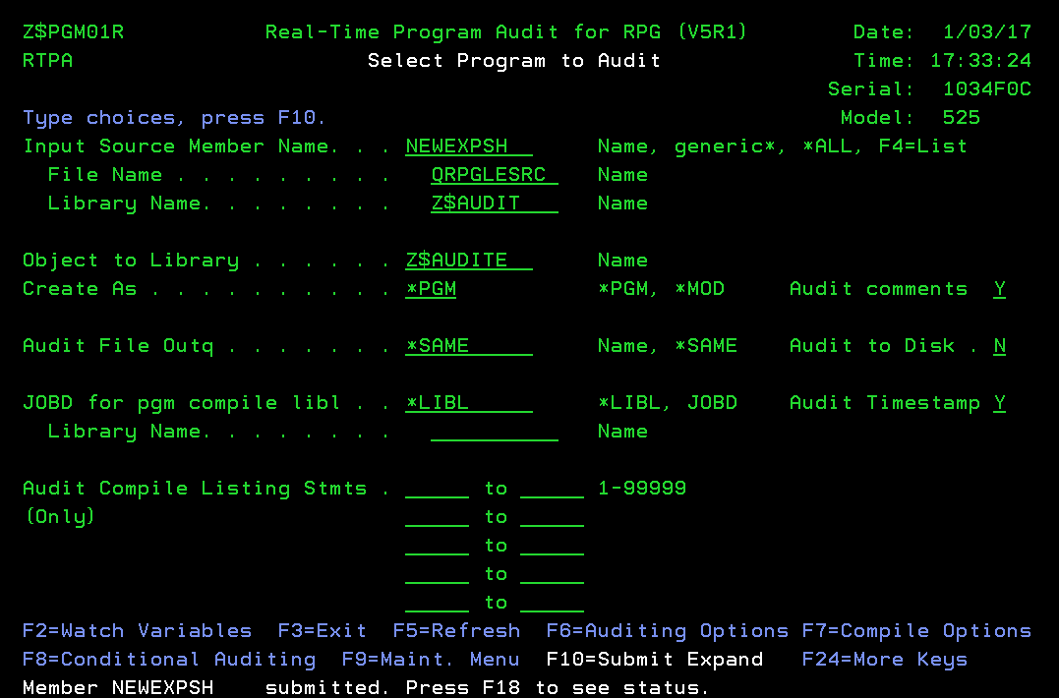

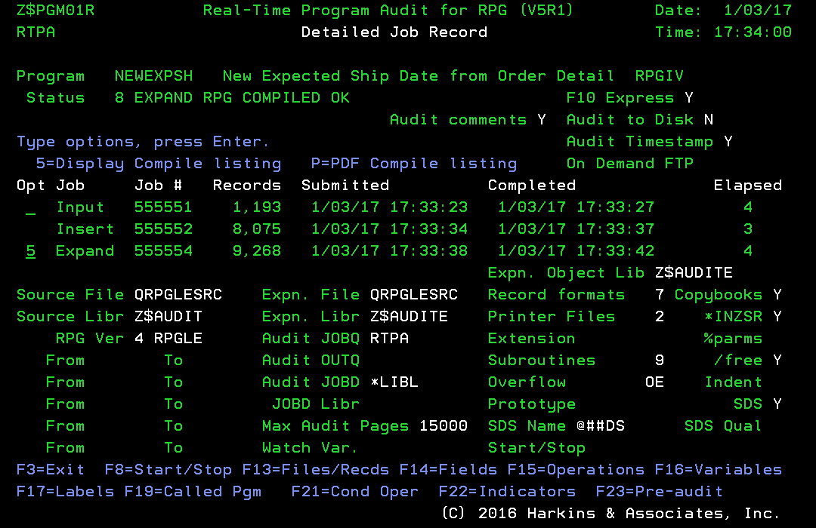
The expanded source program with ZZ audit inserted source statements may be viewed by keying a 5 to the left of the Expand Job. (Note - this expansion status 8 is compile OK for testing)

The easiest correction of the RTPA expand error is to comment the error ZZ audit inserted statement and to recompile the expanded source program in library ZZAUDITE.

Because the IBM SEU (Source Entry Utility) has a limit of 32 thousand records (32K), very large expanded source programs may need to be re-expanded with the from-to statement ranges to reduce the number of generated RTPA ZZ audit statements.

RTPA expansion errors may be reported to Harkins & Associates, Inc. via email for review and possible error correction in a later RTPA update.

Do NOT use special characters in variable or file names
RTPA translates the COPY of the input source program in library ZZAUDITE into upper case, and RTPA may incorrectly translate variable special characters for RTPA users in languages other than English as in this German example:

The original source code looks like this:
C* *DMYJUL *CVDT p3wabi §§JUL 6 0
C Z-ADD p3wabi §§DATE 7 0
C EXSR §CVDT5
C MOVE §§DATE §§JUL 6 0
C ENDIF
The code that you are trying to compile looks like this:
C* *DMYJUL *CVDT p3wabi @@JUL 6 0
ZZ C Z-ADD 183 ZZSRCX
ZZ C CALLP ZZGENS
C Z-ADD p3wabi @@DATE 7 0
ZZ C Z-ADD 184 ZZSRCX
ZZ C CALLP ZZGENS
ZZ C EXCEPT ZZ00184

My program contains field name §§JUL, which is accepted in german language.
RTPA is making @@JUL out of this,

The very best solution to this RTPA translation issue is to NOT use special characters in variable and file names.

The next best solution is to translate the RTPA COPY of this program in library ZZAUDITE to translate the German special character § to an alphanumeric letter, say X, and recompile the source program in library ZZAUDITE.

C* *DMYJUL *CVDT p3wabi XXJUL 6 0

Special-character keyboard set - IBM
https://www.ibm.com › nls › rbagsspeccharkybrdset

The special characters on the enhanced keyboard are used for this group of languages: Belgium, German, French, English, Icelandic, Italian, Spanish, Austrian, Danish, Portuguese, Swedish, Norwegian, Swiss/French, Swiss/German, Spanish Speaking, and Netherlands (Dutch).

The period, the underscore, and the characters $, #, and @ can be used within variable names. For example, A. _$@#1 is a valid variable name. Variable names ending with a period should be avoided, since the period may be interpreted as a command terminator.

Why can’t I compile my large RPGIV program?
Convert RPGIII (OPM) source programs to RPGIV (ILE) source programs with the CVTRPGSRC IBM utility before expanding the source program with RTPA.

The RPGIII compiler is limited to about 20,000 source statements, and is off IBM support.

If you get acompiler error indicating the program is to ;largetrca

Can I ship expanded object programs to other computers?
RTPA expanded (audit enabled) object programs may execute on another System I computer which does not have the RTPA software installed on it. However, the RTPA audit output Printer File ZZAUDITP must be created on the computer which executes the RTPA expanded object program and produces the RTPA audit output..

RTPA is intended for use in program development, unit testing, system testing, pilot production, and in production problem analysis and correction. RTPA is not intended for use in normal production processing, except as needed.

Does RTPA for RPG audit copybook statements?
Yes.

RTPA audits copybook statements by default. If you do not want to audit copybook statements, you can disable auditing of copybook statements in the auditing options.

RTPA does not expand I/COPY copybook statements. For copybooks with D specs, such as SDS definitions, use the format D/COPY instead of I/COPY (as in RPGIII).

Does RTPA for RPG audit procedure statements?
No., not at this time..

The IBM limitations of procedures, including local and global variables, sometimes make RTPA auditing of procedures problematic.

RTPA audits copybook statements by default. Procedures converted from copybooks may be converted back to copybooks to allow RTPA auditing.

Will RTPA exceed maximum file limits in RPGIV?
No.

RTPA increases the number of files used in the RPG source program by two. (This is the printer file or disk file in which the audit file is created.)

Does RTPA for RPG use any indicators?
RTPA for RPG uses the first unused indicator in the source program to turn auditing on or off. If there are no unused indicators in the source program, RTPA auditing is always on.

Does RTPA change the original source or object program?
No. RTPA creates the expanded source program in a temporary directory and puts audit-enabled object program in whatever library you specify. The RTPA User should not replace a production library object program during th RTPA expand process.

How do I expand and create Module objects?
RTPA will create Module objects rather than program objects if the Source type is RPGMOD or SQLRPGMOD. Also RTPA will create Module objects rather than Program objects if *MOD is specified on the RTPA main selection screen.
Create As . . . . . . . . . . . *MOD *PGM, *MOD

Where is the audit output sent during program execution?
By default, RTPA sends its audit output to the printer file ZZAUDITP, which is placed in QGPL when RTPA is installed. This printer file must be in the library list when executing an audit-enabled object. The ZZAUDITP spool file for each audited job is placed in the spool file of the user, and may be displayed with the WRKSPLF command.
RTPA audit output may be placed in a desired output queue as the program executes by entering the output queue on the main RTPA selection screen
Audit File Outq . . . . . . . . *SAME Name, *SAME

How can I direct RTPA audit output to a specific Outq?
Enter the output queue name on the main RTPA selection screen as below:
Audit File Outq . . . . . . . . *SAME Name, *SAME

This is particularly helpful when the programmer wants to send the ZZAUDITP audit output to his or her programmer outq when the application program spooled output goes to another outq.

How can I direct RTPA to use a specific jOBD?
Enter the job description name on the main RTPA selection screen as below:
JOBD for pgm compile libl . . *LIBL *LIBL, JOBD Audit Timestamp Y

This is particularly helpful when the programmer wants to send the ZZAUDITP audit output to his or her programmer outq when the application program spooled output goes to another outq.

How can I expand all the members in a source file?
Use the mass RTPA expansion function on the main RTPA selection screen as below:
Member Name . . . . . . . . . . *ALL Name, generic*, *ALL, F4 List
*ALL in the program name and pressing Command Key 10 expands all source programs in the source file and library.

Member Name . . . . . . . . . . TEST* Name, generic*, *ALL, F4 List
Generic (Partial program name followed by *) expands all source programs with that name
TEST* in the program name and pressing Command Key 10 expands all source programs starting with TEST.

Do I need to expand all my source programs?
Each RPG source program that you want to audit must be expanded with the RTPA. Only expanded programs will produce audit files.

Use the RTPA generic program name (partial name suffixed with an *) to expand all RPG programs with that partial name (for example TEST* expands all programs starting with TEST).

Use the RTPA generic program name *ALL to expand ALL RPG programs in the source member and source file.

How can I selectively audit ranges of source statements?
Use the input compile listing compile statement numbers from the RTPA compile of the input source program to enter from statement and to statement ranges to be audited on the RTPA main screen. This is available by pressing Command Key 18 to review RTPA compile listings of both the input source program and the RTPA enabled expanded source program.
Audit Compile Listing Statements 2500 to 3600 1-99999
4000 to 4500
6001 to 6600
to
to

What is the proper format of a Compile time Array header?
**CTDATA and the name of the Compile Time Array or Table starting in position 10. No other information is valid, including comments.
**CTDATA TAXTAB

Columns . . . : 1 71 Edit ZZAUDITS/QDDSSRC
SEU==> ZZRTPATRK
FMT A* .....A*. 1 ...+... 2 ...+... 3 ...+... 4 ...+... 5 ...+... 6 ...+... 7
*************** Beginning of data *************************************
0001.00 *----------------------------------------------------------------
0002.00 * COPYRIGHT (C) 2016 BY HARKINS & ASSOCIATES, INC. ALL RIGHTS
0003.00 * RESERVED
0004.00 * V6R2M0 RTPA FOR RPG, CLP, COBOL TRACKING SUMMARY
0005.00 *----------------------------------------------------------------
0006.00 0207 *===> DATE LAST CHANGED 02/07/19 SUMMARY SOR REPORTING AND GRAPHS
0007.00 *----------------------------------------------------------------
0008.00 * RTPA JOB TRACKING SUMMARY FILE FOR REPORTING AND GRAPHICS
0009.00 *
0010.00 * Physical File ZZRTPATRK RTPA Job tracking SUMMARY FILE
0011.00 * by Programmer, Program, Input Compile Job
0012.00 *
0013.00 * Date Created 02/07/19
0014.00 * Created by Paul Harkins
0015.00 * Project Real-Time Program Audit Expansion Tracking
0016.00 * Program Usage This file is used to create a summary RTPA Job
0017.00 * tracking record for RPG, CLP and COBOL RTPA
0018.00 * expansions of source programs for summary RTPA
0019.00 * usage reporting and graphical reporting
0020.00 *
0021.00 * Purpose This file summarizes the RTPA tracking files
0022.00 * created in the expansion of RPG, CLP, and COBOL
0023.00 * source programs into file ZZTRPATRK
0024.00 * RPG ZZFI04
0025.00 * CLP ZZFI74
0026.00 * COBOL ZZFC04
0027.00 *----------------------------------------------------------------
0028.00 *Modifications
0029.00 *----------------------------------------------------------------
0030.00 *
0031.00 A UNIQUE
0032.00 *
0033.00 A R ZZTRKREC
0034.00 * SIGNON USER PROFILE
0035.00 A USER 10A TEXT('USER PROFILE')
0036.00 * SOURCE RPG PROGRAM NAME
0037.00 A PROGRAM 10A TEXT('SOURCE PROGRAM NAME')
0038.00 * JOB WHEN SELECTED FOR SOURCE EXPANSION
0039.00 A JOBSESSN 6S 0 TEXT('SESSION JOB ')
0040.00 A STATUS 1A TEXT('AUDIT PRC STATUS')
0041.00 *----------------------------------------------------------------
0042.00 * INPUT SOURCE PROGRAM SUBMITTED FOR ANALYSIS (COMPILE)
0043.00 A JOBINPUT 6S 0 TEXT('INPT SRC JOB ')
0044.00 A DATEINPUT 8S 0 TEXT('INPT SRC SBM DATE')
0045.00 A TIMEINPUT 6S 0 TEXT('INPT SRC SBM TIME')
0046.00 A PROGRAMNA 50A TEXT('PROGRAM DESCRIPTION')
0047.00 A LANGUAGE 3A TEXT('RPG CLP OR COB')
0048.00 A FROMSRCF 10A TEXT('FROM SOURCE FILE')
0049.00 A FROMSRCL 10A TEXT('FROM SOURCE LIBRARY')
0050.00 A TOSRCF 10A TEXT('TO SOURCE FILE')
0051.00 A TOSRCL 10A TEXT('TO SOURCE LIBRARY')
ZZPGM01R Real-Time Program Audit for RPG (V6R2) Date: 2/21/19
PHARKINS Select Program to Audit Time: 10:42:52
RPG3 and RPG4 source members CCSID 37 Serial: 2104FAW
Type choices, press F10. Language ENU Model: 42A
Input Source Member Name. . . TESTTABLE Name, generic*, *ALL, F4=List
File Name . . . . . . . . . QRPGLESRC Name Date Format *MDY
Library Name. . . . . . . . ZZAUDIT Name

Object to Library . . . . . . ZZAUDITE Name
Create As . . . . . . . . . . *PGM *PGM, *MOD Audit comments Y

Audit File Outq . . . . . . . *SAME Name, *SAME Audit copybooks N

JOBD for pgm compile libl . . *LIBL *LIBL, JOBD Audit Timestamp Y
Library Name. . . . . . . . Name
Document Only N
Audit Compile Listing Stmts . to 1-99999
(Only) to Audit to Disk N
to
Project to
Ticket to
F2=Watch Variables F3=Exit F5=Refresh F6=Auditing Options F7=Compile Options
F8=Conditional Auditing F9=Maint. Menu F10=Submit Expand F24=More Keys
(C) 2016 Harkins & Associates, Inc.

RTPA should insert the proper table or array name into the Expanded RPGLE source program in file QRPGLESRC in library ZZAUDITE for a single table or array with a blank table hearder.

This inserting of the missing table or array name allows the RTPA expanded source to properly compile, and does NOT affect the input RPG source program.

Columns . . . : 1 71 Edit ZZAUDITS/QDDSSRC
SEU==> ZZRTPATRK
FMT A* .....A*. 1 ...+... 2 ...+... 3 ...+... 4 ...+... 5 ...+... 6 ...+... 7
*************** Beginning of data *************************************
0001.00 *----------------------------------------------------------------
0002.00 * COPYRIGHT (C) 2016 BY HARKINS & ASSOCIATES, INC. ALL RIGHTS
0003.00 * RESERVED
0004.00 * V6R2M0 RTPA FOR RPG, CLP, COBOL TRACKING SUMMARY
0005.00 *----------------------------------------------------------------
0006.00 0207 *===> DATE LAST CHANGED 02/07/19 SUMMARY SOR REPORTING AND GRAPHS
0007.00 *----------------------------------------------------------------
0008.00 * RTPA JOB TRACKING SUMMARY FILE FOR REPORTING AND GRAPHICS
0009.00 *
0010.00 * Physical File ZZRTPATRK RTPA Job tracking SUMMARY FILE
0011.00 * by Programmer, Program, Input Compile Job
0012.00 *
0013.00 * Date Created 02/07/19
0014.00 * Created by Paul Harkins
0015.00 * Project Real-Time Program Audit Expansion Tracking
0016.00 * Program Usage This file is used to create a summary RTPA Job
0017.00 * tracking record for RPG, CLP and COBOL RTPA
0018.00 * expansions of source programs for summary RTPA
0019.00 * usage reporting and graphical reporting
0020.00 *
0021.00 * Purpose This file summarizes the RTPA tracking files
0022.00 * created in the expansion of RPG, CLP, and COBOL
0023.00 * source programs into file ZZTRPATRK
0024.00 * RPG ZZFI04
0025.00 * CLP ZZFI74
0026.00 * COBOL ZZFC04
0027.00 *----------------------------------------------------------------
0028.00 *Modifications
0029.00 *----------------------------------------------------------------
0030.00 *
0031.00 A UNIQUE
0032.00 *
0033.00 A R ZZTRKREC
0034.00 * SIGNON USER PROFILE
0035.00 A USER 10A TEXT('USER PROFILE')
0036.00 * SOURCE RPG PROGRAM NAME
0037.00 A PROGRAM 10A TEXT('SOURCE PROGRAM NAME')
0038.00 * JOB WHEN SELECTED FOR SOURCE EXPANSION
0039.00 A JOBSESSN 6S 0 TEXT('SESSION JOB ')
0040.00 A STATUS 1A TEXT('AUDIT PRC STATUS')
0041.00 *----------------------------------------------------------------
0042.00 * INPUT SOURCE PROGRAM SUBMITTED FOR ANALYSIS (COMPILE)
0043.00 A JOBINPUT 6S 0 TEXT('INPT SRC JOB ')
0044.00 A DATEINPUT 8S 0 TEXT('INPT SRC SBM DATE')
0045.00 A TIMEINPUT 6S 0 TEXT('INPT SRC SBM TIME')
0046.00 A PROGRAMNA 50A TEXT('PROGRAM DESCRIPTION')
0047.00 A LANGUAGE 3A TEXT('RPG CLP OR COB')
0048.00 A FROMSRCF 10A TEXT('FROM SOURCE FILE')
0049.00 A FROMSRCL 10A TEXT('FROM SOURCE LIBRARY')
0050.00 A TOSRCF 10A TEXT('TO SOURCE FILE')
0051.00 A TOSRCL 10A TEXT('TO SOURCE LIBRARY')
ZZPGM01R Real-Time Program Audit for RPG (V6R2) Date: 2/21/19
PHARKINS Detailed Job Record Time: 10:51:28
Project Ticket CCSID 37 Language: ENU
Program TESTTABLE Sum 12 numbers to a Total *MDY
Status 8 EXPAND RPG COMPILED OK Document only N F10 Express Y
Audit comments Y Audit to Disk N
Type options, press Enter. Audit copybooks N Audit Timestamp Y
5=Display Compile listing P=PDF Compile listing On Demand FTP
Opt Job Job # Records Submitted Completed Elapsed
Input 020757 17 2/21/19 10:51:05 2/21/19 10:51:09 4
Insert 020758 278 2/21/19 10:51:16 2/21/19 10:51:17 1
Expand 020760 295 2/21/19 10:51:20 2/21/19 10:51:23 3
Expn. Object Lib ZZAUDITE
Source File QRPGLESRC Expn. File QRPGLESRC Record formats 1 Copybooks
Source Libr ZZAUDIT Expn. Libr ZZAUDITE Printer Files 1 *INZSR
RPG Ver 4 RPGLE Audit JOBQ RTPA Extension %parms
From To Audit OUTQ Subroutines /free
From To Audit JOBD *LIBL Overflow OG Indent
From To JOBD Libr Prototype SDS
From To Max Audit Pages 15000 SDS Name SDS Qual
From To Watch Var. Start/Stop conditions F8 N
F3=Exit F8=Start/Stop F13=Files/Recds F14=Fields F15=Operations F16=Variables
F2=Watch F17=Labels F19=Called Pgm F21=Cond Oper F22=Indicators F23=Pre-audit
(C) 2016 Harkins & Associates, Inc.

RTPA should insert the proper table or array name into the Expanded RPGLE
Columns . . . : 1 71 Edit ZZAUDITS/QDDSSRC
SEU==> ZZRTPATRK
FMT A* .....A*. 1 ...+... 2 ...+... 3 ...+... 4 ...+... 5 ...+... 6 ...+... 7
*************** Beginning of data *************************************
0001.00 *----------------------------------------------------------------
0002.00 * COPYRIGHT (C) 2016 BY HARKINS & ASSOCIATES, INC. ALL RIGHTS
0003.00 * RESERVED
0004.00 * V6R2M0 RTPA FOR RPG, CLP, COBOL TRACKING SUMMARY
0005.00 *----------------------------------------------------------------
0006.00 0207 *===> DATE LAST CHANGED 02/07/19 SUMMARY SOR REPORTING AND GRAPHS
0007.00 *----------------------------------------------------------------
0008.00 * RTPA JOB TRACKING SUMMARY FILE FOR REPORTING AND GRAPHICS
0009.00 *
0010.00 * Physical File ZZRTPATRK RTPA Job tracking SUMMARY FILE
0011.00 * by Programmer, Program, Input Compile Job
0012.00 *
0013.00 * Date Created 02/07/19
0014.00 * Created by Paul Harkins
0015.00 * Project Real-Time Program Audit Expansion Tracking
0016.00 * Program Usage This file is used to create a summary RTPA Job
0017.00 * tracking record for RPG, CLP and COBOL RTPA
0018.00 * expansions of source programs for summary RTPA
0019.00 * usage reporting and graphical reporting
0020.00 *
0021.00 * Purpose This file summarizes the RTPA tracking files
0022.00 * created in the expansion of RPG, CLP, and COBOL
0023.00 * source programs into file ZZTRPATRK
0024.00 * RPG ZZFI04
0025.00 * CLP ZZFI74
0026.00 * COBOL ZZFC04
0027.00 *----------------------------------------------------------------
0028.00 *Modifications
0029.00 *----------------------------------------------------------------
0030.00 *
0031.00 A UNIQUE
0032.00 *
0033.00 A R ZZTRKREC
0034.00 * SIGNON USER PROFILE
0035.00 A USER 10A TEXT('USER PROFILE')
0036.00 * SOURCE RPG PROGRAM NAME
0037.00 A PROGRAM 10A TEXT('SOURCE PROGRAM NAME')
0038.00 * JOB WHEN SELECTED FOR SOURCE EXPANSION
0039.00 A JOBSESSN 6S 0 TEXT('SESSION JOB ')
0040.00 A STATUS 1A TEXT('AUDIT PRC STATUS')
0041.00 *----------------------------------------------------------------
0042.00 * INPUT SOURCE PROGRAM SUBMITTED FOR ANALYSIS (COMPILE)
0043.00 A JOBINPUT 6S 0 TEXT('INPT SRC JOB ')
0044.00 A DATEINPUT 8S 0 TEXT('INPT SRC SBM DATE')
0045.00 A TIMEINPUT 6S 0 TEXT('INPT SRC SBM TIME')
0046.00 A PROGRAMNA 50A TEXT('PROGRAM DESCRIPTION')
0047.00 A LANGUAGE 3A TEXT('RPG CLP OR COB')
0048.00 A FROMSRCF 10A TEXT('FROM SOURCE FILE')
0049.00 A FROMSRCL 10A TEXT('FROM SOURCE LIBRARY')
0050.00 A TOSRCF 10A TEXT('TO SOURCE FILE')
0051.00 A TOSRCL 10A TEXT('TO SOURCE LIBRARY')
Display Spooled File
File . . . . . : TESTTABLE Page/Line 10/4
Control . . . . . Columns 1 - 78
Find . . . . . .
*...+....1....+....2....+....3....+....4....+....5....+....6....+....7....+...
Number ....+....1....+....2....+....3....+....4....+....5....+....6....+....7.
C o m p i l e T i m e D a t a
298 **CTDATA months
*--------------------------------------------------------------------*
* Array . . . : MONTHS *
*--------------------------------------------------------------------*
299 67890123789012348912345688889999666644448844553365742888885536447443217
300 **CTDATA XY
*--------------------------------------------------------------------*
* Array . . . : XY *
*--------------------------------------------------------------------*
301 8 C eval month = months(ind)
302 15 C eval *inlr = *on
303 **CTDATA XQ
*--------------------------------------------------------------------*
* Array . . . : XQ *
More...
F3=Exit F12=Cancel F19=Left F20=Right F24=More keys

RPGLE tables and arrays must be in the formant **CTDATA Table name

Columns . . . : 1 71 Edit ZZAUDITS/QDDSSRC
SEU==> ZZRTPATRK
FMT A* .....A*. 1 ...+... 2 ...+... 3 ...+... 4 ...+... 5 ...+... 6 ...+... 7
*************** Beginning of data *************************************
0001.00 *----------------------------------------------------------------
0002.00 * COPYRIGHT (C) 2016 BY HARKINS & ASSOCIATES, INC. ALL RIGHTS
0003.00 * RESERVED
0004.00 * V6R2M0 RTPA FOR RPG, CLP, COBOL TRACKING SUMMARY
0005.00 *----------------------------------------------------------------
0006.00 0207 *===> DATE LAST CHANGED 02/07/19 SUMMARY SOR REPORTING AND GRAPHS
0007.00 *----------------------------------------------------------------
0008.00 * RTPA JOB TRACKING SUMMARY FILE FOR REPORTING AND GRAPHICS
0009.00 *
0010.00 * Physical File ZZRTPATRK RTPA Job tracking SUMMARY FILE
0011.00 * by Programmer, Program, Input Compile Job
0012.00 *
0013.00 * Date Created 02/07/19
0014.00 * Created by Paul Harkins
0015.00 * Project Real-Time Program Audit Expansion Tracking
0016.00 * Program Usage This file is used to create a summary RTPA Job
0017.00 * tracking record for RPG, CLP and COBOL RTPA
0018.00 * expansions of source programs for summary RTPA
0019.00 * usage reporting and graphical reporting
0020.00 *
0021.00 * Purpose This file summarizes the RTPA tracking files
0022.00 * created in the expansion of RPG, CLP, and COBOL
0023.00 * source programs into file ZZTRPATRK
0024.00 * RPG ZZFI04
0025.00 * CLP ZZFI74
0026.00 * COBOL ZZFC04
0027.00 *----------------------------------------------------------------
0028.00 *Modifications
0029.00 *----------------------------------------------------------------
0030.00 *
0031.00 A UNIQUE
0032.00 *
0033.00 A R ZZTRKREC
0034.00 * SIGNON USER PROFILE
0035.00 A USER 10A TEXT('USER PROFILE')
0036.00 * SOURCE RPG PROGRAM NAME
0037.00 A PROGRAM 10A TEXT('SOURCE PROGRAM NAME')
0038.00 * JOB WHEN SELECTED FOR SOURCE EXPANSION
0039.00 A JOBSESSN 6S 0 TEXT('SESSION JOB ')
0040.00 A STATUS 1A TEXT('AUDIT PRC STATUS')
0041.00 *----------------------------------------------------------------
0042.00 * INPUT SOURCE PROGRAM SUBMITTED FOR ANALYSIS (COMPILE)
0043.00 A JOBINPUT 6S 0 TEXT('INPT SRC JOB ')
0044.00 A DATEINPUT 8S 0 TEXT('INPT SRC SBM DATE')
0045.00 A TIMEINPUT 6S 0 TEXT('INPT SRC SBM TIME')
0046.00 A PROGRAMNA 50A TEXT('PROGRAM DESCRIPTION')
0047.00 A LANGUAGE 3A TEXT('RPG CLP OR COB')
0048.00 A FROMSRCF 10A TEXT('FROM SOURCE FILE')
0049.00 A FROMSRCL 10A TEXT('FROM SOURCE LIBRARY')
0050.00 A TOSRCF 10A TEXT('TO SOURCE FILE')
0051.00 A TOSRCL 10A TEXT('TO SOURCE LIBRARY')
ZZPGM01R Real-Time Program Audit for RPG (V6R2) Date: 2/21/19
PHARKINS Select Program to Audit Time: 10:42:52
RPG3 and RPG4 source members CCSID 37 Serial: 2104FAW
Type choices, press F10. Language ENU Model: 42A
Input Source Member Name. . . TESTTABLE Name, generic*, *ALL, F4=List
File Name . . . . . . . . . QRPGLESRC Name Date Format *MDY
Library Name. . . . . . . . ZZAUDIT Name

Object to Library . . . . . . ZZAUDITE Name
Create As . . . . . . . . . . *PGM *PGM, *MOD Audit comments Y

Audit File Outq . . . . . . . *SAME Name, *SAME Audit copybooks N

JOBD for pgm compile libl . . *LIBL *LIBL, JOBD Audit Timestamp Y
Library Name. . . . . . . . Name
Document Only N
Audit Compile Listing Stmts . to 1-99999
(Only) to Audit to Disk N
to
Project to
Ticket to
F2=Watch Variables F3=Exit F5=Refresh F6=Auditing Options F7=Compile Options
F8=Conditional Auditing F9=Maint. Menu F10=Submit Expand F24=More Keys
(C) 2016 Harkins & Associates, Inc.

RTPA should insert the proper table or array name into the Expanded RPGLE

Appendix
B

Appendix B: RTPA Command Keys

Command Key | Function
F1 | Display Online Help
F3 | Exit
F4 | Prompt field,
F5 | Refresh screen or Apply screen
F6 | Auditing Options
F7 | Compile Options
F8 | Conditional Auditing
F9 | RTPA Maintenance Menu window
F10 | Submit File for Auditing
F11 | Advanced Auditing
F12 | Previous screen
F13 | (Advanced) Select Records to Audit
F14 | (Advanced) Select Variables to Audit
F15 | (Advanced) Select Operations to Audit
F16 | (Advanced) Select Labels and Subroutines to Audit
F17 | (Advanced) Select Indicators to Audit
F18 | Job History
F19 | Called programs from this expanded source program
F21 | Conditional Operations in program
F22 | Indicators used in program
F23 | Per-Audit Conditions in program
F24 | More command keys (toggle)

Appendix
C

Appendix C: How RTPA Works RTPA Conditional auditing

RPGLE program TESTCOND with RTPA audit statements
Columns . . . : 6 76 Edit ZZAUDIT/QRPGLESRC
SEU==> TESTCOND
FMT * *. 1 ...+... 2 ...+... 3 ...+... 4 ...+... 5 ...+... 6 ...+... 7 ...+.
*************** Beginning of data *************************************
0001.00 * Test conditional auditing
0002.00 C MOVEL 'AAAAAA' HOLD6 6
0003.00 C MOVEL 'BBBBBB' HOLD6
0004.00 C z-add 1 test1n 1 0
0005.00 C test1n IFEQ 1
0006.00 C MOVEL 'CCCCCC' HOLD6
0007.00 C ENDIF
0008.00 C MOVEL 'DDDDDD' HOLD6
0009.00 * Exit program
0010.00 C SETON LR
0011.00 * return to calling program
0012.00 C RETURN
****************** End of data ****************************************

RTPA sample RPGLE program TESTCOND in QRPGLESRC library ZZAUDIT
Programmer Menu
System: S1034F0C
Select one of the following:
1. Start Data File Utility
2. Work with Queries
3. Create an object from a source file object name, type, pgm for CMD
4. Call a program program name
5. Run a command command
6. Submit a job (job name), , ,(command)
7. Go to a menu menu name
8. Edit a source file member (srcmbr), (type)
9. Design display format using SDA (srcmbr), ,(mode)
90. Sign off (*nolist, *list)

Selection . . . . . 5 Parm . . . .
Type . . . . . . . RPGLE Parm 2 . . .
Command . . . . . . rtpa

Source file . . . . QRPGLESRC Source library . . . . . . . ZZAUDIT
Object library . . ZZAUDIT Job description . . . . . . *USRPRF

F3=Exit F4=Prompt F6=Display messages F10=Command entry
F12=Cancel F14=Work with submitted jobs F18=Work with output

RTPA command to display the RTPA for RPG entry screen
ZZPGM01R Real-Time Program Audit for RPG (V6R1) Date: 8/07/18
PHH Select Program to Audit Time: 9:37:55
CCSID 37 Serial: 1034F0C
Type choices, press F10. Language ENU Model: 525
Input Source Member Name. . . TESTCOND Name, generic*, *ALL, F4=List
File Name . . . . . . . . . QRPGLESRC Name
Library Name. . . . . . . . ZZAUDIT Name

Object to Library . . . . . . ZZAUDITE Name
Create As . . . . . . . . . . *PGM *PGM, *MOD Audit comments Y

Audit File Outq . . . . . . . *SAME Name, *SAME Audit copybooks N

JOBD for pgm compile libl . . *LIBL *LIBL, JOBD Audit Timestamp N
Library Name. . . . . . . . Name
Document Only N
Audit Compile Listing Stmts . to 1-99999
(Only) to Audit to Disk N
to
to
to
F2=Watch Variables F3=Exit F5=Refresh F6=Auditing Options F7=Compile Options
F8=Conditional Auditing F9=Maint. Menu F10=Submit Expand F24=More Keys
(C) 2016 Harkins & Associates, Inc.

Member TESTCOND submitted. Press F18 to see status
ZZPGM01R Real-Time Program Audit for RPG (V6R1) Date: 8/07/18
PHH Job History Time: 9:41:16
ODS User CCSID: 37
Type option, press Enter. Language: ENU
4=Delete 5=Display

O Program Job Status Program Name Job# Date Time
5 TESTCOND 8 EXPN OK Test Conditional auditing 173700 8/07/18 9:38:33

F3=Exit F5=Refresh Subfile F12=Cancel
(C) 2016 Harkins & Associates, Inc.

A copy of RPGLE program TESTCOND has been successfully expanded with RTPA audit capability
Key 5 to display the RTPA expansion details (optional)
ZZPGM01R Real-Time Program Audit for RPG (V6R1) Date: 8/07/18
PHH Detailed Job Record Time: 9:46:01
CCSID 37 Language: ENU
Program TESTCOND Test Conditional auditing
Status 8 EXPAND RPG COMPILED OK Document only N F10 Express Y
Audit comments Y Audit to Disk N
Type options, press Enter. Audit copybooks N Audit Timestamp N
5=Display Compile listing P=PDF Compile listing On Demand FTP
Opt Job Job # Records Submitted Completed Elapsed
Input 173700 12 8/07/18 9:38:33 8/07/18 9:38:35 2
Insert 173701 233 8/07/18 9:38:41 8/07/18 9:38:42 1
Expand 173703 245 8/07/18 9:38:42 8/07/18 9:38:43 1
Expn. Object Lib ZZAUDITE
Source File QRPGLESRC Expn. File QRPGLESRC Record formats Copybooks
Source Libr ZZAUDIT Expn. Libr ZZAUDITE Printer Files *INZSR
RPG Ver 4 RPGLE Audit JOBQ RTPA Extension %parms
From To Audit OUTQ Subroutines /free
From To Audit JOBD *LIBL Overflow OG Indent
From To JOBD Libr Prototype SDS
From To Max Audit Pages 15000 SDS Name SDS Qual
From To Watch Var. Start/Stop conditions F8 N
F3=Exit F8=Start/Stop F13=Files/Recds F14=Fields F15=Operations F16=Variables
F17=Labels F19=Called Pgm F21=Cond Oper F22=Indicators F23=Pre-audit

Insert 173701 233
233 RTPA ZZ audit statements have been inserted into a COPY of the input RPGLE source program in RTPA work library ZZAUDITE, and the expanded TESTCOND program in ZZAUDITE has been compiled with the expanded TSTCOND object program in RTPA work library ZZAUDITE.
Edit Library List
System: S1034F0C
Type new/changed information, press Enter.

Sequence Sequence Sequence
Number Library Number Library Number Library
0 150 300
10 QTEMP 160 310
20 ZZAUDITE 170 320
30 ZZAUDIT 180 330
40 QGPL 190 340
50 200 350
60 210 360
70 220 370
80 230 380
90 240 390
100 250 400
110 260 410
120 270 420
130 280 430
140 290 440
More...
F3=Exit F5=Refresh F12=Cancel
RTPA work library ZZAUDITE is in the library list, before RTPA library ZZAUDIT
Programmer Menu
System: S1034F0C
Select one of the following:
1. Start Data File Utility
2. Work with Queries
3. Create an object from a source file object name, type, pgm for CMD
4. Call a program program name
5. Run a command command
6. Submit a job (job name), , ,(command)
7. Go to a menu menu name
8. Edit a source file member (srcmbr), (type)
9. Design display format using SDA (srcmbr), ,(mode)
90. Sign off (*nolist, *list)

Selection . . . . . 5 Parm . . . .
Type . . . . . . . RPGLE Parm 2 . . .
Command . . . . . . call TESTCOND

Source file . . . . QRPGLESRC Source library . . . . . . . ZZAUDIT
Object library . . ZZAUDIT Job description . . . . . . *USRPRF

F3=Exit F4=Prompt F6=Display messages F10=Command entry
F12=Cancel F14=Work with submitted jobs F18=Work with output

call TESTCOND (to create the ZZPRINTP RTPA audit log of executed TESTCOND
WRKSPLF to display the spool files for the user
Work with All Spooled Files

Type options, press Enter.
1=Send 2=Change 3=Hold 4=Delete 5=Display 6=Release 7=Messages
8=Attributes 9=Work with printing status

Device or Total Cur
Opt File User Queue User Data Sts Pages Page Copy
TESTCOND PHH ODSOUTQ RDY 7 1
TESTCOND PHH ODSOUTQ RDY 12 1
5 ZZAUDITP PHH ODSOUTQ TESTCOND HLD 1 1

Bottom
Parameters for options 1, 2, 3 or command
===>
F3=Exit F10=View 4 F11=View 2 F12=Cancel F22=Printers F24=More keys

Display Spooled File
File . . . . . : ZZAUDITP Page/Line 1/1
Control . . . . . Columns 1 - 78
Find . . . . . .
*...+....1....+....2....+....3....+....4....+....5....+....6....+....7....+...
Program-TESTCOND Test Conditional auditing Obj Lib
TESTCOND TESTCOND
Job: 173552 User Profile: PHH Source Type: RPGLE
Line#
2 C MOVEL 'AAAAAA' HOLD6 6
AAAAAA
3 C MOVEL 'BBBBBB' HOLD6
BBBBBB
4 C z-add 1 test1n 1 0
1
5 C test1n IFEQ 1
1
6 C MOVEL 'CCCCCC' HOLD6
CCCCCC
7 C ENDIF
8 C MOVEL 'DDDDDD' HOLD6
DDDDDD
9 * Exit program
10 C SETON LR
11 * return to calling program
12 C RETURN

Bottom
F3=Exit F12=Cancel F19=Left F20=Right F24=More keys
RTPA audit log of RPGLE program TESTCOND executing statements
Columns . . . : 1 71 Edit ZZAUDITE/QRPGLESRC
SEU==> TESTCOND
FMT * ..... *. 1 ...+... 2 ...+... 3 ...+... 4 ...+... 5 ...+... 6 ...+... 7
*************** Beginning of data *************************************
0001.00 * Test conditional auditing
0002.00 ZZ FZZAUDITP O F 280 PRINTER
0003.00 ZZ F USROPN
0004.00 ZZ FZZAUDSRC IF E K DISK
0005.00 ZZ D # S 100 DIM(00001) CTDATA PERRCD(1)
0006.00 ZZ D #Q S 23 DIM(00001) CTDATA PERRCD(1)
0007.00 ZZ D DS
0008.00 ZZ D ZZBIN4 1 4B 0
0009.00 ZZ D ZZSTOPA 5 5
0010.00 ZZ D ZZMAXP 7 11 0
0011.00 ZZ D ZZNME 12 25
0012.00 ZZ D ZZH S 100 DIM(300)
0013.00 ZZ D ZZCONS C CONST('0115000 N '
0014.00 ZZ D ZZCON1 C CONST('TESTCOND JOB 173700'
0015.00 ZZ D ZZCON2 C CONST(' ')
0016.00 ZZ D ZZCON3 C CONST(' ') 0017.00 ZZ D ZZCONF C CONST('QRPGLESRC ZZAUDIT '
0018.00 ZZ D ZZCONT C CONST('RPGLE '
0019.00 ZZ D ZZOVRP C CONST('OVRPRTF FILE(ZZAUDIT-
0020.00 ZZ D P) OUTQ(ZZOQ10) ')
0021.00 ZZ D ZZCONN C CONST('00010 '
0022.00 ZZ D ZZCOD1 C CONST('Test Conditional aud'
0023.00 ZZ D ZZCOD2 C CONST('iting '
0024.00 ZZ D ZZCOD3 C CONST(' ')
0025.00 ZZ D ZZUNDE C CONST('*UNDEF')
0026.00 ZZ D ZZDateTime S Z
0027.00 ZZ D DS
0028.00 ZZ D ZZDateTimeDS 1 26
0029.00 ZZ D ZZdate 1 10
0030.00 ZZ D ZZTime 12 23
0031.00 ZZ D DS
0032.00 ZZ D ZZAudStampDS 1 52 0034.00 ZZ D ZZUserRe 8 17
0035.00 ZZ D ZZPROGRE 19 28
0036.00 ZZ D ZZDateRe 30 39
0037.00 ZZ D ZZTimeRe 41 52
0038.00 ZZ D ZZTIMB S 12 INZ(' ')
0039.00 ZZ D SDS
0040.00 ZZ D ZZPROG 1 10
0041.00 ZZ D ZZPRLI 81 90
0042.00 ZZ D ZZJBNA 244 253
0043.00 ZZ D ZZUSRP 254 263
0044.00 ZZ D ZZJOB# 264 269
0045.00 ZZ D ZZPROP 334 343
0046.00 ZZ D ZZPROM 344 353
0047.00 ZZ C EXSR ZZINIT
0048.00 ZZ C Z-ADD 1 ZZSRC#
0049.00 C MOVEL 'AAAAAA' HOLD6 6
0050.00 ZZ C Z-ADD 1 ZZSRC# 0051.00 ZZ C EXSR ZZGENS
0052.00 ZZ C EXCEPT ZZ00001
0053.00 C MOVEL 'BBBBBB' HOLD6
0054.00 ZZ C Z-ADD 2 ZZSRC#
0055.00 ZZ C EXSR ZZGENS
0056.00 ZZ C EXCEPT ZZ00002
0057.00 C z-add 1 test1n 1 0
0058.00 ZZ C Z-ADD 3 ZZSRC#
0059.00 ZZ C EXSR ZZGENS
0060.00 ZZ C EXCEPT ZZ00003
0061.00 ZZ C EXSR ZZGETI
0062.00 ZZ C EXCEPT Z#00001
0063.00 C test1n IFEQ 1
0064.00 C MOVEL 'CCCCCC' HOLD6
0065.00 ZZ C Z-ADD 4 ZZSRC#
0066.00 ZZ C EXSR ZZGENS
0067.00 ZZ C EXCEPT ZZ00004 0068.00 C ENDIF
0069.00 ZZ C Z-ADD 5 ZZSRC#
0070.00 ZZ C EXSR ZZGENS
0071.00 C MOVEL 'DDDDDD' HOLD6
0072.00 ZZ C Z-ADD 6 ZZSRC#
0073.00 ZZ C EXSR ZZGENS
0074.00 ZZ C EXCEPT ZZ00006
0075.00 * Exit program
0076.00 ZZ C Z-ADD 7 ZZSRC#
0077.00 ZZ C EXSR ZZGENS
0078.00 C SETON
0079.00 ZZ C Z-ADD 8 ZZSRC#
0080.00 ZZ C EXSR ZZGENS
0081.00 * return to calling program
0082.00 ZZ C Z-ADD 9 ZZSRC#
0083.00 ZZ C EXSR ZZGENS
0084.00 ZZ C Z-ADD 10 ZZSRC#
0085.00 ZZ C EXSR ZZGENS
0086.00 C RETURN
0087.00 ZZ C ZZINIT BEGSR
0088.00 ZZ C ZZAUDKEY KLIST
0089.00 ZZ C KFLD ZDPROG
0090.00 ZZ C KFLD ZDJOB1
0091.00 ZZ C KFLD ZDVISEQ
0092.00 ZZ C move ZZPROG ZDPROG
0093.00 ZZ C move ZZCON1 ZDJOB1
0094.00 ZZ C z-add 1000000 ZDVISEQ
0095.00 ZZ C Z-ADD *ZEROS ZZSRC# 5 0
0096.00 ZZ C Z-ADD *ZEROS ZZSRC#2 5 0
0097.00 ZZ C ZZOPNS IFEQ *BLANK
0098.00 ZZ C MOVEL '1' ZZOPNS 1
0099.00 ZZ C MOVEL *BLANKS ZZOTXT 50
0100.00 ZZ C MOVEL ZZCONS ZZHLD7 7
0101.00 ZZ C MOVE ZZHLD7 ZZHLD5 5 0
0102.00 ZZ C Z-ADD ZZHLD5 ZZMAXP
0103.00 ZZ C 10 SUBST(P) ZZCONS:8 ZZOQ10 10
0104.00 ZZ C ZZOQ10 IFNE *BLANKS
0105.00 ZZ C MOVEL ZZOVRP $$OVRP 40
0106.00 ZZ C ZZOQ10 CAT(P) ')' ZZOQ11 11
0107.00 ZZ C MOVE ZZOQ11 $$OVRP
0108.00 ZZ C Z-ADD 40 $$LEN 15 5
0109.00 ZZ C CALL 'QCMDEXC'
0110.00 ZZ C PARM $$OVRP
0111.00 ZZ C PARM $$LEN
0112.00 ZZ C ENDIF
0113.00 ZZ C OPEN ZZAUDITP
0114.00 ZZ C ZZOQ10 IFNE *BLANKS
0115.00 ZZ C CALL 'ZZPGM25C'
0116.00 ZZ C PARM ZZOQ10
0117.00 ZZ C PARM ZZERR 1
0118.00 ZZ C ENDIF 0119.00 ZZ C TIME ZZDATETIME
0120.00 ZZ C MOVE ZZDATETIME ZZDATETIMEDS
0121.00 ZZ C MOVE ZZTIME ZZTIMS 12
0122.00 ZZ C Z-ADD 1 ZZPAGP 5 0
0123.00 ZZ C MOVE ZZJOB# ZZJOBRE
0124.00 ZZ C MOVE ZZUSRP ZZUSERRE
0125.00 ZZ C MOVE ZZPROG ZZPROGRE
0126.00 ZZ C EXSR ZZGETI
0127.00 ZZ C EXCEPT ZZSTRT
0128.00 ZZ C END
0129.00 ZZ C ZZBAUD TAG
0130.00 ZZ C ENDSR
0131.00 ZZ C ZZGETI BEGSR
0132.00 ZZ C TIME ZZDATETIME
0133.00 ZZ C MOVE ZZDATETIME ZZDATETIMEDS
0134.00 ZZ C MOVE ZZTIME ZZTIMN 12
0135.00 ZZ C MOVE ZZTIMN ZZTIMERE 12 0136.00 ZZ C MOVE ZZDATE ZZDATERE 10
0137.00 ZZ C ZZNOPR TAG
0138.00 ZZ C ENDSR
0139.00 ZZ C ZZ$MLP BEGSR
0140.00 ZZ C Z-ADD *ZEROS FRM$ 5 0
0141.00 ZZ C Z-ADD *ZEROS END$ 5 0
0142.00 ZZ C *LIKE DEFINE END$ ZZEND
0143.00 ZZ C DO 300 $X$$ 4 0
0144.00 ZZ C $X$$ IFEQ 1
0145.00 ZZ C SETON 8
0146.00 ZZ C END
0147.00 ZZ C END$ IFEQ *ZEROS
0148.00 ZZ C Z-ADD $X$$ FRM$
0149.00 ZZ C Z-ADD 100 END$
0150.00 ZZ C ELSE
0151.00 ZZ C END$ ADD 1 FRM$
0152.00 ZZ C FRM$ ADD 99 END$ 0153.00 ZZ C ENDIF
0154.00 ZZ C END$ IFGT ZZEND
0155.00 ZZ C Z-ADD ZZEND END$
0156.00 ZZ C ENDIF
0157.00 ZZ C ZZH($X$$) IFNE *BLANKS
0158.00 ZZ C EXCEPT ZZ$MPL
0159.00 ZZ C SETOFF 8
0160.00 ZZ C ENDIF
0161.00 ZZ C END$ IFEQ ZZEND
0162.00 ZZ C LEAVE
0163.00 ZZ C ENDIF
0164.00 ZZ C ENDDO
0165.00 ZZ C ENDSR
0166.00 ZZ C ZZGENS BEGSR
0167.00 ZZ C EXSR ZZGETI
0168.00 ZZ C z-add 1000000 ZDVISEQ
0169.00 ZZ C add ZZSRC# ZDVISEQ 0170.00 ZZ C MOVEL *blanks ZDAUDSTM
0171.00 ZZ C MOVEL 'NO SOURCE' ZDAUDSTM
0172.00 ZZ C zzaudkey CHAIN ZZAUDREC
0173.00 ZZ C if not%found
0174.00 ZZ C MOVEL 'NO SOURCE' ZDAUDSTM
0175.00 ZZ C ELSE
0176.00 ZZ C MOVE ZDAUDSTM ZZFILNAM 10
0177.00 ZZ C END
0178.00 ZZ C EXCEPT ZZGENP
0179.00 ZZ C MOVEL *BLANKS ZZMESG 20
0180.00 ZZ C MOVEL *BLANKS ZZTIMB
0181.00 ZZ C ENDSR
0182.00 ZZ OZZAUDITP E ZZSTRT 1 01
0183.00 ZZ O 8 'Program-'
0184.00 ZZ O ZZPROG 18
0185.00 ZZ O ZZCOD1 40 0187.00 ZZ O ZZCOD3 70
0188.00 ZZ O 80 'Obj Lib: '
0189.00 ZZ O ZZPRLI 90
0190.00 ZZ O 101 'Initiated:'
0191.00 ZZ O UDATE 110 ' / / '
0192.00 ZZ O ZZTIMS 123
0193.00 ZZ O 130 'PAGE'
0194.00 ZZ O ZZPAGP Z 135
0195.00 ZZ O ZZCONT 159
0196.00 ZZ O ZZPROG 169
0197.00 ZZ O E ZZSTRT 1
0198.00 ZZ O ZZPROP 19
0199.00 ZZ O ZZPROM 31
0200.00 ZZ O E ZZSTRT 1
0201.00 ZZ O 5 'Job: '
0202.00 ZZ O ZZJOB# 11
0203.00 ZZ O 39 'User Profile:' 0204.00 ZZ O ZZUSRP 50
0205.00 ZZ O 65 'Source Type:'
0206.00 ZZ O ZZCONT 86
0207.00 ZZ O 100 'Source File/Librar
0208.00 ZZ O ZZCONF 121
0209.00 ZZ O ZZCON1 145
0210.00 ZZ O E ZZSTRT 1
0211.00 ZZ O 5 'Line#'
0212.00 ZZ O 103 'Do#'
0213.00 ZZ O 109 'SrcId'
0214.00 ZZ O 116 'ChgDat'
0215.00 ZZ O 123 ' Seq#'
0216.00 ZZ O E ZZ$MPL 1
0217.00 ZZ O 88 ZZNME 14
0218.00 ZZ O ZZH($X$$) 127
0219.00 ZZ O 027 '''' 0221.00 ZZ O FRM$ Z 25
0222.00 ZZ O E ZZGENP 1
0223.00 ZZ O ZDAUDSTM 138
0224.00 ZZ O ZZMESG 144
0225.00 ZZ O ZZTIMB 157
0226.00 ZZ O ZZFILNAM 211
0227.00 ZZ O E ZZ00001 1
0228.00 ZZ O HOLD6 055
0229.00 ZZ O E ZZ00002 1
0230.00 ZZ O HOLD6 055
0231.00 ZZ O E ZZ00003 1
0232.00 ZZ O test1n L 056
0233.00 ZZ O E Z#00001 1
0234.00 ZZ O #(00001) 100
0235.00 ZZ O #Q(00001) 123
0236.00 ZZ O E Z#00001 1
0237.00 ZZ O test1n L 018
0238.00 ZZ O E ZZ00004 1
0239.00 ZZ O HOLD6 055
0240.00 ZZ O E ZZ00006 1
0241.00 ZZ O HOLD6 055
0242.00 **CTDATA #
0243.00 5 C test1n IFEQ 1
0244.00 **CTDATA #Q
0245.00 B01 180730 500
****************** End of data ****************************************

F3=Exit F4=Prompt F5=Refresh F9=Retrieve F10=Cursor F11=Toggle
F16=Repeat find F17=Repeat change F24=More keys

COPY of RPGLE source program TESTCOND in RTPA work library with RTPA ZZ inserted statements to enable RTPA auditing of all audit enabled source statements that execute in this job (with this data)
RTPA normally audits all executing program statements, unless selective RTPA auditing is implemented including:
- Audit only ranges of executable statements from the compile listing (Key up to 5 ranges of compile listing statements)
- Audit only Watch variables of executable statements from the compile listing (command key 2)
- Dynamically Audit based on conditional auditing statements of executable statements (command key 8)
Audit only ranges of executable statements from the compile listing

Work with All Spooled Files

Type options, press Enter.
1=Send 2=Change 3=Hold 4=Delete 5=Display 6=Release 7=Messages
8=Attributes 9=Work with printing status

Device or Total Cur
Opt File User Queue User Data Sts Pages Page Copy
5 TESTCOND PHH ODSOUTQ RDY 7 1
TESTCOND PHH ODSOUTQ RDY 12 1
ZZAUDITP PHH ODSOUTQ TESTCOND HLD 1 1

Bottom
Parameters for options 1, 2, 3 or command
===>
F3=Exit F10=View 4 F11=View 2 F12=Cancel F22=Printers F24=More keys

RPGLE source program TESTCOND input compile listing
Display Spooled File
File . . . . . : TESTCOND Page/Line 2/3
Control . . . . . Columns 1 - 78
Find . . . . . .
*...+....1....+....2....+....3....+....4....+....5....+....6....+....7....+...
Line <---------------------- Source Specifications -------------------------
Number ....1....+....2....+....3....+....4....+....5....+....6....+....7....+.
S o u r c e L i s t i n g
1 * Test conditional auditing
2 C MOVEL 'AAAAAA' HOLD6 6
3 C MOVEL 'BBBBBB' HOLD6
4 C z-add 1 test1n 1 0
5 C test1n IFEQ 1
6 C MOVEL 'CCCCCC' HOLD6
7 C ENDIF
8 C MOVEL 'DDDDDD' HOLD6
9 * Exit program
10 C SETON ----LR
11 * return to calling program
12 C RETURN
* * * * * E N D O F S O U R C E * * * * *

RPGLE source program TESTCOND input compile listing
Audit range of compile listing statements 2 through 4
ZZPGM01R Real-Time Program Audit for RPG (V6R1) Date: 8/07/18
PHH Select Program to Audit Time: 10:43:32
CCSID 37 Serial: 1034F0C
Type choices, press F10. Language ENU Model: 525
Input Source Member Name. . . TESTCOND Name, generic*, *ALL, F4=List
File Name . . . . . . . . . QRPGLESRC Name
Library Name. . . . . . . . ZZAUDIT Name

Object to Library . . . . . . ZZAUDITE Name
Create As . . . . . . . . . . *PGM *PGM, *MOD Audit comments Y

Audit File Outq . . . . . . . *SAME Name, *SAME Audit copybooks N

JOBD for pgm compile libl . . *LIBL *LIBL, JOBD Audit Timestamp N
Library Name. . . . . . . . Name
Document Only N
Audit Compile Listing Stmts . 2 to 4 1-99999
(Only) to Audit to Disk N
to
to
to
F2=Watch Variables F3=Exit F5=Refresh F6=Auditing Options F7=Compile Options
F8=Conditional Auditing F9=Maint. Menu F10=Submit Expand F24=More Keys
(C) 2016 Harkins & Associates, Inc.

Audit range of compile listing statements 2 through 4
ZZPGM01R Real-Time Program Audit for RPG (V6R1) Date: 8/07/18
PHH Detailed Job Record Time: 10:45:18
CCSID 37 Language: ENU
Program TESTCOND Test Conditional auditing
Status 8 EXPAND RPG COMPILED OK Document only N F10 Express Y
Audit comments Y Audit to Disk N
Type options, press Enter. Audit copybooks N Audit Timestamp N
5=Display Compile listing P=PDF Compile listing On Demand FTP
Opt Job Job # Records Submitted Completed Elapsed
Input 173862 12 8/07/18 10:45:09 8/07/18 10:45:10 1
Insert 173863 202 8/07/18 10:45:13 8/07/18 10:45:13
Expand 173865 214 8/07/18 10:45:13 8/07/18 10:45:14 1
Expn. Object Lib ZZAUDITE
Source File QRPGLESRC Expn. File QRPGLESRC Record formats Copybooks
Source Libr ZZAUDIT Expn. Libr ZZAUDITE Printer Files *INZSR
RPG Ver 4 RPGLE Audit JOBQ RTPA Extension %parms
From 2 To 4 Audit OUTQ Subroutines /free
From To Audit JOBD *LIBL Overflow OG Indent
From To JOBD Libr Prototype SDS
From To Max Audit Pages 15000 SDS Name SDS Qual
From To Watch Var. Start/Stop conditions F8 N
F3=Exit F8=Start/Stop F13=Files/Recds F14=Fields F15=Operations F16=Variables
F17=Labels F19=Called Pgm F21=Cond Oper F22=Indicators F23=Pre-audit
(C) 2016 Harkins & Associates, Inc.

Audit range of compile listing statements 2 through 4
Insert 173863 202 (only 202 RTPA ZZ audit statements were inserted instead of 233 RTPA ZZ audit statements when all executable program statements were audited, if executed in this job.
CALL TESTCOND
Display Spooled File
File . . . . . : ZZAUDITP Page/Line 1/1
Control . . . . . Columns 1 - 78
Find . . . . . .
*...+....1....+....2....+....3....+....4....+....5....+....6....+....7....+...
Program-TESTCOND Test Conditional auditing Obj Lib
TESTCOND TESTCOND
Job: 173552 User Profile: PHH Source Type: RPGLE
Line#
2 C MOVEL 'AAAAAA' HOLD6 6
AAAAAA
3 C MOVEL 'BBBBBB' HOLD6
BBBBBB
4 C z-add 1 test1n 1 0
1

Bottom
F3=Exit F12=Cancel F19=Left F20=Right F24=More keys

Only RPGLE TESTCOND statements 2 – 4 are audited (if they are executed in this job)

Audit only Watch variables of executable statements from the compile listing (command key 2)

Columns . . . : 6 76 Edit ZZAUDIT/QRPGLESRC
SEU==> TESTCOND
FMT * *. 1 ...+... 2 ...+... 3 ...+... 4 ...+... 5 ...+... 6 ...+... 7 ...+.
*************** Beginning of data *************************************
0001.00 * Test conditional auditing
0002.00 C MOVEL 'AAAAAA' HOLD6 6
0003.00 C MOVEL 'BBBBBB' HOLD6
0004.00 C z-add 1 test1n 1 0
0005.00 C test1n IFEQ 1
0006.00 C MOVEL 'CCCCCC' HOLD6
0007.00 C ENDIF
0008.00 C MOVEL 'DDDDDD' HOLD6
0009.00 * Exit program
0010.00 C SETON LR
0011.00 * return to calling program
0012.00 C RETURN
****************** End of data ****************************************

Audit only the execution of Watch variable HOLD6
ZZPGM01R Real-Time Program Audit for RPG (V6R1) Date: 8/07/18
PHH Select Program to Audit Time: 12:30:46
CCSID 37 Serial: 1034F0C
Type choices, press F10. Language ENU Model: 525
Input Source Member Name. . . TESTCOND Name, generic*, *ALL, F4=List
File Name . . . . . . . . . QRPGLESRC Name
Library Name. . . . . . . . ZZAUDIT Name

Object to Library . . . . . . ZZAUDITE Name
Create As . . . . . . . . . . *PGM *PGM, *MOD Audit comments Y

Audit File Outq . . . . . . . *SAME Name, *SAME Audit copybooks N

JOBD for pgm compile libl . . *LIBL *LIBL, JOBD Audit Timestamp N
Library Name. . . . . . . . Name
Document Only N
Audit Compile Listing Stmts . to 1-99999
(Only) to Audit to Disk N
to
to
to
F2=Watch Variables F3=Exit F5=Refresh F6=Auditing Options F7=Compile Options
F8=Conditional Auditing F9=Maint. Menu F10=Submit Expand F24=More Keys
(C) 2016 Harkins & Associates, Inc.

F2=Watch Variables command key 2 to enter Watch variables
ZZPGM01R Real-Time Program Audit for RPG (V6R1) Date: 8/07/18
PHH Watch selected variables statements Time: 12:30:46

Auditing is Off unless statement contains a watched variable
Enter variables to be Watched (Audited)
Variable
1 HOLD6
2
3
4
5
6
7
8
9
10
11
12
13
14
15
16
F3=Exit F5=Apply Watched Variables F12=Cancel

Key HOLD6 variable to watch execution of this variable in this Job
F5 to apply
ZZPGM01R Real-Time Program Audit for RPG (V6R1) Date: 8/07/18
PHH Watch selected variables statements Time: 12:30:46

Auditing is Off unless statement contains a watched variable
Enter variables to be Watched (Audited)
Variable
1 HOLD6
2
3
4
5
6
7
8
9
10
11
12
13
14
15
16
F3=Exit F5=Apply Watched Variables F12=Cancel

Key HOLD6 variable to watch execution of this variable in this Job
F5 to apply
F3 to exit
ZZPGM01R Real-Time Program Audit for RPG (V6R1) Date: 8/07/18
PHH Detailed Job Record Time: 12:38:56
CCSID 37 Language: ENU
Program TESTCOND Test Conditional auditing
Status 8 EXPAND RPG COMPILED OK Document only N F10 Express Y
Audit comments Y Audit to Disk N
Type options, press Enter. Audit copybooks N Audit Timestamp N
5=Display Compile listing P=PDF Compile listing On Demand FTP
Opt Job Job # Records Submitted Completed Elapsed
Input 174125 12 8/07/18 12:38:36 8/07/18 12:38:37 1
Insert 174126 207 8/07/18 12:38:39 8/07/18 12:38:39
Expand 174128 219 8/07/18 12:38:40 8/07/18 12:38:40
Expn. Object Lib ZZAUDITE
Source File QRPGLESRC Expn. File QRPGLESRC Record formats Copybooks
Source Libr ZZAUDIT Expn. Libr ZZAUDITE Printer Files *INZSR
RPG Ver 4 RPGLE Audit JOBQ RTPA Extension %parms
From To Audit OUTQ Subroutines /free
From To Audit JOBD *LIBL Overflow OG Indent
From To JOBD Libr Prototype SDS
From To Max Audit Pages 15000 SDS Name SDS Qual
From To Watch Var. Y Start/Stop conditions F8 N
F3=Exit F8=Start/Stop F13=Files/Recds F14=Fields F15=Operations F16=Variables
F17=Labels F19=Called Pgm F21=Cond Oper F22=Indicators F23=Pre-audit
(C) 2016 Harkins & Associates, Inc.

Insert 174126 207 RTPA inserted 207 ZZ audit statements to watch the execution of variable HOLD6
CALL TESTCOND
Display Spooled File
File . . . . . : ZZAUDITP Page/Line 1/1
Control . . . . . Columns 1 - 78
Find . . . . . .
*...+....1....+....2....+....3....+....4....+....5....+....6....+....7....+...
Program-TESTCOND Test Conditional auditing Obj Lib
TESTCOND TESTCOND
Job: 173552 User Profile: PHH Source Type: RPGLE
Line#
2 C MOVEL 'AAAAAA' HOLD6 6
AAAAAA
3 C MOVEL 'BBBBBB' HOLD6
BBBBBB
6 C MOVEL 'CCCCCC' HOLD6
CCCCCC
8 C MOVEL 'DDDDDD' HOLD6
DDDDDD

Bottom
F3=Exit F12=Cancel F19=Left F20=Right F24=More keys

RTPA audit of the execution of TESTCOND statements containing the variable HOLD6 (with the variable data)

Dynamically audit based on conditional auditing statements of executable statements (command key 8)
RTPA audit only if variable HOLD6 is equal to ‘BBBBBB’
ZZPGM01R Real-Time Program Audit for RPG (V6R1) Date: 8/07/18
PHH Select Program to Audit Time: 12:51:48
CCSID 37 Serial: 1034F0C
Type choices, press F10. Language ENU Model: 525
Input Source Member Name. . . TESTCOND Name, generic*, *ALL, F4=List
File Name . . . . . . . . . QRPGLESRC Name
Library Name. . . . . . . . ZZAUDIT Name

Object to Library . . . . . . ZZAUDITE Name
Create As . . . . . . . . . . *PGM *PGM, *MOD Audit comments Y

Audit File Outq . . . . . . . *SAME Name, *SAME Audit copybooks N

JOBD for pgm compile libl . . *LIBL *LIBL, JOBD Audit Timestamp N
Library Name. . . . . . . . Name
Document Only N
Audit Compile Listing Stmts . to 1-99999
(Only) to Audit to Disk N
to
to
to
F2=Watch Variables F3=Exit F5=Refresh F6=Auditing Options F7=Compile Options
F8=Conditional Auditing F9=Maint. Menu F10=Submit Expand F24=More Keys
(C) 2016 Harkins & Associates, Inc.

F8=Conditional Auditing Press command key 8 to enter conditional auditing statements
ZZPGM01R Real-Time Program Audit for RPG (V6R1) Date: 8/07/18
PHH Conditional Auditing Start/Stop Time: 12:51:48

Enter conditions, press F5 to apply Valid Conditions:
IFxx, ANDxx, ORxx, ELSE, ENDIF
Auditing is OFF until condition ON is true (xx=EQ, GE, LT, NE, NG, NL)
Multiple IFxx statements may be entered ON OFF
Line Factor 1 Condition Factor 2 ON=Audit on OFF=Audit off
1 HOLD6 IFEQ 'BBBBBB'
2 ON
3 ELSE
4 OFF
5 ENDIF
6
7
8
9
10
11
12
13
14
F3=Exit F5=Apply F7=Program Variables F12=Cancel Enter=Validate Input

F5 to apply
F3 to exit
ZZPGM01R Real-Time Program Audit for RPG (V6R1) Date: 8/07/18
PHH Detailed Job Record Time: 12:58:18
CCSID 37 Language: ENU
Program TESTCOND Test Conditional auditing
Status 8 EXPAND RPG COMPILED OK Document only N F10 Express Y
Audit comments Y Audit to Disk N
Type options, press Enter. Audit copybooks N Audit Timestamp N
5=Display Compile listing P=PDF Compile listing On Demand FTP
Opt Job Job # Records Submitted Completed Elapsed
Input 174164 12 8/07/18 12:58:11 8/07/18 12:58:12 1
Insert 174166 233 8/07/18 12:58:15 8/07/18 12:58:15
Expand 174168 245 8/07/18 12:58:15 8/07/18 12:58:16 1
Expn. Object Lib ZZAUDITE
Source File QRPGLESRC Expn. File QRPGLESRC Record formats Copybooks
Source Libr ZZAUDIT Expn. Libr ZZAUDITE Printer Files *INZSR
RPG Ver 4 RPGLE Audit JOBQ RTPA Extension %parms
From To Audit OUTQ Subroutines /free
From To Audit JOBD *LIBL Overflow OG Indent
From To JOBD Libr Prototype SDS
From To Max Audit Pages 15000 SDS Name SDS Qual
From To Watch Var. Start/Stop conditions F8 Y
F3=Exit F8=Start/Stop F13=Files/Recds F14=Fields F15=Operations F16=Variables
F17=Labels F19=Called Pgm F21=Cond Oper F22=Indicators F23=Pre-audit
(C) 2016 Harkins & Associates, Inc.

Start/Stop conditions F8 Y
ZZPGM01R Conditional Auditing Start/Stop Job# 174164 8/07/18 12:51:48
Program TESTCOND
Audits are OFF unless conditional audits ON Condition
Line Factor 1 Condition Factor 2 ON=Audits on OFF=Audits off
1 HOLD6 IFEQ 'BBBBBB'
2 ON
3 ELSE
4 OFF
5 ENDIF

Enter=Previous F12=Cancel (C) 2016 Harkins & Associates, Inc.

CALL TESTCOND
Display Spooled File
File . . . . . : ZZAUDITP Page/Line 1/1
Control . . . . . Columns 1 - 78
Find . . . . . .
*...+....1....+....2....+....3....+....4....+....5....+....6....+....7....+...
Program-TESTCOND Test Conditional auditing Obj Lib
TESTCOND TESTCOND
Job: 173552 User Profile: PHH Source Type: RPGLE
Line#
3 C MOVEL 'BBBBBB' HOLD6
BBBBBB
4 C z-add 1 test1n 1 0
1
5 C test1n IFEQ 1
1

Bottom
F3=Exit F12=Cancel F19=Left F20=Right F24=More keys

RPGLE program TESTCOND with conditional auditing to audit statements only when variable HOLD6 is equal to ‘BBBBBB’
NOTE – The expanded RPGLE source program TESTCOND in file QRPGLESRC in library ZZAUDITE contains the RTPA conditional auditing statements after the label ZZGETI, and may be changed for other auditing conditions, then compiled to library ZZAUDITE
There is no need to expand the RPGLE program TESTCOND again
Indicator 01 is an unused indicator, and is used by RTPA to turn auditing on and off

0134.00 $ C ZZGETI BEGSR
0135.00 $CO *** conditional auditing
0136.00 $CO C SETON 01
0137.00 $CO C HOLD6 ifeq 'BBBBBB'
0138.00 $CO C SETON 01
0139.00 $CO C else
0140.00 $CO C SETOFF 01
0141.00 $CO C Endif
0142.00 $CO *** conditional auditing
0143.00 $ C TIME ZZDATETIME

This conditional auditing dynamically turns auditing off (SETON 01) when variable HOLD6 is ‘BBBBBB’ and turns auditing on (SETOFF 01) when variable HOLD6 is NOT ‘BBBBBB’
Compile RPGLE program TESTCOND from file QRPGLESRC ZZAUDITE and test again

CALL TESTCOND

Display Spooled File
File . . . . . : ZZAUDITP Page/Line 1/1
Control . . . . . Columns 1 - 78
Find . . . . . .
*...+....1....+....2....+....3....+....4....+....5....+....6....+....7....+...
Program-TESTCOND Test Conditional auditing Obj Lib
TESTCOND TESTCOND
Job: 173552 User Profile: PHH Source Type: RPGLE
Line#
2 C MOVEL 'AAAAAA' HOLD6 6
AAAAAA
6 C MOVEL 'CCCCCC' HOLD6
CCCCCC
7 C ENDIF
8 C MOVEL 'DDDDDD' HOLD6
DDDDDD
9 * Exit program
10 C SETON LR
11 * return to calling program
12 C RETURN

Bottom
F3=Exit F12=Cancel F19=Left F20=Right F24=More keys

This conditional auditing dynamically turns auditing off (SETON 01) when variable HOLD6 is ‘BBBBBB’ and turns auditing on (SETOFF 01) when variable HOLD6 is NOT ‘BBBBBB’

RPGLE source program with manually inserted ZZCC statements to enable conditional auditing

Columns . . . : 1 71 Edit ZZAUDIT/QCPYLESRC
SEU==> TESTCOND
FMT * ..... *. 1 ...+... 2 ...+... 3 ...+... 4 ...+... 5 ...+... 6 ...+... 7
*************** Beginning of data *************************************
0001.00 * EXPANDED RTPA SOURCE from QRPGLESRC in ZZAUDITE- CONDITIONAL AU
0002.00 * Test conditional auditing
0003.00 ZZ FZZAUDITP O F 280 PRINTER
0004.00 ZZ F USROPN
0005.00 ZZ FZZAUDSRC IF E K DISK
0006.00 ZZ D # S 100 DIM(00001) CTDATA PERRCD(1)
0007.00 ZZ D #Q S 23 DIM(00001) CTDATA PERRCD(1)
0008.00 ZZ D DS
0009.00 ZZ D ZZBIN4 1 4B 0
0010.00 ZZ D ZZSTOPA 5 5
0011.00 ZZ D ZZMAXP 7 11 0
0012.00 ZZ D ZZNME 12 25
0013.00 ZZ D ZZH S 100 DIM(300)
0014.00 ZZ D ZZCONS C CONST('0115000 Y '
0015.00 ZZ D ZZCON1 C CONST('TESTCOND JOB 174197'
0016.00 ZZ D ZZCON2 C CONST(' ')
0017.00 ZZ D ZZCON3 C CONST(' ')
0018.00 ZZ D ZZCONF C CONST('QRPGLESRC ZZAUDIT '
0019.00 ZZ D ZZCONT C CONST('RPGLE '
0020.00 ZZ D ZZOVRP C CONST('OVRPRTF FILE(ZZAUDIT-
0021.00 ZZ D P) OUTQ(ZZOQ10) ')
0022.00 ZZ D ZZCONN C CONST('00010 '
0023.00 ZZ D ZZCOD1 C CONST('Test Conditional aud'
0024.00 ZZ D ZZCOD2 C CONST('iting '
0025.00 ZZ D ZZCOD3 C CONST(' ')
0026.00 ZZ D ZZUNDE C CONST('*UNDEF')
0027.00 ZZ D ZZDateTime S Z
0028.00 ZZ D DS
0029.00 ZZ D ZZDateTimeDS 1 26
0030.00 ZZ D ZZdate 1 10
0031.00 ZZ D ZZTime 12 23
0032.00 ZZ D DS 0034.00 ZZ D ZZJobRe 1 6
0035.00 ZZ D ZZUserRe 8 17
0036.00 ZZ D ZZPROGRE 19 28
0037.00 ZZ D ZZDateRe 30 39
0038.00 ZZ D ZZTimeRe 41 52
0039.00 ZZ D ZZTIMB S 12 INZ(' ')
0040.00 ZZ D SDS
0041.00 ZZ D ZZPROG 1 10
0042.00 ZZ D ZZPRLI 81 90
0043.00 ZZ D ZZJBNA 244 253
0044.00 ZZ D ZZUSRP 254 263
0045.00 ZZ D ZZJOB# 264 269
0046.00 ZZ D ZZPROP 334 343
0047.00 ZZ D ZZPROM 344 353
0048.00 ZZ C EXSR ZZINIT
0049.00 ZZ C Z-ADD 1 ZZSRC#
0050.00 C MOVEL 'AAAAAA' HOLD6 6
0051.00 ZZ C Z-ADD 1 ZZSRC#
0052.00 ZZ C EXSR ZZGENS
0053.00 ZZCC C N01 EXCEPT ZZ00001
0054.00 C MOVEL 'BBBBBB' HOLD6
0055.00 ZZ C Z-ADD 2 ZZSRC#
0056.00 ZZ C EXSR ZZGENS
0057.00 ZZCC C N01 EXCEPT ZZ00002
0058.00 C z-add 1 test1n 1 0
0059.00 ZZ C Z-ADD 3 ZZSRC#
0060.00 ZZ C EXSR ZZGENS
0061.00 ZZCC C N01 EXCEPT ZZ00003
0062.00 ZZ C EXSR ZZGETI
0063.00 ZZCC C N01 EXCEPT Z#00001
0064.00 C test1n IFEQ 1
0065.00 C MOVEL 'CCCCCC' HOLD6
0066.00 ZZ C Z-ADD 4 ZZSRC#
0067.00 ZZ C EXSR ZZGENS
0068.00 ZZCC C N01 EXCEPT ZZ00004
0069.00 C ENDIF
0070.00 ZZ C Z-ADD 5 ZZSRC#
0071.00 ZZ C EXSR ZZGENS
0072.00 C MOVEL 'DDDDDD' HOLD6
0073.00 ZZ C Z-ADD 6 ZZSRC#
0074.00 ZZ C EXSR ZZGENS
0075.00 ZZCC C N01 EXCEPT ZZ00006
0076.00 * Exit program
0077.00 ZZ C Z-ADD 7 ZZSRC#
0078.00 ZZ C EXSR ZZGENS
0079.00 C SETON
0080.00 ZZ C Z-ADD 8 ZZSRC#
0081.00 ZZ C EXSR ZZGENS
0082.00 * return to calling program
0083.00 ZZ C Z-ADD 9 ZZSRC#
0084.00 ZZ C EXSR ZZGENS
0085.00 ZZ C Z-ADD 10 ZZSRC#
0086.00 ZZ C EXSR ZZGENS
0087.00 C RETURN
0088.00 ZZ C ZZINIT BEGSR
0089.00 ZZ C ZZAUDKEY KLIST
0090.00 ZZ C KFLD ZDPROG
0091.00 ZZ C KFLD ZDJOB1
0092.00 ZZ C KFLD ZDVISEQ
0093.00 ZZ C move ZZPROG ZDPROG
0094.00 ZZ C move ZZCON1 ZDJOB1
0095.00 ZZ C z-add 1000000 ZDVISEQ
0096.00 ZZ C Z-ADD *ZEROS ZZSRC# 5 0
0097.00 ZZ C Z-ADD *ZEROS ZZSRC#2 5 0
0098.00 ZZ C ZZOPNS IFEQ *BLANK
0099.00 ZZ C MOVEL '1' ZZOPNS 1
0100.00 ZZ C MOVEL *BLANKS ZZOTXT 50
0101.00 ZZ C MOVEL ZZCONS ZZHLD7 7 0102.00 ZZCO C MOVEL ZZCONS ZZUNUSED 2
0103.00 ZZCO C MOVE ZZCONS ZZCONDIT 2
0104.00 ZZ C MOVE ZZHLD7 ZZHLD5 5 0
0105.00 ZZ C Z-ADD ZZHLD5 ZZMAXP
0106.00 ZZ C 10 SUBST(P) ZZCONS:8 ZZOQ10 10
0107.00 ZZ C ZZOQ10 IFNE *BLANKS
0108.00 ZZ C MOVEL ZZOVRP $$OVRP 40
0109.00 ZZ C ZZOQ10 CAT(P) ')' ZZOQ11 11
0110.00 ZZ C MOVE ZZOQ11 $$OVRP
0111.00 ZZ C Z-ADD 40 $$LEN 15 5
0112.00 ZZ C CALL 'QCMDEXC'
0113.00 ZZ C PARM $$OVRP
0114.00 ZZ C PARM $$LEN
0115.00 ZZ C ENDIF
0116.00 ZZ C OPEN ZZAUDITP
0117.00 ZZ C ZZOQ10 IFNE *BLANKS
0118.00 ZZ C CALL 'ZZPGM25C'
0119.00 ZZ C PARM ZZOQ10
0120.00 ZZ C PARM ZZERR 1
0121.00 ZZ C ENDIF
0122.00 ZZ C TIME ZZDATETIME
0123.00 ZZ C MOVE ZZDATETIME ZZDATETIMEDS
0124.00 ZZ C MOVE ZZTIME ZZTIMS 12
0125.00 ZZ C Z-ADD 1 ZZPAGP 5 0
0126.00 ZZ C MOVE ZZJOB# ZZJOBRE
0127.00 ZZ C MOVE ZZUSRP ZZUSERRE
0128.00 ZZ C MOVE ZZPROG ZZPROGRE
0129.00 ZZ C EXSR ZZGETI
0130.00 ZZ C EXCEPT ZZSTRT
0131.00 ZZ C END
0132.00 ZZ C ZZBAUD TAG
0133.00 ZZ C ENDSR
0134.00 ZZ C ZZGETI BEGSR
0135.00 ZZCO *** conditional auditing
0136.00 ZZCO C SETON 01
0137.00 ZZCO C HOLD6 ifeq 'BBBBBB'
0138.00 ZZCO C SETOFF 01
0139.00 ZZCO C else
0140.00 ZZCO C SETON 01
0141.00 ZZCO C Endif
0142.00 ZZCO *** conditional auditing
0143.00 ZZ C TIME ZZDATETIME
0144.00 ZZ C MOVE ZZDATETIME ZZDATETIMEDS
0145.00 ZZ C MOVE ZZTIME ZZTIMN 12
0146.00 ZZ C MOVE ZZTIMN ZZTIMERE 12
0147.00 ZZ C MOVE ZZDATE ZZDATERE 10
0148.00 ZZ C ZZNOPR TAG
0149.00 ZZ C ENDSR
0150.00 ZZ C ZZ$MLP BEGSR
0151.00 ZZ C Z-ADD *ZEROS FRM$ 5 0
0152.00 ZZ C Z-ADD *ZEROS END$ 5 0
0153.00 ZZ C *LIKE DEFINE END$ ZZEND
0154.00 ZZ C DO 300 $X$$ 4 0
0155.00 ZZ C $X$$ IFEQ 1
0156.00 ZZ C SETON 8
0157.00 ZZ C END
0158.00 ZZ C END$ IFEQ *ZEROS
0159.00 ZZ C Z-ADD $X$$ FRM$
0160.00 ZZ C Z-ADD 100 END$
0161.00 ZZ C ELSE
0162.00 ZZ C END$ ADD 1 FRM$
0163.00 ZZ C FRM$ ADD 99 END$
0164.00 ZZ C ENDIF
0165.00 ZZ C END$ IFGT ZZEND
0166.00 ZZ C Z-ADD ZZEND END$
0167.00 ZZ C ENDIF
0168.00 ZZ C ZZH($X$$) IFNE *BLANKS
0169.00 ZZCC C N01 EXCEPT ZZ$MPL
0170.00 ZZ C SETOFF
0171.00 ZZ C ENDIF
0172.00 ZZ C END$ IFEQ ZZEND
0173.00 ZZ C LEAVE
0174.00 ZZ C ENDIF
0175.00 ZZ C ENDDO
0176.00 ZZ C ENDSR
0177.00 ZZ C ZZGENS BEGSR
0178.00 ZZ C EXSR ZZGETI
0179.00 ZZ C z-add 1000000 ZDVISEQ
0180.00 ZZ C add ZZSRC# ZDVISEQ
0181.00 ZZ C MOVEL *blanks ZDAUDSTM
0182.00 ZZ C MOVEL 'NO SOURCE' ZDAUDSTM
0183.00 ZZ C zzaudkey CHAIN ZZAUDREC
0184.00 ZZ C if not%found
0185.00 ZZ C MOVEL 'NO SOURCE' ZDAUDSTM
0186.00 ZZ C ELSE
0187.00 ZZ C MOVE ZDAUDSTM ZZFILNAM 10
0188.00 ZZ C END
0189.00 ZZCC C N01 EXCEPT ZZGENP
0190.00 ZZ C MOVEL *BLANKS ZZMESG 20
0191.00 ZZ C MOVEL *BLANKS ZZTIMB
0192.00 ZZ C ENDSR
0193.00 ZZ OZZAUDITP E ZZSTRT 1 01
0194.00 ZZ O 8 'Program-'
0195.00 ZZ O ZZPROG 18
0196.00 ZZ O ZZCOD1 40
0197.00 ZZ O ZZCOD2 60
0198.00 ZZ O ZZCOD3 70
0199.00 ZZ O 80 'Obj Lib: '
0200.00 ZZ O ZZPRLI 90
0201.00 ZZ O 101 'Initiated:'
0202.00 ZZ O UDATE 110 ' / / '
0203.00 ZZ O ZZTIMS 123
(no other conditional auditing changes

0053.00 ZZCO C N01 EXCEPT ZZ00001
Condition all ZZ Audit EXCEPT to only audit if conditional auditing is YES with N01
0014.00 ZZ D ZZCONS C CONST('0115000 Y '
0102.00 ZZCO C MOVEL ZZCONS ZZUNUSED 2
0103.00 ZZCO C MOVE ZZCONS ZZCONDIT 2
Variable ZZUNUSED is the first unused indicator in program (01)
Variable ZZCONDIT is Y if conditional auditing has been selected
0136.00 ZZCO C SETON 01
0137.00 ZZCO C HOLD6 ifeq 'BBBBBB'
0138.00 ZZCO C SETOFF 01
0139.00 ZZCO C else
0140.00 ZZCO C SETON 01
0141.00 ZZCO C Endif

Conditional auditing statements Copied from ZZFI21
ON converted to SETOFF 01
OFF converted to SETON 01
Display Physical File Member
File . . . . . . : ZZFI21 Library . . . . : ZZAUDIT
Member . . . . . : ZZFI21 Record . . . . . : 1
Control . . . . . Column . . . . . : 1
Find . . . . . . .
*...+....1....+....2....+....3....+....4....+....5....+....6....+....7....+...
TESTCOND 174858CHOLD6 IFEQ 'BBBBBB' PHH
TESTCOND 174858C ON PHH
TESTCOND 174858C ELSE PHH
TESTCOND 174858C OFF PHH
TESTCOND 174858C ENDIF PHH
****** END OF DATA ******

Bottom
F3=Exit F12=Cancel F19=Left F20=Right F24=More keys

Appendix
D

Appendix D: User Profile and Job Description for RTPA
Changing the RTPA Expanded source program in library ZZAUDITE and recompiling it

The expanded RPG source program is placed in library ZZAUDITE (the RTPA library for Expanded source programs and Expanded object programs). This RPG source program contains the ZZ audit statements that produce the audit report in the printer file ZZAUDITP when the expanded object program is executed. This expanded source program in ZZAUDITE may be modified as desired and the compiled as a normal RPG program (with PDM and compiled with option 14 of PDM).

RPGIV expanded source programs are in file QRPGLESRC in library ZZAUDITE.

Library ZZAUDIT is required to be in the library list when the expanded object program is executed because the RTPA file ZZAUDSRC in library ZZAUDIT is needed to retrieve the audited source statements.
Display Physical File Member
File . . . . . . : ZZAUDSRC Library . . . . : ZZAUDIT
Member . . . . . : ZZAUDSRC Record . . . . . : 1
Control . . . . . Column . . . . . : 1
Find . . . . . . .
*...+....1....+....2....+....3....+....4....+....5....+....6....+....7....+...
NEWEXPSH 1232701000001 280 * CUSTOMER MASTER KEY
NEWEXPSH 1232701000002 284 *
NEWEXPSH 1232701000003 285 * RECEIVE PARAMETERS PASSED FROM CALLING PROGRAM
NEWEXPSH 1232702000001 286 C *ENTRY PLIST
NEWEXPSH 1232702000002 287 C PARM PARMIN
NEWEXPSH 1232701000004 288 *
NEWEXPSH 1232701000005 289 * INPUT DATA AREA TSTDTA
NEWEXPSH 1232701000006 291 C IN TSTDTA
NEWEXPSH 1232701000007 292 *
NEWEXPSH 1232701000008 293 C TIME TIMES
NEWEXPSH 1232701000009 294 * MOVE INPUT PARM INTO FOUR PARM FIELDS IN DS
NEWEXPSH 1232701000010 295 C MOVEL PARMIN PARMRE
NEWEXPSH 1232701000011 296 C Movel Rptid Progid
NEWEXPSH 1232701000012 297 C Movel Rptdesc Progde
NEWEXPSH 1232701000013 298 C Movel Rpthead Headde
More...
F3=Exit F12=Cancel F19=Left F20=Right F24=More keys
Figure D.1 RTPA audited source statements in file ZZAUDSRC

Work with Members Using SEU

Source file . . . . . . QRPGLESRC Library . . . . . ZZAUDITE
Position to . . . . . . . . . . . . . . . . . . . . . . . . . . . .
New member . . . . . . . . . . . . . . . . . . . . . . . . . . . .
Type for new member . . . . . . . . . . . . . . . . . . . . . . . RPGLE
Text . . . . . . . . .

Type options, press Enter.
2=Edit 4=Delete 5=Browse 6=Print

Opt Member Type Text
5 NEWEXPSH RPGLE New Expected Ship Date from Order Detail RPGIV

Bottom
F3=Exit F5=Refresh F12=Cancel F14=Display date
F15=Sort by date F17=Subset
Figure D.2 RTPA expanded source with ZZ Audit statements is in library ZZAUDITE
File ZZAUDITE/QRGLESRC

The expanded RPGLE source program is placed in library ZZAUDITE
Columns . . . : 6 76 Browse ZZAUDITE/QRPGLESRC
SEU==> NEWEXPSH
FMT H HKeywords++++++++++++++++++++++++++++++++++++++++++++++++++++++++++++++
*************** Beginning of data *************************************
0001.00 H*title Text Advanced RPGIV operations and Built-In-Functions (BIFs)
0002.00 H DATEDIT(*MDY)
0003.00 H*
0004.00 H altseq(*NONE)
0005.00 H option(*srcstmt :*Nodebugio)
0006.00
0007.00 *----------------------------------------------------------------
0008.00 * DATE LAST CHANGED 01/17/07 PROJECT abcdef
0009.00 * (THIS IS AN RPGIV SOURCE PROGRAM FOR THE IBM System i COMPUTER)
0010.00 * (THIS RPGIV SOURCE PROGRAM USES SOME NEW RPGIV CODING TECHNIQUES)
0011.00 *----------------------------------------------------------------
0012.00 *
0013.00 * PROGRAM: NEWEXPSH - NEW EXPECTED SHIP DATE FOR ORDER, LINE
0014.00 * AUTHOR: PAUL H HARKINS
0015.00 * DATE: 08/15/05
0016.00 * PROJECT: RTPA

F3=Exit F5=Refresh F9=Retrieve F10=Cursor F11=Toggle F12=Cancel
F16=Repeat find F24=More keys
Figure D.3 RTPA expanded source with ZZ Audit statements is in library ZZAUDITE
File ZZAUDITE/QRGLESRC

Columns . . . : 6 76 Browse ZZAUDITE/QRPGLESRC
SEU==> NEWEXPSH
FMT H HKeywords++++++++++++++++++++++++++++++++++++++++++++++++++++++++++++++
*************** Beginning of data *************************************
0001.00 H*title Text Advanced RPGIV operations and Built-In-Functions (BIFs)
0002.00 H DATEDIT(*MDY)
0003.00 H*
0004.00 H altseq(*NONE)
0005.00 H option(*srcstmt :*Nodebugio)
0006.00
0007.00 *----------------------------------------------------------------
0008.00 * DATE LAST CHANGED 01/17/07 PROJECT abcdef
0009.00 * (THIS IS AN RPGIV SOURCE PROGRAM FOR THE IBM System i COMPUTER)
0010.00 * (THIS RPGIV SOURCE PROGRAM USES SOME NEW RPGIV CODING TECHNIQUES)
0011.00 *----------------------------------------------------------------
0012.00 *
0013.00 * PROGRAM: NEWEXPSH - NEW EXPECTED SHIP DATE FOR ORDER, LINE
0014.00 * AUTHOR: PAUL H HARKINS
0015.00 * DATE: 08/15/05
0016.00 * PROJECT: RTPA

F3=Exit F5=Refresh F9=Retrieve F10=Cursor F11=Toggle F12=Cancel
F16=Repeat find F24=More keys
Figure D.4 RTPA expanded source with ZZ Audit statements is in library ZZAUDITE
File ZZAUDITE/QRGLESRC

The expanded RPG object program is placed in library ZZAUDITE, UNLESS THE RTPA USER PROFILE has been changed to allow the object to library t be entered.

Columns . . . : 1 71 Browse ZZAUDITE/QRPGLESRC
SEU==> NEWEXPSH
FMT * ..... *. 1 ...+... 2 ...+... 3 ...+... 4 ...+... 5 ...+... 6 ...+... 7
0269.00 * RECEIVE PARAMETERS PASSED FROM CALLING PROGRAM
0270.00 ZZ C Z-ADD 3 ZZSRC#
0271.00 ZZ C EXSR ZZGENS
0272.00 C *ENTRY PLIST
0273.00 C PARM PARMIN 44
0274.00 ZZ C EXSR ZZGETI
0275.00 ZZ C EXCEPT Z#00001
0276.00 ZZ C MOVE *BLANKS ZZTIMB 12
0277.00 *
0278.00 ZZ C Z-ADD 4 ZZSRC#
0279.00 ZZ C EXSR ZZGENS
0280.00 * INPUT DATA AREA TSTDTA
0281.00 ZZ C Z-ADD 5 ZZSRC#
0282.00 ZZ C EXSR ZZGENS
0283.00 C *DTAARA DEFINE TSTDTA
0284.00 C IN TSTDTA
0285.00 ZZ C Z-ADD 6 ZZSRC#

F3=Exit F5=Refresh F9=Retrieve F10=Cursor F11=Toggle F12=Cancel
F16=Repeat find F24=More keys
Figure D.5 RTPA expanded source ZZ Audit statements may be deleted or changed

0280.00 * INPUT DATA AREA TSTDTA
0281.00 ZZ C Z-ADD 5 ZZSRC#
0282.00 ZZ C EXSR ZZGENS

RTPA ZZ executable Audit statements actually produce the audit output in the audit file ZZAUDITP. These ZZ audit statements may be commented or changed, if needed, and the source program NEWEXPSH may be compiled from file QRPGLESRC in library ZZAUDITE to produce an expanded object program for auditing.

Typical Programmer Profile for RTPA expansion (PHH)
This sample Programmer User Profile uses the job description RTPA in QGPL, which contains a library list including the two required RTPA libraries ZZAUDIT and ZZAUDITE for expanding RPG input source programs.

Display User Profile - Basic

User profile . . . . . . . . . . . . . . . : PHH

Previous sign-on . . . . . . . . . . . . . : 07/19/18 18:54:43
Sign-on attempts not valid . . . . . . . . : 0
Status . . . . . . . . . . . . . . . . . . : *ENABLED
Date password last changed . . . . . . . . : 04/17/08
Password expiration interval . . . . . . . : *SYSVAL
Set password to expired . . . . . . . . . : *NO
Local password management . . . . . . . . : *YES
User class . . . . . . . . . . . . . . . . : *PGMR
Special authority . . . . . . . . . . . . : *JOBCTL
*SAVSYS
Group profile . . . . . . . . . . . . . . : ODSQPGMR
Owner . . . . . . . . . . . . . . . . . . : *GRPPRF
Group authority . . . . . . . . . . . . . : *NONE
Group authority type . . . . . . . . . . . : *PRIVATE
Supplemental groups . . . . . . . . . . . : *NONE
More...
Press Enter to continue.

F3=Exit F12=Cancel
(C) COPYRIGHT IBM CORP. 1980, 2005.
Figure D.4 Sample User Programmer Profile PHH

Display User Profile - Basic

User profile . . . . . . . . . . . . . . . : PHH

Assistance level . . . . . . . . . . . . . : *INTERMED
Current library . . . . . . . . . . . . . : ODSQGPL
Initial program . . . . . . . . . . . . . : *NONE
Library . . . . . . . . . . . . . . . . :
Initial menu . . . . . . . . . . . . . . . : MAIN
Library . . . . . . . . . . . . . . . . : *LIBL
Limit capabilities . . . . . . . . . . . . : *NO
Text . . . . . . . . . . . . . . . . . . . : ODS User

Display sign-on information . . . . . . . : *SYSVAL
Limit device sessions . . . . . . . . . . : *SYSVAL
Keyboard buffering . . . . . . . . . . . . : *SYSVAL

More...
Press Enter to continue.

F3=Exit F12=Cancel

Display User Profile - Basic

User profile . . . . . . . . . . . . . . . : PHH

Storage information:
Maximum storage allowed . . . . . . . . : *NOMAX
Storage used . . . . . . . . . . . . . . : 4044
Storage used on independent ASP . . . . : *NO
Highest scheduling priority . . . . . . . : 3
Job description . . . . . . . . . . . . . : RTPA
Library . . . . . . . . . . . . . . . . : ODSQGPL
Accounting code . . . . . . . . . . . . . :
Message queue . . . . . . . . . . . . . . : PHH
Library . . . . . . . . . . . . . . . . : QUSRSYS
Message queue delivery . . . . . . . . . . : *NOTIFY
Message queue severity . . . . . . . . . . : 00
Output queue . . . . . . . . . . . . . . . : ODSOUTQ
Library . . . . . . . . . . . . . . . . : ODSQGPL
Printer device . . . . . . . . . . . . . . : ODSOUTQ
More...
Press Enter to continue.

F3=Exit F12=Cancel

Display User Profile - Basic

User profile . . . . . . . . . . . . . . . : PHH

Special environment . . . . . . . . . . . : *SYSVAL
Attention program . . . . . . . . . . . . : CLPATNPGM
Library . . . . . . . . . . . . . . . . : *LIBL
Sort sequence . . . . . . . . . . . . . . : *SYSVAL
Library . . . . . . . . . . . . . . . . :
Language identifier . . . . . . . . . . . : *SYSVAL
Country or region identifier . . . . . . . : *SYSVAL
Coded character set identifier . . . . . . : *SYSVAL
Character identifier control . . . . . . . : *SYSVAL
Locale job attributes . . . . . . . . . . : *SYSVAL

More...
Press Enter to continue.

F3=Exit F12=Cancel

Display User Profile - Basic

User profile . . . . . . . . . . . . . . . : PHH

Locale . . . . . . . . . . . . . . . . . . : *SYSVAL

User options . . . . . . . . . . . . . . . : *NONE
More...
Press Enter to continue.

F3=Exit F12=Cancel

RTPA Job Description in Library QGPL

Display Job Description
System: S1034F0C
Job description: RTPA Library: ODSQGPL

User profile . . . . . . . . . . . . . . . . . . : *RQD
CL syntax check . . . . . . . . . . . . . . . . : *NOCHK
Hold on job queue . . . . . . . . . . . . . . . : *NO
End severity . . . . . . . . . . . . . . . . . . : 30
Job date . . . . . . . . . . . . . . . . . . . . : *SYSVAL
Job switches . . . . . . . . . . . . . . . . . . : 00000000
Inquiry message reply . . . . . . . . . . . . . : *RQD
Job priority (on job queue) . . . . . . . . . . : 4
Job queue . . . . . . . . . . . . . . . . . . . : QPGMR
Library . . . . . . . . . . . . . . . . . . . : QGPL
Output priority (on output queue) . . . . . . . : 5
Printer device . . . . . . . . . . . . . . . . . : *USRPRF
Output queue . . . . . . . . . . . . . . . . . . : *USRPRF
Library . . . . . . . . . . . . . . . . . . . :

More...
Press Enter to continue.

F3=Exit F12=Cancel
Figure D.4 Sample Job Description RTPA

Display Job Description
System: S1034F0C
Job description: RTPA Library: ODSQGPL

Message logging:
Level . . . . . . . . . . . . . . . . . . . . : 4
Severity . . . . . . . . . . . . . . . . . . . : 0
Text . . . . . . . . . . . . . . . . . . . . . : *NOLIST
Log CL program commands . . . . . . . . . . . . : *NO
Job log output . . . . . . . . . . . . . . . . . : *SYSVAL
Accounting code . . . . . . . . . . . . . . . . : *USRPRF
Print text . . . . . . . . . . . . . . . . . . . : *SYSVAL

Routing data . . . . . . . . . . . . . . . . . . : QCMDI

Request data . . . . . . . . . . . . . . . . . . : *NONE

More...
Press Enter to continue.

F3=Exit F12=Cancel

Display Job Description
System: S1034F0C
Job description: RTPA Library: ODSQGPL

DDM conversation . . . . . . . . . . . . . . . . : *KEEP
Device recovery action . . . . . . . . . . . . . : *SYSVAL
Time slice end pool . . . . . . . . . . . . . . : *SYSVAL
Job message queue maximum size . . . . . . . . . : *SYSVAL
Job message queue full action . . . . . . . . . : *SYSVAL
Allow multiple threads . . . . . . . . . . . . . : *NO
Initial ASP group . . . . . . . . . . . . . . . : *NONE
Spooled file action . . . . . . . . . . . . . . : *SYSVAL
Text . . . . . . . . . . . . . . . . . . . . . . : RTPA PROGRAMMER

Bottom
Press Enter to continue.

F3=Exit F12=Cancel

Appendix
E

Appendix E: RTPA Documentation Only Examples

Examples of RTPA Documentation Only of Source Programs
RTPA immediate Understanding of DevOps for IBM i from the first day Documentation Only capability can greatly increase RPG and COBOL program understanding

The Real-Time Program Audit (RTPA) documents MUCH DIFFERENTLY than all other (known) productivity tools like ARCAD, Help Systems, Fresche, etc.

RTPA for RPG and RTPA for COBOL provides a DOCUMENTATION ONLY capability that inserts RTPA ZZ comment statements into a COPY of the RPG or COBOL source program to document:

- File descriptions
- File Keys
- Called programs descriptions
- (other RTPA documentation could be easily implemented)
An RPG or COBOL source program documented by the RTPA Documentation Only capability is much more easily understandable both when reviewing the source program in a source editor like SEU, PDM or RDI, AND when reviewing the RTPA audit output of the executing program and data (both the Dev part and the Ops part of DevOps).

This much more understandable (and smarter) source program may then be used as the production source program so ALL programmers will then be much better able to understand the source program from that point on, starting from day ONE of RTPA.

RTPA alone audits source program comment statements during program execution (executing program comment statements are part of the RTPA output log), including the called program comments, so that programmers, and auditors, can much more easily understand the program execution.

So RTPA helps at the source program development (DEV) part, AND at the program execution testing part (OPS) of the entire DevOps process.

NO OTHER (known) tool (X-Analysis, Observer, etc. actually makes the actual source program smarter and much easier to understand.

All other tools like X-Analysis, Observer, etc. provide global documentation EXTERNAL to the actual source program in some global repository, which may be overwhelming to the programmer, and does NOT make the actual RPG or COBOL source program itself much more understandable.

Fresche X-Analysis examples (in RDI)

Fresche X-Analysis example Data Model diagram

Fresche X-Analysis example File Field cross reference diagram

Fresche X-Analysis example Program diagram

Fresche X-Analysis example Object where used diagram

Fresche X-Analysis example Pseudo code diagram

RTPA audit output with executed comment statements
Display Spooled File
File . . . . . : ZZAUDITP Page/Line 1/1
Control . . . . . Columns 1 - 78
Find . . . . . .
*...+....1....+....2....+....3....+....4....+....5....+....6....+....7....+...
Program-NEWEXPSH New Expected Ship Date from Order Detail RPGIV Obj Lib
NEWEXPSH NEWEXPSH
Job: 987815 User Profile: PHH Source Type: RPGLE
Line#
1171 C *INZSR BEGSR
1172 * initialize fields and arrays
1173 C MOVEL *BLANKS MOVSW 1

1174 C Z-ADD 12 $$D
12121212121212121212121212
1175 C MOVEA *ZERO $$D2
00000000000000000000000000000
1176 C MOVEA 1111 $$D3
11110000000000000000000000000
1177 C MOVEL '88888888' $$A
1178 C ENDSR
More...
F3=Exit F12=Cancel F19=Left F20=Right F24=More keys

RTPA audit output includes comment statements executed
1172 * initialize fields and arrays
Display Spooled File
File . . . . . : ZZAUDITP Page/Line 20/76
Control . . . . . Columns 1 - 78
Find . . . . . .
*...+....1....+....2....+....3....+....4....+....5....+....6....+....7....+...
564 * Batch program with call to another batch program
565 C call 'BATCHPGM1' Call-
566 C PARM @MSGDA 79
AAAAAAAAAAAAAAAAAAAAAAAAAAAAA
567 C PARM @MSGDB 79
BBBBBBBBBBBBBBBBBBBBBBBBBBBBB
568 C ENDIF
569 *
570 *----------------------------------------------------------------
571 C CUSKEY CHAIN CUSTREC1 30
N30 00020500000001
CUCUST-0002050 CUSTOR-0000001 CUNAME-ABC STORES STORE #522 CUAD1-231 70TH
CUTELE-1-212-555-1212 CUSTAT- CUWEB1-1111111111111111111111111 CUWEB2-222222
572 C z-add *all'1' aa 3 0
111
573 C z-add *all'2' bb 3 0
More...
F3=Exit F12=Cancel F19=Left F20=Right F24=More keys

564 * Batch program with call to another batch program
565 C call 'BATCHPGM1'

Columns . . . : 6 76 Edit ZZAUDIT/QRPGLESRC
SEU==> NEWEXPSH
FMT * *. 1 ...+... 2 ...+... 3 ...+... 4 ...+... 5 ...+... 6 ...+... 7 ...+.
0059.00 * FILE DESCRIPTIONS:
0060.00 *----------------------------------------------------------------
0061.00 *
0062.00 * Screens for NEWEXPSH *DSP
0063.00 FNEWEXPDS CF E WORKSTN
0064.00 *
0065.00 * Order Detail File for RPGIV *PHY
0066.00 * 2 Keys ODORD# ODLINE
0067.00 FORDERDE UF E K DISK
0068.00 *
0069.00 * 3 Keys ODCUST ODORD# ODLINE
0070.00 FORDERDL2 IF E K DISK
0071.00 F RENAME(ODETREC:ODETREL2)
0072.00 *
0073.00 * Customer Master File *PHY
0074.00 * 2 Keys CUCUST CUSTOR
0075.00 FCUSTMAST IF E K DISK
RTPA Documentation Only ZZ Comment statements with File description and Keys
0073.00 * Customer Master File *PHY
0074.00 * 2 Keys CUCUST CUSTOR

ZZPGM01R Real-Time Program Audit for RPG (V6R1) Date: 6/06/18
PHH Select Program to Audit Time: 14:23:56
Serial: 1034F0C
Type choices, press F10. Model: 525
Input Source Member Name. . . NEWEXPSH Name, generic*, *ALL, F4=List
File Name . . . . . . . . . QRPGLESRC Name
Library Name. . . . . . . . ZZAUDIT Name

Object to Library . . . . . . ZZAUDITE Name
Create As . . . . . . . . . . *PGM *PGM, *MOD Audit comments Y

Audit File Outq . . . . . . . *SAME Name, *SAME Audit copybooks N

JOBD for pgm compile libl . . *LIBL *LIBL, JOBD Audit Timestamp Y
Library Name. . . . . . . . Name
Document Only N
Audit Compile Listing Stmts . to 1-99999
(Only) to Audit to Disk N
to
to
to
F2=Watch Variables F3=Exit F5=Refresh F6=Auditing Options F7=Compile Options
F8=Conditional Auditing F9=Maint. Menu F10=Submit Expand F24=More Keys
(C) 2016 Harkins & Associates, Inc.

F6=Auditing Options for RTPA Documentation Only
ZZPGM01R Real-Time Program Audit for RPG (V6R1) Date: 6/06/18
PHH Job Audit Options Maintenance for this Expand Time: 14:23:56
Type choices, press F5 to apply
Types of Statements to Audit: Option

Audit copybook subroutines Y=Include
Show all variable values Y Y=Yes
Lines of record data 2 0,1,2,3,A= All fields
Audit Zoned Decimal variables Y Y=Yes (DS may not be initialized)
Audit File Key Fields Y Y=Yes (May be not initialized)
Only selected variables stmts Y=Yes (F11 focused audits only)
Match Change ID (Source Statement cols 1-5)
Compare Date (YY/MM/DD or YYMMDD) Comparator (GT, LT, EQ)
-----------------------------------------------------------------------------
Insert ZZC Comment Stmts Only Y Y=Yes Documents source program
(Inserts only Documentation stmts into the Output Source in Library ZZAUDITE)
(To make Source Program more readable - No RTPA ZZ Audit Stmts are generated)
F3=Exit F5=Apply F12=Cancel (C) 2016 Harkins & Associates, Inc.

Insert ZZC Comment Stmts Only Y Y=Yes Documents source program
F5=Apply

ZZPGM01R Real-Time Program Audit for RPG (V6R1) Date: 6/08/18
PHH Detailed Job Record Time: 15:10:09

Program NEWEXPSH New Expected Ship Date from Order Detail RPGIV
Status 8 EXPAND RPG COMPILED OK Document only Y F10 Express Y
Audit comments Y Audit to Disk N
Type options, press Enter. Audit copybooks N Audit Timestamp Y
5=Display Compile listing P=PDF Compile listing On Demand FTP
Opt Job Job # Records Submitted Completed Elapsed
Input 996520 1,180 6/08/18 15:09:52 6/08/18 15:09:53 1
Insert 996521 10 6/08/18 15:09:57 6/08/18 15:09:58 1
Expand 996523 1,190 6/08/18 15:09:58 6/08/18 15:09:59 1
Expn. Object Lib ZZAUDITE
Source File QRPGLESRC Expn. File QRPGLESRC Record formats 7 Copybooks Y
Source Libr ZZAUDIT Expn. Libr ZZAUDITE Printer Files 2 *INZSR Y
RPG Ver 4 RPGLE Audit JOBQ RTPA Extension %parms
From To Audit OUTQ Subroutines 9 /free Y
From To Audit JOBD *LIBL Overflow OE Indent
From To JOBD Libr Prototype SDS Y
From To Max Audit Pages 15000 SDS Name @##DS SDS Qual
From To Watch Var. Start/Stop conditions F8 N
F3=Exit F8=Start/Stop F13=Files/Recds F14=Fields F15=Operations F16=Variables
F17=Labels F19=Called Pgm F21=Cond Oper F22=Indicators F23=Pre-audit
(C) 2016 Harkins & Associates, Inc.

Insert 996521 10 6/08/18 15:09:57 6/08/18 15:09:58 1

Ten RTPA ZZC Documentation only comments were inserted into a COPY of the input RPGLE source program in file QRPGLESRC in library ZZAUDITS

Programmer Menu
System: S1034F0C
Select one of the following:
1. Start Data File Utility
2. Work with Queries
3. Create an object from a source file object name, type, pgm for CMD
4. Call a program program name
5. Run a command command
6. Submit a job (job name), , ,(command)
7. Go to a menu menu name
8. Edit a source file member (srcmbr), (type)
9. Design display format using SDA (srcmbr), ,(mode)
90. Sign off (*nolist, *list)

Selection . . . . . 8 Parm . . . . NEWEXPSH
Type . . . . . . . RPGLE Parm 2 . . .
Command . . . . . .

Source file . . . . QRPGLESRC Source library . . . . . . . ZZAUDITE
Object library . . ZZASUDITE Job description . . . . . . *USRPRF

F3=Exit F4=Prompt F6=Display messages F10=Command entry
F12=Cancel F14=Work with submitted jobs F18=Work with output

The RTPA COPY of the input RPGLE source program is created in file QRPGLESRC in RTPA library ZZAUDITE

Columns . . . : 1 71 Edit ZZAUDITE/QRPGLESRC
SEU==> NEWEXPSH
FMT * ..... *. 1 ...+... 2 ...+... 3 ...+... 4 ...+... 5 ...+... 6 ...+... 7
0062.00 ZZC * Screens for NEWEXPSH *DSP
0063.00 FNEWEXPDS CF E WORKSTN
0064.00 ZZC *
0065.00 ZZC * Order Detail File for RPGIII *PHY
0066.00 ZZC * 2 Keys ODORD# ODLINE
0067.00 FORDERDE UF E K DISK
0068.00 ZZC *
0069.00 ZZC * 3 Keys ODCUST ODORD# ODLINE
0070.00 FORDERDL2 IF E K DISK
0071.00 F RENAME(ODETREC:ODETREL2)
0072.00 ZZC *
0073.00 ZZC * Customer Master File *PHY
0074.00 ZZC * 2 Keys CUCUST CUSTOR
0075.00 FCUSTMAST IF E K DISK
0076.00 F RENAME(CUSTREC:CUSTREC1)
0077.00 * OUTPUT WORK FILE FOR ORDER DETAIL FILE
0078.00 ZZC *
0079.00 ZZC * Order Detail Output Work File *PHY
0080.00 FORDERWK O E K DISK
0081.00 * error report
0082.00 ZZC *
0083.00 ZZC * Printer for Order Detail report - Externally defined *PRT
0084.00 FPRTORDER O E PRINTER
0085.00 * PRINT AUDIT
F3=Exit F4=Prompt F5=Refresh F9=Retrieve F10=Cursor F11=Toggle
F16=Repeat find F17=Repeat change F24=More keys

RTPA Documentation Only ZZC comment statements are inserted into a COPY of the input RTPLE surce program

Columns . . . : 1 71 Edit ZZAUDITE/QRPGLESRC
SEU==> NEWEXPSH
FMT * ..... *. 1 ...+... 2 ...+... 3 ...+... 4 ...+... 5 ...+... 6 ...+... 7
0498.00 * call with parms
0499.00 ZZC *
0500.00 ZZC * Batch program with call to another batch program
0501.00 C call 'BATCHPGM1'
0502.00 C PARM @MSGDA 79
0503.00 C PARM @MSGDB 79
0504.00 C ENDIF
0505.00 ZZC *
0506.00 *----------------------------------------------------------------
0507.00 C CUSKEY CHAIN CUSTREC1 3
0508.00 C z-add *all'1' aa 3 0
0509.00 C z-add *all'2' bb 3 0
0510.00 C z-add *all'3' cc 3 0
0511.00 C z-add *all'4' dd 3 0
0512.00 C z-add *all'5' ee 3 0
0513.00 C z-add *all'6' ff 3 0
0514.00 C z-add *all'7' gg 3 0

F3=Exit F4=Prompt F5=Refresh F9=Retrieve F10=Cursor F11=Toggle
F16=Repeat find F17=Repeat change F24=More keys
String ZZC found.

0499.00 ZZC *
0500.00 ZZC * Batch program with call to another batch program
0501.00 C call 'BATCHPGM1'

Call statements are also documented with the called program program description

No other known productivity tool (Fresche, Arcad, Help Systems, Rocket Software) makes the actual RPG or COBOL source program much more understandable and makes the program execution much more understandable.

RTPA does.

Appendix
F

Appendix F: RTPA Query Examples

RTPA Query examples RUN QUERY

RTPA Query Run QUERY of ZZAUDITD RTPA DB2 Audit log

The RTPA ZZAUDITD (audit to Disk) file is a 280 character disk file that contains the exact same format as the RTPA audit to print (WRKSPLF).
The ZZAUDITD DB2 file may be queried with SQL or with the IBM Query (RUNQRY) command or other analytics programs that analyze IBM DB2 files (like SEQUEL).

The RTPA audit to print (WRKSPLF) ZZAUDITP files may be copied to the RTPA Audit to Disk DB2 file ZZAUDITD with the CPYSPLF command to allow SQL, IBM Query, SEQUEL or other analytics programs to analyze RTPA real-time RTPA audit output.

NOTE – RTPA Sample CL program ZZTEST1N and RPGLE NEWEXPSH have already been RTPA audit enabled in Chapter one.

ZZPGM64R Real-Time Program Audit File Query V6R2 2/20/19
PHARKINS View ZZAUDITP, Combine to ZZAUDITC, Analysis to ZZAUDITS 12:37:38
CCSID 00037 Language ENU Date Format *MDY Data in Char and Hex N
1 Select ZZAUDITP file(s) combined by execution time (F8) or analytics (F10)
4 Select spool file(s) to be Deleted. then press Enter
5 Select spool file(s) to be Displayed. then press Enter
S Select WRKSPLF Spool Files from execution of program (in User Data)
Opt File User Queue User Data Pages Date Time Job #

F3=Exit F5=Refresh F6=Summary Options F8=Create ZZAUDITC by execution time
F10=Create ZZAUDITS with summary analytics F11=ADD SPLF to ZZAUDITD DB2 File
F13=RUNQRY over ZZAUDITD DB2 Audit output (C) 2016 Harkins & Associates, Inc.
RTPA Query Selection of ZZAUDITP files for analysis
RTPA Auditing user display error messages for training and productivity
(never before captured and analyzed before RTPA)

This example shows the interactive user making errors, including entering an invalid order number or an invalid order line number, which the program NEWEXPSH identifies with error messages on the bottom of the screen.
These display error messages are displayed to the operator at the bottom of the screen, and are NOT otherwise recorded to a DB2 file for analysis.

Columns . . . : 1 71 Browse ZZAUDIT/QDDSSRC
SEU==> NEWEXPDS
FMT DP .....AAN01N02N03T.Name++++++RLen++TDpBLinPosFunctions++++++++++++++++++
0025.00 A 9 3'Line Number'
0026.00 A KLINE 5Y 0B 9 17EDTCDE(Z)
0027.00 A 42 DSPATR(RI)
0028.00 A 42 DSPATR(PC)
0029.00 A COLOR(WHT)
0030.00 A 42 ERRMSG('Invalid Order/Line
0031.00 A CHECK(RB)
0032.00 A UDATE 6Y 0O 1 62EDTWRD(' / / ')
0033.00 A TIMEN 6Y 0O 1 72EDTWRD(' : : ')
0034.00 A 22 1'F3=Exit'
0035.00 A COLOR(BLU)
0036.00 A 22 15'Enter=Display expected shi
0037.00 A COLOR(BLU)
0038.00 A* DISPLAY SCREEN 2
0039.00 A*
0040.00 A R NEWEXPD2
0041.00 A*%%TS SD 20000324 212220 PHH REL-V4R4M0 5769-PW1

F3=Exit F5=Refresh F9=Retrieve F10=Cursor F11=Toggle F12=Cancel
F16=Repeat find F24=More keys

Display file NEWEXPDS KLINE error messages (only sent to the operator)

Columns . . . : 6 76 Edit ZZAUDIT/QRPGLESRC
SEU==> NEWEXPSH
FMT C CL0N01Factor1+++++++Opcode&ExtFactor2+++++++Result++++++++Len++D+HiLoEq
0292.00 C Z-ADD KLINE OLINE
0293.00 C SETOFF 42
0294.00 * NO INDICATOR USED ON CHAIN chain by file name, not record name
0295.00 * AUDIT RPGIV CHAIN STATEMENT (NO ERROR INDICATOR)
0296.00 C ordkey chain orderde
0297.00 C if not%found
0298.00 C SETON 42
0299.00 C GOTO disp01
0300.00 C END

Columns . . . : 50 100 Edit ZZAUDIT/QRPGLESRC
SEU==> NEWEXPSH
FMT C Result++++++++Len++D+HiLoEq....Comments++++++++++++
0292.00 OLINE 001007
0293.00 42 180604
0294.00 name, not record name 030426
0295.00 ICATOR) 000918
0296.00 180531
0297.00 ERROR REC NOT FOUND 180531
0298.00 42 ERROR - NO Order/Det 180604
0299.00 180604
0300.00 030504
0301.00 --------------------------- 000909
0302.00 990918
0303.00 000323
0304.00 FORMAT MMDDYY 000317
0305.00 CHECK FOR ZERO 030504
0306.00 expmd 4 0 MMDD 030504
0307.00 expyy 2 0 YY 010330
0308.00 expmdy 6 0 MMDD00 010330

Window 50

Order Line error has ERROR in the statement comment field, so errors may be analyzed in real-time by RTPA as te error statement is audited in real-time
ERROR REC NOT FOUND
42 ERROR - NO Order/Det

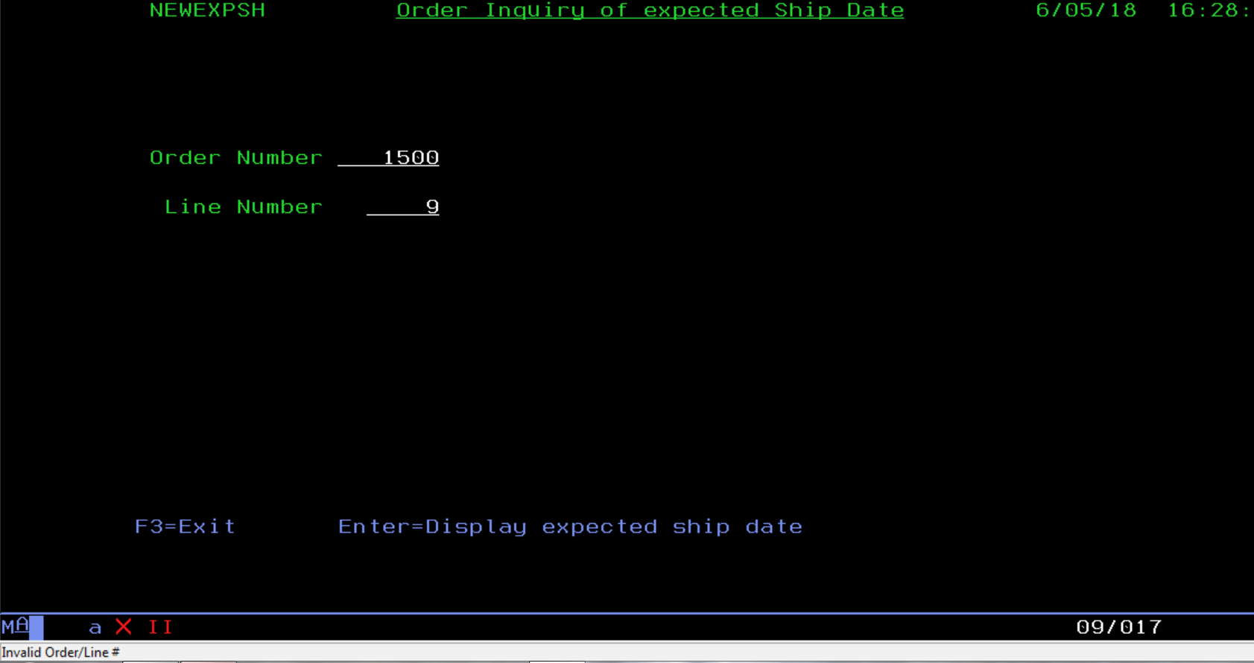
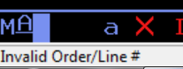
Invalid Order/line# error message to display User (NOT previously logged to disk)
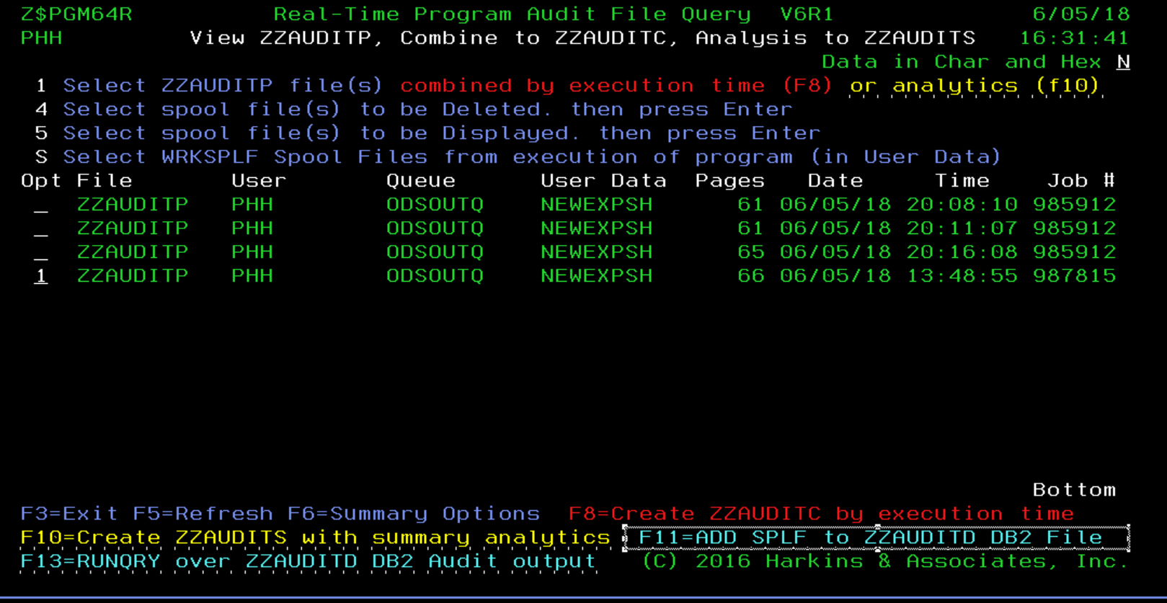
F11 to copy RTPA WRKSPLF ZZAUDITP to ZZAUDITD DB2 file for analysis

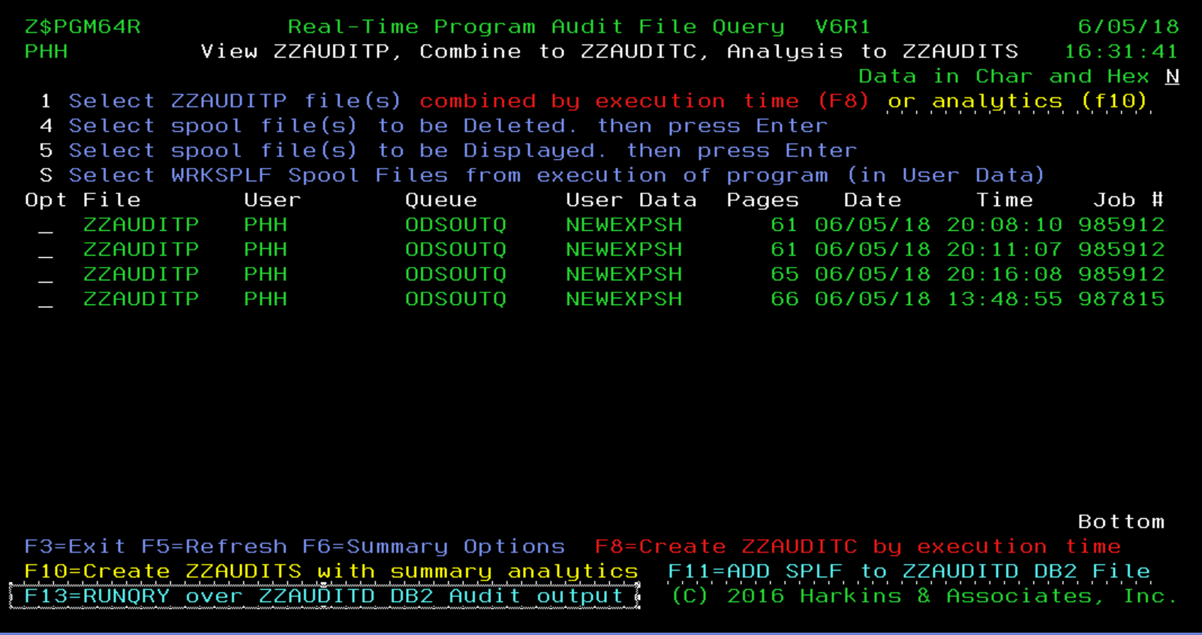
F13 to RUN QUERY over RTPA ZZAUDITD DB2 file to view Record ERRORS by USER PHH in program NEWEXPSH (query QZZAUDITD in library ZZAUDIT
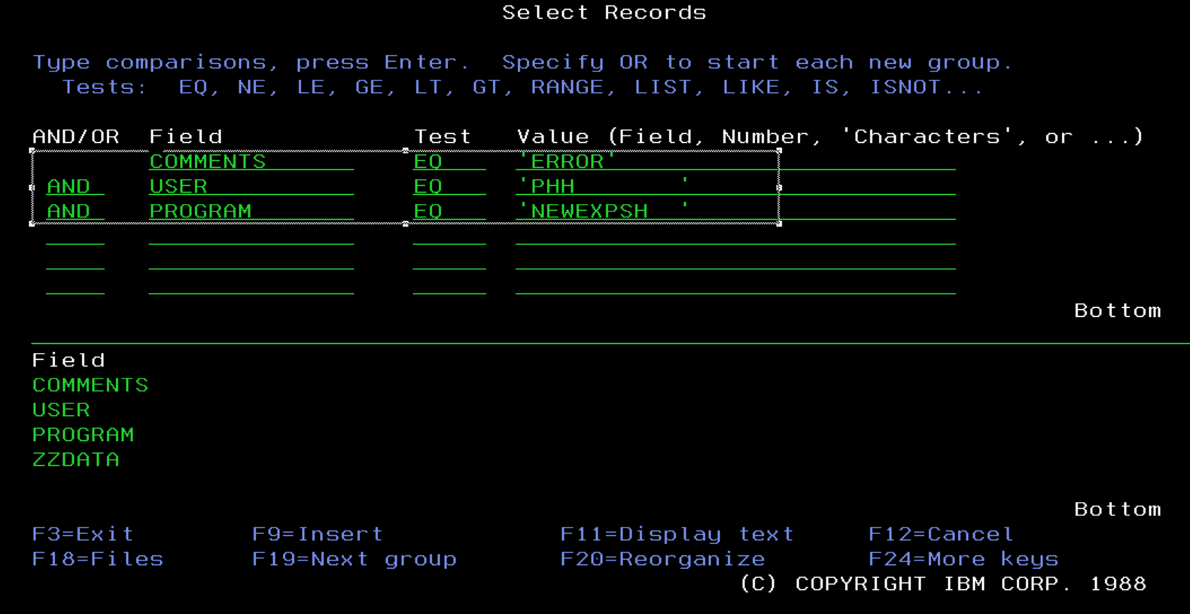
Comments is ZZAUDITD file field ZZDATA positions 81-90 (comments in RPG source statement)
User is ZZAUDITD file field ZZDATA positions 236-245
Program is ZZAUDITD file field ZZDATA positions 247-256
ZZDATA is the 280 character RTPA audit record
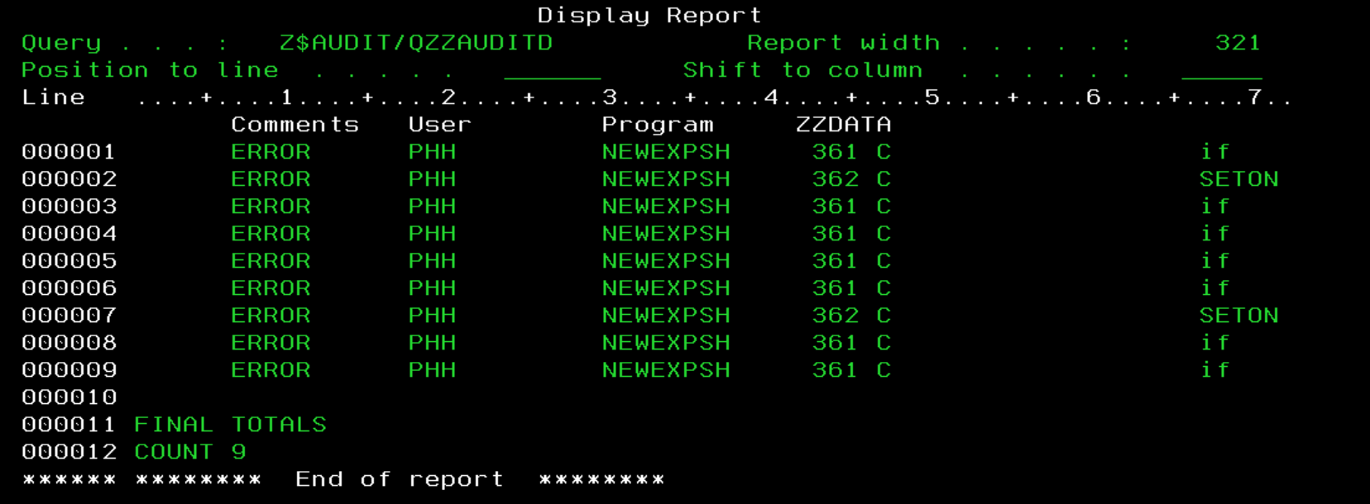
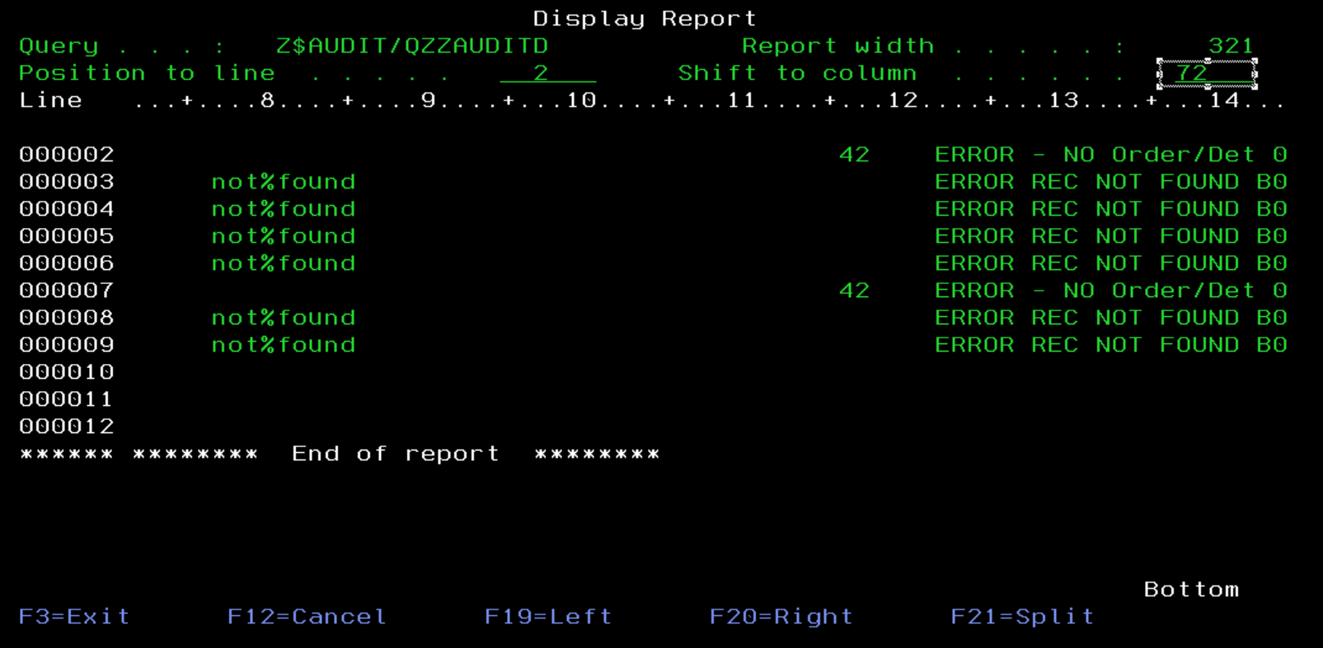
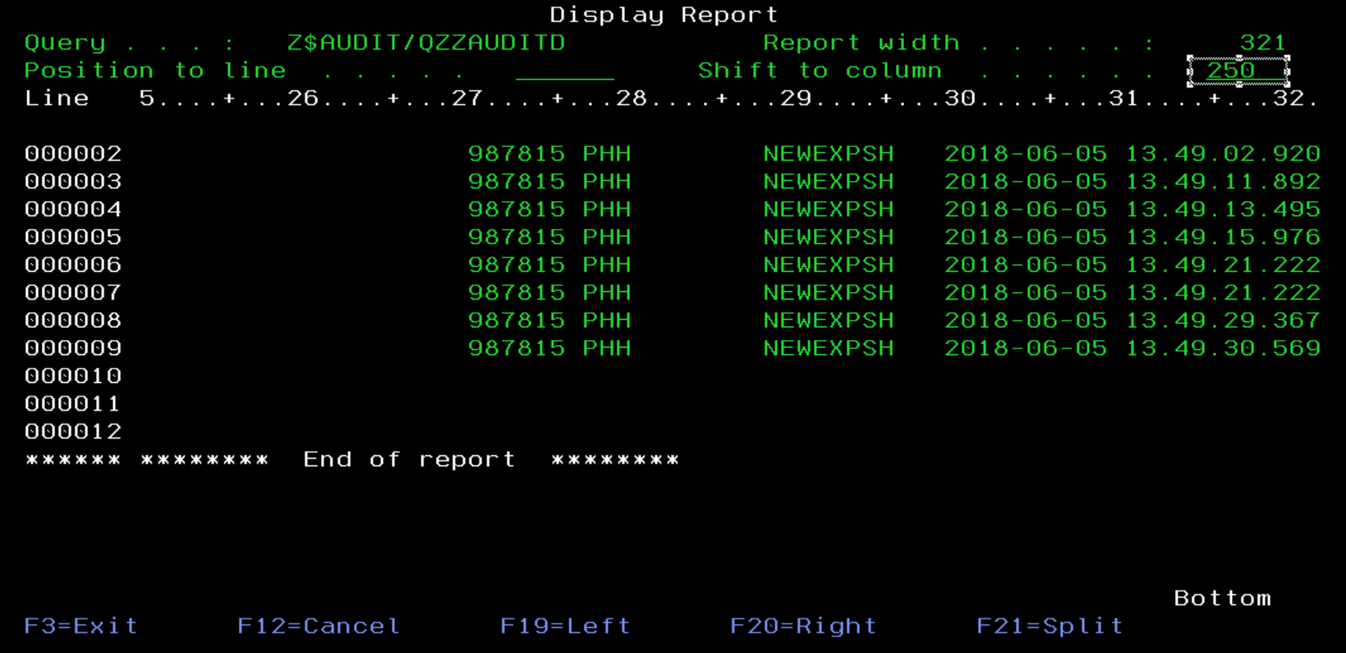

This ZZAUDITD DB2 Real-Time auditing logging and analysis of crucial information (errors made by display users, or real-time production statistics) has never before been automatically logged or made available for real-time analysis and action with RTPA.

Appendix
G

Appendix G: RTPA audit output to DB2 file ZZAUDITD

RTPA audit output to DB2 disk file ZZAUDITD
The RTPA real-time audit output can be directly to a DB2 disk file ZZAUDITD (audit to disk Y), or to the user spool file (WRKSPLF) ZZAUDITP

ZZPGM01R Real-Time Program Audit for RPG (V7R1) Date 8/15/20
PHARKINS Select Program to Audit Time 16:41:04
RPG3 and RPG4 source members CCSID 37 Serial 2104FAW
Type choices, Press F10 Language ENU Model 42A
Source Member . . . . . . TESTBASIC Name, generic*, *ALL, F4 for List
Source File . . . . . . . QRPGLESRC Name Date Format *MDY
Library . . . . . . . . ZZAUDIT Name Audit comments Y

Object to Library . . . . . . ZZAUDITE Name Audit copybooks Y

Audit Timestamp Y
Audit File Outq . . . . . . . *SAME Name, *SAME
Audit Procedures Y
JOBD for pgm compile libl . . *LIBL *LIBL, JOBD
Library . . . . . . . . Name Audit Variable contents A
A=All N=None V=F16 Var W=F2 Watch
Audit Compile Listing Stmts . to 1-99999 Audit to Disk Y
(Only) to
to Document Only N
Project to
Ticket to Remote RTPA via FTP N
F2=Watch Variables F3=Exit F6=Auditing options F7=Compile Options
F8=Conditional Auditing F9=Maint. Menu F10=Submit Expand F12=Cancel
F18=RTPA history today F24=More Keys (C) Harkins & Associates, Inc.

RTPA entry screen to expand RTPA auditing to disk file ZZAUDITD rather than printer file ZZAUDITP
Audit to Disk Y

The RTPA audit is to a DB2 file ZZAUDITD rather than to prnter file ZZAUDITP.

The RTPA audit record is 280 characters to both ZZAUDITD andZZAUDITP.

ZZPGM01R Real-Time Program Audit for RPG (V7R1) Date 8/15/20
PHARKINS RTPA history today Time 16:46:46
Paul Harkins RTPA user profile CCSID: 37
Type option, press Enter Language ENU
4=Delete 5=Display Date Format *MDY

O Program Status Program Name Job Date Time
5 TESTBASIC 8 EXPN OK Test basic flow 101643 8/15/20 16:46:35

F3=Exit F5=Refresh F12=Cancel F20=RTPA User history
F22=RTPA Analytics Report (C) HARKINS & ASSOCIATES, INC.

ZZPGM01R Real-Time Program Audit for RPG (V7R1) Date 8/15/20
PHARKINS Select Program to Audit Time 16:47:23
Project Ticket *MDY CCSID 37 Language ENU
Program TESTBASIC Test basic flow Audit Variable con A
Status 8 Expand Pgm compiled OK Audit comments Y Audit to Disk Y
Audit copybooks Y Document Only N
Type option, press Enter Audit Timestamp Y Remote RTPA FTP N
5=Display compile listing Audit Procedures Y Variable used 23
OPT Job Records Submitted Completed Elapsed Comp recds
Input 101643 109 8/15/20 16:46:35 8/15/20 16:46:36 1 130
Inserted 101644 851 8/15/20 16:46:38 8/15/20 16:46:40 2
Expanded 101646 960 8/15/20 16:46:41 8/15/20 16:46:42 1 960
Exp Obj lib ZZAUDITE Program Object size 626,688
Source File QRPGLESRC Expand File QRPGLESRC Record formats 1 copybooks
Source Libl ZZAUDIT Exp Src lib ZZAUDITE Printer files *INZSR
RPG Version 4 RPGLE Audit JOBQ RTPA Extension %parms
From To Audit outq Subroutines /free
From To Audit Libr. *LIBL Overflow OG Indent
From To JOBD Libr. Protoype/Proc. N CTA N SDS Y
From To Maximum Pages 15000 SDS Name QXXDS SDS Qual
From To Watch varia DBCS J 48 Start/Stop conditional N
F8=Conditional Auditing F13=Files/Recd F14=Fields F15=Operations F16=Variables
F2=Watch Variables F17=Labels F19=Called Pgm F21=Cond Oper
F3=Exit F22=Indicators F23=Pre Audit (C) 2016 Harkins & Associates, Inc.

Audit to Disk Y

CALL TESTBASIC

Work with All Spooled Files

Type options, press Enter.
1=Send 2=Change 3=Hold 4=Delete 5=Display 6=Release 7=Messages
8=Attributes 9=Work with printing status

Device or Total Cur
Opt File User Queue User Data Sts Pages Page Copy
TESTBASIC PHARKINS RTPA RDY 12 1
TESTBASIC PHARKINS RTPA RDY 30 1

Bottom
Parameters for options 1, 2, 3 or command
===>
F3=Exit F10=View 4 F11=View 2 F12=Cancel F22=Printers F24=More keys

The RTPA audit output is to DB2 file ZZAUDITD

DSPPFM ZZAUDITD

Display Physical File Member
File . . . . . . : ZZAUDITD Library . . . . : ZZAUDIT
Member . . . . . : ZZAUDITD Record . . . . . : 1
Control . . . . . Column . . . . . : 1
Find . . . . . . .
*...+....1....+....2....+....3....+....4....+....5....+....6....+....7....+...
Program-TESTBASIC Test basic flow Obj Lib
TESTBASIC TESTBASIC
Job: 101642 User Profile: PHARKINS Source Type: RPGLE
Line
48 * initialize key list to customer 2050
49 C Z-ADD 2050 CUCUST
2050
50 C Z-ADD 1 CUSTOR
1
51 C movel 'BBBB' holdb 4
BBBB
52 C custor IFEQ 1
1
53 C holdb andeq 'BBBB'
== window 205 of 280 character DB2 record for timestamp ====================

Display Physical File Member
File . . . . . . : ZZAUDITD Library . . . . : ZZAUDIT
Member . . . . . : ZZAUDITD Record . . . . . : 1
Control . . . . . W205 Column . . . . . : 205
Find . . . . . . .
+....1....+....2....+....3....+....4....+....5....+....6....+....7....+....8
RPGLE 101642 PHARKINS TESTBASIC 2020-08-15 16.49.02.049
RPGLE 101642 PHARKINS TESTBASIC 2020-08-15 16.49.02.049
RPGLE 101642 PHARKINS TESTBASIC 2020-08-15 16.49.02.049
RPGLE 101642 PHARKINS TESTBASIC 2020-08-15 16.49.02.049
comment RPGLE 101642 PHARKINS TESTBASIC 2020-08-15 16.49.02.056
Z-ADD RPGLE 101642 PHARKINS TESTBASIC 2020-08-15 16.49.02.057
RPGLE 101642 PHARKINS TESTBASIC 2020-08-15 16.49.02.057
Z-ADD RPGLE 101642 PHARKINS TESTBASIC 2020-08-15 16.49.02.057
RPGLE 101642 PHARKINS TESTBASIC 2020-08-15 16.49.02.057
MOVEL RPGLE 101642 PHARKINS TESTBASIC 2020-08-15 16.49.02.057
RPGLE 101642 PHARKINS TESTBASIC 2020-08-15 16.49.02.057
RPGLE 101642 PHARKINS TESTBASIC 2020-08-15 16.49.02.057
RPGLE 101642 PHARKINS TESTBASIC 2020-08-15 16.49.02.057
RPGLE 101642 PHARKINS TESTBASIC 2020-08-15 16.49.02.057
RPGLE 101642 PHARKINS TESTBASIC 2020-08-15 16.49.02.057
=============================================================================
54 C movel 'CCCC' holdb
CCCC
55 C endif
57 * chain by file name
58 c CUSKEY CHAIN CUSTMAST 30
N30 00020500000001
CUCUST-0002050 CUSTOR-0000001 CUNAME- CUAD1-
CUTELE-
59 C *IN30 IFEQ *OFF
0
60 C MOVEL CUNAME KCUSNA 25
XYZ STORE - ARDMORE
XYZ STORE - ARDMORE
61 C MOVEL CUAD1 KAD1 25
122 MONTGOMERY AVE 122 MONTGOMERY AVE
62 C MOVEL CUAD2 KAD2 25
THIRD FLOOR
THIRD FLOOR
63 C MOVEL CUCITY KCITY 25
ARDMORE
ARDMORE
64 C MOVEL CUSTA KSTA 2
PA
PA
65 C MOVEL CUZIP KZIP 9
18555
18555
66 C MOVEL CUTELE KTELE 11
610-555-1212 610-555-121
67 C ENDIF
68 C MOVEL 'AAAAAA' HOLD6 6
AAAAAA
69 * chain by record name
70 C CUSKEY CHAIN CUSTREC1 30
N30 00020500000001
CUCUST-0002050 CUSTOR-0000001 CUNAME-XYZ STORE - ARDMORE CUAD1-122 MONTG
CUTELE-610-555-1212
71 * check for a good chain - indicator 30 will be off
72 C *IN30 IFEQ *OFF
0
73 C cucust andeq 1050
2050
82 C ENDIF
83 * initialize key list to customer 1000
84 C Z-ADD 1000 CUCUST
1000
85 C Z-ADD 1 CUSTOR
1
86 * chain by file name
87 C CUSKEY CHAIN CUSTMAST 30
N30 00010000000001
CUCUST-0001000 CUSTOR-0000001 CUNAME-XYZ STORE - ARDMORE CUAD1-122 MONTG
CUTELE-610-555-1212
88 C *IN30 IFEQ *OFF
0
89 C MOVEL CUNAME KCUSNA 25
ABC STORES INC
ABC STORES INC
90 C MOVEL CUAD1 KAD1 25
423 MONTGOMERY AVENUE
423 MONTGOMERY AVENUE
91 C MOVEL CUAD2 KAD2 25

92 C MOVEL CUCITY KCITY 25
ARDMORE
ARDMORE
93 C MOVEL CUSTA KSTA 2
PA
PA
94 C MOVEL CUZIP KZIP 9
19333
19333
95 C MOVEL CUTELE KTELE 11
888-825-1212
888-825-121
96 C ENDIF
97 C MOVEL 'BBBBBB' HOLD6 6
BBBBBB
98 * chain by record name
99 C CUSKEY CHAIN CUSTREC1 30
N30 00010000000001
CUCUST-0001000 CUSTOR-0000001 CUNAME-ABC STORES INC CUAD1-423 MONTG
CUTELE-888-825-1212
100 * check for a good chain - indicator 30 will be off
101 C *IN30 IFEQ *OFF
0
102 * move the customer record fields to work fields
103 C MOVEL CUNAME KCUSNA 25
ABC STORES INC
ABC STORES INC
104 C MOVEL CUAD1 KAD1 25
423 MONTGOMERY AVENUE
423 MONTGOMERY AVENUE
105 C MOVEL CUAD2 KAD2 25

106 C MOVEL CUCITY KCITY 25
ARDMORE
ARDMORE
107 C MOVEL CUSTA KSTA 2
PA
PA
108 C MOVEL CUZIP KZIP 9
19333
19333
109 C MOVEL CUTELE KTELE 11
888-825-1212
888-825-121
110 C ENDIF
111 C MOVEL 'CCCCCC' HOLD6 6
CCCCCC
112 * Call program TEST3
113 c call 'TEST3 ' Call-
114 C MOVEL '1' X 1
1
115 * Call program ZZpgm01C
116 C CALL 'ZZPGM01C'
117 C PARM INUSRP
PAUL HARKI
118 C z-add *zeros SSD
00000000000000000000000000
119 c if SSd(13) = *zero
0
122 *
123 c if SSwk1 < *zeros
0
125 C ENDIF
126 C ENDIF
127 * Exit program
128 C SETON LR
129 * return to calling program
130 C RETURN

The RTPA real-time audit output of RPGLE TESTBASIC is to DB2 file ZZAUDITD

The RTPA distribution system provides several logical files over the ZZAUDITD physical file to enable real-time qureries and searching and analytics over the ZZAUDITD audit data

RTPA ZZAUDITD logical files ZZAUDITDLX
Logical files over RTPA DB2 Disk log file ZZAUDITD for real-time applications

Work with Members Using SEU

Source file . . . . . . QDDSSRC Library . . . . . ZZAUDIT
Position to . . . . . . . . . . . . . . . . . . . . . . . . . . . .
New member . . . . . . . . . . . . . . . . . . . . . . . . . . . .
Type for new member . . . . . . . . . . . . . . . . . . . . . . . LF
Text . . . . . . . . .

Type options, press Enter.
2=Edit 4=Delete 5=Browse 6=Print

Opt Member Type Text
ZZAUDITD PF Output file for ZZAUDITD Audit to Disk
ZZAUDITDLX LF ZZAUDITD ERRFLG, JOBNBR, JOBUSR, PGMNAM, EXCDAT
ZZAUDITDL1 LF ZZAUDITD by timestamp
ZZAUDITDL2 LF ZZAUDITD with ERROR in 81-85 Display errors
ZZRTPATRK PF RTPA Expansion Tracking RPG, CLP, COBOL

Bottom
F3=Exit F5=Refresh F12=Cancel F14=Display date
F15=Sort by date F17=Subset

ZZAUDITD Logical files ZZAUDITDL) over ZZAUDITD RTPAaudit output file

Columns . . . : 1 71 Browse ZZAUDIT/QDDSSRC
SEU==> ZZAUDITDLX
FMT A* .....A*. 1 ...+... 2 ...+... 3 ...+... 4 ...+... 5 ...+... 6 ...+... 7
*************** Beginning of data *************************************
0001.00 *----------------------------------------------------------------
0002.00 * COPYRIGHT (C) 2018 BY HARKINS & ASSOCIATES, INC. ALL RIGHTS
0003.00 * RESERVED
0004.00 * V6R2M0
0005.00 *----------------------------------------------------------------
0006.00 *---> DATE LAST CHANGED 02/23/19
0007.00 *----------------------------------------------------------------
0008.00 * FILE: ZZAUDITDLX - LOGICAL OVER ZZAUDITD
0009.00 * ERRFLG, JOBUSR, PGMNAM, EXCDAT, EXCTIM, EXCDTA,
0010.00 * TYPE: LOGICAL
0011.00 * KEY: NONE
0012.00 *----------------------------------------------------------------
0013.00 * MODIFICATIONS
0014.00 *
0015.00 *----------------------------------------------------------------
0016.00 *
0017.00 A R ZZAUDITREC PFILE(ZZAUDITD)
0018.00 A ZZDATA
0019.00 A ERRFLG I SST(ZZDATA 81 05)
0020.00 A TEXT('ERRFLG')
0021.00 A JOBNBR I SST(ZZDATA 229 06)
0022.00 A TEXT('JOBNBR')
0023.00 A JOBUSR I SST(ZZDATA 236 10)
0024.00 A TEXT('JOBUSR')
0025.00 A PGMNAM I SST(ZZDATA 247 10)
0026.00 A TEXT('PGMNAM')
0027.00 A EXCDAT I SST(ZZDATA 258 10)
0028.00 A TEXT('EXCDAT')
0029.00 A TIMESTAMP I SST(ZZDATA 258 23)
0030.00 A TEXT('TIME STAMP')
0031.00 A EXCTIM I SST(ZZDATA 269 11)
0032.00 A TEXT('EXCDAT')
0033.00 A EXCDTA I SST(ZZDATA 1 228)
0034.00 A TEXT('EXCDTA')
0035.00 * RPGLE FIXED FORMAT PROGRAM EXECUTION AUDIT OUTPUT
0036.00 A SEQNO I SST(ZZDATA 1 4)
0037.00 A TEXT('SEQNO')
0038.00 A SRCTYPE I SST(ZZDATA 6 1)
0039.00 A TEXT('SRCTYPE')
0040.00 A SRC7 I SST(ZZDATA 7 1)
0041.00 A TEXT('SRC7')
0042.00 A FACTOR1 I SST(ZZDATA 12 14)
0043.00 A TEXT('FACTOR1')
0044.00 A OPERATION I SST(ZZDATA 26 10)
0045.00 A TEXT('OPERATION')
0046.00 A FACTOR2 I SST(ZZDATA 36 14)
0047.00 A TEXT('FACTOR2')
0048.00 A RESULT I SST(ZZDATA 50 14)
0049.00 A TEXT('FACTOR2')
0050.00 A COMMENT I SST(ZZDATA 81 20)
0051.00 A TEXT('COMMENT')
0052.00 * KEY FIELDS
ZZAUDITDLX Logical File over ZZAUDITD for queries

Columns . . . : 1 71 Browse ZZAUDIT/QDDSSRC
SEU==> ZZAUDITDL1
FMT A* .....A*. 1 ...+... 2 ...+... 3 ...+... 4 ...+... 5 ...+... 6 ...+... 7
*************** Beginning of data *************************************
0001.00 *----------------------------------------------------------------
0002.00 * COPYRIGHT (C) 2018 BY HARKINS & ASSOCIATES, INC. ALL RIGHTS
0003.00 * RESERVED
0004.00 * V6R1M0
0005.00 *----------------------------------------------------------------
0006.00 *---> DATE LAST CHANGED 09/20/18
0007.00 *----------------------------------------------------------------
0008.00 * FILE: ZZAUDITDL1 - LOGICAL OVER ZZAUDITD BY TIMESTAMP
0009.00 * TYPE: LOGICAL
0010.00 * KEY: ZZTIMEST
0011.00 *----------------------------------------------------------------
0012.00 * MODIFICATIONS
0013.00 *
0014.00 *----------------------------------------------------------------
0015.00 *
0016.00 A R ZZAUDITREC PFILE(ZZAUDITD)
0017.00 A ZZDATA
0018.00 A ZZTIMEST I SST(ZZDATA 258 23)
0019.00 A TEXT('TIME STAMP')
0020.00 A ZZBLANKS I SST(ZZDATA 1 50)
0021.00 A TEXT('BLANKS')
0022.00 * KEY FIELDS
0023.00 A K ZZTIMEST
0024.00 A O ZZBLANKS COMP(EQ '
****************** End of data **************************************
ZZAUDITDL1 Logical File over ZZAUDITD by timestamp

Display Physical File Member
File . . . . . . : ZZAUDITD Library . . . . : ZZAUDIT
Member . . . . . : ZZAUDITD Record . . . . . : 1
Control . . . . . Column . . . . . : 1
Find . . . . . . .
*...+....1....+....2....+....3....+....4....+....5....+....6....+....7....+...
Program-TESTBASIC Test basic flow Obj Lib
TESTBASIC TESTBASIC
Job: 021098 User Profile: PHARKINS Source Type: RPGLE
Line
48 * initialize key list to customer 2050
49 C Z-ADD 2050 CUCUST
2050
50 C Z-ADD 1 CUSTOR
1
51 C movel 'BBBB' holdb 4
BBBB
52 C custor IFEQ 1
1
53 C holdb andeq 'BBBB'
BBBB
ZZAUDITD RTPA real-time audit output of RPGLE program TESTBASIC execution

Display Physical File Member
File . . . . . . : ZZAUDITD Library . . . . : ZZAUDIT
Member . . . . . : ZZAUDITD Record . . . . . : 1
Control . . . . . W220 Column . . . . . : 220
Find . . . . . . .
2....+....3....+....4....+....5....+....6....+....7....+....8
021098 PHARKINS TESTBASIC 2019-02-23 15.23.28.955
021098 PHARKINS TESTBASIC 2019-02-23 15.23.28.955
021098 PHARKINS TESTBASIC 2019-02-23 15.23.28.955
021098 PHARKINS TESTBASIC 2019-02-23 15.23.28.955
021098 PHARKINS TESTBASIC 2019-02-23 15.23.28.965
021098 PHARKINS TESTBASIC 2019-02-23 15.23.28.966
021098 PHARKINS TESTBASIC 2019-02-23 15.23.28.966
021098 PHARKINS TESTBASIC 2019-02-23 15.23.28.966
021098 PHARKINS TESTBASIC 2019-02-23 15.23.28.966
021098 PHARKINS TESTBASIC 2019-02-23 15.23.28.966
021098 PHARKINS TESTBASIC 2019-02-23 15.23.28.966
021098 PHARKINS TESTBASIC 2019-02-23 15.23.28.966
021098 PHARKINS TESTBASIC 2019-02-23 15.23.28.966
021098 PHARKINS TESTBASIC 2019-02-23 15.23.28.966
021098 PHARKINS TESTBASIC 2019-02-23 15.23.28.966

F3=Exit F12=Cancel F19=Left F20=Right F24=More keys
ZZAUDITD RTPA real-time audit output of RPGLE program TESTBASIC execution Window 205

ZZAUDITD Logical files ZZAUDITDL) over ZZAUDITD RTPAaudit output file

(SQL creation of logical views over ZZAUDITD)
CREATE VIEW ZZAUDIT/ZZAUDITDLX
AS SELECT
Substr(ZZDATA, 81 5) as ERRFLG,
Substr(ZZDATA, 229 6) as JOBNBR,
Substr(ZZDATA, 236 10) as JOBUSR,
Substr(ZZDATA, 247 10) as PGMNAM,
Substr(ZZDATA, 258 10) as EXCDAT,
Substr(ZZDATA, 269 11) as EXCTIM,
Substr(ZZDATA, 1 228) as EXCDTA
FROM ZZAUDITD

(SQL creation of logical view ZZAUDITLX over ZZAUDITD)

Output RTPA execution to ZZAUDITD DB2 RTPA audit output Physical file (arrival sequence)
ZZPGM01R Real-Time Program Audit for RPG (V7R1) Date 8/15/20
PHARKINS Select Program to Audit Time 16:58:41
RPG3 and RPG4 source members CCSID 37 Serial 2104FAW
Type choices, Press F10 Language ENU Model 42A
Source Member . . . . . . TESTCOND Name, generic*, *ALL, F4 for List
Source File . . . . . . . QRPGLESRC Name Date Format *MDY
Library . . . . . . . . ZZAUDIT Name Audit comments Y

Object to Library . . . . . . ZZAUDITE Name Audit copybooks Y

Audit Timestamp Y
Audit File Outq . . . . . . . *SAME Name, *SAME
Audit Procedures Y
JOBD for pgm compile libl . . *LIBL *LIBL, JOBD
Library . . . . . . . . Name Audit Variable contents A
A=All N=None V=F16 Var W=F2 Watch
Audit Compile Listing Stmts . to 1-99999 Audit to Disk Y
(Only) to
to Document Only N
Project to
Ticket to Remote RTPA via FTP N
F2=Watch Variables F3=Exit F6=Auditing options F7=Compile Options
F8=Conditional Auditing F9=Maint. Menu F10=Submit Expand F12=Cancel
F18=RTPA history today F24=More Keys (C) Harkins & Associates, Inc.

RPGLE source program TESTCOND entry screen for RTPA expansion with audits
Audit to Disk Y (outputs RTPA audits to DB2 file ZZAUDITD
Audit Timestamp Y (outputs time stamp in each RTPA audit output record) Positions 229 through 280 of ZZAUDITD record
.3....+....4....+....5....+....6....+....7....+....8
180318 PHH TESTCOND 2018-08-09 14.46.09.327
RTPA audit output to disk file ZZAUDIT (in library ZZAUDIT) combines all RTPA audit output for all users into one ZZAUDITD DB2 File, so including the RTPA timestamp when auditing is very useful for real-time analytics

RTPA audit output to the user spool file (WRKSPLF) isolates RTPA audit output ot only that user.

RTPA real-time audit output to disk (ZZAUDITD) allows SQL, IBM QUERY, and other Business Intelligence (BI) tools to be used in real-time, as well as other IBM i user written programs to analyze the streaming RTPA audit output.
Columns . . . : 6 76 Edit ZZAUDIT/QRPGLESRC
SEU==> TESTCOND
FMT * *. 1 ...+... 2 ...+... 3 ...+... 4 ...+... 5 ...+... 6 ...+... 7 ...+.
*************** Beginning of data *************************************
0001.00 * Test conditional auditing
0002.00 C MOVEL 'AAAAAA' HOLD6 6
0003.00 C MOVEL 'BBBBBB' HOLD6
0004.00 C z-add 1 test1n 1 0
0005.00 C test1n IFEQ 1
0006.00 C MOVEL 'CCCCCC' HOLD6
0007.00 C ENDIF
0008.00 C MOVEL 'DDDDDD' HOLD6
0009.00 * Exit program
0010.00 C SETON LR
0011.00 * return to calling program
0012.00 C RETURN
****************** End of data ****************************************

F3=Exit F4=Prompt F5=Refresh F9=Retrieve F10=Cursor F11=Toggle
F16=Repeat find F17=Repeat change F24=More keys
(C) COPYRIGHT IBM CORP. 1981, 2005.

RPGLE source program TESTCOND in file QRPGLESRC in library ZZAUDIT

Display Physical File Member
File . . . . . . : ZZAUDITD Library . . . . : ZZAUDIT
Member . . . . . : ZZAUDITD Record . . . . . : 1
Control . . . . . Column . . . . . : 1
Find . . . . . . .
*...+....1....+....2....+....3....+....4....+....5....+....6....+....7....+...
Program-TESTCOND Test Conditional auditing Obj Lib
TESTCOND TESTCOND
Job: 179494 User Profile: PHH Source Type: RPGLE
Line#
2 C MOVEL 'AAAAAA' HOLD6 6
AAAAAA
3 C MOVEL 'BBBBBB' HOLD6
BBBBBB
4 C z-add 1 test1n 1 0
1
5 C test1n IFEQ 1
1
6 C MOVEL 'CCCCCC' HOLD6
CCCCCC
7 C ENDIF
8 C MOVEL 'DDDDDD' HOLD6
DDDDDD
9 * Exit program
10 C SETON LR
11 * return to calling program
12 C RETURN
****** END OF DATA ******
More...
F3=Exit F12=Cancel F19=Left F20=Right F24=More keys

RTPA audit output of RPGLE source program TESTCOND to ZZAUDITD (DB2 file)

ZZCOB01R Real-Time Program Audit for COBOL (V6R2) Date 8/24/18
PHH Select Program to Audit Time 12:48:46
Type choices, press F10. CCSID 37 Serial 1034F0C
Language ENU ModeI 525
Input Source Member Name. . . TESTCOB1 Name, generic*, *ALL, F4=List
File Name . . . . . . . . . QCBLSRC Name
Library Name. . . . . . . . ZZAUDIT Name

Object to Library . . . . . . ZZAUDITE Name
Create As . . . . . . . . . . *PGM *PGM, *MOD Audit comments Y

Audit File Outq . . . . . . . *SAME Name, *SAME Audit copybooks N

JOBD for pgm compile libl . . *LIBL *LIBL, JOBD Audit Timestamp Y
Library Name. . . . . . . . Name
Document Only N
Audit Compile Listing Stmts . to 1-99999
(Only) to Audit to Disk Y
to CBL and CBLLE source programs are
to compiled as CBLLE with expanded
to source in QCBLLESRC in ZZAUDITE
F2=Watch Variables F3=Exit F5=Refresh F6=Auditing Options F7=Compile Options
F8=Conditional Auditing F9=Maintenance Menu F10=Submit Expand F24=More Keys
(C) 2016 Harkins & Associates, Inc.

RTPA audit selection of audit to disk of CBL source program TESTCOB1 to ZZAUDITD (DB2 file)

Audit to Disk Y
ZZCOB01R Real-Time Program Audit for COBOL (V6R2) Date: 8/24/18
PHH Detailed Job Record Time: 12:51:47
CCSID 37 Language: ENU
Program TESTCOB1 COBOL/400 Test Program 1 Basic
Status 8 EXPAND CBL COMPILED OK Document only N F10 Express Y
Audit comments Y Audit to Disk Y
Type options, press Enter. Audit copybooks N Audit Timestamp Y
5=Display Compile listing P=PDF Compile listing On Demand FTP
Opt Job Job # Records Submitted Completed Elapsed
Input 221845 137 8/24/18 12:51:41 8/24/18 12:51:41
Insert 221846 486 8/24/18 12:51:42 8/24/18 12:51:42
Expand 221847 623 8/24/18 12:51:42 8/24/18 12:51:43 1

Source File QCBLSRC Object Lib ZZAUDITE Declaratives
Library ZZAUDIT Audit JOBQ RTPA
CBL Ver L CBLLE Audit OUTQ
From To Audit JOBD *LIBL
From To JOBD Libr
From To Watch Var.
From To Start/Stop
From To
F2=Watch Variables F3=Exit F8=Conditional Auditing Start/Stop F12=Previous
F13=Program Files F16=Variables F19=Called Programs F15=Commands
(C) 2016 Harkins & Associates, Inc.

RTPA audit expansion of CBL source program TESTCOB1 to ZZAUDITD (DB2 file)
Display Physical File Member
File . . . . . . : ZZAUDITD Library . . . . : ZZAUDIT
Member . . . . . : ZZAUDITD Record . . . . . : 1
Control . . . . . Column . . . . . : 1
Find . . . . . . .
*...+....1....+....2....+....3....+....4....+....5....+....6....+....7....+...
Program-TESTCOB1 COBOL/400 Test Program 1 Basic Obj Lib

Job: 221829 User Profile: PHH Source Type: CBLLE
STMT SEQNBR -A 1 B..+....2....+....3....+....4....+....5....+....6....+....7
8600 100-MAIN-MODULE.
8800* OPEN FILES
63 8900 OPEN INPUT ORDER-FILE
9000 OUTPUT ORDER-REPORT.
9200* ORDER DETAIL RECORD PROCESSING
9300 READ-AGAIN.
64 9400 READ ORDER-FILE
&êY1815 É¬Øb¤AU
10200 END-READ.
10400* ORDER DETAIL RECORD routine
10600* MOVE DISK FIELDS TO REPORT FIELDS
70 10700 MOVE SPACES TO PRINT-RECORD.
71 10800 MOVE ORDER-NUMBER TO ORDER-NUMBER-P.
1500 1500
72 10900 MOVE ORDER-LINE TO ORDER-LINE-P.
1 1
73 11000 MOVE CUSTOMER-NUMBER TO CUSTOMER-NUMBER-P.
1000 1000
74 11100 MOVE STORE-NUMBER TO STORE-NUMBER-P.
522 522
75 11200 MOVE ITEM-CODE TO ITEM-CODE-P.
Y1815 Y1815
76 11300 MOVE ITEM-PRICE TO ITEM-PRICE-P.
21.00 21.00
77 11400 MOVE ITEM-QUANTITY TO ITEM-QUANTITY-P.
12 12
78 11500 MOVE REQUESTED-SHIP-DATE TO REQUESTED-SHIP-DATE-P.
20071105 20071105
79 11600 MOVE EXPECTED-SHIP-DATE TO EXPECTED-SHIP-DATE-P.
20180829 20180829
80 11700 MOVE INVOICE-DATE TO INVOICE-DATE-P.
0 0
81 11800 MOVE INVOICE-NUMBER TO INVOICE-NUMBER-P.
0 0
82 11900 MOVE STATUS-CODE TO STATUS-CODE-P.
A A
83 12000 MOVE RECORD-CODE TO RECORD-CODE-P.
U U
12100* WRITE PRINT LINE
84 12200 WRITE PRINT-RECORD.
0001500 00001 0001000 0000522 Y1815 12300 PROCESS-EXIT.
85 12400 EXIT.
12500 DONEIT.
86 12600 IF ANY-MORE-RECORDS = 'NO '
YES
13500 END-IF.
91 13600 STOP RUN.
****** END OF DATA ******

RTPA audit output of CBL source program TESTCOB1 to ZZAUDITD (DB2 file)
Display Physical File Member
File . . . . . . : ZZAUDITD Library . . . . : ZZAUDIT
Member . . . . . : ZZAUDITD Record . . . . . : 1
Control . . . . . W220 Column . . . . . : 220
Find . . . . . . .
2....+....3....+....4....+....5....+....6....+....7....+....8
221829 PHH TESTCOB1 2018-08-24 12.54.49.841
221829 PHH TESTCOB1 2018-08-24 12.54.49.841
221829 PHH TESTCOB1 2018-08-24 12.54.49.841
221829 PHH TESTCOB1 2018-08-24 12.54.49.841
221829 PHH TESTCOB1 2018-08-24 12.54.49.841
221829 PHH TESTCOB1 2018-08-24 12.54.49.841
221829 PHH TESTCOB1 2018-08-24 12.54.49.856
221829 PHH TESTCOB1 2018-08-24 12.54.49.856
221829 PHH TESTCOB1 2018-08-24 12.54.49.856
221829 PHH TESTCOB1 2018-08-24 12.54.49.856
221829 PHH TESTCOB1 2018-08-24 12.54.49.856
221829 PHH TESTCOB1 2018-08-24 12.54.49.856
221829 PHH TESTCOB1 2018-08-24 12.54.49.856
221829 PHH TESTCOB1 2018-08-24 12.54.49.856
221829 PHH TESTCOB1 2018-08-24 12.54.49.858
Mor
F3=Exit F12=Cancel F19=Left F20=Right F24=More keys

RTPA audit timestamp output of CBL source program TESTCOB1 to ZZAUDITD (DB2 file)

Example of using the IBM QUERY program to Query (analyze) the RTPA real-time audit output file ZZAUDITD

F13 to RUN QUERY over RTPA ZZAUDITD DB2 file to view Record ERRORS by USER PHH in program NEWEXPSH (query QZZAUDITD in library ZZAUDIT
Comments is ZZAUDITD file field ZZDATA positions 81-90 (comments in RPG source statement)
User is ZZAUDITD file field ZZDATA positions 236-245
Program is ZZAUDITD file field ZZDATA positions 247-256
ZZDATA is the 280 character RTPA audit record

Columns . . . : 6 76 Edit ZZAUDITE/QRPGLESRC
SEU==> TESTCOND
FMT * *. 1 ...+... 2 ...+... 3 ...+... 4 ...+... 5 ...+... 6 ...+... 7 ...+.
*************** Beginning of data *************************************
0001.00 * Test conditional auditing
0002.00 FZZAUDITD O F 280 DISK USROPN
0003.00 FZZAUDSRC IF E K DISK
0004.00 D # S 100 DIM(00001) CTDATA PERRCD(1)
0005.00 D #Q S 23 DIM(00001) CTDATA PERRCD(1)
0006.00 D DS
0007.00 D ZZBIN4 1 4B 0
0008.00 D ZZSTOPA 5 5
0009.00 D ZZMAXP 7 11 0
0010.00 D ZZNME 12 25
0011.00 D ZZH S 100 DIM(300)
0012.00 D ZZCONS C CONST('0115000 N ')
0013.00 D ZZCON1 C CONST('TESTCOND JOB 180180')
0014.00 D ZZCON2 C CONST(' ')
0015.00 D ZZCON3 C CONST(' ')
0016.00 D ZZCONF C CONST('QRPGLESRC ZZAUDIT ')
0017.00 D ZZCONT C CONST('RPGLE ')
0018.00 D ZZOVRP C CONST('OVRPRTF FILE(ZZAUDIT-
0019.00 D P) OUTQ(ZZOQ10) ')
0020.00 D ZZCONN C CONST('00010 ')
0021.00 D ZZCOD1 C CONST('Test Conditional aud')
0022.00 D ZZCOD2 C CONST('iting ')
0023.00 D ZZCOD3 C CONST(' ')
0024.00 D ZZUNDE C CONST('*UNDEF')
0025.00 D ZZDateTime S Z
0026.00 D DS
0027.00 D ZZDateTimeDS 1 26
0028.00 D ZZdate 1 10
0029.00 D ZZTime 12 23
0030.00 D DS
0031.00 D ZZAudStampDS 1 52
0032.00 D ZZJobRe 1 6
0033.00 D ZZUserRe 8 17
0034.00 D ZZPROGRE 19 28
0035.00 D ZZDateRe 30 39
0036.00 D ZZTimeRe 41 52
0037.00 D ZZTIMB S 12 INZ(' ')
0038.00 D SDS
0039.00 D ZZPROG 1 10
0040.00 D ZZPRLI 81 90
0041.00 D ZZJBNA 244 253
0042.00 D ZZUSRP 254 263
0043.00 D ZZJOB# 264 269
0044.00 D ZZPROP 334 343
0045.00 D ZZPROM 344 353
0046.00 C EXSR ZZINIT
0047.00 C SETON 01
0048.00 C Z-ADD 1 ZZSRC#
0049.00 C MOVEL 'AAAAAA' HOLD6 6
0050.00 C Z-ADD 1 ZZSRC#
0051.00 C EXSR ZZGENS
0052.00 C EXCEPT ZZ00001
0053.00 C MOVEL 'BBBBBB' HOLD6
0054.00 C Z-ADD 2 ZZSRC#
0055.00 C EXSR ZZGENS
0056.00 C EXCEPT ZZ00002
0057.00 C z-add 1 test1n 1 0
0058.00 C Z-ADD 3 ZZSRC#
0059.00 C EXSR ZZGENS
0060.00 C EXCEPT ZZ00003
0061.00 C EXSR ZZGETI
0062.00 C EXCEPT Z#00001
0063.00 C test1n IFEQ 1
0064.00 C MOVEL 'CCCCCC' HOLD6
0065.00 C Z-ADD 4 ZZSRC#
0066.00 C EXSR ZZGENS
0067.00 C EXCEPT ZZ00004
0068.00 C ENDIF
0069.00 C Z-ADD 5 ZZSRC#
0070.00 C EXSR ZZGENS
0071.00 C MOVEL 'DDDDDD' HOLD6
0072.00 C Z-ADD 6 ZZSRC#
0073.00 C EXSR ZZGENS
0074.00 C EXCEPT ZZ00006
0075.00 * Exit program
0076.00 C Z-ADD 7 ZZSRC#
0077.00 C EXSR ZZGENS
0078.00 C SETON LR
0079.00 C Z-ADD 8 ZZSRC#
0080.00 C EXSR ZZGENS
0081.00 * return to calling program
0082.00 C Z-ADD 9 ZZSRC#
0083.00 C EXSR ZZGENS
0084.00 C Z-ADD 10 ZZSRC#
0085.00 C EXSR ZZGENS
0086.00 C RETURN
0087.00 C ZZINIT BEGSR
0088.00 C ZZAUDKEY KLIST
0089.00 C KFLD ZDPROG
0090.00 C KFLD ZDJOB1
0091.00 C KFLD ZDVISEQ
0092.00 C move ZZPROG ZDPROG
0093.00 C move ZZCON1 ZDJOB1
0094.00 C z-add 1000000 ZDVISEQ
0095.00 C Z-ADD *ZEROS ZZSRC# 5 0
0096.00 C Z-ADD *ZEROS ZZSRC#2 5 0
0097.00 C ZZOPNS IFEQ *BLANK
0098.00 C MOVEL '1' ZZOPNS 1
0099.00 C MOVEL *BLANKS ZZOTXT 50
0100.00 C MOVEL ZZCONS ZZHLD7 7
0101.00 C MOVE ZZHLD7 ZZHLD5 5 0
0102.00 C Z-ADD ZZHLD5 ZZMAXP
0103.00 C 10 SUBST(P) ZZCONS:8 ZZOQ10 10
0104.00 C ZZOQ10 IFNE *BLANKS
0105.00 C MOVEL ZZOVRP $$OVRP 40
0106.00 C ZZOQ10 CAT(P) ')' ZZOQ11 11
0107.00 C MOVE ZZOQ11 $$OVRP
0108.00 C Z-ADD 40 $$LEN 15 5
0109.00 C CALL 'QCMDEXC'
0110.00 C PARM $$OVRP
0111.00 C PARM $$LEN
0112.00 C ENDIF
0113.00 ***C OPEN ZZAUDITP
0114.00 C OPEN ZZAUDITD
0115.00 C ZZOQ10 IFNE *BLANKS
0116.00 C CALL 'ZZPGM25C'
0117.00 C PARM ZZOQ10
0118.00 C PARM ZZERR 1
0119.00 C ENDIF
0120.00 C TIME ZZDATETIME
0121.00 C MOVE ZZDATETIME ZZDATETIMEDS
0122.00 C MOVE ZZTIME ZZTIMS 12
0123.00 C Z-ADD 1 ZZPAGP 5 0
0124.00 C MOVE ZZJOB# ZZJOBRE
0125.00 C MOVE ZZUSRP ZZUSERRE
0126.00 C MOVE ZZPROG ZZPROGRE
0127.00 C EXSR ZZGETI
0128.00 C EXCEPT ZZSTRT
0129.00 C END
0130.00 C ZZBAUD TAG
0131.00 C ENDSR
0132.00 C ZZGETI BEGSR
0133.00 C TIME ZZDATETIME
0134.00 C MOVE ZZDATETIME ZZDATETIMEDS
0135.00 C MOVE ZZTIME ZZTIMN 12
0136.00 C MOVE ZZTIMN ZZTIMERE 12
0137.00 C MOVE ZZDATE ZZDATERE 10
0138.00 C ZZNOPR TAG
0139.00 C ENDSR
0140.00 C ZZ$MLP BEGSR
0141.00 C Z-ADD *ZEROS FRM$ 5 0
0142.00 C Z-ADD *ZEROS END$ 5 0
0143.00 C *LIKE DEFINE END$ ZZEND
0144.00 C DO 300 $X$$ 4 0
0145.00 C $X$$ IFEQ 1
0146.00 C SETON 88
0147.00 C END
0148.00 C END$ IFEQ *ZEROS
0149.00 C Z-ADD $X$$ FRM$
0150.00 C Z-ADD 100 END$
0151.00 C ELSE
0152.00 C END$ ADD 1 FRM$
0153.00 C FRM$ ADD 99 END$
0154.00 C ENDIF
0155.00 C END$ IFGT ZZEND
0156.00 C Z-ADD ZZEND END$
0157.00 C ENDIF
0158.00 C ZZH($X$$) IFNE *BLANKS
0159.00 C EXCEPT ZZ$MPL
0160.00 C SETOFF 88
0161.00 C ENDIF
0162.00 C END$ IFEQ ZZEND
0163.00 C LEAVE
0164.00 C ENDIF
0165.00 C ENDDO
0166.00 C ENDSR
0167.00 C ZZGENS BEGSR
0168.00 C EXSR ZZGETI
0169.00 C z-add 1000000 ZDVISEQ
0170.00 C add ZZSRC# ZDVISEQ
0171.00 C MOVEL *blanks ZDAUDSTM
0172.00 C MOVEL 'NO SOURCE' ZDAUDSTM
0173.00 C zzaudkey CHAIN ZZAUDREC
0174.00 C if not%found
0175.00 C MOVEL 'NO SOURCE' ZDAUDSTM
0176.00 C ELSE
0177.00 C MOVE ZDAUDSTM ZZFILNAM 10
0178.00 C END
0179.00 C EXCEPT ZZGENP
0180.00 C MOVEL *BLANKS ZZMESG 20
0181.00 C MOVEL *BLANKS ZZTIMB
0182.00 C ENDSR
0183.00 **OZZAUDITP E ZZSTRT 1 01
0184.00 OZZAUDITD E ZZSTRT
0185.00 O 8 'Program-'
0186.00 O ZZPROG 18
0187.00 O ZZCOD1 40
0188.00 O ZZCOD2 60
0189.00 O ZZCOD3 70
0190.00 O 80 'Obj Lib: '
0191.00 O ZZPRLI 90
0192.00 O 101 'Initiated:'
0193.00 O UDATE 110 ' / / '
0194.00 O ZZTIMS 123
0195.00 O 130 'PAGE'
0196.00 O ZZPAGP Z 135
0197.00 O ZZCONT 159
0198.00 O ZZPROG 169
0199.00 O E ZZSTRT
0200.00 O ZZPROP 19
0201.00 O ZZPROM 31
0202.00 O E ZZSTRT
0203.00 O 5 'Job: '
0204.00 O ZZJOB# 11
0205.00 O 39 'User Profile:'
0206.00 O ZZUSRP 50
0207.00 O 65 'Source Type:'
0208.00 O ZZCONT 86
0209.00 O 100 'Source File/Library:'
0210.00 O ZZCONF 121
0211.00 O ZZCON1 145
0212.00 O E ZZSTRT
0213.00 O 5 'Line#'
0214.00 O 103 'Do#'
0215.00 O 109 'SrcId'
0216.00 O 116 'ChgDat'
0217.00 O 123 ' Seq#'
0218.00 O E ZZ$MPL
0219.00 O 88 ZZNME 14
0220.00 O ZZH($X$$) 127
0221.00 O 027 ''''
0222.00 O 128 ''''
0223.00 O FRM$ Z 25
0224.00 O E ZZGENP
0225.00 O ZDAUDSTM 138
0226.00 O ZZMESG 144
0227.00 O ZZTIMB 157
0228.00 O ZZFILNAM 211
0229.00 O E ZZ00001
0230.00 O HOLD6 055
0231.00 O E ZZ00002
0232.00 O HOLD6 055
0233.00 O E ZZ00003
0234.00 O test1n L 056
0235.00 O E Z#00001
0236.00 O #(00001) 100
0237.00 O #Q(00001) 123
0238.00 O E Z#00001
0239.00 O test1n L 018
0240.00 O E ZZ00004
0241.00 O HOLD6 055
0242.00 O E ZZ00006
0243.00 O HOLD6 055
0244.00 ATA #
0245.00 C test1n IFEQ 1
0246.00 ATA #Q
0247.00 180730 500
****************** End of data ****************************************

F3=Exit F4=Prompt F5=Refresh F9=Retrieve F10=Cursor F11=Toggle
F16=Repeat find F17=Repeat change F24=More keys

RPGLE program with RTPA ZZ inserted audit statements with audits to ZZAUDITD

Columns . . . : 6 76 Edit ZZAUDITE/QRPGLESRC
SEU==> TESTCOND
FMT * *. 1 ...+... 2 ...+... 3 ...+... 4 ...+... 5 ...+... 6 ...+... 7 ...+.
*************** Beginning of data *************************************
0001.00 * Test conditional auditing
0002.00 FZZAUDITD O F 280 DISK USROPN
0003.00 FZZAUDSRC IF E K DISK
0004.00 D # S 100 DIM(00001) CTDATA PERRCD(1)
0005.00 D #Q S 23 DIM(00001) CTDATA PERRCD(1)
0006.00 D DS
0007.00 D ZZBIN4 1 4B 0
0008.00 D ZZSTOPA 5 5
0009.00 D ZZMAXP 7 11 0
0010.00 D ZZNME 12 25
0011.00 D ZZH S 100 DIM(300)
0012.00 D ZZCONS C CONST('0115000 N ')
0013.00 D ZZCON1 C CONST('TESTCOND JOB 180180')
0014.00 D ZZCON2 C CONST(' ')
0015.00 D ZZCON3 C CONST(' ')
0016.00 D ZZCONF C CONST('QRPGLESRC ZZAUDIT ')
0017.00 D ZZCONT C CONST('RPGLE ')
0018.00 D ZZOVRP C CONST('OVRPRTF FILE(ZZAUDIT-
0019.00 D P) OUTQ(ZZOQ10) ')
0020.00 D ZZCONN C CONST('00010 ')
0021.00 D ZZCOD1 C CONST('Test Conditional aud')
0022.00 D ZZCOD2 C CONST('iting ')
0023.00 D ZZCOD3 C CONST(' ')
0024.00 D ZZUNDE C CONST('*UNDEF')
0025.00 D ZZDateTime S Z
0026.00 D DS
0027.00 D ZZDateTimeDS 1 26
0028.00 D ZZdate 1 10
0029.00 D ZZTime 12 23
0030.00 D DS
0031.00 D ZZAudStampDS 1 52
0032.00 D ZZJobRe 1 6
0033.00 D ZZUserRe 8 17
0034.00 D ZZPROGRE 19 28
0035.00 D ZZDateRe 30 39
0036.00 D ZZTimeRe 41 52
0037.00 D ZZTIMB S 12 INZ(' ')
0038.00 D SDS
0039.00 D ZZPROG 1 10
0040.00 D ZZPRLI 81 90
0041.00 D ZZJBNA 244 253
0042.00 D ZZUSRP 254 263
0043.00 D ZZJOB# 264 269
0044.00 D ZZPROP 334 343
0045.00 D ZZPROM 344 353
0046.00 C EXSR ZZINIT
0047.00 C SETON 01
0048.00 C Z-ADD 1 ZZSRC#
0049.00 C MOVEL 'AAAAAA' HOLD6 6
0050.00 C Z-ADD 1 ZZSRC#
0051.00 C EXSR ZZGENS
0052.00 C EXCEPT ZZ00001
0053.00 C MOVEL 'BBBBBB' HOLD6
0054.00 C Z-ADD 2 ZZSRC#
0055.00 C EXSR ZZGENS
0056.00 C EXCEPT ZZ00002
0057.00 C z-add 1 test1n 1 0
0058.00 C Z-ADD 3 ZZSRC#
0059.00 C EXSR ZZGENS
0060.00 C EXCEPT ZZ00003
0061.00 C EXSR ZZGETI
0062.00 C EXCEPT Z#00001
0063.00 C test1n IFEQ 1
0064.00 C MOVEL 'CCCCCC' HOLD6
0065.00 C Z-ADD 4 ZZSRC#
0066.00 C EXSR ZZGENS
0067.00 C EXCEPT ZZ00004
0068.00 C ENDIF
0069.00 C Z-ADD 5 ZZSRC#
0070.00 C EXSR ZZGENS
0071.00 C MOVEL 'DDDDDD' HOLD6
0072.00 C Z-ADD 6 ZZSRC#
0073.00 C EXSR ZZGENS
0074.00 C EXCEPT ZZ00006
0075.00 * Exit program
0076.00 C Z-ADD 7 ZZSRC#
0077.00 C EXSR ZZGENS
0078.00 C SETON LR
0079.00 C Z-ADD 8 ZZSRC#
0080.00 C EXSR ZZGENS
0081.00 * return to calling program
0082.00 C Z-ADD 9 ZZSRC#
0083.00 C EXSR ZZGENS
0084.00 C Z-ADD 10 ZZSRC#
0085.00 C EXSR ZZGENS
0086.00 C RETURN
0087.00 C ZZINIT BEGSR
0088.00 C ZZAUDKEY KLIST
0089.00 C KFLD ZDPROG
0090.00 C KFLD ZDJOB1
0091.00 C KFLD ZDVISEQ
0092.00 C move ZZPROG ZDPROG
0093.00 C move ZZCON1 ZDJOB1
0094.00 C z-add 1000000 ZDVISEQ
0095.00 C Z-ADD *ZEROS ZZSRC# 5 0
0096.00 C Z-ADD *ZEROS ZZSRC#2 5 0
0097.00 C ZZOPNS IFEQ *BLANK
0098.00 C MOVEL '1' ZZOPNS 1
0099.00 C MOVEL *BLANKS ZZOTXT 50
0100.00 C MOVEL ZZCONS ZZHLD7 7
0101.00 C MOVE ZZHLD7 ZZHLD5 5 0
0102.00 C Z-ADD ZZHLD5 ZZMAXP
0103.00 C 10 SUBST(P) ZZCONS:8 ZZOQ10 10
0104.00 C ZZOQ10 IFNE *BLANKS
0105.00 C MOVEL ZZOVRP $$OVRP 40
0106.00 C ZZOQ10 CAT(P) ')' ZZOQ11 11
0107.00 C MOVE ZZOQ11 $$OVRP
0108.00 C Z-ADD 40 $$LEN 15 5
0109.00 C CALL 'QCMDEXC'
0110.00 C PARM $$OVRP
0111.00 C PARM $$LEN
0112.00 C ENDIF
0113.00 ***C OPEN ZZAUDITP
0114.00 C OPEN ZZAUDITD
0115.00 C ZZOQ10 IFNE *BLANKS
0116.00 C CALL 'ZZPGM25C'
0117.00 C PARM ZZOQ10
0118.00 C PARM ZZERR 1
0119.00 C ENDIF
0120.00 C TIME ZZDATETIME
0121.00 C MOVE ZZDATETIME ZZDATETIMEDS
0122.00 C MOVE ZZTIME ZZTIMS 12
0123.00 C Z-ADD 1 ZZPAGP 5 0
0124.00 C MOVE ZZJOB# ZZJOBRE
0125.00 C MOVE ZZUSRP ZZUSERRE
0126.00 C MOVE ZZPROG ZZPROGRE
0127.00 C EXSR ZZGETI
0128.00 C EXCEPT ZZSTRT
0129.00 C END
0130.00 C ZZBAUD TAG
0131.00 C ENDSR
0132.00 C ZZGETI BEGSR
0133.00 C TIME ZZDATETIME
0134.00 C MOVE ZZDATETIME ZZDATETIMEDS
0135.00 C MOVE ZZTIME ZZTIMN 12
0136.00 C MOVE ZZTIMN ZZTIMERE 12
0137.00 C MOVE ZZDATE ZZDATERE 10
0138.00 C ZZNOPR TAG
0139.00 C ENDSR
0140.00 C ZZ$MLP BEGSR
0141.00 C Z-ADD *ZEROS FRM$ 5 0
0142.00 C Z-ADD *ZEROS END$ 5 0
0143.00 C *LIKE DEFINE END$ ZZEND
0144.00 C DO 300 $X$$ 4 0
0145.00 C $X$$ IFEQ 1
0146.00 C SETON 88
0147.00 C END
0148.00 C END$ IFEQ *ZEROS
0149.00 C Z-ADD $X$$ FRM$
0150.00 C Z-ADD 100 END$
0151.00 C ELSE
0152.00 C END$ ADD 1 FRM$
0153.00 C FRM$ ADD 99 END$
0154.00 C ENDIF
0155.00 C END$ IFGT ZZEND
0156.00 C Z-ADD ZZEND END$
0157.00 C ENDIF
0158.00 C ZZH($X$$) IFNE *BLANKS
0159.00 C EXCEPT ZZ$MPL
0160.00 C SETOFF 88
0161.00 C ENDIF
0162.00 C END$ IFEQ ZZEND
0163.00 C LEAVE
0164.00 C ENDIF
0165.00 C ENDDO
0166.00 C ENDSR
0167.00 C ZZGENS BEGSR
0168.00 C EXSR ZZGETI
0169.00 C z-add 1000000 ZDVISEQ
0170.00 C add ZZSRC# ZDVISEQ
0171.00 C MOVEL *blanks ZDAUDSTM
0172.00 C MOVEL 'NO SOURCE' ZDAUDSTM
0173.00 C zzaudkey CHAIN ZZAUDREC
0174.00 C if not%found
0175.00 C MOVEL 'NO SOURCE' ZDAUDSTM
0176.00 C ELSE
0177.00 C MOVE ZDAUDSTM ZZFILNAM 10
0178.00 C END
0179.00 C EXCEPT ZZGENP
0180.00 C MOVEL *BLANKS ZZMESG 20
0181.00 C MOVEL *BLANKS ZZTIMB
0182.00 C ENDSR
0183.00 **OZZAUDITP E ZZSTRT 1 01
0184.00 OZZAUDITD E ZZSTRT
0185.00 O 8 'Program-'
0186.00 O ZZPROG 18
0187.00 O ZZCOD1 40
0188.00 O ZZCOD2 60
0189.00 O ZZCOD3 70
0190.00 O 80 'Obj Lib: '
0191.00 O ZZPRLI 90
0192.00 O 101 'Initiated:'
0193.00 O UDATE 110 ' / / '
0194.00 O ZZTIMS 123
0195.00 O 130 'PAGE'
0196.00 O ZZPAGP Z 135
0197.00 O ZZCONT 159
0198.00 O ZZPROG 169
0199.00 O E ZZSTRT
0200.00 O ZZPROP 19
0201.00 O ZZPROM 31
0202.00 O E ZZSTRT
0203.00 O 5 'Job: '
0204.00 O ZZJOB# 11
0205.00 O 39 'User Profile:'
0206.00 O ZZUSRP 50
0207.00 O 65 'Source Type:'
0208.00 O ZZCONT 86
0209.00 O 100 'Source File/Library:'
0210.00 O ZZCONF 121
0211.00 O ZZCON1 145
0212.00 O E ZZSTRT
0213.00 O 5 'Line#'
0214.00 O 103 'Do#'
0215.00 O 109 'SrcId'
0216.00 O 116 'ChgDat'
0217.00 O 123 ' Seq#'
0218.00 O E ZZ$MPL
0219.00 O 88 ZZNME 14
0220.00 O ZZH($X$$) 127
0221.00 O 027 ''''
0222.00 O 128 ''''
0223.00 O FRM$ Z 25
0224.00 O E ZZGENP
0225.00 O ZDAUDSTM 138
0226.00 O ZZMESG 144
0227.00 O ZZTIMB 157
0228.00 O ZZFILNAM 211
0229.00 O E ZZ00001
0230.00 O HOLD6 055
0231.00 O E ZZ00002
0232.00 O HOLD6 055
0233.00 O E ZZ00003
0234.00 O test1n L 056
0235.00 O E Z#00001
0236.00 O #(00001) 100
0237.00 O #Q(00001) 123
0238.00 O E Z#00001
0239.00 O test1n L 018
0240.00 O E ZZ00004
0241.00 O HOLD6 055
0242.00 O E ZZ00006
0243.00 O HOLD6 055
0244.00 ATA #
0245.00 C test1n IFEQ 1
0246.00 ATA #Q
0247.00 180730 500
****************** End of data ****************************************

F3=Exit F4=Prompt F5=Refresh F9=Retrieve F10=Cursor F11=Toggle
F16=Repeat find F17=Repeat change F24=More keys

RPGLE program with RTPA ZZ inserted audit statements with audits to ZZAUDITD

Appendix
G

Appendix
H

Appendix H: RTPA Profile Maintenance

RTPA for RPG, COBOL or CLP creates an RTPA user profile in file ZZFI01 the first time an IBM i user signs on to RTPA.

Display Physical File Member
File . . . . . . : ZZFI01 Library . . . . : ZZAUDIT
Member . . . . . : ZZFI01 Record . . . . . : 1
Control . . . . . Column . . . . . : 1
Find . . . . . . .
*...+....1....+....2....+....3....+....4....+....5....+....6....+....7....+...
DPIRANI Daniel Pirani RTPA profile 3
DUTCHNETH DUTCH NETHERLANDS Profile qsy2923 CCSID 256 3
GERMAN German language User Profile qsy2929 CCSID 273 3
ITALIAN Italian language User Profile qsy2932 CCSID 280 3
JAPANUNIVEUniveral Japanese Profile qsy2930 CSID 5035 3
NBONETT Nancy Bonett PROFILE 3
PHARKINS Paul Harkins RTPA user profile 3
PORTUGUESEPORTUGUESE Language User Profie QSYS2922 PTG C 284 3
QSECOFR Security Officer 3
RSCHNEIDERRSchneider German User Profile qsy2929 CCSID 273 3
SPANISH Spanish language User Profile qsy2931 CCSID 284 3
SWEDISH Swedish language User Profile qsys2937 CCSID 278 3
TOOLMAKER Toolmaker German User Profile qsy2929 CCSID 273 3
TESTSYSVALTEST using all system values *SYSVAL 3
****** END OF DATA ******
Bottom
F3=Exit F12=Cancel F19=Left F20=Right F24=More keys

RTPA file ZZFI01 is the RTPA user profile for RPG (RTPA command)

Display Spooled File
File . . . . . : QPDSPFFD Page/Line 1/1
Control . . . . . Columns 1 - 78
Find . . . . . .
*...+....1....+....2....+....3....+....4....+....5....+....6....+....7....+...
Display File Field Description
Input parameters
File . . . . . . . . . . . . . . . . . . . : ZZFI01
Library . . . . . . . . . . . . . . . . . : ZZAUDIT
File Information
File . . . . . . . . . . . . . . . . . . . : ZZFI01
Library . . . . . . . . . . . . . . . . . : ZZAUDIT
File location . . . . . . . . . . . . . . . : *LCL
Externally described . . . . . . . . . . . : Yes
Number of record formats . . . . . . . . . : 1
Type of file . . . . . . . . . . . . . . . : Physical
File creation date . . . . . . . . . . . . : 06/19/20
Text 'description'. . . . . . . . . . . . . : Programmer RPG Audit Profile
Record Format Information
Record format . . . . . . . . . . . . . . . : ZZF01REC
Format level identifier . . . . . . . . . . : 2F9E0F9F6FD19 Number of fields . . . . . . . . . . . . . : 86
Record length . . . . . . . . . . . . . . . : 574
Field Level Information
Data Field Buffer Buffer Field Column
Field Type Length Length Position Usage Heading
Z1USRP CHAR 10 10 1 Both Z1USRP
Field text . . . . . . . . . . . . . . . : USER PROFILE
Coded Character Set Identifier . . . . . : 37
Z1UTXT CHAR 50 50 11 Both Z1UTXT
Field text . . . . . . . . . . . . . . . : USER TEXT
Coded Character Set Identifier . . . . . : 37
Z1APRO CHAR 10 10 61 Both Z1APRO
Field text . . . . . . . . . . . . . . . : CURRENT AUDIT PROFILE
Coded Character Set Identifier . . . . . : 37
Z1RPGL CHAR 1 1 71 Both Z1RPGL
Field text . . . . . . . . . . . . . . . : RPG LANGUAGE 3/4 Coded Character Set Identifier . . . . . : 37
Z1FIL1 CHAR 1 1 72 Both Z1FIL1
Field text . . . . . . . . . . . . . . . : FILLER 1
Coded Character Set Identifier . . . . . : 37
Z1F3SF CHAR 10 10 73 Both Z1F3SF
Field text . . . . . . . . . . . . . . . : FROM RPG3 SRC FILE
Coded Character Set Identifier . . . . . : 37
Z1F3SL CHAR 10 10 83 Both Z1F3SL
Field text . . . . . . . . . . . . . . . : FROM RPG3 SRC LIB
Coded Character Set Identifier . . . . . : 37
Z1T3SF CHAR 10 10 93 Both Z1T3SF
Field text . . . . . . . . . . . . . . . : TO RPG3 SRC FILE
Coded Character Set Identifier . . . . . : 37
Z1T3SL CHAR 10 10 103 Both Z1T3SL
Field text . . . . . . . . . . . . . . . : TO RPG3 SRC LIB
Coded Character Set Identifier . . . . . : 37 Z1CR3L CHAR 10 10 113 Both Z1CR3L
Field text . . . . . . . . . . . . . . . : CREATE RPG3 OBJ IN LIB
Coded Character Set Identifier . . . . . : 37
Z1FIL2 CHAR 1 1 123 Both Z1FIL2
Field text . . . . . . . . . . . . . . . : FILLER 2
Coded Character Set Identifier . . . . . : 37
Z1F4SF CHAR 10 10 124 Both Z1F4SF
Field text . . . . . . . . . . . . . . . : FROM RPG4 SRC FILE
Coded Character Set Identifier . . . . . : 37
Z1F4SL CHAR 10 10 134 Both Z1F4SL
Field text . . . . . . . . . . . . . . . : FROM RPG4 SRC LIB
Coded Character Set Identifier . . . . . : 37
Z1T4SF CHAR 10 10 144 Both Z1T4SF
Field text . . . . . . . . . . . . . . . : TO RPG4 SOURCE FILE
Coded Character Set Identifier . . . . . : 37
Z1T4SL CHAR 10 10 154 Both Z1T4SL Field text . . . . . . . . . . . . . . . : TO RPG4 SRC LIB
Coded Character Set Identifier . . . . . : 37
Z1CR4L CHAR 10 10 164 Both Z1CR4L
Field text . . . . . . . . . . . . . . . : CREATE RPG4 OBJ IN LIB
Coded Character Set Identifier . . . . . : 37
Z1CRTO CHAR 1 1 174 Both Z1CRTO
Field text . . . . . . . . . . . . . . . : CREATE OBJECT
Coded Character Set Identifier . . . . . : 37
Z1JOBQ CHAR 10 10 175 Both Z1JOBQ
Field text . . . . . . . . . . . . . . . : JOBQ
Coded Character Set Identifier . . . . . : 37
Z1OUTQ CHAR 10 10 185 Both Z1OUTQ
Field text . . . . . . . . . . . . . . . : OUTQ
Coded Character Set Identifier . . . . . : 37
Z1JOBD CHAR 10 10 195 Both Z1JOBD
Field text . . . . . . . . . . . . . . . : JOBD Coded Character Set Identifier . . . . . : 37
Z1JOBDLI CHAR 10 10 205 Both Z1JOBDLI
Field text . . . . . . . . . . . . . . . : JOBD LIBRARY
Coded Character Set Identifier . . . . . : 37
Z1DEL2 CHAR 4 4 215 Both Z1DEL2
Field text . . . . . . . . . . . . . . . : SQLRPG DELAY PREPARE
Coded Character Set Identifier . . . . . : 37
Z1COM2 CHAR 5 5 219 Both Z1COM2
Field text . . . . . . . . . . . . . . . : SQLRPG COMITTMENT CTL
Coded Character Set Identifier . . . . . : 37
Z1CLO2 CHAR 7 7 224 Both Z1CLO2
Field text . . . . . . . . . . . . . . . : SQLRPG CLOSE SQL CURSOR
Coded Character Set Identifier . . . . . : 37
Z1GEN3 PACKED 2 0 2 231 Both Z1GEN3
Field text . . . . . . . . . . . . . . . : RPGLE GEN SEV LVL
Z1TY41 CHAR 11 11 233 Both Z1TY41 *...+....1....+....2....+....3....+....4....+....5....+....6....+....7....+.
Field text . . . . . . . . . . . . . . . : RPGLE TYPE CONVERSION 1
Coded Character Set Identifier . . . . . : 37
Z1TY42 CHAR 11 11 244 Both Z1TY42
Field text . . . . . . . . . . . . . . . : RPGLE TYPE CONVERSION 2
Coded Character Set Identifier . . . . . : 37
Z1TY43 CHAR 11 11 255 Both Z1TY43
Field text . . . . . . . . . . . . . . . : RPGLE TYPE CONVERSION 3
Coded Character Set Identifier . . . . . : 37
Z1TY44 CHAR 11 11 266 Both Z1TY44
Field text . . . . . . . . . . . . . . . : RPGLE TYPE CONVERSION 4
Coded Character Set Identifier . . . . . : 37
Z1DEF3 CHAR 4 4 277 Both Z1DEF3
Field text . . . . . . . . . . . . . . . : RPGLE DEFAULT ACT GRP
Coded Character Set Identifier . . . . . : 37
Z1ALL4 CHAR 10 10 281 Both Z1ALL4
Field text . . . . . . . . . . . . . . . : RPGLE ALLOW NULL VALUES Coded Character Set Identifier . . . . . : 37
Z1FIX1 CHAR 12 12 291 Both Z1FIX1
Field text . . . . . . . . . . . . . . . : RPGLE FIX NUMERIC
Coded Character Set Identifier . . . . . : 37
Z1FIX2 CHAR 12 12 303 Both Z1FIX2
Field text . . . . . . . . . . . . . . . : RPGLE FIX NUMERIC
Coded Character Set Identifier . . . . . : 37
Z1LAID CHAR 7 7 315 Both Z1LAID
Field text . . . . . . . . . . . . . . . : LANGUAGE ID
Coded Character Set Identifier . . . . . : 37
Z1DEBV CHAR 7 7 322 Both Z1DEBV
Field text . . . . . . . . . . . . . . . : DEBUGGING VIEWS
Coded Character Set Identifier . . . . . : 37
Z1OPTL CHAR 6 6 329 Both Z1OPTL
Field text . . . . . . . . . . . . . . . : OPTIMIZION LEVEL
Coded Character Set Identifier . . . . . : 37
Z1DEL4 CHAR 4 4 335 Both Z1DEL4
Field text . . . . . . . . . . . . . . . : SQLRPGLE DELAY PREPARE
Coded Character Set Identifier . . . . . : 37
Z1COM4 CHAR 5 5 339 Both Z1COM4
Field text . . . . . . . . . . . . . . . : SQLRPGLE COMITTMENT CTL
Coded Character Set Identifier . . . . . : 37
Z1CLO4 CHAR 10 10 344 Both Z1CLO4
Field text . . . . . . . . . . . . . . . : SQLRPGLE CLOSE SQL CURSOR
Coded Character Set Identifier . . . . . : 37
Z1TARG CHAR 8 8 354 Both Z1TARG
Field text . . . . . . . . . . . . . . . : TARGET RELEASE
Coded Character Set Identifier . . . . . : 37
Z1UPRF CHAR 6 6 362 Both Z1UPRF
Field text . . . . . . . . . . . . . . . : USER PROFILE
Coded Character Set Identifier . . . . . : 37
Z1AUTH CHAR 10 10 368 Both Z1AUTH
Field text . . . . . . . . . . . . . . . : AUTHORITY
Coded Character Set Identifier . . . . . : 37
Z1TRUN CHAR 4 4 378 Both Z1TRUN
Field text . . . . . . . . . . . . . . . : TRUNCATE NUMERIC
Coded Character Set Identifier . . . . . : 37
Z1DCRT PACKED 9 0 5 382 Both Z1DCRT
Field text . . . . . . . . . . . . . . . : DATE CREATED
Z1TCRT PACKED 9 0 5 387 Both Z1TCRT
Field text . . . . . . . . . . . . . . . : TIME CREATED
Z1DCHG PACKED 9 0 5 392 Both Z1DCHG
Field text . . . . . . . . . . . . . . . : DATE CHANGED
Z1TCHG PACKED 9 0 5 397 Both Z1TCHG
Field text . . . . . . . . . . . . . . . : TIME CHANGED
Z1USER CHAR 10 10 402 Both Z1USER
Field text . . . . . . . . . . . . . . . : USER
Coded Character Set Identifier . . . . . : 37 Z1PROG CHAR 10 10 412 Both Z1PROG
Field text . . . . . . . . . . . . . . . : PROGRAM
Coded Character Set Identifier . . . . . : 37
Z1SMBR CHAR 10 10 422 Both Z1SMBR
Field text . . . . . . . . . . . . . . . : SAVED MEMBER
Coded Character Set Identifier . . . . . : 37
Z1SFIL CHAR 10 10 432 Both Z1SFIL
Field text . . . . . . . . . . . . . . . : SAVED SOURCE FILE
Coded Character Set Identifier . . . . . : 37
Z1SLIB CHAR 10 10 442 Both Z1SLIB
Field text . . . . . . . . . . . . . . . : SAVED SOURCE LIBRARY
Coded Character Set Identifier . . . . . : 37
Z1SPRO CHAR 10 10 452 Both Z1SPRO
Field text . . . . . . . . . . . . . . . : SAVED AUDIT PROFILE
Coded Character Set Identifier . . . . . : 37
Z1SOUT CHAR 10 10 462 Both Z1SOUT Field text . . . . . . . . . . . . . . . : SAVED OUTPUT QUEUE
Coded Character Set Identifier . . . . . : 37
Z1SJBD CHAR 10 10 472 Both Z1SJBD
Field text . . . . . . . . . . . . . . . : SAVED JOB DESCRIPTION
Coded Character Set Identifier . . . . . : 37
Z1SJBDLI CHAR 10 10 482 Both Z1SJBDLI
Field text . . . . . . . . . . . . . . . : SAVED JOB DESCR. LIBRARY
Coded Character Set Identifier . . . . . : 37
Z1SOBJ CHAR 10 10 492 Both Z1SOBJ
Field text . . . . . . . . . . . . . . . : SAVED OBJECT LIBRARY
Coded Character Set Identifier . . . . . : 37
Z1SMAX PACKED 5 0 3 502 Both Z1SMAX
Field text . . . . . . . . . . . . . . . : SAVED MAX AUDIT PAGES
Z1SCHI CHAR 5 5 505 Both Z1SCHI
Field text . . . . . . . . . . . . . . . : SAVED CHANGE ID
Coded Character Set Identifier . . . . . : 37
Z1SCHD PACKED 6 0 4 510 Both Z1SCHD
Field text . . . . . . . . . . . . . . . : SAVED CHANGE DATE
Z1SCHC CHAR 2 2 514 Both Z1SCHC
Field text . . . . . . . . . . . . . . . : SAVED CHANGE COMPARATOR
Coded Character Set Identifier . . . . . : 37
Z1SFRS PACKED 5 0 3 516 Both Z1SFRS
Field text . . . . . . . . . . . . . . . : SAVED FROM STMT SEQ.
Z1STOS PACKED 5 0 3 519 Both Z1STOS
Field text . . . . . . . . . . . . . . . : SAVED TO STMT SEQ.
Z1SFR2 PACKED 5 0 3 522 Both Z1SFR2
Field text . . . . . . . . . . . . . . . : SAVED FROM STMT SEQ. 2
Z1STO2 PACKED 5 0 3 525 Both Z1STO2
Field text . . . . . . . . . . . . . . . : SAVED TO STMT SEQ. 2
Z1SFR3 PACKED 5 0 3 528 Both Z1SFR3
Field text . . . . . . . . . . . . . . . : SAVED FROM STMT SEQ. 3
Z1STO3 PACKED 5 0 3 531 Both Z1STO3 Field text . . . . . . . . . . . . . . . : SAVED TO STMT SEQ. 3
Z1SMOD CHAR 5 5 534 Both Z1SMOD
Field text . . . . . . . . . . . . . . . : SAVED CREATE MODULE
Coded Character Set Identifier . . . . . : 37
Z1AUDDISK CHAR 1 1 539 Both Z1AUDDISK
Field text . . . . . . . . . . . . . . . : AUDIT TO ZZAUDITD
Coded Character Set Identifier . . . . . : 37
Z1AUDVARI CHAR 1 1 540 Both Z1AUDVARI
Field text . . . . . . . . . . . . . . . : VARIABLES AUDIT
Coded Character Set Identifier . . . . . : 37
Z1AUTOCHGO CHAR 1 1 541 Both Z1AUTOCHGO
Field text . . . . . . . . . . . . . . . : AUTO CHANGE OF EXPAND OPTNS
Coded Character Set Identifier . . . . . : 37
Z1AUTOCHGS ZONED 5 0 5 542 Both Z1AUTOCHGS
Field text . . . . . . . . . . . . . . . : AUTO STOP AUD VARI SRC STMTS
Z1AUTOCHGV ZONED 5 0 5 547 Both Z1AUTOCHGV
Field text . . . . . . . . . . . . . . . : AUTO STOP AUD VARI REF VARAB
Z1AUDPROC CHAR 1 1 552 Both Z1AUDPROC
Field text . . . . . . . . . . . . . . . : AUDIT PROCEDURES
Coded Character Set Identifier . . . . . : 37
Z1AUDSTAMP CHAR 1 1 553 Both Z1AUDSTAMP
Field text . . . . . . . . . . . . . . . : AUDIT TIMESTAMP
Coded Character Set Identifier . . . . . : 37
Z1COMMENTS CHAR 1 1 554 Both Z1COMMENTS
Field text . . . . . . . . . . . . . . . : AUDIT COMMENTS
Coded Character Set Identifier . . . . . : 37
Z1COPYBOOK CHAR 1 1 555 Both Z1COPYBOOK
Field text . . . . . . . . . . . . . . . : AUDIT COPY BOOKS
Coded Character Set Identifier . . . . . : 37
Z1RETRYEXP CHAR 1 1 556 Both Z1RETRYEXP
Field text . . . . . . . . . . . . . . . : RETRY EXPAND IF STATUS 9
Coded Character Set Identifier . . . . . : 37
Z1RETRYLIM ZONED 5 0 5 557 Both Z1RETRYLIM
Field text . . . . . . . . . . . . . . . : MAXIMUM SEVERITY 30 ERRORS
Z1ONDEMAND CHAR 1 1 562 Both Z1ONDEMAND
Field text . . . . . . . . . . . . . . . : ON-DEMAND FTP
Coded Character Set Identifier . . . . . : 37
Z1CHGOBJL CHAR 1 1 563 Both Z1CHGOBJL
Field text . . . . . . . . . . . . . . . : CHANGE RTPA OBJECT LIBRARY
Coded Character Set Identifier . . . . . : 37
Z1CCSID PACKED 5 0 3 564 Both Z1CCSID
Field text . . . . . . . . . . . . . . . : CCSID COUNTRY CODE
Z1LANG CHAR 3 3 567 Both Z1LANG
Field text . . . . . . . . . . . . . . . : COUNTRY LANGUAGE
Coded Character Set Identifier . . . . . : 37
Z1DBCS CHAR 1 1 570 Both Z1DBCS
Field text . . . . . . . . . . . . . . . : DBCS CODE
Coded Character Set Identifier . . . . . : 37
Z1DAYSHIST ZONED 3 0 3 571 Both Z1DAYSHIST
Field text . . . . . . . . . . . . . . . : DAYS HISTORY TO DISPLAY
Z1AUDRTPA CHAR 1 1 574 Both Z1AUDRTPA
Field text . . . . . . . . . . . . . . . : AUDIT RTPA EXPANSION N B A M
Coded Character Set Identifier . . . . . : 37

RTPA user profile for RPG file ZZFI01 fields
RTPA User profile field Z1AUDRTPA value Y allows the expansion of user RPGLE programs to include audii output of how RTPA programs, on WRKSPLF QPRINT2, ZZPGM24R and ZZPGM22R are creating the RTPA expanded audit enabled user program in library ZZAUDITE.

See Appendix J How Fast and Efficient is RTPA auditing?

The answer is essentially infinitely fast and very efficient.

The RTPA user profile in RTPA file ZZFI01 is created the first time an IBM i user signs on to RTPA for RPG (command RTPA) and displays program ZZPGM01R RTPA entry
The RTPA entry program allow changing of several RTPA user profile records with command key 9 RTPA maintenance Menu option 1, which is illustrated elsewhere.

ZZPGM01R Real-Time Program Audit for RPG (V7R1) Date 8/15/20
PHARKINS Select Program to Audit Time 18:16:49
RPG3 and RPG4 source members CCSID 37 Serial 2104FAW
Type choices, Press F10 Language ENU Model 42A
Source Member . . . . . . TESTBASIC Name, generic*, *ALL, F4 for List
Source File . . . . . . . QRPGLESRC Name Date Format *MDY
Library . . . . . . . . ZZAUDIT Name Audit comments Y

Object to Library . . . . . . ZZAUDITE Name Audit copybooks Y

Audit Timestamp Y
Audit File Outq . . . . . . . *SAME Name, *SAME
Audit Procedures Y
JOBD for pgm compile libl . . *LIBL *LIBL, JOBD
Library . . . . . . . . Name Audit Variable contents A
A=All N=None V=F16 Var W=F2 Watch
Audit Compile Listing Stmts . to 1-99999 Audit to Disk N
(Only) to
to Document Only N
Project to
Ticket to Remote RTPA via FTP N
F2=Watch Variables F3=Exit F6=Auditing options F7=Compile Options
F8=Conditional Auditing F9=Maint. Menu F10=Submit Expand F12=Cancel
F18=RTPA history today F24=More Keys (C) Harkins & Associates, Inc.

Press F9 for the RTPA maintenance menu

Select option 1 to change the RTPA user profile
ZZPGM01R Real-Time Program Audit for RPG (V7R1) Date 8/15/20
PHARKINS Select Program to Audit Time 18:16:49
RPG3 and RPG4 source members CCSID 37 Serial 2104FAW
Type choices, Press F10 Language ENU Model 42A
Source Member . . . . . . TESTBASIC Name, generic*, *ALL, F4 for List
Source File . . . . . . . QRPGLESRC Name Date Format *MDY
Library . . . . . . . . ZZAUDIT Name Audit comments Y

Object to Library . . . . . . ZZAUDITE Name Audit copybooks Y

Audit Timestamp Y
Audit File Outq . . . . . . . *SAME Name, *SAME
Audit Procedures Y
JOBD for pgm compile libl . . *LIBL *LIBL, JOBD
Library . . . . . . . . Name Audit Variable contents A
A=All N=None V=F16 Var W=F2 Watch
Audit Compile Listing Stmts . to 1-99999 Audit to Disk N
(Only) to
to Document Only N
Project to
Ticket to Remote RTPA via FTP N
F2=Watch Variables F3=Exit F6=Auditing options F7=Compile Options
F8=Conditional Auditing F9=Maint. Menu F10=Submit Expand F12=Cancel
F18=RTPA history today F24=More Keys (C) Harkins & Associates, Inc.

Press F9 for the RTPA maintenance menu

ZZPGM01R Real-Time Program Audit for RPG (V7R1) Date 8/15/20
PHARKINS Select Program to Audit Time 18:16:49
RPG3 and RPG4 source members CCSID 37 Serial 2104FAW
Type choices, Press F10 Language ENU Model 42A
Source Member
Source File . RTPA Maintenance Menu Y
Library . . Y
Type option, press Enter
Object to Library Y
1. User Profile Maintenance
2. User standard audit options Maintenance Y
Audit File Outq . 3. RTPA Language Literals Maintenance by country
4. RPGIV Operation code Maint. Y
JOBD for pgm comp 5. Standard subroutine to be bypass
Library . . 6. Create user RTPA testing library A
7. WRKSPLF
Audit Compile Lis 8. Delete spooled files for user N
(Only) 9. WRKSBMJOB *JOB
A. RTPA Analytics Report N
Project Option 1
Ticket Clear RTPA expanded objects in N
F2=Watch Variable F3=Exit ZZAUDITE for all CALL ZZCLRFIL
F8=Conditional Au
F18=RTPA history

Press F9 for the RTPA maintenance menu
ZZPGM11R Real-Time Program Audit for RPGLE (V7R1) Date: 8/19/20
PHARKINS User Profile Maintenance Time: 15:21:10
Type options, press F5 to apply. Paul Harkins RTPA user profile
RPGLE Only Override Valid Overrides RTPA Default
Generation Severity Level 10 1-21 10
Type Conversion Options (all valid options) *NONE

Default Activation Group *NO, *YES (RPGLE) *YES
Delay PREPARE *YES, *NO *NO
Commitment Control *ALL, *CSL, *NONE *CHG
Close SQL Cursor *ENDMOD, *ENDACTGRP *ENDACTGRP
Allow Null Values (all valid options) *NO
Audit Comment statements Y Y or N Y
Audit Copy books Y Y or N N
Insert Audit timestamp Y Y or N N
Audit RPGLE Procedures Y Y or N N
Audit to disk N Y or N ZZAUDITD N ZZAUDITP
Default Jobq for Audits RTPA Default Outq for Audits
Audit RTPA expansion blank or Y to audit RTPA expsnsion
User Profile (all valid options)
Authority (all valid options) *LIBCRTAUT
Language ID (all valid options) *JOBRUN
F3=Exit F5=Apply F6=RPG Compile Options and Overrides F12=Cancel
Enter=Validate (C) 2000 Harkins & Associates, Inc.

Press F9 for the RTPA maintenance menu

RTPA restricts changing some of the RTPA default fields for security purposes, like changing the RTPA expanded object program library from ZZAUDITE Z1CHGOBJL: ZZAUDITE.

The RTPA authorized customers may also change the ZZFI01 fields with the DFU utility.

Change a Data File

Type choices, press Enter.

Program . . . . . . . . . . DFUZZFI01 Name, F4 for list
Library . . . . . . . . . ZZAUDIT Name, *LIBL, *CURLIB

Data file . . . . . . . . . ZZFI01 Name, *SAME, F4 for list

Library . . . . . . . . . ZZAUDIT Name, *LIBL, *CURLIB
Member . . . . . . . . . . ZZFI01 Name, *FIRST, F4 for list

F3=Exit F4=Prompt F12=Cancel

DFU of the RTPA user profile for RPG file ZZFI01 for user PHARKINS

DFUZZFI01 Mode . . . . : CHANGE
Format . . . . : ZZF01REC File . . . . : ZZFI01

Z1USRP: PHARKINS

F3=Exit F5=Refresh F6=Select format
F9=Insert F10=Entry F11=Change

DFUZZFI01 Mode . . . . : CHANGE
Format . . . . : ZZF01REC File . . . . : ZZFI01

Z1USRP: PHARKINS
Z1UTXT: Paul Harkins RTPA user profile
Z1APRO: Z1RPGL: 3 Z1FIL1:
Z1F3SF: Z1F3SL: Z1T3SF:
Z1T3SL: Z1CR3L: Z1FIL2:
Z1F4SF: QRPGLESRC Z1F4SL: ZZAUDIT Z1T4SF: QRPGLESRC
Z1T4SL: ZZAUDITE Z1CR4L: Z1CRTO: Y
Z1JOBQ: RTPA Z1OUTQ: Z1JOBD:
Z1JOBDLI: Z1DEL2: Z1COM2:
Z1CLO2: Z1GEN3: 10 Z1TY41:
Z1TY42: Z1TY43: Z1TY44:
Z1DEF3: Z1ALL4: Z1FIX1:
Z1FIX2: Z1LAID: Z1DEBV:
Z1OPTL: Z1DEL4: Z1COM4:
Z1CLO4: Z1TARG: Z1UPRF:
Z1AUTH: Z1TRUN: Z1DCRT: 20200217
Z1TCRT: 173815 Z1DCHG: 20200809 Z1TCHG: 144358

F3=Exit F5=Refresh F6=Select format
F9=Insert F10=Entry F11=Change

DFU of file ZZFI01 RTPA for RPG user profile settings
ENTER to display second page of DFU RTPA user profile

Appendix
I

Appendix I: How RTPA for IBM i works
The Real-Time Program Audit (RTPA) for IBM i works as described in the United Sates Patent 6,775,827.

The Real-Time Program Audit US Patent 6,775,827

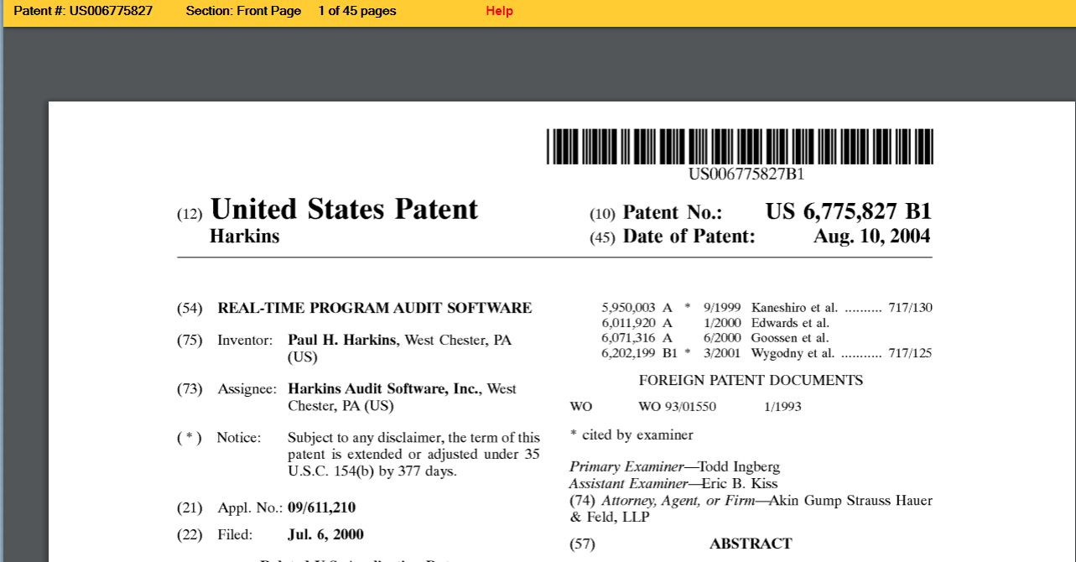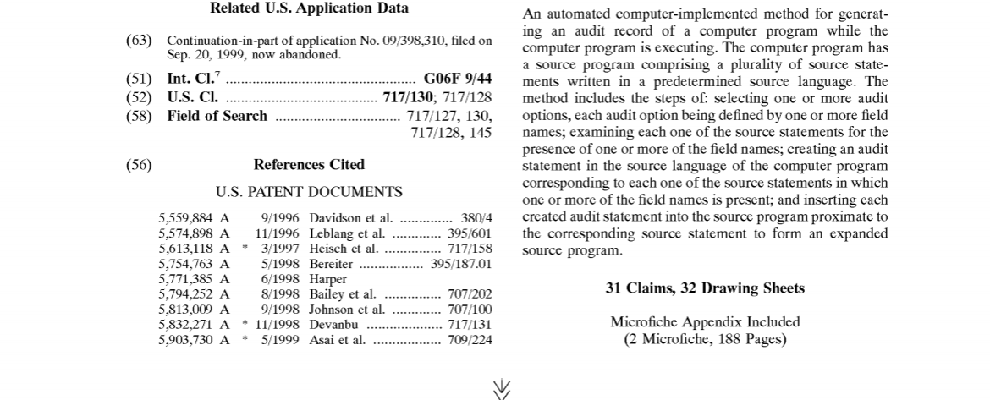
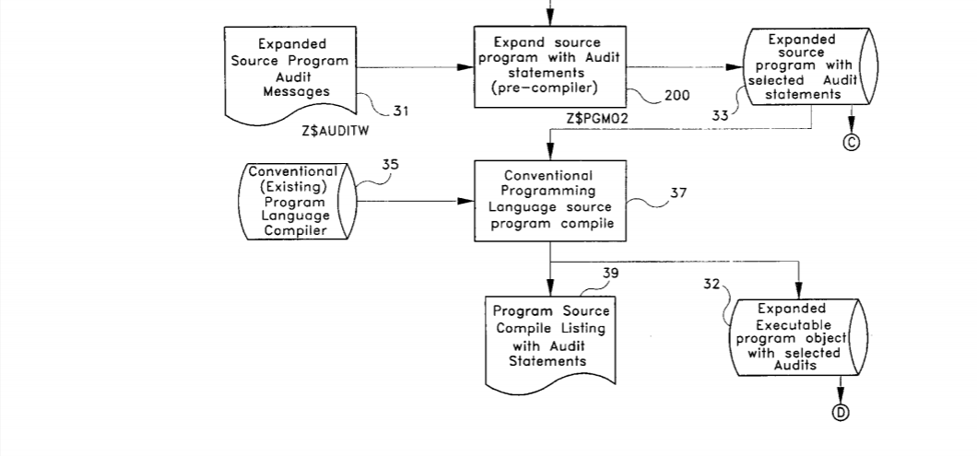
United States Patent 6,775,827 The Real-Time Program Audit
author Paul Houston Harkins

SUMMARY OF THE INVENTION
The current invention, a real-time program audit software program, is a software program, a method, and a system for generating source program audit statements which examine and verify program statements and data as the program executes. The audits generated by the real-time program audit provide real-time analysis of the execution of the program. The real-time program audit software may be used with any programming language that uses source program statements, whether the source statements are compiled into an executable object or are interpreted during program execution. Conventional source programs are selected for auditing based on an audit profile. The audit profile is customized for specific compile and initial execution options. The source program is expanded with the selected audit statements. The source program is compiled with a conventional language compiler. Program execution audits are based on the initial execution audit profile, customized execution audits, or dynamic audits specified during program execution. Program audit output is to a disk or print file, and is available for immediate online display or printing, or for expanded auditing analysis. Expanded auditing analysis provides for extensive analysis of the real-time program audit output data from all audited programs based on the desired analysis, which includes program, user, date and time ranges, audit code prefixes, audited file, field, label, and any execution audited data value.
The real-time program audit software is a new approach to auditing the execution processing of programs of virtually any source programming language. The real-time program audit is basically a pre-compiler program that is specific for the type of programming language utilized. In other words, a different version of the real-time program audit software is required for each programming language compiler or interpreter utilized.
Accordingly, it is a principal object of the invention to audit the execution of every program statement selected for auditing in real-time. The audit includes all field names used in the audited source statements and their data values at program execution. Date and time are included in the audit. Real-time online review and analysis of the auditing is an integral part of the real-time audit program software. Real-time printing of the auditing for off-line review and analysis is also provided.
It is another object of the invention to expand the input conventional source program with the audit statements, using an easily understood method of source program expansion that does not materially alter or change the processing, flow or conventional output of the program as it executes. The invention, alternatively, permits the existing conventional source program to optionally remain unchanged by creating a separate expanded source program in another library.
It is a further object of the invention to utilize the expanded source program and the audit statements as the basis for analysis of the program execution audit output. The invention provides for more rapid understanding and correction of errors, problems, or programming logic than is possible with the conventional source program. The source program is expanded with standard comprehensive program documentation. Examples of the documentation provided are file names, file keys, and call program names. This expansion results in source program's being significantly faster to write and test by the original programmer. Also, the program is much easier to read and understand by programmers unfamiliar with it, and therefore programmers can more easily modify the program.
Still another object of the invention is to provide default audit compile profiles which provide for typical auditing environments such as first program test audits, completed program test audits, pilot production audits, and production environment audits. The default audit profiles simplify the process of selecting auditing options to be included in the expanded source program. The invention allows a selected audit profile to be modified for the selected program and used when the conventional source program is expanded with audit statements.
Another object of the invention is to allow virtually any executable source program statement to be audited. The invention also allows virtually any file in the source program to be audited, together with desired file operation codes, and the data for all key fields used in the audited file operations. The invention provides ten levels of auditing which may be dynamically changed during program execution. Any executable operation code may be audited together with all fields referenced in each audited statement. Also, the invention provides standard audit operation code audit prefix codes beginning with the characters Z$, and with a suffix code unique to the operation code.
A further object of the invention is to allow virtually any field or label used in the source program to be audited when either referenced or modified, together with the data value of each audited field. Also, the invention provides select and omit functions which qualify the auditing of operation codes by field name(s).
Another object is to provide program default initial execution profiles, which are provided for typical initial execution environments, such as first program test, completed program test, pilot production, and production environment. The default initial execution profiles simplify the process of auditing the execution of programs by providing frequently selected audit execution options. The invention allows a selected execution profile to be modified for the selected program and used during the execution of the program.
It is a further object of the invention to provide for dynamic modification of program auditing during program execution by changing execution auditing options, or turning auditing on or off completely. Audits must have been previously selected for potential audit and included in the expanded source program.
An additional object is to optionally output audit data to a disk, and to provide for the retention of the audit data for both test and production environments. The invention also provides an audit database in date and time sequences from all audited programs. This provides for analysis of audited statements across all audited programs by date and time sequence. The analysis may include program, user, date and time range, audit code prefix, file, field, label, and/or any execution audited data value. The invention provides formatted audit reporting of historical audit information for use by internal and external auditors at a level of detail and auditability not possible previously.
Another object of this invention is to reduce the cost of developing and maintaining source programs by significantly reducing the skills and training needed by programmers, and to reduce much of the risk involved in implementing and maintaining programs. The invention also reduces the number of programmers required to develop and maintain programs.
Additionally, it is an object of the invention to provide the real-time detailed audit information needed for advanced event detection and event action software functions. This object may be advantageous in a large variety of computer operation settings and is particularly useful with multiple programmers and users that are utilizing the same programming language on the same compiler on a remote computer.
It is an object of the invention to provide improved elements and arrangements thereof in real-time program audit software for the purposes described which is inexpensive, dependable and fully effective in accomplishing its intended purposes.
These and other objects of the present invention will become readily apparent upon further review of the following specification and drawings.

RTPA works similar to the IBM SQL pre-compiler
The Real-Time Program Audit (RTPA) for IBM i works in a similar way as the IBM i RPGLE, COBOL, and CL compilers, which process source programs and create executable object programs output of the IBM compilers.

However, RTPA processes the source programs in s similar way as the IBM i SQL pre-compiler processes SQL source statements in an RPGLE or COBOL source program and instead of creating SQL executable statements, RTPA instead creates RPGLE or COBOL source statement (ZZ audit statements) that enable the RPGLE or COBOL executing statements to audit their execution in real-time in an RTPA audit file (ZZAUDITP or ZZAUDITD).

The RTPA real-time audit file, ZZAUDITP or ZZAUDITD) is produces as the pexpanded object program executes, similar to how the IBM Job file (QHST) is created when an IBM i Job is initiated or ends.

The RTPA expansion of the input IBM source program is created in a COPY of the input source program in liberry ZZAUDITE (RTPA expanded library) where both the RTPA expanded source program with ZZ auditing ststements and the resulting RTPA expanded object program are created after the exoanded source program is created.

Then simply think how IBM imolenemted the SQL pre-compiler to expand the capability of RPG and COBOL source programs with SQL capability, and that is how RTPA implements the RTPA real-time auditing (MUCH smarter RPG and COBOL and CL programs with real-time auditing capability, without changing the input source program.

IBM could easily implement real-time auditing in its language compilers
IBM could easily implement RTPA real-time auditing in its RPGLE, COBOL, CL and other language compilers and multiply programmer productivity, value, AND instant understanding by 3, 5, 10, 100 TIMES. (just by copying RTPA)

IBM compilers with real-time auditing capability, like RTPA, would save many Billions of dollars annually of wasted programmer time and effort and cost and greatly strengthen their IBM I customer base and IBM and the IBM i.

RTPA auditing of RPGLE procedures
This example of RTPA expansion and auditing of RTPA sample program TESTBASP illustrates how RTPA uses RPGLE procedures to audit all user programs, how user programs with procedures, like TESTBASP, are audited and illustrates how limitations in IBM i RPGLE and COBOL language compiler implementation and capability should be removed in future IBM compiler releases.

Specifically, the current IBM i RPGLE and COBOL compilers, among others, were not designed and implemented with the CRAZY idea of automatically at least optionally providing IBM support of real-time auditing and instant understanding of what was happening, and real-time control and management with informantion not outut to disk (like operator error messges), and instant capability of real-time AI).

How RTPA for RPG expands Sample program TESTBASP (RPGLE) Procedures
How RTPA expands RPGLE program TESTBASP is illustrated, including the RPGLE source program TESTBASP and key RTPA created files (of the perhaps 20 RTPA created files in an RPGLE program expansion with audit statements.

RTPA expansion of RPGLE and COBOL source programs should take only several elapsed seconds, normally less than 5 elapsed seconds in an LPAR with 4,000 CPW and 12 gigs of memory.

Columns . . . : 1 71 Edit ZZAUDIT/QRPGLESRC
SEU==> TESTBASP
FMT H .....HKeywords+++++++++++++++++++++++++++++++++++++++++++++++++++++++++
*************** Beginning of data *************************************
0001.00 h dftactgrp(*NO)
0002.00 * must compile override Default Activation Group *NO
0003.00 * DEFINE VARIABLES USED IN PROCEDURES GLOBALLY TO BE ABLE TO AUDI
0004.00 * (DO NOT DEFINE PROCEDURE VARIABLES INSIDE THE PROCEDURE (LOCAL)
0005.00 D HOLD8 S 8A
0006.00 D HOLD9 S 9A
0007.00 D INTDTA S 8A
0008.00 * prototype for procedure longproc
0009.00 dlongproc pr
0010.00 dfreeproc pr
0011.00 * start calc specs
0012.00 C MOVEL 'AAAAAAAA' CHECKP 8
0013.00 C MOVEL 'BBBB' HOLDP 4
0014.00 c movel 'pppppppp' hold8
0015.00 c movel 'aaaaaaaaa' hold9
0016.00 c movel '111' intdta 0017.00 C MOVEL 'DDDD' HOLDD 4
0018.00 C MOVEL 'AAAAAAAA' CHECK8 8
0019.00 C Z-ADD 5 FIRST 2 0
0020.00 C EVAL HOLD7 = '6666666'
0021.00 C MOVEL 'BBBB' HOLDB 4
0022.00 C CHECK8 IFEQ 'AAAAAAAA'
0023.00 C holdb andeq 'BBBB'
0024.00 C movel 'CCCC' holdr 4
0025.00 C endif
0026.00 C MOVEL 'DDDD' HOLDD 4
0027.00 C MOVEL 'EEEE' HOLDE 4
0028.00 /free
0029.00 if check8 = 'AAAAAAAA' and holdb = 'BBBB';
0030.00 holdr = 'CCCC';
0031.00 endif;
0032.00 holdd = 'DDDD';
0033.00 /end-free 0034.00 * call a procedure in fixed format
0035.00 c callp longproc
0036.00 C Z-ADD 10 SECOND 2 0
0037.00 /free
0038.00 eval hold7 = 'fffffff';
0039.00 // call a procedure in free format
0040.00 callp freeproc();
0041.00 holdd = 'XXXX';
0042.00 holde = 'FFFF';
0043.00 /end-free
0044.00 c movel 'ccccccc' hold7 7
0045.00 C exsr shipto
0046.00 * end program
0047.00 C move '1' *inlr
0048.00 C RETURN
0049.00 C shipto begsr
0050.00 C z-add 20 value 5 0 0051.00 C endsr
0052.00 plongproc b
0053.00 * comment in a prototyped call longproc
0054.00 C EVAL HOLD7 = '6666666'
0055.00 C CHECKP IFEQ 'AAAAAAAA'
0056.00 C holdP andeq 'BBBB'
0057.00 C movel 'CCCC' holdr
0058.00 C endif
0059.00 C MOVEL 'DDDD' HOLDD
0060.00 plongproc e
0061.00 pfreeproc b
0062.00 /free
0063.00 // free form comment in a procedure
0064.00 eval hold9 = 'hhhhhhhhh';
0065.00 if checkp = 'AAAAAAAA' and holdp = 'BBBB';
0066.00 holdr = 'CCCC';
0067.00 endif; 0068.00 holdd = 'DDDD';
0069.00 /end-free
0070.00 pfreeproc e
****************** End of data ****************************************

F3=Exit F4=Prompt F5=Refresh F9=Retrieve F10=Cursor F11=Toggle
F16=Repeat find F17=Repeat change F24=More keys

RTPA RPGLE sample program TESTBASP source

TESTBASP is an RPGLE batch program with procedures.

Enter the RTPA for RPG command RTPA to audit enable RPG source programs

RTPA (to display the entry screen for RTPA for RPG)

NOTE – If the RTPA for RPG program entry screen is NOT displayed, then there is an error in the RTPA license or security code.

MAIN IBM i Main Menu
System: LS053
Select one of the following:

1. User tasks
2. Office tasks
3. General system tasks
4. Files, libraries, and folders
5. Programming
6. Communications
7. Define or change the system
8. Problem handling
9. Display a menu
10. Information Assistant options
11. IBM i Access tasks

90. Sign off

Selection or command
===> rtpa

F3=Exit F4=Prompt F9=Retrieve F12=Cancel F13=Information Assistant
F23=Set initial menu
(C) COPYRIGHT IBM CORP. 1980, 2015.

Key RTPA to display the RTPA for RPG entry screen

PHARKINS (USA User Profile) RTPA entry screen date format *MDY

ZZPGM01R Real-Time Program Audit for RPG (V7R1) Date 8/17/20
PHARKINS Select Program to Audit Time 12:36:42
RPG3 and RPG4 source members CCSID 37 Serial 2104FAW
Type choices, Press F10 Language ENU Model 42A
Source Member . . . . . . TESTBASP Name, generic*, *ALL, F4 for List
Source File . . . . . . . QRPGLESRC Name Date Format *MDY
Library . . . . . . . . ZZAUDIT Name Audit comments Y

Object to Library . . . . . . ZZAUDITE Name Audit copybooks Y

Audit Timestamp Y
Audit File Outq . . . . . . . *SAME Name, *SAME
Audit Procedures Y
JOBD for pgm compile libl . . *LIBL *LIBL, JOBD
Library . . . . . . . . Name Audit Variable contents A
A=All N=None V=F16 Var W=F2 Watch
Audit Compile Listing Stmts . to 1-99999 Audit to Disk N
(Only) to
to Document Only N
Project PROCEDURES to
Ticket T1234567 to Remote RTPA via FTP N
F2=Watch Variables F3=Exit F6=Auditing options F7=Compile Options
F8=Conditional Auditing F9=Maint. Menu F10=Submit Expand F12=Cancel
F18=RTPA history today F24=More Keys (C) Harkins & Associates, Inc.

(the RTPA for RPG program entry screen is displayed)

Expand RPGLE source program TESTBASP TESPBASP has two procedures

Enter the RPGLE Source program name TESTBASP source file (QRPGLESRC) and source library ZZAUDIT to be RTPA audit enabled (expanded with RTPA ZZ audit statements in a COPY of the program)

RTPA sample RPGLE source program TESTBASP in file QRPGLESRC in library ZZAUDIT is selected.
Press command Key 10 (F10) to submit TESTBASP for RTPA expansion with auditing statements

RTPA tracks projects and tickets
Project PROCEDURES
Ticket T1234567

F10=Submit Expand

Member TESTBASP Input RPG program submitted. Press F18 to see status.
ZZPGM01R Real-Time Program Audit for RPG (V7R1) Date 8/17/20
PHARKINS RTPA history today Time 12:41:21
Paul Harkins RTPA user profile CCSID: 37
Type option, press Enter Language ENU
4=Delete 5=Display Date Format *MDY

O Program Status Program Name Job Date Time
5 TESTBASP 8 EXPN OK TESTBAS basic with CALLP INIT 101758 8/17/20 12:41:10

F3=Exit F5=Refresh F12=Cancel F20=RTPA User history
F22=RTPA Analytics Report (C) HARKINS & ASSOCIATES, INC.

The TESTBASP RPGLE source program is successfully expanded with RTPA audit ststements in library ZZAUDITE

Key 5 to display the RTPA detail expansion screen

ZZPGM01R Real-Time Program Audit for RPG (V7R1) Date 8/17/20
PHARKINS Select Program to Audit Time 12:42:04
Project PROCEDURES Ticket T1234567 *MDY CCSID 37 Language ENU
Program TESTBASP TESTBAS basic with CALLP INIT Audit Variable con A
Status 8 Expand Pgm compiled OK Audit comments Y Audit to Disk N
Audit copybooks Y Document Only N
Type option, press Enter Audit Timestamp Y Remote RTPA FTP N
5=Display compile listing Audit Procedures Y Variable used 15
OPT Job Records Submitted Completed Elapsed Comp recds
Input 101758 70 8/17/20 12:41:10 8/17/20 12:41:11 1 70
Inserted 101759 481 8/17/20 12:41:13 8/17/20 12:41:14 1
Expanded 101761 551 8/17/20 12:41:15 8/17/20 12:41:16 1 575
Exp Obj lib ZZAUDITE Program Object size 397,312
Source File QRPGLESRC Expand File QRPGLESRC Record formats copybooks
Source Libl ZZAUDIT Exp Src lib ZZAUDITE Printer files *INZSR
RPG Version 4 RPGLE Audit JOBQ RTPA Extension 4 %parms
From To Audit outq Subroutines 1 /free Y
From To Audit Libr. *LIBL Overflow OG Indent
From To JOBD Libr. Protoype/Proc. Y CTA N SDS
From To Maximum Pages 15000 SDS Name SDS Qual
From To Watch varia DBCS J 11 Start/Stop conditional N
F8=Conditional Auditing F13=Files/Recd F14=Fields F15=Operations F16=Variables
F2=Watch Variables F17=Labels F19=Called Pgm F21=Cond Oper
F3=Exit F22=Indicators F23=Pre Audit (C) 2016 Harkins & Associates, Inc.

The TESTBASP RPGLE source program is successfully expanded with all 15 variables audited and all executable RTPA atatements audited (the RTPA defaults)

Execute the TESTBASP batch program with RTPA audits from library ZZAUDITE

CALL TESTBASP

Work with All Spooled Files

Type options, press Enter.
1=Send 2=Change 3=Hold 4=Delete 5=Display 6=Release 7=Messages
8=Attributes 9=Work with printing status

Device or Total Cur
Opt File User Queue User Data Sts Pages Page Copy
TESTBASP PHARKINS RTPA RDY 9 1
TESTBASP PHARKINS RTPA RDY 19 1
5 ZZAUDITP PHARKINS RTPA TESTBASP HLD 2 1

Bottom
Parameters for options 1, 2, 3 or command
===>
F3=Exit F10=View 4 F11=View 2 F12=Cancel F22=Printers F24=More keys

The TESTBASP RPGLE source program is successfully expanded with RTPA audit statements in library ZZAUDITE

WRKSPLF to display the RTPA audit file of TESTBASP execution ZZAUDITP

Display Spooled File
File . . . . . : ZZAUDITP Page/Line 1/1
Control . . . . . Columns 1 - 78
Find . . . . . .
*...+....1....+....2....+....3....+....4....+....5....+....6....+....7....+...
Program-TESTBASP TESTBAS basic with CALLP INIT Obj Lib
TESTBASP TESTBASP
Job: 101737 User Profile: PHARKINS Source Type: RPGLE
Line
12 C MOVEL 'AAAAAAAA' CHECKP 8
AAAAAAAA
13 C MOVEL 'BBBB' HOLDP 4
BBBB
14 c movel 'pppppppp' hold8
pppppppp
15 c movel 'aaaaaaaaa' hold9
aaaaaaaaa
16 c movel '111' intdta
111
17 C MOVEL 'DDDD' HOLDD 4 18 C MOVEL 'AAAAAAAA' CHECK8 8
AAAAAAAA
19 C Z-ADD 5 FIRST 2 0
5
20 C EVAL HOLD7 = '6666666'
6666666
21 C MOVEL 'BBBB' HOLDB 4
BBBB
22 C CHECK8 IFEQ 'AAAAAAAA'
AAAAAAAA
23 C holdb andeq 'BBBB'
BBBB
24 C movel 'CCCC' holdr 4
CCCC
25 C endif
26 C MOVEL 'DDDD' HOLDD 4 DDDD
27 C MOVEL 'EEEE' HOLDE 4
EEEE
29 if check8 = 'AAAAAAAA' and holdb = 'BBBB';
AAAAAAAA BBBB
30 holdr = 'CCCC';
CCCC
31 endif;
32 holdd = 'DDDD';
DDDD
34 * call a procedure in fixed format
35 c callp longproc Call-
52 plongproc b
53 * comment in a prototyped call longproc
54 C EVAL HOLD7 = '6666666'
6666666
55 C CHECKP IFEQ 'AAAAAAAA'
AAAAAAAA
56 C holdP andeq 'BBBB'
BBBB
57 C movel 'CCCC' holdr
CCCC
58 C endif
59 C MOVEL 'DDDD' HOLDD
DDDD
60 plongproc e
36 C Z-ADD 10 SECOND 2 0
10
38 eval hold7 = 'fffffff';
fffffff
39 // call a procedure in free format
40 callp freeproc(); Call- 61 pfreeproc b
63 // free form comment in a procedure
64 eval hold9 = 'hhhhhhhhh';
hhhhhhhhh
65 if checkp = 'AAAAAAAA' and holdp = 'BBBB';
AAAAAAAA BBBB
66 holdr = 'CCCC';
CCCC
67 endif;
68 holdd = 'DDDD';
DDDD
70 pfreeproc e
41 holdd = 'XXXX';
XXXX
42 holde = 'FFFF';
FFFF 44 c movel 'ccccccc' hold7 7
ccccccc
45 C exsr shipto
49 C shipto begsr
50 C z-add 20 value 5 0
20
51 C endsr
46 * end program
47 C move '1' *inlr
1
48 C RETURN
===== window 205 for statement timestamp ==============================
Display Spooled File
File . . . . . : ZZAUDITP Page/Line 1/81
Control . . . . . W205 Columns 205 - 280
Find . . . . . .
+....1....+....2....+....3....+....4....+....5....+....6....+....7....+....8
MOVEL RPGLE 101737 PHARKINS TESTBASP 2020-08-17 12.43.46.759
RPGLE 101737 PHARKINS TESTBASP 2020-08-17 12.43.46.759
MOVEL RPGLE 101737 PHARKINS TESTBASP 2020-08-17 12.43.46.759
BEGSR RPGLE 101737 PHARKINS TESTBASP 2020-08-17 12.43.46.759
Z-ADD RPGLE 101737 PHARKINS TESTBASP 2020-08-17 12.43.46.759
RPGLE 101737 PHARKINS TESTBASP 2020-08-17 12.43.46.759
ENDSR RPGLE 101737 PHARKINS TESTBASP 2020-08-17 12.43.46.759
comment RPGLE 101737 PHARKINS TESTBASP 2020-08-17 12.43.46.759
MOVE RPGLE 101737 PHARKINS TESTBASP 2020-08-17 12.43.46.759
RPGLE 101737 PHARKINS TESTBASP 2020-08-17 12.43.46.759
RETURN RPGLE 101737 PHARKINS TESTBASP 2020-08-17 12.43.46.763

All TESTBASP executing statements are audited together with the contents of all variables and the timestamp of each executing statement

The the execution of the two procedures is audited
52 plongproc b
61 pfreeproc b

RTPA expands the input RPGLE source program by:

- Compiling the input RPGLE source program TESTBASP
- Stripping the TESTBASP compile listing (which may be in many languages) of the input program source statements, variables used, and other information needed to insert RTPA ZZ auditing statements into a COPY of the source program in library ZZAUDITE

Work with All Spooled Files

Type options, press Enter.
1=Send 2=Change 3=Hold 4=Delete 5=Display 6=Release 7=Messages
8=Attributes 9=Work with printing status

Device or Total Cur
Opt File User Queue User Data Sts Pages Page Copy
5 TESTBASP PHARKINS RTPA RDY 9 1
TESTBASP PHARKINS RTPA RDY 19 1
ZZAUDITP PHARKINS RTPA TESTBASP HLD 2 1

Bottom
Parameters for options 1, 2, 3 or command
===>
F3=Exit F10=View 4 F11=View 2 F12=Cancel F22=Printers F24=More keys

The TESTBASP input RPGLE source program compile has included all copybooks and file fields.
Display Spooled File
File . . . . . : TESTBASP Page/Line 1/1
Control . . . . . Columns 1 - 78
Find . . . . . .
*...+....1....+....2....+....3....+....4....+....5....+....6....+....7....+...
5770WDS V7R3M0 160422 RN IBM ILE RPG QTEMP/TESTBASP
Command . . . . . . . . . . . . : CRTBNDRPG
Issued by . . . . . . . . . . : PHARKINS
Program . . . . . . . . . . . . : TESTBASP
Library . . . . . . . . . . . : QTEMP
Text 'description' . . . . . . . : *SRCMBRTXT
Source Member . . . . . . . . . : TESTBASP
Source File . . . . . . . . . . : ZZCOPINP
Library . . . . . . . . . . . : QTEMP
CCSID . . . . . . . . . . . . : 37
Text 'description' . . . . . . . : copied input RPG source to QTEMP
Last Change . . . . . . . . . . : 08/19/20 12:29:18
Generation severity level . . . : 10
Default activation group . . . . : *YES
Compiler options . . . . . . . . : *XREF *GEN *NOSECLVL *SHOWC
*EXPDDS *EXT *NOSHOWSKP *NOSRC
================================================================================

8 * prototype for procedure longproc
9 dlongproc pr
10 dfreeproc pr
11 * start calc specs
12 C MOVEL 'AAAAAAAA' CHECKP 8
13 C MOVEL 'BBBB' HOLDP 4
14 c movel 'pppppppp' hold8
15 c movel 'aaaaaaaaa' hold9
16 c movel '111' intdta
17 C MOVEL 'DDDD' HOLDD 4
5770WDS V7R3M0 160422 RN IBM ILE RPG QTEMP/TESTBASP
Line <---------------------- Source Specifications -------------------------
Number ....1....+....2....+....3....+....4....+....5....+....6....+....7....+.
18 C MOVEL 'AAAAAAAA' CHECK8 8
19 C Z-ADD 5 FIRST 2 0
20 C EVAL HOLD7 = '6666666'

RPGLE TESTBASP input RPGLE source program compile listing.

RTPA uses the input program compile listing line number for selecting ranges of ststements to be audited
12 C MOVEL 'AAAAAAAA' CHECKP 8
13 C MOVEL 'BBBB' HOLDP 4

Display Spooled File
File . . . . . : TESTBASP Page/Line 6/12
Control . . . . . Columns 1 - 78
Find . . . . . .
*...+....1....+....2....+....3....+....4....+....5....+....6....+....7....+...
Global Field References:
Field Attributes References (D=Defined M=Modified
*INLR N(1) 47M
CHECKP A(8) 12D 55 65
CHECK8 A(8) 18D 22 29
FIRST P(2,0) 19D
FREEPROC PROTOTYPE 10D 40 61 70
HOLDB A(4) 21D 23 29
HOLDD A(4) 17D 26D 32M 41M
59M 68M
HOLDE A(4) 27D 42M
HOLDP A(4) 13D 56 65
HOLDR A(4) 24D 30M 57M 66M
HOLD7 A(7) 20M 38M 44D 54M
HOLD8 A(8) 5D 14M
HOLD9 A(9) 6D 15M 64M

RTPA uses the input program compile listing Global field references to create RTPA files including ZZFI09 to audit all or selected global reference fields in statements being executed.

Variables defined in RPGLE procedures are local variables defined and used in only that procedure, and cannot be audited by RTPA.

Local procedure variables can be audited by RTPA by putting them in the main program, as in TESTBASP.

RTPA uses RTPA procedures in the audit enabled TESTBASP program in library ZZAUDITE, to audit the input source program procedures, so the data contents of audited local variables is blanks.

Display Physical File Member
File . . . . . . : ZZFI09 Library . . . . : ZZAUDIT
Member . . . . . : ZZFI09 Record . . . . . : 1
Control . . . . . Column . . . . . : 1
Find . . . . . . .
*...+....1....+....2....+....3....+....4....+....5....+....6....+....7....+...
TESTBASP 101919*INLR N000010000000 Y
TESTBASP 101919CHECKP A000080000000 Y
TESTBASP 101919CHECK8 A000080000000 Y
TESTBASP 101919FIRST P000020000000 Y
TESTBASP 101919HOLDB A000040000000 Y
TESTBASP 101919HOLDD A000040000000 Y
TESTBASP 101919HOLDE A000040000000 Y
TESTBASP 101919HOLDP A000040000000 Y
TESTBASP 101919HOLDR A000040000000 Y
TESTBASP 101919HOLD7 A000070000000 Y
TESTBASP 101919HOLD8 A000080000000 Y
TESTBASP 101919HOLD9 A000090000000 Y
TESTBASP 101919INTDTA A000080000000 Y
TESTBASP 101919SECOND P000020000000 Y
TESTBASP 101919VALUE P000050000000 Y
More...
F3=Exit F12=Cancel F19=Left F20=Right F24=More keys

RTPA File ZZFI09 RTPA global variables used in RPGLE TESTBASP

RTPA ctrates file ZZFI09 to be able to audit ALL or selected global variables in the RTPA expanded program in library ZZAUDITE

Display Physical File Member
File . . . . . . : ZZFI17 Library . . . . : ZZAUDIT
Member . . . . . : ZZFI17 Record . . . . . : 1
Control . . . . . Column . . . . . : 1
Find . . . . . . .
*...+....1....+....2....+....3....+....4....+....5....+....6....+....7....+...
TESTBASP 101919000070000070 LLLLLL ROC E
TESTBASP 101919000061000061 ROC B
TESTBASP 101919000060000060 ROC E
TESTBASP 101919000059000059MOVEL 'DDDD' 'D
TESTBASP 101919000058000058ENDIF MOVEL
TESTBASP 101919000057000057MOVEL ENDIF 'CCCC' 'C
TESTBASP 101919000056000056ANDEQ MOVEL HOLDP 'BBBB' 'B
TESTBASP 101919000055000055IFEQ ANDEQ CHECKP 'AAAAAAAA' 'A
TESTBASP 101919000054000054EVAL IFEQ HOLD7 = '66666HO
TESTBASP 101919000052000052 EVAL ROC B
TESTBASP 101919000051000051ENDSR
TESTBASP 101919000050000050Z-ADD ENDSR 20 20
TESTBASP 101919000049000049BEGSR Z-ADD SHIPTO
TESTBASP 101919000048000048RETURN BEGSR
TESTBASP 101919000047000047MOVE RETURN '1' '1
More...
F3=Exit F12=Cancel F19=Left F20=Right F24=More keys

RTPA File ZZFI17 RTPA Calculation specs used in RPGLE TESTBASP

RTPA uses RTPA file ZZFI17 to control the inserting of ZZAUDIT statements in the expanded source program in library ZZAUDITE, depending on what the IBM RPGLE compiler allows.

TESTBASP 101919000057000057MOVEL ENDIF 'CCCC' 'C
TESTBASP 101919000056000056ANDEQ MOVEL HOLDP 'BBBB' 'B
TESTBASP 101919000055000055IFEQ ANDEQ CHECKP 'AAAAAAAA' 'A
TESTBASP 101919000054000054EVAL IFEQ HOLD7 = '66666HO

RTPA uses RTPA file ZZFI17 to control the inserting of ZZAUDIT statements in the expanded source program in library ZZAUDITE, depending on what the IBM i RPGLE compiler allows.

Display Physical File Member
File . . . . . . : ZZAUDSRC Library . . . . : ZZAUDIT
Member . . . . . : ZZAUDSRC Record . . . . . : 1
Control . . . . . Column . . . . . : 1
Find . . . . . . .
*...+....1....+....2....+....3....+....4....+....5....+....6....+....7....+...
TESTBASP 1019191000001MOVEL 12 C MOVEL 'AAAAAAAA'
TESTBASP 1019191000002MOVEL 13 C MOVEL 'BBBB'
TESTBASP 1019191000003MOVEL 14 c movel 'pppppppp'
TESTBASP 1019191000004MOVEL 15 c movel 'aaaaaaaaa
TESTBASP 1019191000005MOVEL 16 c movel '111'
TESTBASP 1019191000006MOVEL 17 C MOVEL 'DDDD'
TESTBASP 1019191000007MOVEL 18 C MOVEL 'AAAAAAAA'
TESTBASP 1019191000008Z-ADD 19 C Z-ADD 5
TESTBASP 1019192000001EVAL 20 C EVAL HOLD7 = '6
TESTBASP 1019191000009MOVEL 21 C MOVEL 'BBBB'
TESTBASP 1019192000002IFEQ 22 C CHECK8 IFEQ 'AAAAAAAA'
TESTBASP 1019192000003ANDEQ 23 C holdb andeq 'BBBB'
TESTBASP 1019191000010MOVEL 24 C movel 'CCCC'
TESTBASP 1019191000011ENDIF 25 C endif
TESTBASP 1019191000012MOVEL 26 C MOVEL 'DDDD' TESTBASP 1019191000013MOVEL 27 C MOVEL 'EEEE'
TESTBASP 1019191000014 29 if check8 = 'AAAAAAAA' and holdb =
TESTBASP 1019191000015 30 holdr = 'CCCC';
TESTBASP 1019191000016 31 endif;
TESTBASP 1019191000017 32 holdd = 'DDDD';
TESTBASP 1019191000018comment 34 * call a procedure in fixed format
TESTBASP 1019191000019CALLP 35 c callp longproc
TESTBASP 1019191000020Z-ADD 36 C Z-ADD 10
TESTBASP 1019191000021 38 eval hold7 = 'fffffff';
TESTBASP 1019191000022comment 39 // call a procedure in free format
TESTBASP 1019191000023 40 callp freeproc();
TESTBASP 1019191000024 41 holdd = 'XXXX';
TESTBASP 1019191000025 42 holde = 'FFFF';
TESTBASP 1019191000026MOVEL 44 c movel 'ccccccc'
TESTBASP 1019191000027MOVEL 45 C exsr shipto TESTBASP 1019191000028comment 46 * end program
TESTBASP 1019191000029MOVE 47 C move '1'
TESTBASP 1019191000030RETURN 48 C RETURN
TESTBASP 1019191000031BEGSR 49 C shipto begsr
TESTBASP 1019191000032Z-ADD 50 C z-add 20
TESTBASP 1019191000033ENDSR 51 C endsr
TESTBASP 1019191000034B 52 plongproc b
TESTBASP 1019191000035comment 53 * comment in a prototyped call longproc
TESTBASP 1019192000004EVAL 54 C EVAL HOLD7 = '6
TESTBASP 1019192000005IFEQ 55 C CHECKP IFEQ 'AAAAAAAA'
TESTBASP 1019192000006ANDEQ 56 C holdP andeq 'BBBB'
TESTBASP 1019191000036MOVEL 57 C movel 'CCCC'
TESTBASP 1019191000037ENDIF 58 C endif
TESTBASP 1019191000038MOVEL 59 C MOVEL 'DDDD'
TESTBASP 1019191000039E 60 plongproc e TESTBASP 1019191000040B 61 pfreeproc b
TESTBASP 1019191000041comment 63 // free form comment in a procedure
TESTBASP 1019191000042 64 eval hold9 = 'hhhhhhhhh';
TESTBASP 1019191000043 65 if checkp = 'AAAAAAAA' and holdp =
TESTBASP 1019191000044 66 holdr = 'CCCC';
TESTBASP 1019191000045 67 endif;
TESTBASP 1019191000046 68 holdd = 'DDDD';
TESTBASP 1019191000047E 70 pfreeproc e
****** END OF DATA ******

RTPA File ZZAUDSRC RTPA auditable source statements in RPGLE program TESTBASP

RTPA uses RTPA file ZZAUDSRC to contain the program executable source statements (calculation specs) for use during RTPA execution of the expanded audit enables object program TESTBASP.

RTPA uses this ZZAUDSRC file for the TESTBASP statement description during exececution of the expanded audit enabled TESTBASP object program rather than the object program Debug views, due to size limitaions of the IBM RPGLE compiler.

Appendix
J

Appendix J: How Fast and Efficient is RTPA auditing?
The answer is RTPA and user implemented real-time program auditing is essentially infinitely fast and very efficient.

RTPA and user implemented real-time program auditing utilizes the essentially infinite speed, power, capability, availability, and minimal or no cost of the computer to automate and simplify and elimate huge amounts of the traditional work of programmers, which have traditionally been human centric focused with minimal actual use of the computer.

At the dawn of corporate computing in the early 1960s when I was an IBM Systems Engineer (programmer) working with customer programmers on the IBM 1401 and IBM 1440 comouters (16 thousand positions of core storage, not 16 gigs of memory), we wrote application programs in IBM assembly language (Autocoder or Symbolic Programming Systems), and we typically got the evening, after customer production, to use the hugely expensive corporate computer, which ran one ONE program at a time in the computer.

We typically each got only one or two program compiles a night as the IBM 1401 or 1440 computer took about 45 minutes to compile a amall (all programs were small) assembly program, and the expensive computer time was recorded and typically charged to the project.

We used the available primitate development and program debugging tools then available which involved stopping the entire computer (which was executing only your program) and looking at the computer console lights to see which computer statement stopped the computer and single cycling the computer one statement at a time using switches on the computer console.

We had to try to remember what we were seeing and doing on the computer console, as the console display was in IBM 1401 7 bit ASCII code or later 8 bit IBM system/360 EBCDIC code to represent each character.

This stop the entire computer and look at the computer console lights and change computer instructions and data inside the computer on the console technique was migrated to IBM’s Interactive Debug program when computer displays became available and multiple computer programs could be run simultaneously in the computer.

Incredibly, this primitive, obsolete, unproductive, slow, costly, and inefficient Interactive Debug technique is still being widely used today, and it is costing IBM i customers and IBM System z mainframe customers, and the IBM corporation itself many billions of dollars annually in wasted time and effort and productivity, and ultimately in the loss of customers and programmer jobs.

Incredibly, this primitive, obslote, unproductive, slow, costly, and inefficient Interactive Debug technique and IBMs focus on programmer human centric work has so crippled IBM i customers and IBM itself that a host of companies including Microsoft, Oracle, SAP, Apple that did not exist when I worked at IBM, have eclipsed IBM with many times the annual revenue per employee and market capitalization and revenue, like Microsoft and Apple, that dwarf IBM’s.

IBM still will not change to become current and competitive.

Computers are millions of times faster than human brains and human backs

Computers are essentially infinitely fast and incredibly powerful and are getting faster and more powerful and cheaper every year.

On-Demand simultaneous real-time streaming of movies over the Internet to millions of TVs illustrates the essentially infinite speed and capability of fiber optics and now 5G wide band communication at very low costs.

Security camera real-time recording and analytics is like RTPA
Every corner convenience store and many homes and even some automobiles now have continuous high definition video recording and real-time analytics of several camera views in a $1000 video recording unit.

The purpose of the security camera real-time recording is to record and permanently document exactly what is happening, which is exactly the purpose of RTPA.

Real-time analytics of the real-time visual recordings, such as facial recognition, crime detection, and other analytics such as murder investigations also parallel the capability and use of RTPA audit recordings.

A $1000 visual recording unit can easily have four video camera recording in high definition video, 24 hours a day and 7 days a week, saving the recorded information until it is not needed..

RTPA provides IBM i recording and auditing and storage capabilities similar to the security camera capability, without significant or even noticeable overhead as is illustrated below.

GoToMeeting video recording is essentially infinitely fast
On a 5 year old laptop computer, GoToMeeting video recording in high definition MP4 with up to six web cams recording is essentially infinitially fast, with no noticeable delay. The GoToMeetings require about one million characters of disk storage for each minute of the recording.

Microsoft Word Find function is essentially infinitely fast
On a 5 year old laptop computer, The Microsoft Word Find function (F5) scanned the entire 600 page RTPA User Manual for the occurances of the word RTPA and found 2644 occurances in about ONE ELAPSED SECOND.

Microsoft Word searched all 600 pages of the RTPA Users manual for the word RTPA

Word additionally underscored all 2644 occurances of the word RTPA and also indexed all 2644 occurances of RTPA so they ould be sequentially retrieved from the 600 page RTPA User Manual.

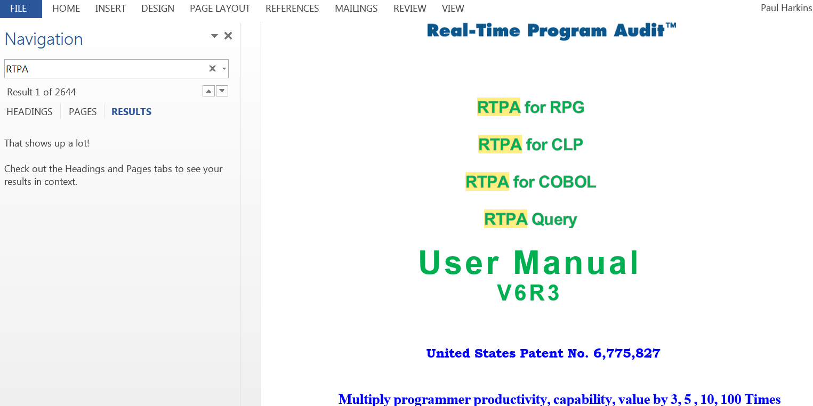

The Microsoft Word Find function (F5) scanned the entire 600 page RTPA User Manual for the occurances of the word i and found 33805 occurances in about ONE ELAPSED SECOND.

Microsoft Word searched all 600 pages of the RTPA Users manual for the word i.

Word additionally underscored all 33805 occurances of the word i and also indexed all 33805 occurances of i so they ould be sequentially retrieved from the 600 page RTPA User Manual.

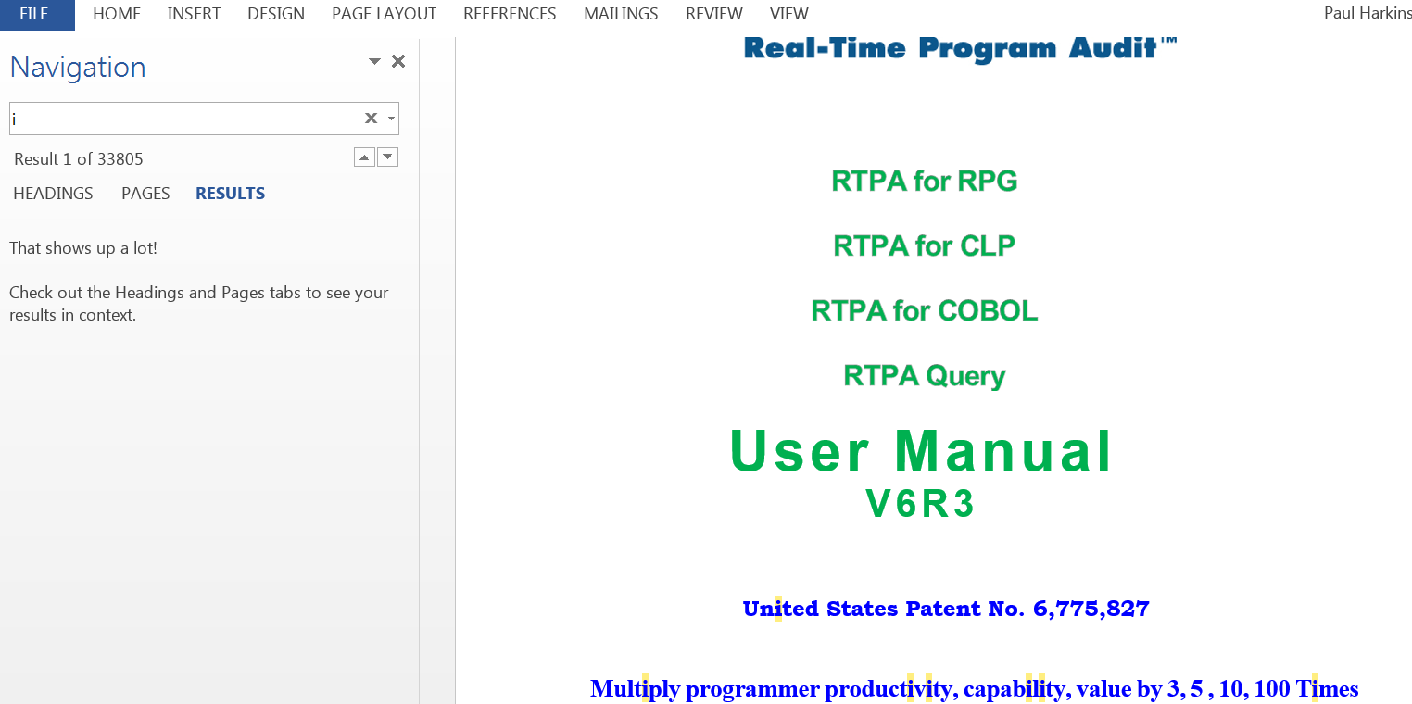

IBM i Find function (F16) is essentially infinitely fast
The IBM i Find function (F16) capability is very similar to the Microsoft Word capability and essentially infinitely fast and free for the programmer to use all day long.

The IBM i Find function (F16) typically takes one or two seconds to find a character string in a 200 page file, and less than ten seconds to find a character string in a 1000 page file (100 pages a second or more).

The RTPA RPGLE interactive sample program NEWEXPSH testing has found an error condition where the displayed customer number is 2050 instead of the correct customer number 1000.

ZZPGM01R Real-Time Program Audit for RPG (V7R1) Date 8/20/20
PHARKINS Select Program to Audit Time 15:26:19
Project Ticket *MDY CCSID 37 Language ENU
Program NEWEXPSH New Expected Ship Date from Order Deta Audit Variable con A
Status 8 Expand Pgm compiled OK Audit comments Y Audit to Disk N
Audit copybooks Y Document Only N
Type option, press Enter Audit Timestamp Y Remote RTPA FTP N
5=Display compile listing Audit Procedures Y Variable used 220
OPT Job Records Submitted Completed Elapsed Comp recds
Input 102078 1,186 8/20/20 15:25:59 8/20/20 15:26:00 1 1,333
Inserted 102079 5,509 8/20/20 15:26:04 8/20/20 15:26:10 6
Expanded 102081 6,695 8/20/20 15:26:11 8/20/20 15:26:17 6 6,670
Exp Obj lib ZZAUDITE Program Object size 4,587,520
Source File QRPGLESRC Expand File QRPGLESRC Record formats 7 copybooks Y
Source Libl ZZAUDIT Exp Src lib ZZAUDITE Printer files 2 *INZSR Y
RPG Version 4 RPGLE Audit JOBQ RTPA Extension %parms
rom To Audit outq Subroutines 9 /free Y
rom To Audit Libr. *LIBL Overflow OE Indent
rom To JOBD Libr. Protoype/Proc. N CTA Y SDS Y
rom To Maximum Pages 15000 SDS Name QXXDS SDS Qual
rom To Watch varia DBCS J 291 Start/Stop conditional N
8=Conditional Auditing F13=Files/Recd F14=Fields F15=Operations F16=Variables
F2=Watch Variables F17=Labels F19=Called Pgm F21=Cond Oper
F3=Exit F22=Indicators F23=Pre Audit (C) 2016 Harkins & Associates, Inc.

RTPA expansion of interactive RPGLE NEWEXPSH program

CALL ZZTEST1N (execute NEWEXPSH with CLP ZZTEST1N parms)

NEWEXPSH Order Inquiry of expected Ship Date 8/20/20 15:31:53

Customer 2050 XYZ STORE - ARDMORE Store 1

Order Number 1500

Line Number 1

Expected Ship Date 9/27/20

F3=Exit Enter=Change expected ship date

3

RPGLE NEWEXPSH execution of RTPA enabled program in ZZAUDITE with customer 2050 error condition (about the tenth screen displayed)

Display Job
System: LS053
Job: QPADEV0001 User: PHARKINS Number: 102071

Select one of the following:

1. Display job status attributes
2. Display job definition attributes
3. Display job run attributes, if active
4. Display spooled files

10. Display job log, if active, on job queue, or pending
11. Display call stack, if active
12. Display locks, if active
13. Display library list, if active
14. Display open files, if active
15. Display file overrides, if active
16. Display commitment control status, if active
More...
Selection
4

F3=Exit F12=Cancel

Interrupt the job on the error condition and display the NEWEXPSH program in real-time to review the RTPA real-time audit of NEWEXPSH executing statements

Display Job Spooled Files

Job: QPADEV0001 User: PHARKINS Number: 102071

Type options, press Enter.
5=Display

Device or Total Current
Opt File Queue User Data Status Pages Page Copies
QPRINT2 QPRINT2 NEWEXPSH OPN 0 1
PRTORDER RTPA NEWEXPSH OPN 0 1
5 ZZAUDITP RTPA NEWEXPSH HLD 18 1

Bottom
F3=Exit F10=View 3 F11=View 2 F12=Cancel F24=More keys

Display Spooled File
File . . . . . : ZZAUDITP Page/Line 1/1
Control . . . . . Columns 1 - 78
Find . . . . . . 2050
*...+....1....+....2....+....3....+....4....+....5....+....6....+....7....+...
Program-NEWEXPSH New Expected Ship Date from Order Detail RPGIV Obj Lib
NEWEXPSH NEWEXPSH
Job: 102071 User Profile: PHARKINS Source Type: RPGLE
Line
1177 C *INZSR BEGSR
1178 * initialize fields and arrays
1179 C MOVEL *BLANKS MOVSW 1

1180 C Z-ADD 12 ZZD
12121212121212121212121212
1181 C MOVEA *ZERO ZZD2
00000000000000000000000000000
1182 C MOVEA 1111 ZZD3
11110000000000000000000000000
1183 C MOVEL '88888888' ZZA
1184 C ENDSR
More...
F3=Exit F12=Cancel F19=Left F20=Right F24=More keys

Use the IBM I Find function to scan for the invaild 2050 customer in real0time as NEWEXPSH is still executing

Display Spooled File
File . . . . . : ZZAUDITP Page/Line 18/52
Control . . . . . Columns 1 - 78
Find . . . . . . 2050
*...+....1....+....2....+....3....+....4....+....5....+....6....+....7....+...
558 C ADD 1050 CUCUST
2050
559 C Z-ADD 1 CUSTOR
1
560 C ENDIF
561 * call with parms
562 *
563 * Batch program with call to another batch program
564 C UPDREC IFEQ 3
2
570 C ENDIF
571 *
572 C UPDREC IFEQ 4
2
575 C ENDIF
576 *----------------------------------------------------------------
More...
F3=Exit F12=Cancel F19=Left F20=Right F24=More keys
String found in position 52.

Statement 558 is the error statement

558 C ADD 1050 CUCUST

Display Spooled File
File . . . . . : ZZAUDITP Page/Line 18/50
Control . . . . . -2 Columns 1 - 78
Find . . . . . . 2050
*...+....1....+....2....+....3....+....4....+....5....+....6....+....7....+...
557 C UPDREC IFEQ 2
2
558 C ADD 1050 CUCUST
2050
559 C Z-ADD 1 CUSTOR
1
560 C ENDIF
561 * call with parms
562 *
563 * Batch program with call to another batch program
564 C UPDREC IFEQ 3
2
570 C ENDIF
571 *
572 C UPDREC IFEQ 4
2
More...
F3=Exit F12=Cancel F19=Left F20=Right F24=More keys

Statement 558 is the error statement, caused when UPREC was 2 (the second time the record was updated)
557 C UPDREC IFEQ 2
2
558 C ADD 1050 CUCUST
2050

RTPA real-time records and audits crucial new information
RTPA auditing generates huge amounts of new crucial real-time information that have never before been recorded, and this example illustrates how the IBM i computer can now audit, control, and manage company deportment worldwide with real-time management of all departments using the IBM i.

RTPA crucial new data recording enables real-time management and control of all users of corporate information technology and IBM i machine learning and AI, not possible without real-time auditing recording of executing programs.

The IBM i Find function (F16) capability is very similar to the Microsoft Word capability and essentially

Work with All Spooled Files

Type options, press Enter.
1=Send 2=Change 3=Hold 4=Delete 5=Display 6=Release 7=Messages
8=Attributes 9=Work with printing status

Device or Total Cur
Opt File User Queue User Data Sts Pages Page Copy
NEWEXPSH PHARKINS RTPA RDY 44 1
NEWEXPSH PHARKINS RTPA RDY 170 1
QPRINT PHARKINS RTPA TESTCOB1 RDY 1 1
5 ZZAUDITP PHARKINS RTPA NEWEXPSH HLD 31 1

Bottom
Parameters for options 1, 2, 3 or command
===>
F3=Exit F10=View 4 F11=View 2 F12=Cancel F22=Printers F24=More keys

Alternatively, the RTPA real-time audit log ZZAUDITP 31 page completed audit could be reviewed after the NEWEXPSH program execution ws complete, and the error customer 2050 condition found with the same IBM i Find function

Display Spooled File
File . . . . . : ZZAUDITP Page/Line 18/52
Control . . . . . Columns 1 - 78
Find . . . . . . 2050
*...+....1....+....2....+....3....+....4....+....5....+....6....+....7....+...
558 C ADD 1050 CUCUST
2050
559 C Z-ADD 1 CUSTOR
1
560 C ENDIF
561 * call with parms
562 *
563 * Batch program with call to another batch program
564 C UPDREC IFEQ 3
2
570 C ENDIF
571 *
572 C UPDREC IFEQ 4
2
575 C ENDIF
576 *----------------------------------------------------------------
More...
F3=Exit F12=Cancel F19=Left F20=Right F24=More keys
String found in position 52.
==============Window 205 for time stamp ===================================
Display Spooled File
File . . . . . : ZZAUDITP Page/Line 18/52
Control . . . . . W205 Columns 205 - 280
Find . . . . . . 2050
+....1....+....2....+....3....+....4....+....5....+....6....+....7....+....8
ADD RPGLE 102071 PHARKINS NEWEXPSH 2020-08-20 15.31.53.756
RPGLE 102071 PHARKINS NEWEXPSH 2020-08-20 15.31.53.756
Z-ADD RPGLE 102071 PHARKINS NEWEXPSH 2020-08-20 15.31.53.756
RPGLE 102071 PHARKINS NEWEXPSH 2020-08-20 15.31.53.756
ENDIF RPGLE 102071 PHARKINS NEWEXPSH 2020-08-20 15.31.53.756
comment RPGLE 102071 PHARKINS NEWEXPSH 2020-08-20 15.31.53.756
comment RPGLE 102071 PHARKINS NEWEXPSH 2020-08-20 15.31.53.756
comment RPGLE 102071 PHARKINS NEWEXPSH 2020-08-20 15.31.53.756
RPGLE 102071 PHARKINS NEWEXPSH 2020-08-20 15.31.53.756
RPGLE 102071 PHARKINS NEWEXPSH 2020-08-20 15.31.53.756
ENDIF RPGLE 102071 PHARKINS NEWEXPSH 2020-08-20 15.31.53.756
comment RPGLE 102071 PHARKINS NEWEXPSH 2020-08-20 15.31.53.756
RPGLE 102071 PHARKINS NEWEXPSH 2020-08-20 15.31.53.757
RPGLE 102071 PHARKINS NEWEXPSH 2020-08-20 15.31.53.757
ENDIF RPGLE 102071 PHARKINS NEWEXPSH 2020-08-20 15.31.53.757
comment RPGLE 102071 PHARKINS NEWEXPSH 2020-08-20 15.31.53.757
More...
F3=Exit F12=Cancel F19=Left F20=Right F24=More keys

Alternatively, the RTPA real-time audit log ZZAUDITP 31 page audit could be reviewed after the NEWEXPSH program execution ws complete, and the error customer 2050 condition found with the same IBM i Find function

No programmer presence or work or intervention is needed to create the RTPA audit recordings (ZZAUDITP or ZZAUDITD) of executing programs

RTPA auditing is essentially infinitely fast
The speed of real-time audit recording of executing programs by user implemented real-time program auditing and by RTPA auditing is documented in the following illustrations.

Both RTPA auditing and user programmer created real-time program auditing in user developed programs (both illustrated in this RTPA User Manual), is ultimately written to IBM i DB2 disk files, as IBM i printer file output is also to disk.

The real-time program audit examples output is to:

- ZZAUDITP RTPA audit output to WRKSPLF printer file
- ZZAUDITD RTPA audit output to DB2 disk file
- QPRINT2 RTPA audit output of executing RTPA programs to WRKSPLF, using real-time program auditing in RTPA programs including ZZPGM01R, ZPGM22R and ZZPGM24R (RTPA auditing was, of course, not available when the RTPA programs were written)

No programmer presence or work or intervention is needed to create the RTPA audit recordings (ZZAUDITP or ZZAUDITD), or needed when user implemented real-time programmer auditing (typically to printer file QPRINT2) is implemented by users in user programs.

RTPA auditing speed illustrations IBM i environment
The Harkins & Associates, Inc. development IBM i LPAR is used for these RTPA speed illustrations.

The Harkins & Associates, Inc. IBM i is a very small LPAR (Logical Partition) using perhaps a hundredth of a large IBM i capability, with 1920 CPW (Computer Processing Workload), and 12 Gigs of memory and 500 gigs of disk.

Increasing the CPW from 1920 to 15,000, which is the CPW (or processing power) of a single core on the IBM i Power 8, would result in virtually instaneous RTPA auditing.

Work with System Status LS053
08/21/20 15:42:38 EDT
% CPU used . . . . . . . : 3.2 Auxiliary storage:
Elapsed time . . . . . . : 00:00:21 System ASP . . . . . . : 481.0 G
Jobs in system . . . . . : 589 % system ASP used . . : 24.5838
% perm addresses . . . . : .010 Total . . . . . . . . : 481.0 G
% temp addresses . . . . : .062 Current temporary used : 8124 M
Peak temporary used . : 8515 M

Type changes (if allowed), press Enter.

System Pool Reserved Max -------DB------- -----Non-DB-----
Pool Size (M) Size (M) Active Faults Pages Faults Pages
1 1126.78 579.41 +++++ .0 .0 .0 .0
2 9809.54 70.17 140 .0 .0 .0 .0
3 122.87 .00 5 .0 .0 .0 .0
4 1228.78 .00 203 .0 .0 .0 .0

Bottom
Command
===>
F3=Exit F4=Prompt F5=Refresh F9=Retrieve F10=Restart F12=Cancel
F19=Extended system status F24=More keys

IBM i WRKSYSSTS Work with System Status

RTPA normal expansion of RPGLE NEWEXPSH
ZZPGM01R Real-Time Program Audit for RPG (V7R1) Date 8/21/20
PHARKINS Select Program to Audit Time 15:48:33
RPG3 and RPG4 source members CCSID 37 Serial 2104FAW
Type choices, Press F10 Language ENU Model 42A
Source Member . . . . . . NEWEXPSH Name, generic*, *ALL, F4 for List
Source File . . . . . . . QRPGLESRC Name Date Format *MDY
Library . . . . . . . . ZZAUDIT Name Audit comments Y

Object to Library . . . . . . ZZAUDITE Name Audit copybooks Y

Audit Timestamp Y
Audit File Outq . . . . . . . *SAME Name, *SAME
Audit Procedures Y
JOBD for pgm compile libl . . *LIBL *LIBL, JOBD
Library . . . . . . . . Name Audit Variable contents A
A=All N=None V=F16 Var W=F2 Watch
Audit Compile Listing Stmts . to 1-99999 Audit to Disk N
(Only) to
to Document Only N
Project to
Ticket to Remote RTPA via FTP N
F2=Watch Variables F3=Exit F6=Auditing options F7=Compile Options
F8=Conditional Auditing F9=Maint. Menu F10=Submit Expand F12=Cancel
F18=RTPA history today F24=More Keys (C) Harkins & Associates, Inc.

RTPA expansion of RPGLE interactive program NEWEXPSH

ZZPGM01R Real-Time Program Audit for RPG (V7R1) Date 8/21/20
PHARKINS Select Program to Audit Time 15:49:14
Project Ticket *MDY CCSID 37 Language ENU
Program NEWEXPSH New Expected Ship Date from Order Deta Audit Variable con A
Status 8 Expand Pgm compiled OK Audit comments Y Audit to Disk N
Audit copybooks Y Document Only N
Type option, press Enter Audit Timestamp Y Remote RTPA FTP N
5=Display compile listing Audit Procedures Y Variable used 220
OPT Job Records Submitted Completed Elapsed Comp recds
Input 102136 1,186 8/21/20 15:48:55 8/21/20 15:48:57 2 1,333
Inserted 102137 5,509 8/21/20 15:49:01 8/21/20 15:49:06 5
Expanded 102139 6,695 8/21/20 15:49:07 8/21/20 15:49:13 6 6,670
Exp Obj lib ZZAUDITE Program Object size
Source File QRPGLESRC Expand File QRPGLESRC Record formats 7 copybooks Y
Source Libl ZZAUDIT Exp Src lib ZZAUDITE Printer files 2 *INZSR Y
RPG Version 4 RPGLE Audit JOBQ RTPA Extension %parms
From To Audit outq Subroutines 9 /free Y
From To Audit Libr. *LIBL Overflow OE Indent
From To JOBD Libr. Protoype/Proc. N CTA Y SDS Y
From To Maximum Pages 15000 SDS Name QXXDS SDS Qual
From To Watch varia DBCS J 291 Start/Stop conditional N
F8=Conditional Auditing F13=Files/Recd F14=Fields F15=Operations F16=Variables
F2=Watch Variables F17=Labels F19=Called Pgm F21=Cond Oper
F3=Exit F22=Indicators F23=Pre Audit (C) 2016 Harkins & Associates, Inc.

RTPA expansion of RPGLE interactive program NEWEXPSH to enable real-time auditing of NEWEXPSH execution (see Chapter 1 for NEWEXPSH example)

Input 102136 1,186 8/21/20 15:48:55 8/21/20 15:48:57 2 1,333
The IBM i took 2 elapsed seconds (not CPU seconds) to compile the input RPGLE NEWEXPSH source program 1,186 source statements

Inserted 102137 5,509 8/21/20 15:49:01 8/21/20 15:49:06 5
The IBM i took 5 elapsed seconds (not CPU seconds) to cexecute the approximately 20 RTPA programs and insert 5,509 ZZAUDIT statements in the copy of NEWEXPSH in library ZZAUDITE

RTPA defaults to NOT real-time program audit the RTPA programs execution in creating the 5,509 ZZ inserted audit statements, which requires about 20 RTPA programs

Audit RTPA expansion N N=No, B=Basic, A=Advanced, M=Multiple

Expanded 102139 6,695 8/21/20 15:49:07 8/21/20 15:49:13 6 6,670
The IBM i took 6 elapsed seconds (not CPU seconds) to compile the RTPA expanded audirt enabled program of 6,695 statements in library ZZAUDITE

This is the normal way RTPA audit enables user RPGLE source programs.

So in 13 elapsed seconds RTPA auditing can be accomplished with the RPGLE object program in library ZZAUDITE

In a typical IBM i customer develop DevOps environment, that 13 elapsed seconds would be less than 5 elapsed seconds.

Job 102141/PHARKINS/NEWEXPSH started on 08/21/20 at 15:49:14 in subsystem QBA
Job 102141/PHARKINS/NEWEXPSH ended on 08/21/20 at 15:49:14; .004 seconds used

This RTPA expansion of RPGLE NEWEXPSH Job 102141 tool .004 CPU seconds

RPGLE program NEWEXPSH may be executed normally with real-time program audits

CALL ZZTEST1N CLP ZZTEST1n CALLS NEWEXPSH passing order and line number

NEWEXPSH Order Inquiry of expected Ship Date 8/21/20 16:20:30

Customer 1000 ABC STORES STORE #522 Store 522

Order Number 1500

Line Number 1

Expected Ship Date 9/27/20

F3=Exit Enter=Change expected ship date

RPGLE program NEWEXPSH execution with RTPA real-time program audits in ZZAUDITP

Display Spooled File
File . . . . . : ZZAUDITP Page/Line 1/1
Control . . . . . Columns 1 - 78
Find . . . . . .
*...+....1....+....2....+....3....+....4....+....5....+....6....+....7....+...
Program-NEWEXPSH New Expected Ship Date from Order Detail RPGIV Obj Lib
NEWEXPSH NEWEXPSH
Job: 102129 User Profile: PHARKINS Source Type: RPGLE
Line
1177 C *INZSR BEGSR
1178 * initialize fields and arrays
1179 C MOVEL *BLANKS MOVSW 1

1180 C Z-ADD 12 ZZD
12121212121212121212121212
1181 C MOVEA *ZERO ZZD2
00000000000000000000000000000
1182 C MOVEA 1111 ZZD3
11110000000000000000000000000
1183 C MOVEL '88888888' ZZA
1184 C ENDSR

304 // value of iorder has now been computed
305 xorder = torder + 13.45 +
1618.19 1500
306 // this is a continuation free form statement preceeded with +
307 26.2 + iorder;
78.543
308 sorder = torder + xorder + iorder + rorder + morder + norder;
93330.496 1500
1618.19 78.543
32109.876
34567.098
23456.789
309 // end of free form
311 * resume fixed format calc statements
312 c eval rorder = iorder +98
176.543

Review of RTPA real-time program audit file ZZAUDITP

How to audit how RTPA expands programs?

Now be a help desk programmer for Harkins & Associates, Inc. receiving this RTPA audit log for the execution of RPGLE program NEWEXPSH, where the customer says RTPA is not auditing the NEWEXPSH program execution correctly, or that the RTPA expansion of RPGLE NEWEXPSH failed with a compile error.

Or, be a customer help desk programmer receiving a help desk ticket for any user program issue.

INSTEAD of using traditional methods of guessing what happened and using the IBM Interactive Debug Program and poking aroung inside the IBM i for hours and totally guessing what happened, simply turn on real-time program auditing and OBSERVE what actually happened.

Since RTPA programs were created bfore there was RTPA auditing, the development of RTPA was expediated, and support is expedited by simply turning on real-time program auditing within the RTPA object programs, and NEVER using Interactive Debug.

Audit how RTPA expands programs
This time, use command key 9 of the RTPA entry screen to enable the real-time program auditing of key RTPA programs as they insert audits into the copy of the user source program in library ZZAUDITE.

ZZPGM01R Real-Time Program Audit for RPG (V7R1) Date 8/21/20
PHARKINS Select Program to Audit Time 16:46:46
RPG3 and RPG4 source members CCSID 37 Serial 2104FAW
Type choices, Press F10 Language ENU Model 42A
Source Member . . . . . . NEWEXPSH Name, generic*, *ALL, F4 for List
Source File . . . . . . . QRPGLESRC Name Date Format *MDY
Library . . . . . . . . ZZAUDIT Name Audit comments Y

Object to Library . . . . . . ZZAUDITE Name Audit copybooks Y

Audit Timestamp Y
Audit File Outq . . . . . . . *SAME Name, *SAME
Audit Procedures Y
JOBD for pgm compile libl . . *LIBL *LIBL, JOBD
Library . . . . . . . . Name Audit Variable contents A
A=All N=None V=F16 Var W=F2 Watch
Audit Compile Listing Stmts . to 1-99999 Audit to Disk N
(Only) to
to Document Only N
Project to
Ticket to Remote RTPA via FTP N
F2=Watch Variables F3=Exit F6=Auditing options F7=Compile Options
F8=Conditional Auditing F9=Maint. Menu F10=Submit Expand F12=Cancel
F18=RTPA history today F24=More Keys (C) Harkins & Associates, Inc.

Command key 9 to change the RTPA user profile PHARKINS auditing.

F9=Maint. Menu

ZZPGM01R Real-Time Program Audit for RPG (V7R1) Date 8/21/20
PHARKINS Select Program to Audit Time 16:46:46
RPG3 and RPG4 source members CCSID 37 Serial 2104FAW
Type choices, Press F10 Language ENU Model 42A
Source Member
Source File . RTPA Maintenance Menu Y
Library . . Y
Type option, press Enter
Object to Library Y
1. User Profile Maintenance
2. User standard audit options Maintenance Y
Audit File Outq . 3. RTPA Language Literals Maintenance by country
4. RPGIV Operation code Maint. Y
JOBD for pgm comp 5. Standard subroutine to be bypass
Library . . 6. Create user RTPA testing library A
7. WRKSPLF
Audit Compile Lis 8. Delete spooled files for user N
(Only) 9. WRKSBMJOB *JOB
A. RTPA Analytics Report N
Project Option 1
Ticket Clear RTPA expanded objects in N
F2=Watch Variable F3=Exit ZZAUDITE for all CALL ZZCLRFIL
F8=Conditional Au
F18=RTPA history

Option1 to change RTPA user profile fields
ZZPGM11R Real-Time Program Audit for RPGLE (V7R1) Date: 8/21/20
PHARKINS User Profile Maintenance Time: 17:25:20
Type options, press F5 to apply. Paul HarkinsPaul HarkinsPaul HarkinsPa
RPGLE Only Override Valid Overrides RTPA Default
Generation Severity Level 10 1-21 10
Type Conversion Options (all valid options) *NONE

Default Activation Group *NO, *YES (RPGLE) *YES
Delay PREPARE *YES, *NO *NO
Commitment Control *ALL, *CSL, *NONE *CHG
Close SQL Cursor *ENDMOD, *ENDACTGRP *ENDACTGRP
Allow Null Values (all valid options) *NO
Audit Comment statements Y Y or N Y
Audit Copy books Y Y or N N
Insert Audit timestamp Y Y or N N
Audit RPGLE Procedures Y Y or N N
Audit to disk N Y or N ZZAUDITD N ZZAUDITP
Default Jobq for Audits RTPA Default Outq for Audits
Audit RTPA expansion B N=No, B=Basic, A=Advanced, M=Multiple
User Profile (all valid options)
Authority (all valid options) *LIBCRTAUT
Language ID (all valid options) *JOBRUN
F3=Exit F5=Apply F6=RPG Compile Options and Overrides F12=Cancel
Enter=Validate (C) 2000 Harkins & Associates, Inc.

Audit RTPA expansion B N=No, B=Basic

Change Audit RTPA expansion from N (no auditing of RTPA expansion)
To B (Basic) RTPA expansion of the RTPA expansion program ZZPGM22R with real-time audits in the ZZPGM22R expansion program

F5 to apply the change

Expand RPGLE program NEWEXPSH again, now auditing the execution of RTPA program ZZPGM22R as it inserts ZZ 5,509 audit statements.

ZZPGM01R Real-Time Program Audit for RPG (V7R1) Date 8/22/20
PHARKINS Select Program to Audit Time 9:04:55
Project Ticket *MDY CCSID 37 Language ENU
Program NEWEXPSH New Expected Ship Date from Order Deta Audit Variable con A
Status 8 Expand Pgm compiled OK Audit comments Y Audit to Disk N
Audit copybooks Y Document Only N
Type option, press Enter Audit Timestamp Y Remote RTPA FTP N
5=Display compile listing Audit Procedures Y Variable used 220
OPT Job Records Submitted Completed Elapsed Comp recds
Input 102199 1,186 8/22/20 9:04:16 8/22/20 9:04:17 1 1,333
Inserted 102200 5,509 8/22/20 9:04:21 8/22/20 9:04:34 13
Expanded 102202 6,695 8/22/20 9:04:35 8/22/20 9:04:41 6 6,670
Exp Obj lib ZZAUDITE Program Object size 4,587,520
Source File QRPGLESRC Expand File QRPGLESRC Record formats 7 copybooks Y
Source Libl ZZAUDIT Exp Src lib ZZAUDITE Printer files 2 *INZSR Y
RPG Version 4 RPGLE Audit JOBQ RTPA Extension %parms
From To Audit outq Subroutines 9 /free Y
From To Audit Libr. *LIBL Overflow OE Indent
From To JOBD Libr. Protoype/Proc. N CTA Y SDS Y
From To Maximum Pages 15000 SDS Name QXXDS SDS Qual
From To Watch varia DBCS J 291 Start/Stop conditional N
F8=Conditional Auditing F13=Files/Recd F14=Fields F15=Operations F16=Variables
F2=Watch Variables F17=Labels F19=Called Pgm F21=Cond Oper
F3=Exit F22=Indicators F23=Pre Audit (C) 2016 Harkins & Associates, Inc.

Inserted 102200 5,509 8/22/20 9:04:21 8/22/20 9:04:34 13

ZZPGM01R Real-Time Program Audit for RPG (V7R1) Date 8/21/20
PHARKINS Select Program to Audit Time 17:40:24
Project Ticket *MDY CCSID 37 Language ENU
Program NEWEXPSH New Expected Ship Date from Order Deta Audit Variable con A
Status 8 Expand Pgm compiled OK Audit comments Y Audit to Disk N
Audit copybooks Y Document Only N
Type option, press Enter Audit Timestamp Y Remote RTPA FTP N
5=Display compile listing Audit Procedures Y Variable used 220
OPT Job Records Submitted Completed Elapsed Comp recds
Input 102145 1,186 8/21/20 17:39:46 8/21/20 17:39:48 2 1,333
Inserted 102146 5,509 8/21/20 17:39:52 8/21/20 17:40:05 13
Expanded 102148 6,695 8/21/20 17:40:06 8/21/20 17:40:12 6 6,670
Exp Obj lib ZZAUDITE Program Object size 4,587,520
Source File QRPGLESRC Expand File QRPGLESRC Record formats 7 copybooks Y
Source Libl ZZAUDIT Exp Src lib ZZAUDITE Printer files 2 *INZSR Y
RPG Version 4 RPGLE Audit JOBQ RTPA Extension %parms
From To Audit outq Subroutines 9 /free Y
From To Audit Libr. *LIBL Overflow OE Indent
From To JOBD Libr. Protoype/Proc. N CTA Y SDS Y
From To Maximum Pages 15000 SDS Name QXXDS SDS Qual
From To Watch varia DBCS J 291 Start/Stop conditional N
F8=Conditional Auditing F13=Files/Recd F14=Fields F15=Operations F16=Variables
F2=Watch Variables F17=Labels F19=Called Pgm F21=Cond Oper
F3=Exit F22=Indicators F23=Pre Audit (C) 2016 Harkins & Associates, Inc.

Inserted 102146 5,509 8/21/20 17:39:52 8/21/20 17:40:05 13

RTPA now took 13 elapsed seconds to create the audit enabled copy of RPGLE NEWEXPSH in library ZZAUDIT and also to create a real-time audit of the RTPA ezpand program in printer file QPRINT2 as it expanded RPGLE NEWEXPSH and created the ZZ audit statements in NEWEXH.
.

Now the RTPA inserting of the 5,509 ZZ audit statements to 13 elapsed seconds because program ZZPGM22R was creating a real-time program audit log of 5270 PAGES of its own execution on WRKSPLF QPRINT2, instead of the 5 elapsed seconds without the QPRINT2 real-time program execution audit log.

So it took 7 elapsed seconds to create the 5270 page real-time program audit log on file QPRINT2 in the RTPA expansion program ZZPGM22R, or about 1000 PAGES of real-time program audit an elapsed second on this very small (1920 CPW) IBM i without solid state drives.

5 QPRINT2 PHARKINS QPRINT2 ZZPGM22R RDY 5270 1

Work with All Spooled Files

Type options, press Enter.
1=Send 2=Change 3=Hold 4=Delete 5=Display 6=Release 7=Messages
8=Attributes 9=Work with printing status

Device or Total Cur
Opt File User Queue User Data Sts Pages Page Copy
NEWEXPSH PHARKINS RTPA RDY 44 1
5 QPRINT2 PHARKINS QPRINT2 ZZPGM22R RDY 5270 1
NEWEXPSH PHARKINS RTPA RDY 170 1

Bottom
Parameters for options 1, 2, 3 or command
===>
F3=Exit F10=View 4 F11=View 2 F12=Cancel F22=Printers F24=More keys

RTPA expansion of RPGLE NEWEXPSH with RTPA real-time auditing of the audit enablline of NEWEXPSH in audit log file QPRINT2.
Columns . . . : 1 71 Edit ZZAUDITS/QRPGLESRC
SEU==> ZZPGM22R
FMT * ..... *. 1 ...+... 2 ...+... 3 ...+... 4 ...+... 5 ...+... 6 ...+... 7
0013.70 0404 * F2 watch variables AUDITING FOR JOB
0013.80 0404 FZZFI46 IF E K DISK
0013.90 * RPGIV COPY BOOK STATEMENTS TO BE INSERTED INTO SOURCE PROGRAM
0014.00 0613 * Add audit to disk ZZAUDITD or to print ZZAUDITP
0014.10 0613 * audit to ZZAUDITP with LF ZZFI94L2
0014.20 FZZFI94L2 IF E K DISK
0014.30 F RENAME(ZZFI94:FI94REC)
0014.40 * RPGIV SOURCE PROGRAM EXPANDED WITH AUDIT STMTS (QTEMP)
0014.50 CTA FZZRPGSW4 UF A E K DISK USROPN
0014.60 F RENAME(ZZRPGSW4:RPGOUT)
0014.70 * PRINT AUDIT PROGRAM LOGIC
0014.80 FQPRINT2 O F 132 PRINTER OFLIND(*INOF)
0014.90 F USROPN
0015.00 * ARRAYS
0015.10 D WKR S 1 DIM(80)
0015.20 D WKF S 1 DIM(14)
0015.30 D WKP S 1 DIM(10)

F3=Exit F4=Prompt F5=Refresh F9=Retrieve F10=Cursor F11=Toggle
F16=Repeat find F17=Repeat change F24=More keys

0014.70 * PRINT AUDIT PROGRAM LOGIC
0014.80 FQPRINT2 O F 132 PRINTER OFLIND(*INOF)
0014.90 F
USROPN

RTPA expansion program ZZPGM22R QPRINT2 printer for user real-time program auditing of the execution of ZZPGM22R .

IBM i programmers can easily implement this user real-time program auditing capability in their RPGLE programs and multiply their productivity and not use the IBM Interactive Debug program again.
Display Spooled File
File . . . . . : QPRINT2 Page/Line 1/1
Control . . . . . Columns 1 - 78
Find . . . . . .
*...+....1....+....2....+....3....+....4....+....5....+....6....+....7....+...
ZZPGM22R 8/22/20 9:04:22 EXPAND RPG SOURCE PROGRAM WITH AUDIT STATEMENTS
MEMBER-NEWEXPSH FILE-QRPGLESRC LIBRARY-ZZAUDIT JOB-NEWEXPSH
AUDW04 WRITE ZZFI30REC
ZCTAS001100-**CTDATA ZZS
ZCTAS101133-
ZCTAS101133-
AUDBYAUDRE BYAUDREC
AUDC01 ZZ04KY CHAIN ZZF04REC N43 ZZ04KY-NEWEXPSH 102199
Z4AUDVARI-A Y PHARKINS NEWEXPSH 102199 4 2020
AUDC01OK ZZ04KY CHAIN ZZF0
Z4FIRSTAUD- 291 FIRSTAUD- 291 SRC1T4-
AUDR03 READ RPGIN N88 READ ZZRPGSO4 RPGIN
AUDR03 READ INPUT ***********************************************************
000001 00001H*title Text Advanced RPGIV operations and Built-In-Functions (BI
AUD789 INPUT RECORD SR2325-nce SR3639-erat *IN94-0 *IN58-0 GOTPROCSW-
SRCDTA- 1 H*title Text Advanced RPGIV operations and Built-In-Functions (BIF AUD727 AUDIT TAG ATNAME ATNAME-NOTRST T
AUDCHKFIR check first audi
Z4FIRSTAUD- 291 FIRSTAUD- 291 SRC1T 1
AUDPROCDTL audit proc detail *** audit proc detail** UC2635-
AUDISCMT Is comment INSCMT-Y *IN86-0
AUDC13 READ ZZF17REC N91 ZZ17KY-NEWEXPSH 10219 2.13 .01
NEWEXPSH 10219 2.KLIST KFLD
AUD418 GOT ZZFI17 NEXT SZGSEQ- 2.13 ZGOPER-KLIST ZGNXOP-KFLD
ZGCOMPLI-000277 INITSW- *IN66-0
AUD418B checkpoint AUD418B INITSW- *IN66-0
AUD154 PRTIT TAG SRCDTA- 1 H*title Text Advanced RPGIV operations and
PRTINP print input stateme
1 H*title Text Advanced RPGIV operations and Built-In-Functions (BIFs)
0000.01 1 H*title Text Advanced RPGIV operations and Built-In-Functions (BI
CHK002 CHECKPOINT *in91-0 *in58-0 *in94-0 GOTPROCSW-
AUDC23 ZZ23KY CHAIN ZZF23REC N91 ZZ23KY-NEWEXPSH 102199000001 CALSEQ-00 ZMSRCE- 1 H*title Text Advanced RPGIV operations and Built-In-Functions (B
AUD359 GOT INPUT STMT ZMSEQ- 1 OPERAT-
*IN94-0 *IN58-0 GOTPROCSW- ZMSEQ- 1 ZMCHGI- ZMCHGD-030928
1 H*title Text Advanced RPGIV operations and Built-In-Functions (BIFs)
AUDX05 EXSR WRTAUD
SRCDTA- 1 H*title Text Advanced RPGIV operations and Built-In-Functions (BIF
AUDB01 WRTAUD BEGSR WRITE RPGOUT source statement
AUDW02 WRITE RPGOUT AUD AUTIME- AUSPAB- AUSPA
SRCDTA- H*title Text Advanced RPGIV operations and Built-In-Functions (BIF
AUD781 SDSSW IFNE Y SDSSW- WRITE WRTAU
Z4COMMENTS-Y Z4COPYBOOK-Y Z4AUDSTAMP-Y Z4AUDDISK-N
AUD781A Checkopint SRC7-* *in72-0 PRMSW-
Z4COMMENTS-Y Z4COPYBOOK-Y Z4AUDSTAMP-Y Z4AUDDISK-N
AUD781C Checkopint SRC7-* *in72-0 PRMSW- OPERAT-
SRCDTA- H*title Text Advanced RPGIV operations and Built-In-Functions (BIF
AUD180 B4 AFTRSW IFEQ Y OPERAT- SR2635-d RPGIV op AFTRSW- AUD180 CHECK DATA SELECTED, IF NOT BYPASS STMT--
VA1EXP- VA2EXP- VA3EXP- VA4EXP- VA5EXP- FA1EXP- FA2EXP- RESEXP-
AUD184 MOVEL Y DEFRSW OP SRCSE .01 ZGOKLIST ZGNKFLD
AUD447 BYPAUD TAG
SRCDTA- H*title Text Advanced RPGIV operations and Built-In-Functions (BIF
AUD396 BEFORE RDNEXT TAG 1 H*title Text Advanced RPGIV operations an
AUD632 SRCSEQ IFNE NXTSEQ SRCSEQ- .01 NXTSEX- UC2635-D
AUD405 CHECK SQL H*title Text Advanced RPGIV operations an
LASTEL- SRCSEQ- .01 LASTEL-
AUD627 RDNEXT TAG AFTRSW- NXTSEX- 000000
H*title Text Advanced RPGIV operations and Built-In-Functions (BIFs)
AUDR04 READ RPGIN N88 READ ZZRPGSO4 RPG
SR0614-H DATEDIT
AUDR04 READ INPUT ***********************************************************
000002 00002H DATEDIT(*MDY)
AUD789 INPUT RECORD SR2325- SR3639- *IN94-0 *IN58-0 GOTPROCSW-

RTPA expansion of RPGLE NEWEXPSH with RTPA real-time auditing of the audit enablline of NEWEXPSH in audit log file QPRINT2.

This RTPA user implemented auditing of real-time program auditing in RTPA program ZZPGM22R printer file QPRINT2, audit every NEWEXPSH spurce statement and how RTPA expands that statement with auditing ZZ audit statements.

AUDR04 is the first audit atatement of each source statement in RPGLE NEWEXPSH.

This is how RTPA audits an RPGLE comment statement and inserts ZZ audit statements if the comment statement is to be audited ( a calculation spec comment statements)

AUDR03 READ RPGIN N88 READ ZZRPGSO4 RPGIN
AUDR03 READ INPUT ***********************************************************
000001 00001H*title Text Advanced RPGIV operations and Built-In-Functions (BI
AUD789 INPUT RECORD SR2325-nce SR3639-erat *IN94-0 *IN58-0 GOTPROCSW-
SRCDTA- 1 H*title Text Advanced RPGIV operations and Built-In-Functions (BIF AUD727 AUDIT TAG ATNAME ATNAME-NOTRST T
AUDCHKFIR check first audi
Z4FIRSTAUD- 291 FIRSTAUD- 291 SRC1T 1
AUDPROCDTL audit proc detail *** audit proc detail** UC2635-
AUDISCMT Is comment INSCMT-Y *IN86-0
AUDC13 READ ZZF17REC N91 ZZ17KY-NEWEXPSH 10219 2.13 .01
NEWEXPSH 10219 2.KLIST KFLD
AUD418 GOT ZZFI17 NEXT SZGSEQ- 2.13 ZGOPER-KLIST ZGNXOP-KFLD
ZGCOMPLI-000277 INITSW- *IN66-0
AUD418B checkpoint AUD418B INITSW- *IN66-0
AUD154 PRTIT TAG SRCDTA- 1 H*title Text Advanced RPGIV operations and
PRTINP print input stateme
1 H*title Text Advanced RPGIV operations and Built-In-Functions (BIFs)
0000.01 1 H*title Text Advanced RPGIV operations and Built-In-Functions (BI
CHK002 CHECKPOINT *in91-0 *in58-0 *in94-0 GOTPROCSW-
AUDC23 ZZ23KY CHAIN ZZF23REC N91 ZZ23KY-NEWEXPSH 102199000001 CALSEQ-00 ZMSRCE- 1 H*title Text Advanced RPGIV operations and Built-In-Functions (B
AUD359 GOT INPUT STMT ZMSEQ- 1 OPERAT-
*IN94-0 *IN58-0 GOTPROCSW- ZMSEQ- 1 ZMCHGI- ZMCHGD-030928
1 H*title Text Advanced RPGIV operations and Built-In-Functions (BIFs)
AUDX05 EXSR WRTAUD
SRCDTA- 1 H*title Text Advanced RPGIV operations and Built-In-Functions (BIF
AUDB01 WRTAUD BEGSR WRITE RPGOUT source statement
AUDW02 WRITE RPGOUT AUD AUTIME- AUSPAB- AUSPA
SRCDTA- H*title Text Advanced RPGIV operations and Built-In-Functions (BIF
AUD781 SDSSW IFNE Y SDSSW- WRITE WRTAU
Z4COMMENTS-Y Z4COPYBOOK-Y Z4AUDSTAMP-Y Z4AUDDISK-N
AUD781A Checkopint SRC7-* *in72-0 PRMSW-
Z4COMMENTS-Y Z4COPYBOOK-Y Z4AUDSTAMP-Y Z4AUDDISK-N
AUD781C Checkopint SRC7-* *in72-0 PRMSW- OPERAT-
SRCDTA- H*title Text Advanced RPGIV operations and Built-In-Functions (BIF
AUD180 B4 AFTRSW IFEQ Y OPERAT- SR2635-d RPGIV op AFTRSW- AUD180 CHECK DATA SELECTED, IF NOT BYPASS STMT--
VA1EXP- VA2EXP- VA3EXP- VA4EXP- VA5EXP- FA1EXP- FA2EXP- RESEXP-
AUD184 MOVEL Y DEFRSW OP SRCSE .01 ZGOKLIST ZGNKFLD
AUD447 BYPAUD TAG
SRCDTA- H*title Text Advanced RPGIV operations and Built-In-Functions (BIF
AUD396 BEFORE RDNEXT TAG 1 H*title Text Advanced RPGIV operations an
AUD632 SRCSEQ IFNE NXTSEQ SRCSEQ- .01 NXTSEX- UC2635-D
AUD405 CHECK SQL H*title Text Advanced RPGIV operations an
LASTEL- SRCSEQ- .01 LASTEL-
AUD627 RDNEXT TAG AFTRSW- NXTSEX- 000000
H*title Text Advanced RPGIV operations and Built-In-Functions (BIFs)
AUDR04 READ RPGIN N88 READ ZZRPGSO4 RPG
SR0614-H DATEDIT
AUDR04 READ INPUT ***********************************************************
000002 00002H DATEDIT(*MDY)

How RPGLE compile listing statement 1178 is audited

How RPGLE NEWEXPSH input program compile listing statement 1178 is audited during RTPA expansion.

Display Spooled File
File . . . . . : NEWEXPSH Page/Line 24/43
Control . . . . . Columns 1 - 78
Find . . . . . . 1178
*...+....1....+....2....+....3....+....4....+....5....+....6....+....7....+...
1177 C *INZSR BEGSR
1178 * initialize fields and arrays
1179 C MOVEL *BLANKS MOVSW 1
1180 C Z-ADD 12 ZZD
1181 C MOVEA *ZERO ZZD2
1182 C MOVEA 1111 ZZD3
1183 C MOVEL '88888888' ZZA
1184 C ENDSR
1185 *
1186 * STANDARD TEST COPY BOOKS
1187 *COPY QCPYSRC,TESTSTDC
1188 * STANDARD SUBROUTINES AS COPY BOOKS RPGIV
1189 * DO NOT COMPILE
1190 C stdsubroutine1BEGSR
1191 C MOVEL '1' STDSW1 1
1192 C Z-ADD 1111111 STDNU1 9 0
More...
F3=Exit F12=Cancel F19=Left F20=Right F24=More keys

RPGLE NEWEXPSH input program compile listing

1177 C *INZSR BEGSR
1178 * initialize fields and arrays

Display Spooled File
File . . . . . : ZZAUDITP Page/Line 1/1
Control . . . . . Columns 1 - 78
Find . . . . . .
*...+....1....+....2....+....3....+....4....+....5....+....6....+....7....+...
Program-NEWEXPSH New Expected Ship Date from Order Detail RPGIV Obj Lib
NEWEXPSH NEWEXPSH
Job: 102205 User Profile: PHARKINS Source Type: RPGLE
Line
1177 C *INZSR BEGSR
1178 * initialize fields and arrays
1179 C MOVEL *BLANKS MOVSW 1

1180 C Z-ADD 12 ZZD
12121212121212121212121212
1181 C MOVEA *ZERO ZZD2
00000000000000000000000000000
1182 C MOVEA 1111 ZZD3
11110000000000000000000000000
1183 C MOVEL '88888888' ZZA
1184 C ENDSR
More...
F3=Exit F12=Cancel F19=Left F20=Right F24=More keys

RTPA real-time audit output of RPGLE NEWEXPSH execution

Display Spooled File
File . . . . . : ZZAUDITP Page/Line 1/1
Control . . . . . Columns 1 - 78
Find . . . . . .
*...+....1....+....2....+....3....+....4....+....5....+....6....+....7....+...
Program-NEWEXPSH New Expected Ship Date from Order Detail RPGIV Obj Lib
NEWEXPSH NEWEXPSH
Job: 102205 User Profile: PHARKINS Source Type: RPGLE
Line
1177 C *INZSR BEGSR
1178 * initialize fields and arrays

Work with Members Using SEU

Source file . . . . . . QRPGLESRC Library . . . . . ZZAUDITE
Position to . . . . . . . . . . . . . . . . . . . . . . . . . . . .
New member . . . . . . . . . . . . . . . . . . . . . . . . . . . .
Type for new member . . . . . . . . . . . . . . . . . . . . . . . RPGLE
Text . . . . . . . . .

Type options, press Enter.
2=Edit 4=Delete 5=Browse 6=Print

Opt Member Type Text
5 NEWEXPSH RPGLE New Expected Ship Date from Order Detail RPGIV

Bottom
F3=Exit F5=Refresh F12=Cancel F14=Display date
F15=Sort by date F17=Subset
(C) COPYRIGHT IBM CORP. 1981, 2013

The RTPA audit enabled copy of RPGLE NEWEXPSH source is in library ZZAUDITE, together with the audit enabled RPGLE object program.

Columns . . . : 1 71 Browse ZZAUDITE/QRPGLESRC
SEU==> NEWEXPSH
FMT * ..... *. 1 ...+... 2 ...+... 3 ...+... 4 ...+... 5 ...+... 6 ...+... 7
3209.00 * initialize fields and arrays
3210.00 ZZ C Z-ADD 669 ZZSRCX
3211.00 ZZ C CALLP ZZGENS
3212.00 C MOVEL *BLANKS MOVSW 1
3213.00 ZZ C Z-ADD 670 ZZSRCX
3214.00 ZZ C CALLP ZZGENS
3215.00 ZZ C EXCEPT ZZ00670
3216.00 C Z-ADD 12 ZZD
3217.00 ZZ C Z-ADD 671 ZZSRCX
3218.00 ZZ C CALLP ZZGENS
3219.00 ZZ C EXCEPT ZZ00671
3220.00 C MOVEA *ZERO ZZD2
3221.00 ZZ C Z-ADD 672 ZZSRCX
3222.00 ZZ C CALLP ZZGENS
3223.00 ZZ C EXCEPT ZZ00672
3224.00 C MOVEA 1111 ZZD3
3225.00 ZZ C Z-ADD 673 ZZSRCX

F3=Exit F5=Refresh F9=Retrieve F10=Cursor F11=Toggle F12=Cancel
F16=Repeat find F24=More keys

3209.00 * initialize fields and arrays
3210.00 ZZ C Z-ADD 669 ZZSRCX
3211.00 ZZ C CALLP ZZGENS

RTPA audits an RPGLE comment statement by inserting two ZZ audit enabling statements after the comment statement in the RPGLE NEWEXPSH copy of the input source program in library ZZAUDITE

3210.00 ZZ C Z-ADD 669 ZZSRCX
3211.00 ZZ C CALLP ZZGENS

Display Physical File Member
File . . . . . . : ZZAUDSRC Library . . . . : ZZAUDIT
Member . . . . . : ZZAUDSRC Record . . . . . : 852
Control . . . . . Column . . . . . : 1
Find . . . . . . . INITIALIZE
*...+....1....+....2....+....3....+....4....+....5....+....6....+....7....+...
NEWEXPSH 1022061000668BEGSR 1177 C *INZSR BEGSR
NEWEXPSH 1022061000669comment 1178 * initialize fields and arrays
NEWEXPSH 1022061000670MOVEL 1179 C MOVEL *BLANKS
NEWEXPSH 1022061000671Z-ADD 1180 C Z-ADD 12
NEWEXPSH 1022061000672MOVEA 1181 C MOVEA *ZERO
NEWEXPSH 1022061000673MOVEA 1182 C MOVEA 1111
NEWEXPSH 1022061000674MOVEL 1183 C MOVEL '88888888'
NEWEXPSH 1022061000675ENDSR 1184 C ENDSR
NEWEXPSH 1022061000676BEGSR 1190 C stdsubroutine1BEGSR
NEWEXPSH 1022061000677MOVEL 1191 C MOVEL '1'
NEWEXPSH 1022061000678Z-ADD 1192 C Z-ADD 1111111
NEWEXPSH 1022061000679ENDSR 1193 C ENDSR
NEWEXPSH 1022061000680BEGSR 1194 C stdsubroutine2BEGSR
NEWEXPSH 1022061000681MOVEL 1195 C MOVEL '2'
NEWEXPSH 1022061000682Z-ADD 1196 C Z-ADD 2222222
More...
F3=Exit F12=Cancel F19=Left F20=Right F24=More keys

NEWEXPSH 1022061000668BEGSR 1177 C *INZSR BEGSR
NEWEXPSH 1022061000669comment 1178 * initialize fields and arrays

RPGLE NEWEXPSH input program compile ststement 1178 is statement 669 in the RTPA file of auditable calculation specs for RPGLE NEWEXPSH

Columns . . . : 6 76 Browse ZZAUDITE/QRPGLESRC
SEU==> NEWEXPSH
FMT PR PName+++++++++++..T...................Keywords+++++++++++++++++++++++++
6624.00 PZZZMLP e
6625.00 PZZGENS b
6626.00 C CALLP ZZGETI
6627.00 C z-add 1000000 ZDVISEQ
6628.00 C add ZZSRCX ZDVISEQ
6629.00 C MOVEL *blanks ZDAUDSTM
6630.00 C MOVEL 'NO SOURCE' ZDAUDSTM
6631.00 C ZZAUDKEY CHAIN ZZAUDREC
6632.00 C if not%found
6633.00 C MOVEL ' NO SRC'ZDAUDSTM
6634.00 C MOVEL ZZSRCX ZDAUDSTM
6635.00 C ELSE
6636.00 C MOVE ZDAUDSTM ZZFILNAM
6637.00 C MOVEL ZDOPER ZZOPER
6638.00 C MOVEL ZDAUDSTM ZZSTMT
6639.00 C END
6640.00 C EXCEPT ZZGENP
6641.00 C MOVEL *BLANKS ZZMESG
6642.00 C MOVEL *BLANKS ZZTIMB
6643.00 C MOVEL *BLANKS ZZOPER
6644.00 C MOVEL *BLANKS ZZSTMT
6645.00 PZZGENS e

F3=Exit F5=Refresh F9=Retrieve F10=Cursor F11=Toggle F12=Cancel
F16=Repeat find F24=More keys

The ZZGENS RTPA procedure in the expanded RPGLE NEWEXPAH gets the comment description from record 669 in file ZZAUDSRC (rather than from an object program Debug View) and prints it in RTPA procedure ZZGENS.

Columns . . . : 6 76 Browse ZZAUDITE/QRPGLESRC
SEU==> NEWEXPSH
FMT O OFilename++DF..N01N02N03Excnam++++B++A++Sb+Sa+.........................
3307.00 O E ZZGENP 1
3308.00 O ZDAUDSTM 138
3309.00 O ZZAUDSTAMPDS 280
3310.00 O ZZMESG 144
3311.00 O ZZTIMB 157
3312.00 O E ZX00001 1
3313.00 O XYB(00001) 100
3314.00 O ZZAUDSTAMPDS 280
3315.00 O E ZX00001 1
3316.00 O XYB(00002) 100
3317.00 O ZZAUDSTAMPDS 280
3318.00 O E ZX00001 1
3319.00 O PARMIN 093
3320.00 O ZZAUDSTAMPDS 280
3321.00 O E ZZ00008 1
3322.00 O TIMES L 055
3323.00 O ZZAUDSTAMPDS 280

F3=Exit F5=Refresh F9=Retrieve F10=Cursor F11=Toggle F12=Cancel
F16=Repeat find F24=More keys

The ZZAUDITP (or ZZAUDITD) output EXCEPT routine ZZGENP prints the audited RPGLE statement together with the statement tine stamp on RTPA printer file ZZAUDITP as expanded RPGLE NEWEXPSH executes.

3307.00 O E ZZGENP 1
3308.00 O ZDAUDSTM 138
3309.00 O ZZAUDSTAMPDS 280
3310.00 O ZZMESG 144
3311.00 O ZZTIMB 157

Because the execution of the RTPA expansion program ZZPGM22R is being real-time audited in the 5270 page QPRINT2 audit file, we can see exactly how RTPA inserted the audit enabling ZZAUDIT statement in every audit calculation satatement in RPGLE NEWEXPSH, nad not ever use the IBM Interactive Debug program or guess what is happening.

We can use he essentially infinitely fast IBM i Find function (F16) to instantly find exactly what we want to see and understand in the RTPA NEWEXPSH expansion and execution.

Work with All Spooled Files

Type options, press Enter.
1=Send 2=Change 3=Hold 4=Delete 5=Display 6=Release 7=Messages
8=Attributes 9=Work with printing status

Device or Total Cur
Opt File User Queue User Data Sts Pages Page Copy
NEWEXPSH PHARKINS RTPA RDY 44 1
5 QPRINT2 PHARKINS QPRINT2 ZZPGM22R RDY 5270 1
NEWEXPSH PHARKINS RTPA RDY 170 1
QPRINT2 PHARKINS QPRINT2 NEWEXPSH RDY 1 1
PRTORDER PHARKINS RTPA NEWEXPSH RDY 1 1
QPRINT2 PHARKINS QPRINT2 NEWEXPSH RDY 1 1
PRTORDER PHARKINS RTPA NEWEXPSH RDY 1 1
ZZAUDITP PHARKINS RTPA NEWEXPSH HLD 32 1

Bottom
Parameters for options 1, 2, 3 or command
===>
F3=Exit F10=View 4 F11=View 2 F12=Cancel F22=Printers F24=More keys

Display Spooled File
File . . . . . : QPRINT2 Page/Line 1/1
Control . . . . . Columns 1 - 78
Find . . . . . .
*...+....1....+....2....+....3....+....4....+....5....+....6....+....7....+...
ZZPGM22R 8/22/20 9:53:33 EXPAND RPG SOURCE PROGRAM WITH AUDIT STATEMENTS
MEMBER-NEWEXPSH FILE-QRPGLESRC LIBRARY-ZZAUDIT JOB-NEWEXPSH
AUDW04 WRITE ZZFI30REC
ZCTAS001100-**CTDATA ZZS
ZCTAS101133-
ZCTAS101133-
AUDBYAUDRE BYAUDREC
AUDC01 ZZ04KY CHAIN ZZF04REC N43 ZZ04KY-NEWEXPSH 102206
Z4AUDVARI-A Y PHARKINS NEWEXPSH 102206 4 2020
AUDC01OK ZZ04KY CHAIN ZZF0
Z4FIRSTAUD- 291 FIRSTAUD- 291 SRC1T4-
AUDR03 READ RPGIN N88 READ ZZRPGSO4 RPGIN
AUDR03 READ INPUT ***********************************************************
000001 00001H*title Text Advanced RPGIV operations and Built-In-Functions (BI
AUD789 INPUT RECORD SR2325-nce SR3639-erat *IN94-0 *IN58-0 GOTPROCSW-
SRCDTA- 1 H*title Text Advanced RPGIV operations and Built-In-Functions (BIF

Display Spooled File
File . . . . . : QPRINT2 Page/Line 4557/41
Control . . . . . Columns 1 - 78
Find . . . . . . initialize
*...+....1....+....2....+....3....+....4....+....5....+....6....+....7....+...
AUDR04 READ INPUT ***********************************************************
001114 01114 * initialize fields and arrays
AUD789 INPUT RECORD SR2325-lds SR3639-s *IN94-0 *IN58-0 GOTPROCSW-
SRCDTA-1178 * initialize fields and arrays
AUD727 AUDIT TAG ATNAME ATNAME-NOTRST T
AUDPROCDTL audit proc detail *** audit proc detail** UC2635-BEGSR
AUDISCMT Is comment INSCMT-Y *IN86-0
AUDC13 READ ZZF17REC N91 ZZ17KY-NEWEXPSH 10220 11.15 11.14
NEWEXPSH 10220 11.MOVEL Z-ADD
AUD418 GOT ZZFI17 NEXT SZGSEQ- 11.15 ZGOPER-MOVEL ZGNXOP-Z-ADD
ZGCOMPLI-001179 INITSW-1 *IN66-0
AUD418B checkpoint AUD418B INITSW-1 *IN66-0
AUD418C checkpoint AUD418C INITSW-1 *IN66-0
AUDSTOPSW STOPSW STOPALP- A STOPSW- ARW-
SRCDTA-1178 * initialize fields and arrays
AUD767 AUDIT ADDL VARIAB VAWMAX-fields OFFSE- 1 LE- 2 SRCDTA-1178 * initialize fields and arrays
AUDC12 ZZ09KY CHAIN ZZF09REC 91 ZZ09KY-NEWEXPSH 102206 FIELDS
AUD756 1ST VAR INVALID ARN-fields OFFSE- 1
VAWVAR- VAWMAX-fields
AUDC12W ZZ26KY CHAIN ZZFI46 91 ZZ46KY-NEWEXPSH 102206
AUD558 BYVARW TAG VAWVAR-
SRCDTA-1178 * initialize fields and arrays
AUD558 BYVARW TAG

AUD767 AUDIT ADDL VARIAB VAWMAX-arrays OFFSE- 1 LE- 2
SRCDTA-1178 * initialize fields and arrays
AUDC12 ZZ09KY CHAIN ZZF09REC 91 ZZ09KY-NEWEXPSH 102206 ARRAYS
AUD756 1ST VAR INVALID ARN-arrays OFFSE- 1
VAWVAR- VAWMAX-arrays
AUDC12W ZZ26KY CHAIN ZZFI46 91 ZZ46KY-NEWEXPSH 102206
AUD558 BYVARW TAG VAWVAR- SRCDTA-1178 * initialize fields and arrays
AUD558 BYVARW TAG
AUDC12W ZZ26KY CHAIN ZZFI46 91 ZZ46KY-NEWEXPSH 102206
AUD558 BYVARW TAG VAWVAR-
SRCDTA-1178 * initialize fields and arrays
AUD558 BYVARW TAG
AUD956W CHECK WATCHZZ WATCHZZ- Z4WATC- AUFROMTO- 1
SRCDTA-1178 * initialize fields and arrays
AUD956 CHECK FROM AND TO TSTSEQ-001178 Z4SRFR-000000 Z4SRTO- 000000
SRCDTA-1178 * initialize fields and arrays
AUD418D checkpoint AUD41ZGSEQ- INITSW-1 *IN66-0
AUDINRNG IN STMT RANGE TSTSEQ-001Z4SRFR-000000 Z4SRTO- 000000
AUD153 AUDIT COMMENT 1178 * initialize fields and arrays
AUD154 PRTIT TAG SRCDTA-1178 * initialize fields and arrays
PRTINP print input stateme
1178 * initialize fields and arrays 0011.14 1178 * initialize fields and arrays
CHK002 CHECKPOINT *in91-0 *in58-0 *in94-0 GOTPROCSW-
AUDC23 ZZ23KY CHAIN ZZF23REC N91 ZZ23KY-NEWEXPSH 102206001178 CALSEQ-00
ZMSRCE- 1178 * initialize fields and arrays
AUD359 GOT INPUT STMT ZMSEQ- 1178 OPERAT-
*IN94-0 *IN58-0 GOTPROCSW- ZMSEQ- 1178 ZMCHGI- ZMCHGD-060318
1178 * initialize fields and arrays
AUDX05 EXSR WRTAUD
SRCDTA-1178 * initialize fields and arrays
AUDB01 WRTAUD BEGSR WRITE RPGOUT source statement
AUDW02 WRITE RPGOUT AUDBEGSR ZZ00668 AUTIME-A AUSPAB- AUSPA
SRCDTA- * initialize fields and arrays
AUD781 SDSSW IFNE Y SDSSW- WRITE WRTAU
Z4COMMENTS-Y Z4COPYBOOK-Y Z4AUDSTAMP-Y Z4AUDDISK-N
AUD781A Checkopint SRC7-* *in72-1 PRMSW-
Z4COMMENTS-Y Z4COPYBOOK-Y Z4AUDSTAMP-Y Z4AUDDISK-N AUD781C Checkopint SRC7-* *in72-1 PRMSW- OPERAT-
SRCDTA- * initialize fields and arrays
AUD180 B4 AFTRSW IFEQ Y OPERAT- SR2635- and array AFTRSW-
AUD180 CHECK DATA SELECTED, IF NOT BYPASS STMT--
VA1EXP- VA2EXP- VA3EXP- VA4EXP- VA5EXP- FA1EXP- FA2EXP- RESEXP-
AUD181 AFTR AFTRSW IFEQOP SR2635- and arrayAFTRSW-Y AUDLBZZ00668
AUDC11 ZZ17KY CHAIN ZZF17REC 91 ZZ17KY-NEWEXPSH 102206 001114
AUD183 CHECKPOINT Y ZGOPER-MOVEL *IN72-1
OP SRCSE 11.14 ZGOMOVEL ZGNZ-ADD
AUD420 AUDIT CMT AUDIT DEFRSW- ZGOPER-MOVEL ZGNXOP-Z-ADD
AUD422 CMT AUDIT IS OK UC2635- AND ARRAY ZGOPER-MOVEL ZGNXOP-Z-A
AUDYESAUD YESAUD TAG OP
AUD011 EXSR NXTLBL AUDBEGSR ZZ00668 AUTIME-A AUSPAB- AUSPA
AUD348 EXSR NXTSEQ AUDLBL-ZZ00668
AUDB76 NXTSEQ BEGSR ----- BEGSR ------------ NXTC- 3NXTNUM- 668
AUD317 ADD 1 NXTNUM 3T7 NXTNUM- 669 AUD118 CHECKPOINT
AUD015 GOTLBL TAG AUDLBL-ZZ00669 ------ GOTLBL TAG-------------
ADD008 INSERT Z-ADD NNNNN ZZSRCH AUDOPR- AND ARRAY ZZ00669 AUTIME-A AUSP
AUD501 INSERT EXSR ZZGENS SR7T11-* ini
* initialize fields and arrays
AUDX08 EXSR WRTAUD ZZ C Z-ADD 669

AUDWRTAUD WRTAUD SR TST6T6- TST7T7-* TST8T8- TST9T9-
ZZ C Z-ADD 669 ZZSRCX
AUDB01 WRTAUD BEGSR WRITE RPGOUT source statement
AUDW02 WRITE RPGOUT AUD AND ARRAZZ00669 AUTIME-A AUSPAB- AUSPA
SRCDTA-ZZ C Z-ADD 669 ZZSRCX
AUDE01 WRTAUD ENDSR
AUD009 INSERT EXCEPTAUDOPR- AND ARRAY ZZ00669 AUTIME-A AUSPA
AUD507B INSERT CALLPZZGENS
AUDX09 EXSR WRTAUD AUDWRTAUD WRTAUD SR TST6T6- TST7T7-* TST8T8- TST9T9-
ZZ C CALLP ZZGENS
AUDB01 WRTAUD BEGSR WRITE RPGOUT source statement
AUDW02 WRITE RPGOUT AUD AND ARRAZZ00669 AUTIME-A AUSPAB- AUSPA
SRCDTA-ZZ C CALLP ZZGENS
AUDE01 WRTAUD ENDSR
AUDCHKNXT NXTSEQ CHECKPOIN
AUD358 GOT INPUT STMTAU358- 2 ZMSEQ- 1178 ZMCHGI- ZMCHGD-060318
1178 * initialize fields and arrays
AUD390 HOSD8S ZMORGS ZMORGS- 111400 HOSD8S-8 111400AUDOPR- AND ARR
AUD390 HOSD8S ZMORGS ZMORGS- 111400 HOSD8S-8 111400AUDOPR- AND ARR
AUDFDNAME1 FDNAME FDNAME- SAVFA2-S
AUDFDNAME1 CHECKPOINT fftype-B audopr- AND ARRAY operat-
HF0700- * INITIALIZE FIELDS AND ARRAYS
AUDRT1T33 RT1T33 RT1T33- 060318 111400 OPERAT- ZCTAS001100-1178 * initialize fields and arrays
ZCTAS101133- 060318 111400
ZCTAS101133- 060318 111400
CHKAUDOK ZZAUDREC WRITE PROGRAM-NEWEXPSH JOB-102206 VIEW/SEQ-1000669
AUDSRC132-
1178 * initialize fields and arrays
OPERATION zGOPER-comment AUDOPR- AND ARRAY ZDOPER-comment
AUDSRC132-
1178 * initialize fields and arrays
AUDBYAUDRE BYAUDREC
AUDENDNXT6 NXTSEQ ENDSR ----- BEGSR ----------------------------------
AUDOUTDATA OUTDATA BEGSR AUDOPR- AND ARRAY ZBGRUP-B
AUD016 OUTPUT SOURCE STMT AUDLBL-ZZ00669 OUTPUT SOURCE CALC STMT ------
AUD528 INSERT SRCE STMT ----- OUTPUT SRCE STMT--
VA1EXP- VA2EXP- VA3EXP- VA4EXP- VA5EXP- FA1EXP- FA2EXP- RESEXP-
AUD017 OUTPUT DATA LINE AUDLBL-ZZ00669 OUTPUT DATA LINE AND RESULTING AUD496 CMPVAR BEGSR
AUD494 RESETV BEGSR Z9FLDN-ARRAYS Z9FLDL-00003
AUD497 RESETV ENDSR
AUD498 CMPVAR ENDSR
AUD728 CHECKPOINT
AUD729 CHECKPOINT
AUD727 AUDIT TAG ATNAME ATNAME-NOT3 T
AUD170 EXSR PUTDAT DATA
AUDE76 NXTSEQ ENDSR ----- ENDSR ------------------------------------------
AUD447 BYPAUD TAG
SRCDTA-1178 * initialize fields and arrays
AUD396 BEFORE RDNEXT TAG 1114 1178 * initialize fields and arrays
AUD632 SRCSEQ IFNE NXTSEQ SRCSEQ- 11.14 NXTSEX- UC2635-
AUD405 CHECK SQL 1178 * initialize fields and arrays
LASTEL- 11.06 SRCSEQ- 11.14 LASTEL- 11.06
AUD627 RDNEXT TAG AFTRSW- NXTSEX- 000000 1178 * initialize fields and arrays
AUDR04 READ RPGIN N88 READ ZZRPGSO4 RP
SR0614-C
AUDR04 READ INPUT **********************************************************
001115 01115C MOVEL *BLANKS MOVSW 1
AUD789 INPUT RECORD SR2325- SR3639-*BLA *IN94-0 *IN58-0 GOTPROCSW-
SRCDTA-1179 C MOVEL *BLANKS MOVSW 1

AUD727 AUDIT TAG ATNAME ATNAME-NOTRST T
AUDPROCDTL audit proc detail *** audit proc detail** UC2635- AND ARRAY
AUD441D*IN94 USED AL3- 5
1179 C MOVEL *BLANKS MOVSW 1
AUD441E*IN94 USED AL3- 6
1179 C MOVEL *BLANKS MOVSW 1
AUDSTOPSW STOPSW STOPALP- A STOPSW- ARW-
SRCDTA-1179 C MOVEL *BLANKS MOVSW 1
More...
F3=Exit F12=Cancel F19=Left F20=Right F24=More keys
String found in position 17.

Virtually instantly we can see the real-time audits of exactly what RTPA expsnsion program executes for the input program NEWEXPSH compile listing statement 1178 comment and exactly how RTPA inserted the audit enabling statements in the expanded NEWEXPSH program in library ZZAUDITE.

AUDWRTAUD WRTAUD SR TST6T6- TST7T7-* TST8T8- TST9T9-
ZZ C Z-ADD 669 ZZSRCX
AUDB01 WRTAUD BEGSR WRITE RPGOUT source statement
AUDW02 WRITE RPGOUT AUD AND ARRAZZ00669 AUTIME-A AUSPAB- AUSPA
SRCDTA-ZZ C Z-ADD 669 ZZSRCX
AUDE01 WRTAUD ENDSR
AUD009 INSERT EXCEPTAUDOPR- AND ARRAY ZZ00669 AUTIME-A AUSPA
AUD507B INSERT CALLPZZGENS
AUDX09 EXSR WRTAUD AUDWRTAUD WRTAUD SR TST6T6- TST7T7-* TST8T8- TST9T9-
ZZ C CALLP ZZGENS
AUDB01 WRTAUD BEGSR WRITE RPGOUT source statement
AUDW02 WRITE RPGOUT AUD AND ARRAZZ00669 AUTIME-A AUSPAB- AUSPA
SRCDTA-ZZ C CALLP ZZGENS
AUDE01 WRTAUD ENDSR

Audit the execution of all programs in an entire application job
Real-Time program audit the execution of multiple RTPA programs expanding the user RPGLE program with audit enabling ZZ audit statements by changing the RTPA user profile audit expansion option to M (audit multiple RTPA expansion programs as they are expand user programs).

ZZPGM11R Real-Time Program Audit for RPGLE (V7R1) Date: 8/22/20
PHARKINS User Profile Maintenance Time: 12:38:54
Type options, press F5 to apply. Paul HarkinsPaul HarkinsPaul HarkinsPa
RPGLE Only Override Valid Overrides RTPA Default
Generation Severity Level 10 1-21 10
Type Conversion Options (all valid options) *NONE

Default Activation Group *NO, *YES (RPGLE) *YES
Delay PREPARE *YES, *NO *NO
Commitment Control *ALL, *CSL, *NONE *CHG
Close SQL Cursor *ENDMOD, *ENDACTGRP *ENDACTGRP
Allow Null Values (all valid options) *NO
Audit Comment statements Y Y or N Y
Audit Copy books Y Y or N N
Insert Audit timestamp Y Y or N N
Audit RPGLE Procedures Y Y or N N
Audit to disk N Y or N ZZAUDITD N ZZAUDITP
Default Jobq for Audits RTPA Default Outq for Audits
Audit RTPA expansion M N=No, B=Basic, A=Advanced, M=Multiple
User Profile (all valid options)
Authority (all valid options) *LIBCRTAUT
Language ID (all valid options) *JOBRUN
F3=Exit F5=Apply F6=RPG Compile Options and Overrides F12=Cancel
Enter=Validate (C) 2000 Harkins & Associates, Inc.

Audit RTPA expansion M N=No, B=Basic, A=Advanced, M=Multiple

ZZPGM01R Real-Time Program Audit for RPG (V7R1) Date 8/22/20
PHARKINS Select Program to Audit Time 12:47:03
Project Ticket *MDY CCSID 37 Language ENU
Program NEWEXPSH New Expected Ship Date from Order Deta Audit Variable con A
Status 8 Expand Pgm compiled OK Audit comments Y Audit to Disk N
Audit copybooks Y Document Only N
Type option, press Enter Audit Timestamp Y Remote RTPA FTP N
5=Display compile listing Audit Procedures Y Variable used 220
OPT Job Records Submitted Completed Elapsed Comp recds
Input 102223 1,186 8/22/20 12:46:19 8/22/20 12:46:21 2 1,333
Inserted 102224 5,509 8/22/20 12:46:28 8/22/20 12:46:42 14
Expanded 102226 6,695 8/22/20 12:46:43 8/22/20 12:46:49 6 6,670
Exp Obj lib ZZAUDITE Program Object size 4,587,520
Source File QRPGLESRC Expand File QRPGLESRC Record formats 7 copybooks Y
Source Libl ZZAUDIT Exp Src lib ZZAUDITE Printer files 2 *INZSR Y
RPG Version 4 RPGLE Audit JOBQ RTPA Extension %parms
From To Audit outq Subroutines 9 /free Y
From To Audit Libr. *LIBL Overflow OE Indent
From To JOBD Libr. Protoype/Proc. N CTA Y SDS Y
From To Maximum Pages 15000 SDS Name QXXDS SDS Qual
From To Watch varia DBCS J 291 Start/Stop conditional N
F8=Conditional Auditing F13=Files/Recd F14=Fields F15=Operations F16=Variables
F2=Watch Variables F17=Labels F19=Called Pgm F21=Cond Oper
F3=Exit F22=Indicators F23=Pre Audit (C) 2016 Harkins & Associates, Inc.

Inserted 102224 5,509 8/22/20 12:46:28 8/22/20 12:46:42 14

Now it takes 14 elapsed instead of 6 elapsed seconds to insert the 5,509 azzaudit statements because multiple RTPA programs are being audited as they execute.

Work with All Spooled Files

Type options, press Enter.
1=Send 2=Change 3=Hold 4=Delete 5=Display 6=Release 7=Messages
8=Attributes 9=Work with printing status

Device or Total Cur
Opt File User Queue User Data Sts Pages Page Copy
NEWEXPSH PHARKINS RTPA RDY 44 1
5 QPRINT2 PHARKINS QPRINT2 ZZPGM24R RDY 1650 1
QPRINT2 PHARKINS QPRINT2 ZZPGM22R RDY 5270 1
NEWEXPSH PHARKINS RTPA RDY 170 1
QPJOBLOG PHARKINS QEZJOBLOG QPADEV0001 RDY 15 1

Bottom
Parameters for options 1, 2, 3 or command
===>
F3=Exit F10=View 4 F11=View 2 F12=Cancel F22=Printers F24=More keys

5 QPRINT2 PHARKINS QPRINT2 ZZPGM24R RDY 1650 1
QPRINT2 PHARKINS QPRINT2 ZZPGM22R RDY 5270 1

Now the execution of both RTPA programs ZZPGM24R (create RTPA files needed in expansion) and ZZPGM22R (expand with ZZ audit statements) are real-time audited for a total of 6,920 PAGES of RTPA auding audits.

In a normal IBM i DevOps environment that 14 elapsed seconds would be perhaps 4 elapsed seconds.

Display Spooled File
File . . . . . : QPRINT2 Page/Line 1/1
Control . . . . . Columns 1 - 78
Find . . . . . .
*...+....1....+....2....+....3....+....4....+....5....+....6....+....7....+...
ZZPGM24R 8/22/20 12:46:24 CREATE CROSS REFERENCE FILES FOR RPGIV
MBRNAM-NEWEXPSH JOBCMP-102223 Z4LANG- PGMR-PHARKINS Z1A
AUDC01 ZZ04KY CHAIN ZZF04REC N43 Z404KY-NEWEXPSH 102223
N43 Z4LANG-ENU
PHARKINS NEWEXPSH 102214 2 2020
GOTMSGID Got MSGID TEXT
TEXT-Source listing indentation
RNT0213 Source listing indentation
Source listing indentation
GOTMSGID Got MSGID TEXT
TEXT- S o u r c e L i s t i n g
RNT2051 S o u r c e L i s t i n g
S o u r c e L i s t i n g
GOTMSGID Got MSGID TEXT
RNL1018 <--- Source Specif
GOTMSGID Got MSGID TEXT
TEXT-File name. . . . . . . . . :
RNT2201 File name. . . . .
. . . . . . . . :
GOTMSGID Got MSGID TEXT
TEXT-External format . . . . . :
RNT2208 External format .
RNT2208-External for
GOTMSGID Got MSGID TEXT
TEXT-RPG record format . . . . :
RNT2211 RPG format
RNT2211-RPG record f
RNT2211 RPG format
RNT2211-RPG record f
GOTMSGID Got MSGID TEXT
TEXT- * * * * * E N D O F S O U R C E * * * * *
RNT2052 * * * * * E N D O F S O U R C E * *
* * * * * E N D O F S O U R C E * * * * *
GOTMSGID Got MSGID TEXT
TEXT- A d d i t i o n a l D i a g n o s t i c M e s
RNT2053 A d d i t i o n a l D i a g n o s t i c
A d d i t i o n a l D i a g n o s t i c M e s
GOTMSGID Got MSGID TEXT
TEXT- * * * * * E N D O F A D D I T I O N A L D I A G N O
RNT2054 E N D O F A D D I T I O N A L D I A
* * * * * E N D O F A D D I T I O N A L D I A G N O
GOTMSGID Got MSGID TEXT
TEXT- C o m p i l e T i m e D a t a
RNT2057 C o m p i l e T i m e D a t a
C o m p i l e T i m e D a t a
GOTMSGID Got MSGID TEXT TEXT-Array . . . :
RNT2510 * Array . .
ay . . . :
GOTMSGID Got MSGID TEXT
TEXT-Table . . . :
RNT2512 * Table . .
le . . . :
GOTMSGID Got MSGID TEXT
TEXT- K e y F i e l d I n f o r m a t i o
RNT2061 K e y F i e l d I n f o r ma t i o n
K e y F i e l d I n f o r m a t i o
GOTMSGID Got MSGID TEXT
TEXT- File and Record References:
RNT2620 File and Record References
File and Record References:
GOTMSGID Got MSGID TEXT
===========================================================================

RTPA program ZZPGM24R eexecution real-time audit log of RPGLE NEWEXPSH being expanded with RTPA audits.

Real-Time program audit all RPGLE programs now or wish you had.
Real-Time Program Audit (RTPA) replaces ancient, unproductive, costly DevOps Technology

https://www.youtube.com/watch?v=96EVrro_0Fc&t=404s

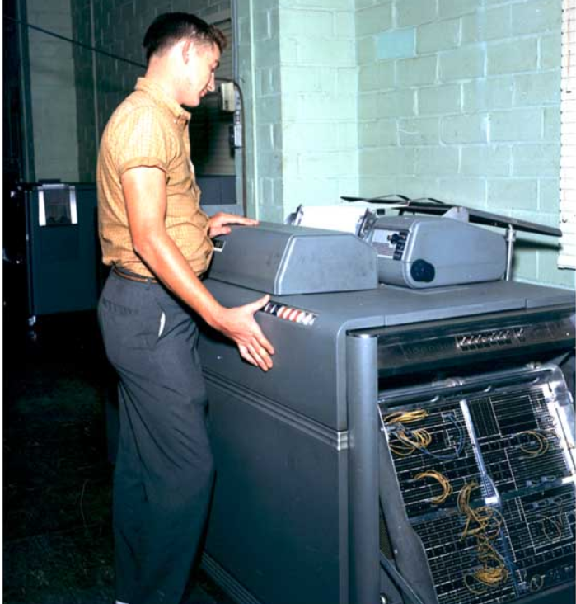

IBM 407 Accounting machine at Redstone Arsenel 1961
Wikipedia

The 407 rented from $800 to $920 per month ($8600 to $9900 per month in 2019 dollars), depending on the model.

IBM 407 - Wikipedia

Unit record equipment
From Wikipedia, the free encyclopedia
Starting at the end of the nineteenth century, well before the advent of electronic computers, data processing was performed using electromechanical machines called unit record equipment, electric accounting machines (EAM) or tabulating machines.^{[1][2][3][4]} Unit record machines came to be as ubiquitous in industry and government in the first two-thirds of the twentieth century as computers became in the last third.

In 1962 the IBM 407 Accounting Machine cost more than IBM Systems Engineers

In 1961 when I started at IBM for a 6 month internship (at 90 dollars a week) as a Drexel cooperative student, the IBM 407 Accounting machine was the premier and most widely used IBM customer installation, with tens of thousands of control panel wirers, like me, programming and operating the huge IBM 407 accounting machine.

The IBM 407 Accounting Machine rented for twice my IBM Systems Engineer payroll cost, and Gulf Oil had dozens of IBM 407s, which is why IBM gave IBM Systems Engineers to customers at no cost until 1968.

The IBM 407 Accounting machines read punched cards at 150 cards per minute and tabulated and printed the results, but it could only add and subtract using electro-mechanical counters (not multiply or divide) and it had no stored memory or disk, and no telecommunication capability.

I soon witnessed essentially all of the tens of thousands of IBM unit record IBM 402 and IBM 407 accounting machine “programmers” and operators of the wired control panels disappear, as they could not or would not learn the stored program progamming Autocoder or SPS (assembly) languages of the first IBM primitive commercial computers, the IBM 1401 and IBM 1440 computers.

Today a single programmer typically costs much more than the cost of the corporate computer per month, so companies are eliminating programmers however they can, as in the case of SAP, Microsoft, Oracle, and many others.

Virtually all computer programmers today are in similar peril of disappearing, and are actually disappearing because they can not or will not multiply their productivity, capability, value by 3, 5, 10, 100 times using real-time program auditing to automate their function

Virtually all computer programmers could implement real-time program auditing in their own programs today.

Every IBM i customer and every IBM i programmer and all DevOps personnel should automate DevOps starting today by implementing real-time program auditing and other productivity enhancing and cost saving techniques that will save their jobs and careers and situations by multiplying their competiveness.

Or, like the tens of thousands of IBM punched card unit record control panel wirers and accounting machine operators in 1962, they will disappear.

Appendix
K

Appendix K: When RTPA does not correctly expand the program

How to successfully real-time program audit virtually all programs
The Real-Time Program Audit (RTPA) for IBM i defaults to real-time audit (like streaming video) the execution of every RPGLE, COBOL, or CLP language statement as it executes including the contents of every variable and a time stamp of the executing program statement.

However, the IBM RPGLE, COBOL, and CLP compilers were designed and implemented decades ago, long before the incredible advantages of real-time program auditing were understood.

The IBM RPGLE, COBOL, and CLP compilers have severe limitations and constraints that limit the full implementation of real-time program auditing in the Real-Time Program Audit (RTPA) for IBM i software, both IBM i compiler size limit limitations, and source program constraints, such as the SELECT statement must be followed only by a WHEN ststement (or a comment) .

As RTPA inserts potentially thousands of ZZ audit statements in a COPY of the input RPGLE or COBOL source program to achieve real-time program auditing during execution of the audit enabled compiled program, RTPA may sometimes not correctly insert the correct ZZ audit statements for complex or unexpected programming styles and techniques RTPA has not encountered before .

Think full autonomous driving for a similar example.

Think also of a programmer writing or modifying an RPGLE or COBOL source program and making a coding weeor which would cause the resulting compiled programr to compile with terminal (level 30) errors.

The programmer would have to correct or remove the error source statements, and that is the same with RTPA.

So, if RTPA currently does not currently perfectly exand an IBM RPGLE or COBOL program with audit statements in your unique programming style, realize that RTPA is evolving and being enhanced with ever more IBM i customer source program knowledge from many programmers, like the Tesla autonomous driving videos.

The very best approach, as always, is to SIMPLIFY program coding, and find a way that works and use that way to succeed, as all successful programmers are doing today.

This appendix K: When RTPA does not expand correctly illustrates how RTPA can be uses successfully on virtually customer RPGLE, C OBOL, and CLP programs to multiply programmer productivity, capability, and value by 3, 5, 10, 100 times.

RTPA, or an implementation of real-time program auditing by IBM or another vendor, will eventually, like Tesla full automomous driving, work essentially perfectly and transform the entire computing world.

The Real-Time Program Audit (RTPA) for IBM i patented software provides essentially real-time “streaming video” of IBM i program execution, and RTPA does this over IBM i language compilers that are significantly limited and were not designed for the quantum jump of real-time program auditing and for the disruptive and transformational computing possible with real-time auditing of executing programs.

Simplify how you program for ultimate success
Computer hardware long ago simplied the computer chip design from CISC (Complex Instruction Set Computer) to RISC (Reduced Instruction Set Computer)

Essentially all media and all communication uses ninth grade level language . and airline piolots and flight controllers all must use the English language to simplify world wide communication.

The most successful computer programmers must also simplify their programs (communication) in exactly the same way as computer hardware chips and the airlines, and virtually all corporations have, by utilizing simplified programming techniques.

This Youtube video discusses how computer programmers must simplify their program for ultimate success
https://www.youtube.com/watch?v=96EVrro_0Fc&t=404s

Multiply Programmer Productivity, Capability, Value, by 3, 5, 10, 100 Times with Automation

YouTube 53 minutes
https://youtu.be/BHBxvQG5n5s

Corporate programmers and DevOps personnel can immediately multiply their productivity, capability, and value by 3, 5, 10, 100 Times or more by automating 90 percent or more of their activities best done by the computer.

Real-time program auditing, which provides a streaming video like capability, can be immediately implemented by all programmers, and can be implemented by the programmer in his or her own programs, or implemented immediately by licensing the Real-Time Audit (RTPA) patented software from Harkins & Associates, Inc. for existing programs.

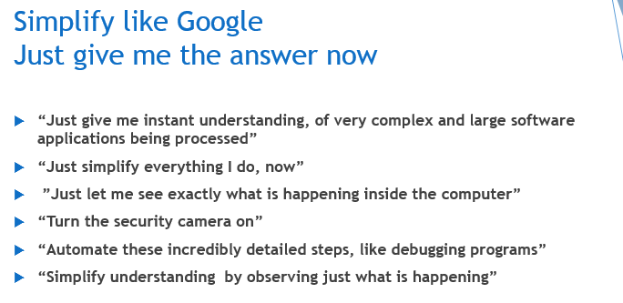

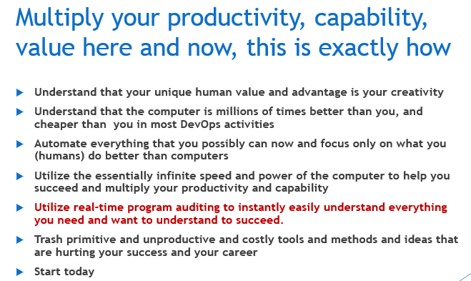
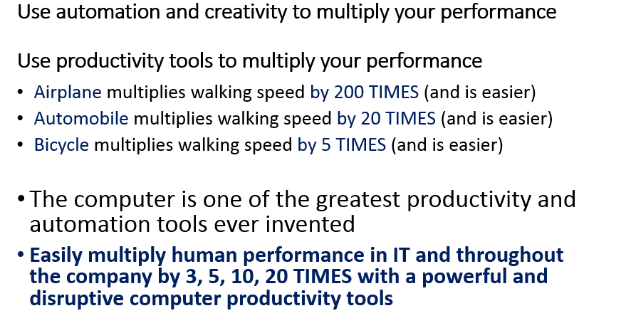

Appendix

APPENDIX

L

Appendix L: Triple Programmer Productivity and Value with Automation

How to Triple Programmer Productivity and Value with Automation

https://youtu.be/bWVWqTaUo4Q

Virtually all computer programmers and other DevOps programming related personnel can immediately Triple their Productivity and Value with Automation by simply implementing the modern real-time programming auditing techniques presented here and illustrated in Appendix L of this RTPA User Manual.

These real-time programming techniques are immediately available to all programmers using virtualy all programming langugaes, and these simple techniques can be implemented immediately without installing any software or hardware and they are FREE.

The video “Triple Programmer Productivity and Value with Automation” illustrates exactly how virtually every computer programmer in virtually every programming language can STOP using ancient, grossly primitive, slow, and costly programming techniques, like using interactive debug to attempt to understand what is happening in executing programs inside the computer.

Published Nov 1, 2020

https://youtu.be/bWVWqTaUo4Q

The forthcoming Amazon.com kindle ebook and paperbook “Triple Programmer Productivity and Value with Automation” contains all of the illustrations and examples in this video, together with much additional related material.

Programmers can immediately START saving perhaps 80 to 90 percent of the current wasted programmer time and effort, and instead focus on the unique human creatitive aspects of programming.

The video “Triple Programmer Productivity and Value with Automation” also illustrates exactly how computer programmers utilizing programing languages already implementing real-time program auditing software, such as the IBM i programming languages RPG, COBOL, and Control Language Program (CLP) can immediately STOP using ancient and grossly primitive programming techniques, like using interactive debug to attempt to understand what is happening in executing programs inside the computer.
These programmers utilizing IBM i RPG,COBOL and CLP languages can immediately START saving perhaps 80 to 90 percent of the current wasted programmer time and effort, and instead focus on the unique human creatitive aspects of programming on their current work and focus on virtually the entire existing set of corporate programs, which is often millions of lines of crucial application program code.

And, these lucky programmers utilizing IBM i programming languages RPG, COBOL and CLP can expect to immediately multiply their value by more than three times, all by utilizing the incredible and available power of the computer as a productivity tool, rather than the over matched human brain (like the chess match of the successful IBM Blue Gene computer against the world chess champion in 1997).

Today, teenagers of average IQ with a computer chess program can routinely defeat the current world chess champion Magnus Carlson, who has an IQ of 190 at chess, because the computer’s incredible and instant capability simply overpowers the brain of Magnus Carlson, and all other humans.

Today, other inventions multiply the capability and ease of human beings in very many ways, and at an astonishing and accelerating pace:
- Bicycle riding is 5 times faster than human walking
- Automobile riding is 20 times faster than walking
- Jet airplane riding is 200 times faster than walking
- Rocket riding 5,000 times faster than walking

Today, the computer multiplies the capability and ease of human beings in very many way not possible before 1950, and the computer is multiplying it’s capability, power and speed while rapidly declining in size and cost per Commercial Processing Work (CPW), an IBM metric for system performance

The early corporate computers of the 1950s (there were no PCs), like the IBM 650 and the IBM 1401 and the IBM 1440 had a CPW of LESS than 1, and only processed one program (1 core and one max thread) at a time in the entire computer.

I programmed all three of these IBM corporate computers and programmers often got only one compile (test) of their work in a day instead of the hundreds of program compiles (tests) a day available to programmers today.

Programmers in the 1950s debugged their programs by stopping the entire computer (only one program was running in the entire expensive corporate compute), and single cycled through computer memory setting break points stepping through their program statements and data by decoding the computer console displays, which were 7 (ASCII) or 8 (EBCDIC) lights per character of memory.

This manual debugging by manually stepping through the computer memory of the STOPPED corporate computer was agonizing slow and required guessing what to look at and what to look at, and what was important to manually write down for later review.

This agnoizing slow and clumsy debugging ot testing computer programs by stepping through the computer memory statement by statement with primitive stepper programs is the same technique used today, when computers are literally millions of times faster than in the 1950s.

Think of still walking across the United States instead of flying in a jet airplane.

This table is courtesy of Timothy Prickett Morgan, editor in chief of ITJungle in his article Max Thread Room ITJungle September 28, 2020 www.itjungle.com.
https://www.itjungle.com/2020/09/28/max-thread-room/

Max Thread Room ITJungle September 28, 2020 www.itjungle.com.
https://www.itjungle.com/2020/09/28/max-thread-room/

The IBM System/36 model B1 (1983) had a CPW rating of 1.

The early corporate computers of the 1950s (there were no PCs), like the IBM 650 and the IBM 1401 and the IBM 1440 had a CPW of LESS than 1, and only processed one program (1 core and one max thread) at a time in the entire computer.

Today, programmers of average IQ and limited experience in programming who utilize the FREE real-time program auditing techniques illustrated in Appendiz L of this RTPA User Manual can routinely outperform top senior corporate programmers who insist of using the primititive debug stepper techniques and who thus waste most of their time and energy guessing instead of creating superior programs and applications.

The incredible speed and power and capability of the computer, and the essentially free access to infinite computing power all day and every day has obsoleted the program debug stepper technique, and has obsoleted those programmers who still utilize the program debug stepper technique.

Prototype design of RPGLE program FCPPROTO
This example is a prototype design of RPGLE program FCPPROTO (Full Case Pick) by the programmer, of the key program in a complex new application requested by executive management for a newly purchased company, to computer optimally allocate full cases of jeans from an inventory of hundreds of thousands of cases of jeans of hundreds of styles, colors and sizes, to individual customer order detail line quantities (pick Tickets), without breaking open cases.

The programmer first created an RPGLE source program, FCPPROTO, with only program comments to develop an optimal way to accomplish executive managements request.

This FCPPROTO RPGLE source program would eventually require tens of thousands of statements to actually successfully accomplish executive managements request
.Columns . . . : 6 76 Edit ZZAUDIT/QRPGLESRC
SEU==> FCPPROTO
FMT ** ... 1 ...+... 2 ...+... 3 ...+... 4 ...+... 5 ...+... 6 ...+... 7 ...+.
*************** Beginning of data *************************************
0001.00 h/title Full Case Pick optimization of full cases to Pick Tickets
0002.00 h datedit(*MDY)
0003.00 *
0004.00 * Program: FCPPROTO - Full Case Pick optimization of full cases
0005.00 * Author: Paul H. Harkins
0006.00 * Date: 08/15/02
0007.00 * Project: 200031 Optimize warehouse Full Case selection for Pick Ti
0008.00 *
0009.00 * This is the prototype design for Full Case Pick optimizat
0010.00 *
0011.00 * DC = Distribution Center (shipping warehouse)
0012.00 * SKU = Stock Keeping Unit (each case is a single SKU)
0013.00 * SKU case quantities can vary from 1 to 160
0014.00 * Pick Ticket = Customer order to be picked and shipped PT
0015.00 * Piece Pick = PT SKU units not allocated to full cases
0016.00 *---------------------------------------------------------------- 0017.00 * Objective:
0018.00 *----------------------------------------------------------------
0019.00 * 1. Optimize the selection of warehouse cases so that full cases
0020.00 * exactly fill the Customer Pick Ticket SKU detail quantity
0021.00 * with no remaining quantity in the selected cases
0022.00 * (no split cases).
0023.00 *
0024.00 * 2. Allocate customer pick tickets by shipping priority and earliest
0025.00 * ship date for all stores for the customer together for
0026.00 * each customer ship-to distribution center.
0027.00 * This is to best utilize available case inventory and ship
0028.00 * the most important customer orders first.
0029.00 *
0030.00 * 3. Optimize the cases selected to minimize warehouse work, time and
0031.00 * resources including considering distance traveled, SKU
0032.00 * lot or batch (color shade), age of inventory, warehouse
0033.00 * location (active or reserve stock), customer requirements 0034.00 * Match up to 4 cases to get an exact match to the pick
0035.00 * ticket detail line SKU total quantity
0036.00 * Allocate smallest quantity cases first for an SKU, to
0037.00 * maximize warehouse available space and reduce the number
0038.00 * of cartons in the warehouse
0039.00 * Consider warehouse aisle and bin, select from same bin
0040.00 * Select highest quantity full cases until the remaining
0041.00 * pick Ticket SKU detail quantity is three times the
0042.00 * standard full case quantity for the SKU
0043.00 *
0044.00 * 4. Where full cases cannot exactly fill all customer picket ticket
0045.00 * detail SKU quantities (partial case or split case is
0046.00 * needed), summarize all customer split picket quantities f
0047.00 * the SKU, and allocate full cases to this piece pick SKU
0048.00 *
0049.00 * 5. Allocate cases selected, update pick tickets with case numbers,
0050.00 * as allocated, print warehouse case pull documents, and 0051.00 * print piece pick ticket (filling picket with opened cases
0052.00 * documents.
0053.00 * Unallocate any cases temporarily allocated in the case
0054.00 * optimization matching, but not finally selected.
0055.00 *
0056.00 * 6. Create cases for the remaining piece pick quantities not used, f
0057.00 * warehouse restocking as available cases.
0058.00 * Print bar-code case labels. piece pick documents
0059.00 *
0060.00 * 7. Compute and print warehouse case pull sheets, statistics for
0061.00 * warehouse resource requirements
0062.00 *
0063.00 *----------------------------------------------------------------
0064.00 * Displays: None
0065.00 *
0066.00 * Printers: None
0067.00 * 0068.00 * Data Bases: Warehouse ERP files including:
0069.00 * - Available case inventory for Pick Tickets
0070.00 * - Pick Tickets to be filled at the warehouse
0071.00 * - Product master, Customer, and related master files
0072.00 *
0073.00 *----------------------------------------------------------------
0074.00 * Functional Steps: Pseudocode of the major processing phases
0075.00 *----------------------------------------------------------------
0076.00 *
0077.00 * PHASE 1 Initialization
0078.00 * Calling program passes parameters to this program
0079.00 *
0080.00 * PHASE 2 Select unallocated warehouse case inventory and sequence
0081.00 * for FCP optimization of pick ticket SKU detail quantity
0082.00 *
0083.00 * PHASE 3 Select customer pick tickets and sequence for FCP case
0084.00 * allocation 0085.00 *
0086.00 * PHASE 4 Read pick ticket SKU details and try a one case match of
0087.00 * PT SKU quantity to a SKU full case quantity. If exact
0088.00 * match, allocate the case to the picket ticket SKU detail
0089.00 *
0090.00 * PHASE 5 Read pick ticket SKU details and allocate highest quantity
0091.00 * full cases until the remaining PT SKU quantity is three
0092.00 * times the SKU standard quantity.
0093.00 *
0094.00 * PHASE 6 Read pick ticket SKU details and do match on up to 4 cases
0095.00 * to exactly fill PT SKU detail remaining unallocated quantit
0096.00 *
0097.00 * PHASE 7 Summarize unallocated PT qty for SKU (piece picks) and
0098.00 * allocate full cases for piece pick packing and shipping
0099.00 *
0099.01 * PHASE 8 Compute warehouse case pull sheets, resource statistics
0099.02 * 0100.00 * PHASE 9 Program end-of-job
0101.00 * Return to the calling program
0102.00 *
0103.00 *----------------------------------------------------------------
0104.00 * Modifications
0105.00 *
0106.00 *----------------------------------------------------------------
0107.00 * data definitions
0108.00 *----------------------------------------------------------------
0109.00 d phase s 1s 0 inz(0)
0110.00 d match s 1s 0 inz(0)
0111.00 *
0111.01 *----------------------------------------------------------------
0112.00 *----------------------------------------------------------------
0113.00 * file descriptions
0114.21 *
0116.00 *---------------------------------------------------------------- 0117.00 * calculations:
0118.00 *----------------------------------------------------------------
0119.00 *
0120.00 c eval phase = 1
0121.00 * PHASE 1 initialization
0122.00 c exsr initialize
0123.00 *
0124.00 *----------------------------------------------------------------
0124.11 c eval phase = 2
0129.03 * PHASE 2 select unallocated warehouse case inventory and sequence
0129.16 c exsr selectLcases
0129.17 *
0130.00 C eval phase = 3
0131.00 * PHASE 3 select customer pick tickets and sequence
0132.00 c exsr selectLpick
0133.00 *
0134.00 *---------------------------------------------------------------- 0135.00 c eval phase = 4
0136.00 * PHASE 4 read pick ticket SKU details and try a one case match
0137.00 c exsr processLpt1
0138.00 *
0139.00 *----------------------------------------------------------------
0140.00 c eval phase = 5
0141.00 * PHASE 5 allocate highest quantity full cases to PT SKU details
0142.00 c exsr processLpt2
0143.00 *
0144.00 *----------------------------------------------------------------
0145.00 c eval phase = 6
0146.00 * PHASE 6 do 4 case match to exactly fill remaining PT SKU detai l qty
0147.00 c exsr processLpt3
0148.00 *
0149.00 *----------------------------------------------------------------
0150.00 c eval phase = 7
0151.00 * PHASE 7 summarize PT unallocated qty for SKU, allocate full cases 0152.00 c exsr processLpt4
0153.00 *
0154.00 *----------------------------------------------------------------
0155.00 c eval phase = 8
0156.00 * PHASE 8 compute warehouse case pull sheets, resource statistics
0157.00 c exsr createLpull
0158.00 *
0159.00 *----------------------------------------------------------------
0160.00 c eval phase = 9
0161.00 * PHASE 9 program EOJ
0162.00 C exsr endLofLjob
0163.00 *
0163.01 * Exit program
0163.06 C MOVEL *on *INLR
0163.21 C return
0164.00 *----------------------------------------------------------------
0165.00 * subroutines 0166.00 *----------------------------------------------------------------
0167.00 C initialize begsr
0168.00 * calling program passes parameters to this program
0168.08 C z-add 0 casematch1 7 0
0168.15 C z-add 0 casematch2 7 0
0168.22 C z-add 0 casematch3 7 0
0168.29 C z-add 0 casematch4 7 0
0169.00 * check authorizations
0170.00 c initializee endsr
0171.00 *
0172.00 c selectLcases begsr
0173.00 * select unallocated warehouse case inventory and sequence
0174.00 * for FCP optimization of pick ticket SKU detail quantity
0175.00 c selectLcasese endsr
0176.00 *
0177.00 c selectLpick begsr
0178.00 * select customer pick tickets and sequence for allocation
0179.00 * for FCP optimization of pick ticket SKU detail quantity
0180.00 c selectLpicke endsr
0181.00 *
0182.00 c processLpt1 begsr
0183.00 c eval match = 1
0184.00 * read pick ticket SKU details and try a one case exact match
0185.00 c exsr matchL1
0186.00 c processLpt1e endsr
0187.00 *
0188.00 c processLpt2 begsr
0189.00 * allocate highest quantity full cases to PT SKU details
0190.00 c processLpt2e endsr
0191.00 *
0192.00 c processLpt3 begsr
0193.00 * do 4 case match to exactly fill remaining PT detail qty
0194.00 c eval match = 1
0195.00 C exsr matchL1 0213.00 *
0214.00 c matchL1 begsr
0215.00 * match of PT unallocated SKU detail quantity with 1 full case qty
0216.00 c matchL1e endsr
0217.00 *
0218.00 c matchL2 begsr
0219.00 c eval match = 2
0220.00 * match of PT unallocated SKU detail quantity with 2 full case qtys
0221.00 c matchL2e endsr
0222.00 *
0223.00 c matchL3 begsr
0224.00 c eval match = 3
0225.00 * match of PT unallocated SKU detail quantity with 3 full case qtys
0226.00 c matchL3e endsr
0227.00 *
0228.00 C matchL4 begsr
0229.00 * match of PT unallocated SKU detail quantity with 4 full case qtys 0230.00 c eval match = 4
0231.00 c matchl4e endsr
0232.00 *
0233.00 c endLofLjob begsr
0233.09 * compute total cases allocated and process time for each phase
0233.17 C casematch2 mult 2 case2total 7 0
0233.24 C casematch3 mult 3 case3total 7 0
0233.31 C casematch3 mult 4 case3total 7 0
0233.38 C casematch1 add casematch2 totalcases 7 0
0233.45 C add casematch3 totalcases
0233.52 C add casematch4 totalcases
0237.00 c endofLjobe endsr
0238.00 *
0239.00 *----------------------------------------------------------------
0240.00 * AUDIT OF PROGRAM LOGIC
0241.00 *----------------------------------------------------------------
****************** End of data ****************************************

F3=Exit F4=Prompt F5=Refresh F9=Retrieve F10=Cursor F11=Toggle
F16=Repeat find F17=Repeat change F24=More keys

RPGLE FCPPROTO Full Case Pick prototype of processing logic

Prototype design of RPGLE program FCPPROTO Output

The programmer settled on 9 phases of processing to accomplish executive managementt’s first request of optimally computer allocating the case inventory to the customer pick ticket lines and added the RPGLE subroutines for the 9 phases and compiled and tested his program FCPPROTO and analyzed his result

Job 114750/PHARKINS/FCPPROTO completed normally on 10/25/20 at 13:28:11.

CALL FCPPROTO (execute program FCPPROTO)

WRKSPLF (Work with all spool files)
Work with All Spooled Files

Type options, press Enter.
1=Send 2=Change 3=Hold 4=Delete 5=Display 6=Release 7=Messages
8=Attributes 9=Work with printing status

Device or Total Cur
Opt File User Queue User Data Sts Pages Page Copy
FCPPROTO PHARKINS RTPA RDY 12 1

Bottom
Parameters for options 1, 2, 3 or command
===>
F3=Exit F10=View 4 F11=View 2 F12=Cancel F22=Printers F24=More keys

The programmer got NO spool file (printed output) from the execution of his FCPPOTO program

But, executive management had asked the corporate CIO many crucial questions about this critically new full case allocation application (after already buying the new company for $500 million dollars).

- When would this new application be in production?
- How long would the computer take to allocate the million cases of jeans inventory to the thousands of customer pick tickets every day on top of current processing?
- Could the computer actually do this computer full case allocation?
- How long would it take every day for the computer to do this case allocation?
- How would this crucial new application affect the thousands of users on the computer?
- How good would the computer case allocation be compared to case allocation by humans?
- Do we need a bigger computer?

The CIO did not know

The CIO asked the programmer for accurate answers to executive management’s crucial questions, by next week

Prototype design of RPGLE program FCPPROTO answers with manual auditing

The programmer added manual real-time program audit statements to RPGLE FCPPROTO to accurately answer all of executive management’s crucial questions AND TO DOCUMENT the program. The FCPPROTOZZ source program below is exactly the same as the FCPPROTO source program above, except for the asdded ZZ source statements, all of which directly and definitively answer executive management’s crucial questions and which provide all future workers on the Full Case Pick application key understanding of the application.

Columns . . . : 1 71 Edit ZZAUDIT/QRPGLESRC
SEU==> FCPPROTOZZ
FMT ** ...+... 1 ...+... 2 ...+... 3 ...+... 4 ...+... 5 ...+... 6 ...+... 7
*************** Beginning of data *************************************
0001.00 h/title Full Case Pick optimization of full cases to Pick Tickets
0002.00 h datedit(*MDY)
0003.00 *
0004.00 * Program: FCPPROTO - Full Case Pick optimization of full cases
0005.00 * Author: Paul H. Harkins
0006.00 * Date: 08/15/02
0007.00 * Project: 200031 Optimize warehouse Full Case selection for Pi
0008.00 *
0009.00 * This is the prototype design for Full Case Pick opti
0010.00 *
0011.00 * DC = Distribution Center (shipping warehouse)
0012.00 * SKU = Stock Keeping Unit (each case is a single SKU)
0013.00 * SKU case quantities can vary from 1 to 160
0014.00 * Pick Ticket = Customer order to be picked and shippe
0015.00 * Piece Pick = PT SKU units not allocated to full case
0016.00 *---------------------------------------------------------------- 0017.00 * Objective:
0018.00 *----------------------------------------------------------------
0019.00 * 1. Optimize the selection of warehouse cases so that full case
0020.00 * exactly fill the Customer Pick Ticket SKU detail qua
0021.00 * with no remaining quantity in the selected cases
0022.00 * (no split cases).
0023.00 *
0024.00 * 2. Allocate customer pick tickets by shipping priority and ear
0025.00 * ship date for all stores for the customer together f
0026.00 * each customer ship-to distribution center.
0027.00 * This is to best utilize available case inventory and
0028.00 * the most important customer orders first.
0029.00 *
0030.00 * 3. Optimize the cases selected to minimize warehouse work, tim
0031.00 * resources including considering distance traveled, S
0032.00 * lot or batch (color shade), age of inventory, wareho
0033.00 * location (active or reserve stock), customer require 0034.00 * Match up to 4 cases to get an exact match to the pic
0035.00 * ticket detail line SKU total quantity
0036.00 * Allocate smallest quantity cases first for an SKU, t
0037.00 * maximize warehouse available space and reduce the nu
0038.00 * of cartons in the warehouse
0039.00 * Consider warehouse aisle and bin, select from same b
0040.00 * Select highest quantity full cases until the remaini
0041.00 * pick Ticket SKU detail quantity is three times the
0042.00 * standard full case quantity for the SKU
0043.00 *
0044.00 * 4. Where full cases cannot exactly fill all customer picket ti
0045.00 * detail SKU quantities (partial case or split case is
0046.00 * needed), summarize all customer split picket quantit
0047.00 * the SKU, and allocate full cases to this piece pick
0048.00 *
0049.00 * 5. Allocate cases selected, update pick tickets with case numb
0050.00 * as allocated, print warehouse case pull documents, a 0051.00 * print piece pick ticket (filling picket with opened
0052.00 * documents.
0053.00 * Unallocate any cases temporarily allocated in the ca
0054.00 * optimization matching, but not finally selected.
0055.00 *
0056.00 * 6. Create cases for the remaining piece pick quantities not us
0057.00 * warehouse restocking as available cases.
0058.00 * Print bar-code case labels. piece pick documents
0059.00 *
0060.00 * 7. Compute and print warehouse case pull sheets, statistics fo
0061.00 * warehouse resource requirements
0062.00 *
0063.00 *----------------------------------------------------------------
0064.00 * Displays: None
0065.00 *
0066.00 * Printers: None
0067.00 * 0068.00 * Data Bases: Warehouse ERP files including:
0069.00 * - Available case inventory for Pick Tickets
0070.00 * - Pick Tickets to be filled at the warehouse
0071.00 * - Product master, Customer, and related master files
0072.00 *
0073.00 *----------------------------------------------------------------
0074.00 * Functional Steps: Pseudocode of the major processing phases
0075.00 *----------------------------------------------------------------
0076.00 *
0077.00 * PHASE 1 Initialization
0078.00 * Calling program passes parameters to this program
0079.00 *
0080.00 * PHASE 2 Select unallocated warehouse case inventory and sequen
0081.00 * for FCP optimization of pick ticket SKU detail quant
0082.00 *
0083.00 * PHASE 3 Select customer pick tickets and sequence for FCP case
0084.00 * allocation 0085.00 *
0086.00 * PHASE 4 Read pick ticket SKU details and try a one case match
0087.00 * PT SKU quantity to a SKU full case quantity. If exac
0088.00 * match, allocate the case to the picket ticket SKU de
0089.00 *
0090.00 * PHASE 5 Read pick ticket SKU details and allocate highest quan
0091.00 * full cases until the remaining PT SKU quantity is th
0092.00 * times the SKU standard quantity.
0093.00 *
0094.00 * PHASE 6 Read pick ticket SKU details and do match on up to 4 c
0095.00 * to exactly fill PT SKU detail remaining unallocated qu
0096.00 *
0097.00 * PHASE 7 Summarize unallocated PT qty for SKU (piece picks) and
0098.00 * allocate full cases for piece pick packing and shippin
0099.00 *
0099.01 * PHASE 8 Compute warehouse case pull sheets, resource statistic
0099.02 * 0100.00 * PHASE 9 Program end-of-job
0101.00 * Return to the calling program
0102.00 *
0103.00 *----------------------------------------------------------------
0104.00 * Modifications
0105.00 *
0106.00 *----------------------------------------------------------------
0107.00 * data definitions
0108.00 *----------------------------------------------------------------
0109.00 d phase s 1s 0 inz(0)
0110.00 d match s 1s 0 inz(0)
0111.00 *
0111.01 *----------------------------------------------------------------
0111.02 ZZ * PROGRAM DATA STRUCTURE
0111.03 ZZ D SDS
0111.06 ZZ D QUSER 254 263
0111.07 ZZ D QJOBNO 264 269 0 0111.08 ZZ * ZZLINE is 72 characters starting at column 6 of SEU (like SEU)
0111.09 ZZ D ZZLINE DS
0111.10 ZZ D ZZLINE1 1 24
0111.11 ZZ D ZZLINE2 25 48
0111.12 ZZ D ZZLINE3 49 72
0112.00 *----------------------------------------------------------------
0113.00 * file descriptions
0113.01 ZZ * PROGRAM AUDITS with U2 ON
0113.02 ZZ FQPRINT2 O F 132 PRINTER OFLIND(*INOF)
0113.03 ZZ F USROPN
0114.05 ZZ * GET STARTING TIME
0114.06 ZZ C TIME ZZAUDBEG 6 0
0114.08 ZZ * CHECK IF PROGRAM LOGIC AUDITING IS DESIRED
0114.10 ZZ * PRINT AUDIT OF PROGRAM IF U2 IS ON
0114.11 ZZ C ZZOVROPN IFEQ *BLANKS
0114.12 ZZ * turn on program audits
0114.13 ZZ C MOVE *ON *INU2 0114.14 ZZ * turn off program audits
0114.15 ZZ C******* MOVE *OFF *INU2
0114.16 ZZ C U2 OPEN QPRINT2
0114.18 ZZ C U2 EXCEPT AUDSTR
0114.19 ZZ C MOVEL 'Y' ZZOVROPN 1
0114.20 ZZ C ENDIF
0114.21 *
0116.00 *----------------------------------------------------------------
0117.00 * calculations:
0118.00 *----------------------------------------------------------------
0118.01 ZZ C MOVEL 'C 'ZZLINE1
0118.02 ZZ C MOVE ' eval'ZZLINE1
0118.03 ZZ C MOVEl ' phase 'ZZLINE2
0118.04 ZZ C MOVE '= 1 'ZZLINE2
0118.05 ZZ C U2 EXSR ZZAUDS
0119.00 *
0120.00 c eval phase = 1 0121.00 * PHASE 1 initialization
0121.01 ZZ C MOVEL ' * PHASE 1 i'ZZLINE1
0121.02 ZZ C MOVE 'nitializatio'ZZLINE1
0121.03 ZZ C MOVEl 'n 'ZZLINE2
0121.04 ZZ C U2 EXSR ZZAUDS
0121.14 ZZ C MOVEL 'C 'ZZLINE1
0121.15 ZZ C MOVE ' exsr'ZZLINE1
0121.16 ZZ C MOVEl ' initia'ZZLINE2
0121.17 ZZ C MOVE 'lize 'ZZLINE2
0121.18 ZZ C U2 EXSR ZZAUDS
0122.00 c exsr initialize
0123.00 *
0124.00 *----------------------------------------------------------------
0124.06 ZZ C MOVEL 'C 'ZZLINE1
0124.07 ZZ C MOVE ' eval'ZZLINE1
0124.08 ZZ C MOVEl ' phase 'ZZLINE2
0124.09 ZZ C MOVE '= 2 'ZZLINE2 0124.10 ZZ C U2 EXSR ZZAUDS
0124.11 c eval phase = 2
0129.03 * PHASE 2 select unallocated warehouse case inventory and sequenc
0129.04 ZZ C MOVEL ' * PHASE 2 s'ZZLINE1
0129.05 ZZ C MOVE 'elect unallo'ZZLINE1
0129.06 ZZ C MOVEl 'cated wareho'ZZLINE2
0129.07 ZZ C MOVE 'use case inv'ZZLINE2
0129.08 ZZ C MOVEL 'entory and s'ZZLINE3
0129.09 ZZ C MOVE 'equence 'ZZLINE3
0129.10 ZZ C U2 EXSR ZZAUDS
0129.11 ZZ C MOVEL 'C 'ZZLINE1
0129.12 ZZ C MOVE ' exsr'ZZLINE1
0129.13 ZZ C MOVEl ' select'ZZLINE2
0129.14 ZZ C MOVE 'Lcases 'ZZLINE2
0129.15 ZZ C U2 EXSR ZZAUDS
0129.16 c exsr selectLcases
0129.17 * 0129.18 ZZ C MOVEL 'C 'ZZLINE1
0129.19 ZZ C MOVE ' eval'ZZLINE1
0129.20 ZZ C MOVEl ' phase 'ZZLINE2
0129.21 ZZ C MOVE '= 3 'ZZLINE2
0129.22 ZZ C U2 EXSR ZZAUDS
0130.00 C eval phase = 3
0131.00 * PHASE 3 select customer pick tickets and sequence
0131.05 ZZ C MOVEL ' * PHASE 3 s'ZZLINE1
0131.06 ZZ C MOVE 'elect custom'ZZLINE1
0131.07 ZZ C MOVEl 'er pick tick'ZZLINE2
0131.08 ZZ C MOVE 'ets and sequ'ZZLINE2
0131.09 ZZ C MOVEL 'ence 'ZZLINE3
0131.11 ZZ C U2 EXSR ZZAUDS
0131.12 ZZ C MOVEL 'C 'ZZLINE1
0131.13 ZZ C MOVE ' exsr'ZZLINE1
0131.14 ZZ C MOVEl ' select'ZZLINE2
0131.15 ZZ C MOVE 'Lpick 'ZZLINE2
0131.16 ZZ C U2 EXSR ZZAUDS
0132.00 c exsr selectLpick
0133.00 *
0134.00 *----------------------------------------------------------------
0134.06 ZZ C MOVEL 'C 'ZZLINE1
0134.07 ZZ C MOVE ' eval'ZZLINE1
0134.08 ZZ C MOVEl ' phase 'ZZLINE2
0134.09 ZZ C MOVE '= 4 'ZZLINE2
0134.10 ZZ C U2 EXSR ZZAUDS
0135.00 c eval phase = 4
0136.00 * PHASE 4 read pick ticket SKU details and try a one case match
0136.05 ZZ C MOVEL ' * PHASE 4 r'ZZLINE1
0136.06 ZZ C MOVE 'ead pick tic'ZZLINE1
0136.07 ZZ C MOVEl 'ket SKU deta'ZZLINE2
0136.08 ZZ C MOVE 'ils and try 'ZZLINE2
0136.09 ZZ C MOVEL 'a one case m'ZZLINE3
0136.10 ZZ C MOVE 'atch 'ZZLINE3
0136.11 ZZ C U2 EXSR ZZAUDS
0136.12 ZZ C MOVEL 'C 'ZZLINE1
0136.13 ZZ C MOVE ' exsr'ZZLINE1
0136.14 ZZ C MOVEl ' proces'ZZLINE2
0136.15 ZZ C MOVE 'sLpt1 'ZZLINE2
0136.16 ZZ C U2 EXSR ZZAUDS
0137.00 c exsr processLpt1
0138.00 *
0139.00 *----------------------------------------------------------------
0139.06 ZZ C MOVEL 'C 'ZZLINE1
0139.07 ZZ C MOVE ' eval'ZZLINE1
0139.08 ZZ C MOVEl ' phase 'ZZLINE2
0139.09 ZZ C MOVE '= 5 'ZZLINE2
0139.10 ZZ C U2 EXSR ZZAUDS
0140.00 c eval phase = 5
0141.00 * PHASE 5 allocate highest quantity full cases to PT SKU details
0141.05 ZZ C MOVEL ' * PHASE 5 a'ZZLINE1 0141.06 ZZ C MOVE 'llocate high'ZZLINE1
0141.07 ZZ C MOVEl 'est full cas'ZZLINE2
0141.08 ZZ C MOVE 'es to PT SKU'ZZLINE2
0141.09 ZZ C MOVEL ' details 'ZZLINE3
0141.11 ZZ C U2 EXSR ZZAUDS
0141.12 ZZ C MOVEL 'C 'ZZLINE1
0141.13 ZZ C MOVE ' exsr'ZZLINE1
0141.14 ZZ C MOVEl ' proces'ZZLINE2
0141.15 ZZ C MOVE 'sLpt2 'ZZLINE2
0141.16 ZZ C U2 EXSR ZZAUDS
0142.00 c exsr processLpt2
0143.00 *
0144.00 *--------------------------------------------------------------
0144.06 ZZ C MOVEL 'C 'ZZLINE1
0144.07 ZZ C MOVE ' eval'ZZLINE1
0144.08 ZZ C MOVEl ' phase 'ZZLINE2
0144.09 ZZ C MOVE '= 6 'ZZLINE2 0144.10 ZZ C U2 EXSR ZZAUDS
0145.00 c eval phase = 6
0146.00 * PHASE 6 do 4 case match to exactly fill remaining PT SKU detai
0146.05 ZZ C MOVEL ' * PHASE 6 d'ZZLINE1
0146.06 ZZ C MOVE 'o 4 case mat'ZZLINE1
0146.07 ZZ C MOVEl 'ch to exactl'ZZLINE2
0146.08 ZZ C MOVE 'y fill remai'ZZLINE2
0146.09 ZZ C MOVEL 'ning PT SKU 'ZZLINE3
0146.10 ZZ C MOVE 'detail 1 qty'ZZLINE3
0146.11 ZZ C U2 EXSR ZZAUDS
0146.12 ZZ C MOVEL 'C 'ZZLINE1
0146.13 ZZ C MOVE ' exsr'ZZLINE1
0146.14 ZZ C MOVEl ' proces'ZZLINE2
0146.15 ZZ C MOVE 'sLpt3 'ZZLINE2
0146.16 ZZ C U2 EXSR ZZAUDS
0147.00 c exsr processLpt3
0148.00 * 0149.00 *----------------------------------------------------------------
0149.07 ZZ C MOVEL 'C 'ZZLINE1
0149.08 ZZ C MOVE ' eval'ZZLINE1
0149.09 ZZ C MOVEl ' phase 'ZZLINE2
0149.10 ZZ C MOVE '= 7 'ZZLINE2
0149.11 ZZ C U2 EXSR ZZAUDS
0150.00 c eval phase = 7
0151.00 * PHASE 7 summarize PT unallocated qty for SKU, allocate full cas
0151.05 ZZ C MOVEL ' * PHASE 7 s'ZZLINE1
0151.06 ZZ C MOVE 'ummarize PT 'ZZLINE1
0151.07 ZZ C MOVEl 'unallocated 'ZZLINE2
0151.08 ZZ C MOVE 'qty for SKU,'ZZLINE2
0151.09 ZZ C MOVEL ' allocate fu'ZZLINE3
0151.10 ZZ C MOVE 'll cases 'ZZLINE3
0151.11 ZZ C U2 EXSR ZZAUDS
0151.12 ZZ C MOVEL 'C 'ZZLINE1
0151.13 ZZ C MOVE ' exsr'ZZLINE1 0151.14 ZZ C MOVEl ' proces'ZZLINE2
0151.15 ZZ C MOVE 'sLpt4 'ZZLINE2
0151.16 ZZ C U2 EXSR ZZAUDS
0152.00 c exsr processLpt4
0153.00 *
0154.00 *----------------------------------------------------------------
0154.06 ZZ C MOVEL 'C 'ZZLINE1
0154.07 ZZ C MOVE ' eval'ZZLINE1
0154.08 ZZ C MOVEl ' phase 'ZZLINE2
0154.09 ZZ C MOVE '= 8 'ZZLINE2
0154.10 ZZ C U2 EXSR ZZAUDS
0155.00 c eval phase = 8
0156.00 * PHASE 8 compute warehouse case pull sheets, resource statistics
0156.05 ZZ C MOVEL ' * PHASE 8 c'ZZLINE1
0156.06 ZZ C MOVE 'ompute wareh'ZZLINE1
0156.07 ZZ C MOVEl 'ouse case pu'ZZLINE2
0156.08 ZZ C MOVE 'll sheets, r'ZZLINE2 0156.09 ZZ C MOVEL 'esource stat'ZZLINE3
0156.10 ZZ C MOVE 'istics 'ZZLINE3
0156.11 ZZ C U2 EXSR ZZAUDS
0156.12 ZZ C MOVEL 'C 'ZZLINE1
0156.13 ZZ C MOVE ' exsr'ZZLINE1
0156.14 ZZ C MOVEl ' create'ZZLINE2
0156.15 ZZ C MOVE 'Lpull 'ZZLINE2
0156.16 ZZ C U2 EXSR ZZAUDS
0157.00 c exsr createLpull
0158.00 *
0159.00 *----------------------------------------------------------------
0159.06 ZZ C MOVEL 'C 'ZZLINE1
0159.07 ZZ C MOVE ' eval'ZZLINE1
0159.08 ZZ C MOVEl ' phase 'ZZLINE2
0159.09 ZZ C MOVE '= 9 'ZZLINE2
0159.10 ZZ C EXSR ZZAUDS
0160.00 c eval phase = 9
0161.00 * PHASE 9 program EOJ
0161.05 ZZ C MOVEL ' * PHASE 9 p'ZZLINE1
0161.06 ZZ C MOVE 'rogram EOJ 'ZZLINE1
0161.07 ZZ C U2 EXSR ZZAUDS
0161.08 ZZ C MOVEL 'C 'ZZLINE1
0161.09 ZZ C MOVE ' exsr'ZZLINE1
0161.10 ZZ C MOVEl ' endofL'ZZLINE2
0161.11 ZZ C MOVE 'job 'ZZLINE2
0161.12 ZZ C U2 EXSR ZZAUDS
0162.00 C exsr endLofLjob
0163.00 *
0163.01 * Exit program
0163.03 ZZ C MOVEL ' * Exit prog'ZZLINE1
0163.04 ZZ C MOVE 'ram 'ZZLINE1
0163.05 ZZ C U2 EXSR ZZAUDS
0163.06 C MOVEL *on *INLR
0163.07 ZZ C MOVEL 'C 'ZZLINE1 0163.08 ZZ C MOVE ' move'ZZLINE1
0163.09 ZZ C MOVEl 'l *on 'ZZLINE2
0163.10 ZZ C MOVE ' *INLR 'ZZLINE2
0163.11 ZZ C U2 EXSR ZZAUDS
0163.12 ZZ C MOVEL 'C 'ZZLINE1
0163.13 ZZ C MOVE ' retu'ZZLINE1
0163.14 ZZ C MOVEl 'rn 'ZZLINE2
0163.16 ZZ C U2 EXSR ZZAUDS
0163.21 C return
0164.00 *--------------------------------------------------------------
0165.00 * subroutines
0166.00 *--------------------------------------------------------------
0167.00 C initialize begsr
0167.05 ZZ C MOVEL 'C initia'ZZLINE1
0167.06 ZZ C MOVE 'lize begs'ZZLINE1
0167.07 ZZ C MOVEl 'r 'ZZLINE2
0167.09 ZZ C U2 EXSR ZZAUDS 0168.00 * calling program passes parameters to this program
0168.01 ZZ C MOVEL ' * calling p'ZZLINE1
0168.02 ZZ C MOVE 'rogram passe'ZZLINE1
0168.03 ZZ C MOVEl 's parameters'ZZLINE2
0168.04 ZZ C MOVE ' to this pro'ZZLINE2
0168.05 ZZ C MOVEL 'gram 'ZZLINE3
0168.07 ZZ C U2 EXSR ZZAUDS
0168.08 C z-add 0 casematch1 7 0
0168.09 ZZ C MOVEL 'C 'ZZLINE1
0168.10 ZZ C MOVE ' z-ad'ZZLINE1
0168.11 ZZ C MOVEl 'd 0 'ZZLINE2
0168.12 ZZ C MOVE ' cas'ZZLINE2
0168.13 ZZ C MOVEL 'ematch1 'ZZLINE3
0168.14 ZZ C U2 EXSR ZZAUDS
0168.15 C z-add 0 casematch2 7 0
0168.16 ZZ C MOVEL 'C 'ZZLINE1
0168.17 ZZ C MOVE ' z-ad'ZZLINE1 0168.18 ZZ C MOVEl 'd 0 'ZZLINE2
0168.19 ZZ C MOVE ' cas'ZZLINE2
0168.20 ZZ C MOVEL 'ematch2 'ZZLINE3
0168.21 ZZ C U2 EXSR ZZAUDS
0168.22 C z-add 0 casematch3 7 0
0168.23 ZZ C MOVEL 'C 'ZZLINE1
0168.24 ZZ C MOVE ' z-ad'ZZLINE1
0168.25 ZZ C MOVEl 'd 0 'ZZLINE2
0168.26 ZZ C MOVE ' cas'ZZLINE2
0168.27 ZZ C MOVEL 'ematch3 'ZZLINE3
0168.28 ZZ C U2 EXSR ZZAUDS
0168.29 C z-add 0 casematch4 7 0
0168.31 ZZ C MOVEL 'C 'ZZLINE1
0168.32 ZZ C MOVE ' z-ad'ZZLINE1
0168.33 ZZ C MOVEl 'd 0 'ZZLINE2
0168.34 ZZ C MOVE ' cas'ZZLINE2
0168.35 ZZ C MOVEL 'ematch4 'ZZLINE3 0168.36 ZZ C U2 EXSR ZZAUDS
0169.00 * check authorizations
0169.05 ZZ C MOVEL ' * check aut'ZZLINE1
0169.06 ZZ C MOVE 'horizations 'ZZLINE1
0169.10 ZZ C EXSR ZZAUDS
0169.16 ZZ C MOVEL 'C initia'ZZLINE1
0169.17 ZZ C MOVE 'lizee ends'ZZLINE1
0169.18 ZZ C MOVEl 'r 'ZZLINE2
0169.19 ZZ c U2 EXSR ZZAUDS
0170.00 c initializee endsr
0171.00 *
0172.00 c selectLcases begsr
0172.05 ZZ C MOVEL 'C select'ZZLINE1
0172.06 ZZ C MOVE 'Lcases begs'ZZLINE1
0172.07 ZZ C MOVEl 'r 'ZZLINE2
0172.08 ZZ C U2 EXSR ZZAUDS
0173.00 * select unallocated warehouse case inventory and sequence 0173.05 ZZ C MOVEL ' * select un'ZZLINE1
0173.06 ZZ C MOVE 'allocated wa'ZZLINE1
0173.07 ZZ C MOVEL 'rehouse case'ZZLINE2
0173.08 ZZ C MOVE ' inventory a'ZZLINE2
0173.09 ZZ C MOVEl 'nd sequence 'ZZLINE3
0173.10 ZZ C U2 EXSR ZZAUDS
0174.00 * for FCP optimization of pick ticket SKU detail quantity
0174.01 ZZ C MOVEL ' * for FCP o'ZZLINE1
0174.02 ZZ C MOVE 'ptimization 'ZZLINE1
0174.03 ZZ C MOVEL 'of pick tick'ZZLINE2
0174.04 ZZ C MOVE 'et SKU detai'ZZLINE2
0174.05 ZZ C MOVEl 'l quantity 'ZZLINE3
0174.06 ZZ C U2 EXSR ZZAUDS
0174.07 ZZ C MOVEL 'C select'ZZLINE1
0174.08 ZZ C MOVE 'Lcasese ends'ZZLINE1
0174.09 ZZ C MOVEl 'r 'ZZLINE2
0174.10 ZZ C U2 EXSR ZZAUDS 0175.00 c selectLcasese endsr
0176.00 *
0177.00 c selectLpick begsr
0177.05 ZZ C MOVEL 'C select'ZZLINE1
0177.06 ZZ C MOVE 'Lpick begs'ZZLINE1
0177.07 ZZ C MOVEl 'r 'ZZLINE2
0177.08 ZZ C U2 EXSR ZZAUDS
0178.00 * select customer pick tickets and sequence for allocation
0178.05 ZZ C MOVEL ' * select cu'ZZLINE1
0178.06 ZZ C MOVE 'stomer pick 'ZZLINE1
0178.07 ZZ C MOVEL 'tickets and 'ZZLINE2
0178.08 ZZ C MOVE 'sequence for'ZZLINE2
0178.09 ZZ C MOVEl ' allocation 'ZZLINE3
0178.10 ZZ C U2 EXSR ZZAUDS
0179.00 * for FCP optimization of pick ticket SKU detail quantity
0179.01 ZZ C MOVEL 'C select'ZZLINE1
0179.02 ZZ C MOVE 'Lpicke ends'ZZLINE1 0179.03 ZZ C MOVEl 'r 'ZZLINE2
0179.04 ZZ C U2 EXSR ZZAUDS
0180.00 c selectLpicke endsr
0181.00 *
0182.00 c processLpt1 begsr
0182.05 ZZ C MOVEL 'C proces'ZZLINE1
0182.06 ZZ C MOVE 'sLpt1 begs'ZZLINE1
0182.07 ZZ C MOVEl 'r 'ZZLINE2
0182.08 ZZ C U2 EXSR ZZAUDS
0182.09 ZZ C MOVEL 'C 'ZZLINE1
0182.10 ZZ C MOVE ' eval'ZZLINE1
0182.11 ZZ C MOVEl ' match 'ZZLINE2
0182.12 ZZ C MOVE '= 1 'ZZLINE2
0182.13 ZZ C U2 EXSR ZZAUDS
0183.00 c eval match = 1
0184.00 * read pick ticket SKU details and try a one case exact match
0184.05 ZZ C MOVEL ' * read pick'ZZLINE1 0184.06 ZZ C MOVE ' ticket SKU 'ZZLINE1
0184.07 ZZ C MOVEL 'details and 'ZZLINE2
0184.08 ZZ C MOVE 'try a one ca'ZZLINE2
0184.09 ZZ C MOVEl 'se exact mat'ZZLINE3
0184.10 ZZ C MOVE 'ch 'ZZLINE3
0184.11 ZZ C U2 EXSR ZZAUDS
0184.12 ZZ C MOVEL 'C 'ZZLINE1
0184.13 ZZ C MOVE ' exsr'ZZLINE1
0184.14 ZZ C MOVEl ' matchL'ZZLINE2
0184.15 ZZ C MOVE '1 'ZZLINE2
0184.16 ZZ C U2 EXSR ZZAUDS
0185.00 c exsr matchL1
0185.01 ZZ C MOVEL 'C proces'ZZLINE1
0185.02 ZZ C MOVE 'sLpt1e ends'ZZLINE1
0185.03 ZZ C MOVEl 'r 'ZZLINE2
0185.04 ZZ C U2 EXSR ZZAUDS
0186.00 c processLpt1e endsr 0187.00 *
0188.00 c processLpt2 begsr
0188.05 ZZ C MOVEL 'C proces'ZZLINE1
0188.06 ZZ C MOVE 'sLpt2 begs'ZZLINE1
0188.07 ZZ C MOVEl 'r 'ZZLINE2
0188.08 ZZ C U2 EXSR ZZAUDS
0189.00 * allocate highest quantity full cases to PT SKU details
0189.05 ZZ C MOVEL ' * allocate 'ZZLINE1
0189.06 ZZ C MOVE 'highest quan'ZZLINE1
0189.07 ZZ C MOVEL 'tity full ca'ZZLINE2
0189.08 ZZ C MOVE 'ses to PT SK'ZZLINE2
0189.09 ZZ C MOVEl 'U details 'ZZLINE3
0189.11 ZZ C U2 EXSR ZZAUDS
0189.12 ZZ C MOVEL 'C proces'ZZLINE1
0189.13 ZZ C MOVE 'sLpt2e ends'ZZLINE1
0189.14 ZZ C MOVEl 'r 'ZZLINE2
0189.15 ZZ C U2 EXSR ZZAUDS 0190.00 c processLpt2e endsr
0191.00 *
0192.00 c processLpt3 begsr
0192.05 ZZ C MOVEL 'C proces'ZZLINE1
0192.06 ZZ C MOVE 'sLpt3 begs'ZZLINE1
0192.07 ZZ C MOVEl 'r 'ZZLINE2
0192.08 ZZ C U2 EXSR ZZAUDS
0193.00 * do 4 case match to exactly fill remaining PT detail qty
0193.05 ZZ C MOVEL ' * do 4 case'ZZLINE1
0193.06 ZZ C MOVE ' match to ex'ZZLINE1
0193.07 ZZ C MOVEL 'actly fill r'ZZLINE2
0193.08 ZZ C MOVE 'emaining PT 'ZZLINE2
0193.09 ZZ C MOVEl 'detail qty 'ZZLINE3
0193.10 ZZ C U2 EXSR ZZAUDS
0193.11 ZZ C MOVEL 'C 'ZZLINE1
0193.12 ZZ C MOVE ' eval'ZZLINE1
0193.13 ZZ C MOVEl ' match 'ZZLINE2 0193.14 ZZ C MOVE '= 1 'ZZLINE2
0193.15 ZZ C U2 EXSR ZZAUDS
0194.00 c eval match = 1
0194.01 ZZ C MOVEL 'C 'ZZLINE1
0194.02 ZZ C MOVE ' exsr'ZZLINE1
0194.03 ZZ C MOVEl ' matchL'ZZLINE2
0194.04 ZZ C MOVE '1 'ZZLINE2
0194.05 ZZ C U2 EXSR ZZAUDS
0195.00 C exsr matchL1
0195.04 ZZ C MOVEL 'C 'ZZLINE1
0195.05 ZZ C MOVE ' eval'ZZLINE1
0195.06 ZZ C MOVEl ' match 'ZZLINE2
0195.07 ZZ C MOVE '= 2 'ZZLINE2
0195.08 ZZ C U2 EXSR ZZAUDS
0196.00 c eval match = 2
0196.14 ZZ C MOVEL 'C 'ZZLINE1
0196.15 ZZ C MOVE ' exsr'ZZLINE1 0196.16 ZZ C MOVEl ' matchL'ZZLINE2
0196.17 ZZ C MOVE '2 'ZZLINE2
0196.18 ZZ C U2 EXSR ZZAUDS
0197.00 c exsr matchL2
0197.01 ZZ C MOVEL 'C 'ZZLINE1
0197.02 ZZ C MOVE ' eval'ZZLINE1
0197.03 ZZ C MOVEl ' match 'ZZLINE2
0197.04 ZZ C MOVE '= 3 'ZZLINE2
0197.05 ZZ C U2 EXSR ZZAUDS
0198.00 c eval match = 3
0198.04 ZZ C MOVEL 'C 'ZZLINE1
0198.05 ZZ C MOVE ' exsr'ZZLINE1
0198.06 ZZ C MOVEl ' matchL'ZZLINE2
0198.07 ZZ C MOVE '3 'ZZLINE2
0198.08 ZZ C U2 EXSR ZZAUDS
0199.00 c exsr matchL3
0199.04 ZZ C MOVEL 'C 'ZZLINE1 0199.05 ZZ C MOVE ' eval'ZZLINE1
0199.06 ZZ C MOVEl ' match 'ZZLINE2
0199.07 ZZ C MOVE '= 4 'ZZLINE2
0199.08 ZZ C U2 EXSR ZZAUDS
0200.00 c eval match = 4
0200.04 ZZ C MOVEL 'C 'ZZLINE1
0200.05 ZZ C MOVE ' exsr'ZZLINE1
0200.06 ZZ C MOVEl ' matchL'ZZLINE2
0200.07 ZZ C MOVE '4 'ZZLINE2
0200.08 ZZ C U2 EXSR ZZAUDS
0201.00 c exsr matchL4
0201.07 ZZ C MOVEL 'C proces'ZZLINE1
0201.08 ZZ C MOVE 'sLpt3e ends'ZZLINE1
0201.09 ZZ C MOVEl 'r 'ZZLINE2
0201.10 ZZ C U2 EXSR ZZAUDS
0202.00 c processLpt3e endsr
0203.00 * 0204.00 c processLpt4 begsr
0204.05 ZZ C MOVEL 'C proces'ZZLINE1
0204.06 ZZ C MOVE 'sLpt4 begs'ZZLINE1
0204.07 ZZ C MOVEl 'r 'ZZLINE2
0204.08 ZZ C U2 EXSR ZZAUDS
0205.00 * summarize PT unallocated qty for SKU, allocate cases for piece
0205.05 ZZ C MOVEL ' * summarize'ZZLINE1
0205.06 ZZ C MOVE ' PT unalloca'ZZLINE1
0205.07 ZZ C MOVEL 'ted qty for 'ZZLINE2
0205.08 ZZ C MOVE 'SKU, allocat'ZZLINE2
0205.09 ZZ C MOVEl 'e cases for 'ZZLINE3
0205.10 ZZ C MOVE 'piece picks 'ZZLINE3
0205.11 ZZ C U2 EXSR ZZAUDS
0206.00 * create cases unused full case quantity to be restocked, print c
0206.05 ZZ C MOVEL ' * create ca'ZZLINE1
0206.06 ZZ C MOVE 'ses unused f'ZZLINE1
0206.07 ZZ C MOVEL 'ull case qua'ZZLINE2 0206.08 ZZ C MOVE 'ntity to be 'ZZLINE2
0206.09 ZZ C MOVEl 'restocked, p'ZZLINE3
0206.10 ZZ C MOVE 'rint cases 'ZZLINE3
0206.11 ZZ C U2 EXSR ZZAUDS
0207.00 * labels, piece pick documents
0207.01 ZZ C MOVEL ' * labels, p'ZZLINE1
0207.02 ZZ C MOVE 'iece pick do'ZZLINE1
0207.03 ZZ C MOVEL 'cuments 'ZZLINE2
0207.08 ZZ C EXSR ZZAUDS
0207.09 ZZ C MOVEL 'C proces'ZZLINE1
0207.10 ZZ C MOVE 'sLpt4e ends'ZZLINE1
0207.11 ZZ C MOVEl 'r 'ZZLINE2
0207.12 ZZ C U2 EXSR ZZAUDS
0208.00 c processLpt4e endsr
0209.00 *
0210.00 c createLpull begsr
0210.05 ZZ C MOVEL 'C create'ZZLINE1 0210.06 ZZ C MOVE 'Lpull begs'ZZLINE1
0210.07 ZZ C MOVEl 'r 'ZZLINE2
0210.08 ZZ C U2 EXSR ZZAUDS
0211.00 * create warehouse case pull sheets, warehouse resource statistic
0211.05 ZZ C MOVEL ' * create wa'ZZLINE1
0211.06 ZZ C MOVE 'rehouse case'ZZLINE1
0211.07 ZZ C MOVEL ' pull sheets'ZZLINE2
0211.08 ZZ C MOVE ', warehouse 'ZZLINE2
0211.09 ZZ C MOVEl 'resource sta'ZZLINE3
0211.10 ZZ C MOVE 'tistics 'ZZLINE3
0211.11 ZZ C U2 EXSR ZZAUDS
0211.14 ZZ C MOVEL 'C create'ZZLINE1
0211.15 ZZ C MOVE 'Lpull ends'ZZLINE1
0211.16 ZZ C MOVEl 'r 'ZZLINE2
0211.17 ZZ c U2 EXSR ZZAUDS
0212.00 c createLpullendendsr
0213.00 * 0214.00 c matchL1 begsr
0214.05 ZZ C MOVEL 'C matchL'ZZLINE1
0214.06 ZZ C MOVE '1 begs'ZZLINE1
0214.07 ZZ C MOVEl 'r 'ZZLINE2
0214.08 ZZ C U2 EXSR ZZAUDS
0215.00 * match of PT unallocated SKU detail quantity with 1 full case qt
0215.05 ZZ C MOVEL ' * match of 'ZZLINE1
0215.06 ZZ C MOVE 'PT unallocat'ZZLINE1
0215.07 ZZ C MOVEL 'ed SKU detai'ZZLINE2
0215.08 ZZ C MOVE 'l quantity w'ZZLINE2
0215.11 ZZ C MOVEl 'ith 1 full c'ZZLINE3
0215.12 ZZ C MOVE 'ase qty 'ZZLINE3
0215.13 ZZ C U2 EXSR ZZAUDS
0215.16 ZZ C MOVEL 'C matchL'ZZLINE1
0215.17 ZZ C MOVE '1e ends'ZZLINE1
0215.18 ZZ C MOVEl 'r 'ZZLINE2
0215.19 ZZ c U2 EXSR ZZAUDS 0216.00 c matchL1e endsr
0217.00 *
0218.00 c matchL2 begsr
0218.01 ZZ C MOVEL 'C matchL'ZZLINE1
0218.02 ZZ C MOVE '2 begs'ZZLINE1
0218.03 ZZ C MOVEl 'r 'ZZLINE2
0218.04 ZZ C U2 EXSR ZZAUDS
0218.05 ZZ C MOVEL 'C 'ZZLINE1
0218.06 ZZ C MOVE ' eval'ZZLINE1
0218.07 ZZ C MOVEl ' match 'ZZLINE2
0218.08 ZZ C MOVE '= 2 'ZZLINE2
0218.09 ZZ C U2 EXSR ZZAUDS
0219.00 c eval match = 2
0220.00 * match of PT unallocated SKU detail quantity with 2 full case qt
0220.05 ZZ C MOVEL '* match of P'ZZLINE1
0220.06 ZZ C MOVE 'T unallocate'ZZLINE1
0220.07 ZZ C MOVEL 'd SKU detail'ZZLINE2 0220.08 ZZ C MOVE ' quantity wi'ZZLINE2
0220.09 ZZ C MOVEl 'th 2 full ca'ZZLINE3
0220.10 ZZ C MOVE 'se qtys 'ZZLINE3
0220.11 ZZ C U2 EXSR ZZAUDS
0220.14 ZZ C MOVEL 'C matchL'ZZLINE1
0220.15 ZZ C MOVE '2e ends'ZZLINE1
0220.16 ZZ C MOVEl 'r 'ZZLINE2
0220.17 ZZ c U2 EXSR ZZAUDS
0221.00 c matchL2e endsr
0222.00 *
0223.00 c matchL3 begsr
0223.05 ZZ C MOVEL 'C matchL'ZZLINE1
0223.06 ZZ C MOVE '3 begs'ZZLINE1
0223.07 ZZ C MOVEl 'r 'ZZLINE2
0223.08 ZZ C U2 EXSR ZZAUDS
0224.00 c eval match = 3
0225.00 * match of PT unallocated SKU detail quantity with 3 full case qt 0225.05 ZZ C MOVEL '* match of P'ZZLINE1
0225.06 ZZ C MOVE 'T unallocate'ZZLINE1
0225.07 ZZ C MOVEL 'd SKU detail'ZZLINE2
0225.08 ZZ C MOVE ' quantity wi'ZZLINE2
0225.09 ZZ C MOVEl 'th 3 full ca'ZZLINE3
0225.10 ZZ C MOVE 'se qtys 'ZZLINE3
0225.11 ZZ C U2 EXSR ZZAUDS
0225.14 ZZ C MOVEL 'C 'ZZLINE1
0225.15 ZZ C MOVE ' matchL'ZZLINE1
0225.16 ZZ C MOVEl '3e 'ZZLINE2
0225.17 ZZ c U2 EXSR ZZAUDS
0226.00 c matchL3e endsr
0227.00 *
0228.00 C matchL4 begsr
0228.05 ZZ C MOVEL 'C matchL'ZZLINE1
0228.06 ZZ C MOVE '4 begs'ZZLINE1
0228.07 ZZ C MOVEl 'r 'ZZLINE2 0228.08 ZZ C U2 EXSR ZZAUDS
0229.00 * match of PT unallocated SKU detail quantity with 4 full case q
0229.05 ZZ C MOVEL '* match of P'ZZLINE1
0229.06 ZZ C MOVE 'T unallocate'ZZLINE1
0229.07 ZZ C MOVEL 'd SKU detail'ZZLINE2
0229.08 ZZ C MOVE ' quantity wi'ZZLINE2
0229.09 ZZ C MOVEl 'th 4 full ca'ZZLINE3
0229.10 ZZ C MOVE 'se qtys 'ZZLINE3
0229.11 ZZ C U2 EXSR ZZAUDS
0230.00 c eval match = 4
0230.04 ZZ C MOVEL 'C matchL'ZZLINE1
0230.05 ZZ C MOVE '4e ends'ZZLINE1
0230.06 ZZ C MOVEl 'r 'ZZLINE2
0230.07 ZZ c U2 EXSR ZZAUDS
0231.00 c matchl4e endsr
0232.00 *
0233.00 c endLofLjob begsr 0233.05 ZZ C MOVEL 'C endLof'ZZLINE1
0233.06 ZZ C MOVE 'Ljob begs'ZZLINE1
0233.07 ZZ C MOVEl 'r 'ZZLINE2
0233.08 ZZ C U2 EXSR ZZAUDS
0233.09 * compute total cases allocated and process time for each phase
0233.10 ZZ C MOVEL ' * compute t'ZZLINE1
0233.11 ZZ C MOVE 'otal cases a'ZZLINE1
0233.12 ZZ C MOVEL 'llocated and'ZZLINE2
0233.13 ZZ C MOVE ' process tim'ZZLINE2
0233.14 ZZ C MOVEl 'e for each p'ZZLINE3
0233.15 ZZ C MOVE 'hase 'ZZLINE3
0233.16 ZZ C U2 EXSR ZZAUDS
0233.17 C casematch2 mult 2 case2total 7 0
0233.18 ZZ C MOVEL 'C casema'ZZLINE1
0233.19 ZZ C MOVE 'tch2 mult'ZZLINE1
0233.20 ZZ C MOVEl ' 2 'ZZLINE2
0233.21 ZZ C MOVE ' cas'ZZLINE2 0233.22 ZZ C MOVEL 'e2total 'ZZLINE3
0233.23 ZZ C U2 EXSR ZZAUDS
0233.24 C casematch3 mult 3 case3total 7 0
0233.25 ZZ C MOVEL 'C casema'ZZLINE1
0233.26 ZZ C MOVE 'tch3 mult'ZZLINE1
0233.27 ZZ C MOVEl ' 3 'ZZLINE2
0233.28 ZZ C MOVE ' cas'ZZLINE2
0233.29 ZZ C MOVEL 'e3total 'ZZLINE3
0233.30 ZZ C U2 EXSR ZZAUDS
0233.31 C casematch3 mult 4 case3total 7 0
0233.32 ZZ C MOVEL 'C casema'ZZLINE1
0233.33 ZZ C MOVE 'tch4 mult'ZZLINE1
0233.34 ZZ C MOVEl ' 4 'ZZLINE2
0233.35 ZZ C MOVE ' cas'ZZLINE2
0233.36 ZZ C MOVEL 'e4total 'ZZLINE3
0233.37 ZZ C U2 EXSR ZZAUDS
0233.38 C casematch1 add casematch2 totalcases 7 0
0233.39 ZZ C MOVEL 'C casema'ZZLINE1
0233.40 ZZ C MOVE 'tch1 add 'ZZLINE1
0233.41 ZZ C MOVEl ' casema'ZZLINE2
0233.42 ZZ C MOVE 'tch2 tot'ZZLINE2
0233.43 ZZ C MOVEL 'alcases 'ZZLINE3
0233.44 ZZ C U2 EXSR ZZAUDS
0233.45 C add casematch3 totalcases
0233.46 ZZ C MOVEL 'C 'ZZLINE1
0233.47 ZZ C MOVE ' add 'ZZLINE1
0233.48 ZZ C MOVEl ' casema'ZZLINE2
0233.49 ZZ C MOVE 'tch3 tot'ZZLINE2
0233.50 ZZ C MOVEL 'alcases 'ZZLINE3
0233.51 ZZ C U2 EXSR ZZAUDS
0233.52 C add casematch4 totalcases
0233.53 ZZ C MOVEL 'C 'ZZLINE1
0233.54 ZZ C MOVE ' add 'ZZLINE1
0233.55 ZZ C MOVEl ' casema'ZZLINE2 0233.56 ZZ C MOVE 'tch4 tot'ZZLINE2
0233.57 ZZ C MOVEL 'alcases 'ZZLINE3
0233.58 ZZ C U2 EXSR ZZAUDS
0236.04 ZZ C MOVEL 'C endLof'ZZLINE1
0236.05 ZZ C MOVEL 'C endLof'ZZLINE1
0236.06 ZZ C MOVE 'jobe ends'ZZLINE1
0236.07 ZZ C MOVEl 'r 'ZZLINE2
0236.08 ZZ c U2 EXSR ZZAUDS
0237.00 c endofLjobe endsr
0238.00 *
0238.01 ZZ C ZZAUDS begsr
0238.02 ZZ C TIME ZZAUDSTMT 6 0
0238.17 ZZ C EXCEPT ZZAUDp
0238.18 ZZ C U2 MOVEL *BLANKS ZZLINE
0238.22 ZZ C ENDSR
0239.00 *----------------------------------------------------------------
0240.00 * AUDIT OF PROGRAM LOGIC 0241.00 *----------------------------------------------------------------
0242.00 ZZ OQPRINT2 E AUDSTR 2 01
0243.00 ZZ O 8 'FCPPROTO'
0244.00 ZZ O UDATE 19 ' / / '
0246.00 ZZ O 44 'Full case Pick pro
0247.00 ZZ O QUSER 58
0247.04 ZZ O 62 'JOB'
0251.00 ZZ O QJOBNO z 69
0255.00 ZZ O ZZAUDBEG 78 ' : : '
0255.01 ZZ O 83 'PAGE'
0255.02 ZZ O PAGE z 88
0256.00 ZZ O E ZZAUDp 1
0257.00 ZZ O ZZLINE 72
0257.01 ZZ O ZZAUDSTMT 81 ' : : '
****************** End of data ****************************************

F3=Exit F4=Prompt F5=Refresh F9=Retrieve F10=Cursor F11=Toggle
F16=Repeat find F17=Repeat change F24=More keys

Job 114753/PHARKINS/FCPPROTOZZ completed normally on 10/25/20 at 14:47:53.

CALL FCPPROTOZZ (execute program FCPPROTOZZ)

WRKSPLF (Work with all spool files)

Work with All Spooled Files

Type options, press Enter.
1=Send 2=Change 3=Hold 4=Delete 5=Display 6=Release 7=Messages
8=Attributes 9=Work with printing status

Device or Total Cur
Opt File User Queue User Data Sts Pages Page Copy
FCPPROTO PHARKINS RTPA RDY 12 1
FCPPROTOZZ PHARKINS RTPA RDY 24 1
5 QPRINT2 PHARKINS QPRINT2 FCPPROTOZZ RDY 2 1

Bottom
Parameters for options 1, 2, 3 or command
===>
F3=Exit F10=View 4 F11=View 2 F12=Cancel F22=Printers F24=More keys

After the ZZ real-time program audit statements are added (to FCPPROTOZZ) and FCPPROTO is compiled, the FCPPROTOZZ program is executed

The WRKSPLF now has a real-time program audit (manually inserted by the programmer) of exactly what happened during the execution of the FCPPROTOZZ program

5 QPRINT2 PHARKINS QPRINT2 FCPPROTOZZ RDY 2 1

Display Spooled File
File . . . . . : QPRINT2 Page/Line 1/1
Control . . . . . Columns 1 - 78
Find . . . . . .
*...+....1....+....2....+....3....+....4....+....5....+....6....+....7....+...
FCPPROTO 10/25/20 Full case Pick prototype PHARKINS JOB 114746 14:48:17
C eval phase = 1 14:48
* PHASE 1 initialization 14:48
C exsr initialize 14:48
C initialize begsr 14:48
* calling program passes parameters to this program 14:48
C z-add 0 casematch1 14:48
C z-add 0 casematch2 14:48
C z-add 0 casematch3 14:48
C z-add 0 casematch4 14:48
* check authorizations 14:48
C initializee endsr 14:48
C eval phase = 2 14:48
* PHASE 2 select unallocated warehouse case inventory and sequence 14:48
C exsr selectLcases 14:48
C selectLcases begsr 14:48 * select unallocated warehouse case inventory and sequence 14:48
* for FCP optimization of pick ticket SKU detail quantity 14:48
C selectLcasese endsr 14:48
C eval phase = 3 14:48
* PHASE 3 select customer pick tickets and sequence 14:48
C exsr selectLpick 14:48
C selectLpick begsr 14:48
* select customer pick tickets and sequence for allocation 14:48
C selectLpicke endsr 14:48
C eval phase = 4 14:48
* PHASE 4 read pick ticket SKU details and try a one case match 14:48
C exsr processLpt1 14:48
C processLpt1 begsr 14:48
C eval match = 1 14:48
* read pick ticket SKU details and try a one case exact match 14:48
C exsr matchL1 14:48 C matchL1 begsr 14:48
* match of PT unallocated SKU detail quantity with 1 full case qty 14:48
C matchL1e endsr 14:48
C processLpt1e endsr 14:48
C eval phase = 5 14:48
* PHASE 5 allocate highest full cases to PT SKU details 14:48
C exsr processLpt2 14:48
C processLpt2 begsr 14:48
* allocate highest quantity full cases to PT SKU details 14:48
C processLpt2e endsr 14:48
C eval phase = 6 14:48
* PHASE 6 do 4 case match to exactly fill remaining PT SKU detail 1 qty 14:48
C exsr processLpt3 14:48
C processLpt3 begsr 14:48
* do 4 case match to exactly fill remaining PT detail qty 14:48
C eval match = 1 14:48 C exsr matchL1 14:48
C matchL1 begsr 14:48
* match of PT unallocated SKU detail quantity with 1 full case qty 14:48
C matchL1e endsr 14:48
C eval match = 2 14:48
C exsr matchL2 14:48
C matchL2 begsr 14:48
C eval match = 2 14:48
* match of PT unallocated SKU detail quantity with 2 full case qtys 14:48
C matchL2e endsr 14:48
C eval match = 3 14:48
C exsr matchL3 14:48
C matchL3 begsr 14:48
* match of PT unallocated SKU detail quantity with 3 full case qtys 14:48
C matchL3e 14:48
C eval match = 4 14:48 C exsr matchL4 14:48
C matchL4 begsr 14:48
* match of PT unallocated SKU detail quantity with 4 full case qtys 14:48
C matchL4e endsr 14:48
C processLpt3e endsr 14:48
C eval phase = 7 14:48
* PHASE 7 summarize PT unallocated qty for SKU, allocate full cases 14:48
C exsr processLpt4 14:48
C processLpt4 begsr 14:48
* summarize PT unallocated qty for SKU, allocate cases for piece picks 14:48
* create cases unused full case quantity to be restocked, print cases 14:48
* labels, piece pick documents 14:48
C processLpt4e endsr 14:48
C eval phase = 8 14:48
* PHASE 8 compute warehouse case pull sheets, resource statistics 14:48
C exsr createLpull 14:48 C createLpull begsr 14:48
* create warehouse case pull sheets, warehouse resource statistics 14:48
C createLpull endsr 14:48
C eval phase = 9 14:48
* PHASE 9 program EOJ 14:48
C exsr endofLjob 14:48
C endLofLjob begsr 14:48
* compute total cases allocated and process time for each phase 14:48
C casematch2 mult 2 case2total 14:48
C casematch3 mult 3 case3total 14:48
C casematch4 mult 4 case4total 14:48
C casematch1 add casematch2 totalcases 14:48
C add casematch3 totalcases 14:48
C add casematch4 totalcases 14:48
C endLofjobe endsr 14:48
* Exit program 14:48 C movel *on *INLR 14:48
C return 14:48

Bottom
F3=Exit F12=Cancel F19=Left F20=Right F24=More keys

The programmer has added a time statement for each executing FCPPROTOZZ statement and by windowing 10 the statement execution time of each statement executed may be displayed.
The first statement was executed at 14:48:17

eval phase = 1 14:48:17

The last statement was executed at 14:48.17

return 14:48:17

These manually entered real-time program audits were manually entered into the source program in about three hours, however this real-time program audit output on printer file QPRINT2 actually definitively answered all of executive management’s crucial quentions, as related to them by the happy CIO, and the full case project was implemented very successfully.

Virtually every single programmer in virtually every corporate programming language can successfully implement these maually inserted real-time program audits in all of the programs being developed and instantly become much more productive, capable and valuable.

Prototype design of RPGLE program FCPPROTO answers with RTPA auditing

The Real-Time Program Audit (RTPA) patented software for IBM i provides IBM i RPG, COBOL or CLP programmers with virtually instantaneous, effortless and sophisticated real-time program auditing and real-time additional data, so that manual real-time program auditing by the programmer is not needed.

If the Real-Time Program Audit (RTPA) software is available to the programmer,

The programmer enters the RTPA command :
RTPA for RPG3 or RPGLE program real-time program auditing
RTPACO for COBOL program real-time program auditing
RTPACL for CLP program real-time program auditing

Programming Development Manager (PDM)

Select one of the following:

1. Work with libraries
2. Work with objects
3. Work with members

9. Work with user-defined options

Selection or command
===> RTPA

F3=Exit F4=Prompt F9=Retrieve F10=Command entry
F12=Cancel F18=Change defaults

Enter the RTPA command
ZZPGM01R Real-Time Program Audit for RPG (V7R1) Date 10/25/20
PHARKINS Select Program to Audit Time 15:41:09
RPG3 and RPG4 source members CCSID 37 Serial 2104FAW
Type choices, Press F10 Language ENU Model 42A
Source Member . . . . . . FCPPROTO Name, generic*, *ALL, F4 for List
Source File . . . . . . . QRPGLESRC Name Date Format *MDY
Library . . . . . . . . ZZAUDIT Name Audit comments Y

Object to Library . . . . . . ZZAUDITE Name Audit copybooks Y

Audit Timestamp Y
Audit File Outq . . . . . . . *SAME Name, *SAME
Audit Procedures Y
JOBD for pgm compile libl . . *LIBL *LIBL, JOBD
Library . . . . . . . . Name Audit Variable contents A
A=All N=None V=F16 Var W=F2 Watch
Audit Compile Listing Stmts . to 1-99999 Audit to Disk N
(Only) to
to Document Only N
Project to
Ticket to Remote RTPA via FTP N
F2=Watch Variables F3=Exit F6=Auditing options F7=Compile Options
F8=Conditional Auditing F9=Maint. Menu F10=Submit Expand F12=Cancel
F18=RTPA history today F24=More Keys (C) Harkins & Associates, Inc.

Enter the FCPPROTO program name

Press F10 to expand RPGLE FCPPROTO with RTPAZZ audit statements
ZZPGM01R Real-Time Program Audit for RPG (V7R1) Date 10/25/20
PHARKINS RTPA history today Time 15:43:59
Paul Harkins CCSID: 37
Type option, press Enter Language ENU
4=Delete 5=Display Date Format *MDY
O Program Status Program Name Job Date Time
5 FCPPROTO 8 EXPN OK Full Case Pick Optimization to 114756 10/25/20 15:42:56

F3=Exit F5=Refresh F12=Cancel F20=RTPA User history
F22=RTPA Analytics Report (C) HARKINS & ASSOCIATES, INC.
FCPPROTO is successfully expanded with RTPA ZZ audit statements

ZZPGM01R Real-Time Program Audit for RPG (V7R1) Date 10/25/20
PHARKINS Select Program to Audit Time 15:45:54
Project Ticket *MDY CCSID 37 Language ENU
Program FCPPROTO Full Case Pick Optimization to Pick Ti Audit Variable con A
Status 8 Expand Pgm compiled OK Audit comments Y Audit to Disk N
Audit copybooks Y Document Only N
Type option, press Enter Audit Timestamp Y Remote RTPA FTP N
5=Display compile listing Audit Procedures Y Variable used 10
OPT Job Records Submitted Completed Elapsed Comp recds
Input 114756 252 10/25/20 15:42:56 10/25/20 15:42:57 1 252
Inserted 114757 626 10/25/20 15:42:59 10/25/20 15:43:01 1
Expanded 114759 878 10/25/20 15:43:03 10/25/20 15:43:04 1 862
Exp Obj lib ZZAUDITE Program Object size 532,480
Source File QRPGLESRC Expand File QRPGLESRC Record formats copybooks
Source Libl ZZAUDIT Exp Src lib ZZAUDITE Printer files *INZSR
RPG Version 4 RPGLE Audit JOBQ RTPA Extension %parms
From To Audit outq Subroutines 13 /free
From To Audit Libr. *LIBL Overflow OG Indent
From To JOBD Libr. Protoype/Proc. N CTA N SDS
From To Maximum Pages 15000 SDS Name SDS Qual
From To Watch varia DBCS 112 Start/Stop conditional N
F8=Conditional Auditing F13=Files/Recd F14=Fields F15=Operations F16=Variables
F2=Watch Variables F17=Labels F19=Called Pgm F21=Cond Oper
F3=Exit F22=Indicators F23=Pre Audit (C) 2016 Harkins & Associates, Inc.

The 252 FCPPROTO source statements are expanded with 626 ZZ audit statements in 1 elapsed second in the COPY of the input FCPPROTO source program in library ZZAUDITE.

- All executable FCPPROTO statements are audited
- All 10 Variables in FCPPROTO are audited

Prototype design of RPGLE program FCPPROTO RTPA audit output

CALL FCPPROTO (RTPA expanded object program is in library ZZAUDITE)

Work with All Spooled Files

Type options, press Enter.
1=Send 2=Change 3=Hold 4=Delete 5=Display 6=Release 7=Messages
8=Attributes 9=Work with printing status

Device or Total Cur
Opt File User Queue User Data Sts Pages Page Copy
FCPPROTO PHARKINS RTPA RDY 12 1
FCPPROTOZZ PHARKINS RTPA RDY 24 1
QPRINT2 PHARKINS QPRINT2 FCPPROTOZZ RDY 2 1
FCPPROTO PHARKINS RTPA RDY 12 1
FCPPROTO PHARKINS RTPA RDY 24 1
5 ZZAUDITP PHARKINS RTPA FCPPROTO HLD 2 1

Bottom
Parameters for options 1, 2, 3 or command
===>
F3=Exit F10=View 4 F11=View 2 F12=Cancel F22=Printers F24=More keys

Display Spooled File
File . . . . . : ZZAUDITP Page/Line 1/1
Control . . . . . Columns 1 - 78
Find . . . . . .
*...+....1....+....2....+....3....+....4....+....5....+....6....+....7....+...
Program-FCPPROTO Full Case Pick Optimization to Pick Tickets Obj Lib
FCPPROTO FCPPROTO
Job: 114755 User Profile: PHARKINS Source Type: RPGLE
Line
121 c eval phase = 1
1
122 * PHASE 1 initialization
123 c exsr initialize
170 C initialize begsr
171 * calling program passes parameters to this program
172 C z-add 0 casematch1 7 0
0
173 C z-add 0 casematch2 7 0
0
174 C z-add 0 casematch3 7 0
0
Window 205 for time stamp of each executing statement
Display Spooled File
File . . . . . : ZZAUDITP Page/Line 1/1
Control . . . . . W205 Columns 205 - 280
Find . . . . . .
+....1....+....2....+....3....+....4....+....5....+....6....+....7....+....8
RPGLE 114755 PHARKINS FCPPROTO 2020-10-25 15.54.46.668
RPGLE 114755 PHARKINS FCPPROTO 2020-10-25 15.54.46.668
RPGLE 114755 PHARKINS FCPPROTO 2020-10-25 15.54.46.668
RPGLE 114755 PHARKINS FCPPROTO 2020-10-25 15.54.46.668
RPGLE 114755 PHARKINS FCPPROTO 2020-10-25 15.54.46.668
RPGLE 114755 PHARKINS FCPPROTO 2020-10-25 15.54.46.668
comment RPGLE 114755 PHARKINS FCPPROTO 2020-10-25 15.54.46.668
comment RPGLE 114755 PHARKINS FCPPROTO 2020-10-25 15.54.46.669
BEGSR RPGLE 114755 PHARKINS FCPPROTO 2020-10-25 15.54.46.669
comment RPGLE 114755 PHARKINS FCPPROTO 2020-10-25 15.54.46.669
Z-ADD RPGLE 114755 PHARKINS FCPPROTO 2020-10-25 15.54.46.669
RPGLE 114755 PHARKINS FCPPROTO 2020-10-25 15.54.46.669
Z-ADD RPGLE 114755 PHARKINS FCPPROTO 2020-10-25 15.54.46.669
RPGLE 114755 PHARKINS FCPPROTO 2020-10-25 15.54.46.669
Z-ADD RPGLE 114755 PHARKINS FCPPROTO 2020-10-25 15.54.46.669
RPGLE 114755 PHARKINS FCPPROTO 2020-10-25 15.54.46.669
===============================================================================

175 C z-add 0 casematch4 7 0
0
177 c initializee endsr
124 *
125 *----------------------------------------------------------------
126 c eval phase = 2
2
127 * PHASE 2 select unallocated warehouse case inventory and sequence
128 c exsr selectLcases
179 c selectLcases begsr
182 c selectLcasese endsr
129 *
130 C eval phase = 3
3
131 * PHASE 3 select customer pick tickets and sequence
132 c exsr selectLpick
184 c selectLpick begsr
187 c selectLpicke endsr
133 *
134 *----------------------------------------------------------------
135 c eval phase = 4
4
136 * PHASE 4 read pick ticket SKU details and try a one case match
137 c exsr processLpt1
189 c processLpt1 begsr
190 c eval match = 1
1
191 * read pick ticket SKU details and try a one case exact match
192 c exsr matchL1
221 c matchL1 begsr
223 c matchL1e endsr
193 c processLpt1e endsr
138 *
139 *----------------------------------------------------------------
140 c eval phase = 5
5
141 * PHASE 5 allocate highest quantity full cases to PT SKU details
142 c exsr processLpt2
195 c processLpt2 begsr
197 c processLpt2e endsr
143 *
144 *----------------------------------------------------------------
145 c eval phase = 6
6
146 * PHASE 6 do 4 case match to exactly fill remaining PT SKU detai l qty
147 c exsr processLpt3
199 c processLpt3 begsr
200 * do 4 case match to exactly fill remaining PT detail qty
201 c eval match = 1
1
202 C exsr matchL1
221 c matchL1 begsr
223 c matchL1e endsr
203 c eval match = 2
2
204 c exsr matchL2
225 c matchL2 begsr
226 c eval match = 2
2
228 c matchL2e endsr
205 c eval match = 3
3
206 c exsr matchL3
230 c matchL3 begsr 231 c eval match = 3
3
233 c matchL3e endsr
207 c eval match = 4
4
208 c exsr matchL4
235 C matchL4 begsr
236 * match of PT unallocated SKU detail quantity with 4 full case qtys
237 c eval match = 4
4
238 c matchl4e endsr
209 c processLpt3e endsr
148 *
149 *----------------------------------------------------------------
150 c eval phase = 7
7 151 * PHASE 7 summarize PT unallocated qty for SKU, allocate full cases
152 c exsr processLpt4
211 c processLpt4 begsr
215 c processLpt4e endsr
153 *
154 *----------------------------------------------------------------
155 c eval phase = 8
8
156 * PHASE 8 compute warehouse case pull sheets, resource statistics
157 c exsr createLpull
217 c createLpull begsr
219 c createLpullendendsr
158 *
159 *----------------------------------------------------------------
160 c eval phase = 9
9 161 * PHASE 9 program EOJ
162 C exsr endLofLjob
240 c endLofLjob begsr
241 * compute total cases allocated and process time for each phase
242 C casematch2 mult 2 case2total 7 0
0 0
243 C casematch3 mult 3 case3total 7 0
0 0
244 C casematch3 mult 4 case3total 7 0
0 0
245 C casematch1 add casematch2 totalcases 7 0
0 0
0
246 C add casematch3 totalcases
0
0
247 C add casematch4 totalcases
0
0
248 c endofLjobe endsr
163 *
164 * Exit program
165 C MOVEL *on *INLR
1
166 C return
================================================================================

Window 205 for time stamp of each executing statement
Display Spooled File
File . . . . . : ZZAUDITP Page/Line 2/34
Control . . . . . W205 Columns 205 - 280
Find . . . . . .
+....1....+....2....+....3....+....4....+....5....+....6....+....7....+....8
RPGLE 114755 PHARKINS FCPPROTO 2020-10-25 15.54.46.695
ADD RPGLE 114755 PHARKINS FCPPROTO 2020-10-25 15.54.46.695
RPGLE 114755 PHARKINS FCPPROTO 2020-10-25 15.54.46.695
RPGLE 114755 PHARKINS FCPPROTO 2020-10-25 15.54.46.695
ADD RPGLE 114755 PHARKINS FCPPROTO 2020-10-25 15.54.46.695
RPGLE 114755 PHARKINS FCPPROTO 2020-10-25 15.54.46.695
RPGLE 114755 PHARKINS FCPPROTO 2020-10-25 15.54.46.695
ADD RPGLE 114755 PHARKINS FCPPROTO 2020-10-25 15.54.46.695
RPGLE 114755 PHARKINS FCPPROTO 2020-10-25 15.54.46.695
RPGLE 114755 PHARKINS FCPPROTO 2020-10-25 15.54.46.695
ENDSR RPGLE 114755 PHARKINS FCPPROTO 2020-10-25 15.54.46.695
comment RPGLE 114755 PHARKINS FCPPROTO 2020-10-25 15.54.46.695
comment RPGLE 114755 PHARKINS FCPPROTO 2020-10-25 15.54.46.695
MOVEL RPGLE 114755 PHARKINS FCPPROTO 2020-10-25 15.54.46.695
RPGLE 114755 PHARKINS FCPPROTO 2020-10-25 15.54.46.695
RETURN RPGLE 114755 PHARKINS FCPPROTO 2020-10-25 15.54.46.695
Bottom
F3=Exit F12=Cancel F19=Left F20=Right F24=More keys

Bottom
F3=Exit F12=Cancel F19=Left F20=Right F24=More keys

Prototype design of RPGLE program FCPPROTO RTPA audit output

RTPA time stamps each executing statement to the thousandth of an elapsed second (could be to 5 decimals of a second).

First executing statement is FCPPROTO execution
RPGLE 114755 PHARKINS FCPPROTO 2020-10-25 15.54.46.668

Last executing statement is FCPPROTO execution

RETURN RPGLE 114755 PHARKINS FCPPROTO 2020-10-25 15.54.46.695

FCPPROTO execution took 0.027 elapsed seconds to execute

Like Full Self Driving (FSD) in automobiles compared to human driving, automated Real-Time Program Auditing (RTPA) of executing programs is uses the incredible power of the computer in novel ways not before possible.

RPGLE FCPPROTO RTPA audit source program
Work with Members Using SEU

Source file . . . . . . QRPGLESRC Library . . . . . ZZAUDITE
Position to . . . . . . . . . . . . . . . . . . . . . . . . . . . .
New member . . . . . . . . . . . . . . . . . . . . . . . . . . . .
Type for new member . . . . . . . . . . . . . . . . . . . . . . . RPGLE
Text . . . . . . . . .

Type options, press Enter.
2=Edit 4=Delete 5=Browse 6=Print

Opt Member Type Text
5 FCPPROTO RPGLE Full Case Pick Optimization to Pick Tickets

Bottom
F3=Exit F5=Refresh F12=Cancel F14=Display date
F15=Sort by date F17=Subset
(C) COPYRIGHT IBM CORP. 1981, 2013

RPGLE program FCPPROTO RTPA audit source program member

Copy of input RPGLE FCPPROTO source program with Real-Time Program Audit (RTPA) inserted ZZ auditing statements by RTPA program ZZPGM22R in one elapsed second.

The RTPA inserted ZZ audit enabling statements produce the real-time program audit report on printer file ZZAUDITP (or DB2 disk file ZZAUDITD) when the FCPPROTO audit enabled object program is executed from library ZZAUDITE.

0110.00 ZZ FZZAUDITP O F 280 PRINTER USROPN

The RTPA inserted ZZ audit enabling statements descriptions print from the ZZAUDSRC file rather than from the object program Debug views.

0111.00 ZZ FZZAUDSRC IF E K DISK

Columns . . . : 1 71 Browse ZZAUDITE/QRPGLESRC
SEU==> FCPPROTO
FMT H .....HKeywords+++++++++++++++++++++++++++++++++++++++++++++++++++++++++
*************** Beginning of data *************************************
0001.00 h datedit(*MDY)
0002.00 *
0003.00 * Program: FCPPROTO - Full Case Pick optimization of full cases
0004.00 * Author: Paul H. Harkins
0005.00 * Date: 08/15/02
0006.00 * Project: 200031 Optimize warehouse Full Case selection for Pi
0007.00 *
0008.00 * This is the prototype design for Full Case Pick opti
0009.00 *
0010.00 * DC = Distribution Center (shipping warehouse)
0011.00 * SKU = Stock Keeping Unit (each case is a single SKU)
0012.00 * SKU case quantities can vary from 1 to 160
0013.00 * Pick Ticket = Customer order to be picked and shippe
0014.00 * Piece Pick = PT SKU units not allocated to full case
0015.00 *----------------------------------------------------------------
0016.00 * Objective: 0017.00 *----------------------------------------------------------------
0018.00 * 1. Optimize the selection of warehouse cases so that full case
0019.00 * exactly fill the Customer Pick Ticket SKU detail qua
0020.00 * with no remaining quantity in the selected cases
0021.00 * (no split cases).
0022.00 *
0023.00 * 2. Allocate customer pick tickets by shipping priority and ear
0024.00 * ship date for all stores for the customer together f
0025.00 * each customer ship-to distribution center.
0026.00 * This is to best utilize available case inventory and
0027.00 * the most important customer orders first.
0028.00 *
0029.00 * 3. Optimize the cases selected to minimize warehouse work, tim
0030.00 * resources including considering distance traveled, S
0031.00 * lot or batch (color shade), age of inventory, wareho
0032.00 * location (active or reserve stock), customer require
0033.00 * Match up to 4 cases to get an exact match to the pic 0034.00 * ticket detail line SKU total quantity
0035.00 * Allocate smallest quantity cases first for an SKU, t
0036.00 * maximize warehouse available space and reduce the nu
0037.00 * of cartons in the warehouse
0038.00 * Consider warehouse aisle and bin, select from same b
0039.00 * Select highest quantity full cases until the remaini
0040.00 * pick Ticket SKU detail quantity is three times the
0041.00 * standard full case quantity for the SKU
0042.00 *
0043.00 * 4. Where full cases cannot exactly fill all customer picket ti
0044.00 * detail SKU quantities (partial case or split case is
0045.00 * needed), summarize all customer split picket quantit
0046.00 * the SKU, and allocate full cases to this piece pick
0047.00 *
0048.00 * 5. Allocate cases selected, update pick tickets with case numb
0049.00 * as allocated, print warehouse case pull documents, a
0050.00 * print piece pick ticket (filling picket with opened 0051.00 * documents.
0052.00 * Unallocate any cases temporarily allocated in the ca
0053.00 * optimization matching, but not finally selected.
0054.00 *
0055.00 * 6. Create cases for the remaining piece pick quantities not us
0056.00 * warehouse restocking as available cases.
0057.00 * Print bar-code case labels. piece pick documents
0058.00 *
0059.00 * 7. Compute and print warehouse case pull sheets, statistics fo
0060.00 * warehouse resource requirements
0061.00 *
0062.00 *----------------------------------------------------------------
0063.00 * Displays: None
0064.00 *
0065.00 * Printers: None
0066.00 *
0067.00 * Data Bases: Warehouse ERP files including: 0068.00 * - Available case inventory for Pick Tickets
0069.00 * - Pick Tickets to be filled at the warehouse
0070.00 * - Product master, Customer, and related master files
0071.00 *
0072.00 *----------------------------------------------------------------
0073.00 * Functional Steps: Pseudocode of the major processing phases
0074.00 *----------------------------------------------------------------
0075.00 *
0076.00 * PHASE 1 Initialization
0077.00 * Calling program passes parameters to this program
0078.00 *
0079.00 * PHASE 2 Select unallocated warehouse case inventory and sequen
0080.00 * for FCP optimization of pick ticket SKU detail quant
0081.00 *
0082.00 * PHASE 3 Select customer pick tickets and sequence for FCP case
0083.00 * allocation
0084.00 * 0085.00 * PHASE 4 Read pick ticket SKU details and try a one case match
0086.00 * PT SKU quantity to a SKU full case quantity. If exac
0087.00 * match, allocate the case to the picket ticket SKU de
0088.00 *
0089.00 * PHASE 5 Read pick ticket SKU details and allocate highest quan
0090.00 * full cases until the remaining PT SKU quantity is th
0091.00 * times the SKU standard quantity.
0092.00 *
0093.00 * PHASE 6 Read pick ticket SKU details and do match on up to 4 c
0094.00 * to exactly fill PT SKU detail remaining unallocated qu
0095.00 *
0096.00 * PHASE 7 Summarize unallocated PT qty for SKU (piece picks) and
0097.00 * allocate full cases for piece pick packing and shippin
0098.00 *
0099.00 * PHASE 8 Compute warehouse case pull sheets, resource statistic
0100.00 *
0101.00 * PHASE 9 Program end-of-job 0102.00 * Return to the calling program
0103.00 *
0104.00 *----------------------------------------------------------------
0105.00 * Modifications
0106.00 *
0107.00 *----------------------------------------------------------------
0108.00 * data definitions
0109.00 *----------------------------------------------------------------
0110.00 ZZ FZZAUDITP O F 280 PRINTER USROPN
0111.00 ZZ FZZAUDSRC IF E K DISK
0112.00 d phase s 1s 0 inz(0)
0113.00 d match s 1s 0 inz(0)
0114.00 *
0115.00 *----------------------------------------------------------------
0116.00 *----------------------------------------------------------------
0117.00 * file descriptions
0118.00 * 0119.00 *----------------------------------------------------------------
0120.00 * calculations:
0121.00 *----------------------------------------------------------------
0122.00 *
0123.00 ZZ D XYB S 100 DIM(00017)
0124.00 ZZ D DS
0125.00 ZZ D ZZBIN4 1 4B 0
0126.00 ZZ D ZZSTOPA 5 5
0127.00 ZZ D ZZMAXP 7 11 0
0128.00 ZZ D ZZNME 12 25
0129.00 ZZ D ZZH S 100 DIM(300)
0130.00 ZZ DZZHOLD10 S 10A
0131.00 ZZ DZXOVRP S 40A
0132.00 ZZ DZZXYELEM S 5S 0
0133.00 ZZ DZZXYINDX S 5S 0
0134.00 ZZ DZZSRCX S 5S 0
0135.00 ZZ DZZSRCX2 S 5S 0 0136.00 ZZ DZZOPNS S 1A
0137.00 ZZ DZZOTXT S 50A
0138.00 ZZ DZZHLD7 S 7A
0139.00 ZZ DZZHLD5 S 5S 0
0140.00 ZZ DZZOQ10 S 10A
0141.00 ZZ DZZOQ11 S 11A
0142.00 ZZ DZZLEN S 15S 5
0143.00 ZZ DZZERR S 1A
0144.00 ZZ DZZTIMS S 12A
0145.00 ZZ DZZPAGP S 5S 0
0146.00 ZZ DFRMZ S 5S 0
0147.00 ZZ DENDZ S 5S 0
0148.00 ZZ DZZEND S 5S 0
0149.00 ZZ DZXZZ S 5S 0
0150.00 ZZ DZZTIMN S 12 INZ(' ')
0151.00 ZZ DZZFILNAM S 10A
0152.00 ZZ DZZMESG S 20A 0153.00 ZZ DZZINIT pr
0154.00 ZZ DZZGETI pr
0155.00 ZZ DZZZMLP pr
0156.00 ZZ DZZGENS pr
0157.00 ZZ DZZFILLXY pr
0158.00 ZZ D ZZCONS C CONST('0115000 N '
0159.00 ZZ D ZZCON1 C CONST('FCPPROTO JOB 114765'
0160.00 ZZ D ZZCON2 C CONST(' ')
0161.00 ZZ D ZZCON3 C CONST(' ')
0162.00 ZZ D ZZCONF C CONST('QRPGLESRC ZZAUDIT '
0163.00 ZZ D ZZCONT C CONST('RPGLE '
0164.00 ZZ D ZZOVRP C CONST('OVRPRTF FILE(ZZAUDIT-
0165.00 ZZ D P) OUTQ(ZZOQ10) ')
0166.00 ZZ D ZZCONN C CONST('0008300017 '
0167.00 ZZ D ZZCOD1 C CONST('Full Case Pick Optim'
0168.00 ZZ D ZZCOD2 C CONST('ization to Pick Tick'
0169.00 ZZ D ZZCOD3 C CONST('ets ')
0170.00 ZZ D ZZUNDE C CONST('*UNDEF')
0171.00 ZZ D ZZDateTime S Z
0172.00 ZZ D DS
0173.00 ZZ D ZZDateTimeDS 1 26
0174.00 ZZ D ZZdate 1 10
0175.00 ZZ D ZZTime 12 23
0176.00 ZZ D DS
0177.00 ZZ D ZZAudStampDS 1 80
0178.00 ZZ D ZZSTMT 1 5
0179.00 ZZ D ZZOper 7 16
0180.00 ZZ D ZZLang 18 27
0181.00 ZZ D ZZJobRe 29 34
0182.00 ZZ D ZZUserRe 36 45
0183.00 ZZ D ZZPROGRE 47 56
0184.00 ZZ D ZZDateRe 58 67
0185.00 ZZ D ZZTimeRe 69 80
0186.00 ZZ D ZZTIMB S 12 INZ(' ') 0187.00 ZZ D SDS
0188.00 ZZ D ZZPROG 1 10
0189.00 ZZ D ZZPRLI 81 90
0190.00 ZZ D ZZJBNA 244 253
0191.00 ZZ D ZZUSRP 254 263
0192.00 ZZ D ZZJOB 264 269
0193.00 ZZ D ZZPROP 334 343
0194.00 ZZ D ZZPROM 344 353
0195.00 ZZ C ZZAUDKEY KLIST
0196.00 ZZ C KFLD ZDPROG
0197.00 ZZ C KFLD ZDJOB1
0198.00 ZZ C KFLD ZDVISEQ
0199.00 ZZ C CALLP ZZINIT
0200.00 ZZ C SETON 0
0201.00 c eval phase = 1
0202.00 ZZ C CALLP ZZGETI
0203.00 ZZ C EXCEPT ZX00001 0204.00 * PHASE 1 initialization
0205.00 ZZ C Z-ADD 1 ZZSRCX
0206.00 ZZ C CALLP ZZGENS
0207.00 ZZ C Z-ADD 2 ZZSRCX
0208.00 ZZ C CALLP ZZGENS
0209.00 c exsr initialize
0210.00 *
0211.00 ZZ C Z-ADD 3 ZZSRCX
0212.00 ZZ C CALLP ZZGENS
0213.00 *----------------------------------------------------------------
0214.00 ZZ C Z-ADD 4 ZZSRCX
0215.00 ZZ C CALLP ZZGENS
0216.00 c eval phase = 2
0217.00 ZZ C CALLP ZZGETI
0218.00 ZZ C EXCEPT ZX00002
0219.00 * PHASE 2 select unallocated warehouse case inventory and sequenc
0220.00 ZZ C Z-ADD 5 ZZSRCX 0221.00 ZZ C CALLP ZZGENS
0222.00 ZZ C Z-ADD 6 ZZSRCX
0223.00 ZZ C CALLP ZZGENS
0224.00 c exsr selectLcases
0225.00 *
0226.00 ZZ C Z-ADD 7 ZZSRCX
0227.00 ZZ C CALLP ZZGENS
0228.00 C eval phase = 3
0229.00 ZZ C CALLP ZZGETI
0230.00 ZZ C EXCEPT ZX00003
0231.00 * PHASE 3 select customer pick tickets and sequence
0232.00 ZZ C Z-ADD 8 ZZSRCX
0233.00 ZZ C CALLP ZZGENS
0234.00 ZZ C Z-ADD 9 ZZSRCX
0235.00 ZZ C CALLP ZZGENS
0236.00 c exsr selectLpick
0237.00 * 0238.00 ZZ C Z-ADD 10 ZZSRCX
0239.00 ZZ C CALLP ZZGENS
0240.00 *----------------------------------------------------------------
0241.00 ZZ C Z-ADD 11 ZZSRCX
0242.00 ZZ C CALLP ZZGENS
0243.00 c eval phase = 4
0244.00 ZZ C CALLP ZZGETI
0245.00 ZZ C EXCEPT ZX00004
0246.00 * PHASE 4 read pick ticket SKU details and try a one case match
0247.00 ZZ C Z-ADD 12 ZZSRCX
0248.00 ZZ C CALLP ZZGENS
0249.00 ZZ C Z-ADD 13 ZZSRCX
0250.00 ZZ C CALLP ZZGENS
0251.00 c exsr processLpt1
0252.00 *
0253.00 ZZ C Z-ADD 14 ZZSRCX
0254.00 ZZ C CALLP ZZGENS 0255.00 *---------------------------------------------------------------
0256.00 ZZ C Z-ADD 15 ZZSRCX
0257.00 ZZ C CALLP ZZGENS
0258.00 c eval phase = 5
0259.00 ZZ C CALLP ZZGETI
0260.00 ZZ C EXCEPT ZX00005
0261.00 * PHASE 5 allocate highest quantity full cases to PT SKU details
0262.00 ZZ C Z-ADD 16 ZZSRCX
0263.00 ZZ C CALLP ZZGENS
0264.00 ZZ C Z-ADD 17 ZZSRCX
0265.00 ZZ C CALLP ZZGENS
0266.00 c exsr processLpt2
0267.00 *
0268.00 ZZ C Z-ADD 18 ZZSRCX
0269.00 ZZ C CALLP ZZGENS
0270.00 *---------------------------------------------------------------
0271.00 ZZ C Z-ADD 19 ZZSRCX 0272.00 ZZ C CALLP ZZGENS
0273.00 c eval phase = 6
0274.00 ZZ C CALLP ZZGETI
0275.00 ZZ C EXCEPT ZX00006
0276.00 * PHASE 6 do 4 case match to exactly fill remaining PT SKU detai
0277.00 ZZ C Z-ADD 20 ZZSRCX
0278.00 ZZ C CALLP ZZGENS
0279.00 ZZ C Z-ADD 21 ZZSRCX
0280.00 ZZ C CALLP ZZGENS
0281.00 c exsr processLpt3
0282.00 *
0283.00 ZZ C Z-ADD 22 ZZSRCX
0284.00 ZZ C CALLP ZZGENS
0285.00 *----------------------------------------------------------------
0286.00 ZZ C Z-ADD 23 ZZSRCX
0287.00 ZZ C CALLP ZZGENS
0288.00 c eval phase = 7 0289.00 ZZ C CALLP ZZGETI
0290.00 ZZ C EXCEPT ZX00007
0291.00 * PHASE 7 summarize PT unallocated qty for SKU, allocate full cas
0292.00 ZZ C Z-ADD 24 ZZSRCX
0293.00 ZZ C CALLP ZZGENS
0294.00 ZZ C Z-ADD 25 ZZSRCX
0295.00 ZZ C CALLP ZZGENS
0296.00 c exsr processLpt4
0297.00 *
0298.00 ZZ C Z-ADD 26 ZZSRCX
0299.00 ZZ C CALLP ZZGENS
0300.00 *----------------------------------------------------------------
0301.00 ZZ C Z-ADD 27 ZZSRCX
0302.00 ZZ C CALLP ZZGENS
0303.00 c eval phase = 8
0304.00 ZZ C CALLP ZZGETI
0305.00 ZZ C EXCEPT ZX00008 0306.00 * PHASE 8 compute warehouse case pull sheets, resource statistics
0307.00 ZZ C Z-ADD 28 ZZSRCX
0308.00 ZZ C CALLP ZZGENS
0309.00 ZZ C Z-ADD 29 ZZSRCX
0310.00 ZZ C CALLP ZZGENS
0311.00 c exsr createLpull
0312.00 *
0313.00 ZZ C Z-ADD 30 ZZSRCX
0314.00 ZZ C CALLP ZZGENS
0315.00 *----------------------------------------------------------------
0316.00 ZZ C Z-ADD 31 ZZSRCX
0317.00 ZZ C CALLP ZZGENS
0318.00 c eval phase = 9
0319.00 ZZ C CALLP ZZGETI
0320.00 ZZ C EXCEPT ZX00009
0321.00 * PHASE 9 program EOJ
0322.00 ZZ C Z-ADD 32 ZZSRCX 0323.00 ZZ C CALLP ZZGENS
0324.00 ZZ C Z-ADD 33 ZZSRCX
0325.00 ZZ C CALLP ZZGENS
0326.00 C exsr endLofLjob
0327.00 *
0328.00 ZZ C Z-ADD 34 ZZSRCX
0329.00 ZZ C CALLP ZZGENS
0330.00 * Exit program
0331.00 ZZ C Z-ADD 35 ZZSRCX
0332.00 ZZ C CALLP ZZGENS
0333.00 C MOVEL *on *INLR
0334.00 ZZ C Z-ADD 36 ZZSRCX
0335.00 ZZ C CALLP ZZGENS
0336.00 ZZ C EXCEPT ZZ00036
0337.00 ZZ C Z-ADD 37 ZZSRCX
0338.00 ZZ C CALLP ZZGENS
0339.00 C return 0340.00 *----------------------------------------------------------------
0341.00 * subroutines
0342.00 *----------------------------------------------------------------
0343.00 C initialize begsr
0344.00 ZZ C Z-ADD 38 ZZSRCX
0345.00 ZZ C CALLP ZZGENS
0346.00 * calling program passes parameters to this program
0347.00 ZZ C Z-ADD 39 ZZSRCX
0348.00 ZZ C CALLP ZZGENS
0349.00 C z-add 0 casematch1 7 0
0350.00 ZZ C Z-ADD 40 ZZSRCX
0351.00 ZZ C CALLP ZZGENS
0352.00 ZZ C EXCEPT ZZ00040
0353.00 C z-add 0 casematch2 7 0
0354.00 ZZ C Z-ADD 41 ZZSRCX
0355.00 ZZ C CALLP ZZGENS
0356.00 ZZ C EXCEPT ZZ00041 0357.00 C z-add 0 casematch3 7 0
0358.00 ZZ C Z-ADD 42 ZZSRCX
0359.00 ZZ C CALLP ZZGENS
0360.00 ZZ C EXCEPT ZZ00042
0361.00 C z-add 0 casematch4 7 0
0362.00 ZZ C Z-ADD 43 ZZSRCX
0363.00 ZZ C CALLP ZZGENS
0364.00 ZZ C EXCEPT ZZ00043
0365.00 * check authorizations
0366.00 ZZ C Z-ADD 44 ZZSRCX
0367.00 ZZ C CALLP ZZGENS
0368.00 c initializee endsr
0369.00 c selectLcases begsr
0370.00 ZZ C Z-ADD 45 ZZSRCX
0371.00 ZZ C CALLP ZZGENS
0372.00 * select unallocated warehouse case inventory and sequence
0373.00 * for FCP optimization of pick ticket SKU detail quantity 0374.00 ZZ C Z-ADD 46 ZZSRCX
0375.00 ZZ C CALLP ZZGENS
0376.00 c selectLcasese endsr
0377.00 c selectLpick begsr
0378.00 ZZ C Z-ADD 47 ZZSRCX
0379.00 ZZ C CALLP ZZGENS
0380.00 * select customer pick tickets and sequence for allocation
0381.00 * for FCP optimization of pick ticket SKU detail quantity
0382.00 ZZ C Z-ADD 48 ZZSRCX
0383.00 ZZ C CALLP ZZGENS
0384.00 c selectLpicke endsr
0385.00 c processLpt1 begsr
0386.00 ZZ C Z-ADD 49 ZZSRCX
0387.00 ZZ C CALLP ZZGENS
0388.00 c eval match = 1
0389.00 ZZ C CALLP ZZGETI
0390.00 ZZ C EXCEPT ZX00010 0391.00 * read pick ticket SKU details and try a one case exact match
0392.00 ZZ C Z-ADD 50 ZZSRCX
0393.00 ZZ C CALLP ZZGENS
0394.00 ZZ C Z-ADD 51 ZZSRCX
0395.00 ZZ C CALLP ZZGENS
0396.00 c exsr matchL1
0397.00 ZZ C Z-ADD 52 ZZSRCX
0398.00 ZZ C CALLP ZZGENS
0399.00 c processLpt1e endsr
0400.00 c processLpt2 begsr
0401.00 ZZ C Z-ADD 53 ZZSRCX
0402.00 ZZ C CALLP ZZGENS
0403.00 * allocate highest quantity full cases to PT SKU details
0404.00 ZZ C Z-ADD 54 ZZSRCX
0405.00 ZZ C CALLP ZZGENS
0406.00 c processLpt2e endsr
0407.00 c processLpt3 begsr 0408.00 ZZ C Z-ADD 55 ZZSRCX
0409.00 ZZ C CALLP ZZGENS
0410.00 * do 4 case match to exactly fill remaining PT detail qty
0411.00 ZZ C Z-ADD 56 ZZSRCX
0412.00 ZZ C CALLP ZZGENS
0413.00 c eval match = 1
0414.00 ZZ C CALLP ZZGETI
0415.00 ZZ C EXCEPT ZX00011
0416.00 ZZ C Z-ADD 57 ZZSRCX
0417.00 ZZ C CALLP ZZGENS
0418.00 C exsr matchL1
0419.00 c eval match = 2
0420.00 ZZ C CALLP ZZGETI
0421.00 ZZ C EXCEPT ZX00012
0422.00 ZZ C Z-ADD 58 ZZSRCX
0423.00 ZZ C CALLP ZZGENS
0424.00 c exsr matchL2 0425.00 c eval match = 3
0426.00 ZZ C CALLP ZZGETI
0427.00 ZZ C EXCEPT ZX00013
0428.00 ZZ C Z-ADD 59 ZZSRCX
0429.00 ZZ C CALLP ZZGENS
0430.00 c exsr matchL3
0431.00 c eval match = 4
0432.00 ZZ C CALLP ZZGETI
0433.00 ZZ C EXCEPT ZX00014
0434.00 ZZ C Z-ADD 60 ZZSRCX
0435.00 ZZ C CALLP ZZGENS
0436.00 c exsr matchL4
0437.00 ZZ C Z-ADD 61 ZZSRCX
0438.00 ZZ C CALLP ZZGENS
0439.00 c processLpt3e endsr
0440.00 c processLpt4 begsr
0441.00 ZZ C Z-ADD 62 ZZSRCX 0425.00 c eval match = 3
0426.00 ZZ C CALLP ZZGETI
0427.00 ZZ C EXCEPT ZX00013
0428.00 ZZ C Z-ADD 59 ZZSRCX
0429.00 ZZ C CALLP ZZGENS
0430.00 c exsr matchL3
0431.00 c eval match = 4
0432.00 ZZ C CALLP ZZGETI
0433.00 ZZ C EXCEPT ZX00014
0434.00 ZZ C Z-ADD 60 ZZSRCX
0435.00 ZZ C CALLP ZZGENS
0436.00 c exsr matchL4
0437.00 ZZ C Z-ADD 61 ZZSRCX
0438.00 ZZ C CALLP ZZGENS
0439.00 c processLpt3e endsr
0440.00 c processLpt4 begsr
0441.00 ZZ C Z-ADD 62 ZZSRCX 0459.00 * match of PT unallocated SKU detail quantity with 1 full case qt
0460.00 ZZ C Z-ADD 67 ZZSRCX
0461.00 ZZ C CALLP ZZGENS
0462.00 c matchL1e endsr
0463.00 c matchL2 begsr
0464.00 ZZ C Z-ADD 68 ZZSRCX
0465.00 ZZ C CALLP ZZGENS
0466.00 c eval match = 2
0467.00 ZZ C CALLP ZZGETI
0468.00 ZZ C EXCEPT ZX00015
0469.00 * match of PT unallocated SKU detail quantity with 2 full case qt
0470.00 ZZ C Z-ADD 69 ZZSRCX
0471.00 ZZ C CALLP ZZGENS
0472.00 c matchL2e endsr
0473.00 c matchL3 begsr
0474.00 ZZ C Z-ADD 70 ZZSRCX
0475.00 ZZ C CALLP ZZGENS 0476.00 c eval match = 3
0477.00 ZZ C CALLP ZZGETI
0478.00 ZZ C EXCEPT ZX00016
0479.00 * match of PT unallocated SKU detail quantity with 3 full case qt
0480.00 ZZ C Z-ADD 71 ZZSRCX
0481.00 ZZ C CALLP ZZGENS
0482.00 c matchL3e endsr
0483.00 C matchL4 begsr
0484.00 ZZ C Z-ADD 72 ZZSRCX
0485.00 ZZ C CALLP ZZGENS
0486.00 * match of PT unallocated SKU detail quantity with 4 full case qt
0487.00 ZZ C Z-ADD 73 ZZSRCX
0488.00 ZZ C CALLP ZZGENS
0489.00 c eval match = 4
0490.00 ZZ C CALLP ZZGETI
0491.00 ZZ C EXCEPT ZX00017
0492.00 ZZ C Z-ADD 74 ZZSRCX 0493.00 ZZ C CALLP ZZGENS
0494.00 c matchl4e endsr
0495.00 c endLofLjob begsr
0496.00 ZZ C Z-ADD 75 ZZSRCX
0497.00 ZZ C CALLP ZZGENS
0498.00 * compute total cases allocated and process time for each phase
0499.00 ZZ C Z-ADD 76 ZZSRCX
0500.00 ZZ C CALLP ZZGENS
0501.00 C casematch2 mult 2 case2total 7 0
0502.00 ZZ C Z-ADD 77 ZZSRCX
0503.00 ZZ C CALLP ZZGENS
0504.00 ZZ C EXCEPT ZZ00077
0505.00 C casematch3 mult 3 case3total 7 0
0506.00 ZZ C Z-ADD 78 ZZSRCX
0507.00 ZZ C CALLP ZZGENS
0508.00 ZZ C EXCEPT ZZ00078
0509.00 C casematch3 mult 4 case3total 7 0 0510.00 ZZ C Z-ADD 79 ZZSRCX
0511.00 ZZ C CALLP ZZGENS
0512.00 ZZ C EXCEPT ZZ00079
0513.00 C casematch1 add casematch2 totalcases 7 0
0514.00 ZZ C Z-ADD 80 ZZSRCX
0515.00 ZZ C CALLP ZZGENS
0516.00 ZZ C EXCEPT ZZ00080
0517.00 C add casematch3 totalcases
0518.00 ZZ C Z-ADD 81 ZZSRCX
0519.00 ZZ C CALLP ZZGENS
0520.00 ZZ C EXCEPT ZZ00081
0521.00 C add casematch4 totalcases
0522.00 ZZ C Z-ADD 82 ZZSRCX
0523.00 ZZ C CALLP ZZGENS
0524.00 ZZ C EXCEPT ZZ00082
0525.00 ZZ C Z-ADD 83 ZZSRCX
0526.00 ZZ C CALLP ZZGENS 0527.00 c endofLjobe endsr
0528.00 ZZ OZZAUDITP E ZZSTRT 1 01
0529.00 ZZ O 8 'Program-'
0530.00 ZZ O ZZPROG 18
0531.00 ZZ O ZZCOD1 40
0532.00 ZZ O ZZCOD2 60
0533.00 ZZ O ZZCOD3 70
0534.00 ZZ O 80 'Obj Lib: '
0535.00 ZZ O ZZPRLI 90
0536.00 ZZ O 101 'Initiated:'
0537.00 ZZ O UDATE 110 ' / / '
0538.00 ZZ O ZZTIMS 123
0539.00 ZZ O 130 'PAGE'
0540.00 ZZ O ZZPAGP Z 135
0541.00 ZZ O ZZCONT 159
0542.00 ZZ O ZZPROG 169
0543.00 ZZ O ZZAUDSTAMPDS 280 0544.00 ZZ O E ZZSTRT 1
0545.00 ZZ O ZZPROP 19
0546.00 ZZ O ZZPROM 31
0547.00 ZZ O ZZAUDSTAMPDS 280
0548.00 ZZ O E ZZSTRT 1
0549.00 ZZ O 5 'Job: '
0550.00 ZZ O ZZJOB 11
0551.00 ZZ O 39 'User Profile:'
0552.00 ZZ O ZZUSRP 50
0553.00 ZZ O 65 'Source Type:'
0554.00 ZZ O ZZCONT 86
0555.00 ZZ O 100 'Source File/Librar
0556.00 ZZ O ZZCONF 121
0557.00 ZZ O ZZAUDSTAMPDS 280
0558.00 ZZ O ZZCON1 145
0559.00 ZZ O E ZZSTRT 1
0560.00 ZZ O 5 'Line ' 0561.00 ZZ O 103 'DoX'
0562.00 ZZ O 109 'SrcId'
0563.00 ZZ O 116 'ChgDat'
0564.00 ZZ O 123 ' Seq '
0565.00 ZZ O ZZAUDSTAMPDS 280
0566.00 ZZ O E ZZZMPL
0567.00 ZZ O 88 ZZNME 14
0568.00 ZZ O ZZH(ZXZZ) 127
0569.00 ZZ O 027 ''''
0570.00 ZZ O 128 ''''
0571.00 ZZ O FRMZ Z 25
0572.00 ZZ O ZZAUDSTAMPDS 280
0573.00 ZZ O E ZZGENP 1
0574.00 ZZ O ZDAUDSTM 138
0575.00 ZZ O ZZAUDSTAMPDS 280
0576.00 ZZ O ZZMESG 144
0577.00 ZZ O ZZTIMB 157 0578.00 ZZ O E ZX00001 1
0579.00 ZZ O XYB(00001) 100
0580.00 ZZ O ZZAUDSTAMPDS 280
0581.00 ZZ O 202 'S'
0582.00 ZZ O E ZX00001 1
0583.00 ZZ O phase L 041
0584.00 ZZ O ZZAUDSTAMPDS 280
0585.00 ZZ O E ZX00002 1
0586.00 ZZ O XYB(00002) 100
0587.00 ZZ O ZZAUDSTAMPDS 280
0588.00 ZZ O 202 'S'
0589.00 ZZ O E ZX00002 1
0590.00 ZZ O phase L 041
0591.00 ZZ O ZZAUDSTAMPDS 280
0592.00 ZZ O E ZX00003 1
0593.00 ZZ O XYB(00003) 100
0594.00 ZZ O ZZAUDSTAMPDS 280 0595.00 ZZ O 202 'S'
0596.00 ZZ O E ZX00003 1
0597.00 ZZ O phase L 041
0598.00 ZZ O ZZAUDSTAMPDS 280
0599.00 ZZ O E ZX00004 1
0600.00 ZZ O XYB(00004) 100
0601.00 ZZ O ZZAUDSTAMPDS 280
0602.00 ZZ O 202 'S'
0603.00 ZZ O E ZX00004 1
0604.00 ZZ O phase L 041
0605.00 ZZ O ZZAUDSTAMPDS 280
0606.00 ZZ O E ZX00005 1
0607.00 ZZ O XYB(00005) 100
0608.00 ZZ O ZZAUDSTAMPDS 280
0609.00 ZZ O 202 'S'
0610.00 ZZ O E ZX00005 1
0611.00 ZZ O phase L 041 0612.00 ZZ O ZZAUDSTAMPDS 280
0613.00 ZZ O E ZX00006 1
0614.00 ZZ O XYB(00006) 100
0615.00 ZZ O ZZAUDSTAMPDS 280
0616.00 ZZ O 202 'S'
0617.00 ZZ O E ZX00006 1
0618.00 ZZ O phase L 041
0619.00 ZZ O ZZAUDSTAMPDS 280
0620.00 ZZ O E ZX00007 1
0621.00 ZZ O XYB(00007) 100
0622.00 ZZ O ZZAUDSTAMPDS 280
0623.00 ZZ O 202 'S'
0624.00 ZZ O E ZX00007 1
0625.00 ZZ O phase L 041
0626.00 ZZ O ZZAUDSTAMPDS 280
0627.00 ZZ O E ZX00008 1
0628.00 ZZ O XYB(00008) 100 0629.00 ZZ O ZZAUDSTAMPDS 280
0630.00 ZZ O 202 'S'
0631.00 ZZ O E ZX00008 1
0632.00 ZZ O phase L 041
0633.00 ZZ O ZZAUDSTAMPDS 280
0634.00 ZZ O E ZX00009 1
0635.00 ZZ O XYB(00009) 100
0636.00 ZZ O ZZAUDSTAMPDS 280
0637.00 ZZ O 202 'S'
0638.00 ZZ O E ZX00009 1
0639.00 ZZ O phase L 041
0640.00 ZZ O ZZAUDSTAMPDS 280
0641.00 ZZ O E ZZ00036 1
0642.00 ZZ O *INLR 050
0643.00 ZZ O ZZAUDSTAMPDS 280
0644.00 ZZ O E ZZ00040 1
0645.00 ZZ O casematch1 L 060
0646.00 ZZ O ZZAUDSTAMPDS 280
0647.00 ZZ O E ZZ00041 1
0648.00 ZZ O casematch2 L 060
0649.00 ZZ O ZZAUDSTAMPDS 280
0650.00 ZZ O E ZZ00042 1
0651.00 ZZ O casematch3 L 060
0652.00 ZZ O ZZAUDSTAMPDS 280
0653.00 ZZ O E ZZ00043 1
0654.00 ZZ O casematch4 L 060
0655.00 ZZ O ZZAUDSTAMPDS 280
0656.00 ZZ O E ZX00010 1
0657.00 ZZ O XYB(00010) 100
0658.00 ZZ O ZZAUDSTAMPDS 280
0659.00 ZZ O 202 'S'
0660.00 ZZ O E ZX00010 1
0661.00 ZZ O match L 041
0662.00 ZZ O ZZAUDSTAMPDS 280 0663.00 ZZ O E ZX00011 1
0664.00 ZZ O XYB(00011) 100
0665.00 ZZ O ZZAUDSTAMPDS 280
0666.00 ZZ O 202 'S'
0667.00 ZZ O E ZX00011 1
0668.00 ZZ O match L 041
0669.00 ZZ O ZZAUDSTAMPDS 280
0670.00 ZZ O E ZX00012 1
0671.00 ZZ O XYB(00012) 100
0672.00 ZZ O ZZAUDSTAMPDS 280
0673.00 ZZ O 202 'S'
0674.00 ZZ O E ZX00012 1
0675.00 ZZ O match L 041
0676.00 ZZ O ZZAUDSTAMPDS 280
0677.00 ZZ O E ZX00013 1
0678.00 ZZ O XYB(00013) 100
0679.00 ZZ O ZZAUDSTAMPDS 280 0680.00 ZZ O 202 'S'
0681.00 ZZ O E ZX00013 1
0682.00 ZZ O match L 041
0683.00 ZZ O ZZAUDSTAMPDS 280
0684.00 ZZ O E ZX00014 1
0685.00 ZZ O XYB(00014) 100
0686.00 ZZ O ZZAUDSTAMPDS 280
0687.00 ZZ O 202 'S'
0688.00 ZZ O E ZX00014 1
0689.00 ZZ O match L 041
0690.00 ZZ O ZZAUDSTAMPDS 280
0691.00 ZZ O E ZX00015 1
0692.00 ZZ O XYB(00015) 100
0693.00 ZZ O ZZAUDSTAMPDS 280
0694.00 ZZ O 202 'S'
0695.00 ZZ O E ZX00015 1
0696.00 ZZ O match L 041 0697.00 ZZ O ZZAUDSTAMPDS 280
0698.00 ZZ O E ZX00016 1
0699.00 ZZ O XYB(00016) 100
0700.00 ZZ O ZZAUDSTAMPDS 280
0701.00 ZZ O 202 'S'
0702.00 ZZ O E ZX00016 1
0703.00 ZZ O match L 041
0704.00 ZZ O ZZAUDSTAMPDS 280
0705.00 ZZ O E ZX00017 1
0706.00 ZZ O XYB(00017) 100
0707.00 ZZ O ZZAUDSTAMPDS 280
0708.00 ZZ O 202 'S'
0709.00 ZZ O E ZX00017 1
0710.00 ZZ O match L 041
0711.00 ZZ O ZZAUDSTAMPDS 280
0712.00 ZZ O E ZZ00077 1
0713.00 ZZ O casematch2 L 022 0714.00 ZZ O ZZAUDSTAMPDS 280
0715.00 ZZ O case2total L 060
0716.00 ZZ O ZZAUDSTAMPDS 280
0717.00 ZZ O E ZZ00078 1
0718.00 ZZ O casematch3 L 022
0719.00 ZZ O ZZAUDSTAMPDS 280
0720.00 ZZ O case3total L 060
0721.00 ZZ O ZZAUDSTAMPDS 280
0722.00 ZZ O E ZZ00079 1
0723.00 ZZ O casematch3 L 022
0724.00 ZZ O ZZAUDSTAMPDS 280
0725.00 ZZ O case3total L 060
0726.00 ZZ O ZZAUDSTAMPDS 280
0727.00 ZZ O E ZZ00080 1
0728.00 ZZ O casematch1 L 022
0729.00 ZZ O ZZAUDSTAMPDS 280
0730.00 ZZ O casematch2 L 046 0731.00 ZZ O ZZAUDSTAMPDS 280
0732.00 ZZ O E ZZ00080 1
0733.00 ZZ O totalcases L 060
0734.00 ZZ O ZZAUDSTAMPDS 280
0735.00 ZZ O E ZZ00081 1
0736.00 ZZ O casematch3 L 046
0737.00 ZZ O ZZAUDSTAMPDS 280
0738.00 ZZ O E ZZ00081 1
0739.00 ZZ O totalcases L 060
0740.00 ZZ O ZZAUDSTAMPDS 280
0741.00 ZZ O E ZZ00082 1
0742.00 ZZ O casematch4 L 046
0743.00 ZZ O ZZAUDSTAMPDS 280
0744.00 ZZ O E ZZ00082 1
0745.00 ZZ O totalcases L 060
0746.00 ZZ O ZZAUDSTAMPDS 280
0747.00 ZZ PZZINIT b 0748.00 ZZ C movel ZZPROG ZDPROG
0749.00 ZZ C movel ZZCONT ZZLANG
0750.00 ZZ C move ZZCON1 ZDJOB1
0751.00 ZZ C movel ZZCONN ZZHOLD10
0752.00 ZZ C move ZZhold10 ZZXYelem
0753.00 ZZ C ZZXYelem ifgt 0
0754.00 ZZ C do zzxyelem ZZXYindx
0755.00 ZZ C CALLP ZZFILLXY
0756.00 ZZ C ENDDO
0757.00 ZZ C ENDIF
0758.00 ZZ C z-add 1000000 ZDVISEQ
0759.00 ZZ C Z-ADD *ZEROS ZZSRCX
0760.00 ZZ C Z-ADD *ZEROS ZZSRCX2
0761.00 ZZ C ZZOPNS IFEQ *BLANK
0762.00 ZZ C MOVEL '1' ZZOPNS
0763.00 ZZ C MOVEL *BLANKS ZZOTXT
0764.00 ZZ C MOVEL ZZCONS ZZHLD7 0765.00 ZZ C MOVE ZZHLD7 ZZHLD5
0766.00 ZZ C Z-ADD ZZHLD5 ZZMAXP
0767.00 ZZ C 10 SUBST(P) ZZCONS:8 ZZOQ10
0768.00 ZZ C ZZOQ10 IFNE *BLANKS
0769.00 ZZ C MOVEL ZZOVRP ZXOVRP
0770.00 ZZ C ZZOQ10 CAT(P) ')' ZZOQ11
0771.00 ZZ C MOVE ZZOQ11 ZXOVRP
0772.00 ZZ C Z-ADD 40 ZZLEN
0773.00 ZZ C CALL 'QCMDEXC'
0774.00 ZZ C PARM ZXOVRP
0775.00 ZZ C PARM ZZLEN
0776.00 ZZ C ENDIF
0777.00 ZZ C OPEN ZZAUDITP
0778.00 ZZ C ZZOQ10 IFNE *BLANKS
0779.00 ZZ C CALL 'ZZPGM25C'
0780.00 ZZ C PARM ZZOQ10
0781.00 ZZ C PARM ZZERR 0782.00 ZZ C ENDIF
0783.00 ZZ C TIME ZZDATETIME
0784.00 ZZ C MOVE ZZDATETIME ZZDATETIMEDS
0785.00 ZZ C MOVE ZZTIME ZZTIMS
0786.00 ZZ C Z-ADD 1 ZZPAGP
0787.00 ZZ C MOVE ZZJOB ZZJOBRE
0788.00 ZZ C MOVE ZZUSRP ZZUSERRE
0789.00 ZZ C MOVE ZZPROG ZZPROGRE
0790.00 ZZ C CALLP ZZGETI
0791.00 ZZ C EXCEPT ZZSTRT
0792.00 ZZ C END
0793.00 ZZ C ZZBAUD TAG
0794.00 ZZ PZZINIT e
0795.00 ZZ PZZGETI b
0796.00 ZZ C TIME ZZDATETIME
0797.00 ZZ C MOVE ZZDATETIME ZZDATETIMEDS
0798.00 ZZ C MOVE ZZTIME ZZTIMN 0799.00 ZZ C MOVE ZZTIMN ZZTIMERE
0800.00 ZZ C MOVE ZZDATE ZZDATERE
0801.00 ZZ C ZZNOPR TAG
0802.00 ZZ PZZGETI e
0803.00 ZZ PZZZMLP b
0804.00 ZZ C Z-ADD *ZEROS FRMZ
0805.00 ZZ C Z-ADD *ZEROS ENDZ
0806.00 ZZ C *LIKE DEFINE ENDZ ZZEND
0807.00 ZZ C DO 300 ZXZZ
0808.00 ZZ C ZXZZ IFEQ 1
0809.00 ZZ C SETON 8
0810.00 ZZ C END
0811.00 ZZ C ENDZ IFEQ *ZEROS
0812.00 ZZ C Z-ADD ZXZZ FRMZ
0813.00 ZZ C Z-ADD 100 ENDZ
0814.00 ZZ C ELSE
0815.00 ZZ C ENDZ ADD 1 FRMZ 0816.00 ZZ C FRMZ ADD 99 ENDZ
0817.00 ZZ C ENDIF
0818.00 ZZ C ENDZ IFGT ZZEND
0819.00 ZZ C Z-ADD ZZEND ENDZ
0820.00 ZZ C ENDIF
0821.00 ZZ C ZZH(ZXZZ) IFNE *BLANKS
0822.00 ZZ C EXCEPT ZZZMPL
0823.00 ZZ C SETOFF 8
0824.00 ZZ C ENDIF
0825.00 ZZ C ENDZ IFEQ ZZEND
0826.00 ZZ C LEAVE
0827.00 ZZ C ENDIF
0828.00 ZZ C ENDDO
0829.00 ZZ PZZZMLP e
0830.00 ZZ PZZGENS b
0831.00 ZZ C CALLP ZZGETI
0832.00 ZZ C z-add 1000000 ZDVISEQ 0833.00 ZZ C add ZZSRCX ZDVISEQ
0834.00 ZZ C MOVEL *blanks ZDAUDSTM
0835.00 ZZ C MOVEL 'NO SOURCE' ZDAUDSTM
0836.00 ZZ C ZZAUDKEY CHAIN ZZAUDREC
0837.00 ZZ C if not%found
0838.00 ZZ C MOVEL ' NO SRC'ZDAUDSTM
0839.00 ZZ C MOVEL ZZSRCX ZDAUDSTM
0840.00 ZZ C ELSE
0841.00 ZZ C MOVE ZDAUDSTM ZZFILNAM
0842.00 ZZ C MOVEL ZDOPER ZZOPER
0843.00 ZZ C MOVEL ZDAUDSTM ZZSTMT
0844.00 ZZ C END
0845.00 ZZ C EXCEPT ZZGENP
0846.00 ZZ C MOVEL *BLANKS ZZMESG
0847.00 ZZ C MOVEL *BLANKS ZZTIMB
0848.00 ZZ C MOVEL *BLANKS ZZOPER
0849.00 ZZ C MOVEL *BLANKS ZZSTMT 0850.00 ZZ PZZGENS e
0851.00 ZZ PZZFILLXY b
0852.00 ZZ C z-add 2000000 ZDVISEQ
0853.00 ZZ C add ZZXYINDX ZDVISEQ
0854.00 ZZ C MOVEL *blanks ZDAUDSTM
0855.00 ZZ C MOVEL 'NO SOURCE' ZDAUDSTM
0856.00 ZZ C ZZAUDKEY CHAIN ZZAUDREC
0857.00 ZZ C if not%found
0858.00 ZZ C MOVEL 'NO SOURCE' ZDAUDSTM
0859.00 ZZ C ELSE
0860.00 ZZ C MOVEL ZDAUDSTM XYB(ZZXYINDX)
0861.00 ZZ C END
0862.00 ZZ PZZFILLXY e
****************** End of data ****************************************

RPGLE program FCPPROTO RTPA audit enabled source program member with ZZ audit statements

RPGLE FCPPROTO RTPA audit executable statements file ZZAUDSRC

The RTPA inserted ZZ audit enabling statements descriptions print from the ZZAUDSRC file rather than from the object program Debug views.

0111.00 ZZ FZZAUDSRC IF E K DISK

Display Physical File Member
File . . . . . . : ZZAUDSRC Library . . . . : ZZAUDIT
Member . . . . . : ZZAUDSRC Record . . . . . : 1
Control . . . . . Column . . . . . : 1
Find . . . . . . .
*...+....1....+....2....+....3....+....4....+....5....+....6....+....7....+...
FCPPROTO 1147562000001EVAL 121 c eval phase = 1
FCPPROTO 1147561000001comment 122 * PHASE 1 initialization
FCPPROTO 1147561000002comment 123 c exsr initialize
FCPPROTO 1147561000003comment 124 *
FCPPROTO 1147561000004comment 125 *--------------------------------------
FCPPROTO 1147562000002EVAL 126 c eval phase = 2
FCPPROTO 1147561000005comment 127 * PHASE 2 select unallocated warehouse
FCPPROTO 1147561000006comment 128 c exsr selectLcas
FCPPROTO 1147561000007comment 129 *
FCPPROTO 1147562000003EVAL 130 C eval phase = 3
FCPPROTO 1147561000008comment 131 * PHASE 3 select customer pick tickets
FCPPROTO 1147561000009comment 132 c exsr selectLpic
FCPPROTO 1147561000010comment 133 *
FCPPROTO 1147561000011comment 134 *--------------------------------------
FCPPROTO 1147562000004EVAL 135 c eval phase = 4 FCPPROTO 1147561000012comment 136 * PHASE 4 read pick ticket SKU details
FCPPROTO 1147561000013comment 137 c exsr processLpt
FCPPROTO 1147561000014comment 138 *
FCPPROTO 1147561000015comment 139 *--------------------------------------
FCPPROTO 1147562000005EVAL 140 c eval phase = 5
FCPPROTO 1147561000016comment 141 * PHASE 5 allocate highest quantity ful
FCPPROTO 1147561000017comment 142 c exsr processLpt
FCPPROTO 1147561000018comment 143 *
FCPPROTO 1147561000019comment 144 *--------------------------------------
FCPPROTO 1147562000006EVAL 145 c eval phase = 6
FCPPROTO 1147561000020comment 146 * PHASE 6 do 4 case match to exactly fi
FCPPROTO 1147561000021comment 147 c exsr processLpt
FCPPROTO 1147561000022comment 148 *
FCPPROTO 1147561000023comment 149 *--------------------------------------
FCPPROTO 1147562000007EVAL 150 c eval phase = 7 FCPPROTO 1147561000024comment 151 * PHASE 7 summarize PT unallocated qty
FCPPROTO 1147561000025comment 152 c exsr processLpt
FCPPROTO 1147561000026comment 153 *
FCPPROTO 1147561000027comment 154 *--------------------------------------
FCPPROTO 1147562000008EVAL 155 c eval phase = 8
FCPPROTO 1147561000028comment 156 * PHASE 8 compute warehouse case pull s
FCPPROTO 1147561000029comment 157 c exsr createLpul
FCPPROTO 1147561000030comment 158 *
FCPPROTO 1147561000031comment 159 *--------------------------------------
FCPPROTO 1147562000009EVAL 160 c eval phase = 9
FCPPROTO 1147561000032comment 161 * PHASE 9 program EOJ
FCPPROTO 1147561000033comment 162 C exsr endLofLjob
FCPPROTO 1147561000034comment 163 *
FCPPROTO 1147561000035comment 164 * Exit program
FCPPROTO 1147561000036MOVEL 165 C MOVEL *on FCPPROTO 1147561000037RETURN 166 C return
FCPPROTO 1147561000038BEGSR 170 C initialize begsr
FCPPROTO 1147561000039comment 171 * calling program passes parameters to
FCPPROTO 1147561000040Z-ADD 172 C z-add 0
FCPPROTO 1147561000041Z-ADD 173 C z-add 0
FCPPROTO 1147561000042Z-ADD 174 C z-add 0
FCPPROTO 1147561000043Z-ADD 175 C z-add 0
FCPPROTO 1147561000044ENDSR 177 c initializee endsr
FCPPROTO 1147561000045BEGSR 179 c selectLcases begsr
FCPPROTO 1147561000046ENDSR 182 c selectLcasese endsr
FCPPROTO 1147561000047BEGSR 184 c selectLpick begsr
FCPPROTO 1147561000048ENDSR 187 c selectLpicke endsr
FCPPROTO 1147561000049BEGSR 189 c processLpt1 begsr
FCPPROTO 1147562000010EVAL 190 c eval match = 1
FCPPROTO 1147561000050comment 191 * read pick ticket SKU details and try FCPPROTO 1147561000051comment 192 c exsr matchL1
FCPPROTO 1147561000052ENDSR 193 c processLpt1e endsr
FCPPROTO 1147561000053BEGSR 195 c processLpt2 begsr
FCPPROTO 1147561000054ENDSR 197 c processLpt2e endsr
FCPPROTO 1147561000055BEGSR 199 c processLpt3 begsr
FCPPROTO 1147561000056comment 200 * do 4 case match to exactly fill remai
FCPPROTO 1147562000011EVAL 201 c eval match = 1
FCPPROTO 1147561000057EVAL 202 C exsr matchL1
FCPPROTO 1147562000012EVAL 203 c eval match = 2
FCPPROTO 1147561000058EVAL 204 c exsr matchL2
FCPPROTO 1147562000013EVAL 205 c eval match = 3
FCPPROTO 1147561000059EVAL 206 c exsr matchL3
FCPPROTO 1147562000014EVAL 207 c eval match = 4
FCPPROTO 1147561000060EVAL 208 c exsr matchL4
FCPPROTO 1147561000061ENDSR 209 c processLpt3e endsr FCPPROTO 1147561000062BEGSR 211 c processLpt4 begsr
FCPPROTO 1147561000063ENDSR 215 c processLpt4e endsr
FCPPROTO 1147561000064BEGSR 217 c createLpull begsr
FCPPROTO 1147561000065ENDSR 219 c createLpullendendsr
FCPPROTO 1147561000066BEGSR 221 c matchL1 begsr
FCPPROTO 1147561000067ENDSR 223 c matchL1e endsr
FCPPROTO 1147561000068BEGSR 225 c matchL2 begsr
FCPPROTO 1147562000015EVAL 226 c eval match = 2
FCPPROTO 1147561000069ENDSR 228 c matchL2e endsr
FCPPROTO 1147561000070BEGSR 230 c matchL3 begsr
FCPPROTO 1147562000016EVAL 231 c eval match = 3
FCPPROTO 1147561000071ENDSR 233 c matchL3e endsr
FCPPROTO 1147561000072BEGSR 235 C matchL4 begsr
FCPPROTO 1147561000073comment 236 * match of PT unallocated SKU detail qu
FCPPROTO 1147562000017EVAL 237 c eval match = 4 FCPPROTO 1147561000074ENDSR 238 c matchl4e endsr
FCPPROTO 1147561000075BEGSR 240 c endLofLjob begsr
FCPPROTO 1147561000076comment 241 * compute total cases allocated and pr
FCPPROTO 1147561000077MULT 242 C casematch2 mult 2
FCPPROTO 1147561000078MULT 243 C casematch3 mult 3
FCPPROTO 1147561000079MULT 244 C casematch3 mult 4
FCPPROTO 1147561000080ADD 245 C casematch1 add casematch2
FCPPROTO 1147561000081ADD 246 C add casematch3
FCPPROTO 1147561000082ADD 247 C add casematch4
FCPPROTO 1147561000083ENDSR 248 c endofLjobe endsr
==============================================================================

RPGLE program FCPPROTO RTPA file ZZAUDSRC executable statement descriptions and auditing logic

Appendix

APPENDIX

M

Appendix M: RTPA Key Creation

RTPA key creation requires the IBM i Model and serial number
RTPA Key creation requires the RTPA license Key creation object programs in the RTPA source SAVF libary ZZAUDITZ

RTPA License key Creation and RTPA License Authorization and License key entry
RTPA license key is by IBM i Model and Serial number and for a time period (type)
RTPA License key Creation
Library list
ZZAUDITS (only at the RTPA ISV and in the rtpa71s1.file SAVF)
ZZAUDITE
ZZAUDIT
The RTPA license key creation programs are in library ZZAUDITS
ADDLIBLE ZZAUDITS
STRSBS QPGMR (if not active)
Create RTPA license key to be used by the RTPA customer to pass the RTPA license key (which is created at the RTPA ISV and emailed to the RTPA user) valid check in the initial RTPA program called by the RTPA command RTPA, and is entered by the user after installing RTPA.

CLRPFM RTPAINFO (clear the RTPA License key file)

IBM i Model eg. 525
IBM I Serial eg.1034F0C
License Type T=Trial, 1=1 year, 2=2 Years, P=Perpetual (now additional types)
CALL ZZPGMPASZ RTPA password create

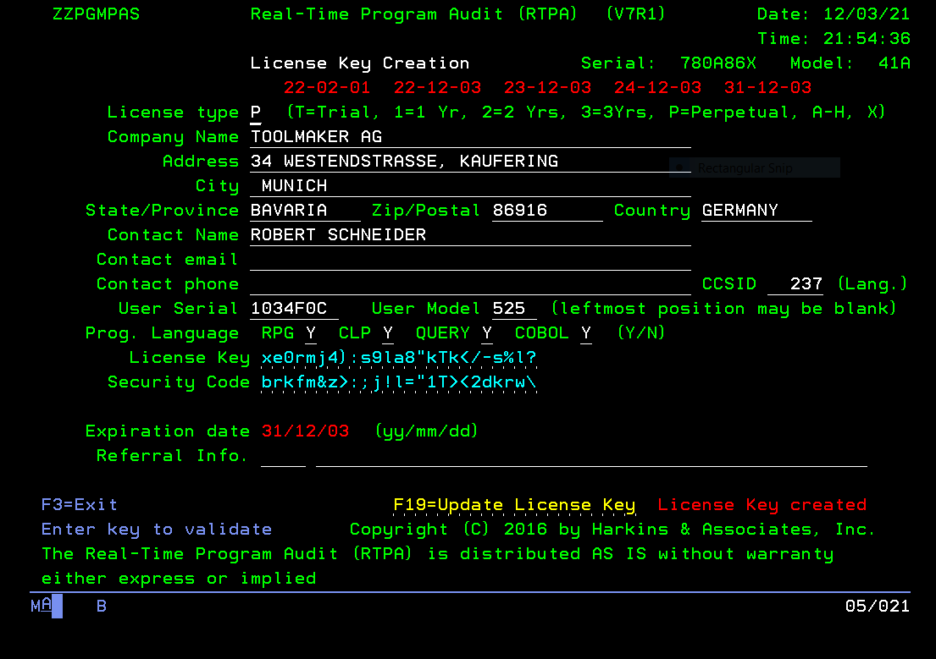

(enter license key information and press F10 to create RTPA license key for User)
(create user license key and email to the user so the user can enter the license key with program

RTPA License key entry at the RTPA user

Library list
ZZAUDITE
ZZAUDIT

CALL ZZLICENSE
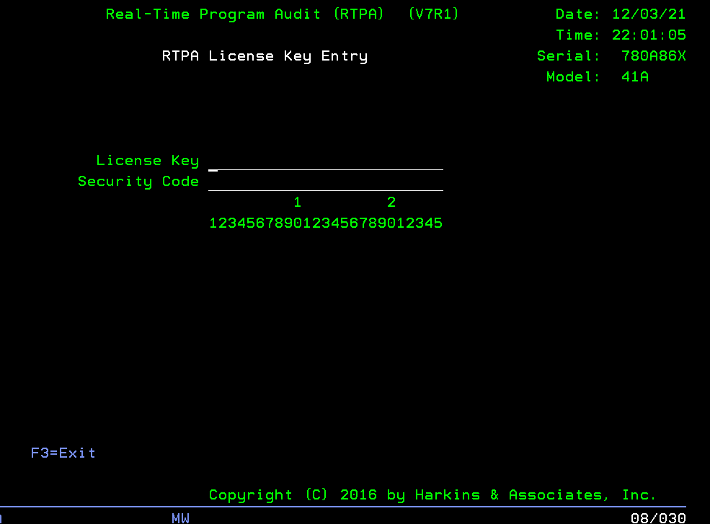

(Enter emailed RTPA license key for the user as in the RTPA User Manual)
License Key ________________________
Security Code ________________________
To bypass RTPA License Key checking in ZZPGM01R
(before entering the command RTPA to display RTPA program entry screen)

(to bypass the RTPA license key without changing CLP RTPA is to set the user switches before entering command RTPA)
U5 ON
U7 OFF
U8 ON

// UPSI XXXX1X01
RTPA
=========================================To always bypass the RTPA License key checking change the RTPA CLP as below in library ZZAUDIT

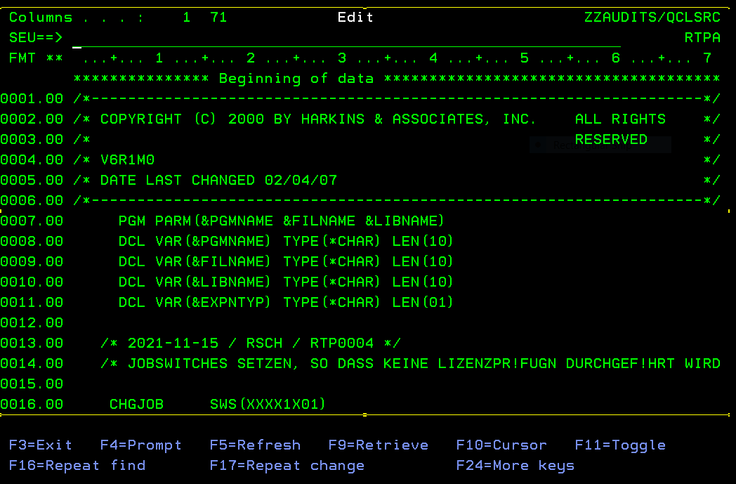
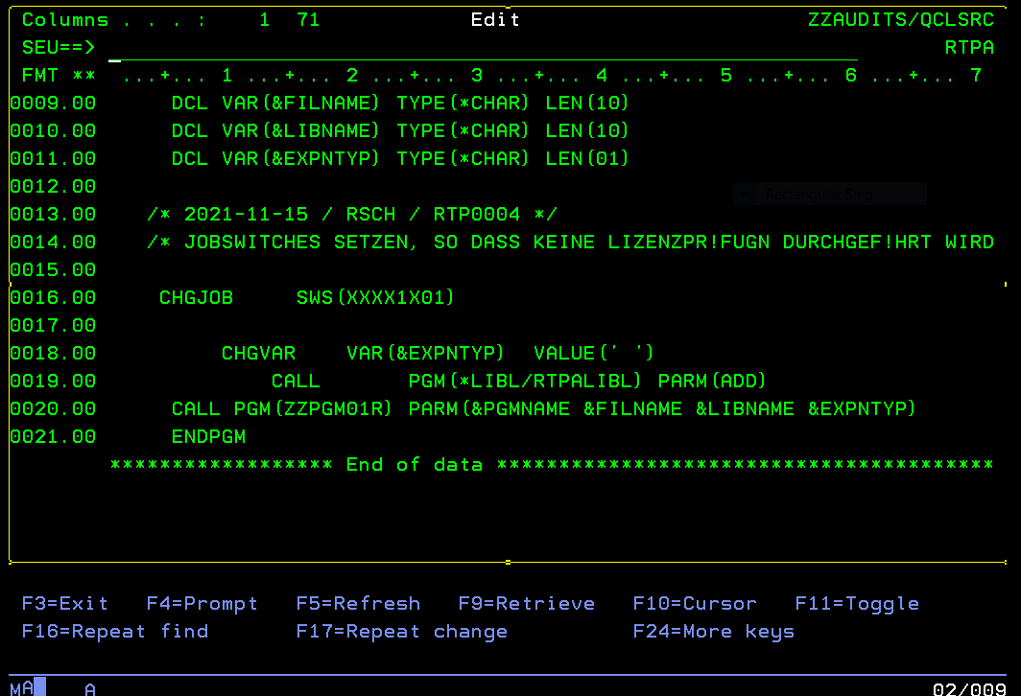

=========================================

Appendix

APPENDIX
N

Appendix N: RTPA Creation of Source and Object SAVFs for distribution
RTPA is distributed to IBM i customers as object library save files (SAVF)

RTPA new version creation of RTPA object SAVF and RTPA source SAVF with MAKERPG command

Review and change the RTPA CLP RTPACRT in ZZAUDITS for changes to the RTPA distribution creation of the SAVfs since the latt RTPA release

RTPA71B1 is the RTPA release V7R1 OBJECT libraries
RTPA71S1 is the RTPA release V7R1 SOURCE libraries for RTPA development

Then compile CLP RTPACRT to ZZAUDITS before running the MAKERPG command to create the SAVFs

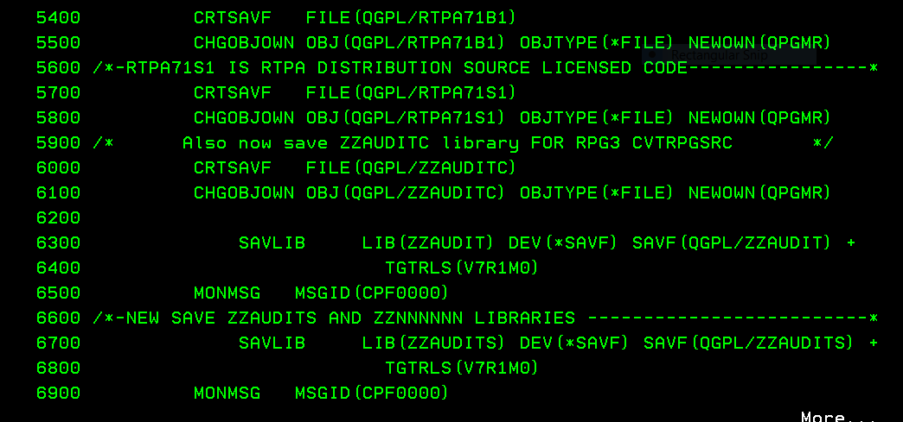

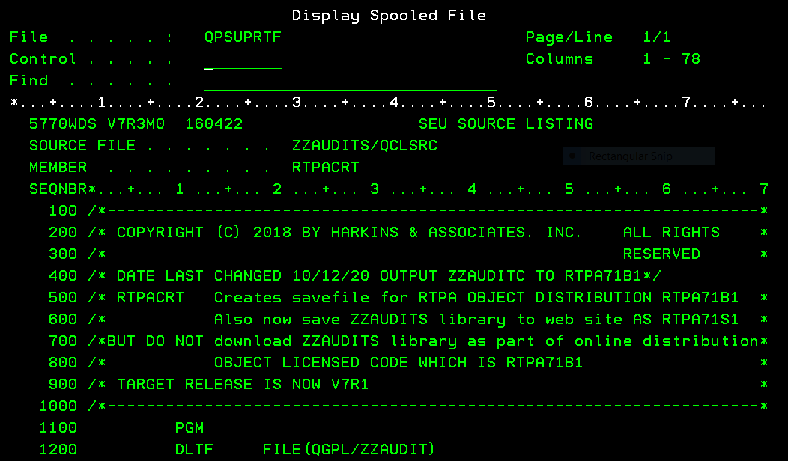

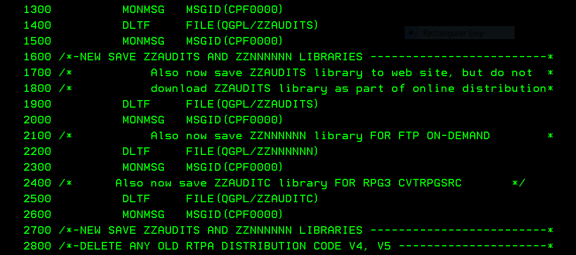
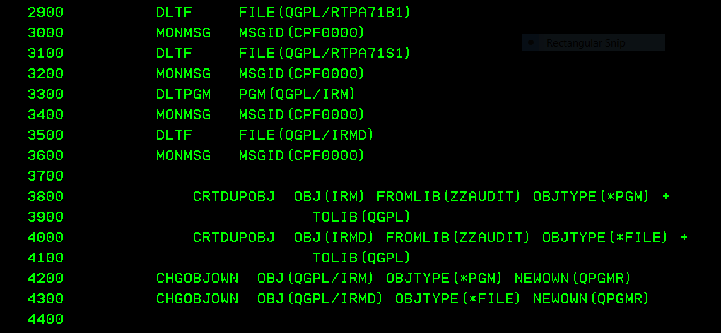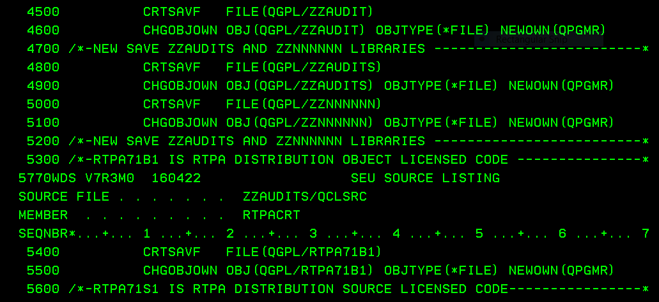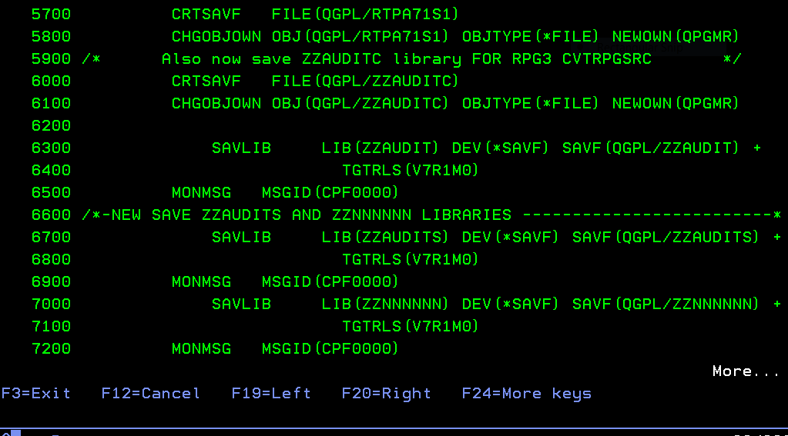

First add any new programs to the MAKERPG CLP which compiles all the RTPA source programs with a target release of V7R1 (two releases back from V7R3)

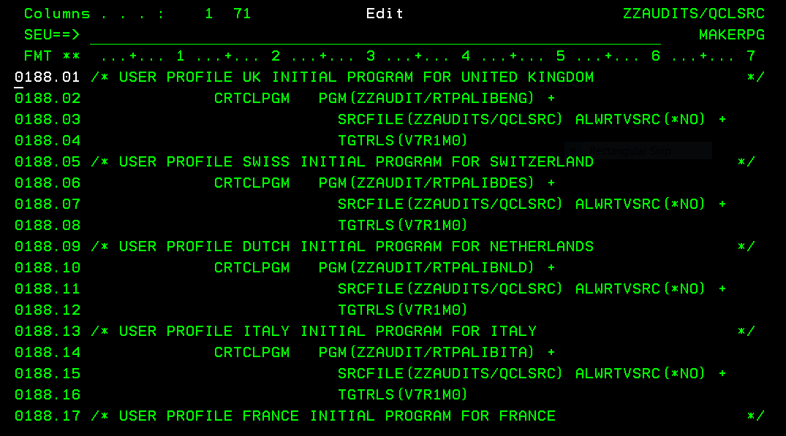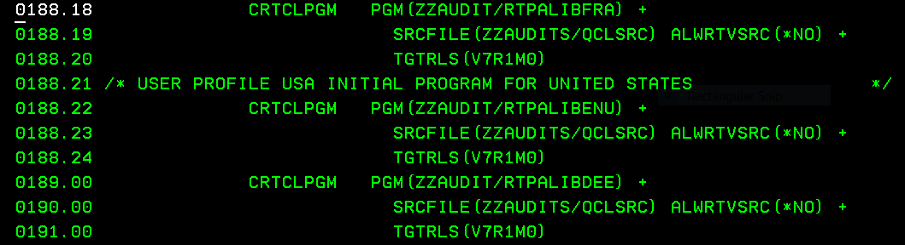

Then Create CLPMAKERPG to library ZZAUDITS

Then run the stream to create the RTPA distribution SAVFs

QSECOFR authority is required
The RTPA MAKERPG command creates new RTPA save files for the entire RTPA system, similar to new IBMi versions
- Recompiles all RTPA source programs in library ZZAUDITS and creates new RTPA object programs in library ZZAUDIT
- Create RTPA Save file in the form RTPA71B1 RTPA user object distribution
- Create RTPA Save file in the form RTPA71S1 RTPA source
(this means that RTPA CAN BE INSTALLED ON ANY IBM i WITH AT LEAST IBM i v7r1 (TARGET RELEASE IN PROGRAM COMPILES IS V7R1M0)
Signon as QSECOFR
ADDLIBLE ZZAUDITS

APPENDIX
O

Appendix O: RTPA User Manual in many languages with Google Docs

The RTPA User Manual can be converted from English to many other languages with Google Docs for free.

Translate an English language document into German with Google Translate online

Top of Form
microsoft Word How to copy a word document to the back of another word document
Microsoft Word 2016
- Open the first document.
- Place the cursor where you want the second document to be inserted.
- From the Insert tab, Text group, click on the down arrow next to Object and choose Text from file.
- Select the file to be inserted.
- Click on Insert.

Top of Form
You can access OneDrive at any time by going to www.onedrive.com in your web browser. From here, you can access your files, create new documents in Office Online, and much more.

If you're looking to translate your entire Word document to another language, there's a feature for that as well. This doesn't require you to select any anything in your document; it takes the contents and translates them to your chosen language. A great aspect of this Word feature is that it won't overwrite your original document.
- Open the Word Document to be translated (from English to German)
- 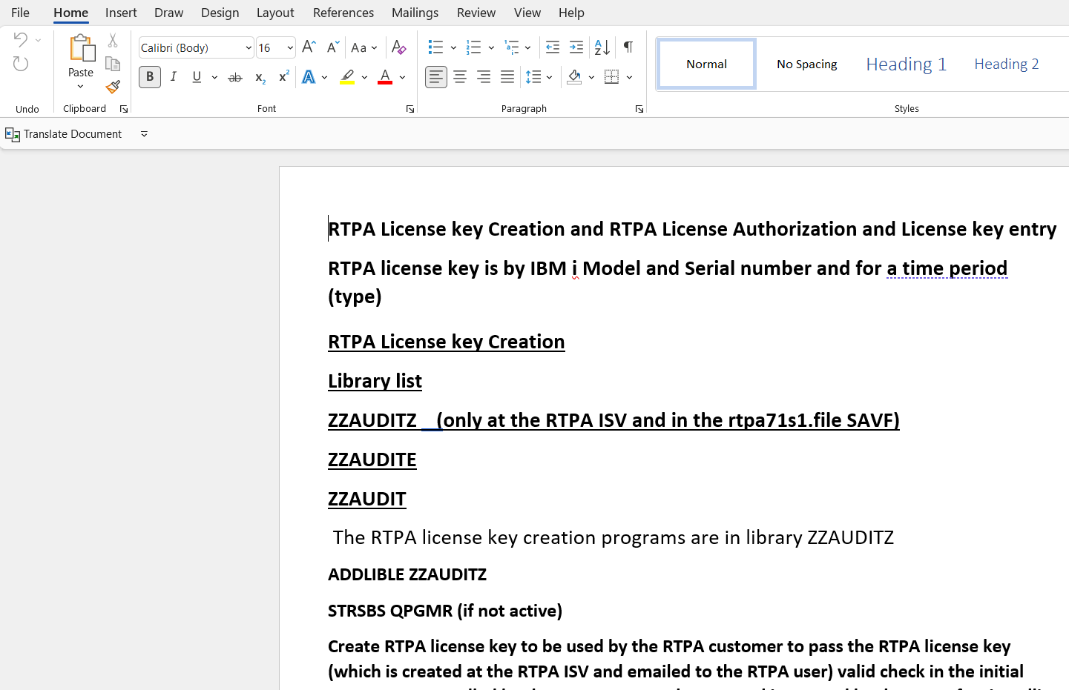
- Select Review
- Select Translate
- Select Translate Document
Create a translated copy of your document with the Microsoft Translator
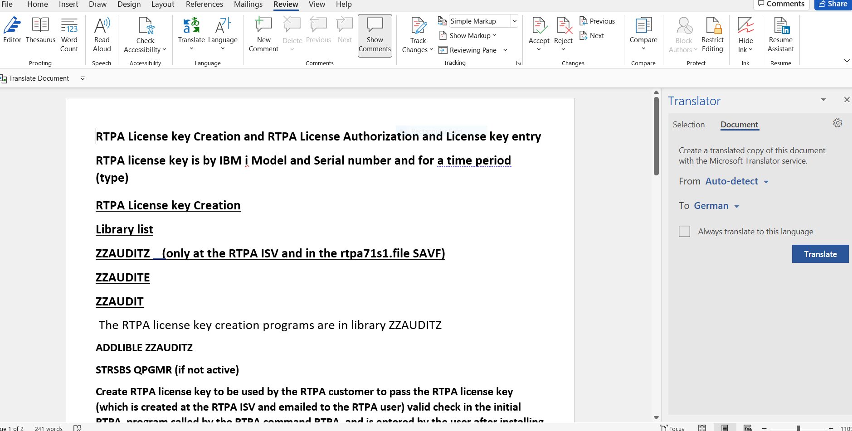
- Select German from the list (after English)
- Select translate
The German translation is displayed as a Word Document
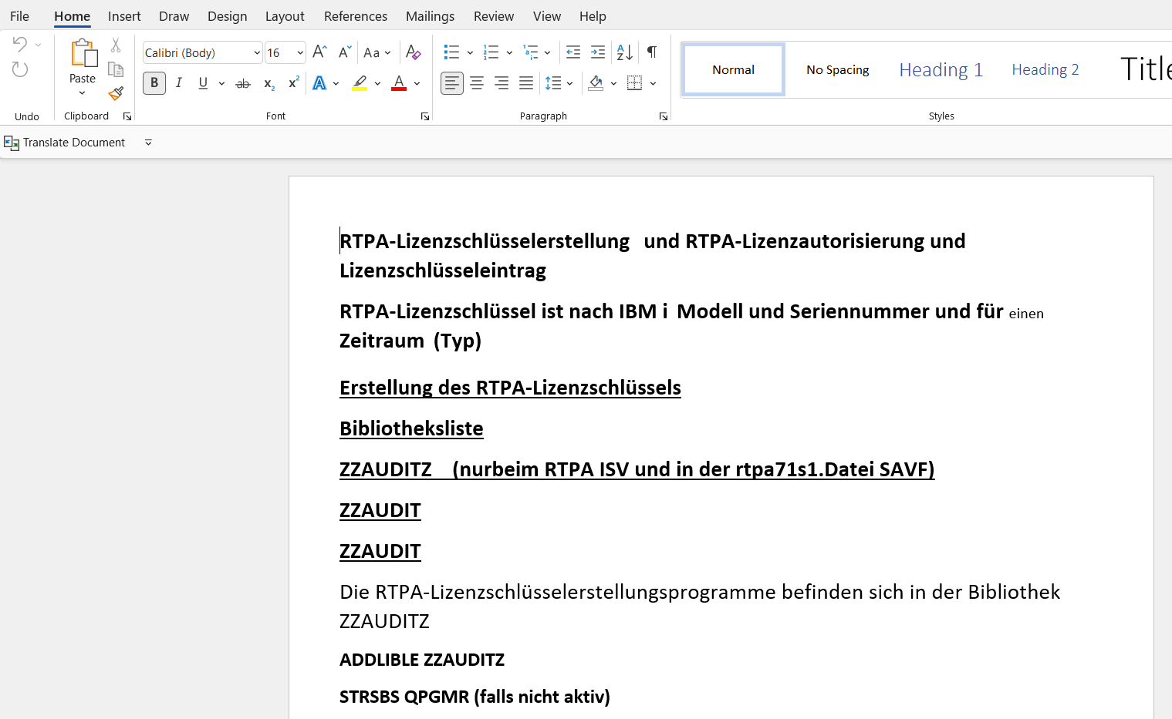

- Press OK after Translation complete message
- Save translated document in German
- 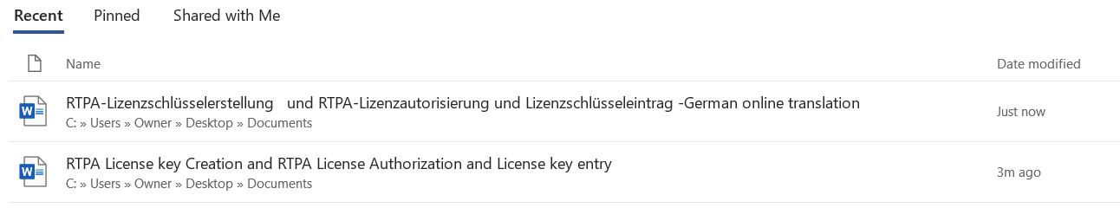
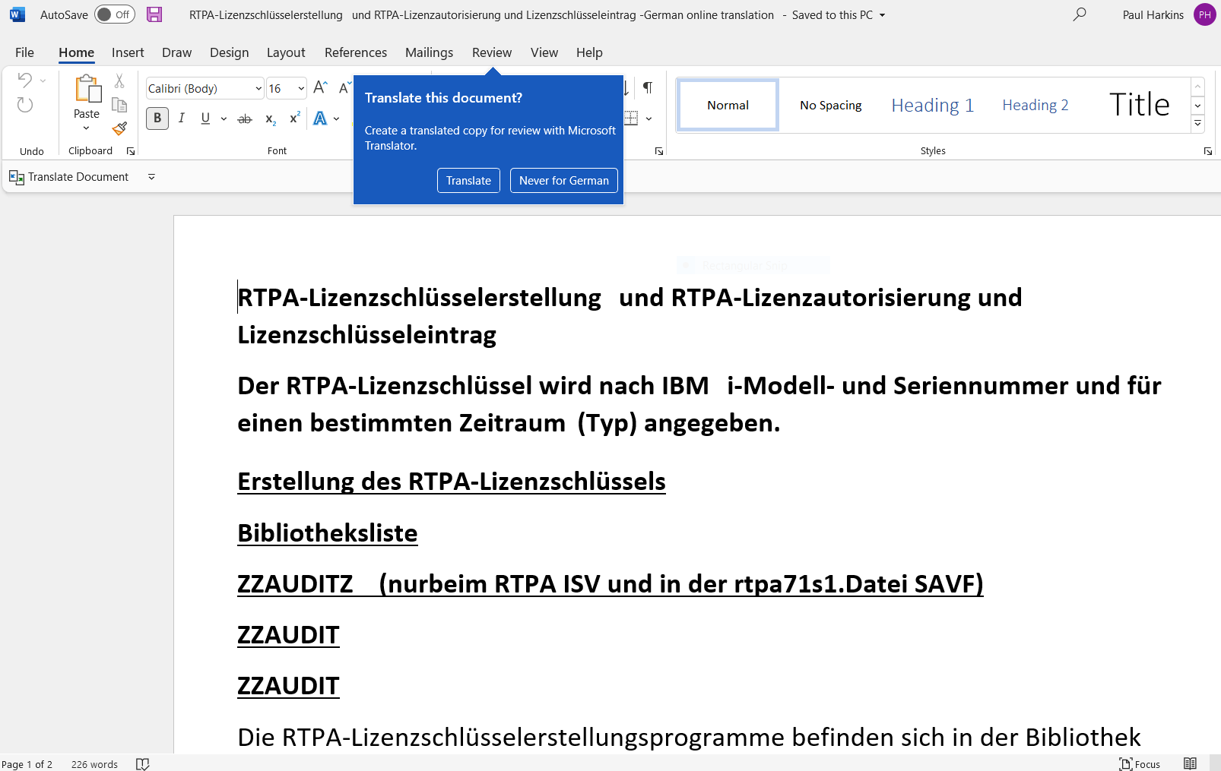
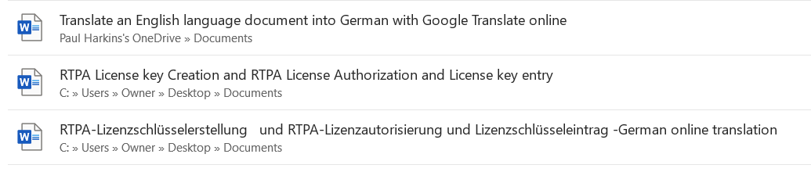

Google translate has a 5,000 word maximum capacity for translating Word documents, so translating the RTPA User manual requires translating perhaps 50 pages at a time, then using the Word insert text option to translate sections of the RTPA User Manual.

Then page number the translated RTPA User Manual and create a new table of contents.

Automatisierung der Unternehmensprogrammierung

Dreifache Programmierer-Produktivität

RTPA für RPG

RTPA für CLP

RTPA für COBOL

RTPA-Abfrage

RTPA On Demand Cloud Computing über FTP

Benutzerhandbuch

V7R1

Us-Patent Nr. 6,775,827
Multiplizieren Sie die Produktivität, Leistungsfähigkeit und den Wert des Programmierers mit dem 3-, 5-, 10-, 100-fachen

APPENDIX
P

Appendix P: RTPA To Dos

Real-Time Program Audit (RTPA) products To Dos
- RTPA for RPG Command RTPA (programs ZZPGMxx)
- Expand RPG source programs for Real-Time-program auditing
- RTPA for CLP Command RTPACL (programs ZZCLPxx)
- Expand CLP source programs for Real-Time-program auditing
- RTPA for COBOL Command RTPACOB (programs ZZCOBxx)
- Expand COBOL source programs for Real-Time-program auditing
- RTPA Query Command RTPAQ (programs ZZPGMxx)
- Query and analytics of RTPA expansions
- RTPA for On Demand Computing via FTP (at cloud service bureau)
- Remote On Demand RTPA expansion via FTP at a cloud service center
- Command RTPAODC (programs ZZODCxx)
- IBM i customer has only RTPA programs to request RTPA expansion (RTPA entry screens) and to FTP to service bureau and receive FTPed RTPA expansion (from ZZAUDITE expanded source) from service bureau and to apply FTPed RTPA expansion to RTPA files at customer.

RTPA to Do
RPG (ZZPGMxx source programs and RTPA Command)
- Fix RPG free auditing TESTBASF not auditing all free statements
- Fix RPG free lower case Select error TESTSELEFF
- Complete DBCS Double Byte Character Set implementation for Japan, China ZZFI09 from operation – to operation to allow bypass of RTPA auditing for newly available op codes
- Implement RPG **FREE free auditing
- Implement RPG no cycle auditing Yusy4Code
- Implement Mohammed Yusuf RPG videos examples and audit
- Allow for new RPG operations in RTPA with do not audit betewwn Fom operation – To operation, do not attempt to audit ZZFI12
(For, etc.)
- Allow for RPG compile of enabled source with ZZ statements at host (Full RTPA IBM i) by using compile listing files and field definitions to create empty F
- Restore /COPY commented source statements in enabled source FTP
- Allow RTPA auto correct of error RTPA inserted ZZ audit statements in enabled RTPA source on host by commenting error RTPA ZZ audit statements
- For FTPed source, create file ZZAUDSRC at customer IBM i from enabled source
COBOL (ZZCOBxx source programs and RTPACOB Command)

- Implement multi-language and new screens
- Fix COBOL interactive program compile error
- Implement Mohammed Yusuf COBOLvideos examples and audit
- If ILE program use Procedures not subroutines in RTPA routines in expanded source
CLP (ZZCLPxx source programs and RTPACL Command)

- Implement multi-language and new screens

RTPA IBM i RTPAODC Cloud Host FTP processing capability (ZZAUDITH ZZAUDITF)
Implement Real-Time Program Audit (RTPA) for IBM i license alternatives
- Full in-house or cloud LPAR RTPA license
- FTP to cloud host LPAR for RTPA enablement (No full RTPA at IBM i customer)

RTPA analytics beyond RTPA Query
- Implement RTPA dashboard analytics (DB2 web query, SEQUEL)
- Management of RTPA usage by developers

